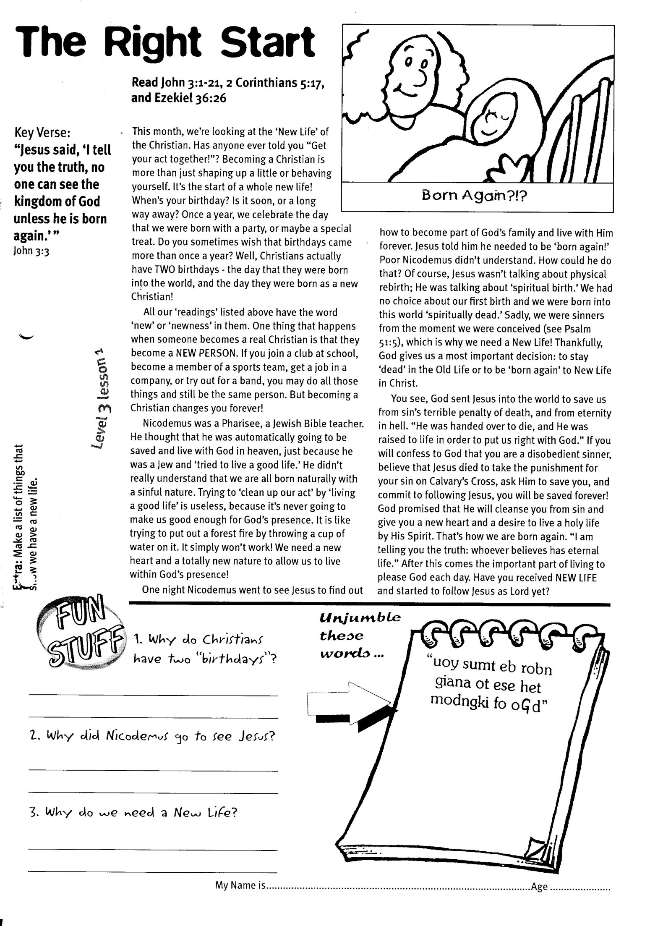

**Read John 3:1-21, 2 Corinthians 5:17, and Ezekiel 36:26**

This month, we’re looking at the ‘New Life’ of the Christian. Has anyone ever told you “Get your act together!”? Becoming a Christian is more than just shaping up a little or behaving yourself. It’s the start of a whole new life! When’s your birthday? Is it soon, or a long way away? Once a year, we celebrate the day that we were born with a party, or maybe a special treat. Do you sometimes wish that birthdays came more than once a year? Well, Christians actually have TWO birthdays - the day that they were born into the world, and the day they were born as a new Christian!

All our ‘readings’ listed above have the word ‘new’ or ‘newness’ in them. One thing that happens when someone becomes a real Christian is that they become a NEW person. If you join a club at school, become a member of a sports team, get a job in a company, or try out for a band, you may do all those things and still be the same person. But becoming a Christian changes you forever!

Nicodemus was a Pharisee, a Jewish Bible teacher. He thought that he was automatically going to be saved and live with God in heaven, just because he was a Jew and ‘tried to live a good life.’ He didn’t really understand that we are all born naturally with a sinful nature. Trying to ‘clean up our act’ by ‘living a good life’ is useless, because it’s never going to make us good enough for God’s presence. It is like trying to put out a forest fire by throwing a cup of water on it. It simply won’t work! We need a new heart and a totally new nature to allow us to live within God’s presence!

didn’t exist either, so

**The Right Start**

Key Verse:  
**“Jesus said, ‘I tell you the truth, unless a man is born again, he cannot see the kingdom of God.’”**  
John 3:3

**Level 3 lesson 1**

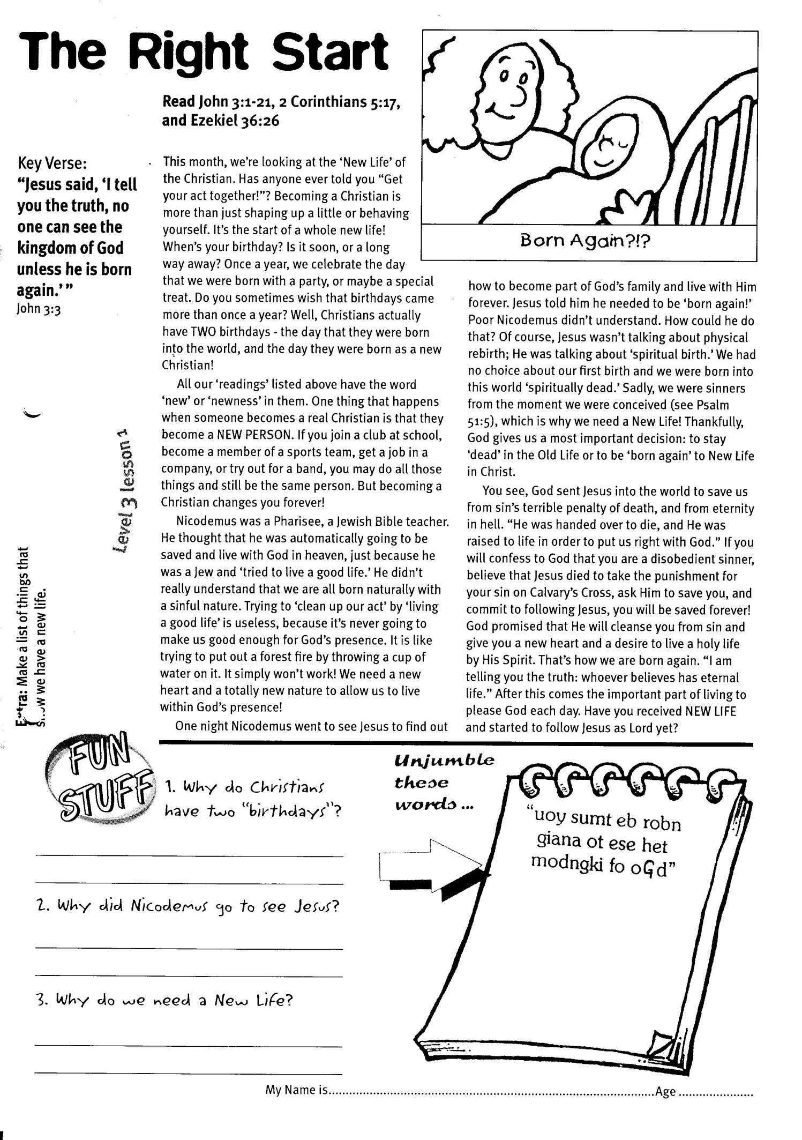

My Name is ………………………………………………………   
Age…………………

1. Why do Christians have two “birthdays”?  
  
________________________________

________________________________

**Extra:** Make a list of things that show we have a new life.

2. Why did Nicodemus go to see Jesus?  
_________________________________________________________

_________________________________________________________

3. Why do we need a NEW LIFE and what’s wrong with the OLD one? __________________________________________

_________________________________________________________

One night Nicodemus went to see Jesus to find out how to become part of God’s family and live with Him forever. Jesus told him he needed to be ‘born again!’ Poor Nicodemus didn’t understand. How could he do that? Of course, Jesus wasn’t talking about physical rebirth; He was talking about ‘spiritual birth.’ We had no choice about our first birth into this world, and we were born into this world ‘spiritually dead.’ Sadly, we were sinners from the moment we were conceived (see Psalm 51:5), which is why we need a New Life! Thankfully, God gives us a most important decision: to stay ‘dead’ in the Old Life, or to be ‘born again’ to New Life in Christ.

You see, God sent Jesus into the world to save us from sin’s terrible penalty of death, and from eternity in hell. “He was handed over to die, and He was raised to life in order to put us right with God.” If you will confess to God that you are a disobedient sinner, believe that Jesus died to take the punishment for your sin on Calvary’s Cross, ask Him to save you, and commit to following Jesus, you will be saved forever! God promised that He will cleanse you from sin and give you a new heart and a desire to live a holy life by His Spirit. That’s how we are born again. “I am telling you the truth: whoever believes has eternal life.” After this comes the important part of living to please God each day. Have you received NEW LIFE and started to follow Jesus as Lord yet?

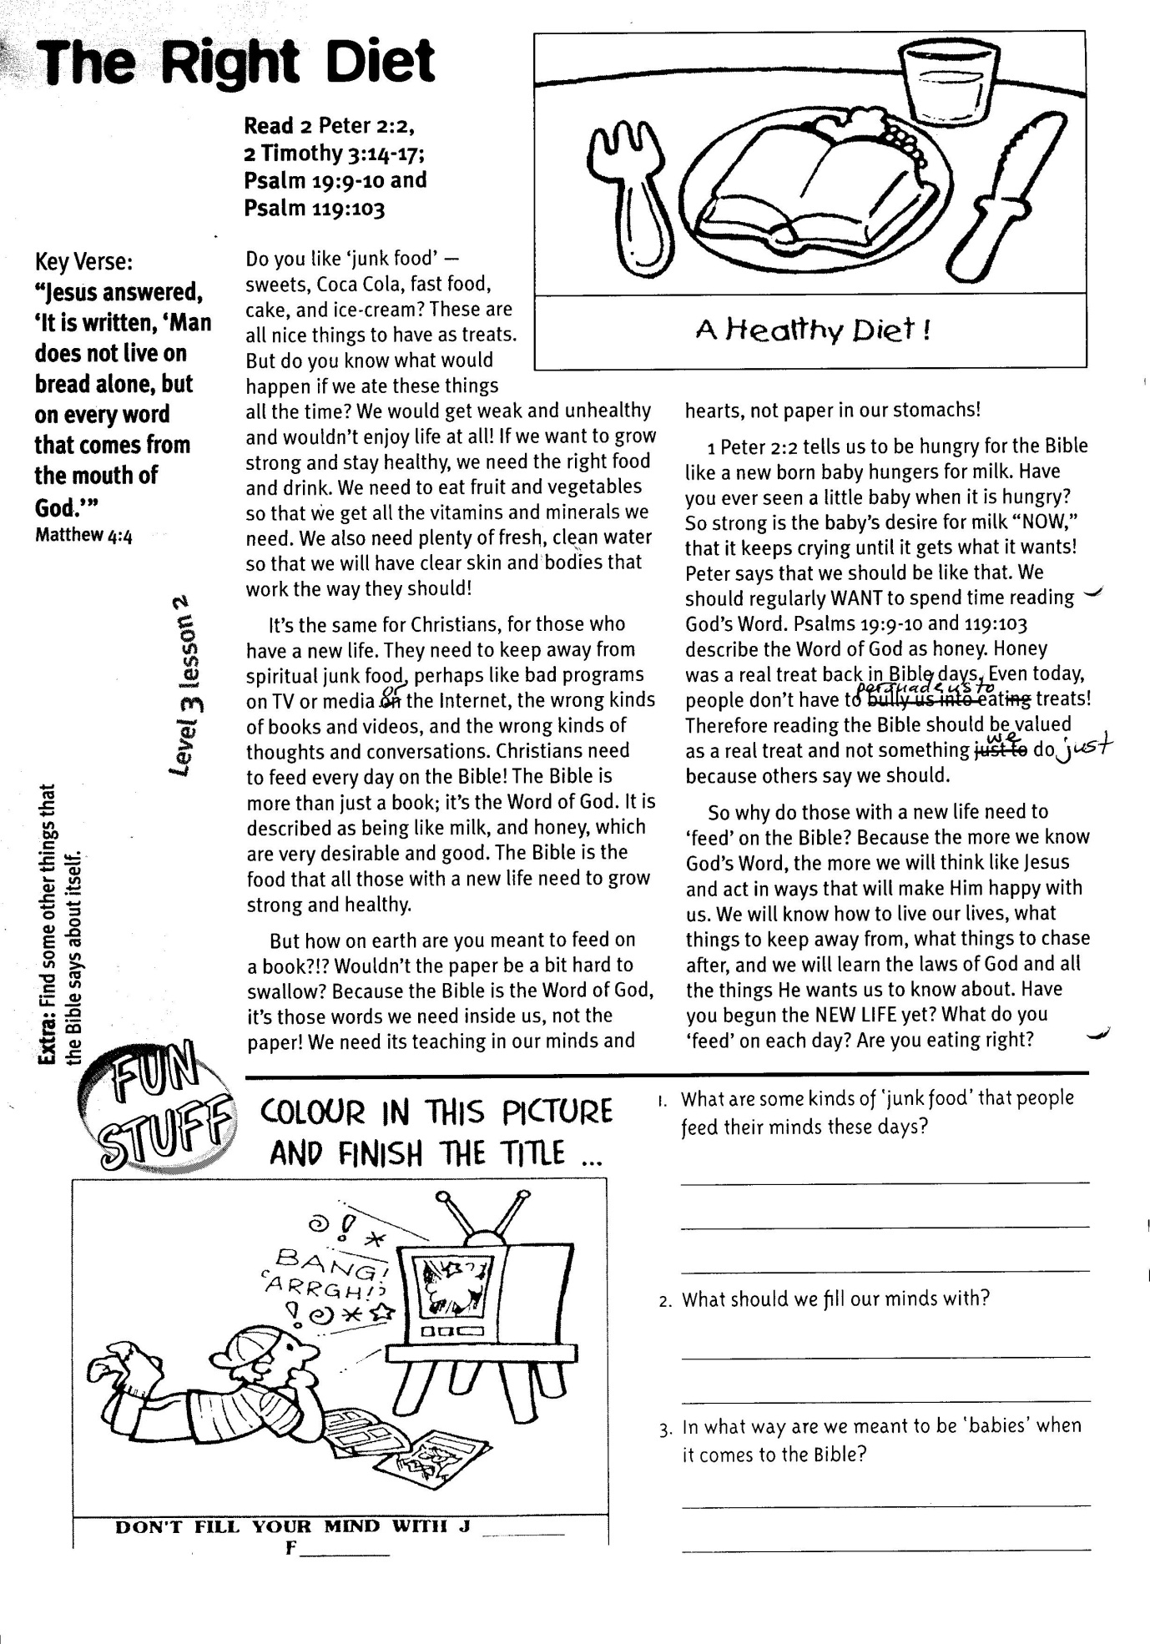

**Read 2 Peter 2:2, 2 Timothy 3:14-17, Psalm 19:9-10 and Psalm 119:103**

Do you like ‘junk food’ — sweets, Coke, fast food, cake, and ice-cream? These are all nice things to have as treats. But do you know what would happen if we ate these things all the time? We would get weak and unhealthy and wouldn’t enjoy life at all! If we want to grow strong and stay healthy, we need the right food and drink. We need to eat fruit and vegetables so that we get all the vitamins and minerals we need. We also need plenty of fresh, clean water so that we will have clear skin and bodies that work the way they should!

It’s the same for Christians, for those who have a new life. They need to keep away from spiritual ‘junk food,’ perhaps like bad programmes on TV or media or the internet, the wrong kinds of books and videos, and the wrong kinds of thoughts and conversations. Christians need to feed every day on the Bible! The Bible is more than just a book; it’s the Word of God. It is described as being like milk, and honey, which are very desirable and good. The Bible is the food that all those with a new life need to grow strong and healthy.

But how on earth are you meant to feed on a book?!? Wouldn’t the paper be a bit hard to swallow? Because the Bible is the Word of God, it’s those words we need inside us, not the

Key Verse:  
**“Jesus answered, “It is written, ‘Man does not live on bread alone, but on every word that comes from the mouth of God.’”**Matthew 4:4

**The Right Diet**



Don’t fill your mind with j ____________ f _____________

Colour in this picture & finish the title …….

2. What should we fill our minds with?  
_________________________________________

__________________________________________

3. In what way are we meant to be ‘babies’ when it comes to the Bible?

__________________________________________

_________________________________________________________

1. What are some kinds of ‘junk food’ that people feed their minds these days?  
  
______________________________________

______________________________________

paper! We need its teaching in our minds and hearts, not paper in our stomachs!

1 Peter 2:2 tells us to be hungry for the Bible like a new born baby hungers for milk. Have you ever seen a little baby when it is hungry? So strong is the baby’s desire for milk “NOW,” that it keeps crying until it gets what it wants! Peter says that we should be like that. We should regularly want to spend time reading God’s Word. Psalms 19:9-10 and 119:103 describe the Word of God as honey. Honey was a real treat back in Bible days. Even today, people don’t have to persuade us to eat treats! Therefore reading the Bible should be valued as a real treat and not something we do just because others say we should.

So why do those with a new life need to ‘feed’ on the Bible? Because the more we know God’s Word, the more we will think like Jesus and act in ways that will make Him happy with us. We will know how to live our lives, what things to keep away from, what things to chase after, and we will learn the laws of God and all the things He wants us to know about. Have you begun the NEW LIFE yet? What do you ‘feed’ on each day? Are you eating right?

**Level 3 lesson 2**

**Extra:** Find some other things that  
the Bible says about itself.

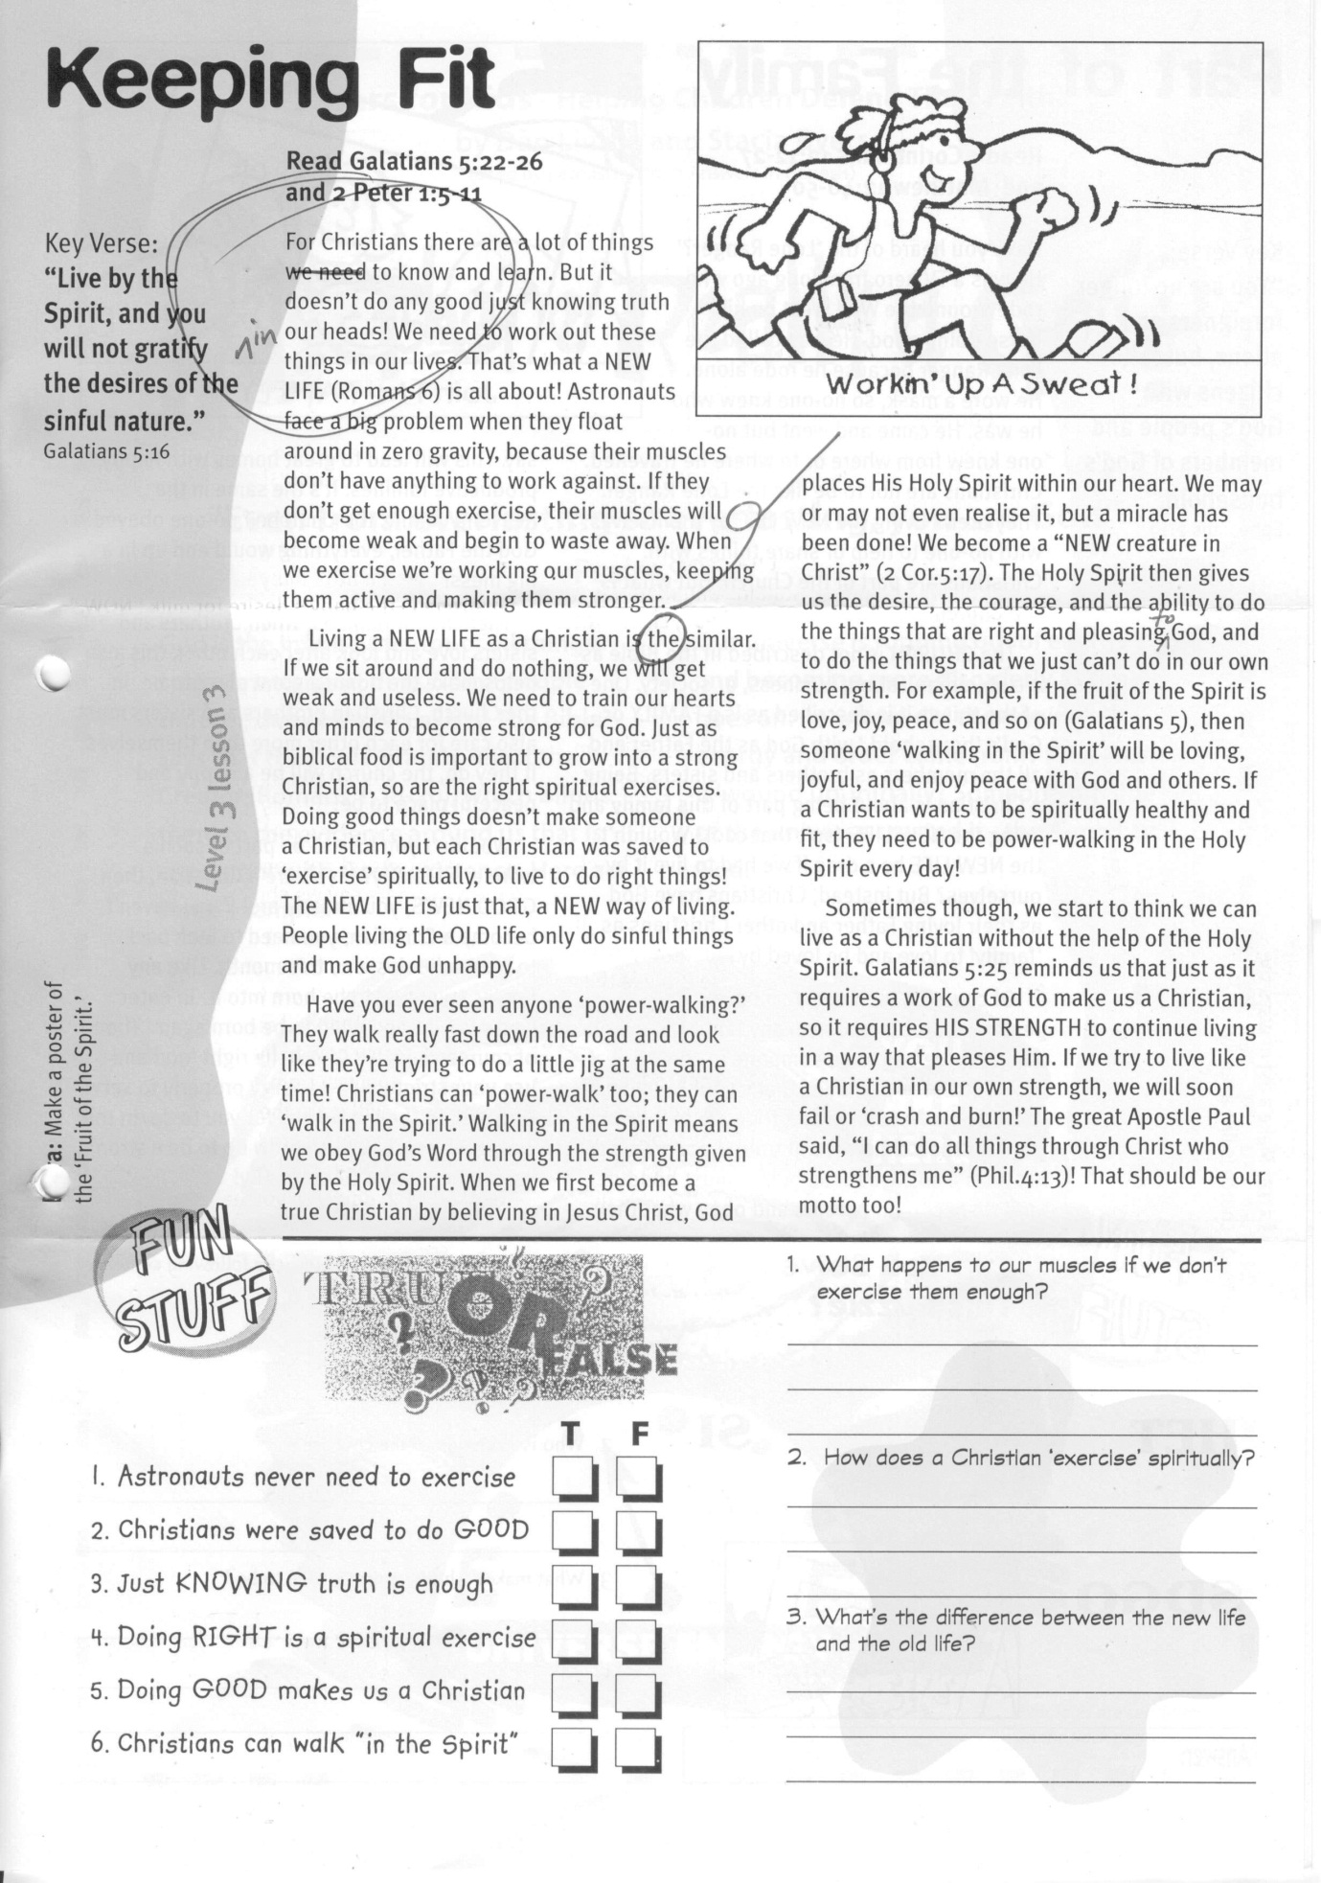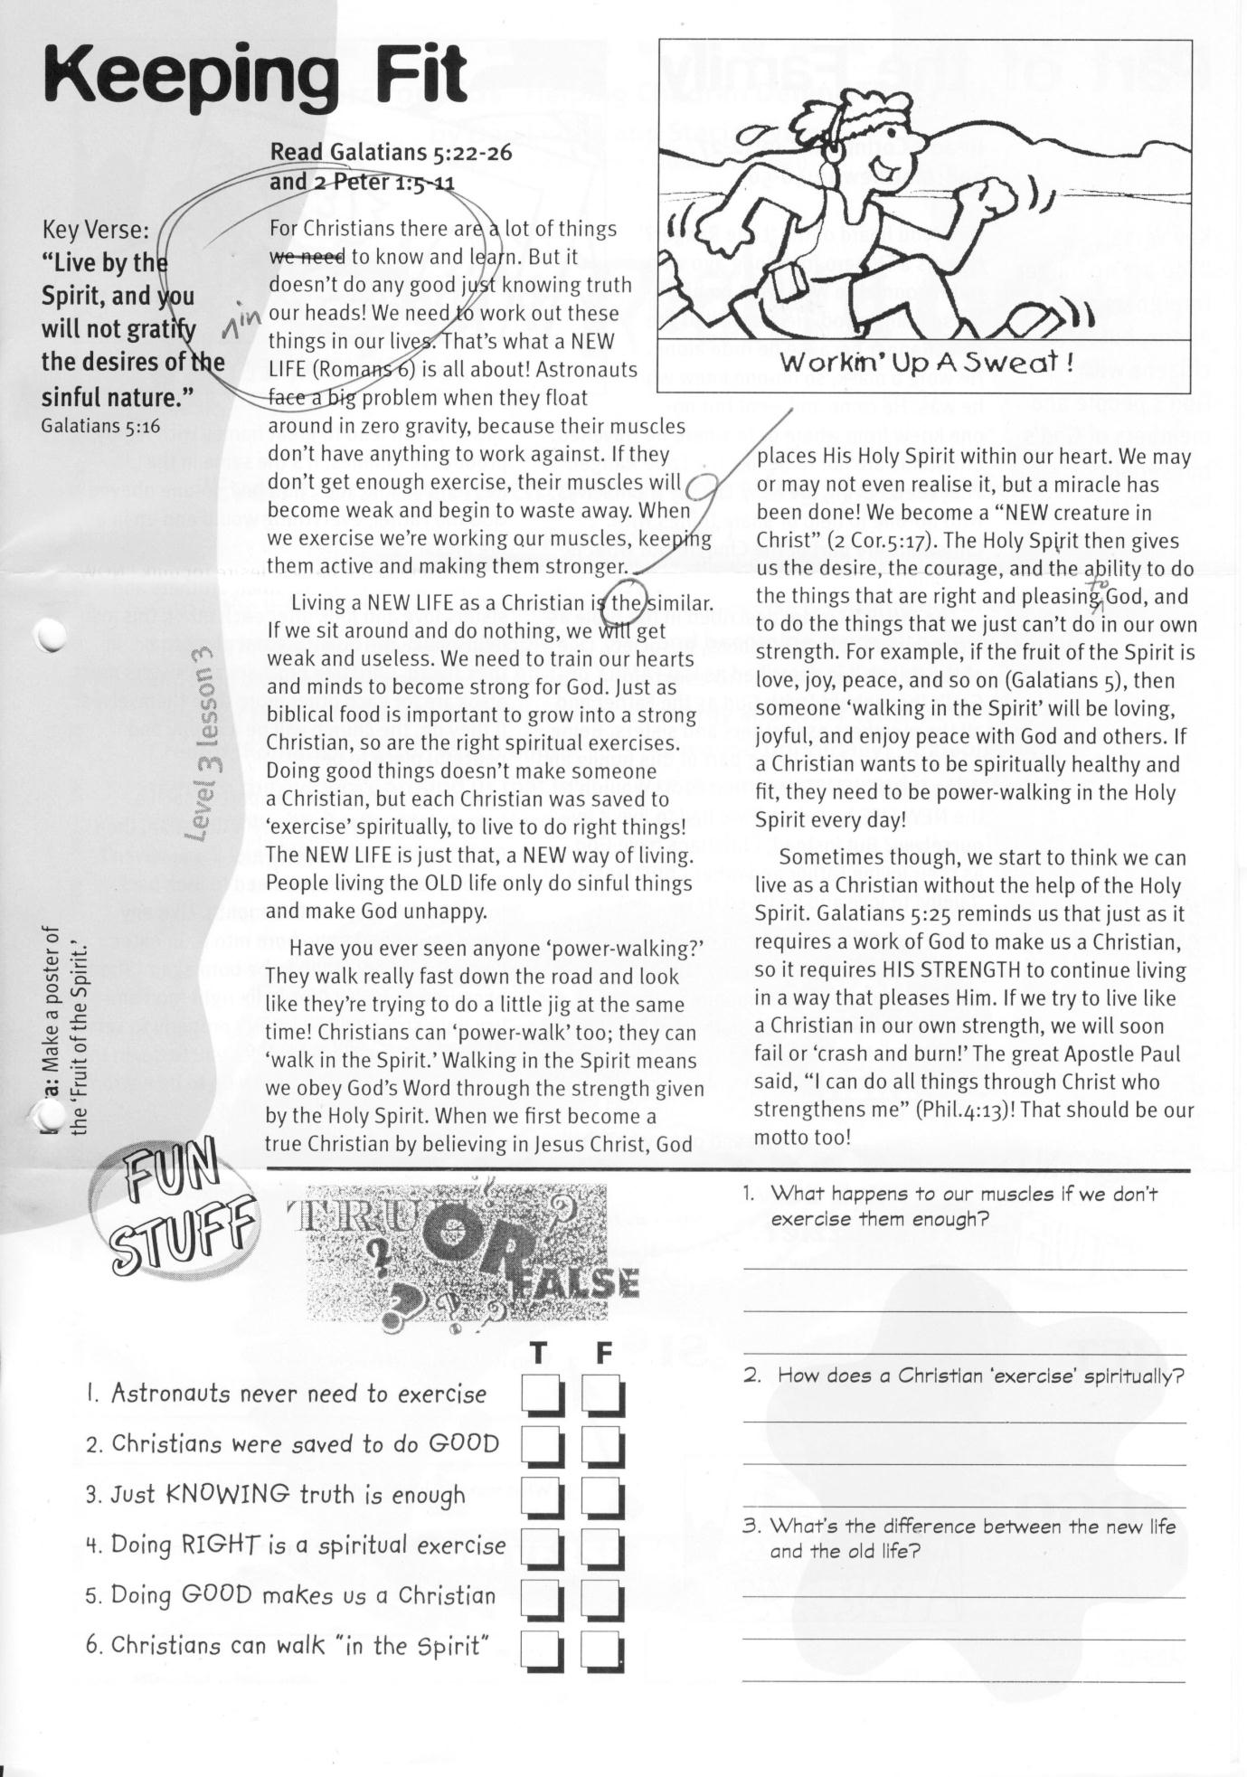

**Read Galatians 5:22-26 and   
2 Peter 1:5-11**

For Christians there are a lot of things to  
know and learn. But it doesn’t do any   
good just knowing truth in our heads!   
We need to work out these things in our lives. That’s what a NEW LIFE (Romans 6) is all about! Astronauts face a big problem when they float around in zero gravity, because their muscles don’t have anything to work against. If they don’t get enough exercise, their muscles will become weak and begin to waste away. When we exercise we’re working our muscles, keeping them active and making them stronger.

Living a NEW LIFE as a Christian is similar. If we sit around and do nothing, we will get weak and useless. We need to train our hearts and minds to become strong for God. Just as biblical food is important to grow into strong Christians, so are the right spiritual exercises. Doing good things doesn’t make someone a Christian, but each Christian was saved to ‘exercise’ spiritually, to live to do right things! The NEW LIFE is just that, a NEW way of living. People living the OLD life only do sinful things and make God unhappy.

Have you ever seen anyone ‘power-walking?’ They walk really fast down the road and look like they’re trying to do a little jig at the same time! Christians can ‘power-walk’ too; they can ‘walk in the Spirit.’ Walking in the Spirit means we obey God’s Word through the

**?**

TRUE OR FALSE

1. What happens to our muscles if we don’t exercise them enough?  
_______________________________________  
_______________________________________

2. How does a Christian ‘exercise’ spiritually?  
______________________________________________________________________________  
_______________________________________

3. What’s the difference between the new life and the old life?  
______________________________________________________________________________  
_______________________________________

**Extra:** Make a poster of the ‘Fruit of the Spirit.’

**Level 3 lesson 3**

Key Verse:  
**“Live by the Spirit, and you will not gratify the desires of the sinful nature.”**Galatians 5:16

**Keeping Fit**

**FUN**

strength given by the Holy Spirit. When we first become a true Christian by believing in Jesus Christ, God places His Holy Spirit within our heart. We may or may not even realise it, but a miracle has been done! We become a “NEW creature in Christ” (2 Cor.5:17). The Holy Spirit then gives us the desire, the courage, and the ability to do the things that are right and pleasing to God, and to do the things that we just can’t do in our own strength. For example, if the fruit of the Spirit is love, joy, peace, and so on (Galatians 5), then someone ‘walking in the Spirit’ will be loving, joyful, and enjoy peace with God and others. If a Christian wants to be spiritually healthy and fit, they need to be power-walking in the Holy Spirit every day!

Sometimes though, we start to think we can live as a Christian without the help of the Holy Spirit. Galatians 5:25 reminds us that just as it requires a work of God to make us a Christian, so it requires HIS strength to continue living in a way that pleases Him. If we try to live like a Christian in our own strength, we will soon fail or ‘crash and burn!’ The great Apostle Paul said, “I can do all things through Christ who strengthens me” (Phil.4:13)! That should be our motto too!

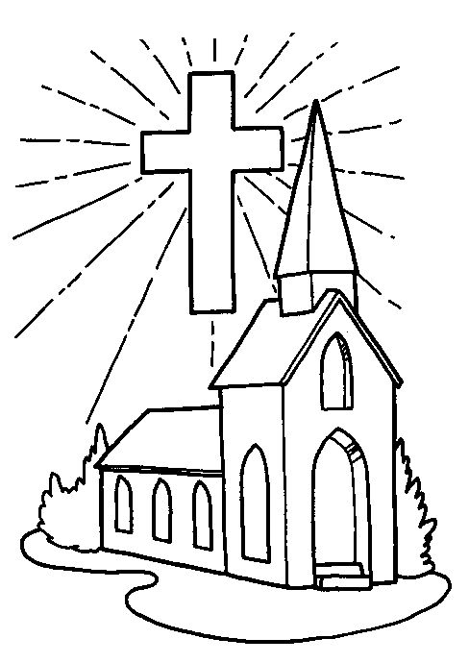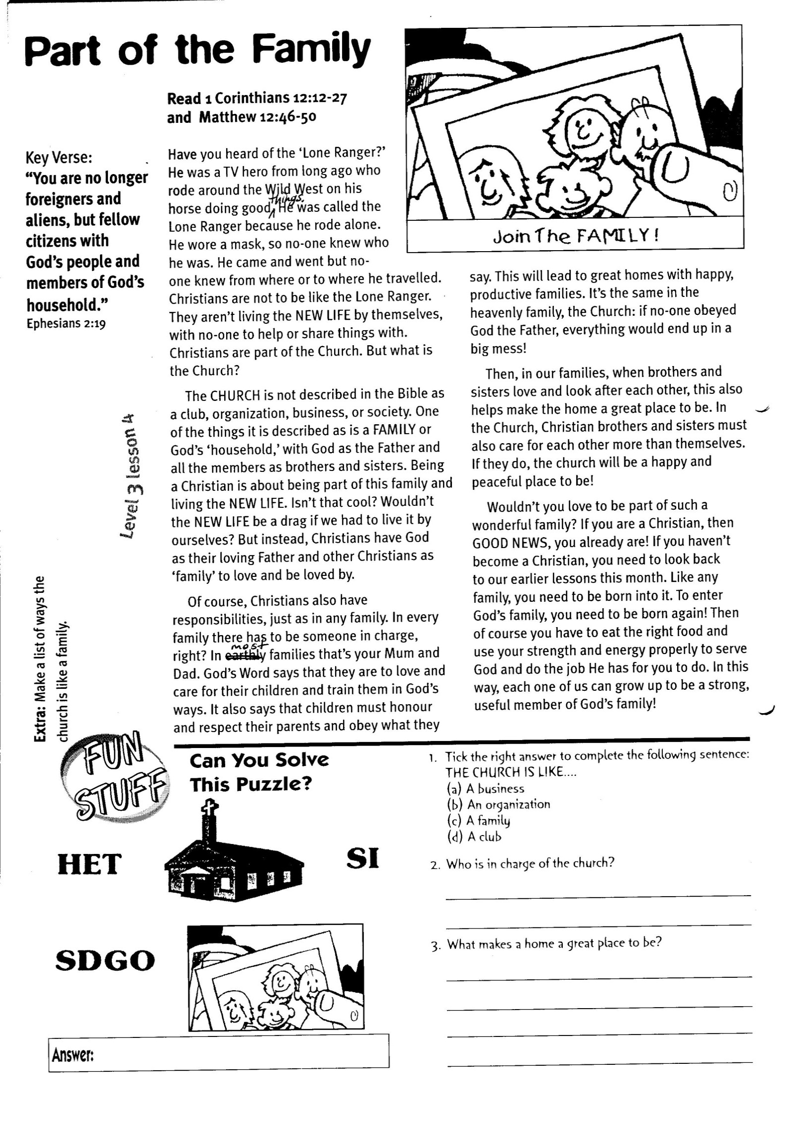

**Answer:**

**SI**

**HET**

**SDGO**

Can you solve the puzzle?

1. Tick the right answer to complete the following sentence:  
THE CHURCH IS LIKE………  
 (a) A business  
 (b) An organization  
 (c) A family  
 (d) A club

2. Who is in charge of the church?  
_______________________________________

3. What makes a home a great place to be?  
______________________________________________________________________________  
_______________________________________  
_______________________________________

and obey what they say. This will lead to great homes with happy, productive families. It’s the same in the heavenly family, the Church: if no-one obeyed God the Father, everything would end up in a big mess!

Then, in our families, when brothers and sisters love and look after each other, this also helps make the home a great place to be. In the Church, Christian brothers and sisters must also care for each other more than themselves. If they do, the church will be a happy and peaceful place to be!

Wouldn’t you love to be part of such a wonderful family? If you are a Christian, then GOOD NEWS, you already are! If you haven’t become a Christian, you need to look back to our earlier lessons this month. Like any family, you need to be born into it. To enter God’s family, you need to be born again! Then of course you have to eat the right food and use your strength and energy properly to serve God and do the job He has for you to do. In this way, each one of us can grow up to be a strong, useful member of God’s family!

**Extra:** Make a listof ways the church is like a family.

**Level 3 lesson 4**

**Read 1 Corinthians 12:12-27 and Matthew 12:46-50**

Have you heard of the ‘Lone Ranger?’ He was a TV hero from long ago who rode around the Wild West on his horse doing good things. He was called the Lone Ranger because he rode alone. He wore a mask, so no-one knew who he was. He came and went but no-one knew from where or to where he travelled. Christians are not to be like the Lone Ranger. They aren’t living the NEW LIFE by themselves, with no-one to help or share things with. Christians are part of the Church. But what is the Church?

The CHURCH is not described in the Bible as a club, organization, business, or society. One of the things it is described as is a FAMILY or God’s ‘household,’ with God as the Father and all the members as brothers and sisters. Being a Christian is about being part of this family and living the NEW LIFE. Isn’t that cool? Wouldn’t the NEW LIFE be a drag if we had to live it by ourselves? But instead, Christians have God as their loving Father and other Christians as ‘family’ to love and be loved by.

Of course, Christians also have responsibilities, just as in any family. In every family there has to be someone in charge, right? In most families that’s your Mum and Dad. God’s Word says that they are to love and care for their children and train them in God’s ways. It also says that children must honour and respect their parents

Key Verse:  
**“You are no longer foreigners and aliens, but fellow citizens with God’s people and members of God’s household.”**Ephesians 2:19

**Part of the Family**