

**Easter**

Key Verse:  
**“The Son of God loved me and gave Himself for me.”**  
Galatians 2:20

**Extra:** What is something you   
can thank God for?

**Level 2 lesson 9**

**Read John 19:1-18 and  
Acts 2:22-24**

Easter is a very special time of the year. It’s a happy holiday time when we have fun with family and friends. We might even eat Easter eggs and hot-cross buns! But there is something much more important about Easter than that. It is about remembering that nearly 2,000 years ago, Jesus Christ died for the sins of all the people in the world!

Jesus Christ is God’s own Son. He always did what God wanted Him to do and never did anything wrong. He always helped people and taught them about God. But the main reason He came to earth was to give up His life to pay for our sins.

So one Friday, He allowed some wicked, cruel men to nail Him on a cross and crucify Him, along with two thieves. Jesus certainly didn’t deserve to die because He has never sinned, but He let God punish Him with death for the sins we have done! He died instead of us, on this day we now call ‘Good Friday.’

Later that day, Jesus’ friends buried His body in a tomb (like a cave with a big stone rolled across the door). But that did not keep Jesus

in; God raised Him to life again the next Sunday! So at Easter we remember that wonderful day when Jesus rose from the dead to live for evermore in heaven. He wants you to live in heaven with Him too!

Believe today that Jesus died for YOUR sins and came back to life three days later. And if you ask Him to forgive and save You, He will save you; live in your heart, and make you a new person on the inside. Then every day you will want to please Him, by obeying what He tells us to do in the Bible. Jesus has promised that one day He will take us to be with Him in Heaven - forever! Our key memory verse for this week reminds us what Jesus did for each one of us. Make sure you learn it and take time to thank Him!

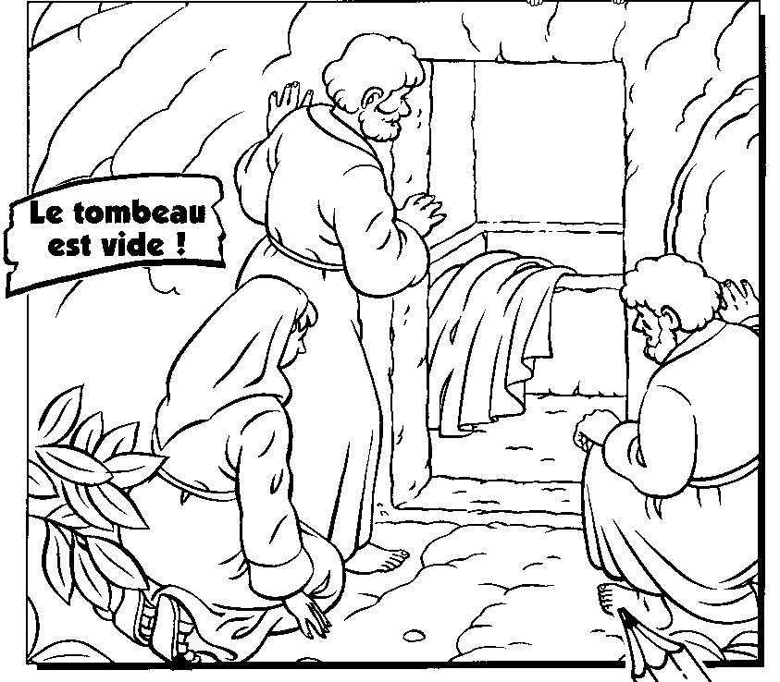

The tomb was empty!

**This picture tells us something about Easter. Can you write about it for us?**

____________________________

____________________________

____________________________

____________________________

____________________________

____________________________

My Name is ……………………………………………………………………… Age……………

|  |  |  |  |  |  |  |
| --- | --- | --- | --- | --- | --- | --- |
| b | d | p | s | p | h | b |
| f | k | f | r | f | p | g |
| h | a | l | i | v | e | m |
| g | m | p | s | r | k | f |
| c | g | n | n | g | d | c |

**Read Mark 16:1-7 and 1 Corinthians 15:3-4**

On Sunday morning, the third day after Jesus had been crucified, three women were walking along a dusty road. They were on their way to the grave where Jesus was buried. Two of them were called Mary and the other one was Salome.

They were very sad. They loved Jesus and they cried as they remembered how good and kind He was. They couldn’t understand why some people had wanted to kill Him. Now they wanted to put some special perfume on His body. They were not sure how they would move the big stone that was over the entrance of the tomb though!

What a huge surprise it was when they arrived at the tomb where Jesus was buried. The stone was already rolled away! When they looked inside the tomb they only saw an angel, and realised he had done it. The angel spoke to them and said, “Jesus is not here. He is alive! Go quickly and tell His disciples this good news.” The women could hardly believe it. They ran into town to tell the others this wonderful news.

Jesus was alive again - and He still is today! We should thank God for sending Jesus to die for us, and raising Him from the dead to be our Saviour. This week’s key memory verse tells us that God is pleased with anyone who believes in Jesus, and obeys what He says in the Bible.

**Level 2 lesson 10**

Key Verse:  
**“Blessed are those who have not seen and yet believe.”**  
John 20:29

**A Sunday Surprise**

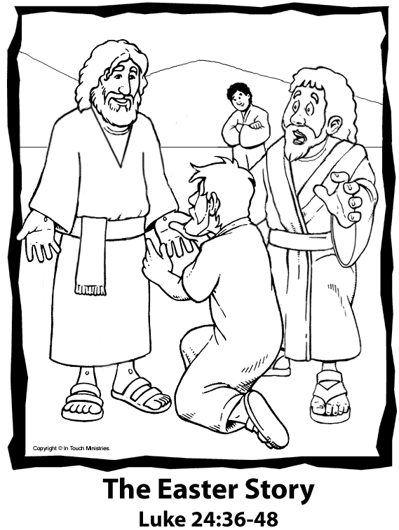

**J_s_s**

**is**

1. Fill in the gaps:

2. Cross out the letters that are used more than once

To find the answer to this puzzle, complete the two instructions below:

**Extra:** Why did Jesus have to die?

**Read Genesis 15:1-6 and Hebrews 11:11**

In this lesson you will be learning more about Abraham. But first, do you remember how God promised Abraham that he would have a very large family.

Yes, God promised Abraham that he would have as many children, grandchildren, and so on, as there are stars in the sky! This seemed impossible, because Abraham and Sarah were very old and had never even one baby. It seemed too late for them to have one of their own, but Abraham loved God and always tried to obey Him. He believed that God would do what He had promised.

After some more time passed and still no children had come, Sarah grew impatient. She told Abraham to marry her servant, Hagar. “If she has children,” she told Abraham, “they can count as mine.”

Abraham then did what Sarah had asked, but he should have never done that! This is because God says a man should have only one wife. Abraham should have followed God’s way and waited for the special son to come through Sarah as promised.

Soon Hagar gave birth to a baby boy, Ishmael, and Abraham thought that God had finally given him the son He had promised. But Ishmael was not the son God had promised. He became a trouble-maker.

How sad that, although Abraham believed God, he disobeyed Him and caused lots of trouble and sadness. When anyone disobeys God’s laws, trouble always comes! That’s also why lots of families are unhappy these days. Let’s always ask God to help us obey Him, and our parents.

**Learning to Obey**

**Level 2 lesson 11**

Key Verse:  
**“Abraham believed the Lord.”**  
Genesis 15:6

|  |  |  |  |  |  |  |  |  |  |  |  |  |  |
| --- | --- | --- | --- | --- | --- | --- | --- | --- | --- | --- | --- | --- | --- |
| **A** | **B** | **R** | **A** | **H** | **A** | **M** | **L** | **D** | **C** | **B** | **A** | **T** | **T** |
| **K** | **J** | **L** | **O** | **I** | **Y** | **B** | **Z** | **O** | **Q** | **T** | **W** | **Y** | **H** |
| **I** | **C** | **Y** | **Q** | **W** | **T** | **I** | **P** | **R** | **R** | **Z** | **M** | **X** | **E** |
| **B** | **E** | **L** | **I** | **E** | **V** | **E** | **D** | **Z** | **E** | **D** | **C** | **D** | **T** |

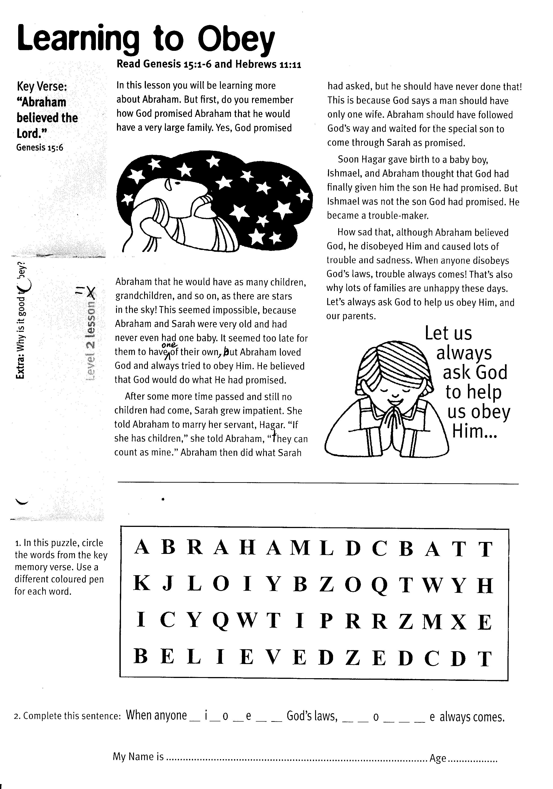

2. Complete this sentence: When anyone __ i __ o __ e __ __ God’s   
laws, __ __ o__ __ __ e always comes.

1. In this puzzle, circle the words from the key memory verse. Use a different coloured pen for each word.

**Extra:** Why is it good to obey?

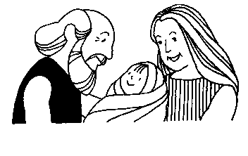

**Read Genesis 18:1-15**

Have you ever had to wait for something really exciting? God had promised Abraham and Sarah a son for a very long time. He had even told them the name they were to call him! He was to be called Isaac. Abraham and Sarah had waited and waited. Sometimes it must have seemed that God would never keep His promise. But Abraham continued to trust God and knew that one day and somehow, God would give him the son He had promised.

Later on, Abraham was sitting outside his tent sheltering from the hot sun and when he looked up he saw three strangers coming to visit him. He ran to see the men and asked them to stay for a while. He called one of the servants to wash their hot dusty feet while others prepared a meal for them. They seemed very glad of Abraham’s kindness and soon they were all talking happily together. Sarah was listening inside the tent to what the men were saying.

**An Impossible Promise**

Key Verse:  
**“The Lord is not slow in keeping His promise.”**  
2 Peter 3:9

**Level 2 lesson 12**

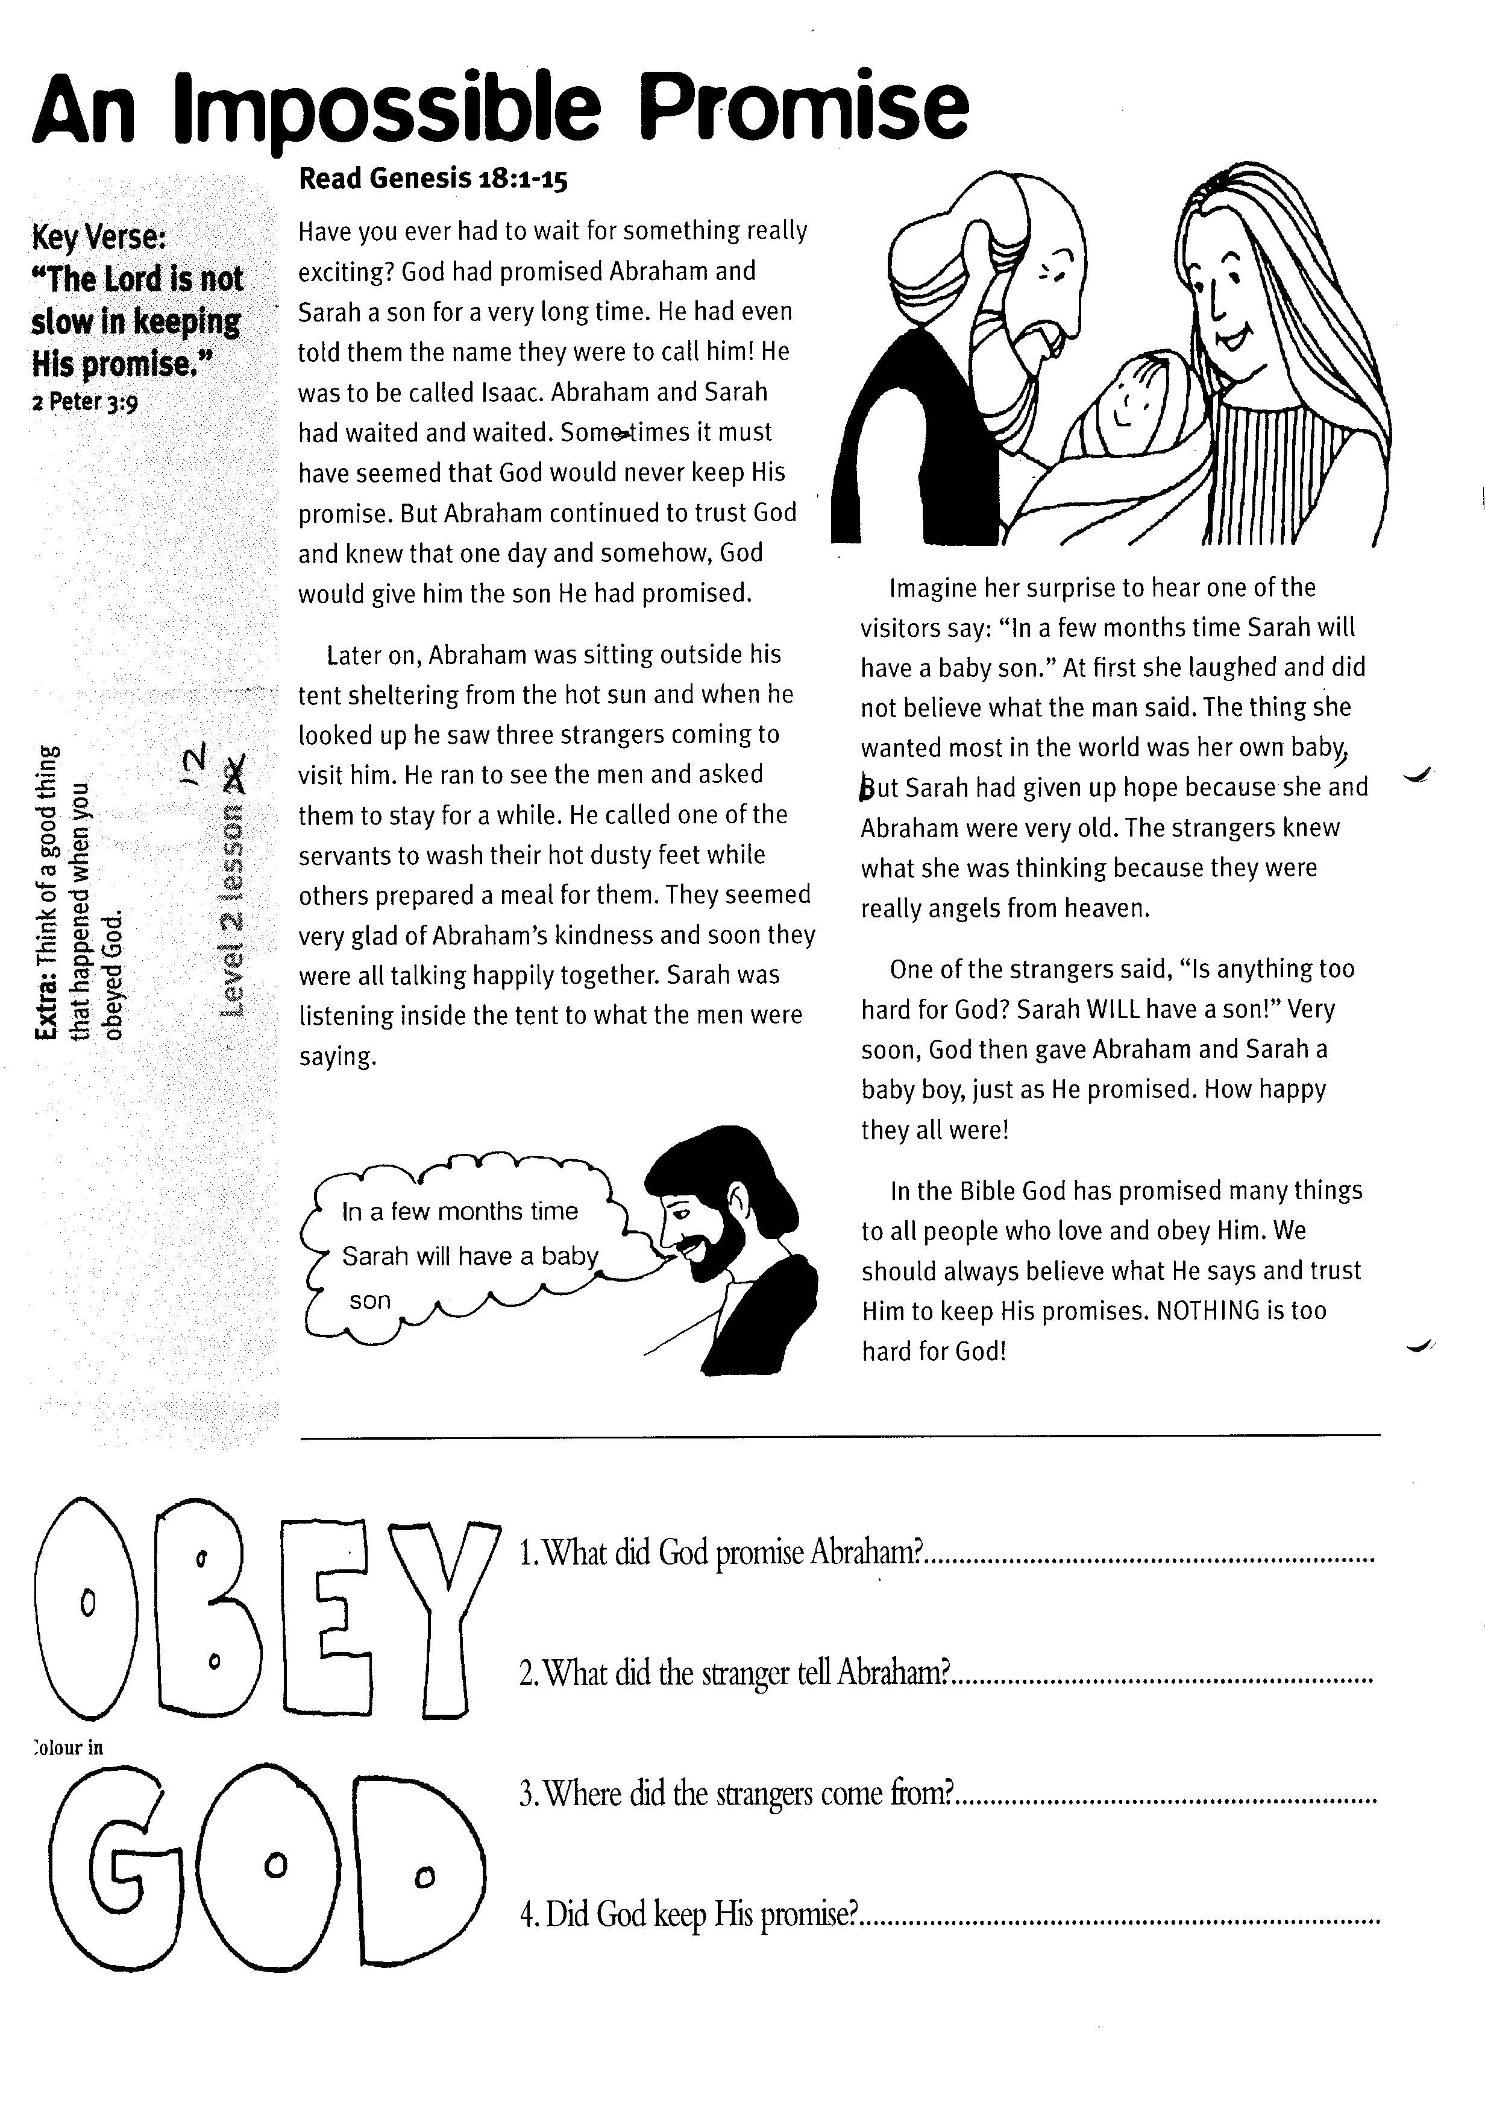1003

OBEY

GOD

1. What did God promise Abraham?

____________________________________________________

2. What did the stranger tell Abraham?

____________________________________________________

3. Where did the strangers come from?

____________________________________________________

4. Did God keep His promise?

_____________________________________________________

Colour in

Imagine her surprise to hear one of the visitors say: “In a few months’ time Sarah will have a baby son.” At first she laughed and did not believe what the man said. The thing she wanted most in the world was her own baby, but Sarah had given up hope because she and Abraham were very old. The strangers knew what she was thinking because they were really angels from Heaven.

One of the strangers said, “Is anything too hard for God? Sarah WILL have a son!” Very soon, God then gave Abraham and Sarah a baby boy, just as He promised. How happy they all were!

In the Bible God has promised many things to all people who love and obey Him. We should always believe what He says and trust Him to keep His promises. NOTHING is too hard for God!

**Extra:** Think of a good thing that happened when you obeyed God.