

Key Verse:  
**“Give thanks in all circumstances, for this is God’s will for you in Christ Jesus.”**  
1 Thessalonians 5:18

**People who please the Lord**

**Read Luke 17:11-19 and Psalm 100:4**

**Thanks a lot!** Have you ever stopped to think of how many things we need to thank the Lord for? The Bible tells us that everything good comes from God (James 1:17), so that’s a whole lot of thanking to do!

What do you want to be when you grow up: A fireman, a nurse, a police officer, a chef, or maybe even a computer programmer? It’s good to set goals for what job you want to do later in life. But there’s something more important than what you DO when you grow up, and that’s what you ARE.

This month, we’re going to be looking at what kind of people please the Lord Jesus. And guess what? Whether you turn out to be a fireman, nurse, police officer, chef, computer programmer, or something else is not so important; instead the Lord is pleased with people who have the right attitude towards Him - no matter what job they have!

One day, while Jesus and His disciples were on a journey, they met ten men who had ‘leprosy.’ Leprosy is a horrible nerve and skin disease, and in Jesus’ time, people were terrified of catching it, as there is no cure. These poor, sick people had to live apart from everyone else in society. So these men stood a way off and called out for Jesus to help them.

Jesus told them to go and show themselves to the priests, who were the only people allowed to say that someone was well enough to live in

**Thankful People**

**Extra:** Can you think of other ways that God’s Word can help us?

My Name is ……………………………………………………… Age…………………

the cities again. So off they walked; and do you know what happened? As they walked, they realized that they had been healed! But guess what? Only one of the ten men went back to Jesus, and he thanked Him and praised God at the top of his voice! Jesus then asked, “Why is this man the only one to come back and say thank you? Ten men were healed ... where are the other nine?”

The Lord Jesus was pleased with this man (even though he was not from Israel) because He returned to say thank you, and so Jesus said “Go, your faith has made you well!” 1 Thessalonians 5:18 tells Christians also to “Give thanks in all circumstances, for this is God’s will for you in Christ Jesus.” But Romans 1:21 says that evil people won’t glorify God or “give Him thanks.” You see, being thankful to God is one of the things that makes the difference between Christians and non-Christians, saved people and unsaved people.

Thankful people please the Lord because they show that they know that everything they have is from God, and they believe in God’s goodness and kindness. How often are you thankful to the Lord Jesus for all He has given you?

**T F**There are lots of things to thank God for □ □  
Jesus healed 11 men in this story □ □The men were healed as they walked away □ □Only one man came back to thank Jesus □ □We need to thank God ALWAYS □ □Half of what we have is from God □ □

TRUE OR FALSE

1. Why is the Lord pleased with thankful people?  
______________________________________  
______________________________________  
______________________________________  
______________________________________  
2. Why should we be thankful always?  
_____________________________________  
_____________________________________  
_____________________________________  
_____________________________________

**?**

**Level 3 lesson 9**



**Read Matthew 9:9, 4:18-22; 21:28-31 and Mark 3:31-35**

**Hearing AND Doing.** “Well done!” “Good on you!” “What an awesome job you’ve done!” We all love to hear how well we’ve done, don’t we? But just because we know what the Lord wants us to do, doesn’t mean that the Lord is pleased with us. What pleases the Lord is people who DO what they know is right! Wouldn’t it be amazing to one day hear the Lord Jesus say to us in front of the whole world, “Well done!”?

Once, as Jesus walked along the shore, He saw Simon Peter and his brother Andrew fishing with their father. He called out to them, “Follow Me!” Now, remember Simon Peter and Andrew weren’t just fishing for a hobby; they and their father were fishermen who caught and sold fish for their living. Yet Simon Peter and Andrew didn’t think about it for a while, or say to the Lord, “We’ll get back to You later!” Straightaway, they left their nets, their boat, and their father - and followed Jesus!

Another time, as Jesus was passing Matthew the tax collector, He said to him, “Follow Me!” In Jesus’ day, tax collectors were dishonest people who ripped people off by taking more money from them than they should have, and keeping it for themselves. In this way they became very rich. Following Jesus meant that Matthew would have to give up his money and change his whole dishonest life. And that’s exactly what he did! Matthew obeyed the Lord right there and then. He didn’t think about it for a week, a day, or even an hour ... he simply obeyed Jesus straight away!

The Lord is still calling for boys and girls to follow Him. Have you ever responded to His

**People who please the Lord**

Key Verse:  
**“Love the Lord your God, walk in all His ways, obey His commands, hold fast to Him and serve Him, with all your heart and all your soul.’”**Joshua 22:5

**Obedient People**

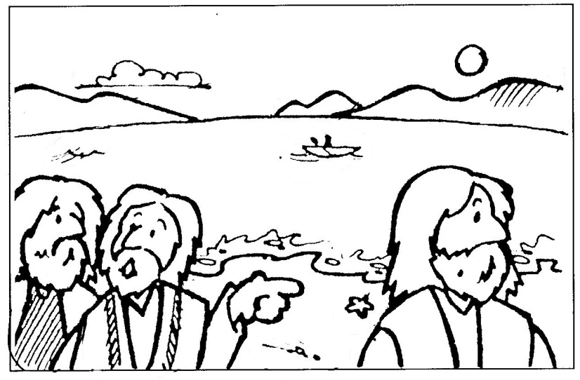

Spot the Difference! Look at the picture above, then circle 10 changes in this picture!

1. What things did Matthew give up to follow Jesus?  
__________________________________________  
__________________________________________  
__________________________________________  
__________________________________________  
3. What should you do is you haven’t been obedient to the Lord? __________________________________________  
__________________________________________  
__________________________________________

**Level 3 lesson 10**

**Extra:** List some good reasons for  
obeying God.

voice? Have you ever said sorry for the sinful things you have done and asked Him to forgive you? Have you ever prayed, “Dear Lord Jesus, Thank You for dying in my place and taking the punishment for my sin; please forgive me and cleanse my heart from sin. Come into my heart as Lord and Saviour and help me live each day in a way that pleases You.”?

Maybe you haven’t done this, but why not do it now, before it’s too late! He will make you a part of His family! Maybe you have done this and are already His child. Now Jesus said that His children will show they love Him by the way they live; being quick to obey and do the things He wants them to do (Mark 3:31-35)! He also said, “If you love Me ... keep My commandments” (John 14:15, 23) Is this what you’re like? Do you obey Him as soon as you know what He wants you to do, and without complaining or arguing?

Perhaps you’ve been disobedient to God in the past? Jesus once spoke of a young man whose father asked him to do something, but he replied “No!” (Matthew 21:28-31a). Then later he changed his mind and went and did it. If you’ve been disobedient, it’s not too late to change! God the Father is still waiting, and if you tell Him you are sorry for your sin and turn away from it, He will forgive you and you can be best friends again! You can live for Him and obey, looking forward to that day when He is able to tell you, “Well done!”



**Read Mark 7:24-30, Matthew 7:7-8 and Luke 18:1-8a**

**Keep It Up!** PERSISTENT is a big word but it simply means to “keep going” or to “stick at” something. Persistent people don’t give up easily! They keep doing something until they complete it. The Lord Jesus is pleased with people who keep doing what’s right without giving up.

Have you ever tried to do the right thing and others have made it hard for you? Maybe you were trying to be good at school and some other kids, who like to mess about and get into trouble, made fun of you. Or maybe you were trying to please Mum and Dad by behaving yourself, and a little brother or sister kept annoying you and made you lose your temper! Being good and doing what we ought to do is not always easy. In fact, the Lord Jesus warned us that sometimes it would be difficult to follow Him and do what’s right!

For the last couple of lessons we’ve been learning about people who please the Lord, and today we’ll see that people who stick at being good, people who never give up doing right, people who keep following the Lord even when it gets tough ... these are the people that the Lord is pleased with!

One day a woman followed Jesus and called out for help. Her daughter had an evil spirit in her body, and her mother knew that only Jesus could help. At first it didn’t seem like the Lord was going to help, but He was testing her

**Persistent People**

**People who please the Lord**

Key Verse:  
**“To those who by persistence in doing good seek glory, honour and immortality, He will give eternal life.”**Romans 2:7

**FUN**

faith; seeing how much she really believed in Him. The woman answered Jesus’ words wisely, showing that she really did have faith in Him and would never give up her hope. So Jesus healed her daughter right then!

Another time, the Lord Jesus told the story of a woman that needed a judge to help her against her enemies. At first the judge was not interested in her case. He couldn’t be bothered helping the poor widow. Imagine if that happened to you! You’d probably think, “What’s the use? I’ve tried and now I’ll just have to put up with it.” But not this widow! She kept asking him until finally the ‘unjust judge’ agreed to help her. Jesus said that if this judge who wasn’t a good man, would help the woman because she was persistent, then God, who is perfectly good, would never turn away someone who comes to Him to for help.

The Bible also says we should keep doing good, even if it’s a bit of a struggle. God is pleased when His dear children keep following and trusting in Him, even when bad things happen to them, or life gets really tough. Are you like that? Our key memory verse, Romans 2:7, reminds us that those who obey the truth and keep on seeking to please God by doing what is good, will one day be rewarded for their faith. God has promised eternal life to each one who does this!

WORD BANK:   
 Jesus pray Up  
 give never Lord

Choose words from the WORD BANK below to finish this sentence:

“The _________ _________ said _______________ and _____________ ______________ __________!”

1. What does PERSISTENT mean?   
____________________________________  
____________________________________  
____________________________________

2. Name some things that make it difficult to follow the Lord at home and at school?  
________________________________________________________________________  
____________________________________  
________________________________________________________________________

**Level 3 lesson 11**

**Extra:** What are some things   
you can do to please God?



humble? Well, in Proverbs 6 there is a list of seven things God hates — that’s right — HATES.  
Guess what is first? It’s PRIDE! So that makes being humble pretty important I’d say. You see, being humble is the opposite of being proud. It shows a right attitude towards God and a correct appreciation of yourself. It shows we understand that He is far greater than us. It shows we understand that God didn’t love us and send His Son to die for us because we were such great people or had done such great things. That’s where the disciples got it wrong. In fact, the opposite is true. Romans 3:23-24 tell us that **nobody is good enough** for God and that only by His grace (His underserved favour) can anyone **be saved**, and **only through Jesus** and what HE has done for us!

When we truly understand God’s great mercy and love for us ­ even when we didn’t deserve it - we will be happy to humbly serve and obey Him out of love. As the Apostle John wrote, “We love because He first loved us!” (1 John 4:19) Jesus once said, that to “Love the Lord your God with all your heart and with all your soul and with all your mind,” and to “Love your neighbour as yourself,” really fulfilled the intent of all God’s laws (Matthew 22:37-40). But if you are not a humble person you won’t love God and you’ll do what YOU want all the time. What God wants will not matter to you. If you’re not humble, you won’t love other people because you will be trying to be more important than them all the time! Humble people please the Lord because they love God and love others!

**Humble People**

**Read Matthew 18:1-4; 22:34-40 and Mark 10:13-16**

**A Humble Heart** “I am the greatest!” Have you ever heard of the famous boxer Mohammed Ali? He was the three times heavyweight champion of the world. He was a real showman who used to claim, “I am the greatest!” He certainly was a great boxer in his day, yet today he is a sick old man. Time and illness have taken away his great skill and humbled him. I thought of him as I read our Bible story today.

You see, Jesus’ disciples were arguing amongst themselves about who was ‘the greatest!’ Each of them wanted to be ‘Number One’ - more important than everyone else. Finally, they decided to sort it out once and for all and asked Jesus, “Who is the greatest in the Kingdom of Heaven?” Jesus’ answer must have puzzled them, because He called a small child to come to Him and said, “I tell you the truth: unless you change and become like little children, you will never enter the kingdom of heaven. Therefore, whoever humbles himself like this child is the greatest in the kingdom of heaven.”

Wow! — that sure shocked the disciples! The way to the top in Jesus’ Kingdom is to put yourself at the bottom? The way to be the greatest person is to be the least? Yes! — that’s what being humble means — not making yourself the most important person, but putting other people first. So are you humble? Or do you always try to be first in line, the loudest to speak, the show-off that everyone notices, or the selfish bully that always tries to get your own way? The Lord definitely isn’t pleased with that kind of person!

Why is it so important for a Christian to be

**Level 3 lesson 12**

**Extra:** How does being humble really help us?

1. What does it mean to be humble?  
__________________________________________________

__________________________________________________

__________________________________________________

__________________________________________________  
2. What are the two most important laws that being HUMBLE helps us to keep?

__________________________________________________

__________________________________________________

__________________________________________________

**People who please the Lord**

Key Verse:  
**“Whoever humbles himself like this child is the kingdom of heaven.”**Matthew 18:4