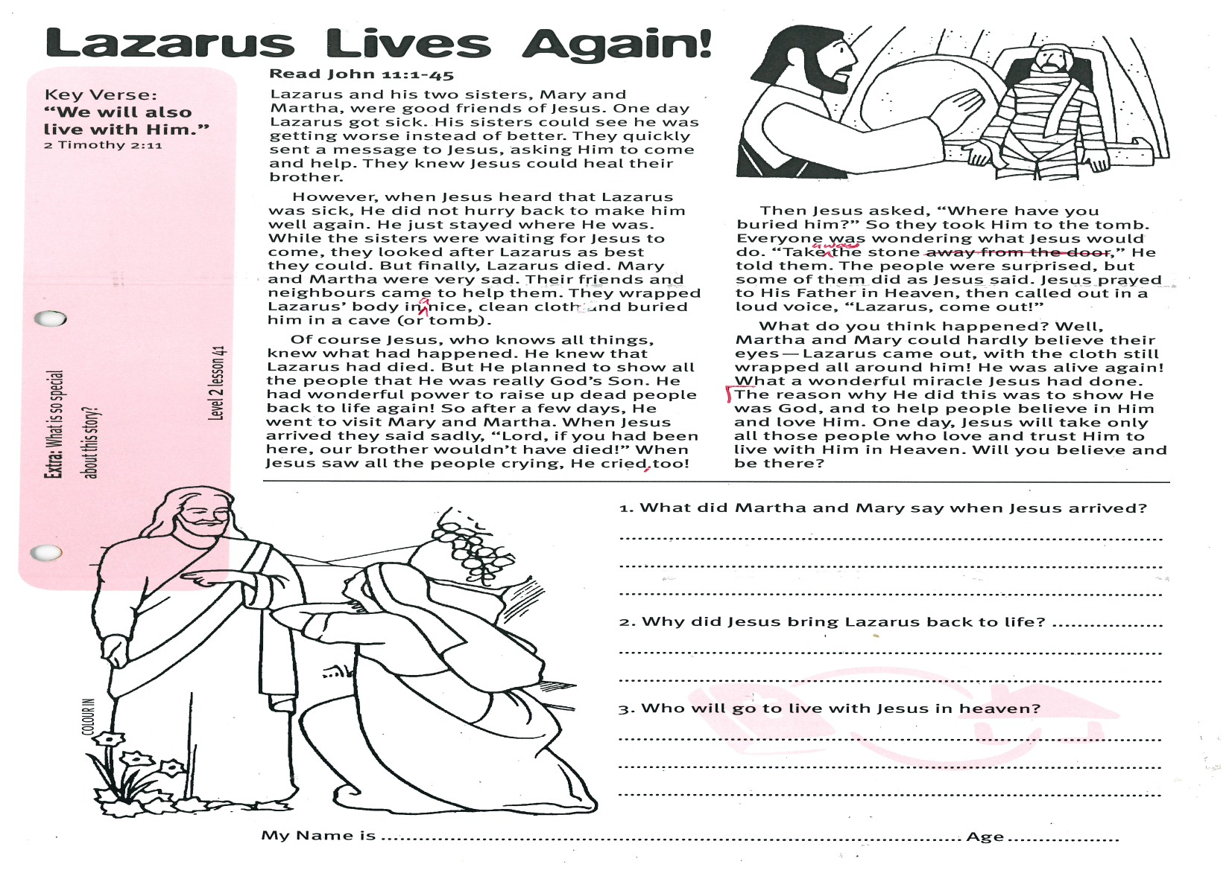

**Read John 11:1-45**

Lazarus and his two sisters, Mary and Martha, were good friends of Jesus. One day Lazarus got sick. His sisters could see he was getting worse instead of better. They quickly sent a message to Jesus, asking Him to come and help. They knew Jesus could heal their brother.

However, when Jesus heard that Lazarus was sick, He did not hurry back to make him well again. He just stayed where He was. While the sisters were waiting for Jesus to come, they looked after Lazarus as best they could. But finally, Lazarus died. Mary and Martha were very sad. Their friends and neighbours came to help them. They wrapped Lazarus’ body in a nice, clean cloth and buried him in a cave (or tomb).

Of course Jesus, who knows all things, knew what had happened. He knew that Lazarus had died. But He planned to show all the people that He was really God’s Son. He had wonderful power to raise up dead people back to life again! So after a few days, He went to visit Mary and Martha. When Jesus arrived they said sadly, “Lord, if you had been here, our brother wouldn’t have died!” When Jesus saw all the people crying, He cried, too!

Key Verse:  
**“We will also live with Him.”**  
2 Timothy 2:11

**Lazarus Lives Again!**

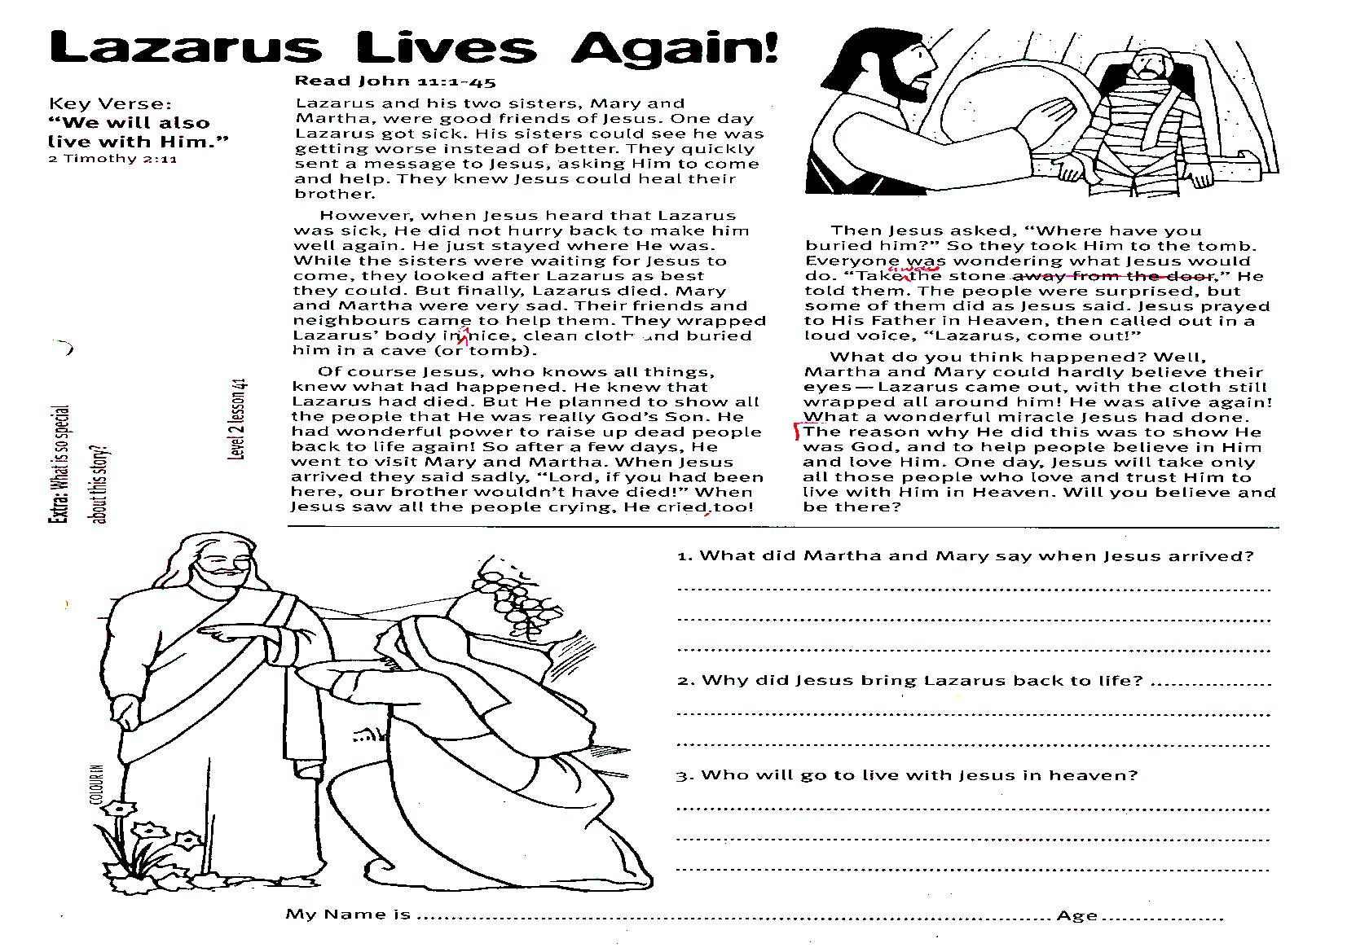

1. What did Martha and Mary say when Jesus arrived?  
______________________________

______________________________

______________________________

2. Why did Jesus bring Lazarus back to life? __________________________

______________________________

______________________________

3. Who will go to live with Jesus in heaven?

______________________________

______________________________

**Level 2 lesson 41**

**Extra:** What is so special about this story?

Then Jesus asked, “Where have you buried him?” So they took Him to the tomb. Everyone was wondering what Jesus would do. “Take away the stone,” He told them. The people were surprised, but some of them did as Jesus said. Jesus prayed to His Father in Heaven, then called out in a loud voice, “Lazarus, come out!”

What do you think happened? Well, Martha and Mary could hardly believe their eyes - Lazarus came out, with the cloth still wrapped all around him! He was alive again! What a wonderful miracle Jesus had done.

The reason why He did this was to show He was God, and to help people believe in Him and love Him. One day, Jesus will take only all those people who love and trust Him to live with Him in Heaven. Will you believe and be there?

My Name is ……………………………………………………………………… Age……………

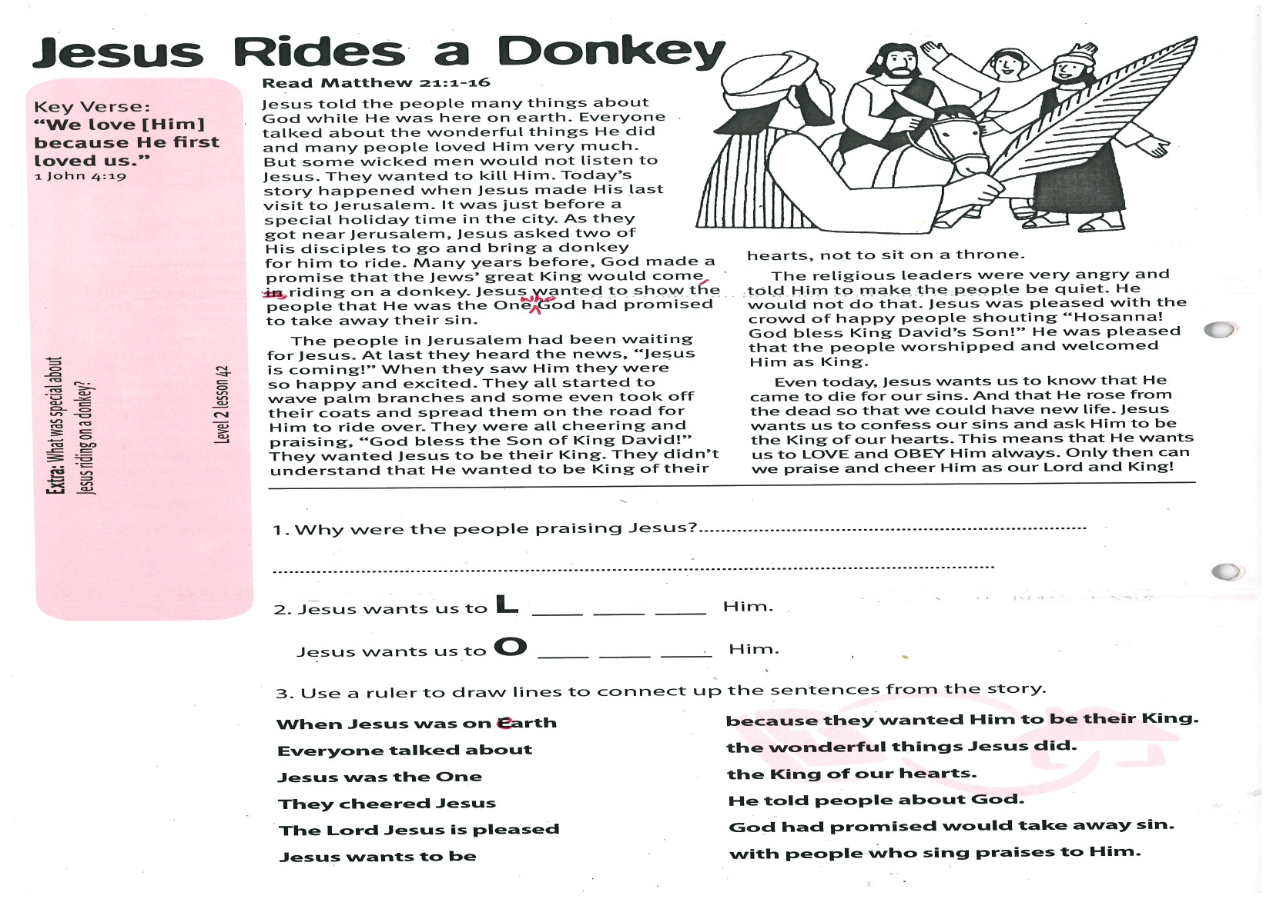

**Read Matthew 21:1-16**

Jesus told the people many things about God while He was here on earth. Everyone talked about the wonderful things He did and many people loved Him very much. But some wicked men would not listen to Jesus. They wanted to kill Him.

Today’s story happened when Jesus made His last visit to Jerusalem. It was just before a special holiday time in the city. As they got near Jerusalem, Jesus asked two of His disciples to go and bring a donkey for him to ride. Many years before, God made a promise that the Jews’ great King would come, riding on a donkey. Jesus wanted to show the people that He was the One who God had promised to take away their sin.

The people in Jerusalem had been waiting for Jesus. At last they heard the news, “Jesus is coming!” When they saw Him they were so happy and excited. They all started to wave palm branches and some even took off their coats and spread them on the road for Him to ride over. They were all cheering and praising, “God bless

Key Verse:  
**“We love [Him] because He first loved us.”**  
1 John 4:19

**Jesus Rides a Donkey**

the Son of King David!” They wanted Jesus to be their King. They didn’t understand that He wanted to be King of their hearts, not to sit on a throne.

The religious leaders were very angry and told Him to make the people be quiet. He would not do that. Jesus was pleased with the crowd of happy people shouting “Hosanna! God bless King David’s Son!” He was pleased that the people worshipped and welcomed Him as King.

Even today, Jesus wants us to know that He came to die for our sins. And that He rose from the dead so that we could have new life. Jesus wants us to confess our sins and ask Him to be the King of our hearts. This means that He wants us to LOVE and OBEY Him always. Only then can we praise and cheer Him as our Lord and King!

gf

2. Jesus wants us to L __ __ __ Him.

Jesus wants us to O __ __ __ Him.

3. Use a ruler to draw lines to connect up the sentences from the story:

**When Jesus was on earth because they wanted Him to be their King.  
 Everyone talked about with people who sing praises to Him.  
 Jesus was the One the wonderful things Jesus did.  
 They cheered Jesus God had promised would take away sin  
 The Lord Jesus is pleased the King of our hearts.  
 Jesus wants to be He told people about God**

**Extra:** What was special   
about Jesus riding on a donkey?

**Level 2 lesson 42**

1. Why were the people praising Jesus? ____________________________

_____________________________________________________________

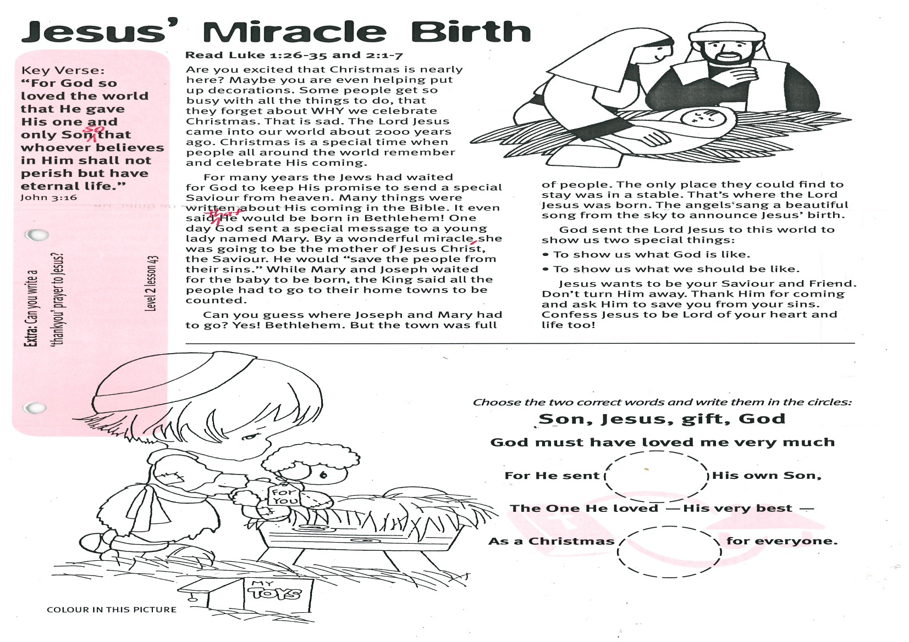

Key Verse:  
**“For God so loved the world that He gave His one and only Son, so that whoever believes in Him shall not perish but have eternal life.”**  
John 3:16

**Read Luke 1:26-35 and 2:1-7**

Are you excited that Christmas is nearly here? Maybe you are even helping put up decorations. Some people get so busy with all the things to do, that they forget about WHY we celebrate Christmas. That is sad. The Lord Jesus came into our world about 2000 years ago. Christmas is a special time when people all around the world remember and celebrate His coming.

For many years the Jews had waited for God to keep His promise to send a special Saviour from heaven. Many things were written about His coming in the Bible. It even said that He would be born in Bethlehem! One day God sent a special message to a young lady named Mary. By a wonderful miracle, she was going to be the mother of Jesus Christ, the Saviour. He would “save the people from their sins.” While Mary and Joseph waited for the baby to be born, the King said all the people had to go to their home towns to be counted.

**Jesus’ Miracle Birth**

Can you guess where Joseph and Mary had to go? Yes! Bethlehem. But the town was full of people. The only place they could find to stay was in a stable. That’s where the Lord Jesus was born. The angels sang a beautiful song from the sky to announce Jesus’ birth.

God sent the Lord Jesus to this world to show us two special things:

• To show us what God is like.

• To show us what we should be like.

Jesus wants to be your Saviour and Friend. Don’t turn Him away. Thank Him for coming and ask Him to save you from your sins. Confess Jesus to be Lord of your heart and life, too!

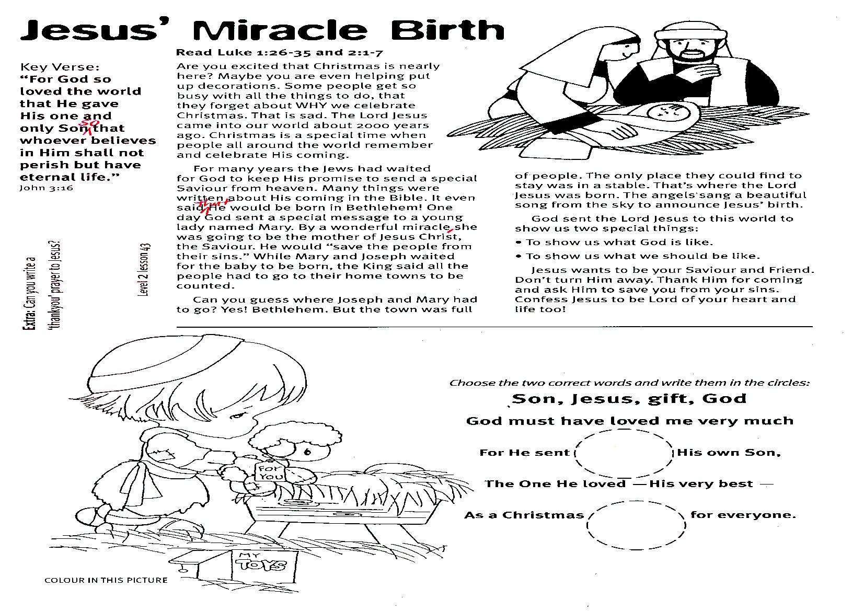

Choose the two correct words and write them in the circles:

**Son, Jesus, gift, God**

God must have loved me very much

For He sent His own Son,

The One He loved - His very best -

As a Christmas for everyone.

**Extra:** Can you write a ‘thank you’  
 prayer to Jesus?

**Level 2 lesson 43**

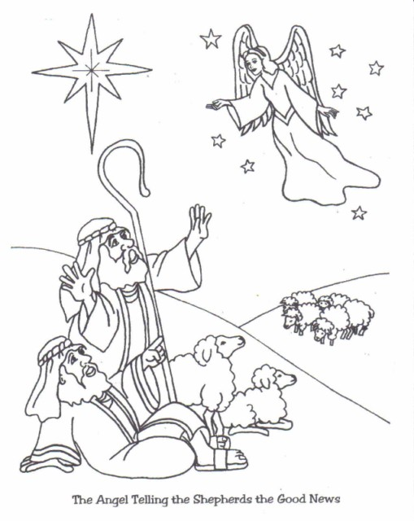

**Read Luke 2:8-20**

On the night Jesus was born in Bethlehem, some shepherds were looking after their sheep in the fields nearby. It was very still and quiet. Suddenly a brightly shining angel of the LORD appeared in front of them! The shepherds were very frightened. “Don’t be afraid,” said the angel, “I’ve got good news for you and for everyone on earth. The Saviour has been born, who is Christ the Lord!”

Then lots of other angels came. They all began singing and praising God. “Praise God in Heaven!” they sang. “Peace on earth to everyone who pleases God!” Then, just as suddenly, they were gone again. The shepherds were amazed! They ran into Bethlehem and found Mary (Jesus’ mother) and Joseph (who planned to marry her) in the cattle shed. Baby Jesus was lying there in a feed manger.

The shepherds were so happy when they saw Jesus. God had made many promises about Jesus. Some of them were made hundreds of years before Jesus was born. They knew their Saviour had finally come.

**Wonderful News**

Key Verse:  
**“A Saviour has been born to you; He is Christ the Lord.”**  
Luke 2:11

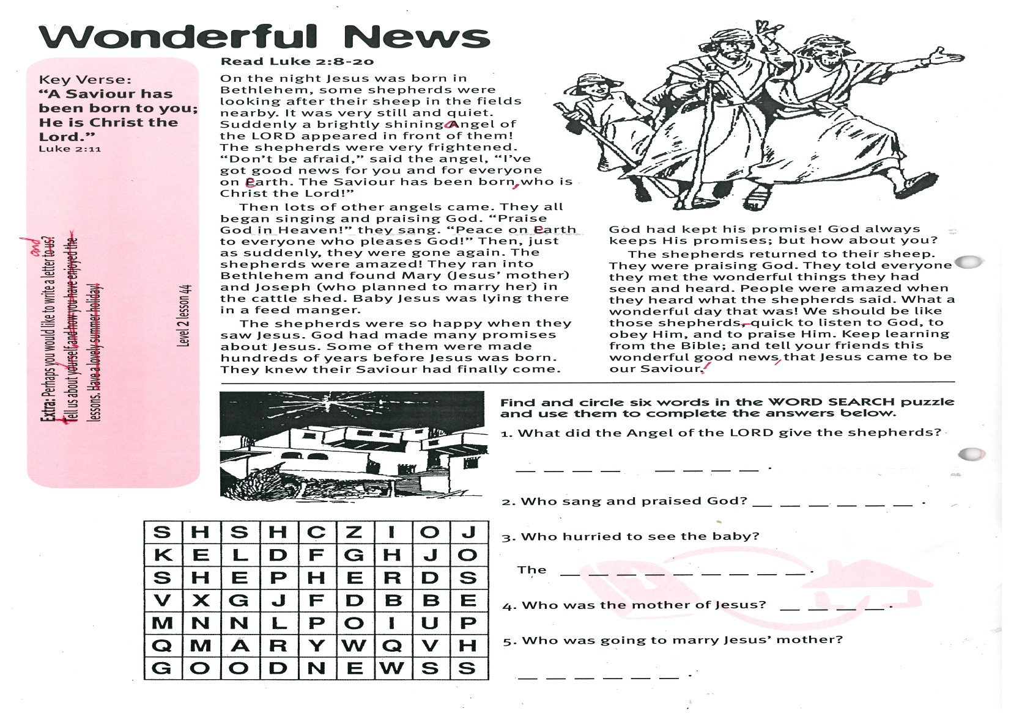1003

Please complete and return by post to   
**PSSM, 1-2a (G2) 93 Dominion Rd, Mt Eden, Auckland 1024**   
or scan & email to **info@biblediscovery.org.nz**

**Extra:** Perhaps you would like to write us a letter and tell us about yourself?

**Level 2 lesson 44**

Find and circle six words in the following WORD SEARCH and write out the answers to fill the in the spaces provided.

1. What did the angel of the LORD give the shepherds?   
_ _ _ _ _ _ _ _ .

2. Who sang and praised God? _ _ _ _ _ _ .

3. Who hurried to see the baby?   
The _ _ _ _ _ _ _ _ _ .

Who was the mother of Jesus? _ _ _ _ .

Who was going to marry Jesus’ mother? _ _ _ _ _ _ .

God had kept his promise! God always keeps His promises; but how about you?

The shepherds returned to their sheep. They were praising God. They told everyone they met the wonderful things they had seen and heard. People were amazed when they heard what the shepherds said. What a wonderful day that was! We should be like those shepherds - quick to listen to God, to obey Him, and to praise Him. Keep learning from the Bible; and tell your friends this wonderful good news, that Jesus came to be our Saviour!