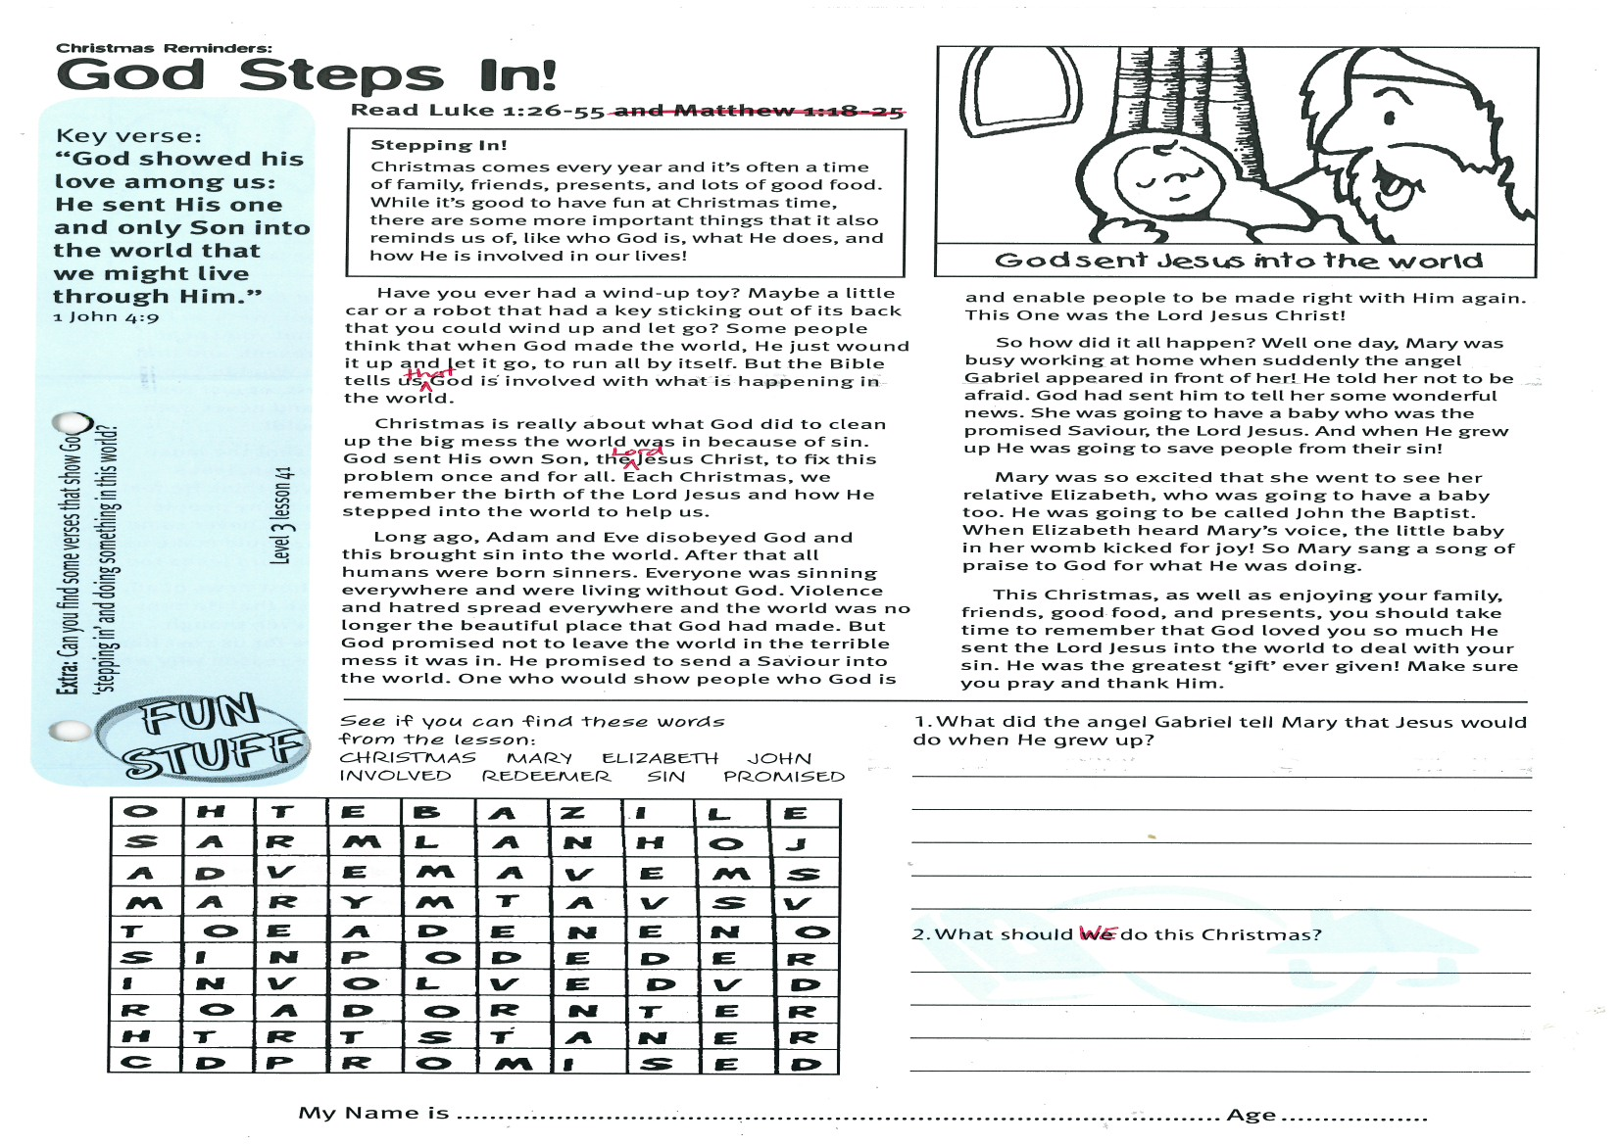

**God Steps In!**

**Read Luke 1:26-55**

**Stepping In!** Christmas comes every year and it’s often a time of family, friends, presents, and lots of good food. While it’s good to have fun at Christmas time, there are some more important things that it also reminds us of; like who God is, what He does, and how He is involved in our lives!

Have you ever had a wind-up toy? Maybe a little car or a robot that had a key sticking out of its back that you could wind up and let go? Some people think that when God made the world, He just wound it up and let it go, to run all by itself. But the Bible tells us that God is involved with what is happening in the world.

Christmas is really about what God did to clean up the big mess the world was in because of sin. God sent His own Son, the Lord Jesus Christ, to fix this problem once and for all. Each Christmas, we remember the birth of the Lord Jesus and how He stepped into the world to help us.

Long ago, Adam and Eve disobeyed God and this brought sin into the world. After that all humans were born sinners. Everyone was sinning everywhere and were living without God. Violence and hatred spread everywhere and the world was no longer the beautiful place that God had made. But God promised not to leave the world in the terrible mess it was in. He promised to send a Saviour into the world: One who would show people who

Key Verse:  
**“God showed his love among us: He sent His one and only Son into the world that we might live through Him.”**  
1 John 4:9

Christmas Reminders:



**Extra:** Can you find some verses that show God ‘stepping in’ and doing something in this world?

CHRISTMAS MARY ELIZABETH JOHN  
INVOLVED REDEEMER SIN PROMISED

See if you can find these words from the lesson:

1. What did the angel Gabriel tell Mary that Jesus would do when He grew up?  
_______________________________________  
_______________________________________  
_______________________________________  
_______________________________________  
2. What should WE do this Christmas?  
_______________________________________  
______________________________________________________________________________  
_______________________________________

God is and enable people to be made right with Him again. This One was the Lord Jesus Christ!

So how did it all happen? Well one day, Mary was busy working at home when suddenly the angel Gabriel appeared in front of her! He told her not to be afraid. God had sent him to tell her some wonderful news. She was going to have a baby who was the promised Saviour, the Lord Jesus. And when He grew up He was going to save people from their sin!

Mary was so excited that she went to see her relative Elizabeth, who was going to have a baby too. He was going to be called John the Baptist. When Elizabeth heard Mary’s voice, the little baby in her womb kicked for joy! So Mary sang a song of praise to God for what He was doing.

This Christmas, as well as enjoying your family, friends, good food, and presents, you should take time to remember that God loved you so much He sent the Lord Jesus into the world to deal with your sin. He was the greatest ‘gift’ ever given! Make sure you pray and thank Him.

**Level 3 lesson 41**

My Name is ………………………………………………… Age ………………….

My Name is ……………………………………………………… Age…………………

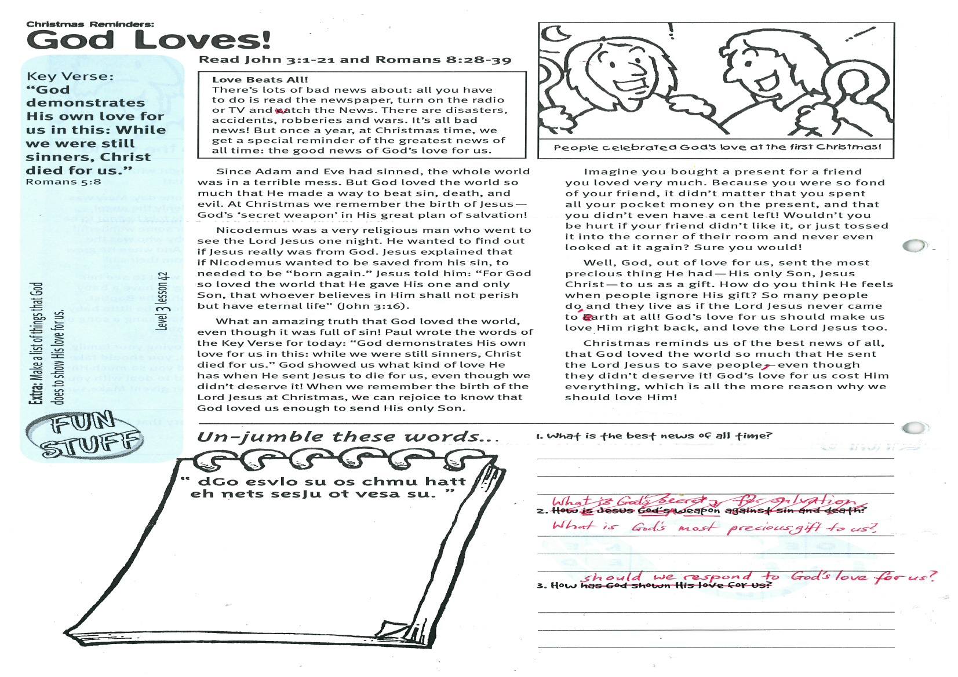

Key Verse:  
**“God demonstrates His own love for us in this: while we were still sinners, Christ died for us.”**1 Peter 5:8

**Read John 3:1-21 and Romans 8:28-39**

**Love Beats All!** There’s lots of bad news about: all you have to do is read the newspaper, turn on the radio or TV and watch the news. There are disasters, accidents, robberies and wars. It’s all bad news! But once a year, at Christmas time, we get a special reminder of the greatest news of all time: the good news of God’s love for us.

Since Adam and Eve had sinned, the whole world was in a terrible mess. But God loved the world so much that He made a way to beat sin, death, and evil. At Christmas we remember the birth of Jesus - God’s ‘secret weapon’ in His great plan of salvation!

Nicodemus was a very religious man who went to see the Lord Jesus one night. He wanted to find out if Jesus really was from God. Jesus explained that if Nicodemus wanted to be saved from his sin, to needed to be “born again.” Jesus told him: “For God so loved the world that He gave His one and only Son, that whoever believes in Him shall not perish but have eternal life” (John 3:16).

What an amazing truth that God loved the world, even though it was full of sin! Paul wrote the words of the Key Verse for today: “God demonstrates His own love for us in this: while we were still sinners, Christ died for us.” God showed us what kind of love He has when He sent Jesus to die for us, even though we didn’t deserve it! When we remember the birth of the Lord Jesus at Christmas, we can

**God Loves!**

Christmas Reminders:



**“dGo esvlo su os chmu hatt  
eh nets sesJu ot vesa su.”**

**Extra:** Make a list of things that   
God does to show His love for us.

**Level 3 lesson 42**

1. What is the best news of all time?  
__________________________________________________

__________________________________________________

__________________________________________________  
2. What is God’s most precious gift to us?

_____________________________________________

_____________________________________________  
3. How should we respond to God’s love for us?  
__________________________________________________

_________________________________________________

rejoice to know that God loved us enough to send His only Son.

Imagine you bought a present for a friend you loved very much. Because you were so fond of your friend, it didn’t matter that you spent all your pocket money on the present, and that you didn’t even have a cent left! Wouldn’t you be hurt if your friend didn’t like it, or just tossed it into the corner of their room and never even looked at it again? Sure you would!

Well, God, out of love for us, sent the most precious thing He had - His only Son, Jesus Christ, to us as a gift. How do you think He feels when people ignore His gift? So many people do, and they live as if the Lord Jesus never came to earth at all! God’s love for us should make us love Him right back, and love the Lord Jesus, too.

Christmas reminds us of the best news of all, that God loved the world so much that He sent the Lord Jesus to save people, even though they didn’t deserve it! God’s love for us cost Him everything, which is all the more reason why we should love Him!

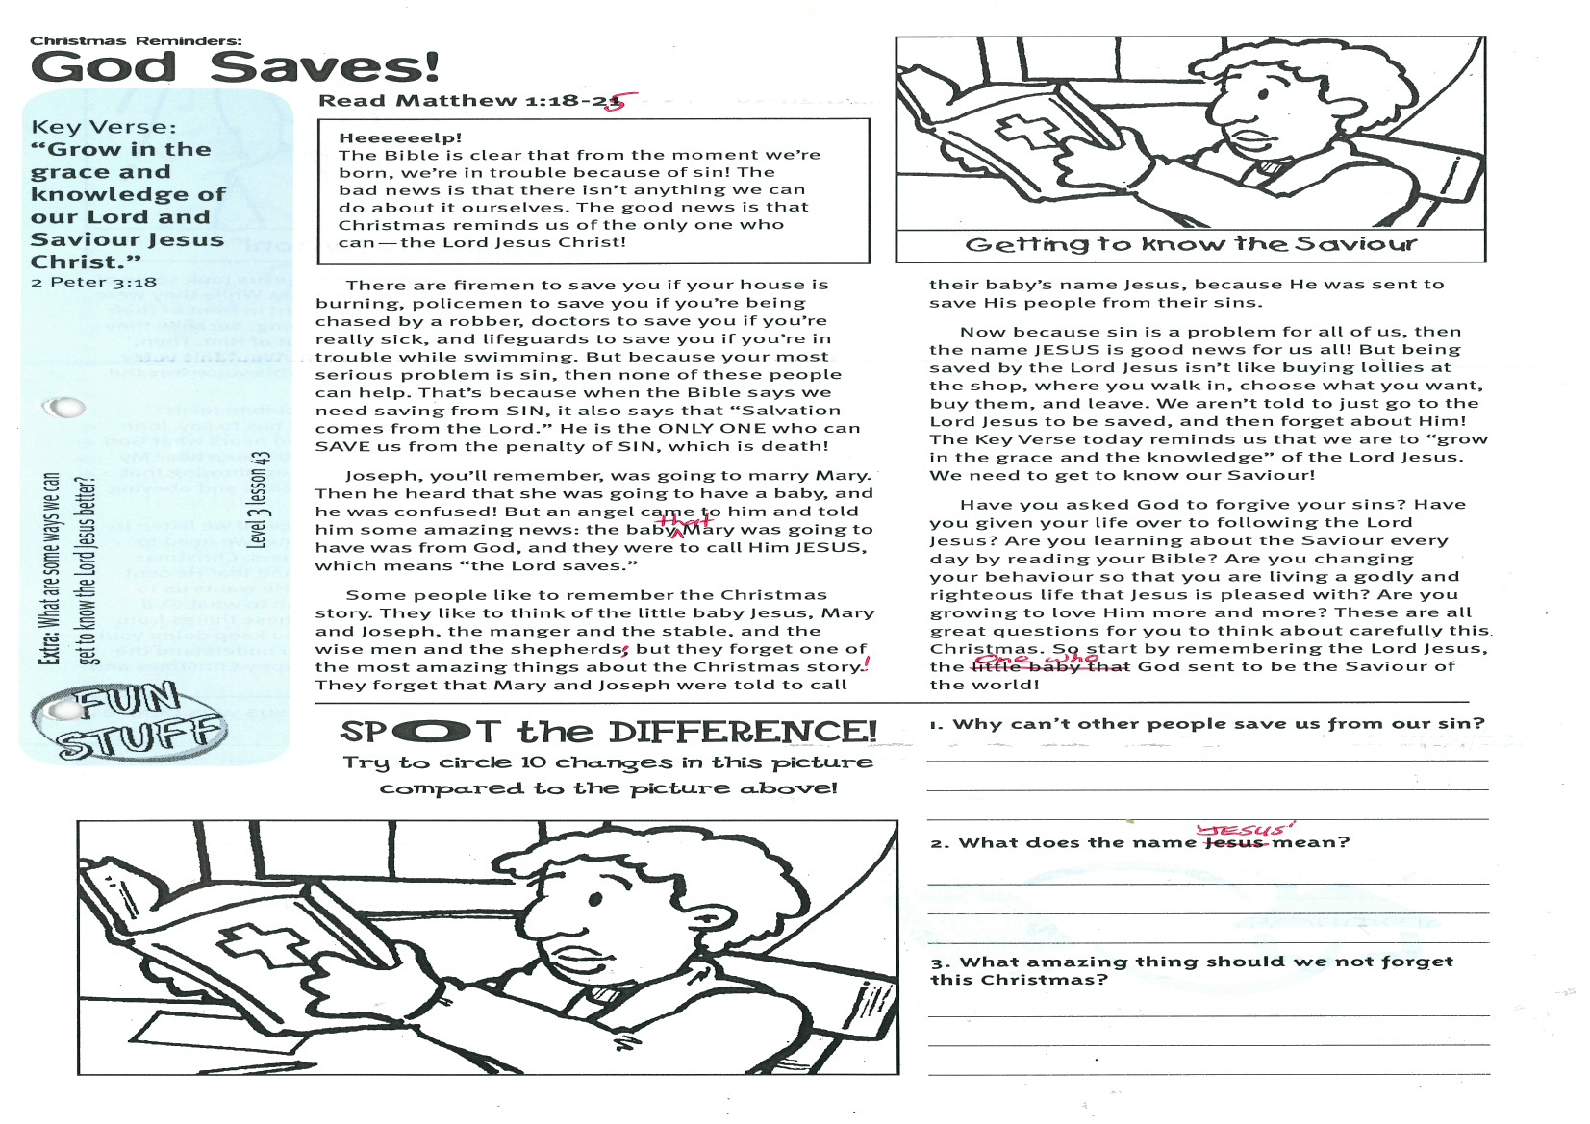

**Read Matthew 1:18-25**

**Heeeeeelp!** The Bible is clear that from the moment we’re born, we’re in trouble because of sin! The bad news is that there isn’t anything we can do about it ourselves. The good news is that Christmas reminds us of the only one who can - the Lord Jesus Christ!

There are firemen to save you if your house is burning, policemen to save you if you’re being chased by a robber, doctors to save you if you’re really sick, and lifeguards to save you if you’re in trouble while swimming. But because your most serious problem is sin, then none of these people can help. That’s because when the Bible says we need saving from SIN, it also says that “Salvation comes from the Lord.” He is the ONLY ONE who can SAVE us from the penalty of SIN, which is death!

Joseph, you’ll remember, was going to marry Mary. Then he heard that she was going to have a baby, and he was confused! But an angel came to him and told him some amazing news: the baby that Mary was going to have was from God, and they were to call Him JESUS, which means “the Lord saves.”

Some people like to remember the Christmas story. They like to think of the little baby Jesus, Mary and Joseph, the manger and the stable, and the wise men and the shepherds; but they forget one of the most amazing things about the Christmas story!

Christmas Reminders:

**God Saves**

Key Verse:  
**“Grow in the grace and knowledge of our Lord and Saviour Jesus Christ.”**2 Peter 3:18

They forget that Mary and Joseph were told to call their baby’s name Jesus, because He was sent to save His people from their sins.

Now because sin is a problem for all of us, then the name JESUS is good news for us all! But being saved by the Lord Jesus isn’t like buying lollies at the shop, where you walk in, choose what you want, buy them, and leave. We aren’t told to just go to the Lord Jesus to be saved, and then forget about Him! The Key Verse today reminds us that we are to “grow in the grace and the knowledge” of the Lord Jesus. We need to get to know our Saviour!

Have you asked God to forgive your sins? Have you given your life over to following the Lord Jesus? Are you learning about the Saviour every day by reading your Bible? Are you changing your behaviour so that you are living a godly and righteous life that Jesus is pleased with? Are you growing to love Him more and more? These are all great questions for you to think about carefully this Christmas. So start by remembering the Lord Jesus, the One who God sent to be the Saviour of the world!



1. Why can’t other people save us from our sin?  
_____________________________________________  
_____________________________________________  
_____________________________________________

2. What does the name, JESUS, mean?  
_____________________________________________  
_____________________________________________  
_____________________________________________  
3. What amazing thing should we not forget this Christmas?  
_____________________________________________  
_____________________________________________  
_____________________________________________

**Extra:** What are some ways we can get to know the Lord Jesus better?

**Spot   
the Difference!**  
Check the picture above and then   
circle 10 changes in this picture!

**Level 3 lesson 43**

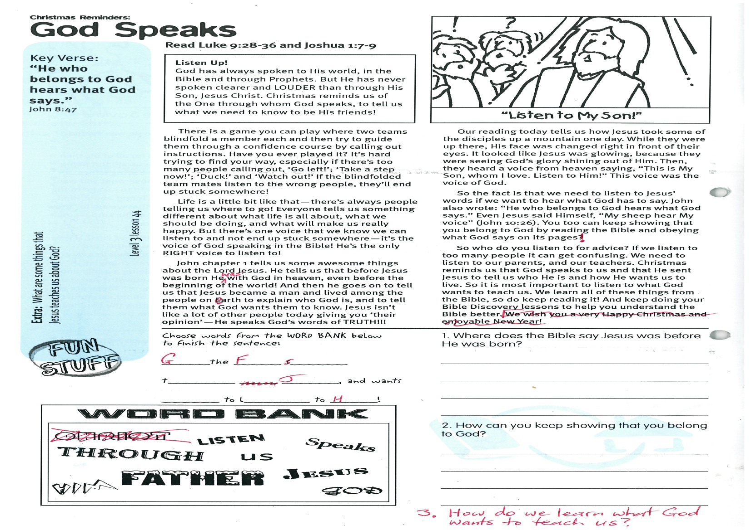

**Read Luke 9:28-36 and Joshua 1:7-9**

**Listen Up!** God has always spoken to His world, in the Bible and through prophets. But He has never spoken clearer and LOUDER than through His Son, Jesus Christ. Christmas reminds us of the One through whom God speaks, to tell us what we need to know to be His friends!

There is a game you can play where two teams blindfold a member each and then try to guide them through a confidence course by calling out instructions. Have you ever played it? It’s hard trying to find your way, especially if there’s too many people calling out, ‘Go left!’; ‘Take a step now!’; ‘Duck!’ and ‘Watch out!’ If the blindfolded team-mates listen to the wrong people, they’ll end up stuck somewhere!

Life is a little bit like that - there’s always people telling us where to go! Everyone tells us something different about what life is all about, what we should be doing, and what will make us really happy. But there’s one voice that we know we can listen to and not end up stuck somewhere - it’s the voice of God speaking in the Bible! He’s the only RIGHT voice to listen to!

John chapter 1 tells us some awesome things about the Lord Jesus. He tells us that before Jesus was born He was with God in heaven, even before the beginning of the world! And then he goes on to tell us that Jesus became a man and lived among the people on earth to explain who God is, and to tell them what God wants them to know. Jesus isn’t like a lot of other people today giving you ‘their opinion’ - He speaks God’s words of TRUTH!!!

Christmas Reminders:

**God Speaks**

**Level 3 lesson 44**

Key Verse:  
**“He who belongs to God hears what God says.”**John 8:47

**Listen** speaks Him  
 through us God  
Jesus Father

G__ __ the F__ __ __ __ __ s__ __ __ __ __ t__ __ __ __ __ __

J__ __ __ __, and wants __ __ to l__ __ __ __ __ to H__ __!

Choose words from the WORD BANK below to finish the sentence:

1. Where does the Bible say Jesus was before He was born?  
____________________________________________________________________________________

2. How can you keep showing that you belong to God?  
______________________________________________________________________________________________________________________________  
3. How do we learn what God wants to teach us?  
__________________________________________  
___________________________________________________________________________________

Please complete and return by post to   
**1-2A (G2) 93 Dominion Rd, Mt Eden, Auckland 1024** or scan & email to **info@biblediscovery.org.nz**

**Extra:** What are some things that Jesus teaches us about God?

Our reading today tells us how Jesus took some of the disciples up a mountain one day. While they were up there, His face was changed right in front of their eyes. It looked like Jesus was glowing, because they were seeing God’s glory shining out of Him. Then, they heard a voice from heaven saying, “This is My Son, whom I love. Listen to Him!” This voice was the voice of God.

So the fact is that we need to listen to Jesus’ words if we want to hear what God has to say. John also wrote: “He who belongs to God hears what God says.” Even Jesus said Himself, “My sheep hear My voice” (John 10:26). You too can keep showing that you belong to God by reading the Bible and obeying what God says on its pages!

So who do you listen to for advice? If we listen to too many people it can get confusing. We need to listen to our parents, and our teachers. Christmas reminds us that God speaks to us and that He sent Jesus to tell us who He is and how He wants us to live. So it is most important to listen to what God wants to teach us. We learn all of these things from the Bible, so do keep reading it! And keep doing your Bible Discovery lessons to help you understand the Bible better.

finish