**March 2013  
Bible Readings**

DATE BOOK REFERENCE

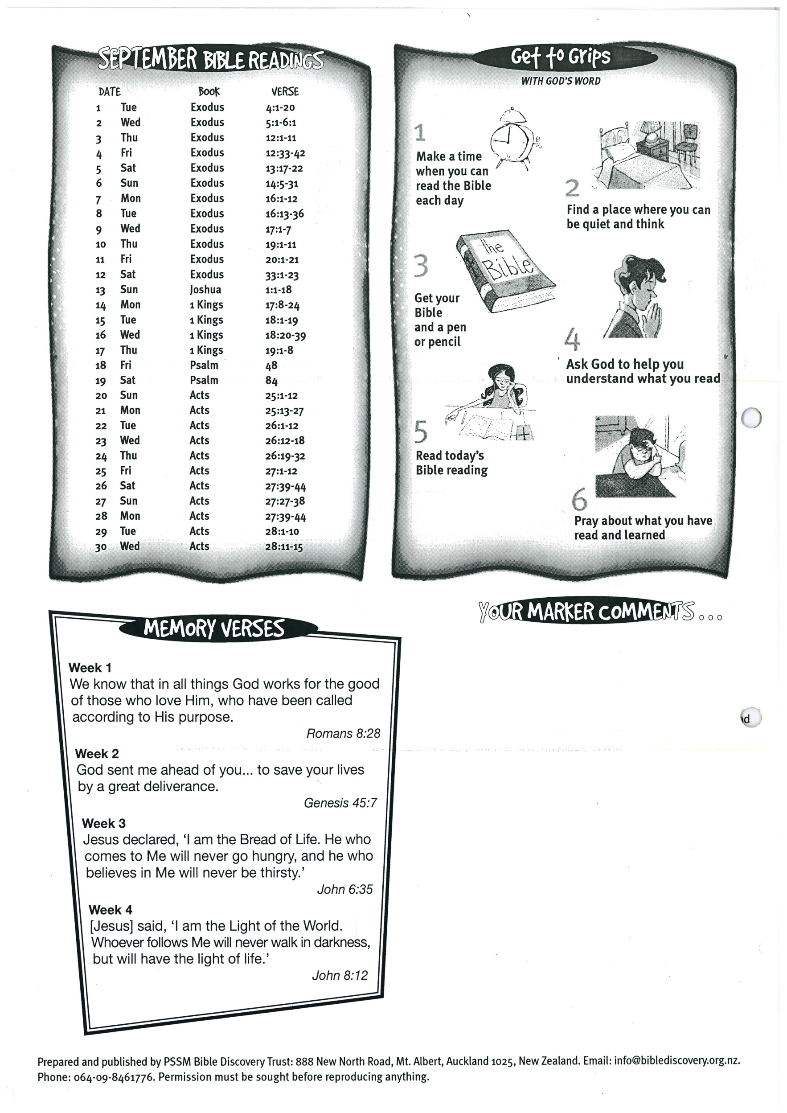



**28  
29  
30 Luke 10:38-42  
31 Luke 7:18-23**