Jesus is Risen!
Key Verse:
“Christ died… was buried…and was raised…..”
1 Corinthians 15:3-4

Read: Mark 16:1-9
and John 20:10-18
The story of the first Easter is written 4 times in the Bible. You can read it in the Gospels of Matthew, Mark, Luke and John. Each of those men knew that this was probably the most important thing they would ever write down for us.
Earlier, the Lord Jesus had warned His disciples He was going to die and then come back to life again. They were surprised and didn’t really understand, but finally that time had come.
Even though Jesus had done so many wonderful miracles, some people still did not believe that He was God’s Son. They stirred up trouble and told lies about Him to Pontius Pilate, the Roman Judge. Pilate soon handed Jesus over to the wicked crowd to be punished, even though he had said, “I find no fault in this just man!” Jesus was nailed to a rough, wooden cross, and after a while, He gave up His life and died.

Later, on Easter Friday, some of Jesus’ friends asked Pilate for permission to take His body off the cross. They took Jesus and laid Him in a new tomb (like a cave in the hillside) and a big stone was rolled across the doorway.
On the Sunday morning, some women who had seen Jesus die, wanted to put sweet smelling spices on His body. So they got up early in the morning and set off for the cave where Jesus was buried. As they walked, they wondered, “How will we get in? We can’t roll back that big stone.” Arriving at the tomb they stopped in amazement; it was already open!
A shining angel appeared and spoke to them. “Don’t be afraid,” he said. “Jesus is not here. He is risen! He’s alive! Go and tell His disciples.” What wonderful news that was! It seemed too good to be true.
While the others hurried away, Mary stayed in the garden near the tomb. She was sad and crying. Suddenly, she saw a man standing beside her. He said to her, “Mary!” Oh, she knew that voice! It was Jesus, He really WAS alive!
The story of Easter is wonderful because it is true! JESUS IS RISEN, and HE IS ALIVE FOR EVER! He knows your name and wants you to love and trust Him, so He can forgive your sin and teach you God’s way.

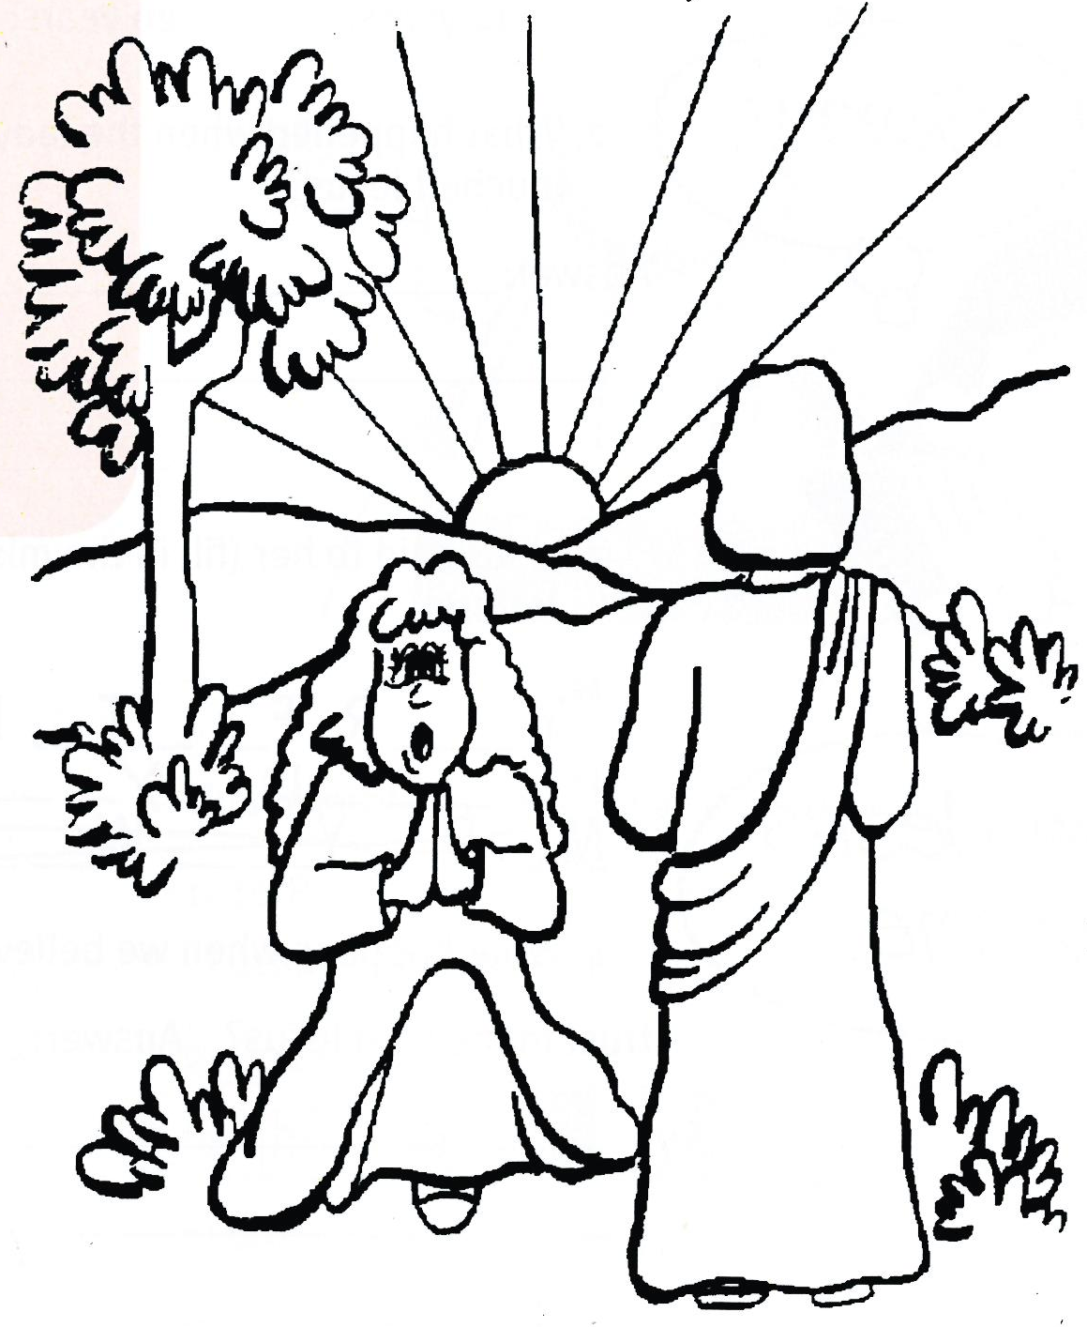
Extra: Think of some things you would like to ask or tell Jesus. Then tell Him in prayer.

Level 2 lesson 9
My Name is________________________________________ Age ______________

1. On what day of the week did Jesus rise from the dead?
_____________________________________________
2. Why do you think Mary was crying?
_____________________________________________
_____________________________________________
3. How did Mary know Jesus was alive?
_____________________________________________
_____________________________________________

Extra: What does it mean to believe and obey Jesus?
Key Verse:
“Believe in the Lord Jesus and you will be saved….”
Acts 16:31
Read Luke 8:43-48
Last week we looked at the Easter story, when Jesus died and rose again. Today we are going to go back and keep learning from His life before that. The Bible tells us that Jesus went around “preaching and teaching and doing good.”
One day, a great crowd of people gathered to hear Him. They pushed closer and closer, trying to hear every word He said. Jesus could hardly move! In the crowd was a poor lady who had been sick for over twelve years. She was sure that Jesus could heal her.
Finally, she got close enough to touch the hem of His coat. Immediately she was healed! “Who touched me?” asked Jesus. Peter and the other disciples standing nearby were surprised. “There are so many people crowding around you,” they said. “How can you ask, ‘Who touched me?’” Jesus replied, “I know because the power has gone out from Me.”
So the woman confessed. She told Jesus why she had come to Him to be healed and cleansed. Jesus gave her a lovely answer. He said, “Your faith has healed you. Go in peace.”
If we confess our sin and trust in the Lord Jesus as Saviour, He will heal us from the sickness of sin. He is the only One who can forgive our sin, because He died on the Cross in our place.
He helps us to worship and obey God and gives us real joy and love in our heart. He helps us to be honest and kind, and to do what is good and right. He helps us to think of others; to be always helpful and caring. He is a wonderful Saviour. He never fails. We can keep close to Him by reading His Word, and praying to Him every day.

The Touch of Faith

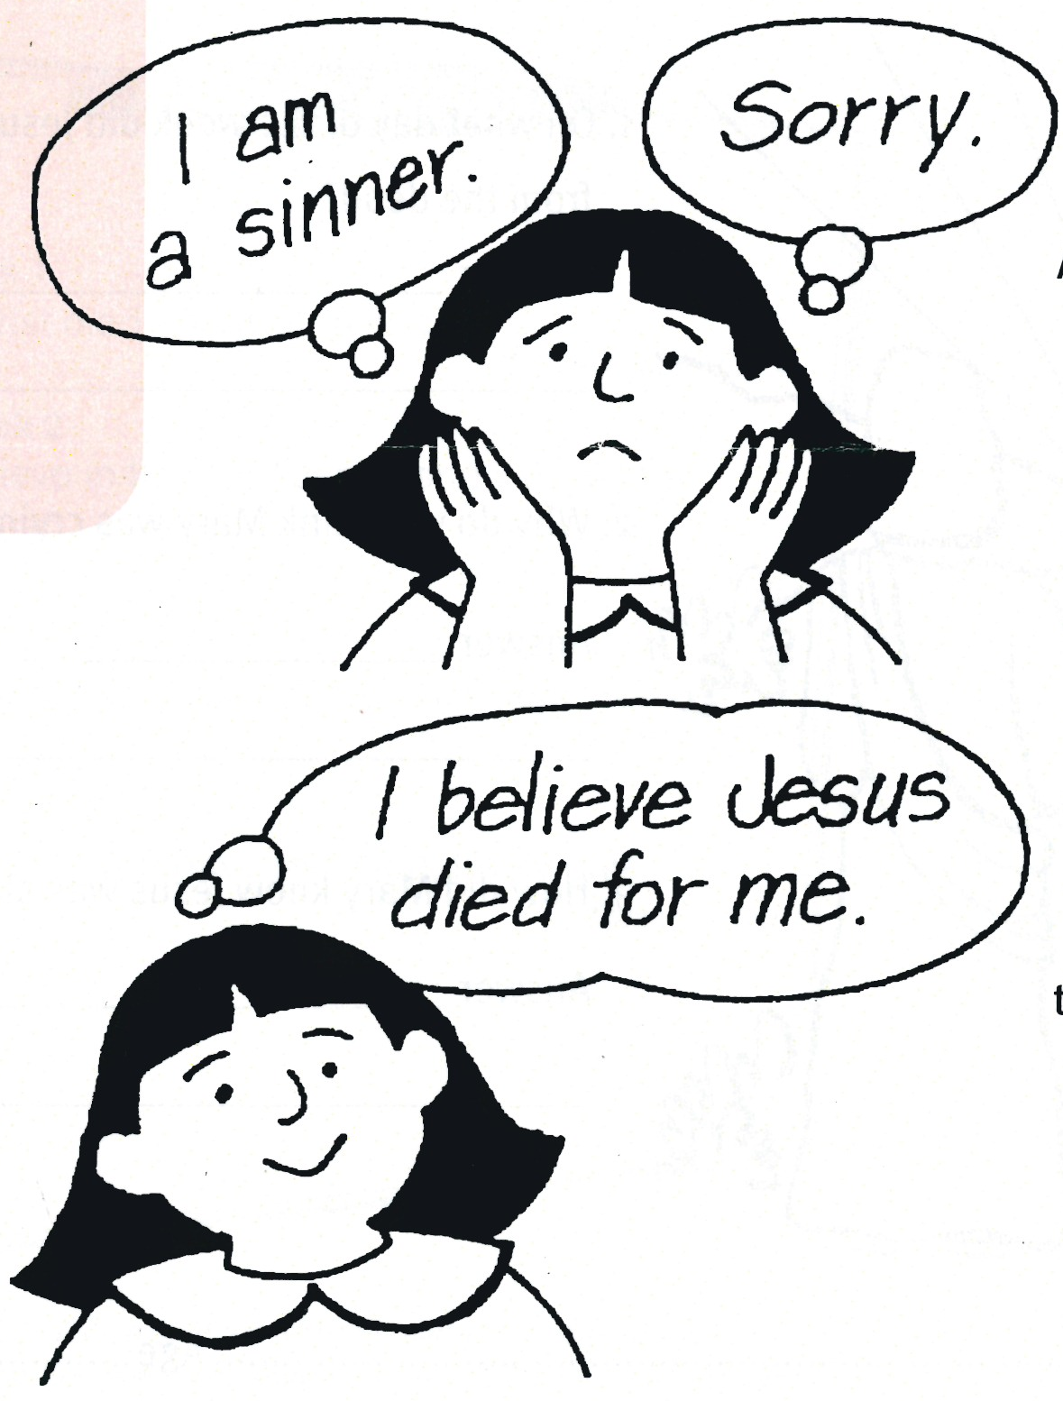
Level 2 lesson 10
1. How long had this lady been sick?
Circle the right answer:
1 year 10 years 12 years 20 years
2. What happened when the lady touched Jesus?
___________________________________________
____________________________________________3. Jesus said to her (fill in the missing letters).
“Y __ __ R F __ __ T __ H __ __
H __ __ L __ D Y __ __.”
4. What happens when we believe and trust in the Lord Jesus?
___________________________________________
____________________________________________

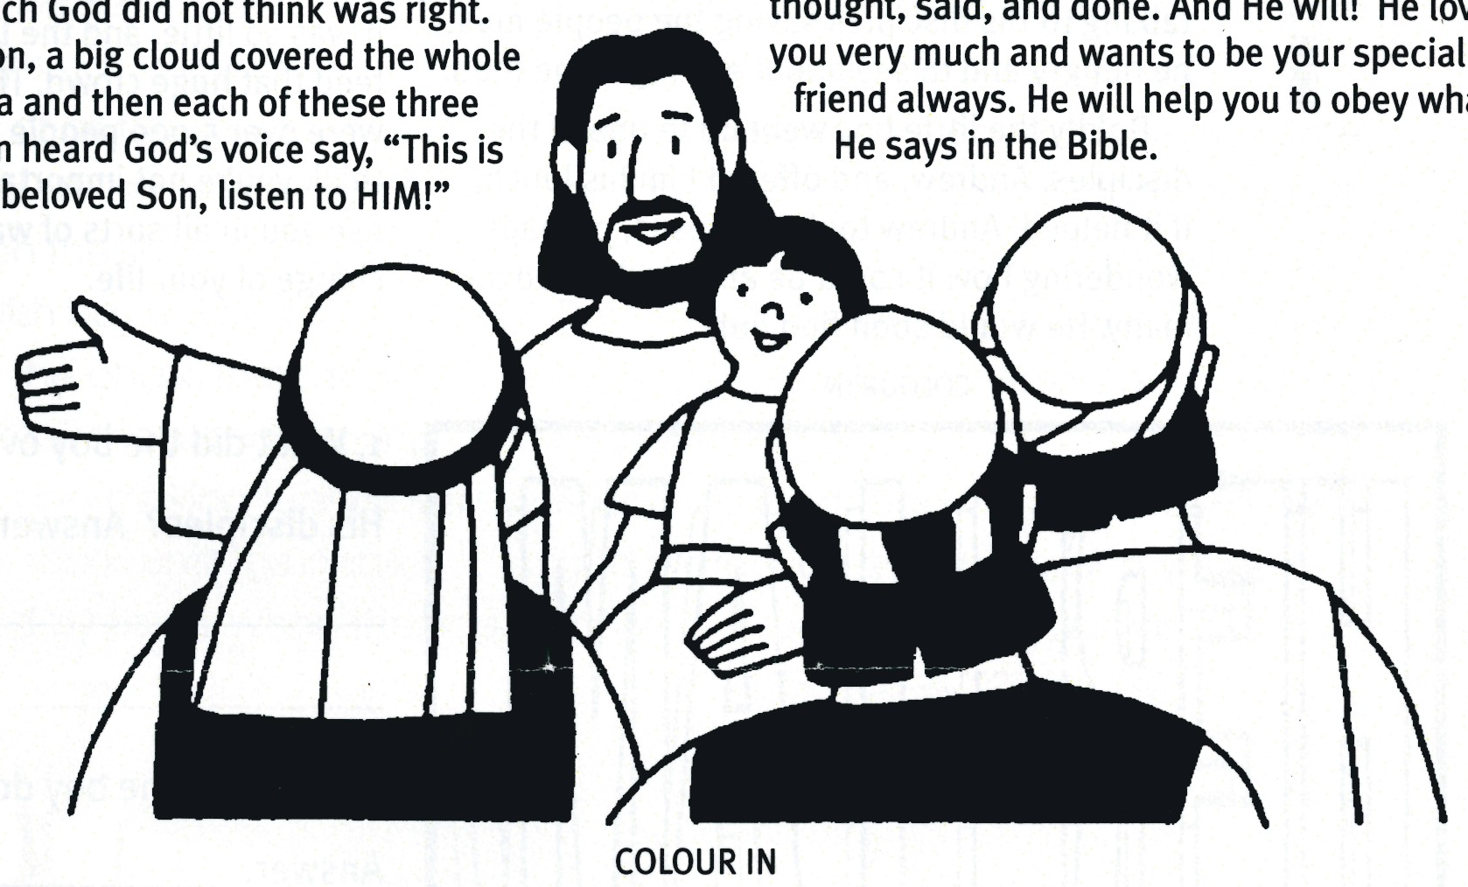
Extra: How can you be a special friend of Jesus?
Special Friends
Read Luke 9:28-35
How would you like to be a special friend of Jesus? In the Bible, we read that Peter, James, and John were special friends of the Lord Jesus. They were often with Him at important times, when special things were happening. They were with Jesus when He did many miracles. Can you remember some miracles they saw?
One day Jesus took these three special friends with Him up to the top of a mountain. He wanted to show them something very special, something no-one else would see. As they sat on the mountain-top, Jesus showed them some of the glory He had in Heaven. His whole body and clothing shone even brighter than the sun! The three disciples were amazed. They had never seen anything like it!
James and John were too amazed to even speak, but Peter suggested they do something which God did not think
was right.
Key Verse:
“Whoever trusts in the Lord is kept safe.”
Proverbs 29:25b
Soon, a big cloud covered the whole area and then each of these three men heard God’s voice say, “This is my beloved Son, listen to HIM!” That meant listen to Jesus and obey Him.
Yes, Peter, James and John had a special friendship with the Lord Jesus. They loved Him lots and wanted to obey him. Yet, even they still made mistakes, like Peter did here. But Jesus forgave and helped them.
Sometimes we make mistakes too, don’t we! We want to do things our way, just like Peter! This is a big lesson we can learn. It is most important if we are friends of Jesus, to listen to Him and do what His Word the Bible says.
What about you, my friend? Do you want to be a special friend of Jesus?
You can be! Simply pray and thank Him for dying for you and taking the punishment for your sin. Then ask Him to come into your heart and cleanse out all the bad things you have thought, said, and done. And He will! He loves you very much and wants to be your special friend always. He will help you to obey what He says in the Bible.

Level 2 lesson 11

Unscramble each word and write in the spaces beside:
1. terPe __ __ __ __ __ meJas __ __ __ __ __ and nohJ __ __ __ __ were Jesus’ special friends.
2. God said
“ __h__ __ __s __y b__ __ __v__ __ __o__ l__ __t __ __ t__ H__ __.”
3. Write down some things you can do to help at home: ______________________________
____________________________________________________________________________

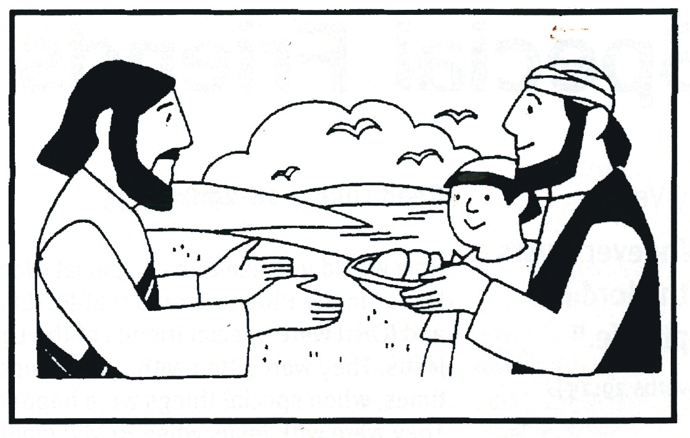

Level 2 lesson 12
Extra: What could you offer to Jesus?
Please complete and return by post to
PSSM, 1-2A (G2) 93 Dominion Rd, Mt Eden, Auckland 1024 or scan & email to info@biblediscovery.org.nz

Key Verse:
“Freely you have received, freely give.”
Matthew 10:8b
Read John 6:5-13
One day a little boy stood outside his home and watched a crowd of people hurrying past. Curious, he called out to his friend, “Hey, what’s happening? Where’s everyone going?” His mate said, “They’re going to see Jesus; to hear Him teach and see Him heal the sick. Do you want to go too?” “Oh yes!” said the boy. “I’ll just ask Mum first!” Quickly he ran inside to ask if he could go. His mum said “Yes” and gave him some lunch for later on: just five little bread buns and two fish.
Excitedly, the little boy made his way to where Jesus was speaking. He wriggled between people until he was right up close to Jesus. What wonderful words He spoke; so loving and kind! Hour after hour, the boy listened and watched. Then he overheard Jesus talking to His disciples saying the people must be hungry and to see about getting some food.
Boldly the little boy went up to one of the disciples, Andrew, and offered him his lunch, if it helped. Andrew took it to Jesus, perhaps wondering how it could be any use to feed so many. He would soon find out!
Jesus made all the people sit down quietly. Taking the boy’s lunch, He prayed to His Father, giving Him thanks. Then, breaking it into pieces, He told the disciples to hand it out to the people. As they did, something amazing happened: there was more and more bread and fish. There was enough for everyone! There were even twelve baskets full left over. What a wonderful miracle!
Imagine how sad it would have been, if that little boy had thought he was too hungry to share, or that it wasn’t much anyway. But he didn’t do that. He gave all he had, even though it was so little, and the Lord Jesus used it to feed that huge crowd. The Bible says there were over 5,000 people there that day! Never think you’re not important to Jesus. He will use you in all sorts of ways if you let Him be in charge of your life.

Giving to Jesus
1. What did the boy overhear Jesus say to His disciples?
_________________________________
_________________________________
2. What did the boy do when he heard that?
_________________________________
_________________________________
3. What did you learn from this story?
_________________________________
_________________________________

HERE I AM,
USE ME

