**Read Luke 5:4-11**Do you remember last month’s lesson when Jesus spoke to the crowds from Peter’s boat? Well, when Jesus had finished teaching the people, He turned to Peter and said to him, “Row your boat out into deeper water, and let down your nets to catch some fish.”

Peter was surprised when the Lord Jesus said that. He had been a fisherman for a long time and thought he knew all about fishing. “Master,” he said to Jesus, “We’ve fished all night and haven’t caught anything!” He probably thought it would be a waste of time. But instead of arguing with Jesus, Peter obeyed. “Because You say so” he said, “I will let down the nets.”

So they did, and they caught so many fish that their net couldn’t hold them all and began to break! In fact, they could not get them all into the boat. Quickly, the fishermen called to their friends in another boat to come and help them. It is good to be helpful, and we should always be ready to help others too.

Peter was amazed, as only God could perform such a miracle! He knew now that Jesus was God. Peter knew he was a sinner, and that Jesus was righteous and holy. He bowed humbly before Jesus and asked His forgiveness. Jesus said to Peter. “Don’t be afraid; from now on you will be a fisher of men.”

Jesus meant that Peter would go and tell others about Jesus, and help them to follow Him. That was far more important than catching lots of fish! And Jesus was able to help Peter because he was willing to admit he was sinful.

If we think we are not sinful and do not need Jesus’ help, then He can’t help us. We need to be humble and admit our sin (just like Peter), then Jesus will cleanse and forgive us. Jesus wants to help us like that. The Bible tells us that when the fishermen brought the boats of fish to land, they made up their minds to follow Jesus forever!

**Fishing**

Key Verse:  
**“Come, follow Me” Jesus said, “and I will make you fishers of men.”**Matthew 4:19

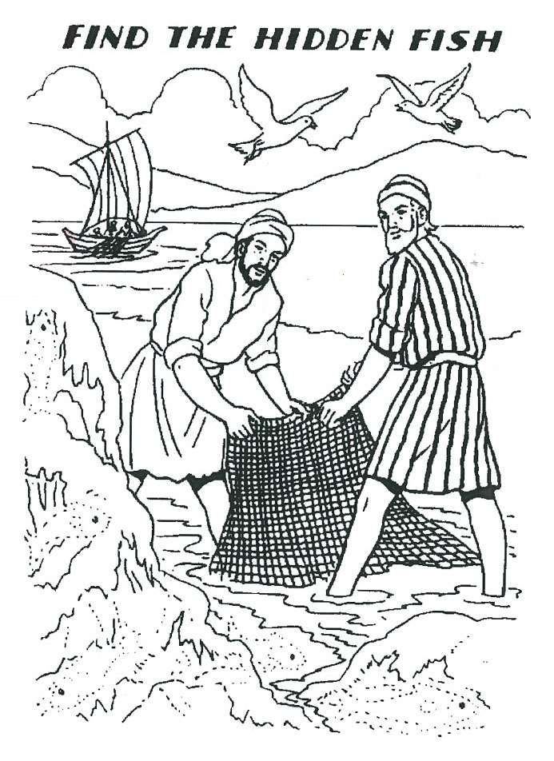

My Name is________________________________________ Age ______________

1. Who did the boat Jesus used belong to?

__________________________________________

2. What happened when the fishermen obeyed Jesus?

__________________________________________

__________________________________________

3. What did Jesus mean when he told Peter he would be a fisher of men?

__________________________________________

__________________________________________

**Level 2 lesson 5**

**Extra:** How can you be a fisherman for Jesus today?

Those men were absolutely convinced that Jesus could heal their friend. The Lord Jesus was so pleased to see their love and faith. He said to the sick man, “Friend, your sins are forgiven.” Some of the people standing around were angry when Jesus said that. They knew only God has the right to forgive sins. They didn’t think Jesus had that right.

Jesus wanted to show that He did have the right to forgive sin and the power to heal. He wanted the people to know He was God. He told the paralysed man to stand up and walk. Straight away, the man got up and walked away! He carried his stretcher outside, giving praise to God for the miracle Jesus had done.

We can “bring” our friends to know the Lord Jesus, too. Of course we need to come to Him in prayer ourselves first, so that He can forgive us and bless us. Then we can tell others about our wonderful Saviour, and ask Jesus to help them believe and love Him, too.

**Read Luke 5:18-26**

One day the Lord Jesus was in a house in Capernaum, teaching the people. Many had come to hear His wise words, and to bring sick people to be healed. There were crowds of people inside and outside the house.

At one point, four men came along the road carrying a crippled man on a stretcher (someone once described this as an eight-legged ambulance!) They wanted to bring their poor friend to the Lord Jesus to be healed. However, they couldn’t get near Him because of the crowd. But, they had an idea!

The houses in those days had flat roofs, with stairways up on the outside. It gets very hot in that country, so people enjoyed sitting on the roof in the cool of the evening. So the men carried their friend up the stairs onto the roof. Then they made a hole in the roof and lowered him down, right in front of the Lord Jesus!

**Helping**

Key Verse:  
**“When Jesus saw their faith, he said, ‘Friend, your sins are forgiven.’”**Luke 5:20

DRAW A PICTURE OR MAKE A PUZZLE ABOUT THIS STORY.

UNSCRAMBLE  
(These words are written backwards)

kcis ____________________________

delaeh ____________________________

dworc ____________________________

snis ____________________________

deklaw ____________________________

ruoivas ____________________________

Who is the only one who can forgive sin?

___________________________________

___________________________________

___________________________________

**Level 2 lesson 6**

**Extra:** Find out all you can about houses in those days.

**Read Luke 8:22-25**  
One day Jesus had been busy teaching the people and was very tired. He told His disciples to get in their boat and sail with Him across Lake Galilee to the other side. As they sailed along, He soon fell asleep in the back of the boat.

Before long, a great storm came up and a fierce wind began to blow. Harder and harder it blew, tossing the little boat around like a cork! Huge waves began to crash right into it and slowly the boat began filling with water.

The disciples started to fear that they would all drown. They called out to Jesus, “Master, Master, don’t you care if we all drown?” The Lord Jesus woke from His sleep and stood up inthe rocking boat. In a firm voice He commanded the wind and waves, “Peace be still!” Straight away, the wind died down and the sea became calm and still!

**Jesus Calms the Storm**

Key Verse:  
**“He commands even the winds and the water and they obey Him.”**Luke 8:25

The disciple’s eyes opened wide in wonder. To think even the winds and waves obeyed the Lord Jesus! Jesus said to His disciples, “Why are you so afraid? What little faith you have.” The disciples didn’t answer Him. They were still wondering, and said to each other, “Who is this? He commands the winds and waves, and they obey Him!” They were beginning to understand that Jesus was much more than just a man. He was truly God!

The Lord Jesus can also calm the “storms” that we have in our lives. Those storms that spring up quickly like temper, jealousy, and disobedience; also storms of hurt, tears, and disappointment. As we pray to Him and trust Him, He can give us peace, even in the storms of life. We must learn to trust Him in every situation, even when things look really bad. Always remember: Jesus cares and is able to save!

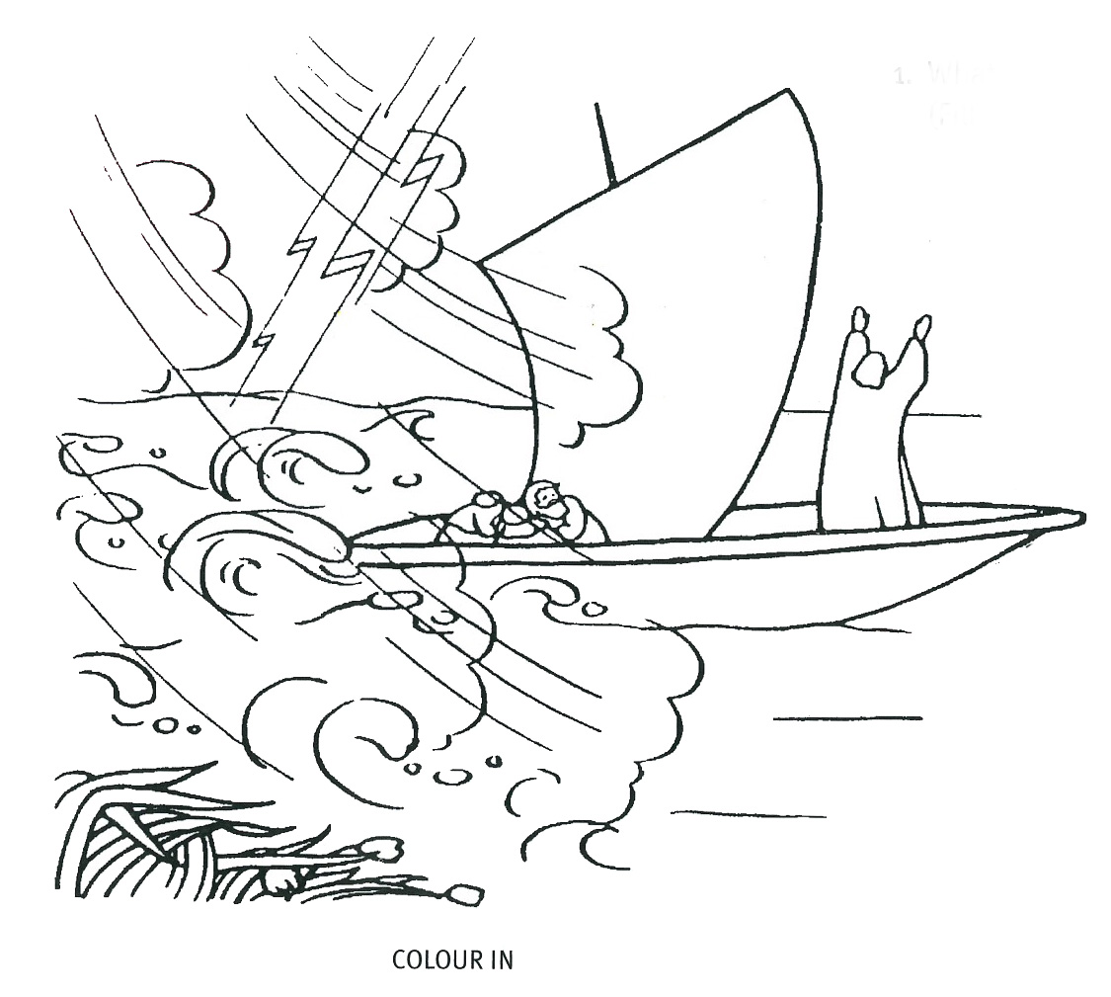

COLOUR IN

1. What did Jesus say to the storm?  
(Fill in the missing letters)

|  |  |  |  |  |
| --- | --- | --- | --- | --- |
| P |  | a |  | e |
| b |  |  |  |  |
| s |  |  | l |  |

2. What sort of troubles do you have in your life?

________________________________

________________________________

3. Who can give peace instead of storms? (Fill in the squares)

|  |  |  |  |  |
| --- | --- | --- | --- | --- |
| J |  |  |  |  |

**Level 2 lesson 7**

**Extra:** Think of ways that Jesus helps you and others.

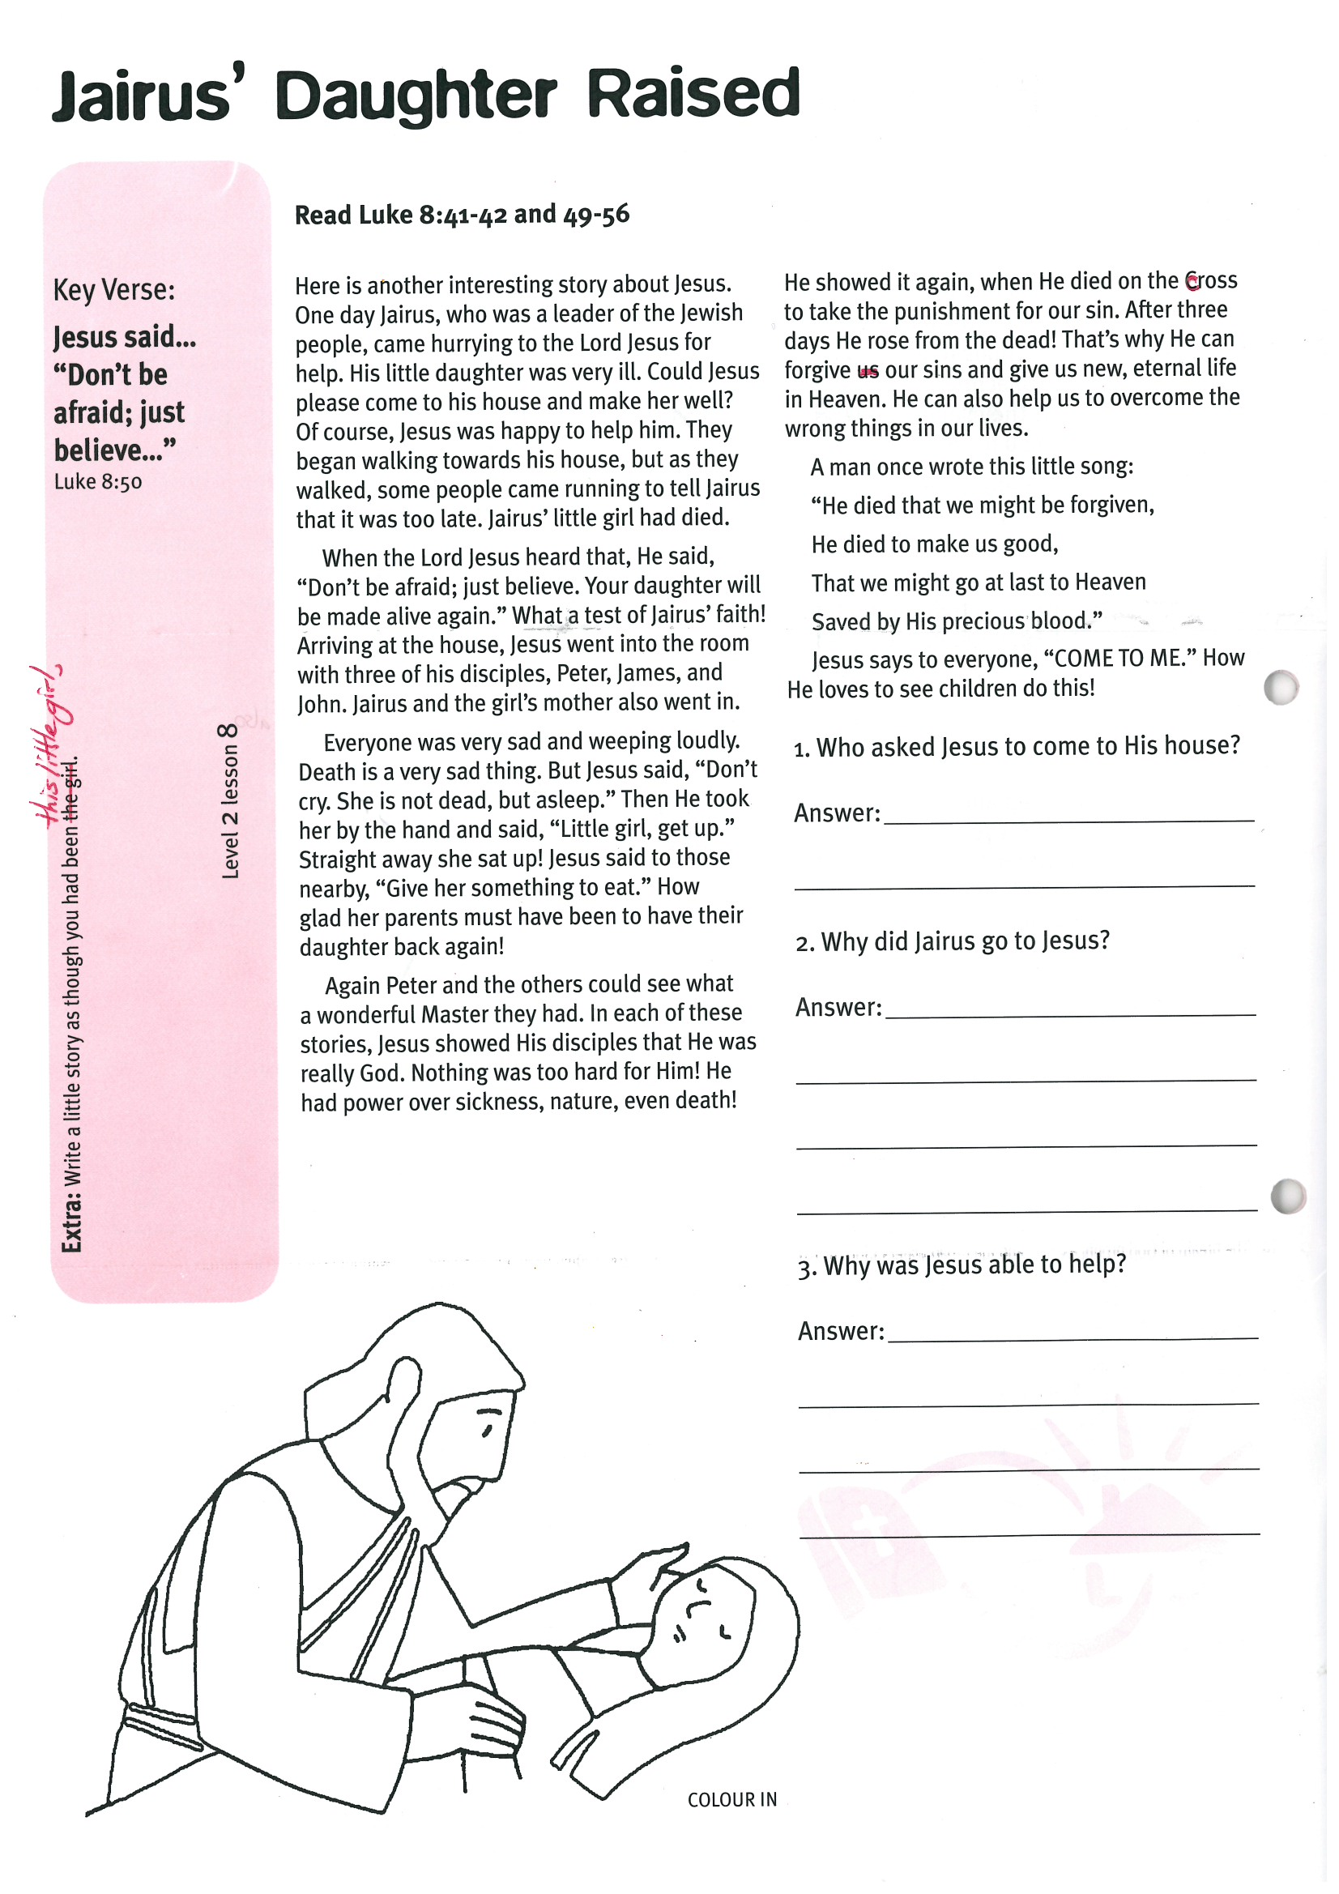

1. Who asked Jesus to come to His house?

______________________________

2. Why did Jairus go to Jesus?

______________________________

______________________________

______________________________

3. Why was Jesus able to help?

______________________________

______________________________

______________________________

Again Peter and the others could see what a wonderful Master they had. In each of these stories, Jesus showed His disciples that He was really God. Nothing was too hard for Him! He had power over sickness, nature, even death!

He showed it again, when He died on the cross to take the punishment for our sin. After three days He rose from the dead! That’s why He can forgive our sins and give us new, eternal life in Heaven. He can also help us to overcome the wrong things in our lives.

A man once wrote this little song:  
  
“He died that we might be forgiven,  
 He died to make us good,  
 that we might go at last to Heaven,  
 saved by His precious blood.”

Jesus says to everyone, “COME TO ME.” How He loves to see children do this!

**Level 2 lesson 8**

**Extra:** Write a little story as though you had been this little girl.

**Read Luke 8:41-42 and 49-56**

Here is another interesting story about Jesus. One day Jairus, who was a leader of the Jewish people, came hurrying to the Lord Jesus for help. His little daughter was very ill. Could Jesus please come to his house and make her well? Of course, Jesus was happy to help him. They began walking towards his house, but as they walked, some people came running to tell Jairus that it was too late. Jairus’ little girl had died.

When the Lord Jesus heard that, He said, “Don’t be afraid; just believe. Your daughter will be made alive again.” What a test of Jairus’ faith! Arriving at the house, Jesus went into the room with three of his disciples, Peter, James, and John. Jairus and the girl’s mother also went in.

Everyone was very sad and weeping loudly. Death is a very sad thing. But Jesus said, “Don’t cry. She is not dead, but asleep.” Then He took her by the hand and said, “Little girl, get up.” Straight away she sat up! Jesus said to those nearby, “Give her something to eat.” How glad her parents must have been to have their daughter back again!

**Jairus’ Daughter Raised**

Key Verse: **“Jesus said… “Don’t be afraid; just believe…”**Luke 8:50

Please complete and return by post to   
**PSSM, 1-2A (G2) 93 Dominion Rd, Mt Eden, Auckland 1024** or scan & email to **info@biblediscovery.org.nz**