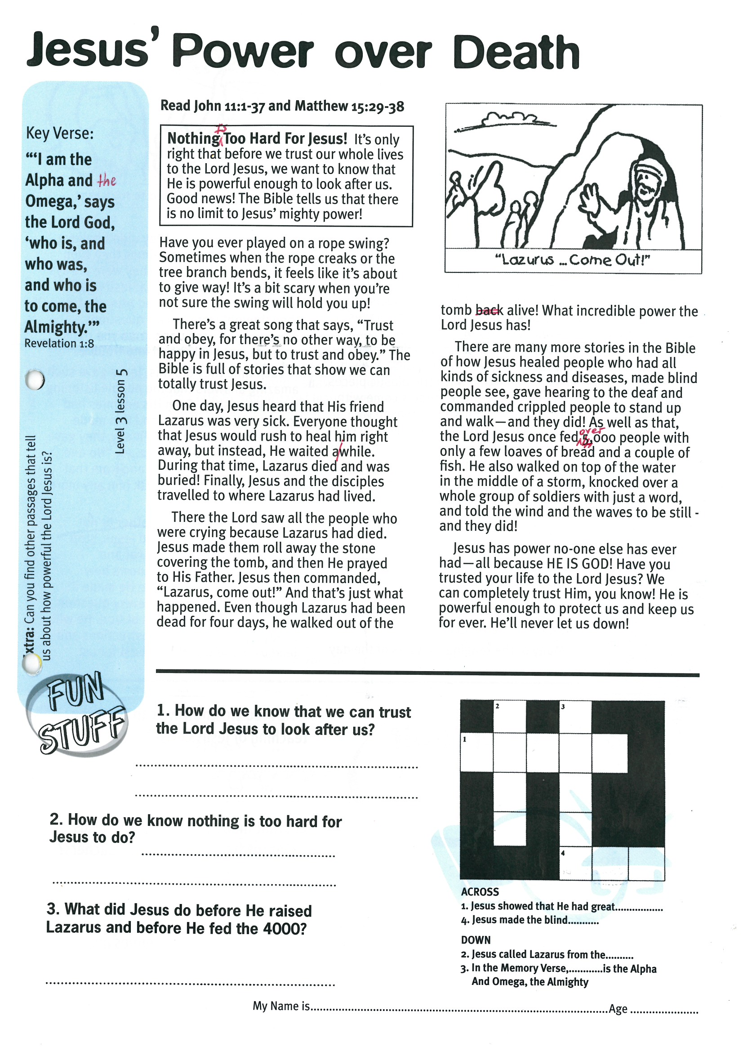

**Read John 11:1-37 and  
Matthew 15:29-38**

**NOTHING IS TOO HARD FOR JESUS!  
It’s only right that before we trust our whole lives to the Lord Jesus, we want to know that He is powerful enough to look after us. Good news! The Bible tells us that there is no limit to Jesus’ mighty power!**

Have you ever played on a rope swing? Sometimes when the rope creaks or the tree branch bends, it feels like it’s about to give way! It’s a bit scary when you’re not sure the swing will hold you up!

There’s a great song that says, “Trust and obey, for there’s no other way, to be happy in Jesus, but to trust and obey.” The Bible is full of stories that show we can totally trust Jesus.

One day, Jesus heard that His friend Lazarus was very sick. Everyone thought that Jesus would rush to heal him right away, but instead, He waited a while. During that time, Lazarus died and was buried! Finally, Jesus and the disciples travelled to where Lazarus had lived.

There the Lord saw all the people who were crying because Lazarus had died. Jesus made them roll away the stone covering the tomb, and then He prayed to His Father.

Key Verse:  
**“’I am the Alpha and the Omega’, says the Lord God, ‘who is, and who was, and who is to come, the Almighty.’”**

Revelation 1:8

**Jesus’ Power over Death**

Jesus then commanded, “Lazarus, come out!” And that’s just what happened. Even though Lazarus had been dead for four days, he walked out of the tomb alive! What incredible power the Lord Jesus has!

There are many more stories in the Bible of how Jesus healed people who had all kinds of sickness and diseases, made blind people see, gave hearing to the deaf and commanded crippled people to stand up and walk - and they did! As well as that, the Lord Jesus once fed over 4,000 people with only a few loaves of bread and a couple of fish. He also walked on top of the water in the middle of a storm, knocked over a whole group of soldiers with just a word, and told the wind and the waves to be still - and they did!

Jesus has power no-one else has ever had - all because HE IS GOD! Have you trusted your life to the Lord Jesus? We can completely trust Him, you know! He is powerful enough to protect us and keep us for ever. He’ll never let us down!

|  |  |  |  |  |  |
| --- | --- | --- | --- | --- | --- |
|  | 2 |  | 3 |  |  |
| 1 |  |  |  |  |  |
|  |  |  |  |  |  |
|  |  |  |  |  |  |
|  |  |  | 4 |  |  |

ACROSS  
1. Jesus showed that he had great………  
4. Jesus made the blind……….  
DOWN  
2. Jesus called Lazarus from the…..  
3. In the Memory Verse, ……………. Is the Alpha And Omega, the Almighty

1. How do we know that we can trust the Lord Jesus to look after us?

__________________________________________________

__________________________________________________

2. How do we know nothing is too hard for Jesus to do?

__________________________________________________

__________________________________________________

3. What did Jesus do before He raised Lazarus and before He fed the 4000?

__________________________________________________

__________________________________________________

**Level 3 lesson 5**

**Extra:** Can you find other Scriptures that tell us about how powerful the Lord Jesus is?

My Name is ……………………………………………………… Age…………………

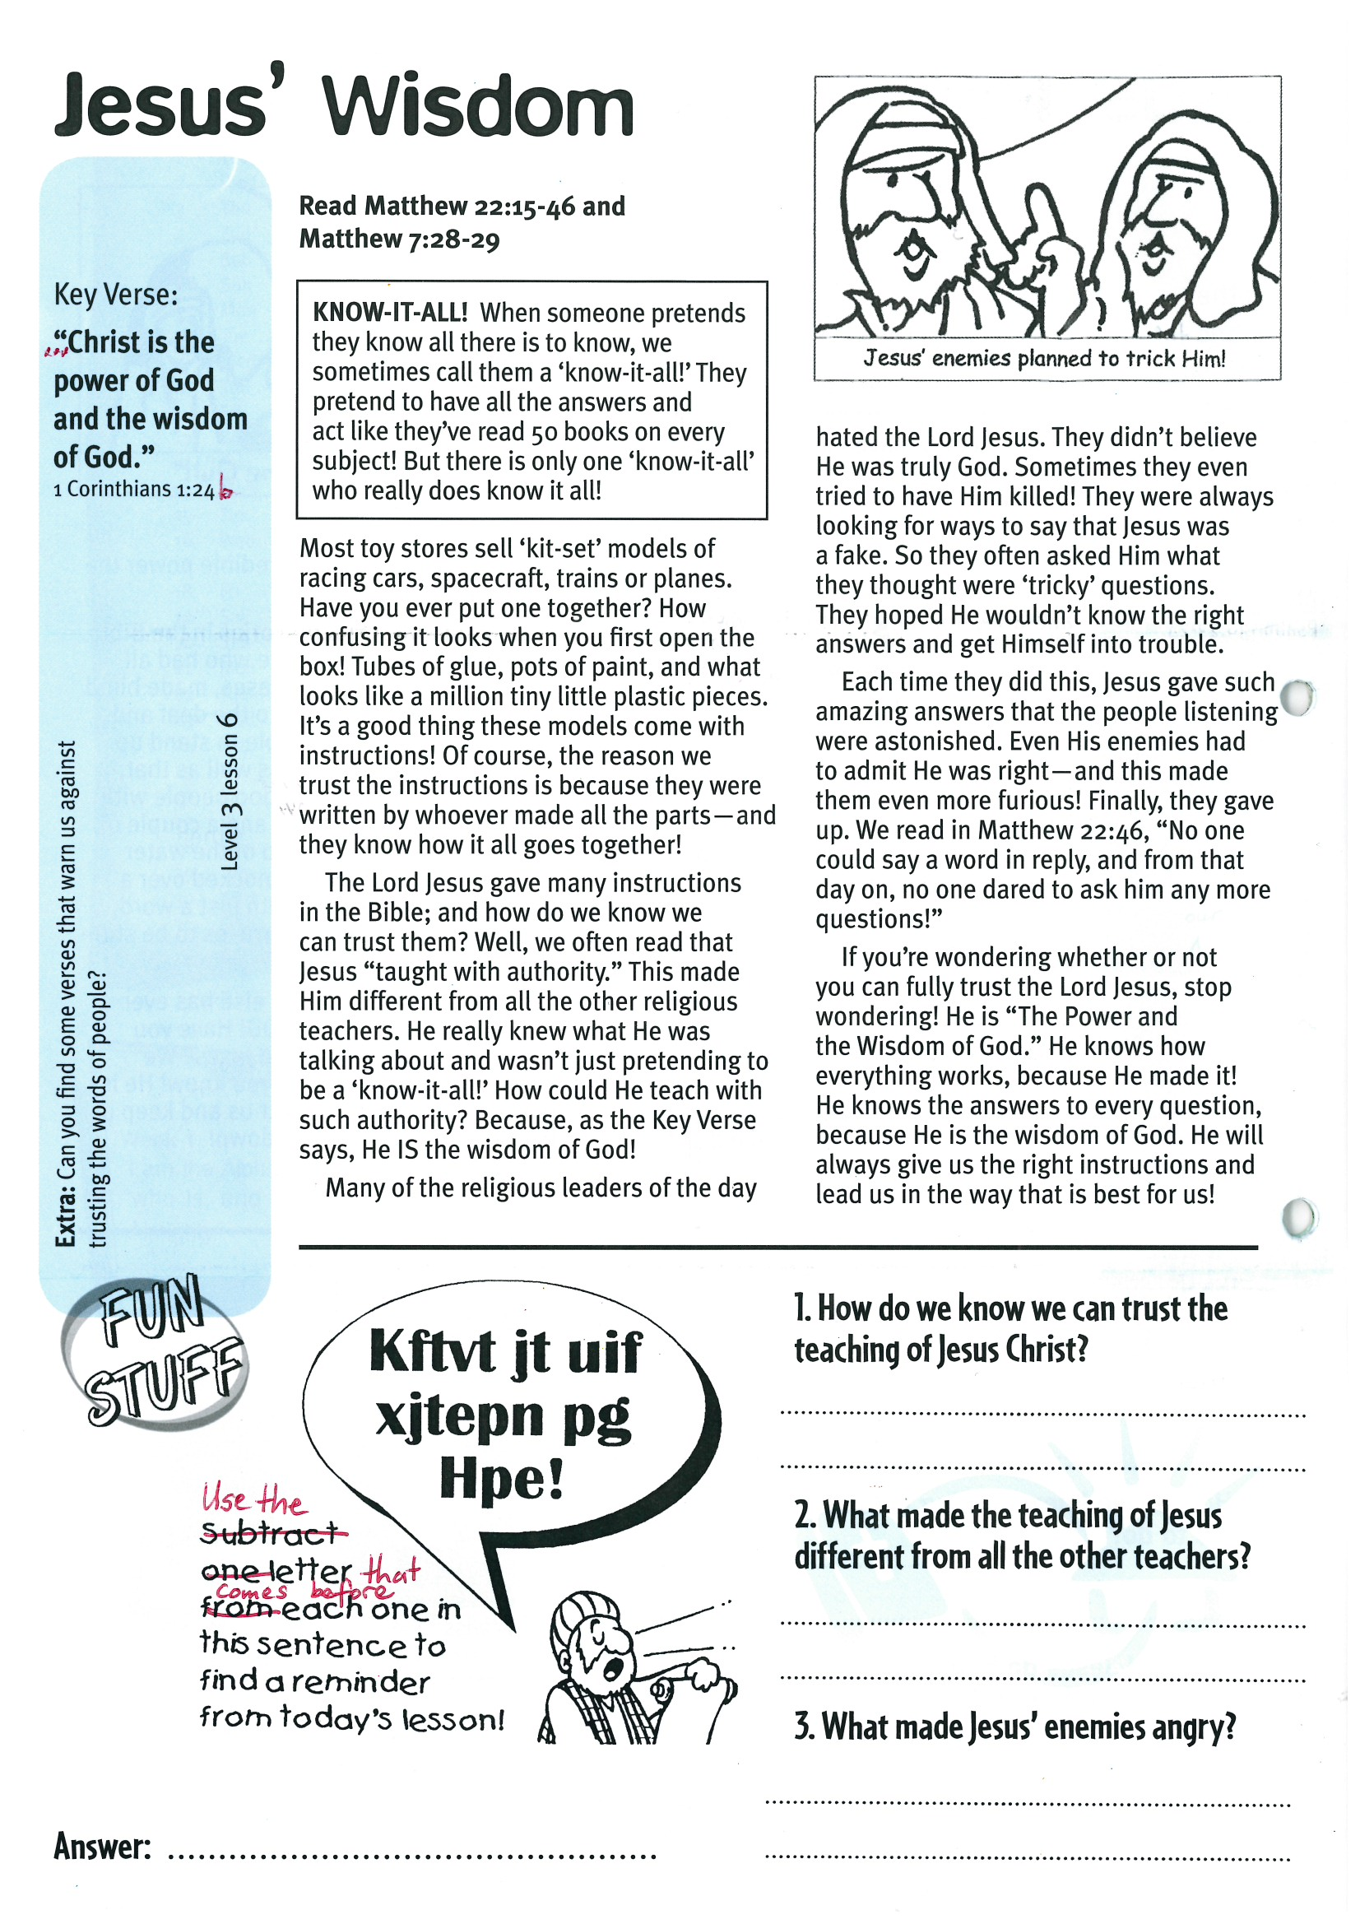

**Read Matthew 22:15-46   
and Matthew 7:28-29**

**KNOW-IT-ALL! When someone pretends they know all there is to know, we sometimes call them a ‘know-it-all!’ They pretend to have all the answers and act like they’ve read 50 books on every subject! But there is only one ‘know-it-all’ who really does know it all!**

Most toy stores sell ‘kit-set’ models of racing cars, spacecraft, trains or planes. Have you ever put one together? How confusing it looks when you first open the box! Tubes of glue, pots of paint, and what looks like a million tiny little plastic pieces. It’s a good thing these models come with instructions! Of course, the reason we trust the instructions is because they were written by whoever made all the parts - and they know how it all goes together!

The Lord Jesus gave many instructions in the Bible, and how do we know we can trust them? Well, we often read that Jesus “taught with authority.” This made Him different from all the other religious teachers. He really knew what He was talking about and wasn’t just pretending to be a ‘know-it-all!’ How could He teach with such authority? Because, as the Key Verse says, He IS the wisdom of God!

**Jesus’ Wisdom**

Key Verse:  
**“Christ is the power of God and the wisdom of God.”**

1 Corinthians 1:24b



Answer: ___________________________________

1. How do we know we can trust the teaching of Jesus Christ?

__________________________________________________

__________________________________________________

2. What made the teaching of Jesus different from all the other teachers?

__________________________________________________

__________________________________________________

3. What made Jesus’ enemies angry?

__________________________________________________

__________________________________________________

Use the letter   
that comes before  
each one in this sentence to find a reminder from todays lesson!

**Level 3 lesson 6**

**Extra:** Can you find some verses that warn us against trusting the words of people?

Many of the religious leaders of the day hated the Lord Jesus. They didn’t believe He was truly God. Sometimes they even tried to have Him killed! They were always looking for ways to say that Jesus was a fake. So they often asked Him what they thought were ‘tricky’ questions. They hoped He wouldn’t know the right answers and get Himself into trouble.

Each time they did this, Jesus gave such amazing answers that the people listening were astonished. Even His enemies had to admit He was right, and this made them even more furious! Finally, they gave up. We read in Matthew 22:46, “No-one could say a word in reply, and from that day on, no-one dared to ask him any more questions!”

If you’re wondering whether or not you can fully trust the Lord Jesus, stop wondering! He is “The Power and the Wisdom of God.” He knows how everything works, because He made it! He knows the answers to every question, because He is the wisdom of God. He will always give us the right instructions and lead us in the way that is best for us!

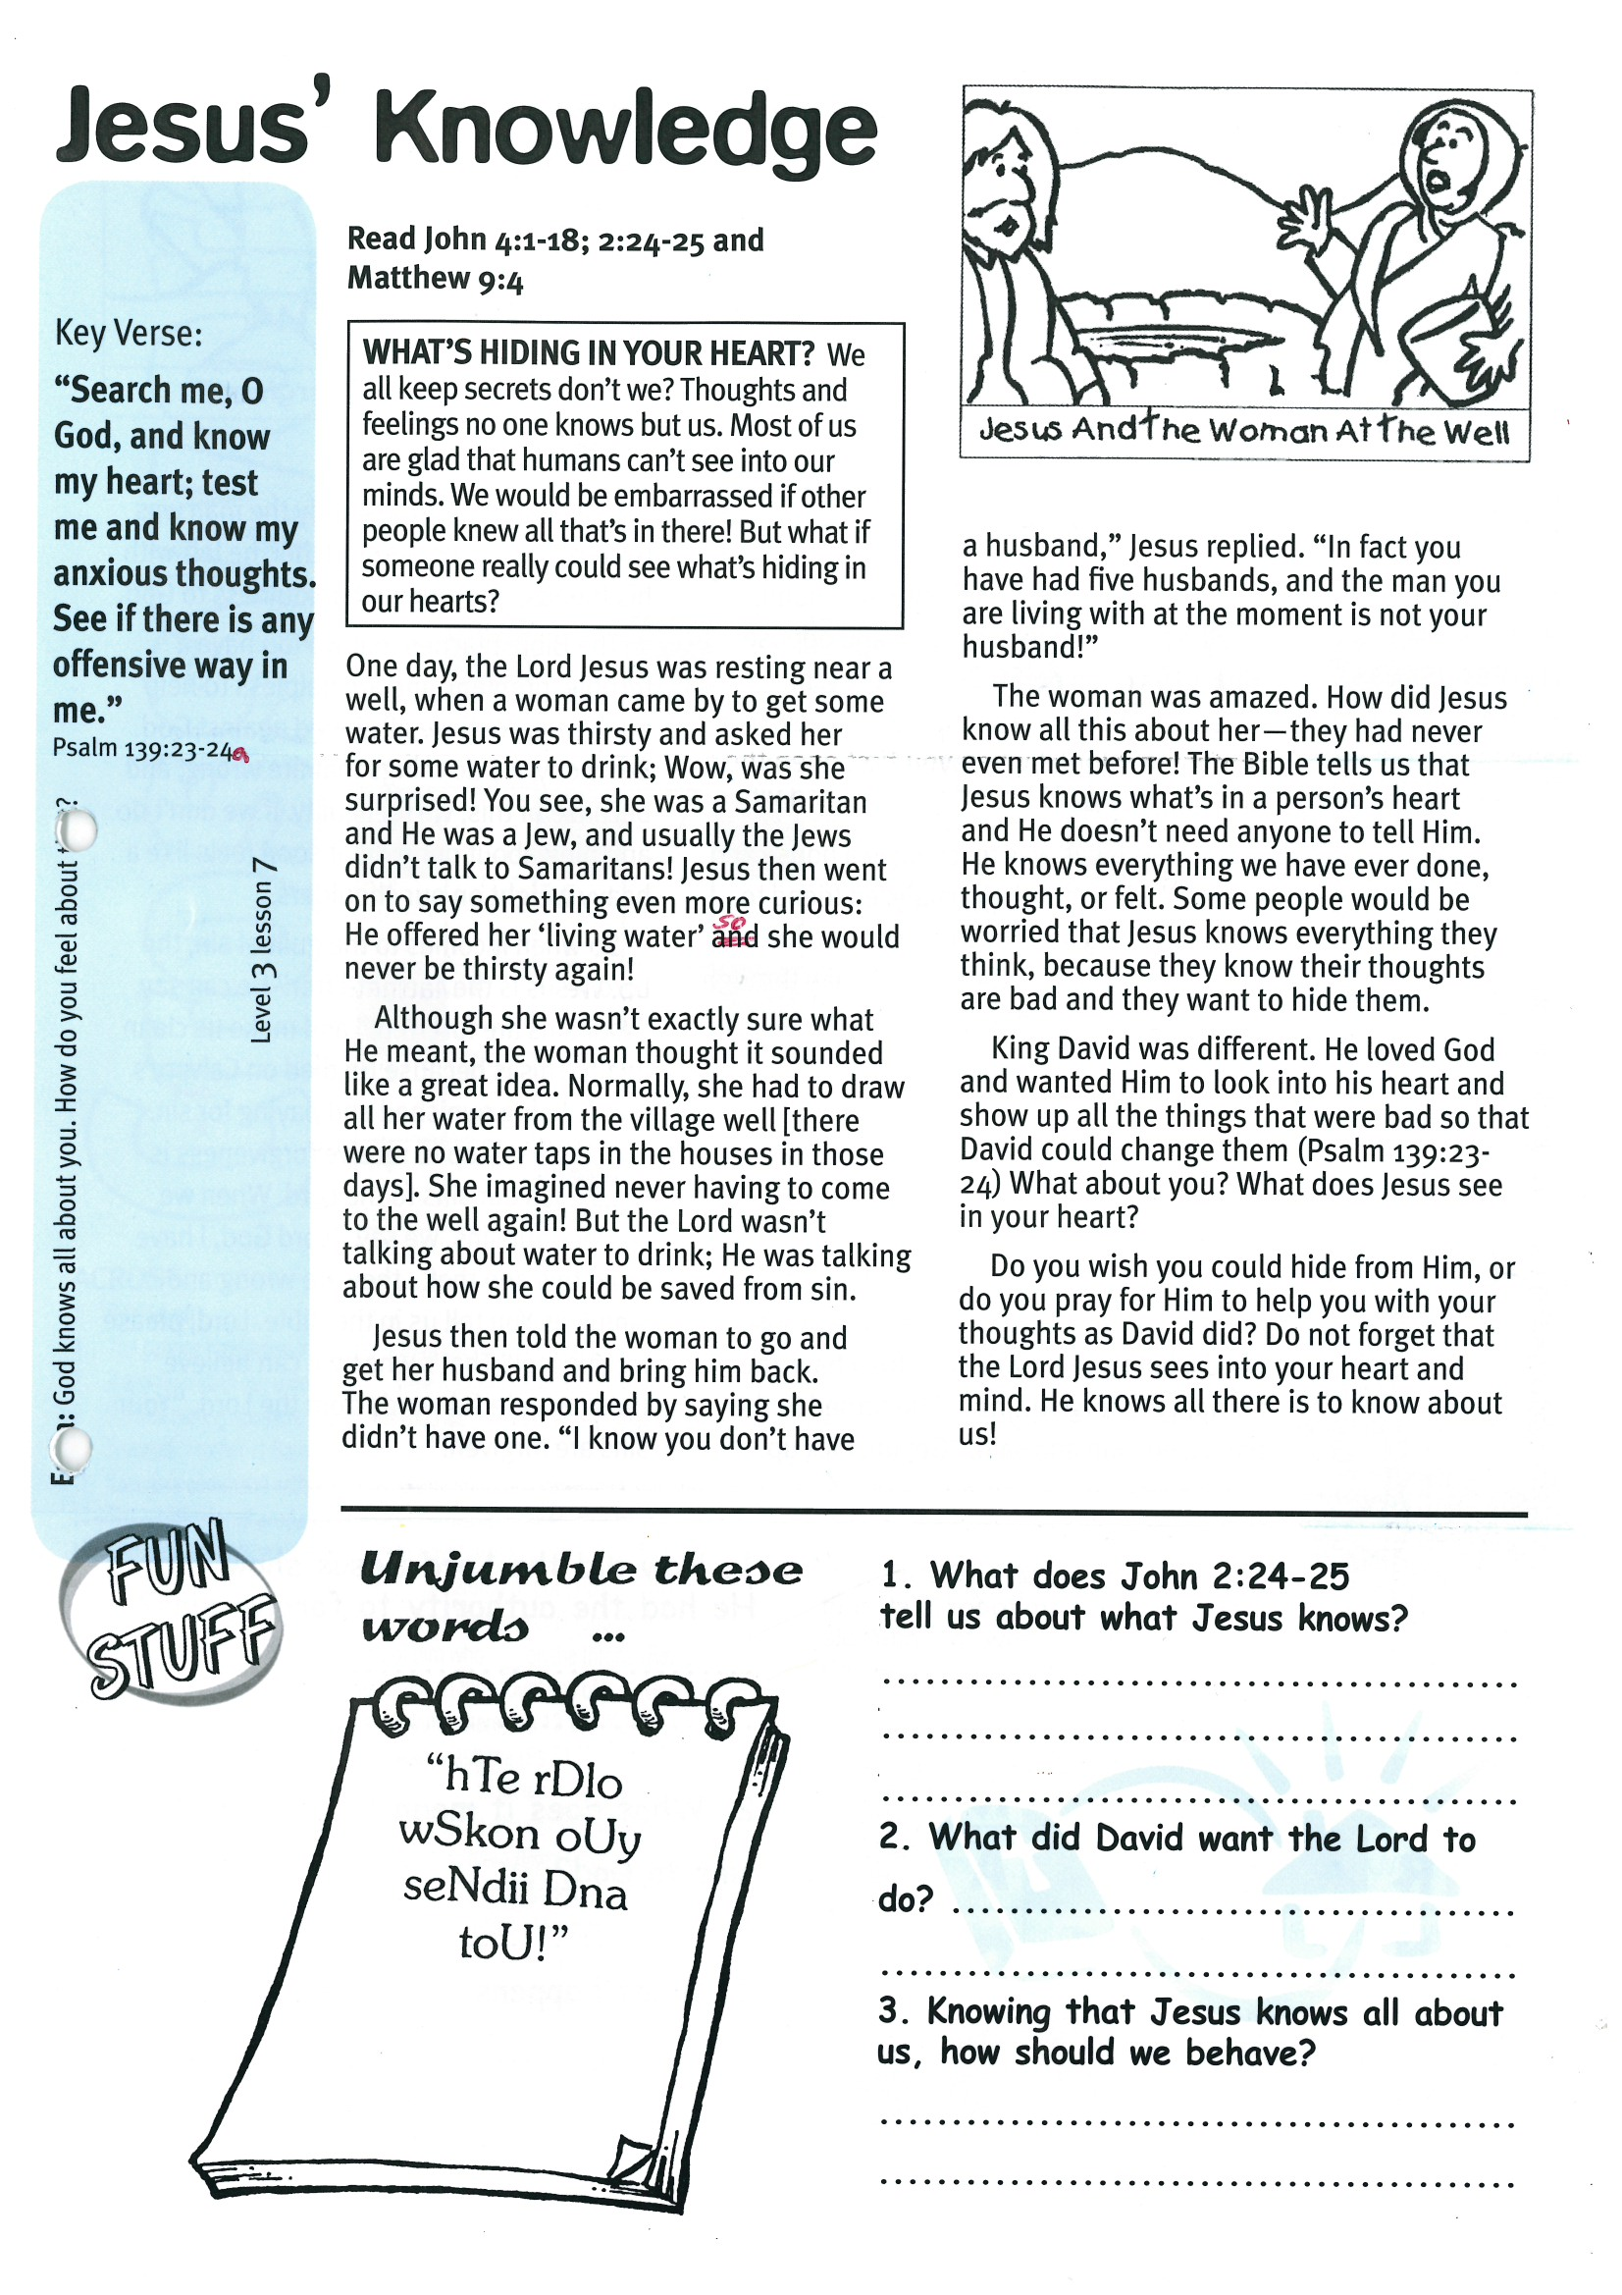

Key Verse:  
**“Search me, O God, and know my heart; test me and know my anxious thoughts. See if there is any offensive way in me.”**

Psalm 139:23-24a

**Read John 4:1-18; 2:24-25   
and Matthew 9:4**

**WHAT’S HIDING IN YOUR HEART? We all keep secrets don’t we? Thoughts and feelings no-one knows but us. Most of us are glad that humans can’t see into our minds. We would be embarrassed if other people knew all that’s in there! But what if someone really could see what’s hiding in our hearts?**

One day, the Lord Jesus was resting near a well, when a woman came by to get some water. Jesus was thirsty and asked her for some water to drink. Wow, was she surprised! You see, she was a Samaritan and He was a Jew, and usually the Jews didn’t talk to Samaritans! Jesus then went on to say something even more curious: He offered her ‘living water’ so she would never be thirsty again!

Although she wasn’t exactly sure what He meant, the woman thought it sounded like a great idea. Normally, she had to draw all her water from the village well [there were no water taps in the houses in those days]. She imagined never having to come to the well again! But the Lord wasn’t talking about water to drink; He was talking about how she could be saved from sin.

Jesus then told the woman to go and get her husband and bring him back. The woman responded by saying she didn’t have one.

**Jesus’ Knowledge**

**C:\Users\Accounts\AppData\Local\Microsoft\Windows\Temporary Internet Files\Content.IE5\1B9HC03T\MC900290926[1].wmf**

“hTe rDlo

wSkon oUy

seNdii Dna toU!”

1. What does John 2:24-25 tell us about what Jesus knows? ___________________________________

__________________________________________

__________________________________________

2. What did David want the Lord to do?

__________________________________________

__________________________________________

3. Knowing that Jesus knows all about you, how should you behave?

__________________________________________

__________________________________________

__________________________________________

Unscramble these words…..

**Level 3 lesson 7**

**Extra:** God knows all about you! How do you feel about this?

“I know you don’t have a husband,” Jesus replied. “In fact you have had five husbands, and the man you are living with at the moment is not your husband!”

The woman was amazed. How did Jesus know all this about her - they had never even met before! The Bible tells us that Jesus knows what’s in a person’s heart and He doesn’t need anyone to tell Him. He knows everything we have ever done, thought, or felt. Some people would be worried that Jesus knows everything they think, because they know their thoughts are bad and they want to hide them.

King David was different. He loved God and wanted Him to look into his heart and show up all the things that were bad so that David could change them (Psalm 139:23-24) What about you? What does Jesus see in your heart?

Do you wish you could hide from Him, or do you pray for Him to help you with your thoughts as David did? Do not forget that the Lord Jesus sees into your heart and mind. He knows all there is to know about us!

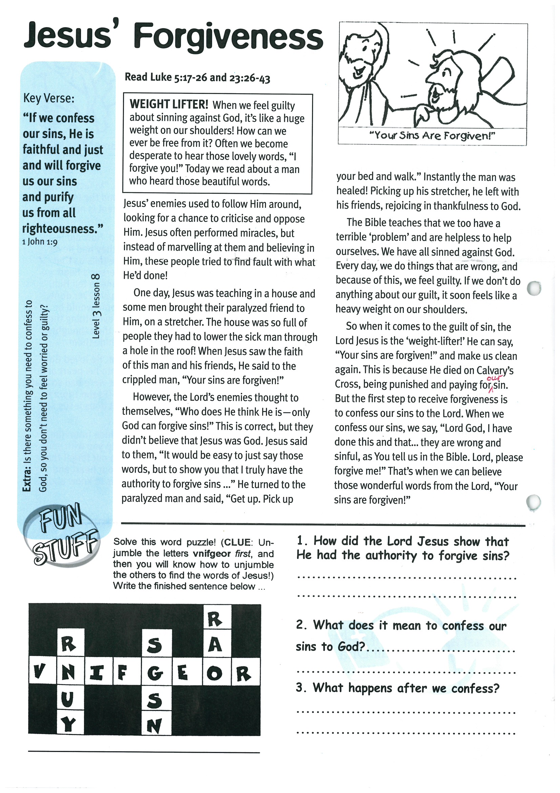

**Read Luke 5:17-26 and  
Luke 23:26-43  
  
  
WEIGHT LIFTER! When we feel guilty about sinning against God, it’s like a huge weight on our shoulders! How can we ever be free from it? Often we become desperate to hear those lovely words, “I forgive you!” Today we read about a man who heard those beautiful words.**

Jesus’ enemies used to follow Him around, looking for a chance to criticise and oppose Him. Jesus often performed miracles, but instead of marvelling at them and believing in Him, these people tried to find fault with what He’d done!

One day, Jesus was teaching in a house and some men brought their paralyzed friend to Him, on a stretcher. The house was so full of people they had to lower the sick man through a hole in the roof! When Jesus saw the faith of this man and his friends, He said to the crippled man, “Your sins are forgiven!”

However, the Lord’s enemies thought to themselves, “Who does He think He is - only God can forgive sins!” This is correct, but they didn’t believe that Jesus was God.

Key Verse:  
**“If we confess our sins, He is faithful and just and will forgive us our sins and purify us from all righteousness.”**

1 John 1:9

**Jesus’ Forgiveness**

Please complete and return by post to   
**PSSM, 1-2A (G2) 93 Dominion Rd, Mt Eden, Auckland 1024** or scan & email to **info@biblediscovery.org.nz**

**Answer:**

Jesus said to them, “It would be easy to just say those words, but to show you that I truly have the authority to forgive sins ...” He turned to the paralyzed man and said, “Get up. Pick up your bed and walk.” Instantly the man was healed! Picking up his stretcher, he left with his friends, rejoicing in thankfulness to God.

The Bible teaches that we too have a terrible ‘problem’ and are helpless to help ourselves. We have all sinned against God. Every day, we do things that are wrong, and because of this, we feel guilty. If we don’t do anything about our guilt, it soon feels like a heavy weight on our shoulders.

So when it comes to the guilt of sin, the Lord Jesus is the ‘weight-lifter!’ He can say, “Your sins are forgiven!” and make us clean again. This is because He died on Calvary’s Cross, being punished and paying for our sin. But the first step to receive forgiveness is to confess our sins to the Lord. When we confess our sins, we say, “Lord God, I have done this and that… they are wrong and sinful, as You tell us in the Bible. Lord, please forgive me!” That’s when we can believe those wonderful words from the Lord, “Your sins are forgiven!”

**Level 3 lesson 8**

**Extra:** Is there something you need to confess to God, so you don’t need to feel worried or guilty?

1. How did the Lord Jesus show that He had the  
authority to forgive sins?

_________________________________________

_________________________________________

_________________________________________

2. What does it mean to confess our sins to God?

_________________________________________

_________________________________________

_________________________________________

3. What happens after we confess them?

_________________________________________

_________________________________________

Solve this word puzzle!   
(Clue: Unscramble the letters VNIFGEOR first,  
 then unscramble the others to find the words of Jesus!)

|  |  |  |  |  |  |  |  |
| --- | --- | --- | --- | --- | --- | --- | --- |
|  |  |  |  |  |  | **R** |  |
|  | **R** |  |  | **S** |  | **A** |  |
| **V** | **N** | **I** | **F** | **G** | **E** | **O** | **R** |
|  | **U** |  |  | **S** |  |  |  |
|  | **Y** |  |  | **N** |  |  |  |

Write the finished sentence below:

______________________________________________