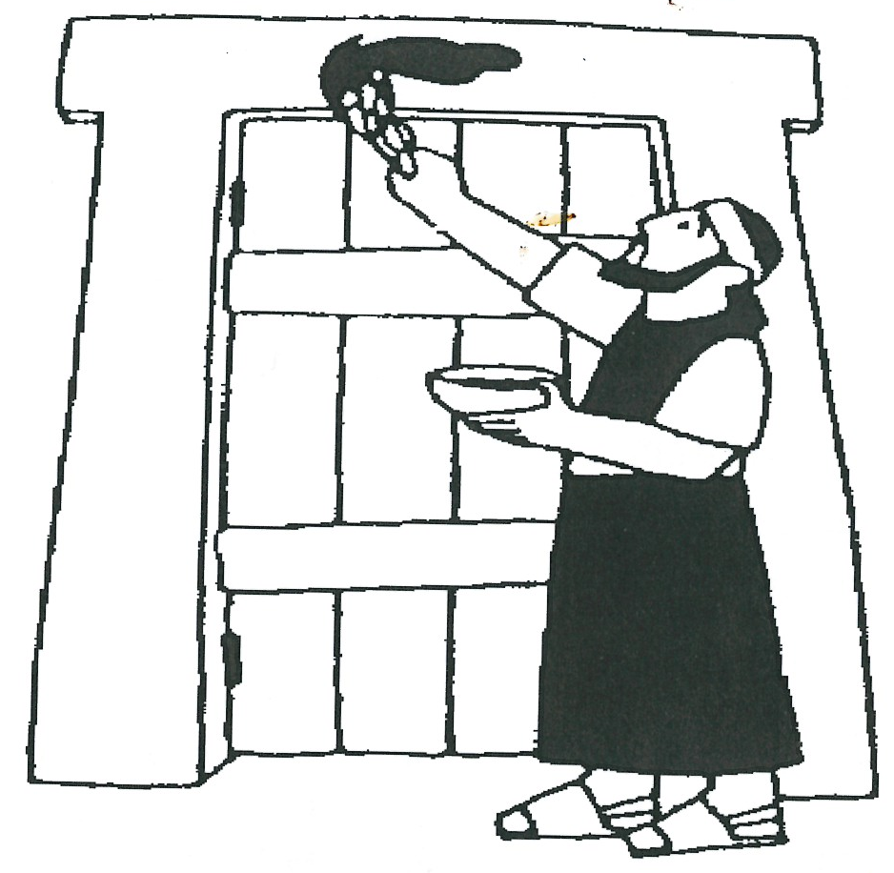
Christ, our ‘Passover’
Key Verse:
“….Christ, our Passover lamb, has been sacrificed.”
1 Corinthians 5:7
Read Exodus 12:1-13, and
1 Peter 1:18-21; Hebrews 2:1-4
No-one in Egypt on that dreadful night would ever forget what happened when God’s destroying angel passed through! With the death of the eldest child in each household (even Pharaoh’s), the Egyptians would surely remember God’s judgement for the way they had treated the Hebrews and ignored Moses’ warning from the Lord (Exodus 11:4-8).
Just as Moses had promised, there was terrible grief and sorrow throughout Egypt, such as had never been seen before. On the other hand, what joy and gratitude must have filled the hearts of the Hebrews as they saw God’s faithfulness to His promise, “When I see the blood, I will pass over you.”
So what was it that saved the Children of Israel? After all, the Egyptians heard the same message as the Hebrews! However, they chose to ignore it in unbelief, whereas the Hebrews were delivered through faith and obedience to the WORD OF GOD. In childlike trust they simply took God at His word and applied the blood as God had said.
We can learn a wonderful principle here. Faithful obedience to the direct command of the Lord brings blessing. But faithless disobedience brings judgement and ultimately, God’s wrath. God is responsible for our eternal security when we trust Him and place our faith in Christ. And as the Hebrews found out, God can be trusted!
The ‘Passover’ was a picture of what was going to take place at Calvary many years later. Jesus Christ would be our ‘Passover Lamb.’ He would die and shed His precious blood on Calvary’s Cross in order to save each one of us.
1. What was it that saved the eldest child in the Hebrew or Israelite homes?
2. Who was responsible for the safety of those who obeyed?
3. What did John the Baptist say about the Lord Jesus Christ?
4. Who did the Lord Jesus die for?
5. Complete this verse that shows us how we can be saved. | B___ ___ ___ ___ ___ ___ ___ ___ T___ ___ L___ ___ ___ J___ ___ ___ ___  C___ ____ ___ ___ ___ ___ ___ ___ ___ ___ ___ W___ ___ ___ __ ___ S___ ___ ___ ___
Extra: How is Christ OUR Passover lamb?

Level 4 lesson 9
QUESTIONS & ANSWERS
Level 3 lesson 1
Remember John the Baptist’s words when he saw Jesus? “Behold (look)! The Lamb of God who takes away the sin of the world!”
In the Bible there are 175 verses that tell of the death of Christ. This is all-important, for God has said, “Without the shedding of blood there is no forgiveness of sin” (Hebrews 9:22). In faith, the Hebrews applied the blood of the lamb to their door and trusted God to save and shelter them. In the same way, when God’s Word says, “The blood of Jesus Christ, God’s Son, purifies us from every sin,” (1 John 1:7) we believe and trust in the life-blood of Jesus Christ, shed on Calvary’s Cross, to save us. Acts 16:31 says, “Believe in the Lord Jesus Christ and you will be saved.” That’s simple isn’t it?
In these lessons we have learned that sin must be punished. However, in His wonderful love and mercy, God has provided a place of perfect safety for us too; if only we will hear His voice and obey the directions He has given us. Have you ever thanked the Lord Jesus for dying for you and trusted Him to save you and cleanse your heart from sin? You can do it right now! If you would like to know more about this, please write and let us know.

My Name is _____________________________________________ Age ___________
Key Verse:
“Jesus said, ‘I tell you the truth, unless a man is born again, he cannot see the kingdom of God.’”
John 3:3
Goodbye to Egypt and Pharaoh
Key Verse:
“By day the Lord went ahead of them…. to guide them on their way.”
Exodus 13:21
Read Exodus 12:31-39; 13:17-22
and 1 Corinthians 5:8

It is hard to imagine the scenes of sorrow and confusion in Egypt on that never-to-be-forgotten morning. In every Egyptian home there was loud weeping; each family had discovered their eldest child was dead! The God of the Hebrews had done exactly as Moses had warned He would. Now the superstitious Egyptians were really scared! “Whatever will happen to us next? Let’s get rid of these troublesome Hebrews!” they said. “Get them out of our land quick, and bribe them if we have to!”
Hurriedly, they gathered up their gold, silver, jewels, clothing, and other valuables and gave it to the Israelites just to get rid of them! Remember, the Israelites had worked as slaves for the Egyptians for hundreds of years without payment, so God told them to accept whatever the Egyptians gave them. In this way He provided for the expense of their journey and rewarded them for their years of slavery.
What a contrast though, in the Israelite homes. No weeping or sorrow there; just rejoicing and great excitement! Finally God had opened the way for them to leave Egypt and to travel to the ‘Promised Land.’ Long before dawn they were all dressed and ready for the journey. Even before their morning meal, the great procession began to move off. This was a really big procession!

Initially, you’ll remember, there was only one Hebrew in Egypt, Joseph. However, his family later joined him and after 400 years there were over one million people, along with all their flocks of sheep and herds of cattle.The women had mixed dough for making their bread, but hadn’t had time yet to add in the yeast and so they carried it on trays on their shoulders as they walked along.
Later on, they baked the bread on hot coals. As there was no yeast (or ‘leaven’ as it was called) in it, they named this bread ‘Unleavened Bread.’ From that day until now, in obedience to the command of the Lord (Exodus 12:14-20), their descendants have observed one week in the year as ‘The feast of Unleavened Bread’ or the ‘Passover,’ in memory of that night when the destroying Angel of God ‘passed over’ them.
Moses and Aaron were in charge of that great company of people, and the Lord led them, choosing their path step by step. During the daytime His presence was shown by a great ‘Pillar of Cloud’ which never left them. At night, this pillar became a ‘Pillar of Fire’ to give them light for when they travelled through the desert in the coolness of the dark.
The people could never forget that God was with them; His presence was always ‘visible.’ This was a comfort as they set out on this wonderful journey. God, who had so miraculously brought them out of Egypt, was now guiding them every day and night.

QUESTIONS:
1. How were the Israelites paid for all their years of slavery?
2. Who was the first Israelite to live in Egypt?
3. How many Israelites came out of Egypt?
4. Name the two men God chose to be leaders.
5. How was the presence of God known and seen?
Extra: How do you think the Israelites felt about leaving Egypt where they had been born?
Level 4 lesson 10
QUESTIONS & ANSWERS

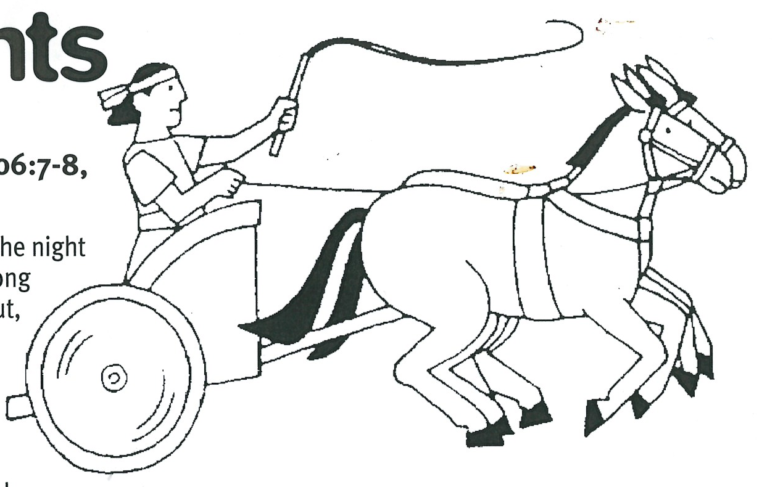
Key Verse:
“That day the Lord saved Israel from the hand of the Egyptians….”
Exodus 14:30
Read Exodus 14:1-12 and
Psalm 106:7-8; John 8:12

That procession out of Egypt during the night must have been a wonderful sight! Long before daylight it was on the move, but as we just read, they were not in darkness, because the pillar of fire lit up the whole countryside. This reminds us of Christ’s words, “Whoever follows me will never walk in darkness, but will have the light of life.” All through the night, the Israelites moved further and further away from Egypt, the land of captivity.
Day after day they marched, led by the pillar of fire at night and the pillar of cloud by day. At Etham, a place on the edge of the wilderness, the cloud stopped and they camped for a while. Then, the cloud brought the Israelites to Baal Zephon, by the Red Sea, where God told Moses to again set up camp. God warned him too, that Pharaoh was angry and regretted letting the Israelites go. The people were missing their slaves and Pharaoh and his servants were now saying: “Why did we let these people go? Who will do all our hard, dirty work now?”
Pharaoh was still hard and cruel, and he decided to chase after the Israelites and bring them back. He had defied God before, and he would try it again! What a terrible example Pharaoh is for us! Instead of humbly accepting the discipline and judgement of God for his defiance, he hardened his heart once more. The last time he did that, his eldest child, and that of every family in Egypt was killed. How could he forget this and again try to defy Almighty God? It is a lesson to each of us, of the need for true repentance before God, to really turn from our sin when God convicts us and speaks to our hearts
about it.
Anxious Moments
1. After the Israelites had left, what did Pharaoh decide to do?
2. How is Pharoah a lesson to each of us?

3. What filled the Israelites with fear?
4. What did they say to Moses?

5. When they grumbled, what had they forgotten?
Extra: How could the Israelites be afraid when they could see the pillar of cloud and fire?

Level 4 lesson 11
QUESTIONS & ANSWERS
So Pharaoh prepared his army to follow the Israelites and bring them back as slaves again. Soon everything was ready and they set off in pursuit. What a frightening sight it must have been! Six hundred chariots and horsemen, headed by Pharaoh and his best soldiers, were speeding across the country raising a huge dust-cloud behind them. Like Pharaoh, the devil tries hard to get us back into his power the moment we set out to serve Christ, but God does not forsake us! We are His and we are safe in His keeping. If we ask Him, He will help and guard us in the hour of temptation and trial.
From their camp at Baal Zephon the Israelites noticed in the distance, the ominous dust cloud in the direction of Egypt. They knew immediately what it meant: Pharaoh’s army was approaching! What were they to do? They could not run; with all their flocks and herds, women and children, they were much slower than Pharaoh’s horses and chariots. They could not stand and fight his powerful, trained soldiers either. They were trapped!
What would happen? There seemed to be no possible way of escape! Fear filled their hearts and they began angrily accusing Moses, saying, “Why did you bring us out of Egypt? Why did you bring us out here to die?” In their fear they forgot that it was God who had brought them out of Egypt, not Moses. Only God could bring them safely to their journey’s end.

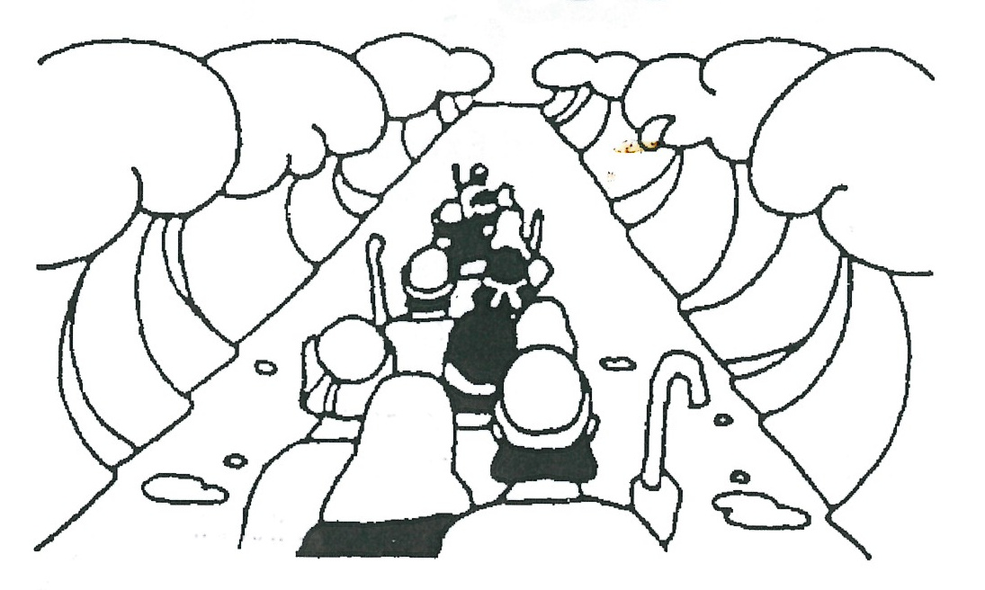
Another Great Deliverance
Key Verse:
“He remembers His covenant forever, the word He commanded, for a thousand generations.”
Psalm 105:8
Read Exodus 14:13-31
and Psalm 103
As panic and terror spread through the Israelite camp, Moses stood on a hill and spoke these wonderful words, “Don’t be afraid! Stand still and see the salvation of the Lord, which He will show you today!” Moses continued, “The Egyptians which you see today, you will never see again!”
What great words of comfort! To the Israelites this must have seemed impossible, because in front was the Red Sea, and behind them came Pharaoh and his army! What would God do? At God’s command, Moses lifted his rod and pointed it out over the sea. Right before the eyes of the amazed Israelites, the waters parted and a wide, dry path formed through them. At the same time, the pillar of cloud went behind the Israelites, covering the Egyptians in thick darkness and halting them in their tracks. What an amazing miracle!
The Israelites began marching across between the walls of water until everyone in the long procession was safely over. Then, the pillar of cloud moved back in front of them. Pharaoh and his army were amazed and annoyed to find the Israelites gone, but they could see them in the distance. Some of Pharaoh’s men cried out, “Let’s give up and go home! The Lord fights for the Israelites!”
Pharaoh stubbornly refused to listen. “Follow me!” he yelled, and galloped off in his chariot into the dry pathway between the walls of water still towering above their heads. All his horsemen and chariots followed, but before they could reach the other side, God confused them and made their chariot wheels fall off in the chaos.
1. What comforting message did Moses speak?
2. What great miracle did God perform for the Children of Israel?
3. What did Pharoah try to do when the Children of Israel passed through the Red Sea?

4. What happened to Pharaoh and his army? Codes: 1=d, 2=h, 3=y, 4=e, 5=w, 6=r, 7=t, 8=s, 9=o | __ __ __ __ __ __ __ __ __ __ __ __ __ __ __ __ __  7 2 4 3 5 4 6 4 1 4 8 7 6 9 3 4 1
5. Why do you think God brought judgement on Pharaoh and his army?
Extra: What are some ways of escape from sin and temptation?
Level 4 lesson 12
QUESTIONS & ANSWERS
Then God told Moses to point his rod out over the sea again. With an enormous roar the walls of water crashed down over Pharaoh and his army, and they were destroyed.
What a terrible final judgement for hard-hearted, unbelieving Pharaoh and those who followed him. But what a great deliverance and lesson for the Hebrews, and even for us today! If we have trusted in Jesus to save us from our sin, we are His people, too. The Apostle Paul tells us, “You belong to Christ,” and Jesus Himself told us that “no-one can pluck us out of His Father’s hand.”
God, who delivered His people so long ago, still lives today and His power has not changed. When sin and our enemy Satan tempt us with things like fear, doubt, temper, selfishness, hate, and jealousy, we can look up and trust God for His help.
Paul wrote in 1 Corinthians 10:13, “God is faithful; He will not let you be tempted beyond what you can bear. When you are tempted, He will also provide a way of escape so that you can stand up under it.” What a great promise!
We are safe because the One who died to save us from sin LIVES to keep us. We must obediently use the way of escape He provides. Sometimes we see God’s way of escape from temptation and choose not to use it. How foolish it would have been for the Israelites to try and deliver themselves. God’s way is the only sure way. Trust in Him and obey His Word!
Please complete and return by post to
PSSM, 1-2A (G2) 93 Dominion Rd, Mt Eden, Auckland 1024 or scan & email to info@biblediscovery.org.nz

