**Jesus Cleanses the Temple**

**Read Luke 19:45-46**Every year, the Jewish people had a special meal called the Passover Feast. It was to remind them of the day when God freed them from being slaves in Egypt. During this meal, the people would offer special sacrifices to God for their sin. Poor people offered two doves, while others offered a lamb, or a cow. If people did not own these animals, they could buy them in the markets and then take them to the temple to be sacrificed to God.

However, one day, Jesus rode into Jerusalem during Passover. As He entered the temple, He found some people selling animals for sacrifice. This was right inside the temple courtyard, which was forbidden! The noise of all the animals and the shouting men was terrible! Even worse, Jesus knew these people were also cheating their customers to get more money. This was not right! The people had lost respect for God. His holy temple was meant to be a place of prayer and worship, but not a marketplace!

Jesus was rightly angry. “It is written,” He said to them, “My house will be a house of prayer, but you have made it a den of robbers!” So Jesus tipped over their tables of money. Then He chased them and all their animals outside the temple!

The Bible says when we ask the Lord Jesus to come into our heart, and forgive our sins, our hearts become a temple for God, too. When the Lord Jesus is in your heart, you will want it to be a lovely place for Him to live in. As you read your Bible and pray to Him every day, He will take away all the sinful things that spoil it and make Him unhappy.

He can drive out bad things like anger, lies, temper, jealousy, and pride. He can help you have good thoughts, love, joy, and kindness in your heart, and to be quick to obey in daily life. These things will help to make you and others happy. What kind of a temple would you like your heart to be?

Key Verse:  
**“Cleanse me… and I shall be clean; wash me and I shall be whiter than snow.”**

Psalm 51:7

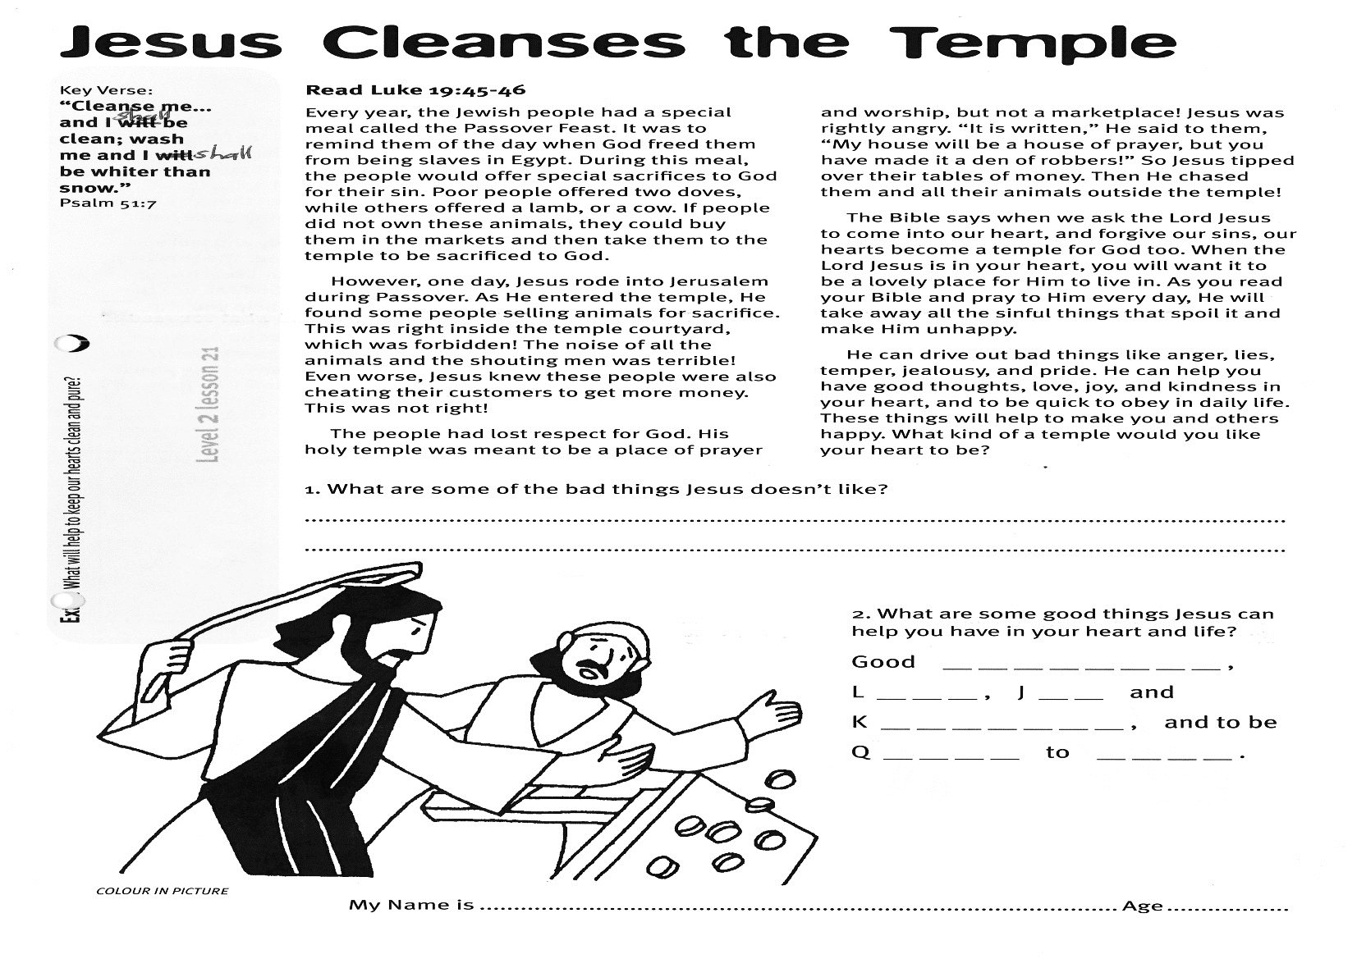

1. What are some of the bad things Jesus doesn’t like?

……………………………………………………………………………………………………………………………………………………………………………………………………………………………………………………………………………………………..

2. What are some good things Jesus can help you have in your heart and life?

Good __ __ __ __ __ __ __ __, L__ __ __,

J__ __ and K__ __ __ __ __ __ __, and

to be Q__ __ __ __ to __ __ __ __.

**Extra:** What will help to keep our hearts clean and pure?

**Level 2 lesson 21**

My Name is________________________________________ Age ______________

**The Widow’s Gift**

Key Verse:  
**“Each [person] should give… for God loves a cheerful giver.”**

2 Corinthians 9:7

**Read Luke 21:1-4**

One day Jesus was talking to His disciples at the temple. They watched as the people brought their gifts to God. Some rich men came and threw a lot of money into the gift boxes. As they watched, a poor widow came in alone. She no longer had a husband to provide for her and her children. She had to work hard to provide food and clothing for her family. She was thin and tired, and her clothes were old and ragged.

The only money she had left was two small coins. It didn’t seem very much to give God after those rich men had put in so much! She would have loved to give more, because she loved God. She wanted to show Him her love by giving something. So although she was poor, and needed all the money she had, she put both the small coins quietly in the offering box!

When Jesus saw what the woman did, He said to his disciples, “Did you see what that poor widow did? She gave all that she had to the Lord. I tell you, this lady has given more than all those rich men! Even though they gave a lot of money, they still had a lot left for themselves. This lady, even though she needed it herself, gave everything she had!”

Maybe you are like this lady and feel you don’t have much to give to God. The very best gift we can give to Jesus is our lives: loving and obeying Him every day. God can use the smallest little thing that you give. So help spread the Good News about Jesus to others. Always remember; Jesus looks on our heart when we give to Him. Do we give happily? Or do we keep as much as we can for ourselves? Let’s all be more like this widow who gave all she had. God still notices!

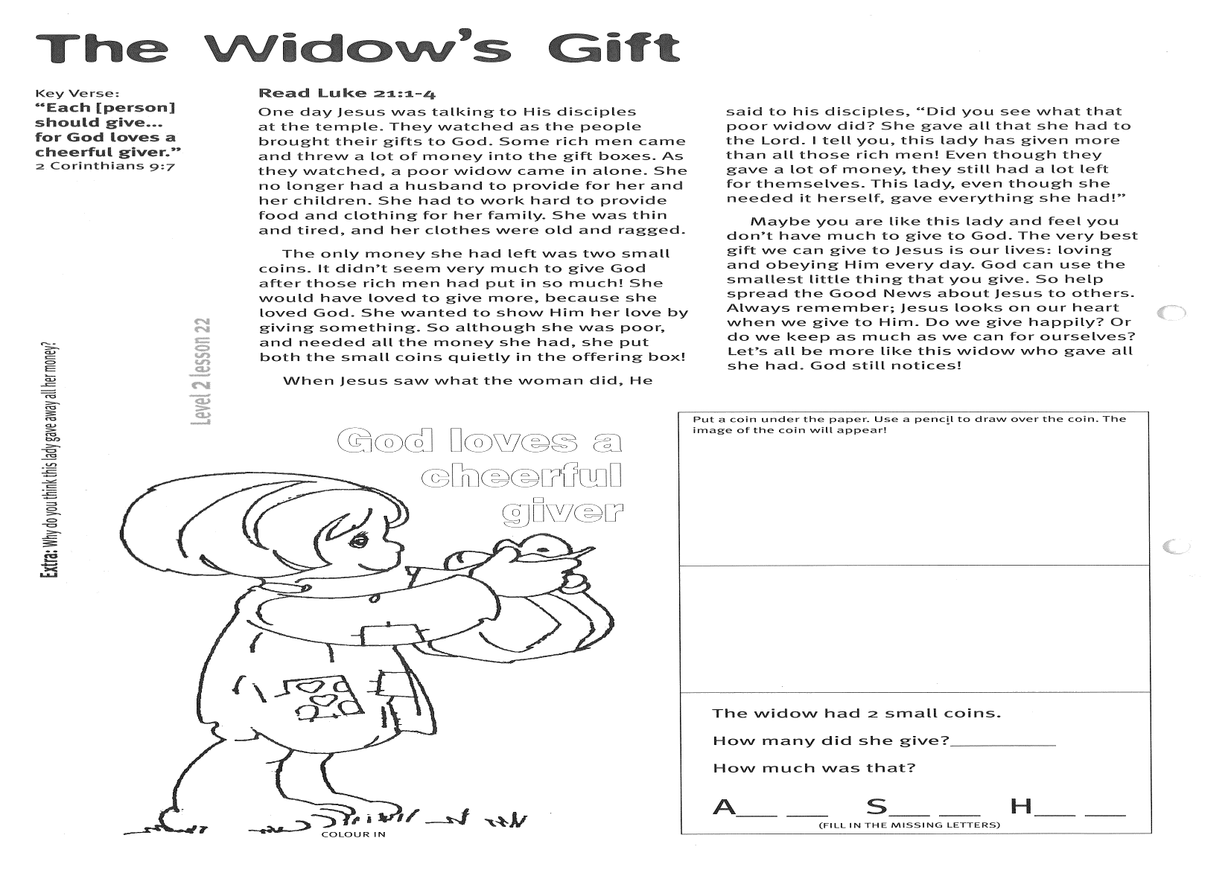

**Extra:** Why do you think this lady gave away all her money?

**Level 2 lesson 22**

Put a coin under the paper. Use a pencil to draw over the coin. The image will appear on this page!

The widow had 2 small coins.

How many did she give? __ __ __

How much was that?

A__ __ S__ __ H__ __  
(Fill in the missing letters)

Key Verse:  
**“Turn from evil and do good…”**

Psalm 34:14a

**Shining for the Lord Jesus**

There is a song that says:

*“Jesus bids us shine with a clear pure light;  
Like a little candle burning in the night;  
In this world of darkness, so we must shine;  
You in your small corner, and I in mine.*

*Jesus bids us shine first of all for Him;  
Well He sees and knows it, if our light grows dim;  
He looks down from Heaven, to see us shine;  
You in your small corner, and I in mine.*

*Jesus bids us shine then for all around;  
Many kinds of darkness in this world are found;  
Sin and want and sorrow, so we must shine;  
You in your small corner, and I in mine.”*

When we shine for the Lord Jesus it is to make Him glad. When we shine for all around, it makes others glad, too. If you want to have real **JOY** in your heart, then put “**J**esus first, **O**thers second, and **Y**ourself last.” Try it!

**Read Matthew 5:14-16**  
The Lord Jesus often talked to His disciples. He told them how to ‘shine’ for Him. He said that we don’t light a candle and then hide it. That would be silly! No; we put it up high, where it can give light all around. That’s why electric lights are on the ceiling or wall in your house, too.

How do you think we can shine for Jesus? Well, a good place to start is to read our Bible to see what it has to say to us. If we love Jesus, we’ll obey what He tells us there. We will choose not to do wrong things; and we will want to do good, kind things. It means we will obey at home and at school, too!

If we love Jesus, we will want to be truthful, kind, and thoughtful, and tell others about Him. We will want others to know about Jesus too! We can pray and ask Him to help us ‘shine’ for Him - by living to please Him.

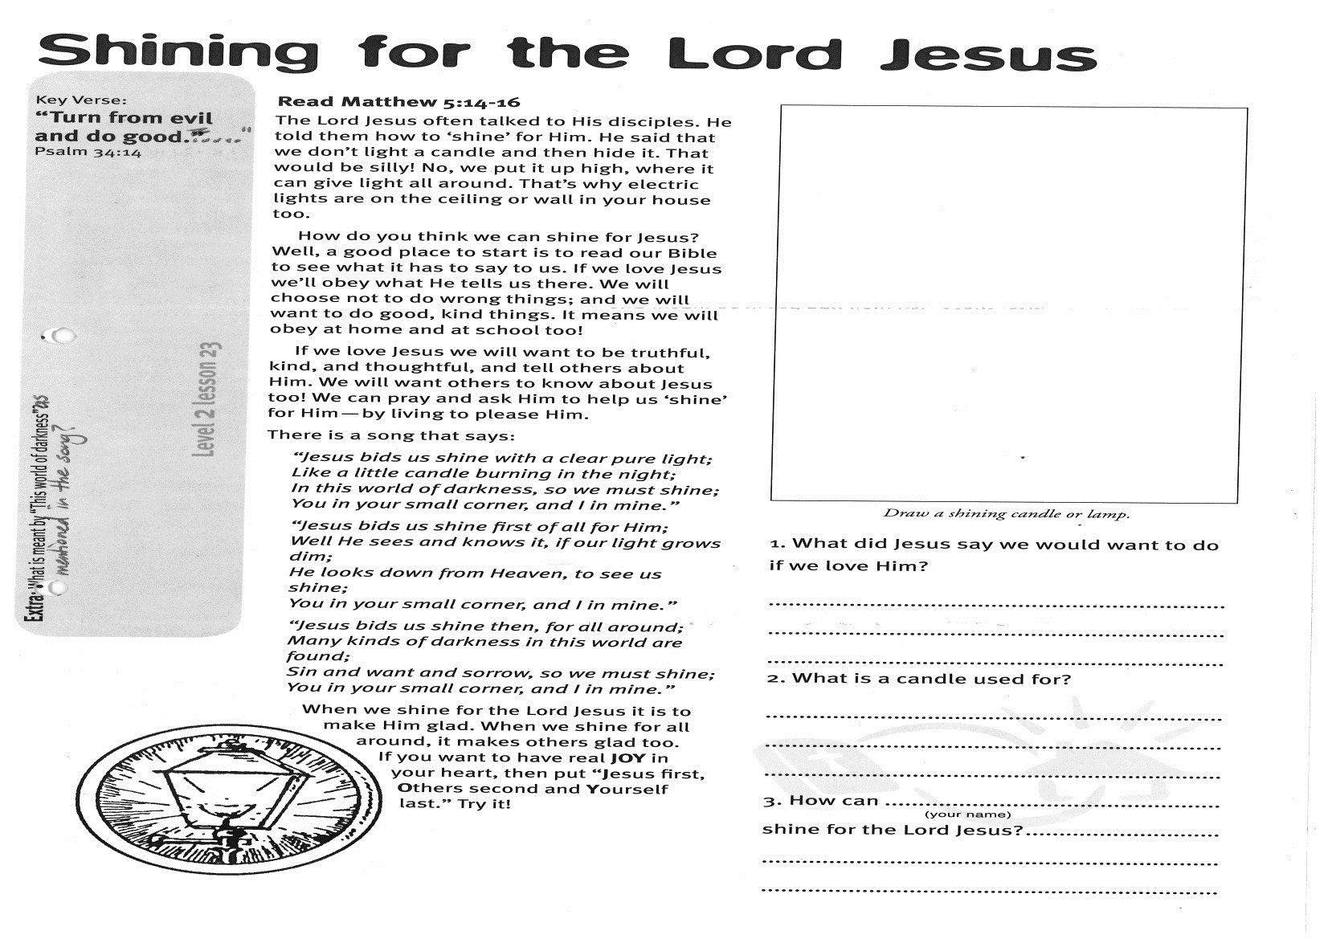

Draw a shining candle or lamp:

1. What did Jesus say we would want to do if we love Him?  
………………………………………………………………………………………………………………………………………………………………………………………

2. What is a candle used for?

………………………………………………………………………………………………………………………………………………………………………………………

3. How can _____________________  
 (print your name)  
shine for the Lord Jesus?

.............................................................................................................................................................................................

**Extra:** What is meant by “this world of darkness” as mentioned in the song?

**Level 2 lesson 23**

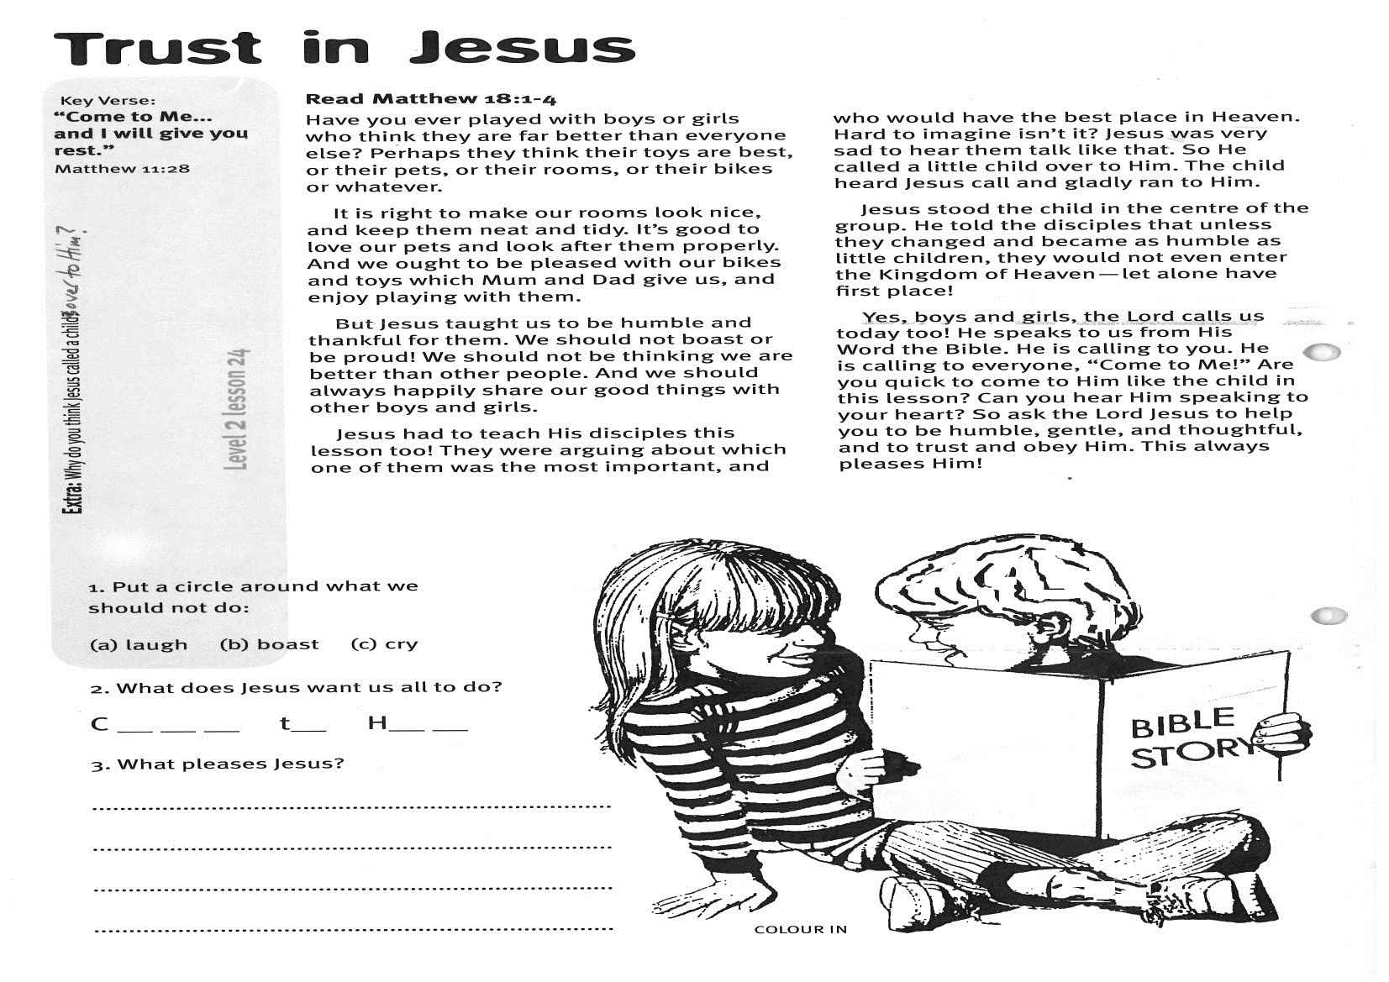

**Trust in Jesus**

1. Put a circle around what we should **not** do:

(a) laugh (b) boast (c) cry

2. What does Jesus want us all to do?

C__ __ __ __ t__ H__ __

3. What pleases Jesus?

………………………………………………………………………………………………………………………………………………………………………

**Level 2 lesson 24**

**Extra:** Why do you think Jesus called a child over to Him?

**Read Matthew 18:1-4**

Have you ever played with boys or girls who think they are far better than everyone else? Perhaps they think their toys are best, or their pets, or their rooms, or their bikes or whatever.

It is right to make our rooms look nice, and keep them neat and tidy. It’s good to love our pets and look after them properly. And we ought to be pleased with our bikes and toys which Mum and Dad give us, and enjoy playing with them.

But Jesus taught us to be humble and thankful for them. We should not boast or be proud! We should not be thinking we are better than other people. And we should always happily share our good things with other boys and girls.

Jesus had to teach His disciples this lesson, too! They were arguing about which one of them was the most important, and who would have the best place in Heaven. Hard to imagine, isn’t it?

Jesus was very sad to hear them talk like that. So He called a little child over to Him. The child heard Jesus call and gladly ran to Him.

Jesus stood the child in the centre of the group. He told the disciples that unless they changed and became as humble as little children, they would not even enter the Kingdom of Heaven; let alone have first place!

Yes, boys and girls, the Lord calls us today, too! He speaks to us from His Word, the Bible. He is calling to you. He is calling to everyone, “Come to Me!” Are you quick to come to Him like the child in this lesson? Can you hear Him speaking to your heart? So ask the Lord Jesus to help you to be humble, gentle, and thoughtful, and to trust and obey Him. This always pleases Him!

Key Verse: **“Come to Me… and I will give you rest.”**

Matthew 11:28

Please complete and return by post to   
**PSSM, 1-2A (G2) 93 Dominion Rd, Mt Eden, Auckland 1024** or scan & email to **info@biblediscovery.org.nz**