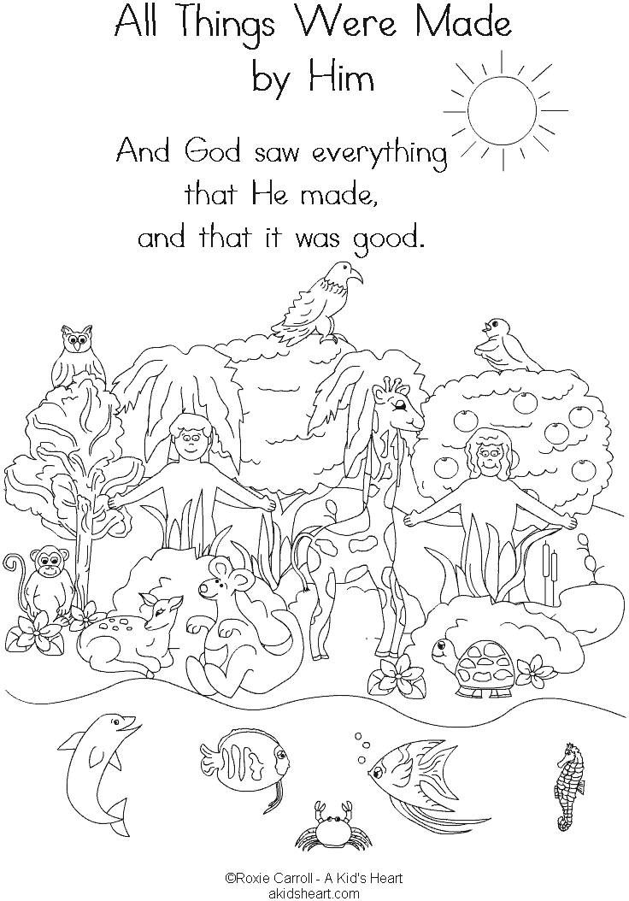

**How Everything Began**

Key Verse:  
**“God saw all that He had made, and it was very good.”**

Genesis 1:31

**Extra:** Think about your life and make a list of some of the things you can do.

**Level 2 lesson 1**

**Read Genesis 1:1-27**

Welcome to the start of a brand new year, and some more PSSM Bible lessons! Did you have a nice holiday over Christmas? I hope you did and that you are all fresh and ready to learn some more wonderful things from the Bible. We’re going to go right back to the beginning of the Bible this month, and learn how God made the world and everything in it.

Have you ever seen men building a house? It takes them quite a long time and they must follow the plans very carefully. Imagine if one day someone told you that a house just grew out of the ground by itself, would you believe them? Of course not! A house doesn’t just come from nowhere, and yet that’s what some people think about our universe! Imagine you wanted to build something. You would need something to build with, wouldn’t you? But the Bible tells us that God made something out of nothing. Only He could do that because He is so much greater than anyone, or anything else. **He is all-powerful and all-knowing, and that means there is nothing He can’t do.**

Many years ago there was NOTHING except GOD. He was living forever before anything else was made. The world did not exist, and there were no people, no flowers, no singing birds, and no animals. The universe (space) didn’t exist either, so there was no sun, no moon, and no stars, planets or galaxies!

In fact, nothing existed except Almighty God! The Bible does not tell us exactly how God made the world. It tells us He simply spoke, and it was done! Only God could do that. First He made the outer-space and the earth, and then he made light and the sky. Next God made the sea, rivers, grass, and trees, followed by the sun, moon, and stars. God also created all kinds of fish, beautiful birds, and so many animals — including the dinosaurs!

Can you guess what God made last? Yes, it was people! **Everything God made was perfect and He saw that it was all VERY GOOD** (see verse 31)! Finally, God made two humans, a man and a woman, and He made them in His image. Adam and Eve were their names, and they were very happy obeying God (that’s the best way for us to live too!). God wanted them to be happy, to enjoy being friends with Him, and to live in the beautiful world He had made. What a good and amazing God we have!!!



**1. Who made the world?** ___________________

**2. What did God make last?** (Put a circle around your answer)  
water sunshine life people air light

**3. God made everything** **P** **__ __ __ __ __ __**   
(Fill in the missing letters)

**4. Why were those first people happy?**

__________________________________________________________________________________

My Name is ……………………………………………………………………… Age……………

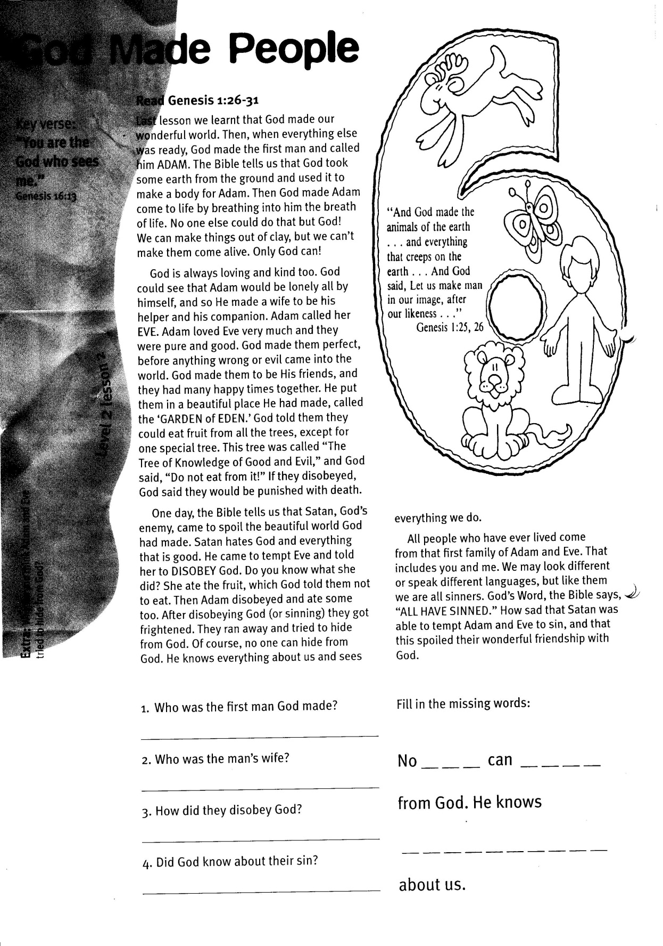

**Read Genesis 1:26-31**

Last lesson we learnt that God made our wonderful world. Then, when everything else was ready, God made the first man and called him ADAM. The Bible tells us that God took some earth from the ground and used it to make a body for Adam. Then God made Adam come to life by breathing into him the breath of life. No one else could do that but God! We can make things out of clay, but we can’t make them come alive. Only God can!

God is always loving and kind too. God could see that Adam would be lonely all by himself, and so He made a wife to be his helper and his companion. Adam called her EVE. Adam loved Eve very much and they were pure and good. God made them perfect, before anything wrong or evil came into the world. God made them to be His friends, and they had many happy times together. He put them in a beautiful place He had made, called the ‘GARDEN of EDEN.’ God told them they could eat fruit from all the trees, except for one special tree. This tree was called “The Tree of Knowledge of Good and Evil,” and God said, “Do not eat from it!” If they disobeyed, God said they would be punished with death.

One day, the Bible tells us that Satan, God’s enemy, came to spoil the beautiful world God had made. Satan hates God and everything that is good. He came to tempt Eve and told her to DISOBEY God.

Key Verse:  
**“You are God who sees me.”**  
Genesis 16:13

**God Made People**

Fill in the missing words:

**No __ __ __ can __ __ __ __**

**from God. He knows  
__ __ __ __ __ __ __ __ __ __**

**about us.**

**1. Who was the first man God made?**

_____________________________________

**2. Who was the man’s wife?**

_____________________________________

**3. How did they disobey God?**

_____________________________________

**4. Did God know about their sin?**

_____________________________________

**Extra:** Why do you think Adam and Eve tried to hide from God?

**Level 2 lesson 2**

Do you know what she did? She ate the fruit, which God told them not to eat. Then Adam disobeyed and ate some too. After disobeying God (or sinning) they got frightened. They ran away and tried to hide from God. Of course, no one can hide from God. He knows everything about us and sees everything we do.

All people who have ever lived come from that first family of Adam and Eve. That includes you and me. We may look different or speak different languages, but like them we are all sinners. God’s Word, the Bible says, “ALL HAVE SINNED.” How sad that Satan was able to tempt Adam and Eve to sin, and that this spoiled their wonderful friendship with God.

Key Verse:  
**“All have sinned and fall short of the glory of God.”**  
Romans 3:23

In the beginning they had been happy all the time, but now God said they would have a lot of trouble and sadness. God sent them out of the garden and put an Angel and a fiery sword at the gate to stop Adam and Eve from ever going back in.

Satan still wants people to disobey and ignore God. Satan is pleased when you are naughty, did you know that? He doesn’t want people to be friends with God again (but God still does)! The Bible says, “The wages of sin is death, but the gift of God is eternal life.” The GOOD NEWS is that it is possible for you to enjoy the gift of life and become a friend of God.

Believe this: God sent His son Jesus Christ to earth to pay the punishment for OUR sin, by dying on the cross. Three days later Jesus rose from the grave to beat death! Satan is now defeated. What a wonderful God! He loves you so much, but hates your sin. So to be saved from the punishment of eternal death, you must ask God to forgive all your sins, ask Jesus to save you and be the master of your life, and then you must turn away from sin and wrongdoing. God has the power to save you and help you do the things that please Him!

**Read Genesis 3:1-8**

The Bible says, “All have sinned” (Romans 3:23). Sadly, we have to admit the Bible is right, don’t we? All of us know that we’ve done things that are wrong. So why do we do bad things? If God is good and made Adam and Eve perfect, then where does all this sin come from? It is a very sad story. As we learnt last lesson, the trouble all began when Satan lied to Eve, and Adam and Eve foolishly decided to believe him instead of God! They disobeyed God and ate the fruit God had told them not to. What a terrible thing to do.

Since that time, everyone who has ever lived was born sinful and has done sins in their life. This sinful nature makes us like doing bad things instead of good things. But none of us likes what happens when we get caught doing bad things! That’s right, we don’t like getting into trouble and receiving the proper punishments!

This is what happened to Adam and Eve too. God was sad but angry they had sinned, because although He loved them, He had to punish them too. You see, God is pure and holy and He cannot stand evil of any kind.

**The Trouble with Sin**

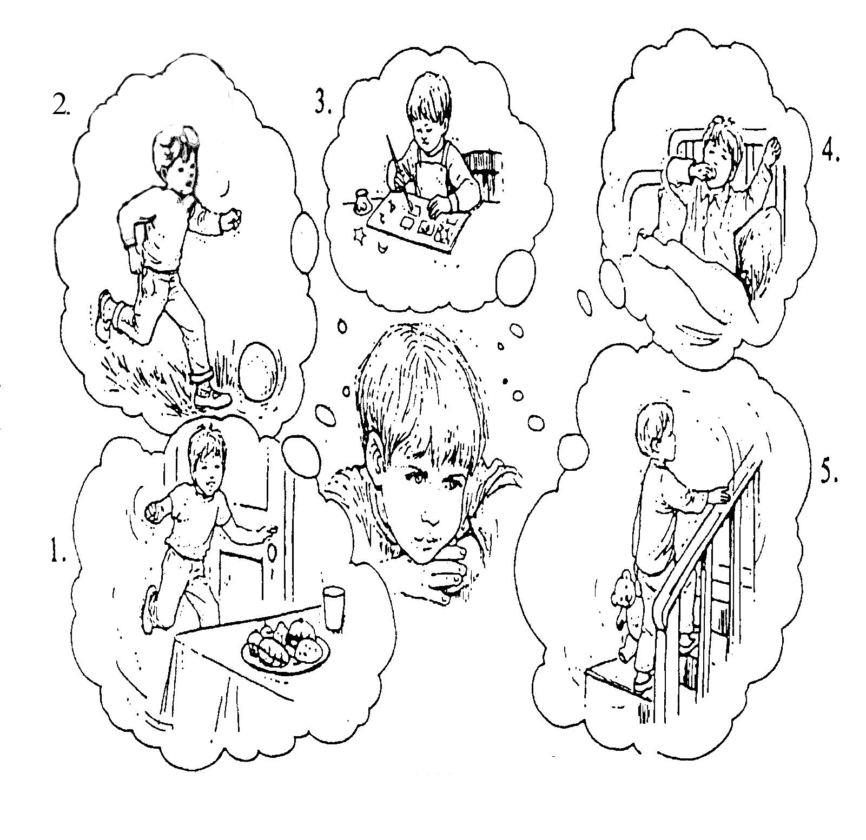

**Extra:** Why do people do bad or wrong things?

God Thinks About Me When…

**Level 2 lesson 3**

**Each of these pictures show some of the many ways that God knows all about us. Write down what is happening in these five pictures:**

**1**._________________________________________________________________  
_________________________________

**2**._________________________________________________________________  
_________________________________

**3**._________________________________________________________________  
_________________________________

**4**._________________________________________________________________  
_________________________________

**5**._________________________________________________________________  
_________________________________

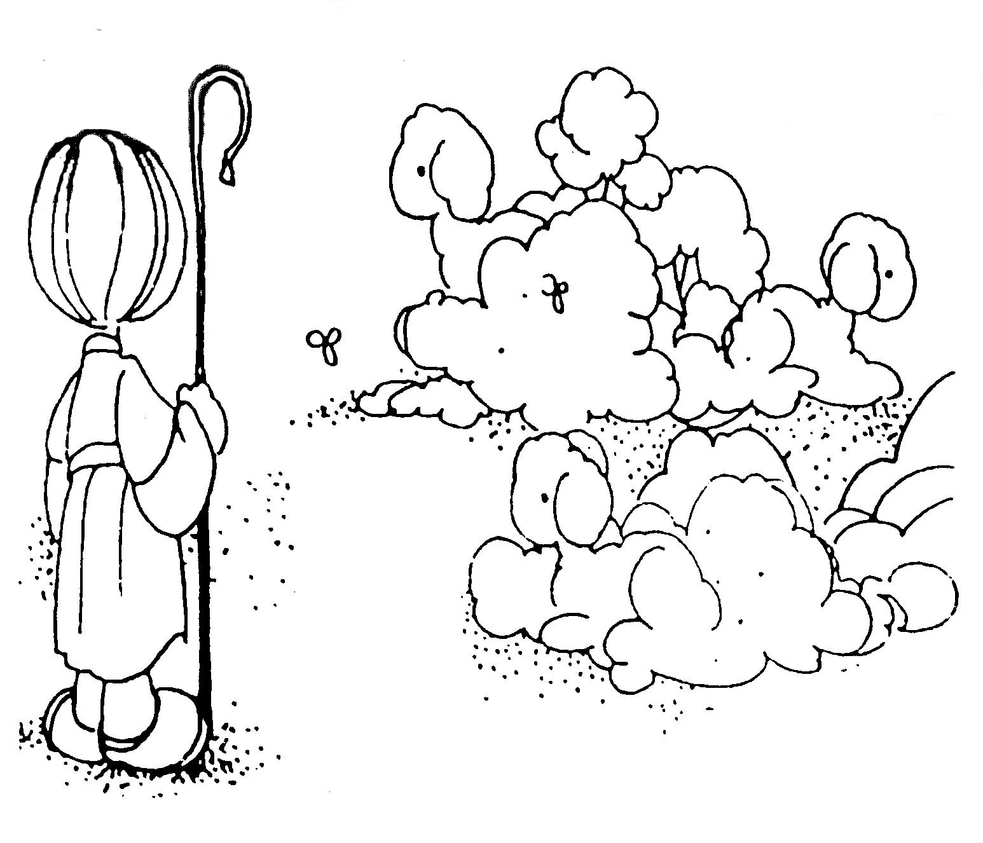

So God asked Cain why he was behaving badly. God then kindly told Cain to try again to do the right thing, and asked him to stop sinning. But instead of bringing an animal offering that God would be pleased with, he led Abel out into the field and murdered his own brother.

What a wicked thing it is to kill another human! Adam and Eve didn’t yet know what had happened, but God did! He wanted Cain to confess what he had done, but Cain told a lie instead. God was angry with Cain for doing all these wicked things and so He punished him.

God knows what is best for us, and He wants us to obey Him and always do right. It is good to know that in the Old Testament of the Bible, God’s people brought a lamb to Him as an offering for their sins. The little lambs would pay the punishment of death, instead of the people who sinned!

This just like what the Lord Jesus Christ did in the New Testament. How wonderful to read that Jesus is the “LAMB of GOD” who takes away the sin of the world” (John 1:29). No more lambs need to die to pay for our sins, because when Jesus died on the Cross He paid the price of death for the sins of the whole world! Believe in Jesus today and ask Him to save you from all your sins. Then follow the Lord and obey all the things He tells us to do in the Bible, because this is the most pleasing gift we can give back to God!

**Read Genesis 4:3-13**

Adam and Eve were very unhappy after God made them leave the beautiful garden. They were so sorry they had done wrong. Although God punished them for doing wrong, He still loved them and did not forget them. After a while, Adam and Eve had a little baby boy and they named him CAIN. Later on, they had another baby boy who they called ABEL.

As the boys grew older they helped with the work each day. Cain liked to grow things and he became a farmer. Abel liked animals, and he became a shepherd. Adam and Eve would have taught them about God, and told them about the garden they used to live in; the terrible time that they disobeyed God, and how God had sacrificed the life of an animal to make them warm animal-skin clothes, and how they had to leave the garden.

One day the two boys each brought a gift to God, which was called an offering. Offerings were usually placed on stone altars, and sacrificed with fire to God. Cain and Abel may have brought these offerings to God to pay for wrong things they had done and to show that they were sorry. Or, they may have offered their gifts to God as a kind of worship. Well here’s what happened: Abel offered up the best meat parts from the first lamb of his flock, and Cain brought an offering of fruit from his garden.

Now, God was pleased with Abel’s gift, but He did not accept Cain’s gift. This made Cain really angry and very unhappy.

Key Verse:  
**“Jesus… the lamb of God who takes away the sin of the world.”**  
John 1:29

**The First Murder**

**Please complete and return by post to:** PSSM, 1-2A (G2) 93 Dominion Rd,  
 Mt Eden, Auckland 1024 or scan & email to info@biblediscovery.org.nz

**Level 2 lesson 4**

**Extra:** Why did Cain kill his brother?

**1. Name the two brothers by filling in the spaces:**   
 C _ _ _ & A _ _ _

**2. What offerings did they bring to God?** ________________________________  
________________________________  
________________________________

**3. Why was Cain angry?** ________________________________  
________________________________

**4. What is the special name for the Lord Jesus (Clue: see John 1:29)**  
 The __ __ __ __  
 __ __ __ __ __

**Can you find the sheep as you colour in this picture?**