**Read Proverbs 10:6-32  
and James 1:26; 3:2-10**

**Watch Your Tongue!** Most of the time, words pop out of our mouths so quickly it’s hard to keep track of what we say! But the Bible says that one day we will have to give an account of every word we’ve said (Matthew 12:36). This month, we’re going to look at what Proverbs says about wisdom, and now, how we can actually be wise with our words.

So what does it mean to ‘be wise’? First, remember that God’s idea of ‘wisdom’ is different from what most people in the world think ‘wisdom’ is. Second, only the Bible tells us what true wisdom is like: it is about following God’s wise ways! Would you like to be wise? Then read on...

After you read Proverbs 10:6-32, you will see many facts about the things people say. You can put all these things into two groups: how wise people talk, and how foolish people talk. Verse 6 says that blessings come from a wise person, but violent threats come from a foolish person! Look through the passage and see how many more things you can put under the headings ‘wise’ and ‘foolish’.

Proverbs says that what comes out of our mouths shows what’s in our hearts. If we are always putting others down, calling people names, saying nasty things about them

Key Verse:  
**“He who guards his mouth and his tongue keeps himself from calamity.”**Proverbs 21:23

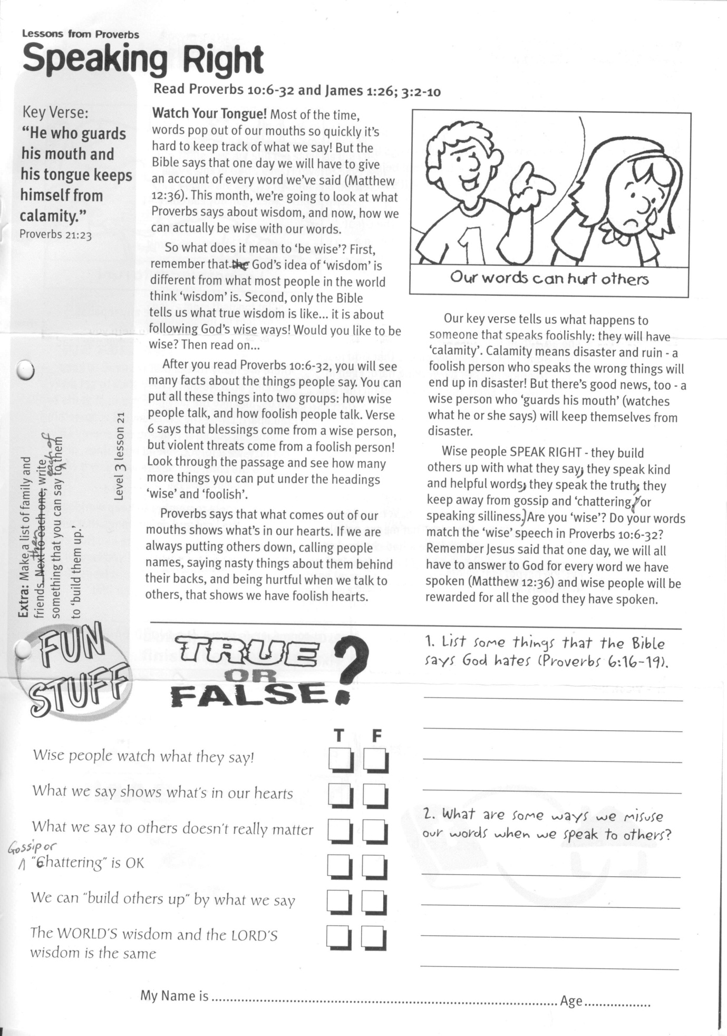

LESSONS FROM PROVERBS

**Speaking Right**

1. List some things that the Bible says God hates (Proverbs 6:16-19).  
______________________________________  
______________________________________  
______________________________________  
______________________________________  
2. What are some ways we misuse our words when we speak to others?  
_____________________________________  
_____________________________________  
_____________________________________  
_____________________________________

**Extra:** Make a list of family and friends, then write something that you can say to each of them to ‘build them up.’

**Level 3 lesson 21**

**?**

TRUE OR FALSE

**T F**

Wise people watch what they say! ⃝ ⃝

What we say shows what’s in our hearts ⃝ ⃝

What we say to others doesn’t really matter ⃝ ⃝

Gossip or ‘chattering’ is OK ⃝ ⃝

We can “build others up” by what we say ⃝ ⃝

The WORLD’S wisdom and the LORD’S ⃝ ⃝  
 wisdom is the same

behind their backs, and being hurtful when we talk to others, that shows we have foolish hearts.

Our key verse tells us what happens to someone that speaks foolishly: they will have ‘calamity’. Calamity means disaster and ruin - a foolish person who speaks the wrong things will end up in disaster! But there’s good news, too - a wise person who ‘guards his mouth’ (watches what he or she says) will keep themselves from disaster.

Wise people SPEAK RIGHT - they build others up with what they say, they speak kind and helpful words, they speak the truth, they keep away from gossip and ‘chattering’ (or speaking silliness). Are you ‘wise’? Do your words match the ‘wise’ speech in Proverbs 10:6-32? Remember Jesus said that one day, we will all have to answer to God for every word we have spoken, and wise people will be rewarded for all the good they have spoken (Matthew 12:36,37).

My Name is ……………………………………………………………… Age ………………….

My Name is ……………………………………………………… Age…………………

Key Verse:  
**“A little sleep, a little slumber, a little folding of the hands to rest, and poverty will come on you like a bandit....”**

Proverbs 24:33-34

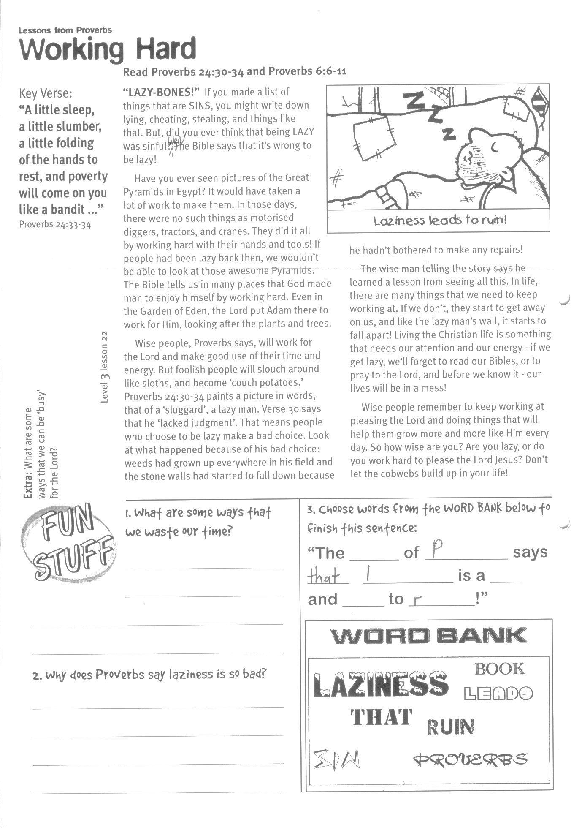

**Read Proverbs 24:30-34  
and Proverbs 6:6-11**

**“LAZY-BONES!”** If you made a list of things that are SINS, you might write down lying, cheating, stealing, and things like that. But, did you ever think that being LAZY was sinful? Well, the Bible says that it’s wrong to be lazy!

Have you ever seen pictures of the Great Pyramids in Egypt? It would have taken a lot of work to make them. In those days, there were no such things as motorised diggers, tractors, and cranes. They did it all by working hard with their hands and tools! If people had been lazy back then, we wouldn’t be able to look at those awesome Pyramids. The Bible tells us in many places that God made man to enjoy himself by working hard. Even in the Garden of Eden, the Lord put Adam there to work for Him, looking after the plants and trees.

Wise people, Proverbs says, will work for the Lord and make good use of their time and energy. But foolish people will slouch around like sloths, and become ‘couch potatoes.’ Proverbs 24:30-34 paints a picture in words, that of a ‘sluggard’, a lazy man. Verse 30 says that he ‘lacked judgment’. That means people who choose to be lazy make a bad choice.

LESSONS FROM PROVERBS

**Working Hard**

3. Choose words from the WORD BANK below to finish this sentence:

Look at what happened because of his bad choice: weeds had grown up everywhere in his field and the stone walls had started to fall down because he hadn’t bothered to make any repairs!

The wise man telling the story says he learned a lesson from seeing all this. In life, there are many things that we need to keep working at. If we don’t, they start to get away on us, and like the lazy man’s wall, it starts to fall apart! Living the Christian life is something that needs our attention and our energy - if we get lazy, we’ll forget to read our Bibles, or to pray to the Lord, and before we know it - our lives will be in a mess!

Wise people remember to keep working at pleasing the Lord and doing things that will help them grow more and more like Him every day. So how wise are you? Are you lazy, or do you work hard to please the Lord Jesus? Don’t let the cobwebs build up in your life!

**Level 3 lesson 22**

**Extra:** What are some ways we can use our bodies for God?

**WORD BANK:**

LAZINESS BOOK **that** LEADS RUIN PROVERBS SIN

“The __ __ __ __ of P__ __ __ __ __ __ __ says   
that l __ __ __ __ __ __ __ is a __ __ __ and  
 __ __ __ __ __ to r__ __ __!”

1. What are some ways that we waste our time?  
__________________________________________  
__________________________________________  
__________________________________________  
__________________________________________  
2. Why does Proverbs say laziness is so bad?  
______________________________________  
______________________________________  
__________________________________________

__________________________________________

**Read Proverbs 3:13-15; 6:17;   
and Proverbs 11:1; 12:22; 21:3**

**Tell It Like It Is:** ‘White lies’ are what people call the little lies they think are okay to tell. But is there such a thing as a ‘small’ lie? NO – ‘little white lies’ are still the same as big lies! Both are sins in God’s eyes.

Proverbs says that WISE people are always truthful and honest. Sometimes you might say, “That’s what happened... HONEST!” but how many times do you not tell the WHOLE truth? How many times do you add little bits here and there to make your stories seem a bit more interesting?

The Bible says that we must be honest. That is more than not telling lies. It means being truthful about all that we say and do. Proverbs 6:16-19 tells us about some of the things that God hates. Because God is holy, he hates all sin.

But what is ‘sin’? Sin includes ‘a proud look’ (someone who is too proud of themselves), ‘hands that shed innocent blood’ (murder), ‘a heart that devises wicked schemes’ (thinks up bad things to do), ‘feet that are quick to rush into evil’ (keen to do wrong things), ‘a false witness’ (gives false information to get others in trouble), ‘one who stirs up dissention’ (a trouble-maker)! Most of us know straight away that these are sins. But there’s one I left out; one thing that the Lord hates, that sometimes we don’t think is too bad; Yes, it’s ‘a lying tongue’ (v17).

Key Verse:  
**“The Lord detests lying lips, but He delights in men who are truthful.”**Proverbs 12:22

**Being Honest**

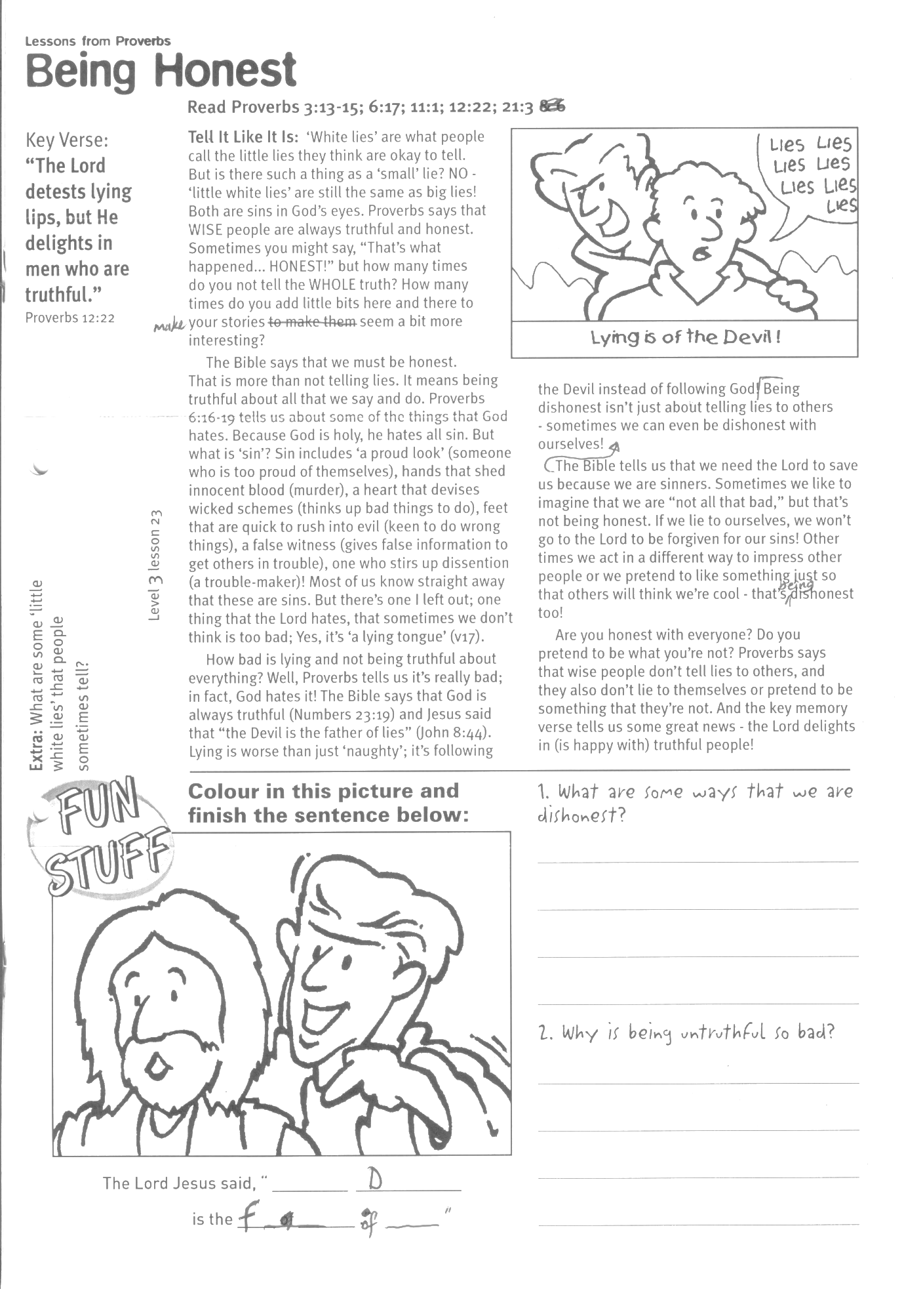

LESSONS FROM PROVERBS

1. What are some ways that we are dishonest?  
____________________________________  
____________________________________  
________________________________________________________________________

2. Why is being untruthful so bad?  
________________________________________________________________________  
____________________________________  
____________________________________

**FUN**

How bad is lying and not being truthful about everything? Well, Proverbs tells us it’s really bad; in fact, God hates it! The Bible says that God is always truthful (Numbers 23:19) and Jesus said that “the devil is the father of lies” (John 8:44) Lying is worse than just ‘naughty’; it’s following the devil instead of following God!

Being dishonest isn’t just about telling lies to others - sometimes we can even be dishonest with ourselves! The Bible tells us that we need the Lord to save us because we are sinners. Sometimes we like to imagine that we are “not all that bad,” but that’s not being honest. If we lie to ourselves, we won’t go to the Lord to be forgiven for our sins! Other times we act in a different way to impress other people or we pretend to like something just so that others will think we’re cool - that’s being dishonest, too!

Are you honest with everyone? Do you pretend to be what you’re not? Proverbs says that wise people don’t tell lies to others, and they also don’t lie to themselves or pretend to be something that they’re not. And the key memory verse tells us some great news – the Lord ‘delights in’ (is happy with) truthful people!

**Colour in this picture and  
finish the sentence below:**

**The Lord Jesus said, “ __ __ __ d__ __ __ __ is  
  
 the f__ __ __ __ __ of __ __ __ __ .”**



**Extra:** What are some ‘little white lies’ that people sometimes tell?

**Level 3 lesson 23**

**Read Proverbs 1:1-8  
and Ecclesiastes 12:1**

**How can we end up being wise**? By starting in the right place! The Bible says that there is only ONE place to begin if we want to be truly wise people. This month, we have been looking at the book of Proverbs in the Bible to see what ‘being wise’ looks like. But just as a building has a foundation that holds all the rest of the bricks and glass and doors and floors up, being wise has a foundation, too.

We’ve seen that wise people SPEAK RIGHT, WORK HARD, and ARE HONEST in all they say and do. But all these things are just like different floors in a tall building ... they are all resting on a foundation. What’s the foundation for being wise? The Bible says that FEAR is the beginning of wisdom! What can that mean?

What are you afraid of? Thunderstorms? Mice? Giving a talk in front of your class at school? Swimming in the deep end of the pool? The Bible is not talking about that sort of fear. It’s talking about a different kind of fear - not the fear of storms or mice or crowds or water ... but the ‘fear of God.’ Proverbs tells us that it is this FOUNDATION that His wisdom is built on.

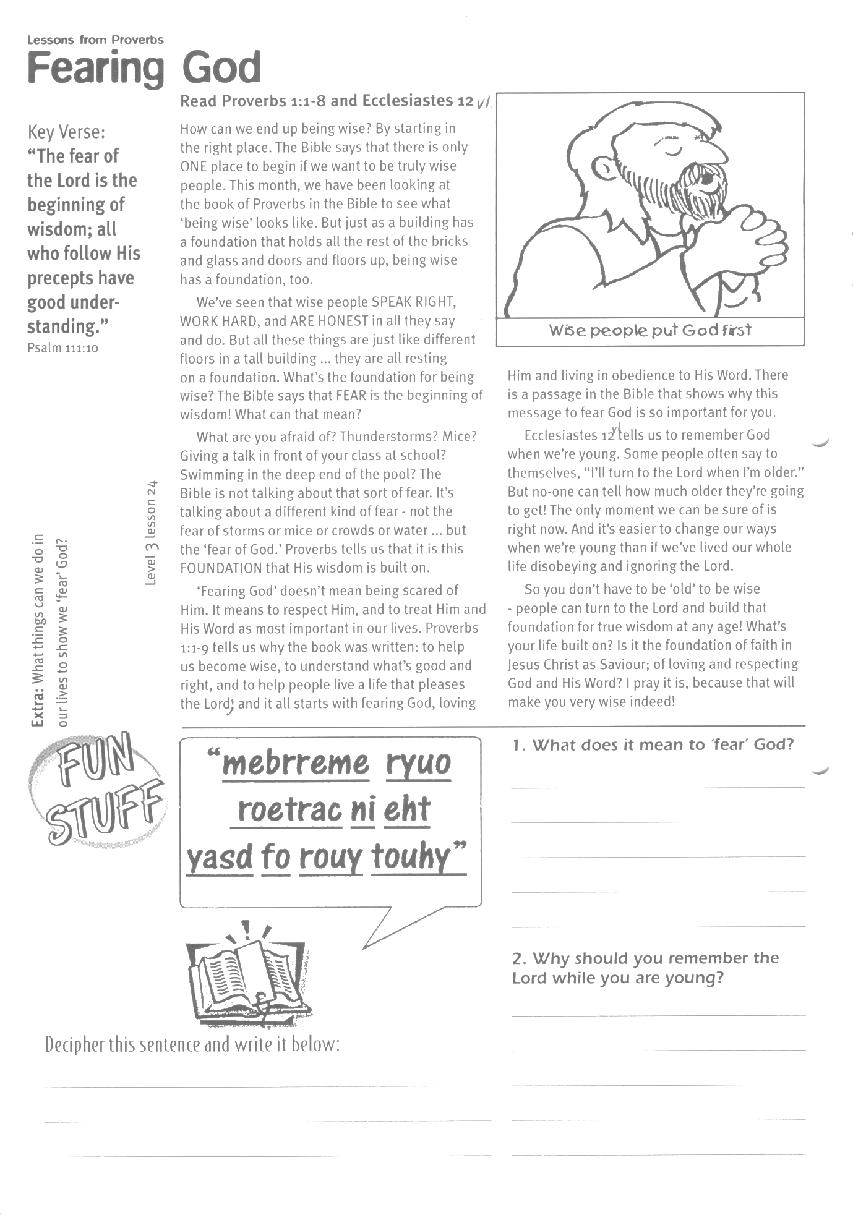

Key Verse:  
**“The fear of the Lord is the beginning of wisdom; all who follow His precepts have good understanding.”**Psalm 111:10

Please complete and return by post to   
**PSSM, 5/399 New North Road, Kingsland, Auckland, 1021** or scan & email to **info@biblediscovery.org.nz**

**Fearing God**

LESSONS FROM PROVERBS

‘Fearing God’ doesn’t mean being scared of Him. It means to respect Him, and to treat Him and His Word as most important in our lives. Proverbs 1:1-9 tells us why the book was written: to help us become wise, to understand what’s good and right, and to help people live a life that pleases the Lord; and it all starts with fearing God, loving Him and living in obedience to His Word. There is a passage in the Bible that shows why this message to fear God is so important for you.

Ecclesiastes 12:1 tells us to remember God when we’re young. Some people often say to themselves, “I’ll turn to the Lord when I’m older.” But no-one can tell how much older they’re going to get! The only moment we can be sure of is right now. And it’s easier to change our ways when we’re young than if we’ve lived our whole life disobeying and ignoring the Lord.

So you don’t have to be ‘old’ to be wise - people can turn to the Lord and build that foundation for true wisdom at any age! What’s your life built on? Is it the foundation of faith in Jesus Christ as Saviour; of loving and respecting God and His Word? I pray it is, because that will make you very wise indeed!

“mebrreme ryou  
roetrac ni eht  
yasd fo rouy touhy”

**Extra:** What things can we do in our   
lives to show we ‘fear’ God?

**Level 3 lesson 24**

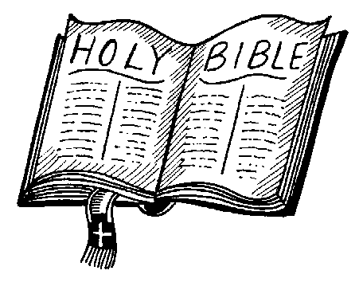

1. What does it mean to ‘fear’ God?  
________________________________________________

________________________________________________

________________________________________________

________________________________________________  
2. Why should you remember the Lord while you are young?

________________________________________________

________________________________________________

________________________________________________

Decipher this sentence and write it below:

_____________________________________________

_____________________________________________

finish