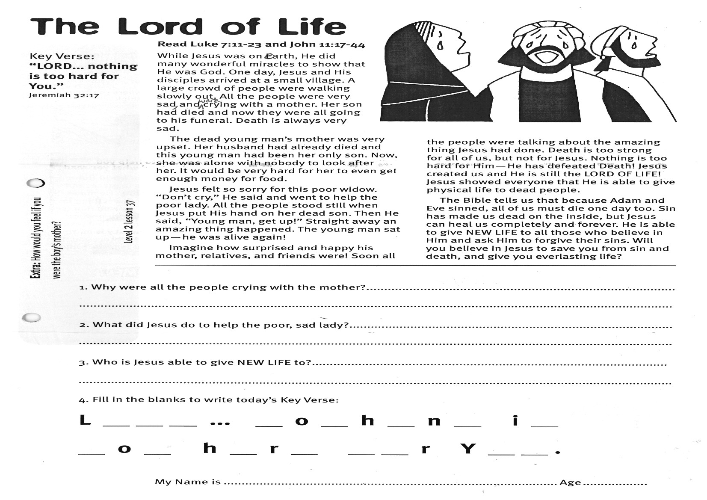

Key Verse:  
**“LORD... nothing is too hard for You.”**  
  
Jeremiah 32:17

**Read Luke 7:11-23  
and John 11:17-44**

While Jesus was on earth, He did many wonderful miracles to show that He was God. One day, Jesus and His disciples arrived at a small village. A large crowd of people were walking slowly out. All the people were very sad, and were crying with a mother. Her son had died and now they were all going to his funeral. Death is always very sad.

The dead young man’s mother was very upset. Her husband had already died and this young man had been her only son. Now, she was alone with nobody to look after her. It would be very hard for her to even get enough money for food.

Jesus felt so sorry for this poor widow. “Don’t cry,” He said and went to help the poor lady. All the people stood still when Jesus put His hand on her dead son. Then He said, “Young man, get up!” Straight away an amazing thing happened. The young man sat up - he was alive again!

**The Lord of Life**

**Extra:** How would you feel if you were the boy’s mother?

3. Who is Jesus able to give NEW LIFE to? ___________________________________________

_____________________________________________________________________________

4. Fill in the blanks to write today’s Key Verse:

L __ __ __ ... __ o __ h __ n __ i __

__ o __ h __ r __ __ __ r Y__ __ .

1. Why were all the people crying with the mother?___________________

_____________________________________________________________

2. What did Jesus do to help the poor, sad lady? _____________________

_____________________________________________________________

Imagine how surprised and happy his mother, relatives, and friends were! Soon all the people were talking about the amazing thing Jesus had done. Death is too strong for all of us, but not for Jesus. Nothing is too hard for Him - He has defeated death! Jesus created us and He is still the LORD OF LIFE! Jesus showed everyone that He is able to give physical life to dead people.

The Bible tells us that because Adam and Eve sinned, all of us must die one day, too. Sin has made us dead on the inside, but Jesus can heal us completely and forever. He is able to give NEW LIFE to all those who believe in Him and ask Him to forgive their sins. Will you believe in Jesus to save you from sin and death, and give you everlasting life?

**Level 2 lesson 37**

My Name is ……………………………………………………………………… Age……………

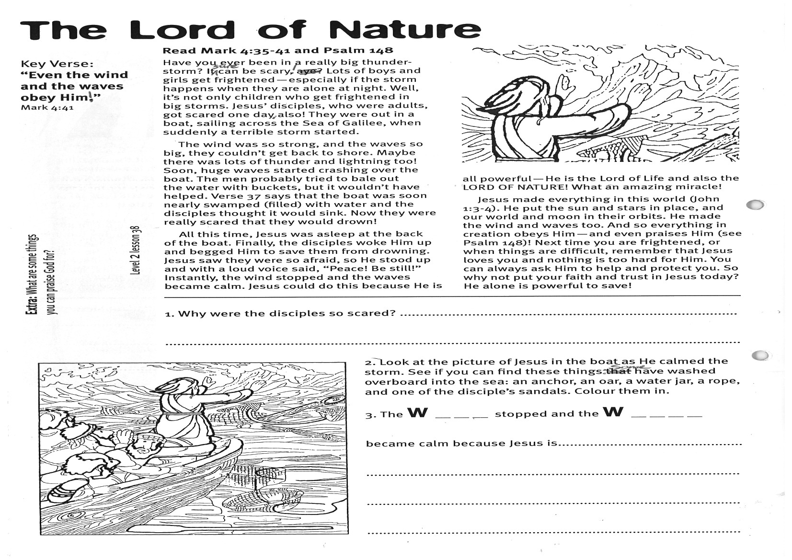

**Read Mark 4:35-41  
and Psalm 148**

Have you ever been in a really big thunder-storm? It sure can be scary! Lots of boys and girls get frightened, especially if the storm happens when they are alone at night. Well, it’s not only children who get frightened in big storms. Jesus’ disciples, who were adults, got scared one day, also! They were out in a boat, sailing across the Sea of Galilee, when suddenly a terrible storm started.

The wind was so strong, and the waves so big, they couldn’t get back to shore. Maybe there was lots of thunder and lightning too! Soon, huge waves started crashing over the boat. The men probably tried to bale out the water with buckets, but it wouldn’t have helped. Verse 37 says that the boat was soon nearly swamped (filled) with water and the disciples thought it would sink. Now they were really scared that they would drown!

All this time, Jesus was asleep at the back of the boat. Finally, the disciples woke Him up and begged Him to save them from drowning.

Key Verse:  
**“Even the wind and the waves obey Him!”**  
  
Mark 4:41

**The Lord of Nature**

Jesus saw they were so afraid, so He stood up and with a loud voice said, “Peace! Be still!” Instantly, the wind stopped and the waves became calm. Jesus could do this because He is all powerful - He is the Lord of Life and also the LORD OF NATURE! What an amazing miracle!

Jesus made everything in this world (John 1:3-4). He put the sun and stars in place, and our world and moon in their orbits. He made the wind and waves, too. And so everything in creation obeys Him, and even praises Him (see Psalm 148)! Next time you are frightened, or when things are difficult, remember that Jesus loves you and nothing is too hard for Him. You can always ask Him to help and protect you. So why not put your faith and trust in Jesus today? He alone is powerful to save!

gf

**Level 2 lesson 38**

2. Look at the picture of Jesus as He raised His hands to calm the storm. See if you can find these things: (some have washed overboard into the sea) **COLOUR THEM IN**

⃝ **an anchor** ⃝ **an oar** ⃝ **a water jar**

⃝ **a rope** ⃝ **one of the disciple’s sandals.**

3. The W__ __ __ stopped and the W__ __ __ __ became calm because Jesus is: _________________________________________________

_________________________________________________

__________________________________________________

**Extra:** What are some things you can praise God for?

1. Why were the disciples so scared?_______________________________

_____________________________________________________________

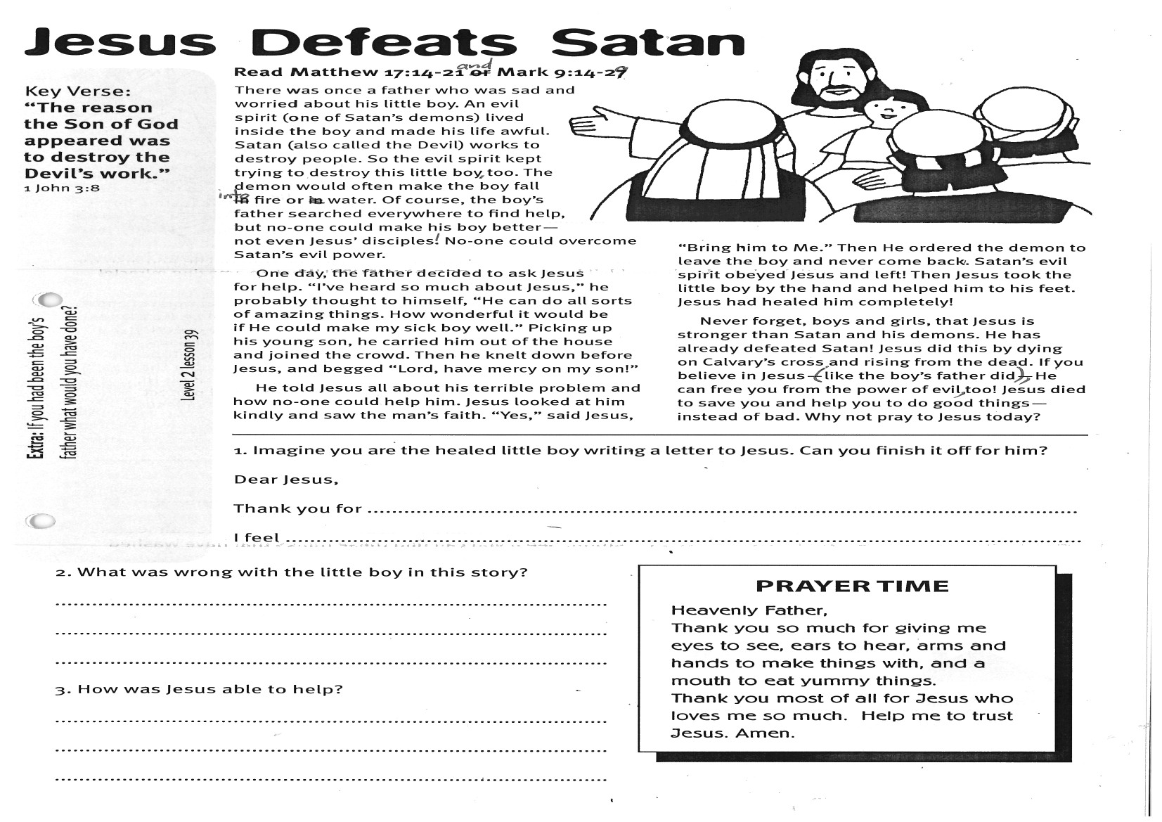

Key Verse:  
**“The reason the Son of God appeared was to destroy the devil’s work.”**  
1 John 3:8

**Read Matthew 17:14-21  
and Mark 9:14-29**

There was once a father who was sad and worried about his little boy. An evil spirit (one of Satan’s demons) lived inside the boy and made his life awful. Satan (also called the Devil) works to destroy people. So the evil spirit kept trying to destroy this little boy, too. The demon would often make the boy fall into fire or water. Of course, the boy’s father searched everywhere to find help, but no-one could make his boy better - not even Jesus’ disciples! No-one could overcome Satan’s evil power.

One day, the father decided to ask Jesus for help. “I’ve heard so much about Jesus,” he probably thought to himself, “He can do all sorts of amazing things. How wonderful it would be if He could make my sick boy well.” Picking up his young son, he carried him out of the house and joined the crowd. Then he knelt down before Jesus, and begged “Lord, have mercy on my son!”

**Jesus Defeats Satan**

He told Jesus all about his terrible problem and how no-one could help him. Jesus looked at him kindly and saw the man’s faith. “Yes,” said Jesus, “Bring him to Me.” Then He ordered the demon to leave the boy and never come back. Satan’s evil spirit obeyed Jesus and left! Then Jesus took the little boy by the hand and helped him to his feet. Jesus had healed him completely!

Never forget, boys and girls, that Jesus is stronger than Satan and his demons. He has already defeated Satan! Jesus did this by dying on Calvary’s cross and rising from the dead. If you believe in Jesus (like the boy’s father did), He can free you from the power of evil, too! Jesus died to save you and help you to do good things - instead of bad. Why not pray to Jesus today?

**Extra:** If you had been the boy’s father what would you have done?

**PRAYER TIME**

“Heavenly Father,

Thank you so much for giving me eyes to see, ears to hear, arms and hands to make things with, and a mouth to eat yummy things.

Thank you most of all for Jesus, who loves me so much. Help me to trust Jesus. Amen.”

Thank you for _________________________________________

I feel ________________________________________________

2. What was wrong with the little boy in this story?

_____________________________________________________

_____________________________________________________

3. How was Jesus able to help?

_____________________________________________________

_____________________________________________________

**1. Imagine you are the healed little boy writing a letter to Jesus. Can you finish it off for him?**  
Dear Jesus,

**Level 2 lesson 39**

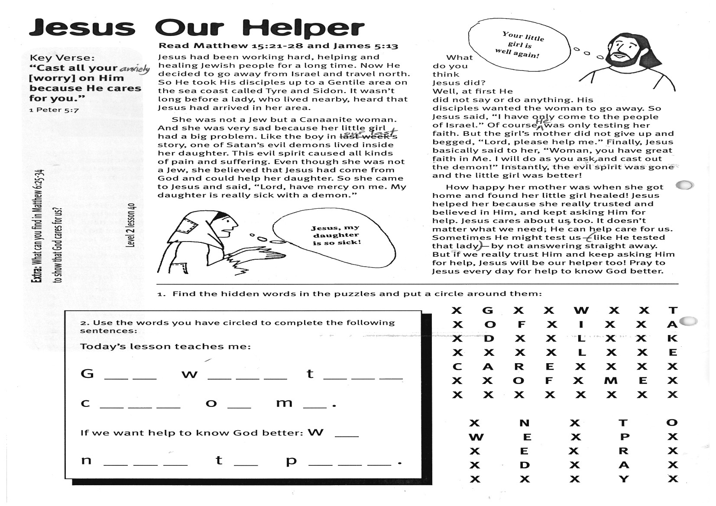

Key Verse:  
**“Cast all your anxiety [worry] on Him because He cares for you.”**  
  
1 Peter 5:7

**Read Matthew 15:21-28  
and James 5:13**

Jesus had been working hard, helping and healing Jewish people for a long time. Now He decided to go away from Israel and travel north. So He took His disciples up to a Gentile area on the sea coast called Tyre and Sidon. It wasn’t long before a lady, who lived nearby, heard that Jesus had arrived in her area.

She was not a Jew but a Canaanite woman. And she was very sad because her little girl had a big problem. Like the boy in our last story, one of Satan’s evil demons lived inside her daughter. This evil spirit caused all kinds of pain and suffering. Even though she was not a Jew, she believed that Jesus had come from God and could help her daughter. So she came to Jesus and said, “Lord, have mercy on me. My daughter is really sick with a demon.”

Your little girl is well again!

**Jesus our Helper**

What do you think Jesus did? Well, at first He did not say or do anything. His disciples wanted the woman to go away. So Jesus said, “I have only come to the people of Israel.” Of course, He was only testing her faith. But the girl’s mother did not give up and begged, “Lord, please help me.” Finally, Jesus basically said to her, “Woman, you have great faith in Me. I will do as you ask, and cast out the demon!” Instantly, the evil spirit was gone and the little girl was better!

How happy her mother was when she got home and found her little girl healed! Jesus helped her because she really trusted and believed in Him, and kept asking Him for help. Jesus cares about us, too. It doesn’t matter what we need; He can help care for us. Sometimes He might test us (like He tested that lady) by not answering straight away. But if we really trust Him and keep asking Him for help, Jesus will be our helper, too! Pray to Jesus every day for help to know God better.

1003

**2. Use the words you have circled to complete the following sentences:**

Today’s lesson teaches me: G__ __ w__ __ __ t__ __ __ c__ __ __ o__ m__ .

If we want to know God better:   
w__ n__ __ __ t__ p__ __ __ .

**X G X X W X X T**

**X O X X I X X A**

**X D X X L X X K**

**X X X X L X X E**

**C A R E X X X X**

**X X O F X M E X**

**X X X X X X X X**

**X N X T O**

**W E X P X**

**X E X R X**

**X D X A X**

**X X X Y X**

**Level 2 lesson 40**

**Extra:** What can you find in Matthew 6:25-34 to show that God cares for us?

Please complete and return by post to   
**PSSM Bible Discovery, 5/399 New North Rd, Kingsland, Auckland 1021**   
or scan & email to **info@biblediscovery.org.nz**

**1. Find the hidden words in the puzzle and put a circle around them:**

Jesus, my daughter is so sick!