

**Read 1 Samuel 8:6-19   
and 1 Samuel 9**

As we saw last month, Israel wanted a king to rule over them instead of trusting in God. Sometimes we’re the same, aren’t we? We trust in people more easily than God, even though God is wiser and more powerful than any person on earth!

Although the Lord had told the people that having a king would be a bad idea, He chose for them a man who should have been the perfect king. Let’s take a look at some good qualities that Saul had.

He was respectful of and obedient to his parents: When Saul’s father Kish told him that their donkeys had wandered off and that he should take a servant and go and look for them, Saul started out on the long, hard journey without complaining. Later, when Saul and his servant had been gone a long time, Saul was concerned that his father might be more upset about them than the donkeys, and decided to go back home.

He also respected the prophet Samuel: The Lord told Samuel that he was about to meet the man who would be Israel’s king. When they did meet, Saul listened to Samuel and did everything he told him to.

Key Verse:  
**“All the people… confirmed Saul as king in the presence of the Lord… and held a great celebration.”**  
1 Samuel 11:15

**A King for God’s People**

1. What are some words you would use to tell us about Saul?

_________________________________

_________________________________

2. What do you think Saul thought after Samuel spoke to him?

_________________________________

_________________________________

3. The Lord told Samuel he was going to meet the man who would be…….. (fill in the vowels)

__ SR__ __ L’S K__ NG

**Level 3 lesson 5**

Saul was also humble to start with: When Samuel told him that God had chosen him as

king, he said, “But I’m just a ‘nobody’ from the smallest tribe in Israel! Why are you saying these things to me?” And later, Saul hid himself when everyone started looking for their new king (while others might have wanted to be noticed by everyone).

To top everything off, Saul was tall and handsome: He really stood out from the crowd. If anyone was going to make a great leader of the people, Saul was just the guy to do it! But as we’re going to see over the next few lessons, Saul did not live up to what he should have been. In fact, as good as this story starts out, Saul ends up as an example for us all of how NOT to live!

Saul had many natural abilities and opportunities from God to be all that he should be, but he didn’t use them. Are you like that? If we don’t use our abilities and take the opportunities the Lord gives us, we may as well not have been given them!

Draw your own picture of Saul below:

**Extra:** List some of the abilities God has given you.   
Are you making the most of them?

My Name is ……………………………………………………… Age…………………



Key Verse:  
**“This is love for God: to obey His commands.”**1 John 5:3

**A Good Start**

**Read 1 Samuel 11:1-15 and   
1 Corinthians 9:24-27**

No sooner had Saul been chosen as King of Israel, than an opportunity came for him to prove himself. And did he ever do that! What a great start for the first king of Israel! Here’s how it all started...

Nahash (who was one of the nearby Ammonites, the enemies of God’s people) tried to muscle in on Israel’s territory by attacking the city of Jabesh Gilead. Nahash gave them a week to find someone to rescue them, or he was going to take them over. Messengers went out from Jabesh Gilead throughout the land of Israel asking for help against Nahash.

When Saul got news of this he was furious, but not because he didn’t get things to go his way. He was angry that someone would dare threaten God’s people and show such disrespect for God! Do you get angry about the same things that make the Lord angry? Or do you just lose your temper when people do things that annoy you and put you out?

The Bible says that man’s anger does not achieve what God wants in our lives (James 1:20). But it’s different if we get angry over things that upset the Lord. This kind of anger is known as ‘righteous anger’ - the only kind of anger that is good. This ‘righteous anger’ shows that we put God and His holy standards first, and that we aren’t just thinking about ourselves.

Saul was filled with righteous anger when he heard about Nahash threatening Jabesh Gilead. He wasted no time in getting a large group of men together and sent a message to the people in Jabesh Gilead to tell them help was on its way.

Saul’s army marched until they reached the Ammonite’s camp. Then they attacked and defeated them in a great victory! Only a few Ammonites were able to escape from Saul’s army! Saul told the people that God had given them the victory (1 Samuel 11:13).

Then all the people gathered at Gilgal and had a huge party to celebrate that Saul had been made king. What a good start indeed! Saul put the Lord first, and the Lord gave him victory over his enemies. If only Saul had stayed on the right track and continued to put the Lord first!

We need to remember that after a good start we still need to run a good race, or else we’ll fizzle out. The Apostle Paul said about the Christian life, “Run in such a way as to get the prize” (1 Corinthians 9:24). In other words, “run like you want to win!” Saul started well, but didn’t run like he wanted to win.

3. How did Saul win the victory over his enemies?

­­­­­_______________________________________

_______________________________________

_______________________________________

____________________________________________________________________________________________________________________________________________________________

**Extra:** The Bible says, “Remember your Creator when you are still young.” (Ecclesiastes 12:1). What ways can you make sure that your good start will keep going strong?

**Level 3 lesson 6**

1. Why was Saul so upset?

_______________________________________________

_______________________________________________

_______________________________________________

2. The only good kind of anger:

**REGNASUOETHGIR** (Clue: back to front)

Answer:_______________________________________________



**Read 1 Samuel 13: 1-14 and   
John 14: 15-24**

If you went around telling people you were 15 feet tall, all it would take to prove you wrong would be a ruler or tape measure! According to the Bible, anyone that says they love the Lord can be proved right or wrong by this one thing: their obedience. You could stand up on a hill and yell that you love the Lord until your words carried all the way across the valley and echoed all the way back. But it wouldn’t mean anything if you weren’t obedient to what the Lord wanted you to do.

We can see this very clearly in Saul’s life: after making such a good start as king, he started to go downhill. At first, Saul was respectful and obedient to the Lord, and to his elders. He was humble too, even though God had blessed him with many gifts and abilities. But you can see in our passage today how much he had changed.

Saul and his son Jonathan set out to attack the Philistines and Saul chose only a small group to do the fighting and sent the rest back to their homes. That’s because he stopped realising how much he needed the Lord, and thought that he was strong enough and wise enough to defeat his enemies by himself. The humble young man we first read of had become **proud.**

Saul soon found out that acting so proudly was not the smartest thing he could have done. The Philistines had so many soldiers and chariots that the Israelites hid, afraid of fighting a losing battle! In order to get out of such a tight spot, Saul called for an animal and sacrificed it - something that only a priest was allowed to do!

Key Verse:  
**“To obey is better than sacrifice.”**1 Samuel 15:22b

**Saul Fizzles Out**

|  |  |  |  |  |  |  |  |  |  |
| --- | --- | --- | --- | --- | --- | --- | --- | --- | --- |
| H |  |  | S |  |  |  |  |  | D |
| R |  |  |  |  |  |  |  | G |  |
| H |  |  |  | M |  |  |  |  |  |
| H |  |  |  | N |  |  |  |  |  |
| T |  |  |  | L |  |  |  |  |  |

Fill in the missing letters to find out what the beginning of Saul’s downfall was:

1. What kind of person was God looking for to be King?

________________________________________

________________________________________

2. Give three words to describe Saul after he had been King for a while.

a. P ____________________________________

b. D ____________________________________

c. D ____________________________________

He was trying to get God to help them, but breaking God’s laws was not the way to do it! The obedient young man we first read of had become **disobedient.**

Then Samuel arrived and found Saul offering up the sacrifice. Because Samuel was a priest, Saul should have waited and let Samuel make the offering. Samuel was angry and hurt. Saul had shown God and His priest no respect in doing this. The respectful young man we first read of had become **disrespectful.**

“You have acted foolishly,” Samuel said, “You have disobeyed, and now God will not allow your family to rule. He has already chosen someone else to rule; a man after his own heart.” Saul tried to make out that he was trying to please the Lord, trying to serve Him faithfully. If someone had asked him, he would have claimed to love the Lord. But his disobedience showed that he didn’t really love God as he said. Actions speak louder than words!

**Level 3 lesson 7**

**Extra:** In what areas of your life can you be more obedient to what the Lord wants you to do?

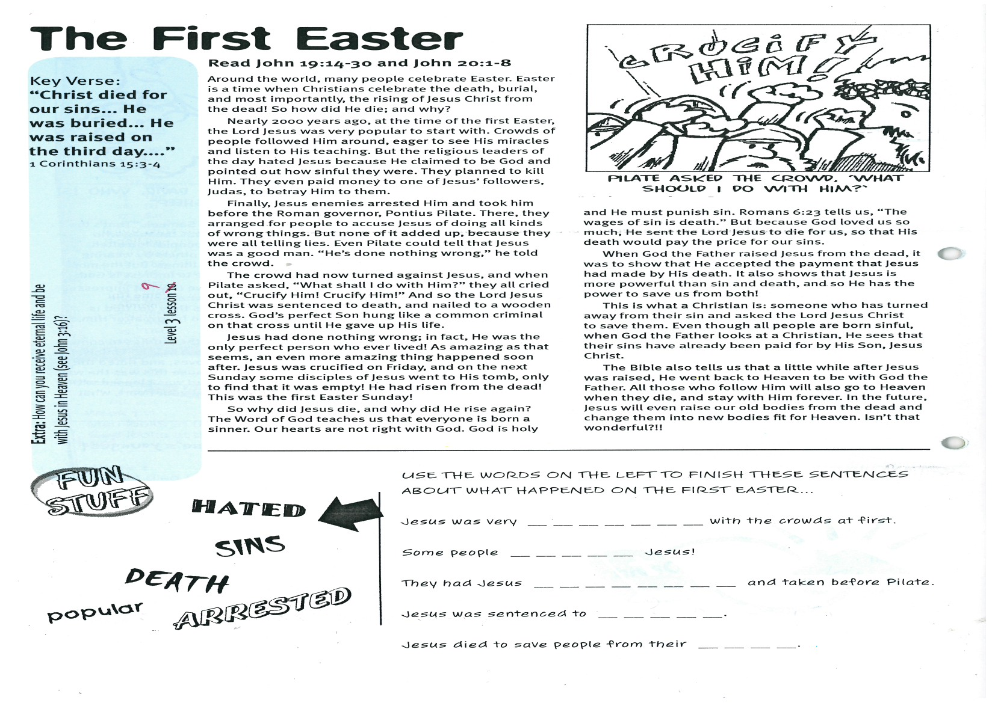

**The First Easter**

**Read John 19:14-30  
and John 20:1-8**

Around the world, many people celebrate Easter. Easter is a time when Christians celebrate the death, burial, and most importantly, the rising of Jesus Christ from the dead! So how did He die; and why?

Over 2000 years ago, at the time of the first Easter, the Lord Jesus was very popular to start with. Crowds of people followed Him around, eager to see His miracles and listen to His teaching. But the religious leaders of the day hated Jesus because He claimed to be God and pointed out how sinful they were. They planned to kill Him. They even paid money to one of Jesus’ followers, Judas, to betray Him to them.

Finally, Jesus’ enemies arrested Him and took him before the Roman governor, Pontius Pilate. There, they arranged for people to accuse Jesus of doing all kinds of wrong things. But none of it added up, because they were all telling lies. Even Pilate could tell that Jesus was a good man. “He’s done nothing wrong,” he told the crowd.

The crowd had now turned against Jesus, and when Pilate asked, “What shall I do with Him?” they all cried out, “Crucify Him! Crucify Him!” And so the Lord Jesus Christ was sentenced to death, and nailed to a wooden cross. God’s perfect Son hung like a common criminal on that cross until He gave up His life.

Jesus had done nothing wrong; in fact, He was the only perfect person who ever lived! As amazing as that seems, an even more amazing thing happened soon after. Jesus was crucified on Friday, and on the next Sunday some disciples of Jesus went to His tomb, only to find that it was empty! He had risen from the dead! This was the first Easter Sunday!

Key Verse:  
**“…Christ died for our sins... He was buried... He was raised on the third day....”**  
1 Corinthians 15:3-4

**Extra:** How can you receive eternal life and be with Jesus in Heaven? (See John 3:16)

Please complete and return by post to   
**PSSM, 5/399 New North Rd, Kingsland, Auckland 1021** or scan & email to **info@biblediscovery.org.nz**

hated sins

**death**

popular

arrested

USE THE WORDS ON THE LEFT TO FINISH THESE SENTENCES ABOUT WHAT HAPPENED ON THE FIRST EASTER...

Jesus was very __ __ __ __ __ __ __ with the crowds at first

Some people __ __ __ __ __ Jesus!

They had Jesus __ __ __ __ __ __ __ __ and taken before Pilate

Jesus was sentenced to __ __ __ __ __

Jesus died to save people from their __ __ __ __

So why did Jesus die, and why did He rise again? The Word of God teaches us that everyone is born a sinner. Our hearts are not right with God. God is holy and He must punish sin. Romans 6:23 tells us, “The wages of sin is death.” But because God loved us so much, He sent the Lord Jesus to die for us, so that His death would pay the price for our sins.

When God the Father raised Jesus from the dead, it was to show that He accepted the payment that Jesus had made by His death. It also shows that Jesus is more powerful than sin and death, and so He has the power to save us from both!

This is what a Christian is: someone who has turned away from their sin and asked the Lord Jesus Christ to save them. Even though all people are born sinful, when God the Father looks at a Christian, He sees that their sins have already been paid for by His Son, Jesus Christ.

The Bible also tells us that a little while after Jesus was raised, He went back to Heaven to be with God the Father. All those who follow Him will also go to Heaven when they die, and stay with Him forever. In the future, Jesus will even raise our old bodies from the dead and change them into new bodies fit for Heaven. Isn’t that wonderful?!!

**Level 3 lesson 8**

**Answer:**