**June Bible Readings**

DATE BOOK REFERENCE

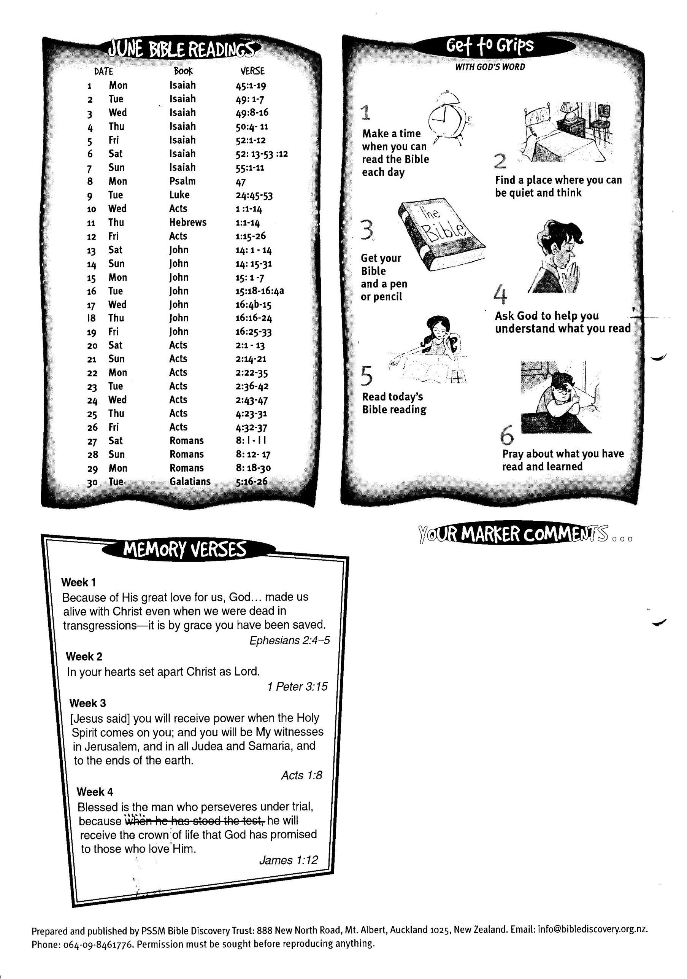

**30 Romans 8:31-39**

6:16 - 28