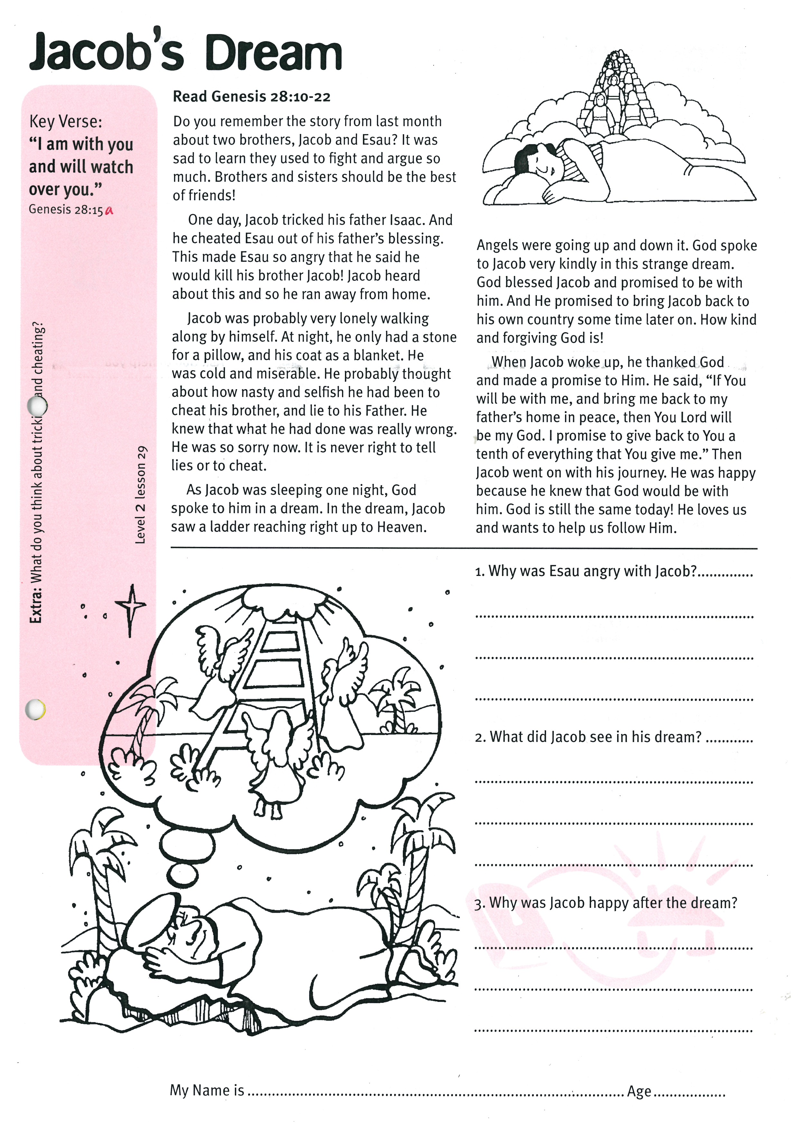

**Read Genesis 28:10-22**

Do you remember the story from last month about two brothers, Jacob and Esau? It was sad to learn they used to fight and argue so much. Brothers and sisters should be the best of friends!

One day, Jacob tricked his father Isaac. And he cheated Esau out of his father’s blessing. This made Esau so angry that he said he would kill his brother Jacob! Jacob heard about this and so he ran away from home.

Jacob was probably very lonely walking along by himself. At night, he only had a stone for a pillow, and his coat as a blanket. He was cold and miserable. He probably thought about how nasty and selfish he had been to cheat his brother, and lie to his father. He knew that what he had done was really wrong. He was so sorry now. It is never right to tell lies or to cheat.

Key Verse:  
**“I am with you and will watch over you…”**

Genesis 28:15a

**Jacob’s Dream**

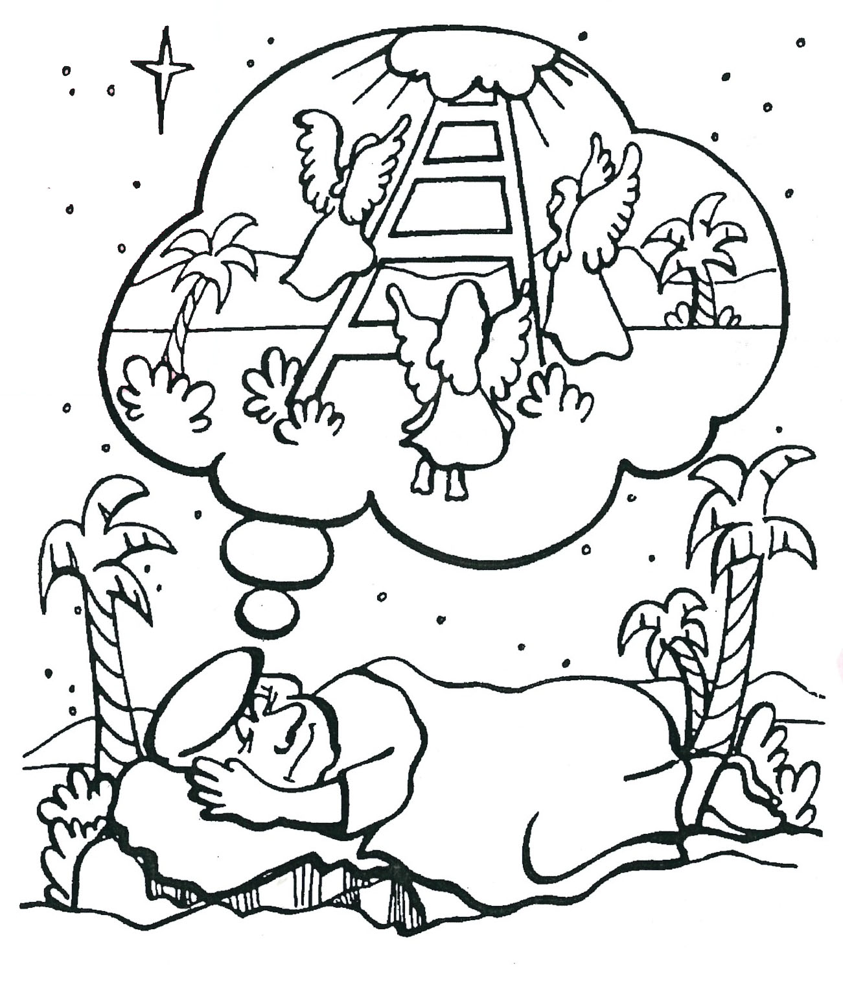

**Extra:** What do you think about tricking and cheating?

**1. Why was Esau angry with Jacob?**

____________________________________

____________________________________

____________________________________

**2. What did Jacob see in his dream?**

____________________________________

____________________________________

____________________________________

**3. Why was Jacob happy after the dream?**

____________________________________

____________________________________

____________________________________

**Level 2 lesson 29**

My Name is________________________________________ Age ______________

As Jacob was sleeping one night, God spoke to him in a dream. In the dream, Jacob saw a ladder reaching right up to Heaven. Angels were going up and down it. God spoke to Jacob very kindly in this strange dream. God blessed Jacob and promised to be with him. And He promised to bring Jacob back to his own country some time later on.   
How kind and forgiving God is!

When Jacob woke up, he thanked God and made a promise to Him. He said, “If You will be with me, and bring me back to my father’s home in peace, then You. Lord. will be my God. I promise to give back to You a tenth of everything that You give me.” Then Jacob went on with his journey. He was happy because he knew that God would be with him. God is still the same today! He loves us and wants to help us follow Him.

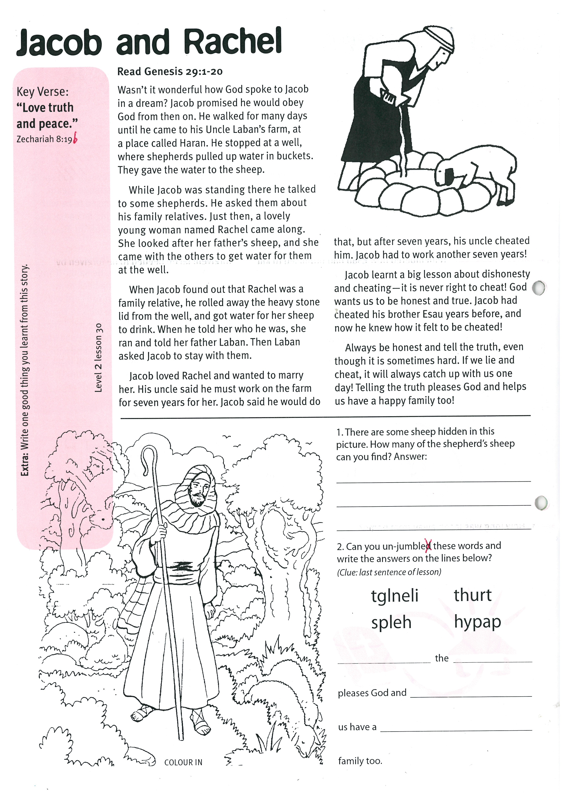

Key Verse:  
**“…Love truth and peace.”**

Zechariah 8:19b

**Read Genesis 29:1-20**

Wasn’t it wonderful how God spoke to Jacob in a dream? Jacob promised he would obey God from then on. He walked for many days until he came to his Uncle Laban’s farm, at a place called Haran. He stopped at a well, where shepherds pulled up water in buckets. They gave the water to the sheep.

While Jacob was standing there he talked to some shepherds. He asked them about his family relatives. Just then, a lovely young woman named Rachel came along. She looked after her father’s sheep, and she came with the others to get water for them at the well.

When Jacob found out that Rachel was a family relative, he rolled away the heavy stone lid from the well, and got water for her sheep to drink. When he told her who he was, she ran and told her father Laban. Then Laban asked Jacob to stay with them.

**Jacob and Rachel**

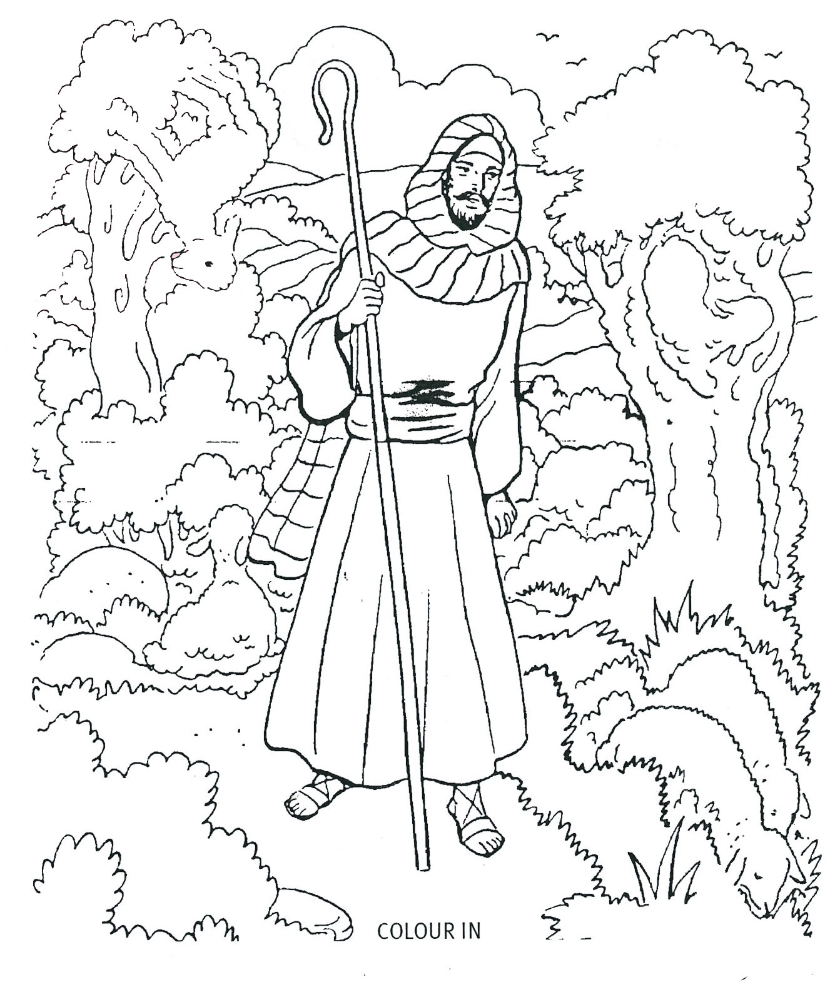

**1. There are some sheep hidden in this picture. How many of the shepherd’s sheep can you find?**

Answer: _________

**2. Can you un-jumble these words and write the answers on the lines below?**(Clue: last sentence of lesson) tglneli thurt

slpeh hypap

__ __ __ __ __ __ __ the __ __ __ __ __

pleases God and __ __ __ __ __

us have a __ __ __ __ __ family too.

**Extra:** Write one good thing you learnt from this story.

**Level 2 lesson 30**

Jacob loved Rachel and wanted to marry her. His uncle said he must work on the farm for seven years for her. Jacob said he would do that, but after seven years, his uncle cheated him. Jacob had to work another seven years!

Jacob learnt a big lesson about dishonesty and cheating - it is never right to cheat! God wants us to be honest and true. Jacob had cheated his brother Esau years before, and now he knew how it felt to be cheated!

Always be honest and tell the truth, even though it is sometimes hard. If we lie and cheat, it will always catch up with us one day! Telling the truth pleases God and helps us have a happy family too!

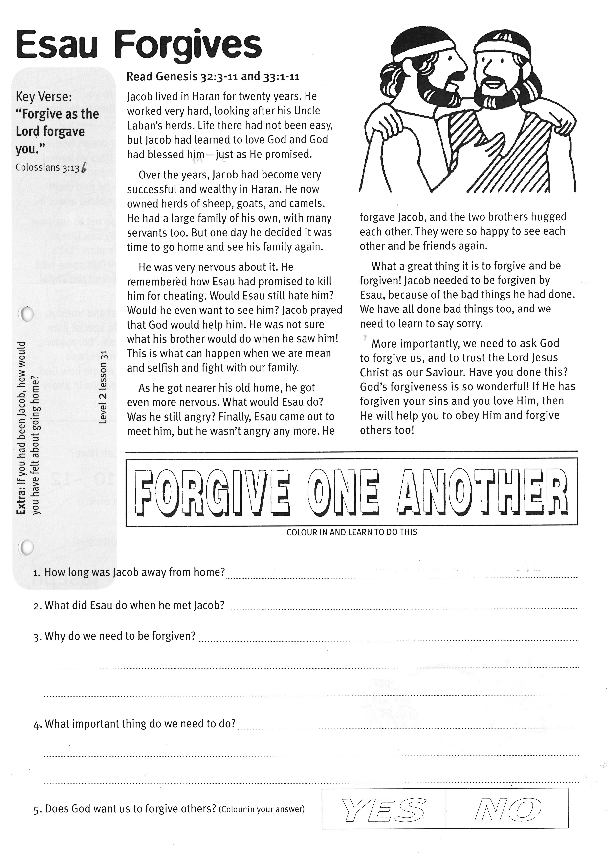

Key Verse:  
**“…forgive as the Lord forgave you.”**

Colossians 3:13b

**Esau Forgives**

**Read Genesis 32:3-11   
and Genesis 33:1-11**

Jacob lived in Haran for twenty years. He worked very hard, looking after his Uncle Laban’s herds. Life there had not been easy, but Jacob had learned to love God and God had blessed him - just as He promised.

Over the years, Jacob had become very successful and wealthy in Haran. He now owned herds of sheep, goats, and camels. He had a large family of his own, with many servants too. But one day he decided it was time to go home and see his family again.

He was very nervous about it. He remembered how Esau had promised to kill him for cheating. Would Esau still hate him? Would he even want to see him? Jacob prayed that God would help him. He was not sure what his brother would do when he saw him!   
This is what can happen when we are mean and selfish and fight with our family.

**Extra:** If you had been Jacob, how would you have felt about going home?

COLOUR IN & LEARN TO DO THIS

**FORGIVE ONE ANOTHER**

**1. How long was Jacob away from home?**_______________________________________________________

**2. What did Esau do when he met Jacob?**_______________________________________________________

**3. Why do we need to be forgiven?**____________________________________________________________

_________________________________________________________________________________________

_________________________________________________________________________________________

**4. What important thing do we need to do?** ____________________________________________________

_________________________________________________________________________________________

**5. Does God want us to forgive others?** (Colour in your answer)

**Level 2 lesson 31**

**NO**

**YES**

As he got nearer his old home, he got even more nervous. What would Esau do? Was he still angry? Finally, Esau came out to meet him, but he wasn’t angry any more. He forgave Jacob, and the two brothers hugged each other. They were so happy to see each other and be friends again.

What a great thing it is to forgive and be forgiven! Jacob needed to be forgiven by Esau, because of the bad things he had done. We have all done bad things too, and we need to learn to say sorry.

More importantly, we need to ask God to forgive us, and to trust the Lord Jesus Christ as our Saviour. Have you done this? God’s forgiveness is so wonderful! If He has forgiven your sins and you love Him, then He will help you to obey Him and forgive others too!

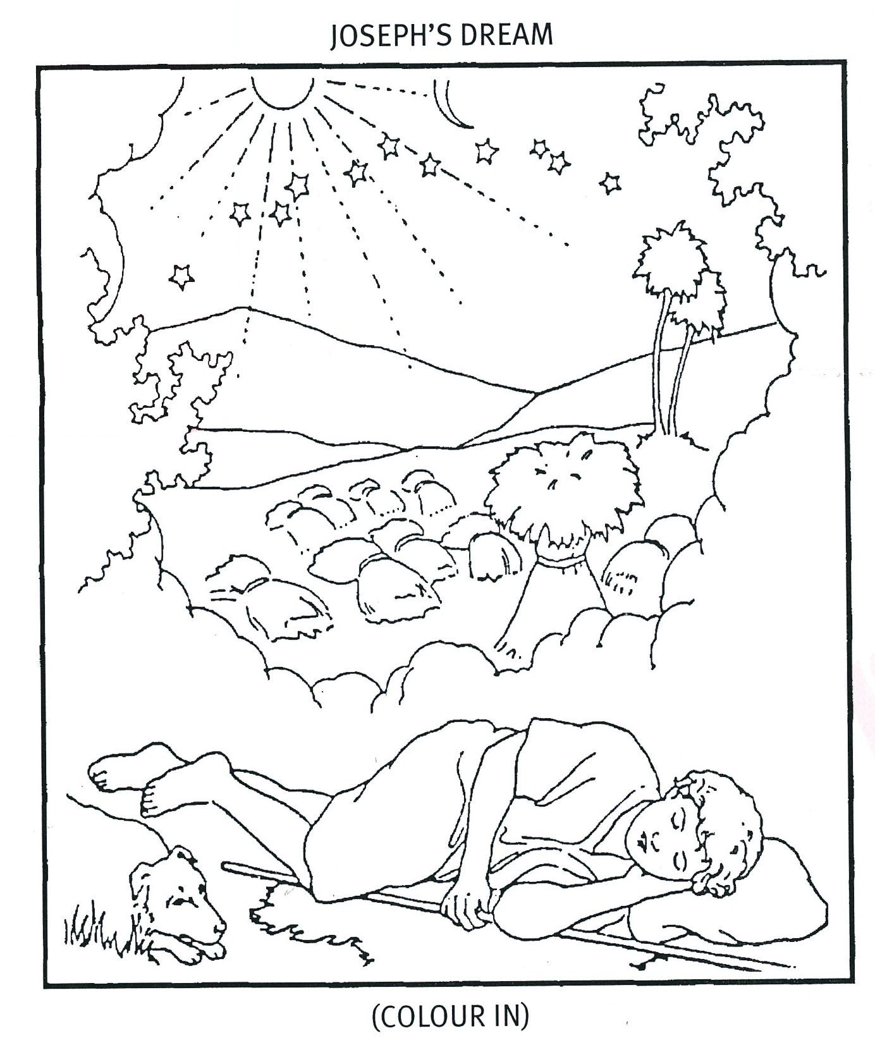

Key Verse:  
**“Hate evil, love good…”**

Amos 5:15a

Please complete and return by post to   
**PSSM Bible Discovery, 5/399 New North Rd, Kingsland, Auckland 1021** or scan & email to **info@biblediscovery.org.nz**

**1. How many sons did Jacob have?**

3 4 7 10 12  
 (Circle the correct answer)

**2. Who was Jacob’s favourite son?**

Reuben Joseph

Benjamin(Circle the correct answer)

**3. Joseph was always...**

h __ __ e __ t andt __ u __ __ __ u __

(Complete these words from your story)

**Extra:** What do you like about Joseph?

**JOSEPH’S DREAM**

“Why should we bow down to you?” “What a dreamer!” they said, and they hated him even more.

Later, Joseph had another dream where the sun, moon, and eleven stars all bowed down to him! What could it mean? His brothers were jealous when he told them about it, but Jacob often wondered about it.

One day, Jacob sent Joseph out to see how his brothers were. When they saw Joseph coming, they made a terrible plan. “Let’s kill him!” they said, “and tell Dad some wild animals killed him.” How wicked and sinful they had become!

Joseph was always honest and truthful. And God loved him. He had a special plan for Joseph’s life. God hates sin. So, readers, always make sure you are honest and truthful. We’ll find out next month how God looked after Joseph and used him in a very special way.

**Read Genesis 37:1-20**

In today’s Bible reading, Jacob is much older now and has twelve sons. The older boys used to look after the sheep out in the fields. The two youngest (Joseph and Benjamin) mostly stayed and helped at home.

Joseph was a good, honest boy and he was Jacob’s favourite son. Jacob gave him a coat with lots of bright colours in it. When his brothers saw Joseph was their father’s favourite, they became jealous. They began to hate him and be unkind to him.

One day Joseph had a strange dream. He dreamt that he was harvesting wheat with his brothers, and putting it into bundles called sheaves. They had all bound a sheaf each, when suddenly, Joseph’s sheaf stood up straight. Then all the other sheaves bowed down to Joseph’s sheaf!

You can imagine how angry his brothers felt when he told them his dream. “Do you think you will rule over us?” they asked.

**Level 2 lesson 32**

**Joseph the Dreamer**