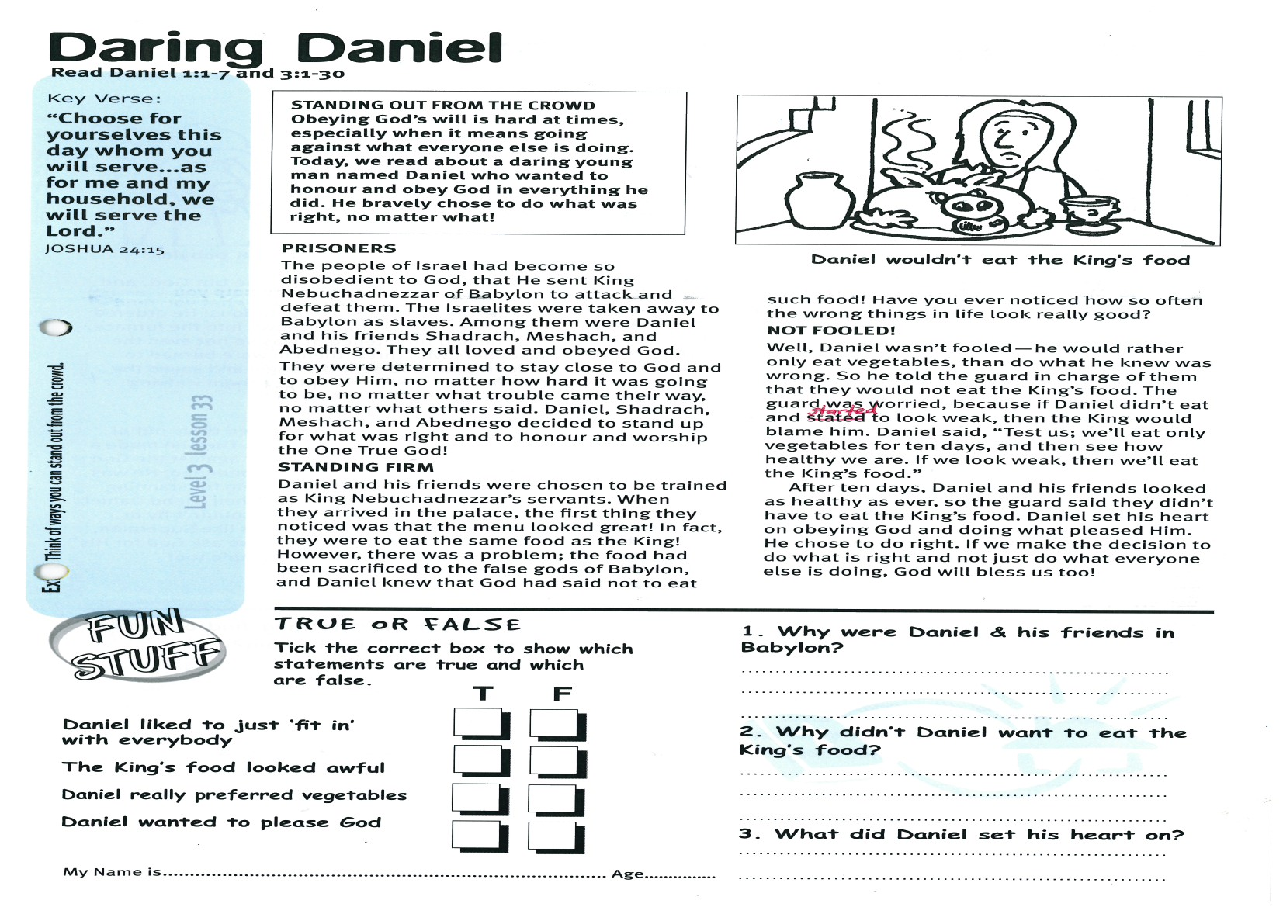

**Read Daniel 1:1-7   
and Daniel 3:1-30**

**STANDING OUT FROM THE CROWD  
Obeying God’s will is hard at times, especially when it means going against what everyone else is doing. Today, we read about a daring young man named Daniel who wanted to honour and obey God in everything he did. He bravely chose to do what was right, no matter what!**

**PRISONERS**The people of Israel had become so disobedient to God, that He sent King Nebuchadnezzar of Babylon to attack and defeat them. The Israelites were taken away to Babylon as slaves. Among them were Daniel and his friends Shadrach, Meshach, and Abednego. They all loved and obeyed God.They were determined to stay close to God and to obey Him, no matter how hard it was going to be, no matter what trouble came their way, no matter what others said. Daniel, Shadrach, Meshach, and Abednego decided to stand up for what was right and to honour and worship the One True God!

**STANDING FIRM**Daniel and his friends were chosen to be trained as King Nebuchadnezzar’s servants. When they arrived in the palace, the first thing they noticed was that the menu looked great! In fact, they were to eat the same food as the King!

Key Verse:  
**“Choose for yourselves this day whom you will serve…as for me and my household, we will serve the Lord.”**Joshua 24:15

**Daring Daniel**

**Extra:** Think of ways you can stand out from the crowd.

**1.** Why were Daniel & his friends in Babylon?

___________________________________

___________________________________

___________________________________

**2.** Why didn’t Daniel want to eat the King’s food?

___________________________________

___________________________________

___________________________________

**3.** What did Daniel set his heart on?

___________________________________

___________________________________

___________________________________

My Name is ……………………………………………………… Age…………………

**True or False?**

**Tick the correct box to show which statements are true and which are false:**

**T F**

Daniel liked to just ‘fit in’ with everybody ⃝ ⃝

The King’s food looked awful ⃝ ⃝

Daniel really preferred vegetables ⃝ ⃝

Daniel wanted to please God ⃝ ⃝

**Level 3 lesson 33**

However, there was a problem; the food had been sacrificed to the false gods of Babylon, and Daniel knew that God had said not to eat such food! Have you ever noticed how so often the wrong things in life look really good?

**NOT FOOLED!**Well, Daniel wasn’t fooled - he would rather only eat vegetables, than do what he knew was wrong. So he told the guard in charge of them that they would not eat the King’s food. The guard was worried, because if Daniel didn’t eat and started to look weak, then the King would blame him. Daniel said, “Test us; we’ll eat only vegetables for ten days, and then see how healthy we are. If we look weak, then we’ll eat the King’s food.”

After ten days, Daniel and his friends looked as healthy as ever, so the guard said they didn’t have to eat the King’s food. Daniel set his heart on obeying God and doing what pleased Him. He chose to do right. If we make the decision to do what is right and not just do what everyone else is doing, God will bless us, too!

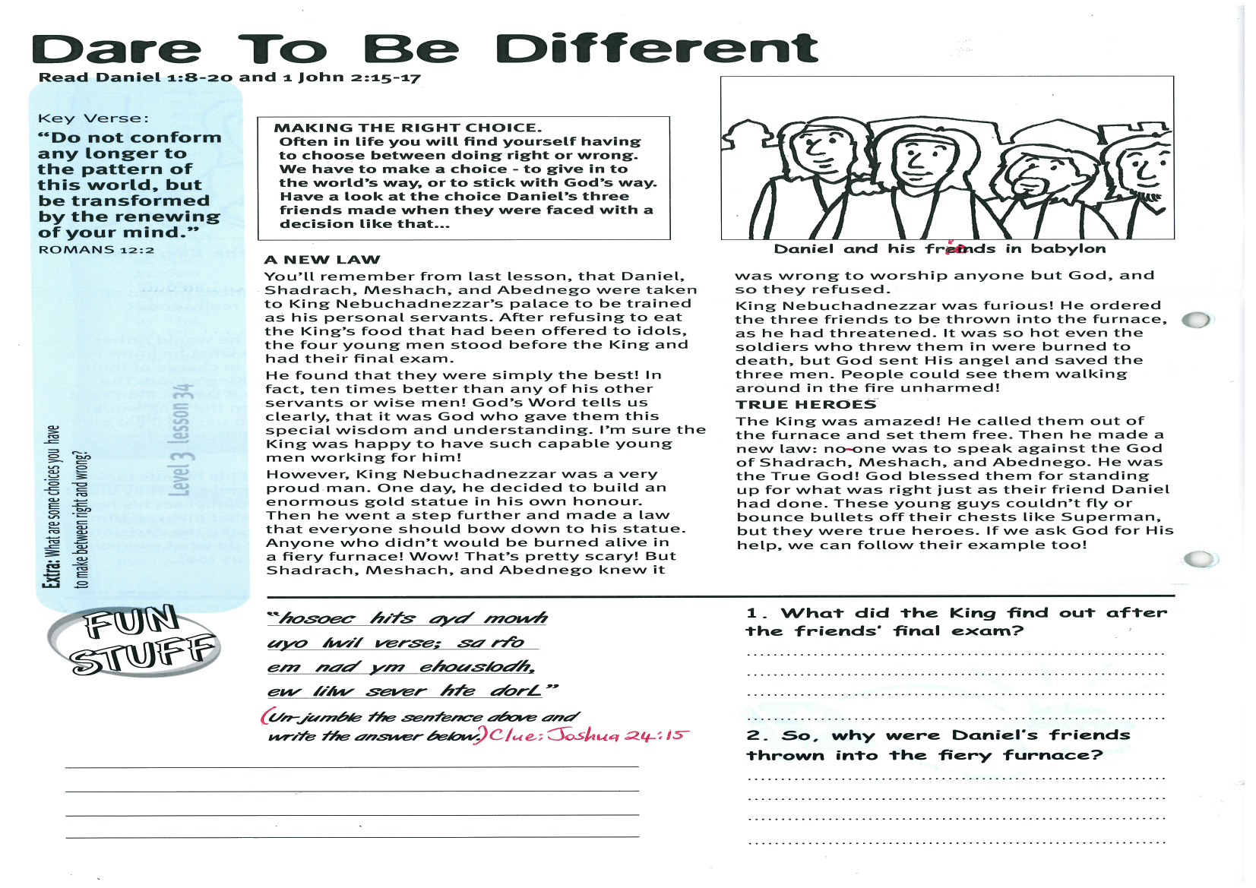

Key Verse:  
**“Do not conform any longer to the pattern of this world, but be transformed by the renewing of your mind…”**Romans 12:2a

**Dare To Be Different**

**Read Daniel 1:8-20   
and 1 John 2:15-17**

**MAKING THE RIGHT CHOICE  
Often in life you will find yourself having to choose between doing right or wrong. We have to make a choice: to give in to the world’s way, or to stick with God’s way. Have a look at the choice Daniel’s three friends made when they were faced with a decision like that...**

**A NEW LAW**You’ll remember from our last lesson, that Daniel, Shadrach, Meshach, and Abednego were taken to King Nebuchadnezzar’s palace to be trained as his personal servants. After refusing to eat the King’s food that had been offered to idols, the four young men stood before the King and had their final exam.

He found that they were simply the best! In fact, ten times better than any of his other servants or wise men! God’s Word tells us clearly, that it was God who gave them this special wisdom and understanding. I’m sure the King was happy to have such capable young men working for him!

However, King Nebuchadnezzar was a very proud man. One day, he decided to build an enormous gold statue in his own honour. Then he went a step further and made a law that everyone should bow down to his statue. Anyone who didn’t would be burned alive in a fiery furnace! Wow! That’s pretty scary! But Shadrach, Meshach, and Abednego knew it was wrong to worship anyone but God, and so they refused.

**1.** What did the King find out after the friends’ final exam?

_______________________________________

_______________________________________

_______________________________________

_______________________________________

**2.** So, why were Daniel’s friends thrown into the fiery furnace?

_______________________________________

_______________________________________

_______________________________________

_______________________________________

**Extra:** What are some choices you have to make between right and wrong?

King Nebuchadnezzar was furious! He ordered the three friends to be thrown into the furnace, as he had threatened. It was so hot even the soldiers who threw them in were burned to death, but God sent His angel and saved the three men. People could see them walking around in the fire unharmed!

**TRUE HEROES**

The King was amazed! He called them out of the furnace and set them free. Then he made a new law: no-one was to speak against the God of Shadrach, Meshach, and Abednego. He was the True God! God blessed them for standing up for what was right - just as their friend Daniel had done. These young guys couldn’t fly or bounce bullets off their chests like Superman, but they were true heroes. If we ask God for His help, we can follow their example, too!

**“hosoec hits ayd mowh**

**uyo lwil verse; sa rfo**

**em nad ym ehouslodh,**

**ew lilw sever hte dorL.”**

Un-jumble the sentence above and write the answer below (Clue: Joshua 24:15)

_____________________________________________

_____________________________________________

__________________________________________________________________________________________

Daniel and his friends in Babylon

**Level 3 lesson 34**

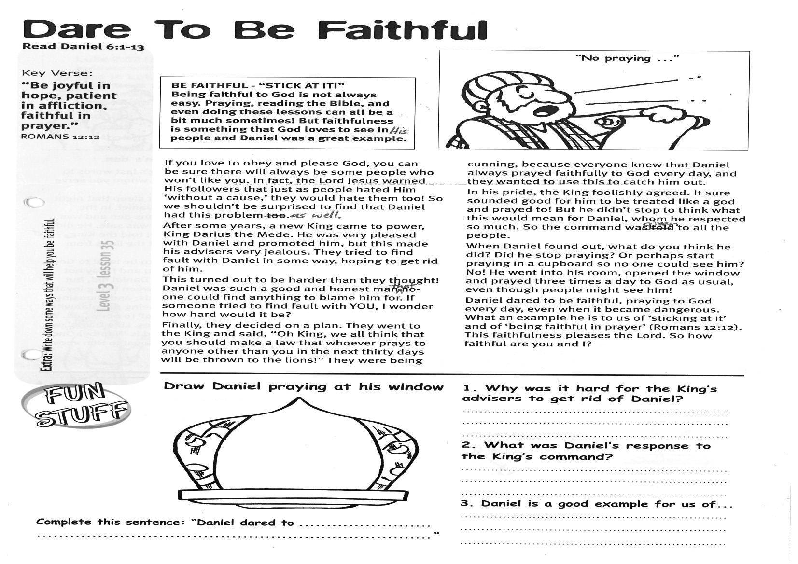

**Read Daniel 6:1-13**

**BE FAITHFUL – “STICK AT IT!”**

**Being faithful to God is not always easy. Praying, reading the Bible, and even doing these lessons can all be a bit much sometimes! But faithfulness is something that God loves to see in His people and Daniel was a great example.**

If you love to obey and please God, you can be sure there will always be some people who won’t like you. In fact, the Lord Jesus warned His followers that just as people hated Him ‘without a cause,’ they would hate them, too! So we shouldn’t be surprised to find that Daniel had this problem as well.

After some years, a new King came to power, King Darius the Mede. He was very pleased with Daniel and promoted him, but this made his advisers very jealous. They tried to find fault with Daniel in some way, hoping to get rid of him.

This turned out to be harder than they thought! Daniel was such a good and honest man that no-one could find anything to blame him for. If someone tried to find fault with YOU, I wonder, how hard would it be?

Finally, they decided on a plan. They went to the King and said, “Oh King, we all think that you should make a law that whoever prays to anyone other than you in the next thirty days will be thrown to the lions!”

Key Verse:  
**“Be joyful in hope, patient in affliction, faithful in prayer.”**Romans 12:12

**Dare To Be Faithful**



**Draw Daniel praying   
at his window**

**Complete this sentence:** “Daniel dared to…  
_______________________________________

_______________________________________

**Extra:** Write down some ways that will help you to be faithful.

**1.** Why was it hard for the King’s advisers to get rid of Daniel?

_______________________________________

_______________________________________

_______________________________________

**2.** What was Daniel’s response to the King’s command?

_______________________________________

_______________________________________

_______________________________________

**3.** Daniel is a good example for us of...

_______________________________________

_______________________________________

_______________________________________

**Level 3 lesson 35**

They were being cunning, because everyone knew that Daniel always prayed faithfully to God every day, and they wanted to use this to catch him out.

In his pride, the King foolishly agreed. It sure sounded good for him to be treated like a god and prayed to! But he didn’t stop to think what this would mean for Daniel, whom he respected so much. So the command was given to all the people.

When Daniel found out, what do you think he did? Did he stop praying? Or perhaps start praying in a cupboard so no-one could see him? No! He went into his room, opened the window and prayed three times a day to God as usual, even though people might see him!

Daniel dared to be faithful, praying to God every day, even when it became dangerous. What an example he is to us of ‘sticking at it’ and of ‘being faithful in prayer’ (Romans 12:12). This faithfulness pleases the Lord. So how faithful are you and I?

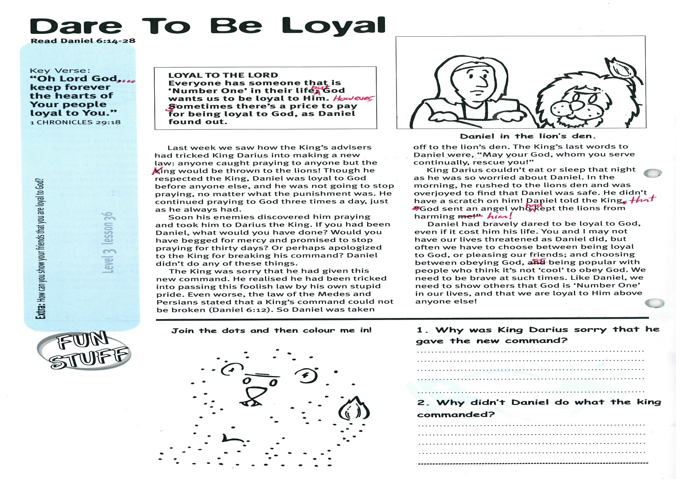

Key Verse:  
**“Oh Lord God… keep forever the hearts of Your people loyal to You.”**1 Chronicles 29:18

**Read Daniel 6:14-28  
  
LOYAL TO THE LORD  
Everyone has someone that is ‘Number One’ in their life; but God wants us to be loyal to Him! However, sometimes there’s a price to pay for being loyal to God, as Daniel found out.**

In our last lesson we saw how the King’s advisers had tricked King Darius into making a new law: any person caught praying to anyone but the King would be thrown to the lions! Though he respected the King, Daniel was loyal to God before anyone else, and he was not going to stop praying, no matter what the punishment was. He continued praying to God three times a day, just as he always had.

Soon his enemies discovered him praying and took him to Darius the King. If you had been Daniel, what would you have done? Would you have begged for mercy and promised to stop praying for thirty days? Or perhaps apologized to the King for breaking his command? Daniel didn’t do any of these things.

The King was sorry that he had given this new command. He realised he had been tricked into passing this foolish law by his own stupid pride. Even worse, the law of the Medes and Persians stated that a King’s command could not be broken (Daniel 6:12). So Daniel was taken off to the lion’s den. The King’s last words to Daniel were, “May your God, whom you serve continually, rescue you!”

**Dare To Be Loyal**

**Answer:**

Daniel in the lion’s den

King Darius couldn’t eat or sleep that night as he was so worried about Daniel. In the morning, he rushed to the lion’s den and was overjoyed to find that Daniel was safe. He didn’t have a scratch on him! Daniel told the King that God sent an angel who had kept the lions from harming him!

Daniel had bravely dared to be loyal to God, even if it cost him his life. You and I may not have our lives threatened as Daniel did, but often we have to choose between being loyal to God, or pleasing our friends; and choosing between obeying God, or being popular with people who think it’s not ‘cool’ to obey God. We need to be brave at such times. Like Daniel, we need to show others that God is ‘Number One’ in our lives, and that we are loyal to Him above anyone else!

**Level 3 lesson 36**

**Extra:** How can you show your friends that you are loyal to God?



**1.** Why was King Darius sorry that he gave the new command?

_______________________________________

_______________________________________

_______________________________________

_______________________________________

**2.** Why didn’t Daniel do what the king commanded?

_______________________________________

_______________________________________

_______________________________________

**Join the dots & colour me in!**

Please complete and return by post to   
**PSSM Bible Discovery, 5/399 New North Rd, Kingsland, Auckland 1021** or scan & email to **info@biblediscovery.org.nz**