Key Verse:  
**“The Lord is my Shepherd.”**

Psalm 23:1a

He followed the sound until at last he found the lost and lonely little lamb, fallen down a bank.

The foolish little lamb had seen a nice bit of green grass. But instead of staying near the others, he had wandered away by himself to get it, and become trapped down the bank, unable to get back! Carefully the shepherd leaned down and gathered up the cold, trembling lamb.

How that little lamb snuggled in close to the shepherd as he went back all the long way home. The shepherd was tired, but his heart was happy! He had found His little lost sheep. He was so happy he told all his friends about it!

The Bible tells us that we are like lost sheep, too. We were lost in sin, but Jesus is the Good Shepherd who came to rescue us. When we ask Him to forgive our sins and be our Saviour we can truly say, “The LORD is MY Shepherd!” And just as that little lamb snuggled in close to the shepherd, so we should stay close to Jesus. As we listen to Him, and lovingly follow and obey Him, He will keep us safe from harm and danger.   
See if you can memorise Psalm 23 which talks about this!

**Read: Luke 15:1-7**The Lord Jesus once told three ‘parables’ about things that were lost. A parable is an earthly story with a heavenly meaning.  
Jesus’ first story was of a shepherd who had a hundred sheep. Each night, he would stand at the door of the ‘fold’ (the sheep-pen) and count his sheep as they went in. One night he counted right up to ninety-eight, ninety-nine, and then… oh no… not 100!

One little lamb was missing! The shepherd looked all around, but he was nowhere to be seen. The shepherd loved all his sheep; he was sad to think of even one lost out in the dark, with dangerous wolves roaming around. All his sheep needed his protection! Leaving the ninety-nine safe and warm, he set off to find the little lost sheep.

Away over the hills the shepherd went, with his shepherd’s crook in his hand. On and on he walked through the dark night, searching along the rocky paths and streams. His ears strained to hear any sound. Suddenly he heard it; a faint little “baa..... baa!”

**The Lost Sheep**

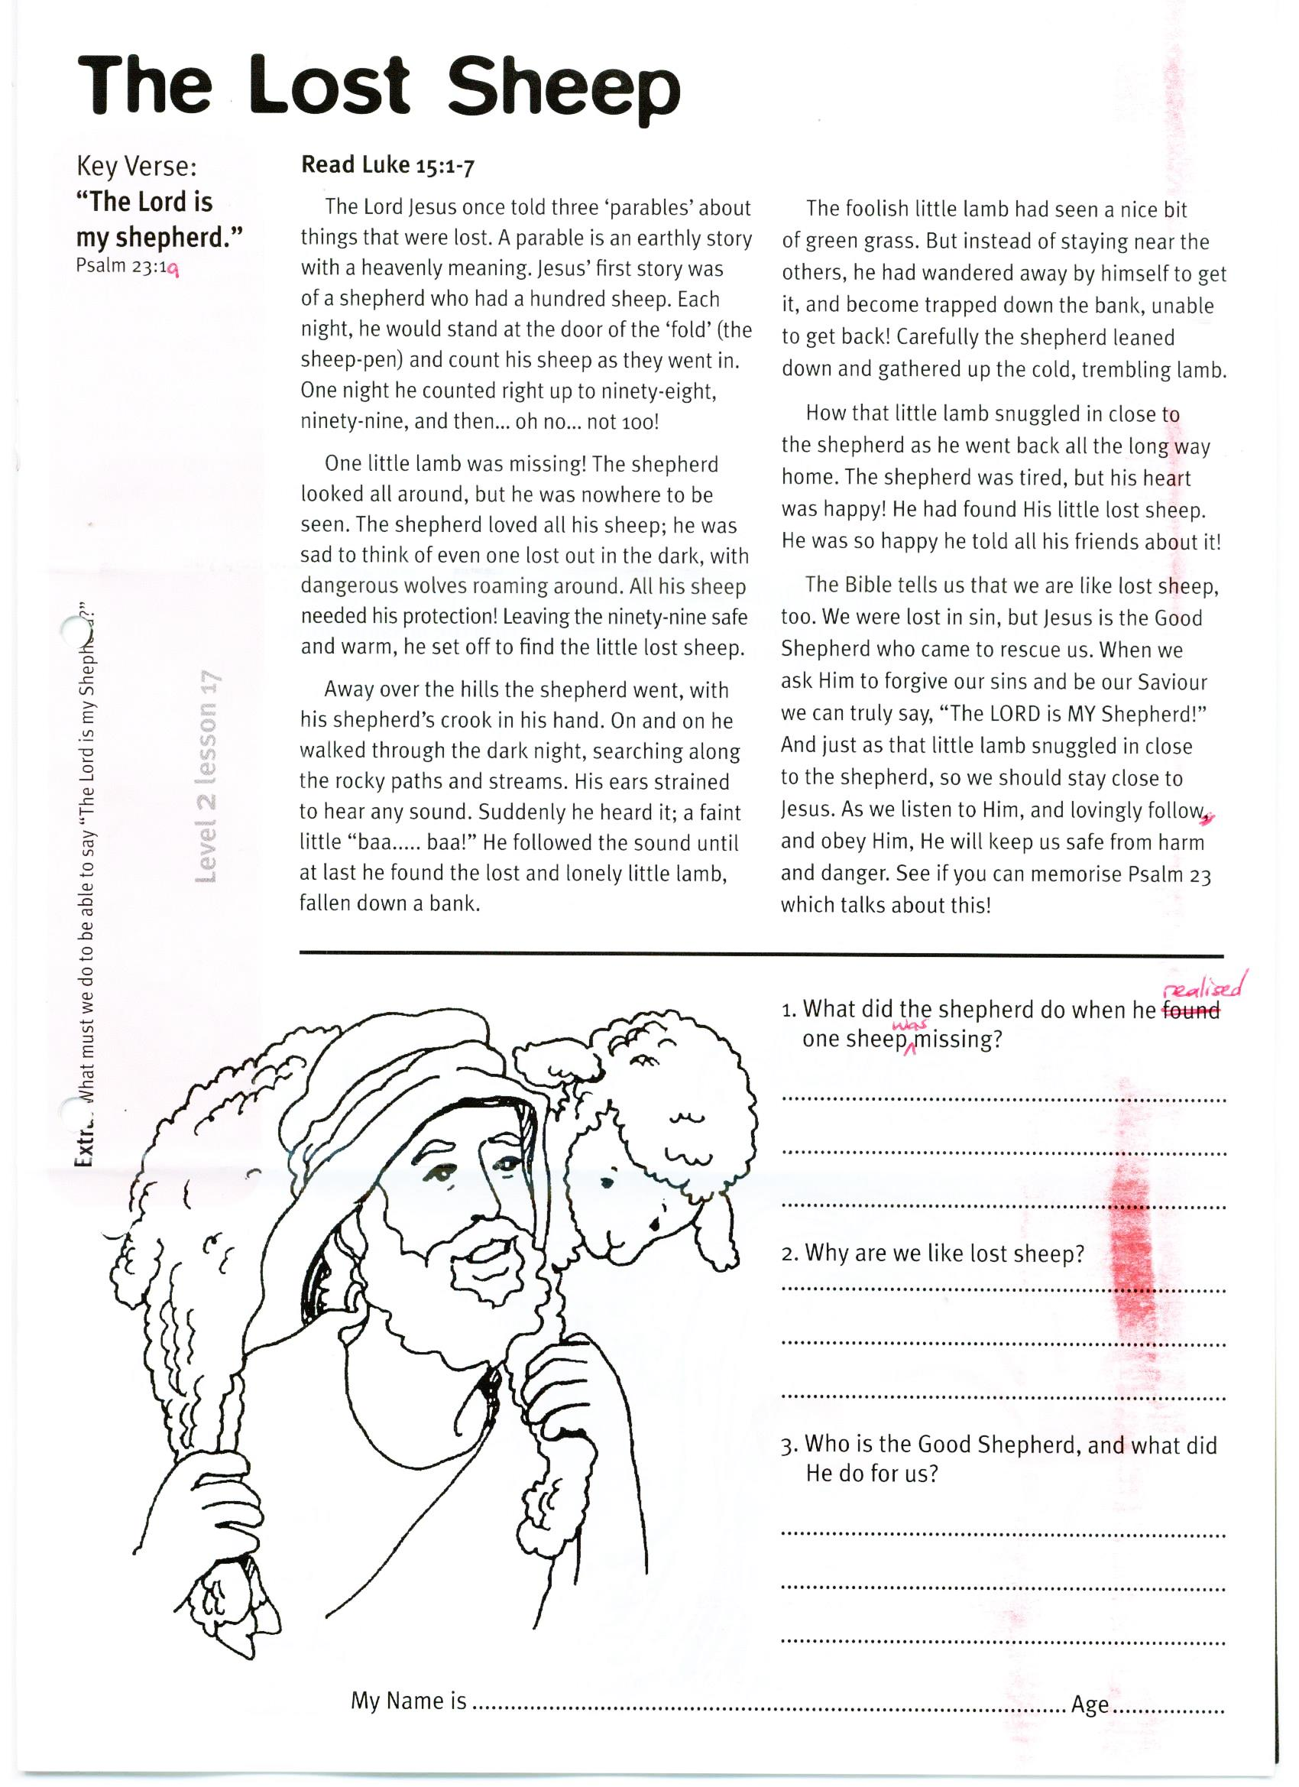

**Extra:** What must we do to be able to say “The Lord is **my** Shepherd”?

1. What did the shepherd do when he realised that one sheep was missing?  
__________________________________________________________________

2. Why are we like lost sheep?  
__________________________________________________________________

3. Who is the Good shepherd, and what did He do for us?  
___________________________________________________________________________________________________

My Name is________________________________________  
Age______

**Level 2 lesson 17**

**The Lost Coin**

Do you know young ones, the Lord Jesus said, “There is joy in Heaven among the angels of God when one lost sinner is found!” The Bible says we are all lost like that coin. But it also says, that Jesus came, “to seek, and to save those who are lost.”

If we come to the Lord Jesus, confess our sins, and ask Him to be our Saviour and Good Shepherd, He and all the angels in heaven will rejoice just like that poor lady when she found her lost coin. Jesus will forgive all our sins and happily say, “I have found another lost sinner!”

**Read Luke 15:8-10**

Jesus told another parable about a poor lady who only had ten coins. Of course they were very precious to her, as they were all she had. Then sadly, one day she lost one of them! She was very upset and started searching all through her house for it. She moved boxes. She swept in corners. She looked behind the chairs and picked up the mats and shook them. Still she could not find her precious coin.

After a while it got dark, but that didn’t stop her! She simply lit a candle and kept on looking (they did not have good torches with batteries like we have today!). She got down on her hands and knees and looked under the beds, and all the furniture, to see if the coin had rolled under there.

When her neighbour called in to see her, she told her about the lost coin too. Then she kept on searching and searching, until she finally found it! How happy she was! Quickly she ran into her friend’s house and called out, “I’ve found it!” Then her friend rejoiced too, because the precious lost coin had been found.

Key Verse:  
**“[Jesus] came to seek and to save what was lost.’ “**

Luke 19:10



Add the missing coin

1. Why is the lady smiling?

___________________________________  
  
___________________________________

2. Why did Jesus come?

___________________________________  
  
___________________________________

**Fill in the missing words:**

This is the story of a lady who had  
__ __ __ coins.

One day she __ __ __ __ one.

When she found it, her friend  
__ __ __ __ __ __ __ __ too.

**Level 2 lesson 18**

**Extra:** Find out what causes joy in Heaven.

Even his father’s servants would have good food to eat! He realised how foolish he had been.

He decided to return home to his father and tell him how sorry he was. He would tell him he had sinned against Heaven and against him. He would ask to become a servant. So he started to walk back home.

All this time, his father’s heart had been very sad. He often looked down the road to see if his son was coming home. Then one day he looked and saw him coming! Happily he ran to meet him and gave him a big hug! He gave him some new clothes and made a big ‘welcome home’ party for his ‘lost’ son.

But the elder brother was jealous and angry at his brother’s welcome. His father explained why he was so happy. “Your brother was dead, and is alive again; he was lost, and now is found!”

What a lovely picture of God’s love for each of us! Just like the father in the story, God loves us and is waiting for each one of us to return to Him and ask for forgiveness. We all need to forgive each other too, just as He has forgiven us.

Key Verse:  
**“If we confess our sins, He… will forgive us…”**

1 John 1:9a

**Read Luke 15:11-31**  
The Lord Jesus then told His disciples a third parable about something that was lost. This story was about a boy who often disobeyed and argued with his father. He thought his father was just trying to stop him have fun. One day, this young man asked his father for the money that would be his when his father died!

Sadly, the father agreed. The youngest son took his money and travelled far away. Now the young man could do as he pleased, and he thought it was great! While he had lots of money, he had plenty of friends! But soon it was all gone. Then a famine came and everyone was hungry. The young man tried to earn some money but he couldn’t get a job.

Soon, he had no home, no money and no food. At last he found work feeding a farmer’s pigs. He was so hungry he was ready to eat some of the pig’s food! Suddenly, he thought about his home and family far away.

**The Lost Boy**

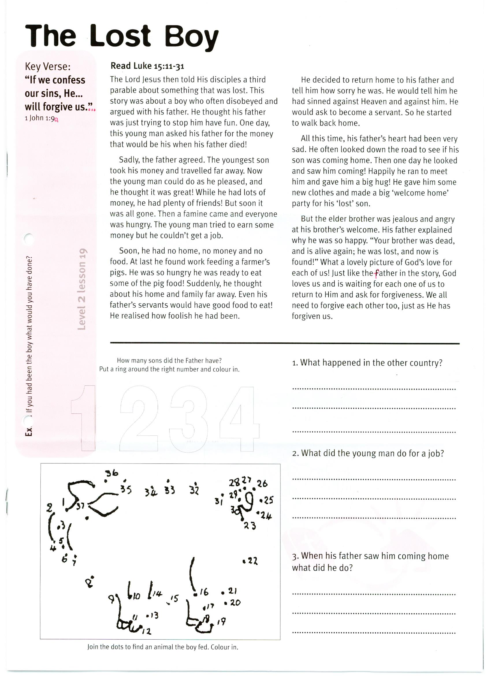

**Level 2 lesson 19**

**Extra:** If you had been the boy, what would you have done?

How many sons did the father have? (Put a ring around the right number)  
**1 2 3 4**

1. What happened in the other country?

_________________________________  
  
_________________________________

2. What did the young man do for a job?

_________________________________  
  
_________________________________

3. When his father saw him coming home, what did he do?

_________________________________  
  
_________________________________

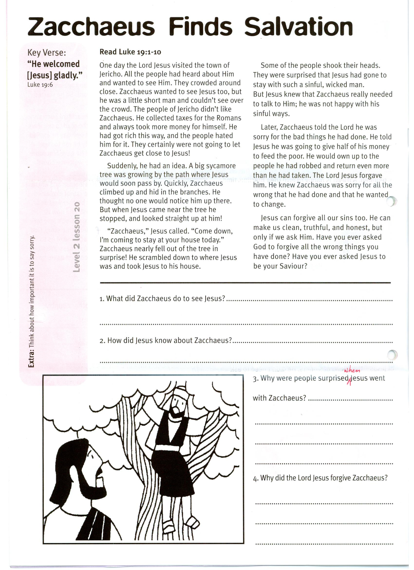

**Extra:** Think about how important it is to say “sorry”.

Key Verse: **“He welcomed [Jesus] gladly.”**

Luke 19:6

Please complete and return by post to   
**PSSM Bible Discovery, 5/399 New North Rd, Kingsland, Auckland 1021** or scan & email to **info@biblediscovery.org.nz**

1. What did Zacchaeus do to see Jesus?

2. How did Jesus know about Zacchaeus?

3. Why were the people surprised when Jesus went with Zacchaeus?

4. Why did the Lord Jesus forgive Zacchaeus?

Some of the people shook their heads. They were surprised that Jesus had gone to stay with such a sinful, wicked man. But Jesus knew that Zacchaeus really needed to talk to Him; he was not happy with his sinful ways.

Later, Zacchaeus told the Lord he was sorry for the bad things he had done. He told Jesus he was going to give half of his money to feed the poor. He would own up to the people he had robbed and return even more than he had taken. The Lord Jesus forgave him. He knew Zacchaeus was sorry for all the wrong that he had done and that he wanted to change.

Jesus can forgive all our sins too. He can make us clean, truthful, and honest, but only if we ask Him. Have you ever asked God to forgive all the wrong things you have done? Have you ever asked Jesus to be your Saviour?

**Read Luke 19:1-10**

One day the Lord Jesus visited the town of Jericho. All the people had heard about Him and wanted to see Him. They crowded around close. Zacchaeus wanted to see Jesus too, but he was a little short man and couldn’t see over the crowd. The people of Jericho didn’t like Zacchaeus. He collected taxes for the Romans and always took more money for himself. He had got rich this way, and the people hated him for it. They certainly were not going to let Zacchaeus get close to Jesus!

Suddenly, he had an idea. A big sycamore tree was growing by the path where Jesus would soon pass by. Quickly, Zacchaeus climbed up and hid in the branches. He thought no one would notice him up there. But when Jesus came near the tree He stopped, and looked straight up at him!

“Zacchaeus,” Jesus called. “Come down, I’m coming to stay at your house today.” Zacchaeus nearly fell out of the tree in surprise! He scrambled down to where Jesus was and took Jesus to his house.

**Level 2 lesson 20**

**Zacchaeus Finds Salvation!**