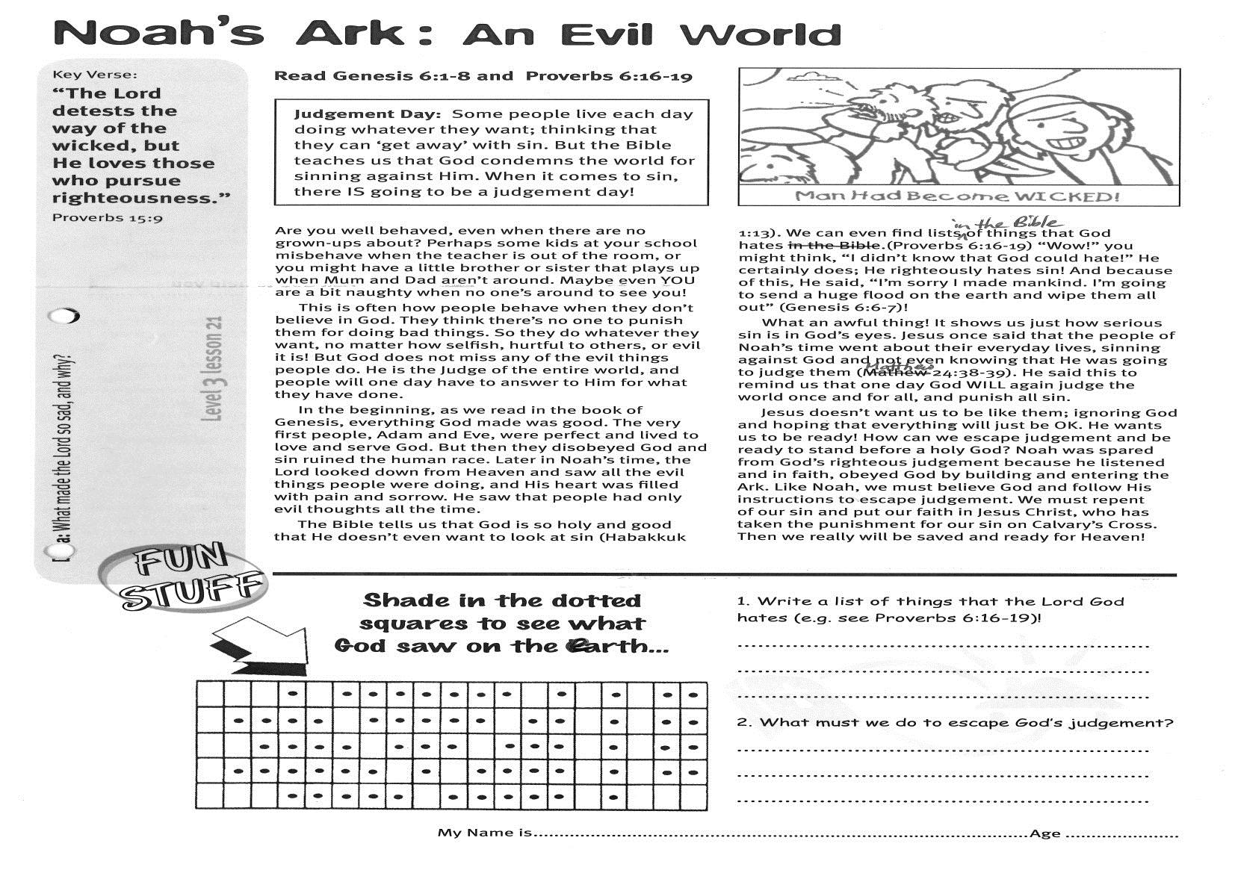

Key Verse:  
**“The Lord detests the way of the wicked, but He loves those who pursue righteousness.”**

Proverbs 15:9

**Read Genesis 6:1-8   
and Proverbs 6:16-19**

**Judgement Day: Some people live each day doing whatever they want; thinking that they can ‘get away’ with sin. But the Bible teaches us that God condemns the world for sinning against Him. When it comes to sin, there IS going to be a judgement day!**

Are you well behaved, even when there are no grown-ups about? Perhaps some kids at your school misbehave when the teacher is out of the room, or you might have a little brother or sister that plays up when Mum and Dad aren’t around. Maybe even YOU are a bit naughty when no one’s around to see you!

This is often how people behave when they don’t believe in God. They think there’s no-one to punish them for doing bad things. So they do whatever they want, no matter how selfish, hurtful to others, or evil it is! But God does not miss any of the evil things people do. He is the Judge of the entire world, and people will one day have to answer to Him for what they have done.

In the beginning, as we read in the book of Genesis, everything God made was good. The very first people, Adam and Eve, were perfect and lived to love and serve God. But then they disobeyed God and sin ruined the human race. Later in Noah’s time, the Lord looked down from Heaven and saw all the evil things people were doing, and His heart was filled with pain and sorrow. He saw that people had only evil thoughts all the time.

**Noah’s Ark: An Evil World**

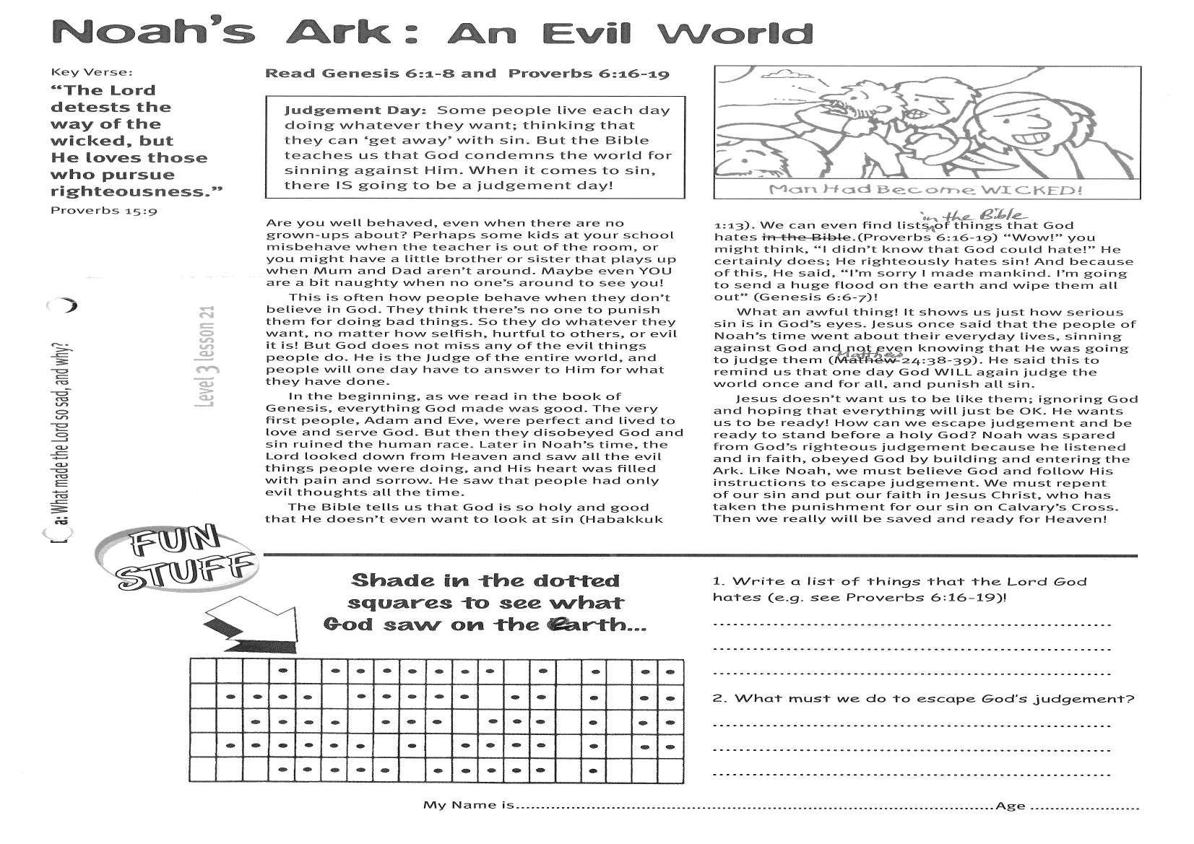

**Shade in the dotted squares to see what God saw on the earth…**

1. Write a list of things that the Lord God hates! (see Proverbs 6:16-19)

_____________________________________

_____________________________________

_____________________________________

_____________________________________

2. What must we do to escape God’s  
judgement?  
_____________________________________  
_____________________________________  
_____________________________________  
_____________________________________

The Bible tells us that God is so holy and good that He doesn’t even want to look at sin (Habakkuk 1:13). We can even find lists in the Bible of things that God hates (Proverbs 6:16-19) “Wow!” you might think, “I didn’t know that God could hate!” He certainly does; He righteously hates sin! And because of this, He said, “I’m sorry I made mankind. I’m going to send a huge flood on the earth and wipe them all out!” (Genesis 6:6-7)  
What an awful thing! It shows us just how serious sin is in God’s eyes. Jesus once said that the people of Noah’s time went about their everyday lives, sinning against God and not even knowing that He was going to judge them (Matthew 24:38-39). He said this to remind us that one day God WILL again judge the world once and for all, and punish all sin.  
Jesus doesn’t want us to be like them; ignoring God and hoping that everything will just be OK. He wants us to be ready! How can we escape judgement and be ready to stand before a holy God? Noah was spared from God’s righteous judgement because he listened and in faith, obeyed God; by building and entering the Ark. Like Noah, we must believe God and follow His instructions to escape judgement. We must repent of our sin and put our faith in Jesus Christ, who has taken the punishment for our sin on Calvary’s Cross. Then we really will be saved and ready for Heaven!

**Level 3 lesson 21**

**Extra:** What made the Lord so sad, and why?

My Name is ……………………………………………………… Age…………………

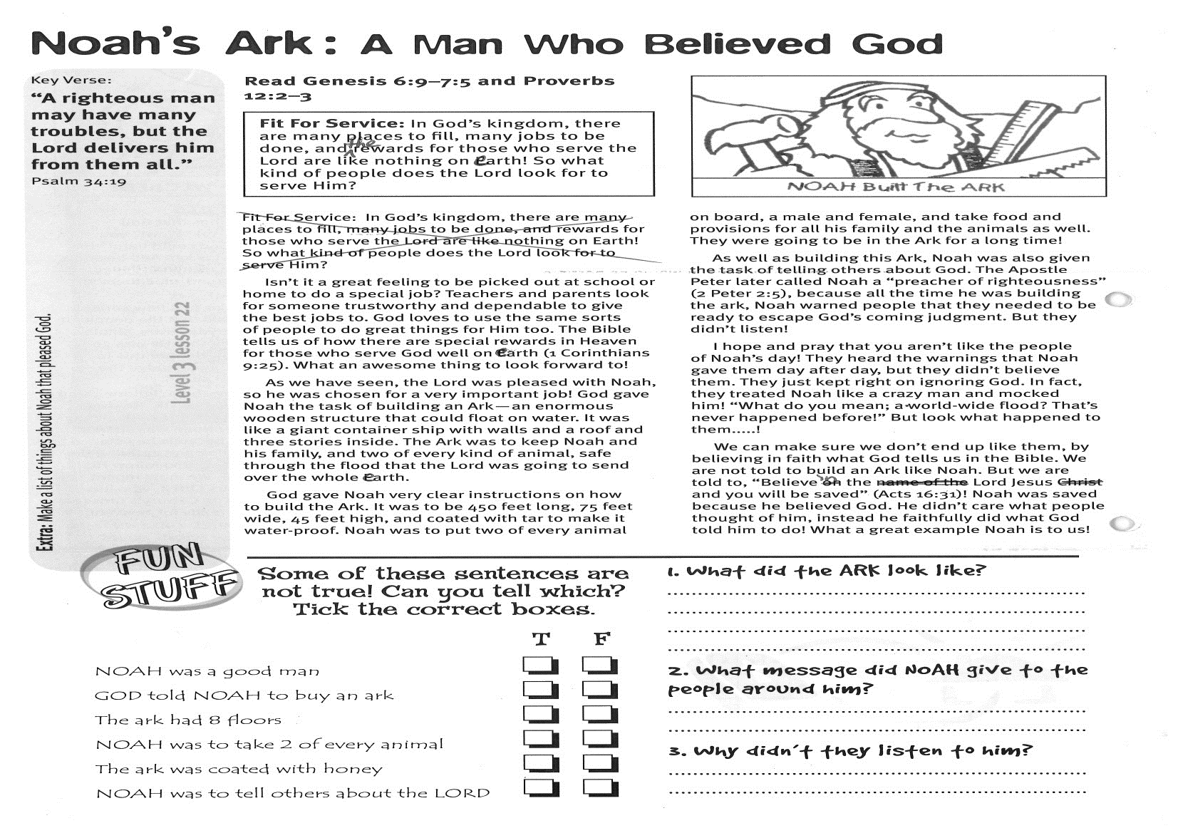

**Noah’s Ark: A Man Who Believed God**

Key Verse:  
**“A righteous man may have many troubles, but the Lord delivers him from them all.”**

Psalm 34:19

**Read Genesis 6:9-7:5   
and Proverbs 12:2-3**

**Fit For Service: In God’s kingdom, there are many places to fill, many jobs to be done, and the rewards for those who serve the Lord are like nothing on earth! So what kind of people does the Lord look for to serve Him?**

Isn’t it a great feeling to be picked out at school or home to do a special job? Teachers and parents look for someone trustworthy and dependable to give the best jobs to. God loves to use the same sorts of people to do great things for Him, too. The Bible tells us of how there are special rewards in Heaven for those who serve God well on earth (1 Corinthians 9:25). What an awesome thing to look forward to!

As we have seen, the Lord was pleased with Noah, so he was chosen for a very important job! God gave Noah the task of building an Ark - an enormous wooden structure that could float on water. It was like a giant container ship with walls and a roof and three stories inside. The Ark was to keep Noah and his family, and two of every kind of animal; safe through the flood that the Lord was going to send over the whole earth.

God gave Noah very clear instructions on how to build the Ark. It was to be 450 feet long, 75 feet wide, 45 feet high, and coated with tar to make it water-proof. Noah was to put two of every animal on board, a male and female, and take food and provisions for all his family and the animals as well. They were going to be in the Ark for a long time!

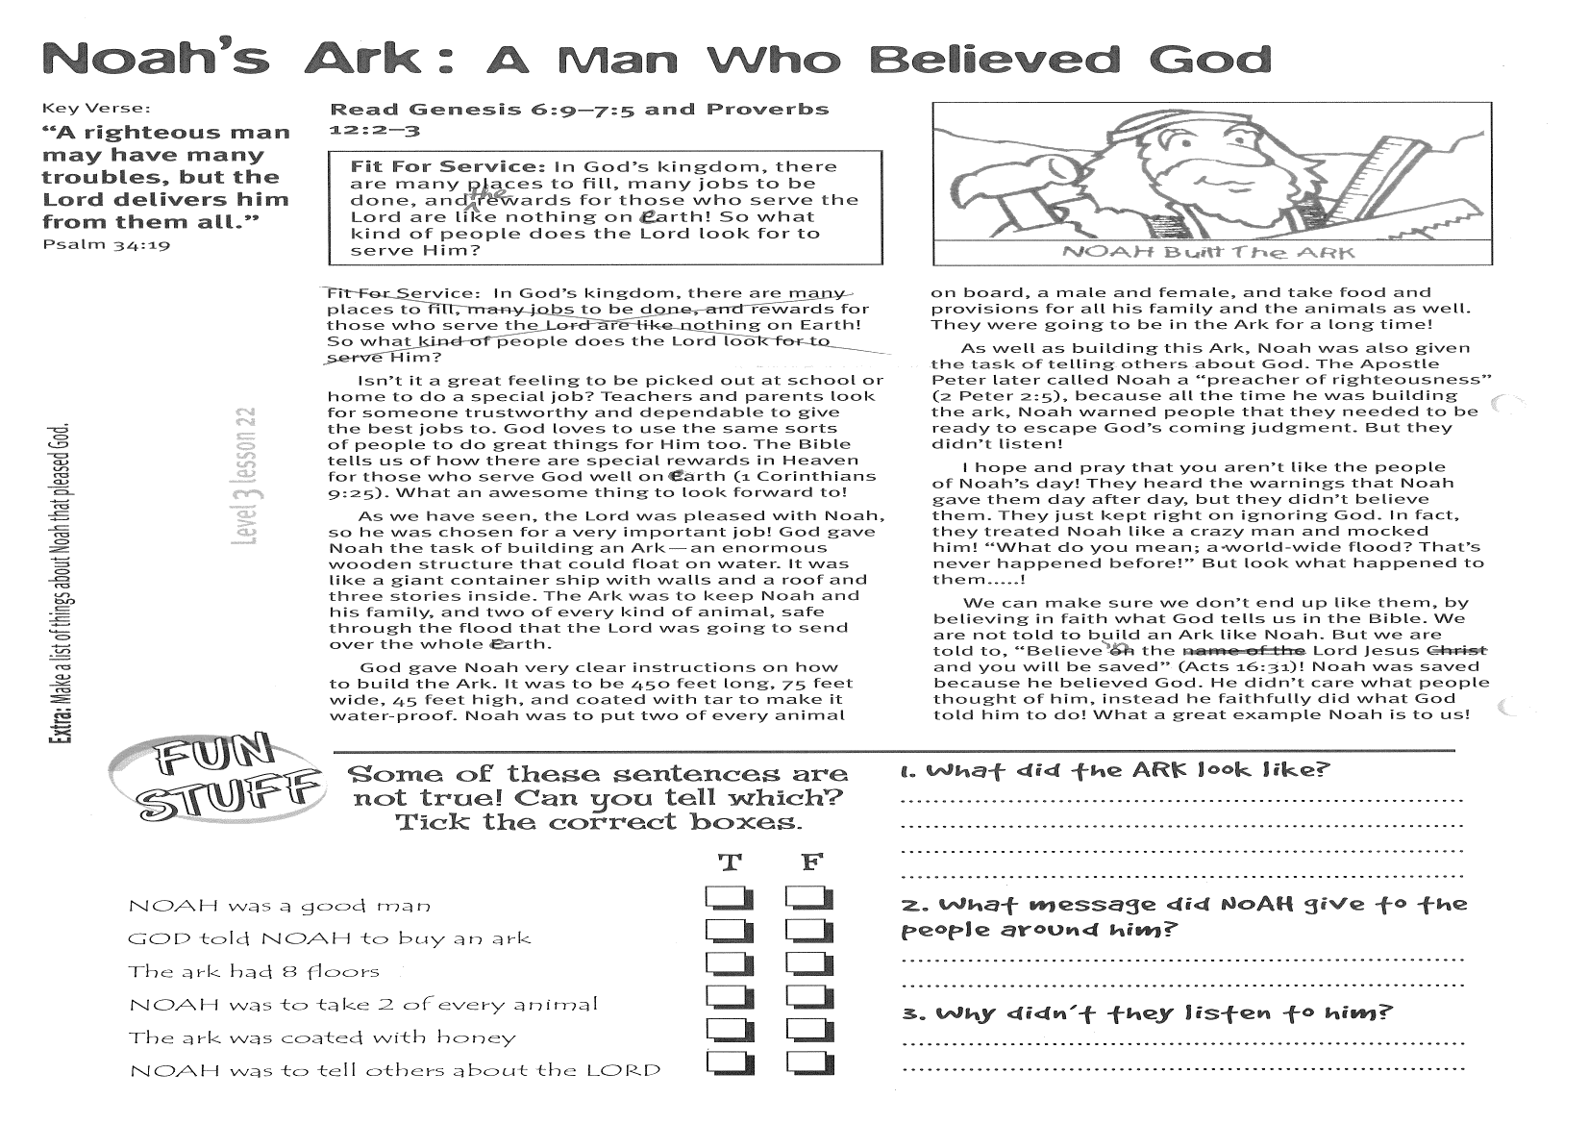

**Some of these sentences are not true! Can you tell which?**

**Tick the correct boxes:**

1. What did the Ark look like?

_________________________________________

__________________________________________________________________________________

2. What message did Noah give to the people around him?

________________________________________

________________________________________

3. Why didn’t they listen to him?

________________________________________

________________________________________

________________________________________

**Level 3 lesson 22**

**Extra:** Make a list of things about Noah that pleased God.

As well as building this Ark, Noah was also given the task of telling others about God. The Apostle Peter later called Noah a “preacher of righteousness” (2 Peter 2:5), because all the time he was building the ark, Noah warned people that they needed to be ready to escape God’s coming judgment. But they didn’t listen!

I hope and pray that you aren’t like the people of Noah’s day! They heard the warnings that Noah gave them day after day, but they didn’t believe them. They just kept right on ignoring God. In fact, they treated Noah like a crazy man and mocked him! “What do you mean; a world-wide flood? That’s never happened before!” But look what happened to them.....!

We can make sure we don’t end up like them, by believing in faith what God tells us in the Bible. We are not told to build an Ark like Noah. But we are told to, “Believe in the Lord Jesus and you will be saved.” (Acts 16:31)   
Noah was saved because he believed God. He didn’t care what people thought of him; instead he faithfully did what God told him to do! What a great example Noah is to us!

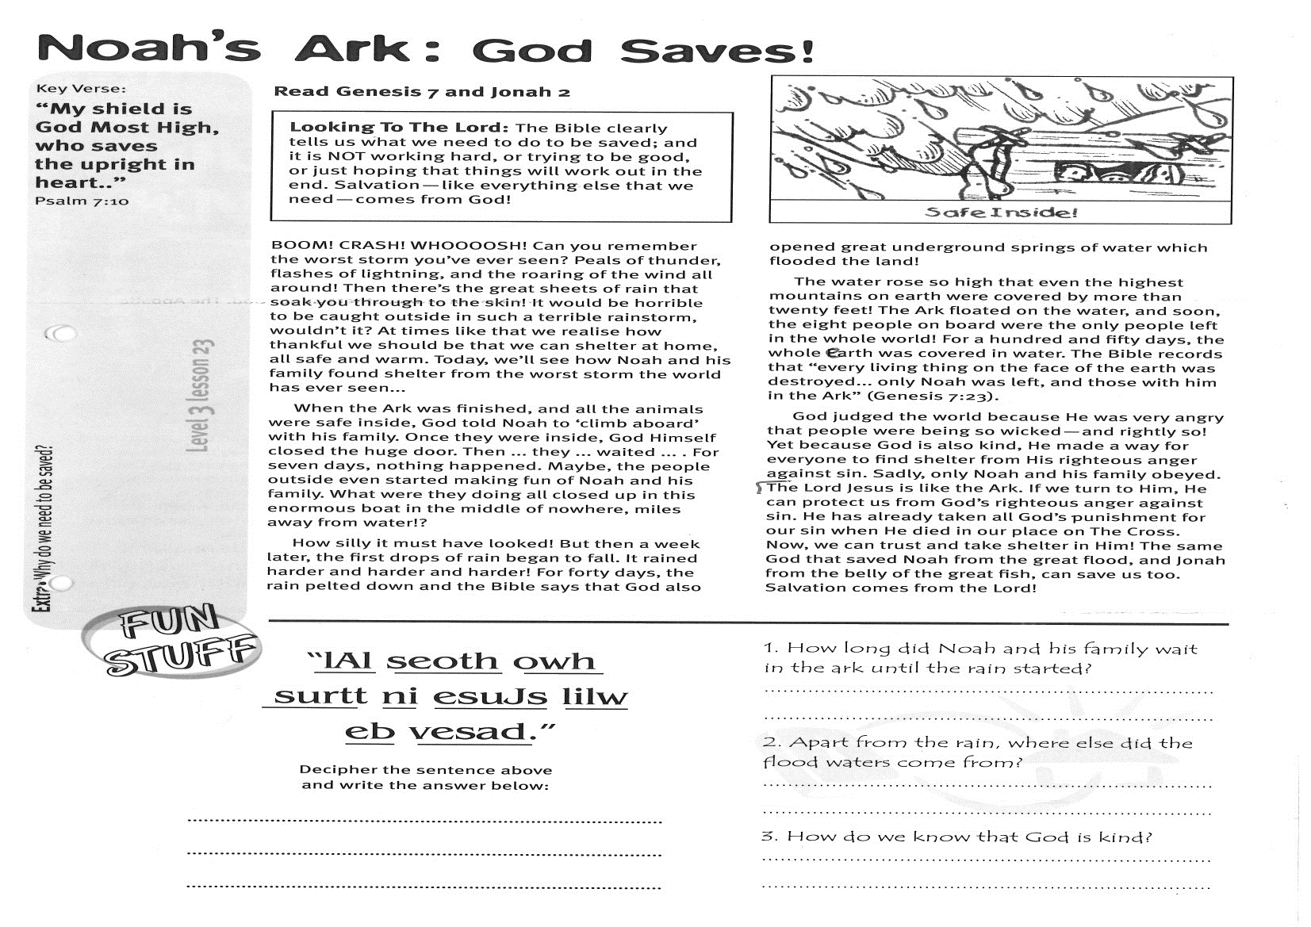

**Read Genesis 7 and Jonah 2**  
**Looking To The Lord: The Bible clearly tells us what we need to do to be saved; and it is NOT working hard, or trying to be good, or just hoping that things will work out in the end. Salvation (like everything else that we need) comes from God!**

BOOM! CRASH! WHOOOOSH! Can you remember the worst storm you’ve ever seen? Peals of thunder, flashes of lightning, and the roaring of the wind all around! Then there’s the great sheets of rain that soak you through to the skin! It would be horrible to be caught outside in such a terrible rainstorm, wouldn’t it? At times like that we realise how thankful we should be that we can shelter at home, all safe and warm. Today, we’ll see how Noah and his family found shelter from the worst storm the world has ever seen...

When the Ark was finished, and all the animals were safe inside, God told Noah to ‘climb aboard’ with his family. Once they were inside, God Himself closed the huge door. Then ... they ... waited ... . For seven days, nothing happened. Maybe, the people outside even started making fun of Noah and his family. What were they doing all closed up in this enormous boat in the middle of nowhere, miles away from water!?

How silly it must have looked! But then a week later, the first drops of rain began to fall. It rained harder and harder and harder! For forty days, the rain pelted down and the Bible says that God also opened great underground springs of water which flooded the land!

Key Verse:  
**“My shield is God Most High, who saves the upright in heart.”**

Psalm 7:10

**Noah’s Ark: God Saves!**

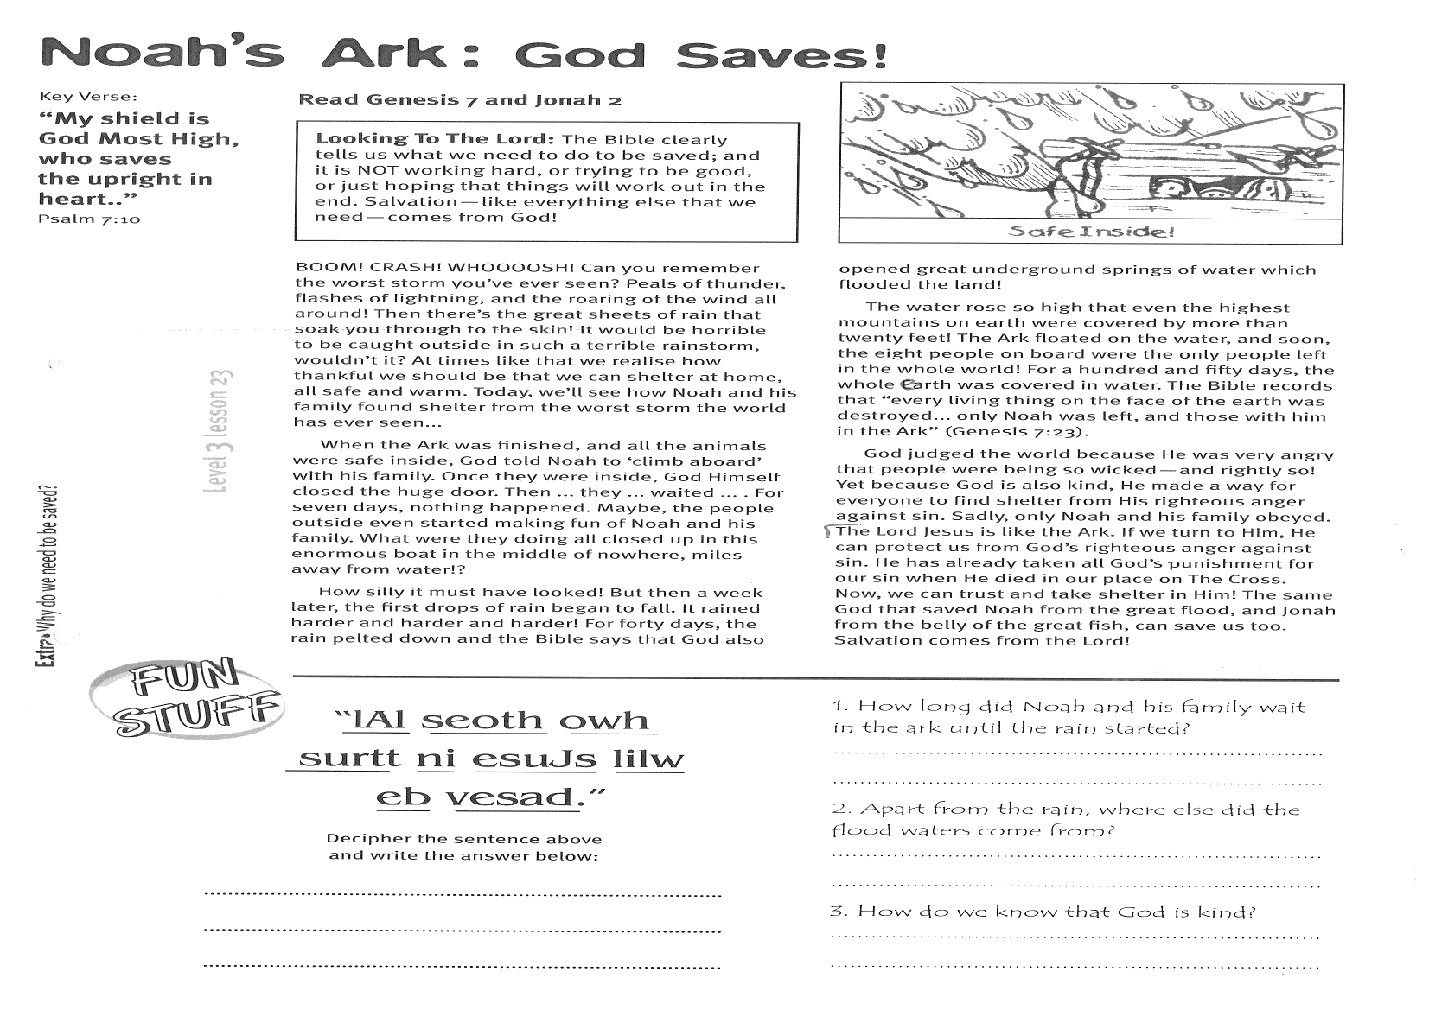

1. How long did Noah and his family wait in the Ark until the rain started?

___________________________________________

___________________________________________

2. Apart from the rain, where else did the flood waters come from?

___________________________________________

___________________________________________

3. How do we know that God is kind?

___________________________________________

___________________________________________

___________________________________________

The water rose so high that even the highest mountains on earth were covered by more than twenty feet! The Ark floated on the water, and soon, the eight people on board were the only people left in the whole world! For a hundred and fifty days, the whole earth was covered in water. The Bible records that “every living thing on the face of the earth was destroyed... only Noah was left, and those with him in the Ark” (Genesis 7:23).

God judged the world because He was very angry that people were being so wicked, and rightly so! Yet because God is also kind, He made a way for everyone to find shelter from His righteous anger against sin. Sadly, only Noah and his family obeyed.

The Lord Jesus is like the Ark. If we turn to Him, He can protect us from God’s righteous anger against sin. He has already taken all God’s punishment for our sin when He died in our place on The Cross. Now, we can trust and take shelter in Him! The same God that saved Noah from the great flood, and Jonah from the belly of the great fish, can save us, too.  
Salvation comes from the Lord!

……………………………………………………………………………………………………………………………………………………………………………………

**Level 3 lesson 23**

**Extra:** Why do we need to be saved?

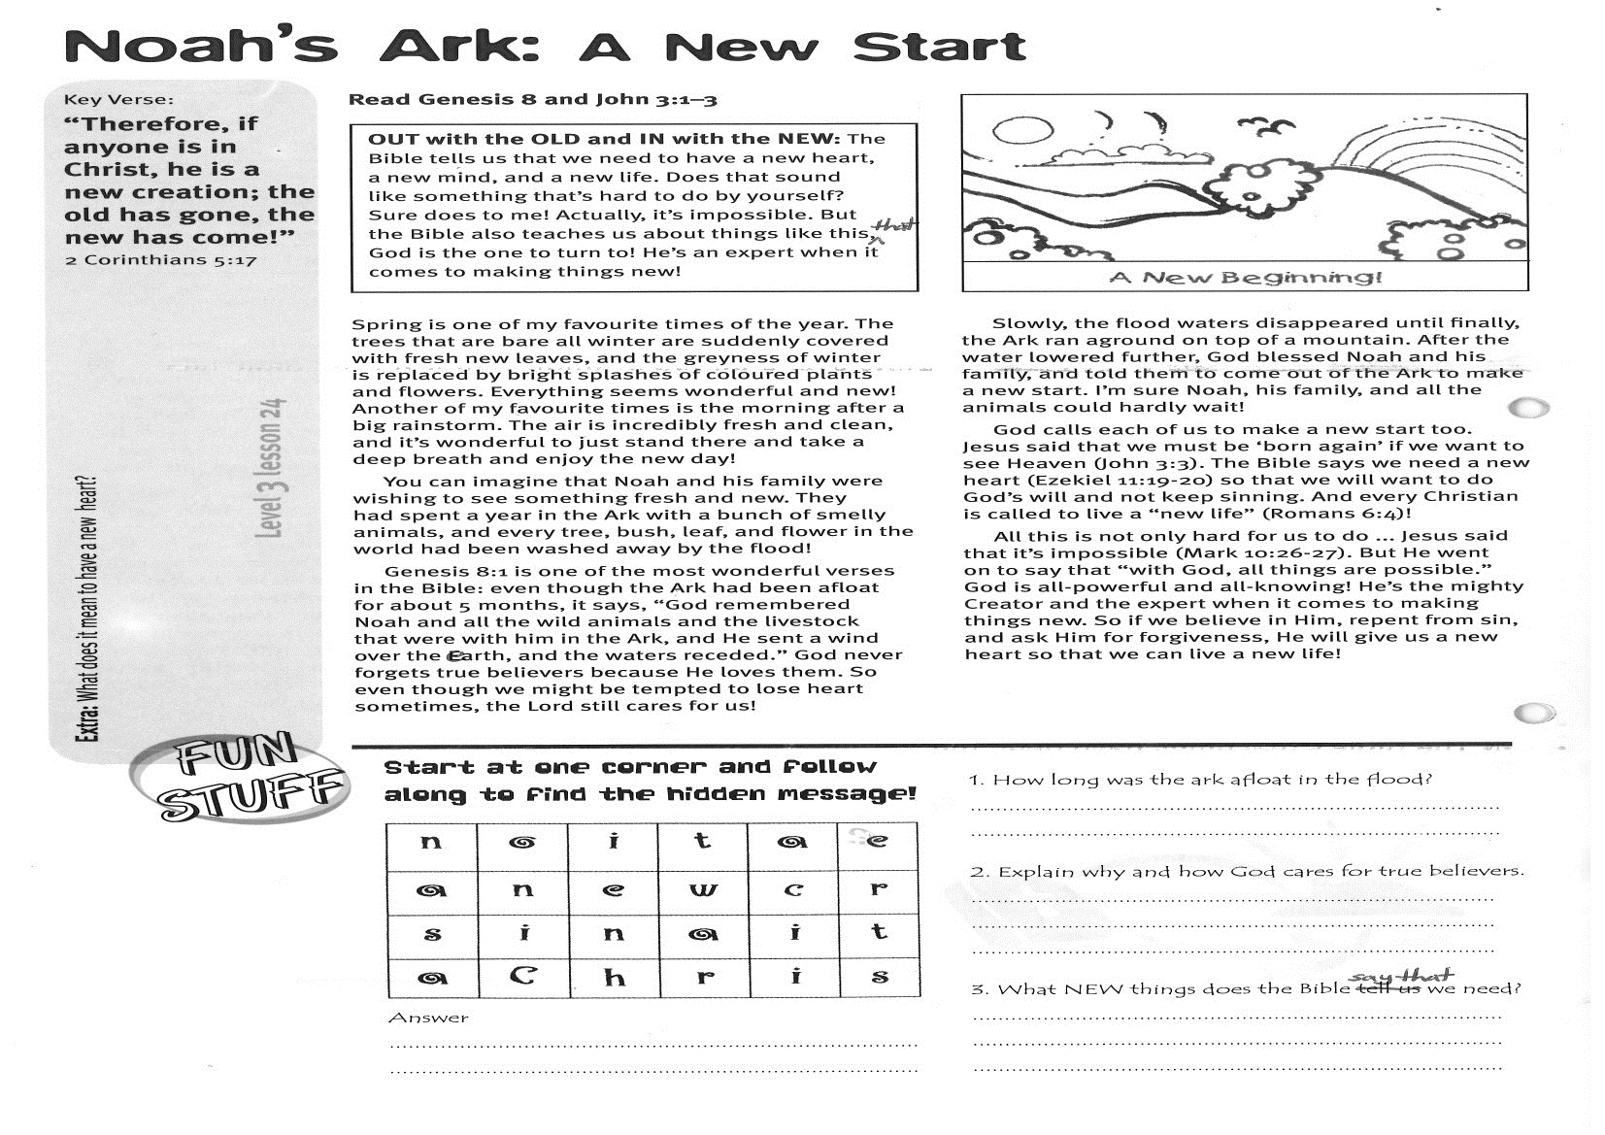

**Read Genesis 8 and John 3:1-3**

**OUT with the OLD and IN with the NEW: The Bible tells us that we need to have a new heart, a new mind, and a new life. Does that sound like something that’s hard to do by yourself? Sure does to me! Actually, it’s impossible. But the Bible also teaches us about things like this, and that God is the one to turn to! He’s an expert when it comes to making things new!**

Spring is one of my favourite times of the year. The trees that are bare all winter are suddenly covered with fresh new leaves, and the greyness of winter is replaced by bright splashes of coloured plants and flowers. Everything seems wonderful and new! Another of my favourite times is the morning after a big rainstorm. The air is incredibly fresh and clean, and it’s wonderful to just stand there and take a deep breath and enjoy the new day!

You can imagine that Noah and his family were wishing to see something fresh and new. They had spent a year in the Ark with a bunch of smelly animals, and every tree, bush, leaf, and flower in the world had been washed away by the flood!  
Genesis 8:1 is one of the most wonderful verses in the Bible: even though the Ark had been afloat for about 5 months, it says, “God remembered Noah and all the wild animals and the livestock that were with him in the Ark, and He sent a wind over the earth, and the waters receded.” God never forgets true believers because He loves them. So even though we might be tempted to lose heart sometimes, the Lord still cares for us!

Key Verse:  
**“Therefore, if anyone is in Christ, he is a new creation; the old has gone, the new has come!”**

2 Corinthians 5:17

**Noah’s Ark: A New Start**

**Answer:**

Slowly, the flood waters disappeared until finally, the Ark ran aground on top of a mountain. After the water lowered further, God blessed Noah and his family, and told them to come out of the Ark to make a new start. I’m sure Noah, his family, and all the animals could hardly wait!

God calls each of us to make a new start, too. Jesus said that we must be ‘born again’ if we want to see Heaven (John 3:3). The Bible says we need a new heart (Ezekiel 11:19-20) so that we will want to do God’s will and not keep sinning. And every Christian is called to live a “new life”! (Romans 6:4)

All this is not only hard for us to do ... Jesus said that it’s impossible (Mark 10:26-27). But He went on to say that “with God, all things are possible.”

God is all-powerful and all-knowing! He’s the mighty Creator and the expert when it comes to making things new. So if we believe in Him, repent from sin, and ask Him for forgiveness, He will give us a new heart so that we can live a new life!

**Level 3 lesson 24**

**Extra:** What does it mean to have a new heart?

1. How long was the ark afloat in the flood?

_______________________________________

_______________________________________

2. Explain why and how God cares for true believers.

_______________________________________

_______________________________________

_______________________________________

3. What NEW things does the Bible say that we need?

_______________________________________

_______________________________________

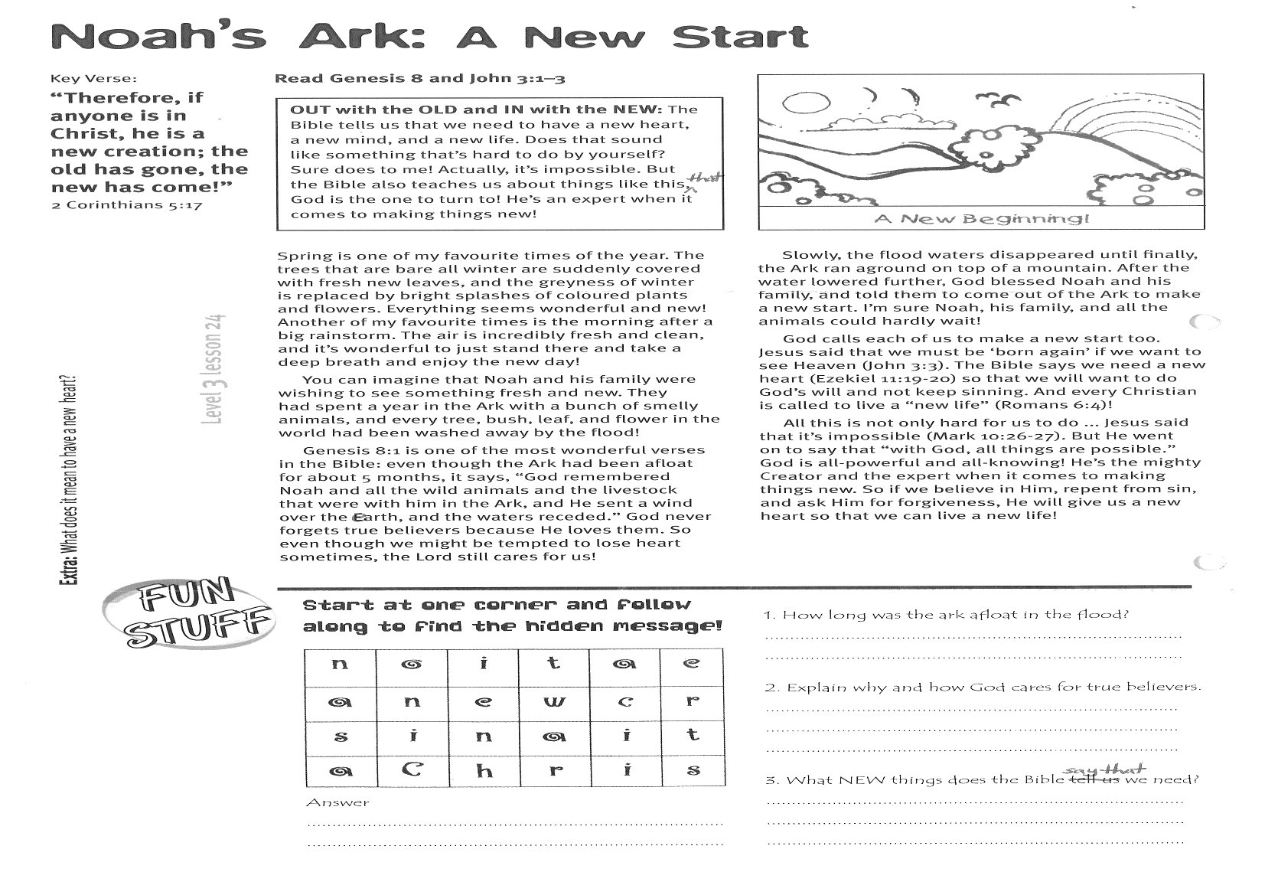

**ANSWER: __________________________________________________**

Please complete and return by post to: **PSSM Bible Discovery, 5/399 New North Rd, Kingsland, Auckland 1021** or scan & email to **info@biblediscovery.org.nz**