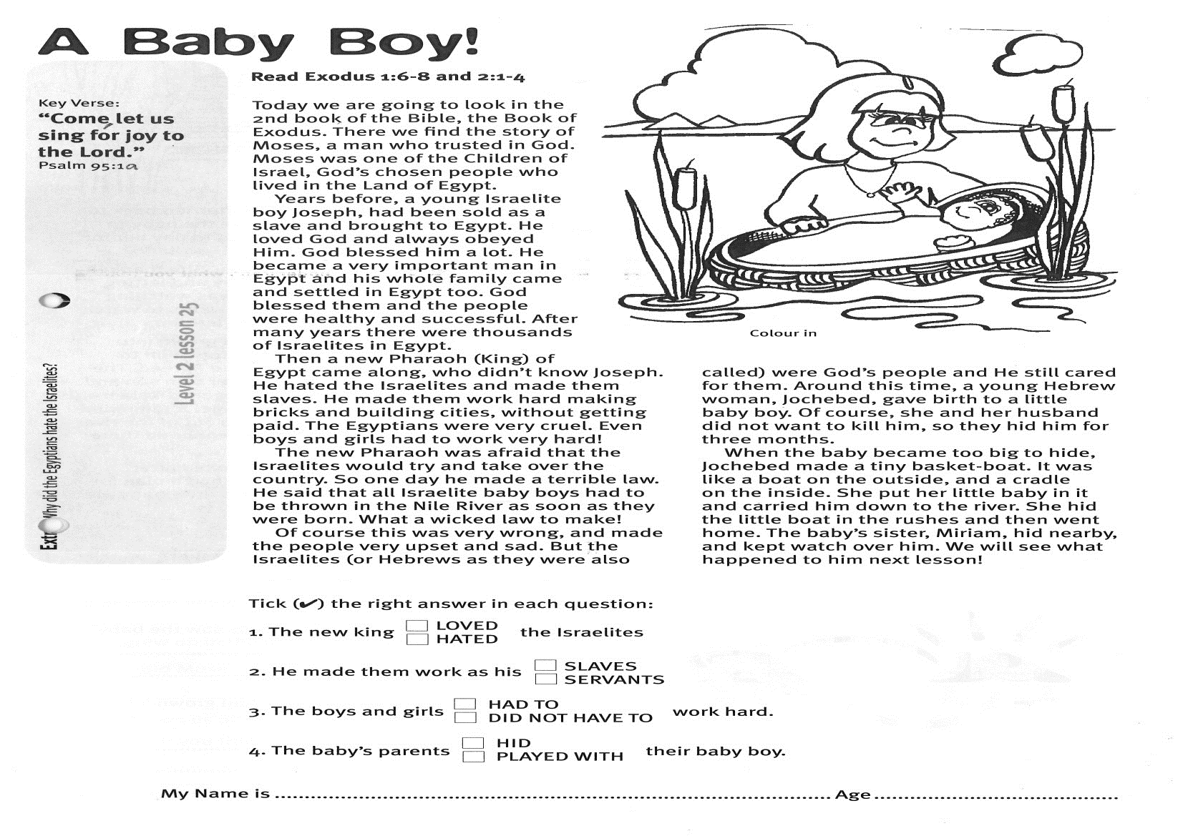

**Read: Exodus 1:6-8; 2:1-4**Today we are going to look in the 2nd book of the Bible, the Book of Exodus. There we find the story of Moses, a man who trusted in God. Moses was one of the Children of Israel, God’s chosen people who lived in the land of Egypt.

Years before, a young Israelite boy, Joseph, had been sold as a slave and brought to Egypt. He loved God and always obeyed Him. God blessed him a lot. He became a very important man in Egypt and his whole family came and settled in Egypt, too. God blessed them and the people were healthy and successful. After many years there were thousands of Israelites in Egypt.

Then a new Pharaoh (King) of Egypt came along, who didn’t know Joseph. He hated the Israelites and made them slaves. He made them work hard making bricks and building cities, without getting paid. The Egyptians were very cruel. Even boys and girls had to work very hard!

The new Pharaoh was afraid that the Israelites would try and take over the country. So one day he made a terrible law. He said that all Israelite baby boys had to be thrown in the Nile River as soon as they were born. What a wicked law to make!

Key Verse:  
**“Come, let us sing for joy to the Lord.”**

Psalm 95:1a

**A Baby Boy!**

Of course this was very wrong, and made the people very upset and sad. But the Israelites (or Hebrews as they were also called) were God’s people and He still cared for them.   
Around this time, a young Hebrew woman, Jochebed, gave birth to a little baby boy. Of course, she and her husband did not want to kill him, so they hid him for three months.

When the baby became too big to hide, Jochebed made a tiny basket-boat. It was like a boat on the outside, and a cradle on the inside. She put her little baby in it and carried him down to the river. She hid the little boat in the rushes and then went home. The baby’s sister, Miriam, hid nearby, and kept watch over him.

We will see what happened to him next lesson!

**Level 2 lesson 25**

**Extra:** Why did the Egyptians hate the Israelites?

Tick the right answer in each question:

1. The new king LOVED HATED the Israelites.

2. He made them work as his SLAVES SERVANTS.

3. The boys and girls HAD TO DID NOT HAVE TO work hard.

4. The baby’s parents HID PLAYED WITH their baby boy.

My Name is________________________________________ Age ______________

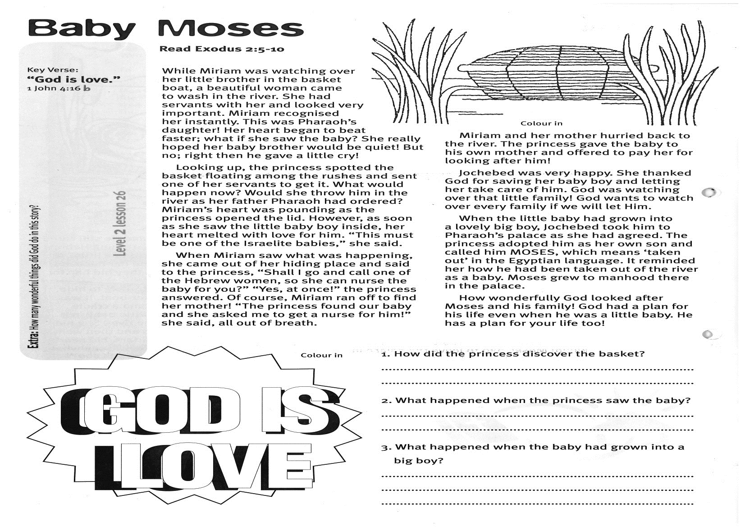

**Read Exodus 2:5-10**

While Miriam was watching over her little brother in the basket-boat, a beautiful woman came to wash in the river. She had servants with her and looked very important. Miriam recognised her instantly. This was Pharaoh’s daughter! Her heart began to beat faster; what if she saw the baby? She really hoped her baby brother would be quiet! But no; right then he gave a little cry!

Looking up, the princess spotted the basket floating among the rushes and sent one of her servants to get it. What would happen now? Would she throw him in the river as her father Pharaoh had ordered? Miriam’s heart was pounding as the princess opened the lid. However, as soon as she saw the little baby boy inside, her heart melted with love for him. “This must be one of the Israelite babies,” she said.

When Miriam saw what was happening, she came out of her hiding place and said to the princess, “Shall I go and call one of the Hebrew women, so she can nurse the baby for you?” “Yes, at once!” the princess answered. Of course, Miriam ran off to find her mother! “The princess found our baby and she asked me to get a nurse for him!” she said, all out of breath.

Key Verse:

**“God is love.”**

1 John 4:16b

**Baby Moses**

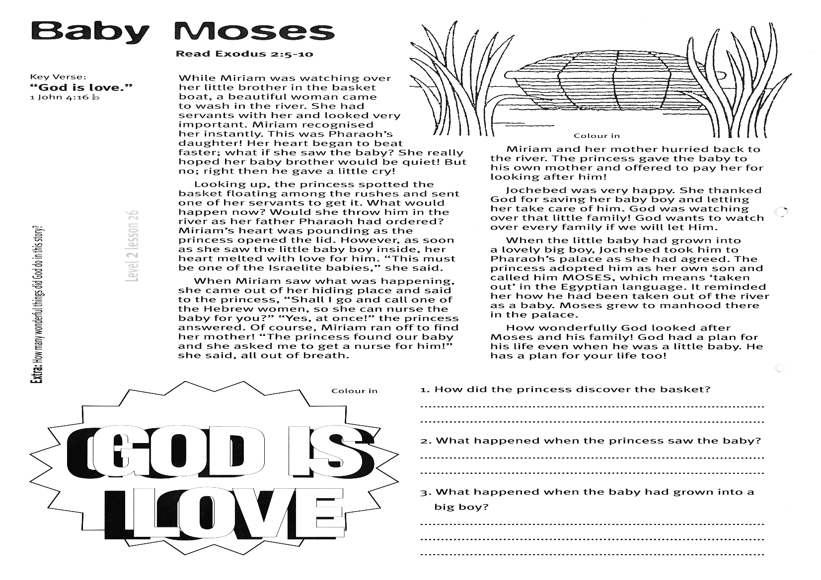

**Level 2 lesson 26**

1. How did the princess discover the basket?

……………………………………………………………………………………………………………………………………………………………………2. What happened when the princess saw the baby?

……………………………………………………………………………………………………………………………………………………………………  
3. What happened when the baby had grown into a big boy?

……………………………………………………………………………………………………………………………………………………………………

Miriam and her mother hurried back to the river. The princess gave the baby to his own mother and offered to pay her for looking after him!

Jochebed was very happy. She thanked God for saving her baby boy and letting her take care of him. God was watching over that little family! God wants to watch over every family if we will let Him.

When the little baby had grown into a lovely big boy, Jochebed took him to Pharaoh’s palace as she had agreed. The princess adopted him as her own son and called him MOSES, which means ‘taken out’ in the Egyptian language. It reminded her how he had been taken out of the river as a baby. Moses grew to manhood there in the palace.

How wonderfully God looked after Moses and his family! God had a plan for his life even when he was a little baby. He has a plan for your life too!

**Extra:** How many wonderful things did God do in this story?

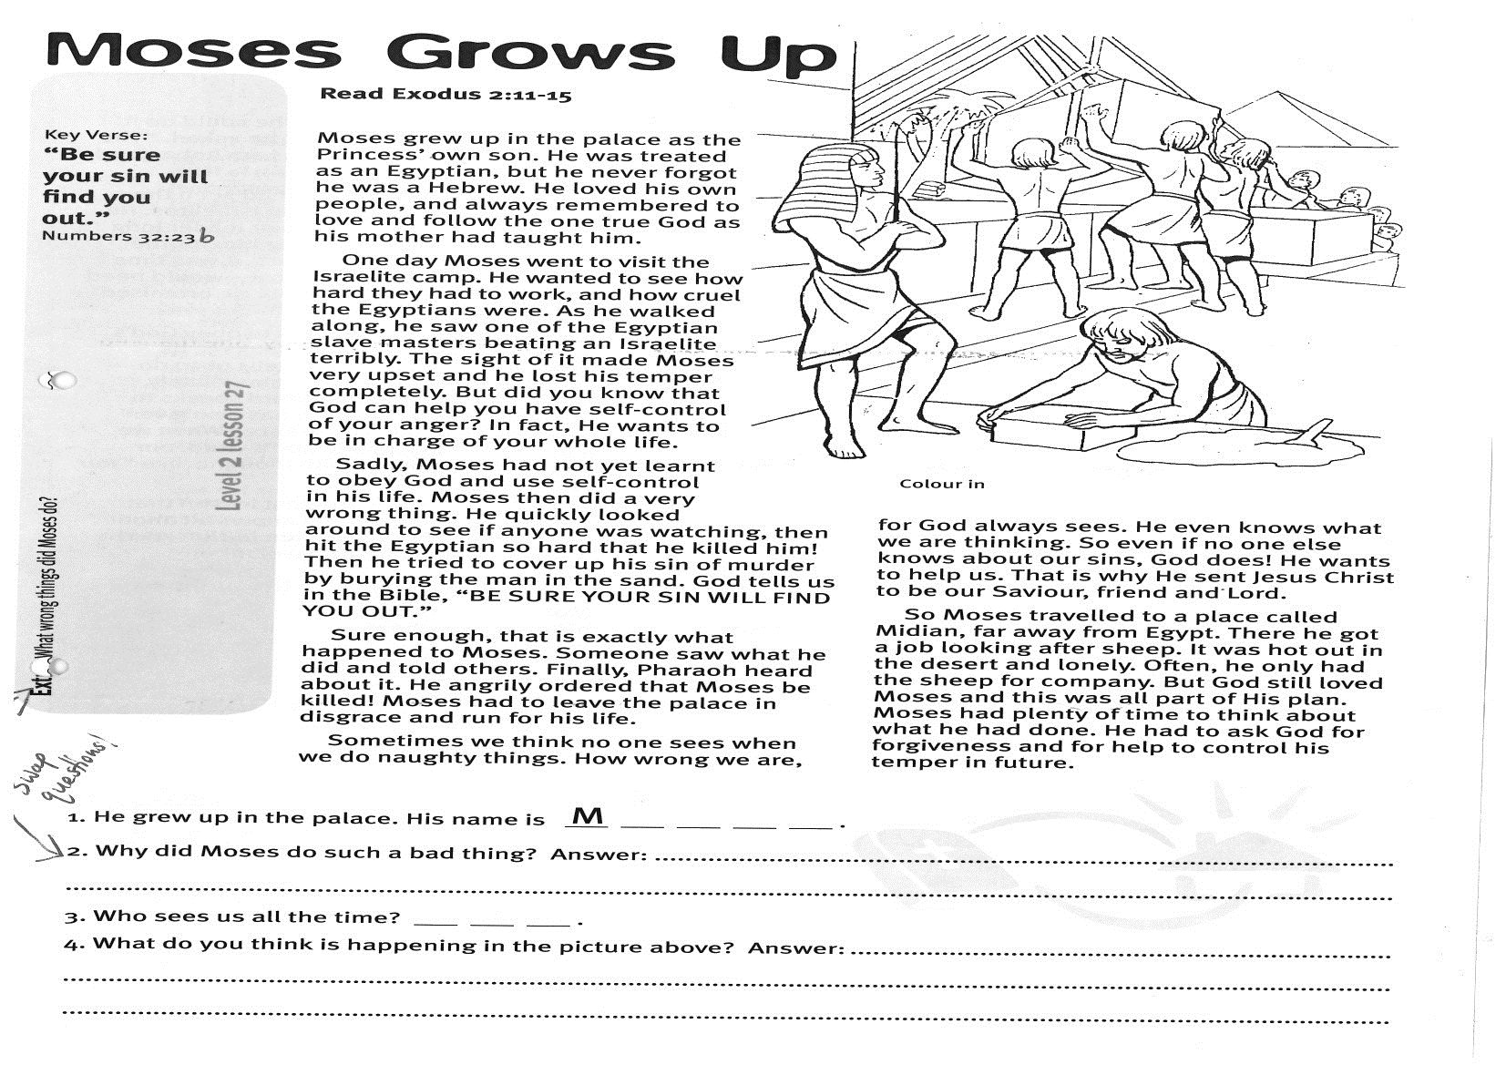

**Read Exodus 2:11-15**  
Moses grew up in the palace as the Princess’ own son. He was treated as an Egyptian, but he never forgot he was a Hebrew. He loved his own people, and always remembered to love and follow the One True God as his mother had taught him.

One day Moses went to visit the Israelite camp. He wanted to see how hard they had to work, and how cruel the Egyptians were. As he walked along, he saw one of the Egyptian slave masters beating an Israelite terribly. The sight of it made Moses very upset and he lost his temper completely. But did you know that God can help you have self-control of your anger? In fact, He wants to be in charge of your whole life.

Sadly, Moses had not yet learnt to obey God and use self-control in his life. Moses then did a very wrong thing. He quickly looked around to see if anyone was watching, then hit the Egyptian so hard that he killed him! Then he tried to cover up his sin of murder by burying the man in the sand. God tells us in the Bible, “BE SURE YOUR SIN WILL FIND YOU OUT.”

Sure enough, that is exactly what happened to Moses. Someone saw what he did and told others.

Key Verse:  
**“Be sure your sin will find you out.”**

Numbers 32:23b

**Moses Grows Up**

1. He grew up in the palace. His name is M ___ ___ ___ ___

2. What wrong things did Moses do?  
……………………………………………………………………………………………………………………………………………………………………………………………………………………………………………………………………………………………………3. Who sees us all the time? ___ ___ ___

4. What do you think is happening in the picture above? ……………………………………………………………………………………………………………………………………………………………………………………………………………………………………………………………………………………………………

**Extra:** Why did Moses do such a bad thing?

Finally, Pharaoh heard about it. He angrily ordered that Moses be killed! Moses had to leave the palace in disgrace and run for his life.  
Sometimes we think no-one sees when we do naughty things. How wrong we are, for God always sees. He even knows what we are thinking! So even if no-one else knows about our sins, God does! He wants to help us. That is why He sent Jesus Christ to be our Saviour, friend and Lord.

So Moses travelled to a place called Midian, far away from Egypt. There he got a job looking after sheep. It was hot out in the desert and lonely. Often, he only had the sheep for company. But God still loved Moses and this was all part of His plan. Moses had plenty of time to think about what he had done. He had to ask God for forgiveness and for help to control his temper in future.

**Level 2 lesson 27**

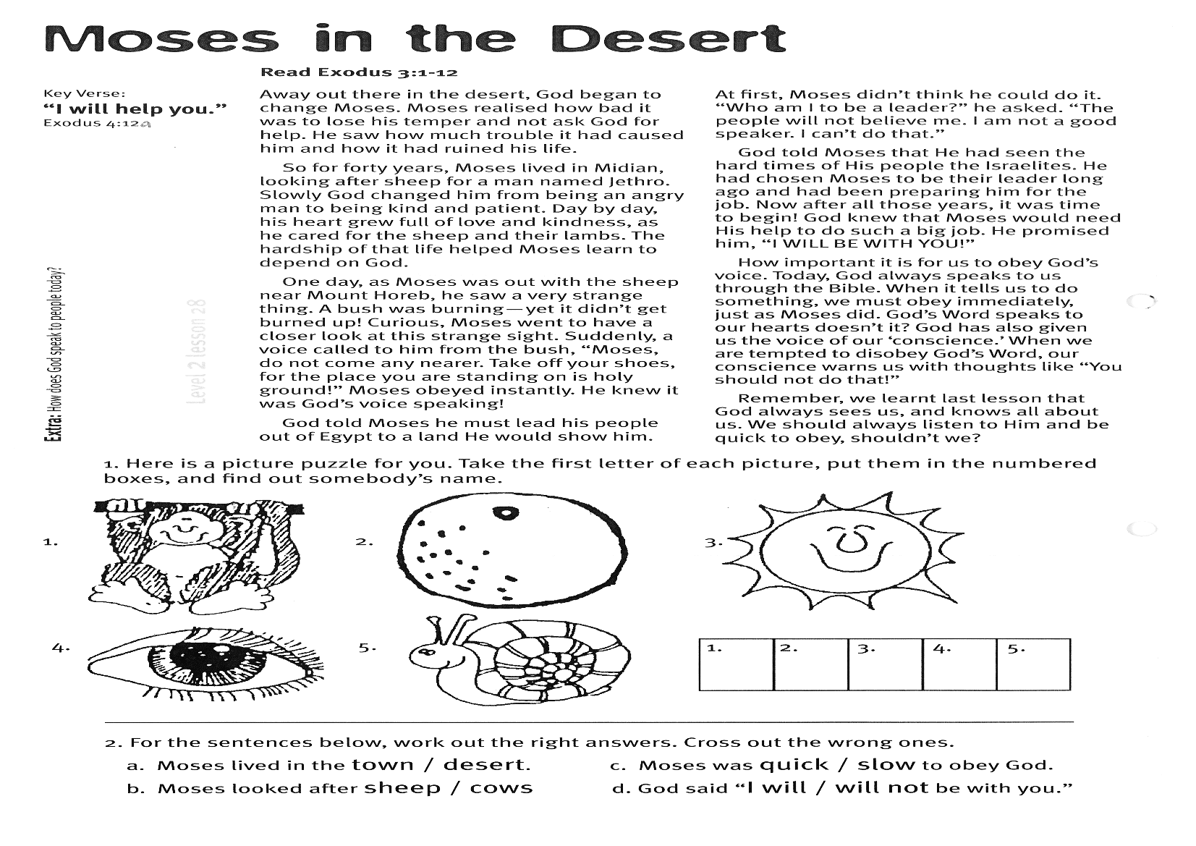

Please complete and return by post to   
**PSSM Bible Discovery, 5/399 New North Rd, Kingsland, Auckland 1021** or scan & email to **info@biblediscovery.org.nz**

God told Moses he must lead his people out of Egypt to a land He would show him. At first, Moses didn’t think he could do it. “Who am I to be a leader?” he asked. “The people will not believe me. I am not a good speaker. I can’t do that.”

God told Moses that He had seen the hard times of His people the Israelites. He had chosen Moses to be their leader long ago and had been preparing him for the job. Now after all those years, it was time to begin! God knew that Moses would need His help to do such a big job. He promised him, “I WILL BE WITH YOU!”

How important it is for us to obey God’s voice. Today, God always speaks to us through the Bible. When it tells us to do something, we must obey immediately, just as Moses did. God’s Word speaks to our hearts, doesn’t it? God has also given us the voice of our ‘conscience.’ When we are tempted to disobey God’s Word, our conscience warns us with thoughts like “You should not do that!”

Remember, we learnt last lesson that God always sees us, and knows all about us. We should always listen to Him and be quick to obey, shouldn’t we?

**Read Exodus 3:1-12**

Away out there in the desert, God began to change Moses. Moses realised how bad it was to lose his temper and not ask God for help. He saw how much trouble it had caused him and how it had ruined his life.

So for forty years, Moses lived in Midian, looking after sheep for a man named Jethro. Slowly God changed him from being an angry man to being kind and patient. Day by day, his heart grew full of love and kindness, as he cared for the sheep and their lambs. The hardship of that life helped Moses learn to depend on God.

One day, as Moses was out with the sheep near Mount Horeb, he saw a very strange thing. A bush was burning - yet it didn’t get burned up! Curious, Moses went to have a closer look at this strange sight. Suddenly, a voice called to him from the bush, “Moses, do not come any nearer. Take off your shoes, for the place you are standing on is holy ground!” Moses obeyed instantly. He knew it was God’s voice speaking!

**Extra:** How does God speak to people today?

2. For the sentences below, cross out the wrong answers, to make them correct:

a. Moses lived in the town / desert. c. Moses was quick / slow to obey God.

b. Moses looked after sheep / cows. d. God said “I will / will not be with you.”

Here is a picture puzzle for you. Take the first letter of each picture, put them in the numbered boxes, and find out someone’s name.

**Level 2 lesson 28**

Key Verse: **“I will help you.”**

Exodus 4:12a

**Moses in the Desert**