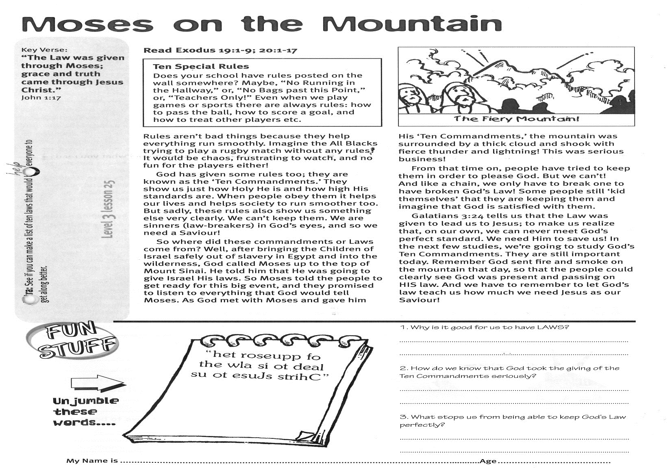

**Read Exodus 19:1-9; 20:1-17**

**Ten Special Rules  
Does your school have rules posted on the wall somewhere? Maybe, “No Running in the Hallway,” or, “No Bags past this Point,” or, “Teachers Only!” Even when we play games or sports there are always rules: how to pass the ball, how to score a goal, and how to treat other players etc.**

Rules aren’t bad things because they help everything run smoothly. Imagine the All Blacks trying to play a rugby match without any rules! It would be chaos, frustrating to watch, and no fun for the players either!

God has given some rules too; they are known as the ‘Ten Commandments.’ They show us just how Holy He is and how high His standards are. When people obey them it helps our lives and helps society to run smoother too. But sadly, these rules also show us something else very clearly. We can’t keep them. We are sinners (law-breakers) in God’s eyes, and so we need a Saviour!

So where did these commandments or Laws come from? Well, after bringing the Children of Israel safely out of slavery in Egypt and into the wilderness, God called Moses up to the top of Mount Sinai. He told him that He was going to give Israel His laws. So Moses told the people to get ready for this big event, and they promised to listen to everything that God would tell Moses.

Key Verse:  
**“The Law was given through Moses; grace and truth came through Jesus Christ.”**

John 1:17

**Moses on the Mountain**



**Level 3 lesson 25**

My Name is ……………………………………………………… Age………….

1. Why is it good for us to have laws?

_____________________________________

_____________________________________

2. How do we know that God took the giving of the Ten Commandments seriously?  
_____________________________________

_____________________________________

3. What stops us from being able to keep God’s Law perfectly?

______________________________________

______________________________________

As God met with Moses and gave him His ‘Ten Commandments,’ the mountain was surrounded by a thick cloud and shook with fierce thunder and lightning! This was serious business!

From that time on, people have tried to keep them in order to please God. But we can’t! And like a chain, we only have to break one to have broken God’s Law! Some people still ‘kid themselves’ that they are keeping them and imagine that God is satisfied with them.

Galatians 3:24 tells us that the Law was given to lead us to Jesus; to make us realize that, on our own, we can never meet God’s perfect standard. We need Him to save us! In the next few studies, we’re going to study God’s Ten Commandments. They are still important today. Remember God sent fire and smoke on the mountain that day, so that the people could clearly see God was present and passing on HIS law. And we have to remember to let God’s law teach us how much we need Jesus as our Saviour!

**Extra:** See if you can make a list of ten laws that would help everyone to get along better.

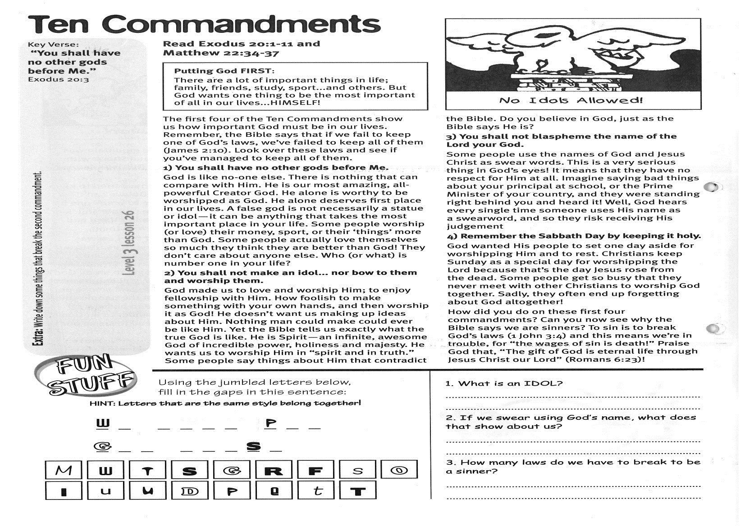

**Ten Commandments**

Key Verse:  
**“You shall have no other gods before Me.”**

Exodus 20:3

**Read Exodus 20:1-11   
and Matthew 22:34-37**

**PUTTING GOD FIRST:  
There are a lot of important things in life: family, friends, study, sport…and others. But God wants one thing to be the most important of all in our lives…HIMSELF!**

The first four of the Ten Commandments show us how important God must be in our lives. Remember, the Bible says that if we fail to keep one of God’s laws, we’ve failed to keep all of them (James 2:10). Look over these laws and see if you’ve managed to keep all of them.

**1) You shall have no other gods before Me.**God is like no-one else. There is nothing that can compare with Him. He is our most amazing, all-powerful Creator God. He alone is worthy to be worshipped as God. He alone deserves first place in our lives. A false god is not necessarily a statue or idol - it can be anything that takes the most important place in your life. Some people worship (or love) their money, sport, or their ‘things’ more than God. Some people actually love themselves so much they think they are better than God! They don’t care about anyone else. Who (or what) is number one in your life?

**2) You shall not make an idol... nor bow to them and worship them.**God made us to love and worship Him; to enjoy fellowship with Him. How foolish to make something with your own hands, and then worship it as God! He doesn’t want us making up ideas about Him. Nothing man could make could ever be like Him. Yet the Bible tells us exactly what the true God is like. He is Spirit - an infinite, awesome God of incredible power, holiness and majesty.

He wants us to worship Him in “spirit and in truth.” Some people say things about Him that contradict the Bible. Do you believe in God, just as the Bible says He is?

**3) You shall not blaspheme the name of the Lord your God.**Some people use the names of God and Jesus Christ as swear words. This is a very serious thing in God’s eyes! It means that they have no respect for Him at all. Imagine saying bad things about your principal at school, or the Prime Minister of your country, and they were standing right behind you and heard it! Well, God hears every single time someone uses His name as a swearword, and so they risk receiving His judgement.

**4) Remember the Sabbath Day by keeping it holy.**God wanted His people to set one day aside for worshipping Him and to rest. Christians keep Sunday as a special day for worshipping the Lord because that’s the day Jesus rose from the dead. Some people get so busy that they never meet with other Christians to worship God together. Sadly, they often end up forgetting about God altogether!

How did you do on these first four commandments? Can you now see why the Bible says we are sinners? To sin is to break God’s laws (1 John 3:4) and this means we’re in trouble, for “the wages of sin is death!” Praise God that, “The gift of God is eternal life through Jesus Christ our Lord” (Romans 6:23)



1. What is an idol?

________________________________________

________________________________________

2. If we swear using God’s name, what does that show about us?

________________________________________

________________________________________

3. How many laws do we have to break to be a sinner?

________________________________________

***Using the jumbled letters below, fill in the gaps in this sentence:***

**Extra:** Write down some things that break the second commandment.

**Level 3 lesson 26**

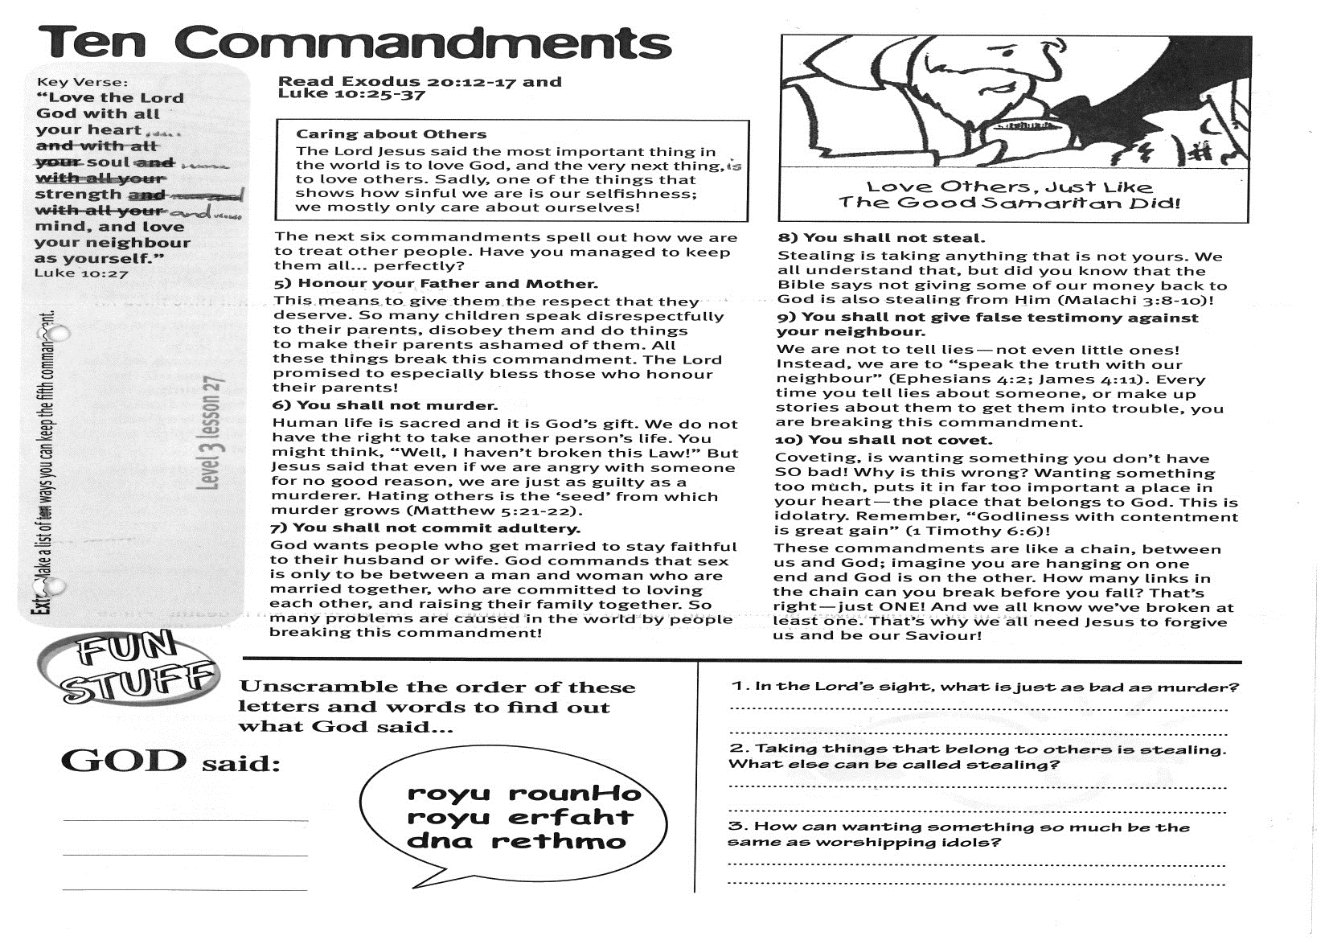

**Read Exodus 20:12-17   
and Luke 10:25-37**

**CARING ABOUT OTHERS:**

**The Lord Jesus said the most important thing in the world is to love God, and the very next thing, is to love others. Sadly, one of the things that shows how sinful we are is our selfishness – we mostly only care about ourselves!**

The next six commandments spell out how we are to treat other people. Have you managed to keep them all... perfectly?

**5) Honour your Father and Mother.**

This means to give them the respect that they deserve. So many children speak disrespectfully to their parents, disobey them and do things to make their parents ashamed of them. All these things break this commandment. The Lord promised to especially bless those who honour their parents!

**6) You shall not murder.**

Human life is sacred and it is God’s gift. We do not have the right to take another person’s life. You might think, “Well, I haven’t broken this Law!” But Jesus said that even if we are angry with someone for no good reason, we are just as guilty as a murderer. Hating others is the ‘seed’ from which murder grows (Matthew 5:21-22).

**7) You shall not commit adultery.**

God wants people who get married to stay faithful to their husband or wife. God commands that sex is only to be between a man and woman who are married together, who are committed to loving each other, and raising their family together. So many problems are caused in the world by people breaking this commandment!

**Ten Commandments**

Key Verse:  
**“Love the Lord God with all your heart, ...soul…strength and.…mind,  
and love your neighbour as yourself.”**

Luke 10:27

|  |  |
| --- | --- |
|  | ***Unscramble the order of these letters and words to find out what God said…*** |
|  |  |
|  |  |



**8) You shall not steal.**

Stealing is taking anything that is not yours. We all understand that, but did you know that the Bible says not giving some of our money back to God is also stealing from Him (Malachi 3:8-10)!

**9) You shall not give false testimony against your neighbour.**

We are not to tell lies - not even little ones! Instead, we are to “speak the truth with our neighbour” (Ephesians 4:2; James 4:11). Every time you tell lies about someone, or make up stories about them to get them into trouble, you are breaking this commandment.

**10) You shall not covet.**

Coveting, is wanting something you don’t have SO bad! Why is this wrong? Wanting something too much, puts it in far too important a place in your heart - the place that belongs to God. This is idolatry! Remember, “Godliness with contentment is great gain” (1 Timothy 6:6)

These commandments are like a chain, between us and God; imagine you are hanging on one end and God is on the other. How many links in the chain can you break before you fall? That’s right - just ONE! And we all know we’ve broken at least one. That’s why we all need Jesus to forgive us and be our Saviour!

_

1. In the Lord’s sight, what is just as bad as murder?

___________________________________________

___________________________________________

2. Taking things that belong to others is stealing. What else can be called stealing?

___________________________________________

___________________________________________

3. How can wanting something so much be the same as worshipping idols?

___________________________________________

___________________________________________

**Level 3 lesson 27**

**Extra:** Make a list of ways you can keep the fifth commandment.

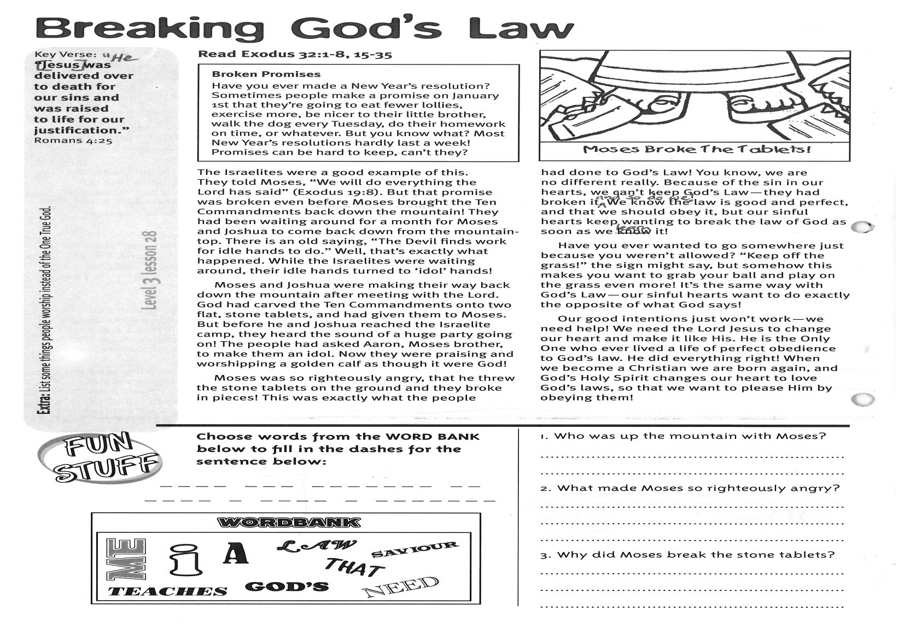

**Read: Exodus 32:1-8, 15-35**

**BROKEN PROMISES:   
Have you ever made a New Year’s resolution? Sometimes people make a promise on January 1st that they’re going to eat fewer lollies, exercise more, be nicer to their little brother, walk the dog every Tuesday, do their homework on time, or whatever. But you know what? Most New Year’s resolutions hardly last a week! Promises can be hard to keep, can’t they?**

The Israelites were a good example of this. They told Moses, “We will do everything the Lord has said” (Exodus 19:8). But that promise was broken even before Moses brought the Ten Commandments back down the mountain! They had been waiting around for a month for Moses and Joshua to come back down from the mountain-top. There is an old saying, “The Devil finds work for idle hands to do.” Well, that’s exactly what happened. While the Israelites were waiting around, their idle hands turned to ‘idol’ hands!

Moses and Joshua were making their way back down the mountain after meeting with the Lord. God had carved the Ten Commandments onto two flat, stone tablets, and had given them to Moses. But before he and Joshua reached the Israelite camp, they heard the sound of a huge party going on! The people had asked Aaron, Moses brother, to make them an idol. Now they were praising and worshipping a golden calf as though it were God!

**Breaking God’s Law**

Key Verse:  
**“He [Jesus] was delivered over to death for our sins and was raised to life  
for our justification.”**

Romans 4:25

**Answer:**

Moses was so righteously angry, that he threw the stone tablets on the ground and they broke in pieces! This was exactly what the people had done to God’s Law! You know, we are no different really. Because of the sin in our hearts, we can’t keep God’s Law - they had broken it, and so do we! We know the law is good and perfect, and that we should obey it, but our sinful hearts keep wanting to break the law of God as soon as we learn it!

Have you ever wanted to go somewhere just because you weren’t allowed? “Keep off the grass!” the sign might say, but somehow this makes you want to grab your ball and play on the grass even more! It’s the same way with God’s Law - our sinful hearts want to do exactly the opposite of what God says!

Our good intentions just won’t work - we need help! We need the Lord Jesus to change our heart and make it like His. He is the Only One who ever lived a life of perfect obedience to God’s law. He did everything right! When we become a Christian, we are born again, and God’s Holy Spirit changes our heart to love God’s laws, so that we want to please Him by obeying them!

**Level 3 lesson 28**

**Extra:** List some things people worship instead of the One True God?

1. Who was up the mountain with Moses?

_______________________________________

_______________________________________

2. What made Moses so righteously angry?

_______________________________________

_______________________________________

_______________________________________

3. Why did Moses break the stone tablets?

_______________________________________

_______________________________________



Please complete and return by post to   
**PSSM Bible Discovery, 5/399 New North Rd, Kingsland, Auckland 1021** or scan & email to **info@biblediscovery.org.nz**