**Noah and the Ark**

Key Verse:  
**“By faith Noah… built an ark to save his family.”**  
Hebrews 11:7

**Level 2 lesson 5**

**Read Genesis 6:5-9; 7:17-23 and 8:13-22**

As time went on, Adam’s family grew bigger. Sadly, most of them didn’t love God or want to be His friends. Like Cain, who killed his brother Abel, they didn’t want to obey God or live to please Him. Slowly, they became worse and worse, and God saw that everyone was doing all kinds of evil things. In the whole world there was only one man who loved God and obeyed Him. That man’s name was NOAH and he was a friend of God.

One day God warned Noah that He was going to punish the people because of their wicked sins. God said He would send a flood to cover the whole Earth and drown all the evil people, and even the birds and animals. But God made a promise to Noah: He would save his wife, his three sons and their wives, and also a male and female of every kind of animal and bird.

To save them, God told Noah to build a big boat called an ‘Ark.’ He gave Noah exact building instructions so the Ark would be big enough to hold at least eight people, two of every kind of animal, bird, (and even seven of some) and insect, along with food for them all. So Noah obeyed God and began building.

While building the Ark Noah also preached “righteousness” to the people (see 2 Peter 2:5). This means he likely taught them about God being good and holy and hating their sin, and warning them to escape the coming flood

of death! But the people didn’t obey. No doubt they just laughed at the sight of Noah building such a big boat, because it had never even rained on the earth before.

When the Ark was finished, God brought the male and female animals and birds to Noah, and he loaded them on board. Then God said to Noah and his family, “Go into the Ark.” Once they were in, God closed the door. Then one week later, heavy rain started falling and the great waters under the ground poured out. For forty days and forty nights the water rose higher and higher, until the highest hills were flooded over!

Sadly, every human and creature outside the Ark drowned, but Noah’s family and the creatures inside the Ark were safe. Finally, the rain stopped and the water began to go down. Then Noah sent out a dove from the Ark to see if it was safe, but there was nowhere for it to land. Later, Noah sent out a raven, but it was still no good. Soon he sent out another dove, and thankfully it came back with a leaf in its mouth.

Noah knew the waters had gone down, so he and his family and all the animals got out of the Ark. Then Noah and his family worshipped and thanked God for saving them. God promised Noah that never again would there be a flood over all the Earth. He put a lovely rainbow in the sky to remind all humans of this promise (see Genesis 9:12-15). Remember this story next time you see a rainbow!

**NOAH OBEYED**  
Noah took many animals and supplies into the ark. Look at the pictures below and cross out everything that is not mentioned in Genesis 6:19-22.

My Name is ……………………………………………………………………… Age……………

**WHO WAS NOAH?**

Underline each true sentence about Noah:

Noah was God’s friend  
Noah was sick and had to stay in bed  
Noah was a good man  
Noah obeyed God and often talked with Him  
Noah had only one son

**WHAT HAPPENED?**

Tick (✓) the five most important sentences:

🞎 God chose to destroy the evil people with a world-wide flood  
🞎 God told Noah to build an ark to save them  
🞎 God saved Noah and his family because Noah was obedient  
🞎 Noah had never seen rain before  
🞎 God saved a male and female of every kind of animal, bird, and insect  
🞎 Noah preached “righteousness” to the people

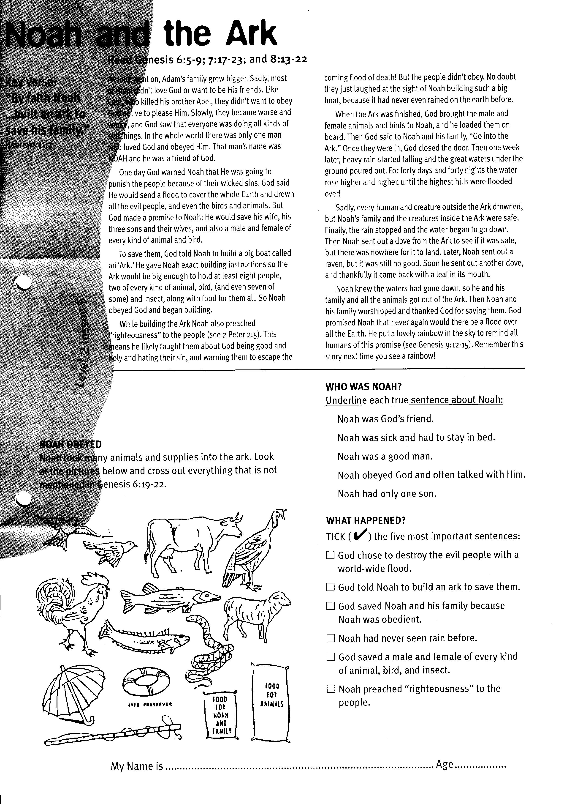

So the people started building the big tower. Up and up it went. How silly to think that they were better than anyone else and could do things their own way! God saw what they were doing and became angry with them for disobeying. So to stop them from making the tower any higher, He simply made them speak in different languages.

Suddenly, they could not understand each other or how to build together. The tower was called ‘the tower of Babel’ because each family group started ‘babbling’ in different languages. God used this to make them move apart and live in different areas of the world, just as He had first commanded!

Even today, there are people like little Bobby and like the people building the tower. They think they don’t need God and that they can live their own way. But no, only God’s way is the right way and He wants everyone to come back to Him!

Now, just like there is only one way to get into a castle with one door, so there is only ONE WAY to get back to God in His heavenly home. Our key verse says, “Jesus said, ‘I am the door,’” and so Jesus is the only way into Heaven. This is why, if you believe in the Lord Jesus Christ and ask Him to forgive your sins, He will save you and let you into Heaven forever!

**Read Genesis 11:1-9**

Melissa and Bobby were excited. They’d each been given a little piece of garden where they could plant some seeds and grow plants. “This is great!” said Bobby, “I’m going to have a little garden all on my own. No one is going to help me; not even God! I’m going to do it all by myself!”

“Oh Bobby, how silly to say you won’t even let God help you,” said Melissa. “Even the little garden is God’s. And God gives sunshine and sends the rain to water things. He even makes those seeds you have planted to grow into plants! God made everything. You can’t say you’re not going to let God help you. Without God you couldn’t have a garden at all!”

Did you know that there were people like Bobby living on Earth after the great flood (see last week’s lesson)? Remember how Noah and his family came safely out of the Ark when the flood water was gone? Well, soon, children were born and families began growing and spreading out over the Earth again. Sadly, the people soon stopped obeying God and started trusting only in themselves.

The people became so proud that one day they said, “Let’s build a tower that will reach high up into the heavens. Then we can be the most famous people, all here in one place!” They thought that they didn’t need God or need to obey His command to travel and live throughout the whole world!

**Level 2 lesson 6**

Key Verse:  
**“I am the Door: whoever enters through Me will be saved.”**  
John 10:9

**The Tower of Babel**

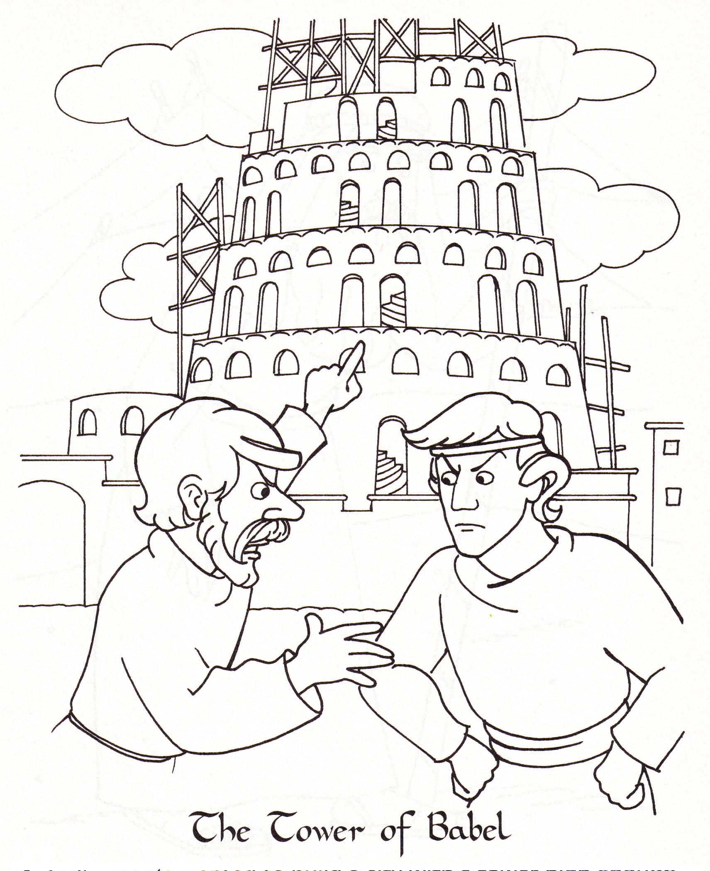

1. Who made the tower and why?

__________________________

__________________________

__________________________

__________________________

__________________________

2. Why can’t these men understand each other?

___________________________

___________________________

3, Tick (√) each true sentence:

□ God made everything

□ My way is better than Gods

□ God stopped the people making the tower

□ Jesus is the ONLY way back to God

Key Verse:  
**“By faith Abraham... obeyed and went.”**  
Hebrews 11:8

**Read Genesis 12:1-7**

Have you ever been for a surprise picnic? It sure is fun finding out where you are going, isn’t it? Well one day God told Abraham to go on a surprise journey, too. Even though Abraham was 75 years old, God told him to leave his country, his home, and his family to go to a new land he had never been to!

God knew that this would be a hard test for an old man but He gave Abraham a wonderful promise... “I will give you a big family of your very own. I will bless you and other people will hear how great you are. Through you Abraham, all the nations of the world will be blessed.”

Although Abraham did not know the place he was going to, he had faith in God. He knew God could be trusted and was sure He would show him which road to take. So Abraham simply obeyed God, and with his wife Sarah, his nephew Lot, and their servants, they packed up all their belongings and left home.

**God’s Friend**

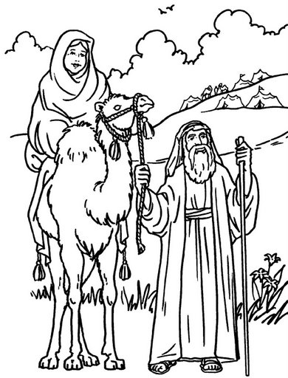

**Picnic road Canaan Abraham home obeyed girls**

1. Choose the right words from this list above to finish the sentences below:

**\*** One day God told __ __ __ __ __ __ __ to leave his country

**\*** God would show him which __ __ __ __ to take

**\*** Abraham __ __ __ __ __ __ God and left his home.

2. What was the name of Abraham’s wife? Answer: _ A _ A _

3. Who else did Abraham take with him? Answer: _ _ _

4. What two things we all need to learn? Fill in the gaps to find out:

**\*** God loves us and wants us to __ __ __ __ Him.

**\*** To say __ H __ __ K Y __ __ to God.

They travelled for a long time until they came to a very good land called Canaan. Then God told Abraham, “This is the country I will give your family!” Abraham then made a special pile of stones, called an ‘altar,’ and thanked God for bringing him to the right place.

How good it is to learn that God loves you, just like Abraham, and He wants only what is best for you. Like Abraham, you too should obey God and trust Him, because He always keeps His promises! But when you disobey God you make Him sad! And so you need to say sorry and ask God to forgive your sins and help you to do what is right.

Boys and girls, another good thing to learn from Abraham is to say “thank you” to God for each of His blessings. That is something you can practice doing every day. Abraham learnt these important lessons, so follow his example!

and wrongdoing. God has the power to save you and help you do the things that please Him!

**Level 2 lesson 7**

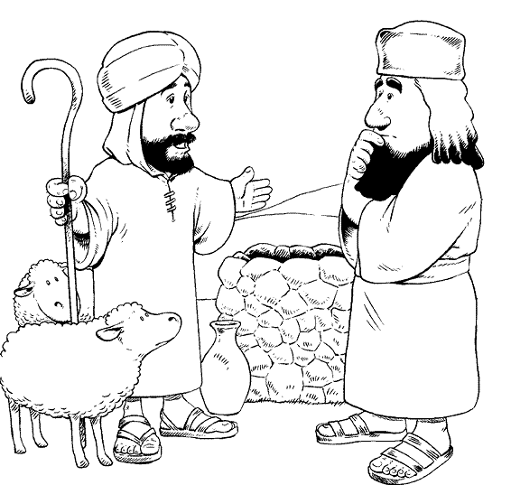

2. When two people fight, it’s sometimes hard to tell who is right and who is wrong. How can friends settle a fight and still be friends?

• Put a cross (🗶) by the suggestions you think will not work.

• Put a tick (✓) by the suggestions you think might be worth a try.

• Put two ticks (✓✓) by the suggestions you think would really help.

___ They could go away for a while and think things over.

___ They could fight each other until one of them is hurt.

___ They could stop yelling at each other.

___ One of them could just give in.

___ They could take turns getting their own way.

___ They could both give in a little to each other.

___ They could ask an older person to help them.

___ They could say nasty things about each other.

___ They could say sorry and ask each other for forgiveness.

1. Put a circle around the words that tell us what Abraham was like.  
**Good Bad Rich**

**Obedient Greedy**

**Selfish Kind Nasty**

**Pleased God Unselfish**

the river. It had the best grass, but was right next to a wicked city called Sodom. This left Abraham with the grass of the hill country.

God saw everything that went on. He was pleased with Abraham, because he was so unselfish and let Lot choose first. After Lot took his flocks and went away, God gave Abraham a wonderful promise. He said, “I will give all the land you can see; to you and your family forever. You will have many children and grandchildren.”

Sadly, poor Lot’s greediness got him into BIG trouble! Abraham kindly went to rescue him from some bad people even though Lot had treated him badly. I wonder which one you are like; Abraham, who was kind and good; or Lot, who was greedy and selfish? We should seek to be like Abraham because this is right and it pleases God!

**Extra:** Why did Cain kill his brither?do.

**Read Genesis 13: 1-13**

There are still lots we can learn from Abraham and Lot, even though they lived a long time ago. They were farmers and had lots of sheep and goats. I’m sure you all know that sheep and goats need to eat lots of grass. (Actually goats will eat just about anything if they can, but that’s another story!) Well after a while, the two men had such large flocks of sheep and goats that there wasn’t enough grass for all of them. Their shepherds started arguing about whose flocks should have the best grass.

Abraham didn’t want trouble with his nephew and knew that one of them would need to go and live where there was more grass. So one day he took Lot up to the top of a high hill, where they could see all around. He told Lot to choose first which part of the land he wanted. Lot was selfish and greedy and wanted the best for himself, so he chose the flat land down by

**Lot’s Selfish Choice**

Key Verse:  
**“Let’s not have any quarrelling.”**  
Genesis 13:8

**Level 2 lesson 4**