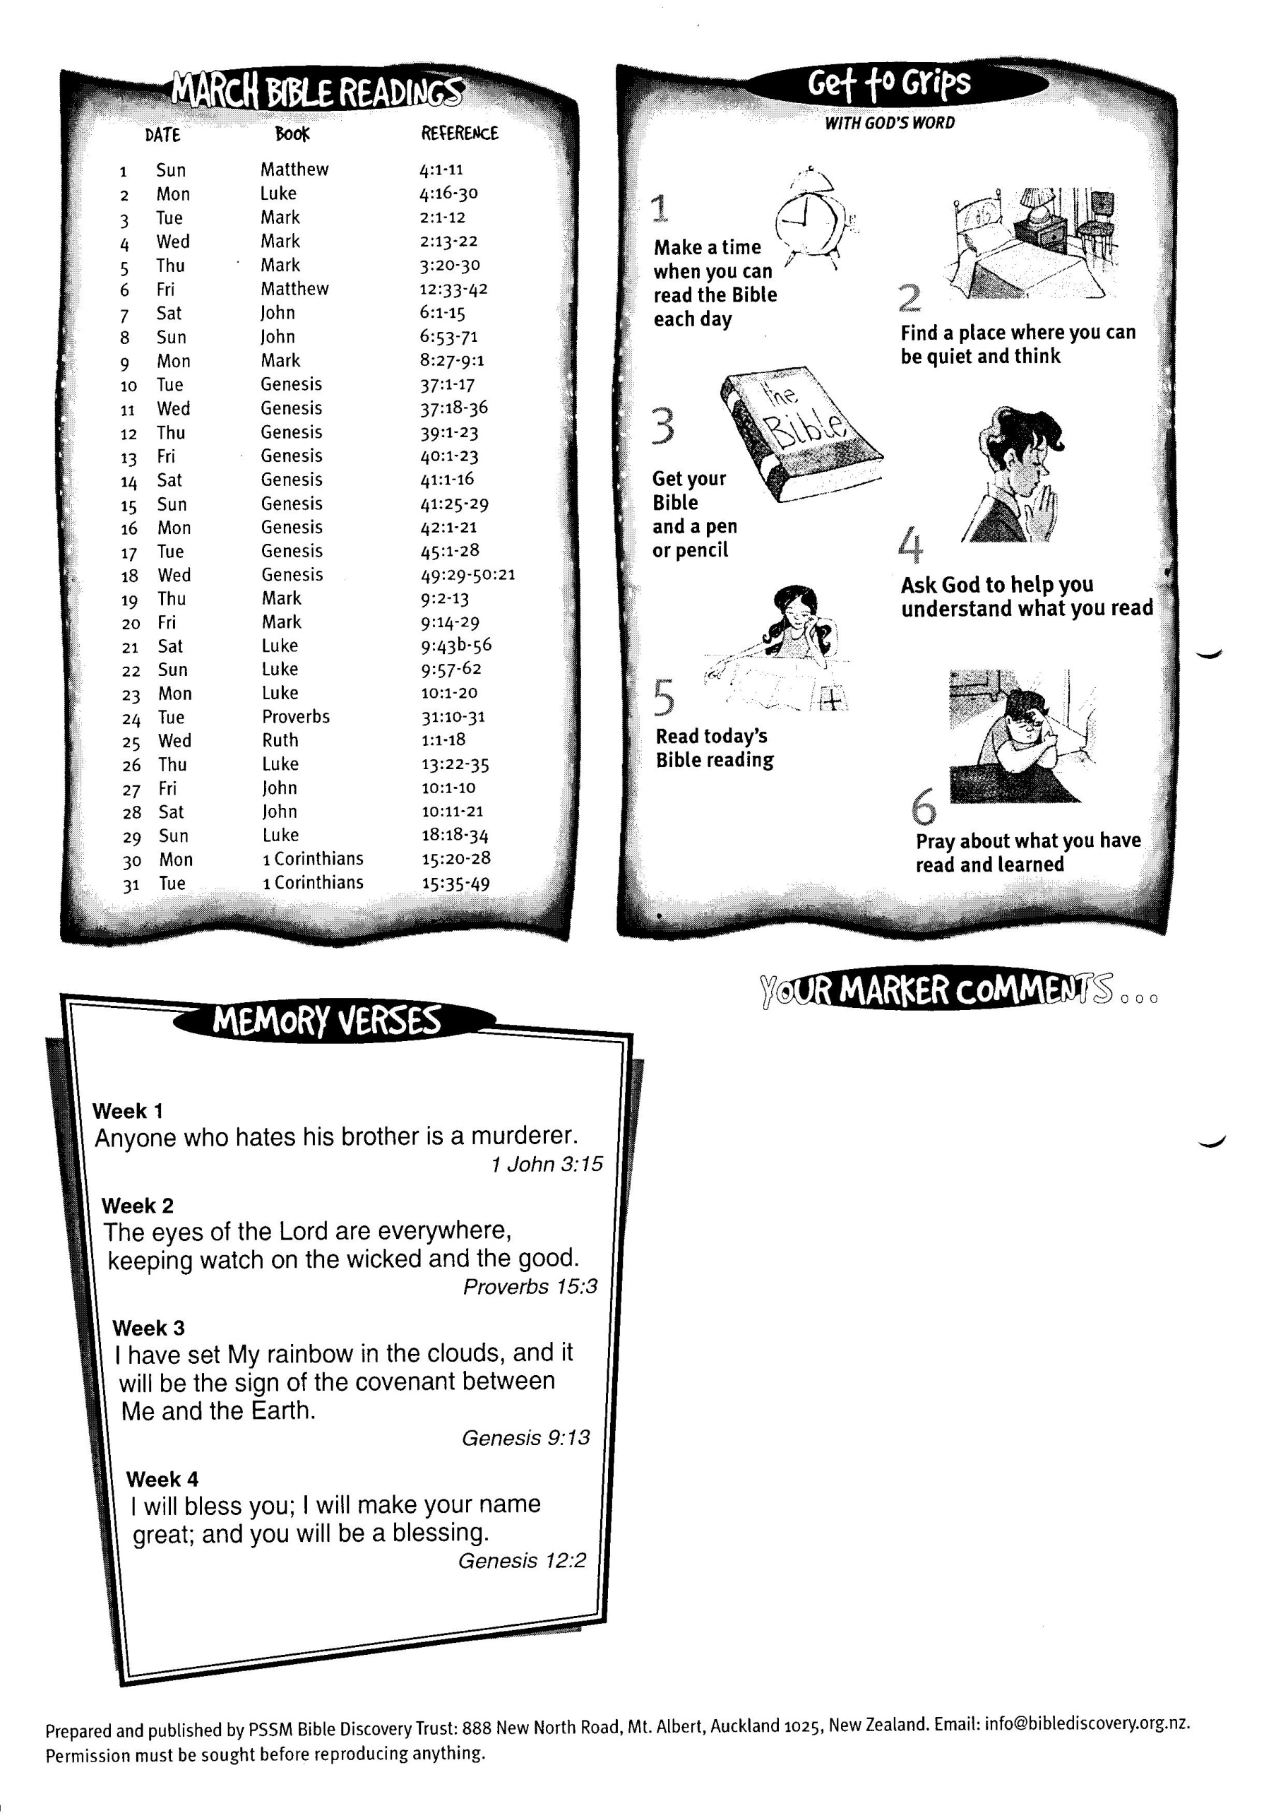

DATE BOOK REFERENCE

**March Bible Readings**