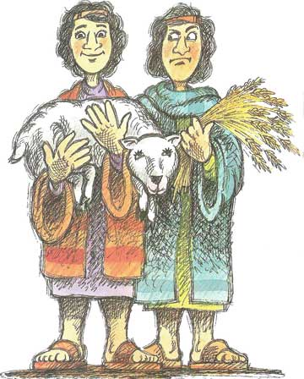
Read Genesis 4:1-16 and 1 John 3:11-15
As the year 2000 approached there was great interest in discovering who would be the first baby born in the new millennium. Well, today we’re going to be learning about the first baby ever born! It wasn’t Adam or Eve, because God created them as full grown adults. So actually, the first baby ever born in the whole world was their son, Cain.
After Cain was born, Adam and Eve had another son, Abel. Although they were brothers, these two boys were as different as ‘chalk and cheese.’ They even chose different jobs: Cain decided to be a gardener, while Abel preferred to tend sheep and cattle.
One day, Cain and Abel each decided to bring offerings to the Lord and sacrifice them. We can safely assume Adam would have told his sons about the animals that God sacrificed in the Garden of Eden to make clothes forEve and himself, and thus cover their nakedness and sin.
Now Hebrews 11:4 tells us that it was Abel’s faith that led him to bring a better sacrifice than Cain. Abel no doubt understood that an animal offering would cover his sins and be pleasing to God. Therefore Abel brought his first spring-born lamb to be sacrificed, but Cain just brought some fruit from his garden as an offering to the Lord. And so the Lord accepted Abel’s offering, but He did not accept Cain’s.
Then Cain got really angry, but he was also sad. As you can see in the Bible reading, God was not unfair. He gave Cain another chance by telling Cain that if he obeyed and brought the right offering with the right attitude, his offering would be accepted. How kind and gracious God is!
Cain, however, did not listen to God. His anger and jealously burned within him and instead he planned a terrible thing: the first murder in the whole world. Cain led Abel out into the fields, and
Cain & Abel
Key Verse:
“Anyone who hates his brother is a murderer.”
1 John 3:15
1. What kind of jobs did the two boys choose?
2. Why did God accept Abel’s offering but not Cain’s?
3. How did Cain respond?
4. How should Cain have responded to God’s command?
5. How can we be strong enough to fight sin in our lives?
My Name is ……………………………………………………………………… Age ………………….
QUESTIONS & ANSWERS
when no-one was looking, he attacked and killed his own brother. Cain had refused to listen to God and control his hate and disobedience, and this terrible murder was the result. How sad!
Many people today are like Cain. They too have no faith and are disobedient to God’s ways. When they have the chance to do what is right by trusting in the Lord Jesus Christ to save them from their sin and be in a right relationship with God, they turn away. They prefer to stay in their sinful ways and on the path to eternal death. Often, their sin takes over their lives, as it did with Cain, and ruins even their earthly lives.
While reading this passage, you may think, “Well, I’ve never murdered anyone!” But God’s Word teaches clearly that we have all sinned (see Romans 3:23). This week’s Key Verse reminds us of Jesus’ words—that to just hate another person makes you a murderer. By God’s standards, hatred is just as bad as murder, so do not let hatred for others become a part of your thinking or take over your heart!
No one is strong enough to fight sin alone, because it is “crouching at the door” (v7) of our choices. We first need to believe in the Lord Jesus Christ for salvation, because this breaks the power of sin. At the moment we are saved, we receive the Spirit of God in our lives, and He gives us the power to say “NO” to the temptations of sin. Why don’t you pray and ask God to help you to be obedient to His Word, and to make you more and more like Jesus Christ every day?

Level 4 lesson 5
Extra: What do you think about Cain’s actions?
The Right Start
Key Verse:
“Jesus said, ‘I tell you the truth, unless a man is born again, he cannot see the kingdom of God.’”
John 3:3
Level 3 lesson 1
1. When God first made man, he was “very good” – what changed?
2. What did God decide to do about man’s wickedness?

3a. What was the name of the man whom God found to be a righteous man?
b. What did God tell him to do?

4. How did the people react to Noah’s message?

5. How can we be safe from God’s second, coming judgement?
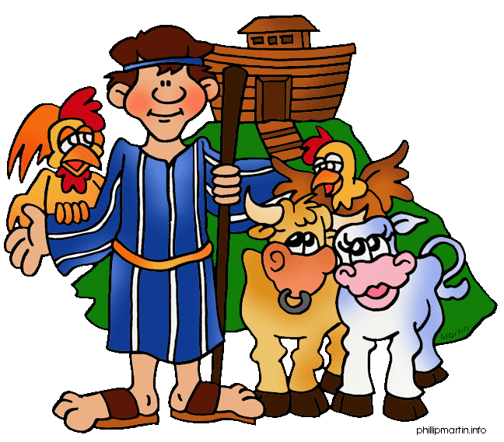
Read Genesis 6:5-22; 7:13-24 and Luke 17:26-30
You may remember, part of God’s instruction to Adam and Eve in Genesis 1:28 was to “Be fruitful and multiply.” Well they did! After Abel’s sad death, we are told they had another son called Seth, and “other sons and daughters” Genesis 5:4. The area in which Adam and Eve lived became full of people, who slowly spread far and wide across the earth. Some became nomadic farmers, living in tents and tending flocks and herds of animals. Others settled down and grew crops, while others built villages and towns, and began to work with brass and iron.
It is important to note, that while they may have lived simple lives by comparison with today; without computers, radios and TV’s etc, the Bible never describes them as ‘primitive.’ They were not ‘ape-men’ or any such thing. In fact, before Adam sinned, he would have been an amazing person with awesome capabilities, as seen for example, in his naming of all the animals. Yes, when God first made Man, he was “very good!”
But Man’s sin spoiled it all. The people disobeyed God’s laws and did not worship Him. They were greedy, selfish, and always fighting. In fact, Genesis 6:5 tells us that they had become so evil and violent that they could only think of doing evil things all the time!
God was both sad and angry: sad at mankind’s terrible state, and angry at his rebellious wickedness. However, one man trusted and obeyed God faithfully. His name was Noah. One day God spoke to him and said, “I am going to bring flood waters on the earth to destroy every creature that has the breath of life in it. Everything on earth will perish” (v17). God told Noah how to build a large boat, an Ark, for his shelter and safety when the flood came. He also told Noah to take his family and at least two of every kind of animal and bird into the Ark with him.

As usual, Noah obeyed God, and for 120 years he built the Ark and preached righteousness, no doubt warning people of God’s coming judgement. But no one took any notice. We can imagine how they laughed and mocked him and his family: “How can anyone believe all that ‘judgement of God’ stuff? What rubbish Noah; you must be crazy! Stupid old fool! What a religious fanatic!” They probably laughed even more as they watched Noah and his family enter the ark and load all the animals safely away. Well at least until it started raining...
Then their laughter would have turned to nervous chatter, and then turned to cries of terror, but it was too late! For the next 40 days and nights the rain poured down as never before, or since. In addition, God opened the great underground springs and lakes, and soon the flood-waters covered everything. God’s judgement on sin came as Noah had warned, and the evil-doers with their mocking taunts, all died. But the Ark floated safely on the water, and Noah and his household and all the animals with him were saved alive.
Friends, God provided the Ark for Noah and his family, to save them from His righteous judgement on sin. The Bible warns us that another day is coming when God will again judge the world. But again, He has provided a way for us by which we may be forgiven and cleansed, and be safe from all judgement. That way is in trusting the Lord Jesus. “Salvation is found in no-one else, for there is no other name under heaven, by which we must be saved.” Repent of your sins, trust in Jesus Christ to save you, and you too will be saved.

Extra: How does this lesson show God’s goodness?
QUESTIONS & ANSWERS
The Flood
Key Verse:
“The eyes of the Lord are everywhere, keeping watch on the wicked and the good.’”
Proverbs 15:3
Level 4 lesson 6
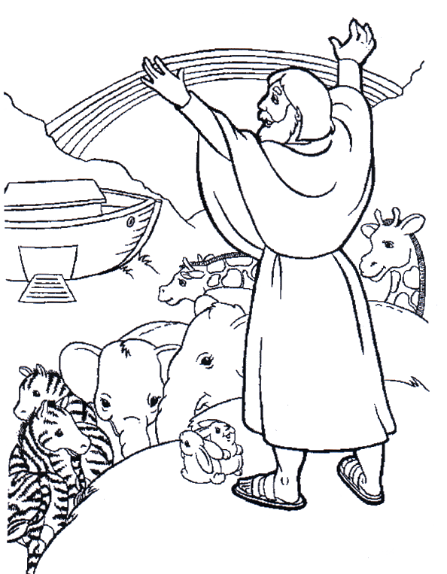
Read Genesis 8:1-22 and
Genesis 9:11-16
What a strange experience it must have been for Noah, his wife and their three sons and daughters-in-law; the only eight people left in the world, floating in the Ark on top of the greatest flood the world has ever known. How grateful they must have been to God, for providing a way of escape for them. How glad that they had believed God and obeyed His instructions!
After the flood had reached its height, God caused the rain to stop and again closed up the deep springs under the earth. He made a strong wind to blow and gradually the water began to go down. Day by day the Ark came nearer the earth, until after 150 days, it came to rest on Mt. Ararat. After 40 days had passed, Noah opened the window of the Ark and sent out a raven, hoping it might be able to find something to show how the flood was decreasing. However, it did not return; perhaps it found some carrion floating in the water to eat and rest on from time to time.
Next, Noah sent out a dove. It returned, unable to find a suitable place to land and rest. After seven days, Noah again released the dove and this time it returned with an olive leaf in its beak! Noah knew by this that vegetation was again beginning to appear. Seven more days passed and the dove was let out again, but this time it did not come back. Noah knew that the flood was over! Finally, after a year in the Ark, God told Noah to leave the Ark and release all the animals and birds so they could begin to breed and multiply in number again.
Noah, and all those with him in the Ark, went out into a whole new world; cleansed and full of new life and beauty. The first thing Noah did was to build an altar with some stones and offer a

Key Verse:
“I have set My rainbow in the clouds, and it will be the sign of the covenant between Me and the Earth.’”
John 3:3
Signs of God’s Promise
1a. How many people were saved in the ark?
b. Who were they?
2. What did Noah do when he first came out of the Ark?
.
3. What does the rainbow remind us about?

4. What did Jesus say about the flood?

5. How are people today like people in Noah’s day?
QUESTIONS & ANSWERS
sacrifice of praise and thanksgiving to the Lord. God was pleased with Noah and He promised to never again destroy the earth by flood. He spread a glorious rainbow across the sky as a sign of His promise. So when you see a rainbow, remember that it’s God’s sign of His promise to us all. You know, it is always wise to believe what God says, even though it may be hard to understand and people may laugh at us. In Noah’s day, many probably thought that he was ignorant or even mad. Today many people sneer at the Bible and those who believe it, and treat the story of Noah as a myth, or fable. They deny it ever happened and laugh at any suggestion that God will one day judge the world again.
However, many scientists are now convinced that a world-wide flood, such as that described here in Genesis, is the most logical explanation for many of the geographical formations which we see around us, and for the existence of fossils. More importantly, Jesus Himself confirmed the story to be true, “As it was in the days of Noah...so it will be at the coming of the Son of Man” (Matthew 24:37-39). He described how people were going about their lives, ignoring the warnings of Noah, until the flood came and destroyed them. It was too late when it started raining; God had shut the door! There are many signs in our world today that Christ will soon return as He promised. God wants us to act in faith and put our trust in Christ now. Don’t wait until it’s too late!

Level 4 lesson 7
Extra: Other than the Bible,
research for more evidence of the flood
1. What did God tell Abraham to do?
2. What was Abraham called?
3. How may we become friends of the Lord Jesus?
4. Why did Abraham willingly obey God?

5. How did Abraham honour God wherever he went?
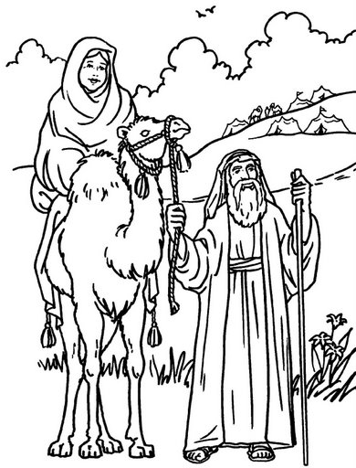
them. Even though
they seemed
impossible, Abraham still believed God. That’s why Abraham is spoken of in the New Testament as a great example of faith. Friends, do you believe God’s promises in His Word? If you are already trusting Christ as Saviour and following Him as Lord, you can always rely on God to faithfully keep His promises to you!
HE OBEYED GOD
Disobedience is sin. We saw last month what terrible results followed Adam and Eve’s disobedience. Because God is good, righteous, and holy; it is always wiser to obey Him. God asked Abraham to do a really hard thing when He told Him to leave his homeland and go to another place, unknown to him. But because Abraham knew God, he knew that God would only tell him to do what was good for him. Sometimes we think we know best, but to obey God is always the best thing to do. God always wants what is best for each of us, even if what He asks us to do is hard or difficult.
HE HONOURED GOD
Wherever he went, Abraham publicly made known his faith in God to others. He built altars on which he offered burnt offerings to the Lord. This was a real testimony to all around him that he worshipped and served the Living God. If we love the Lord Jesus we can honour him too; by witnessing to others of His love and grace, and by giving God the glory for our achievements. Rather than building altars, our sacrifices can be giving up something, or doing something, for the Lord’s sake, to please and obey Him. The Lord says, “Those who honour me, I will honour.”

Abraham, the friend of God
Extra: List some things necessary
for you to be a friend of God
Read Genesis 11:31 to 12:9 and Hebrews 11:8-12
Long after Noah had died, the earth was again filled with people. They too had chosen to disobey God’s laws and now worshipped other idols. Many had begun to worship the sun and stars. In the city of Ur, the people worshipped the moon in a huge temple called the ‘Zigguraat.’ A man lived there, whose name was Terah. He was a good man, and was not content with the life and worship of the people around him. He left Ur but before he had gone very far he died in Haran. Abraham was his eldest son, and he too, was seeking the true God.
One day God spoke to Abraham and told him these wonderful words. “Leave your country, and go to a land that I will show you: I will bless you and make your name great, and you shall be a blessing.” Abraham believed God’s words, and obeyed Him. We read that in faith, he packed up all his belongings, gathered his wife, nephew, and servants together, and set out for the Land of Canaan.
There are four important things we can notice about Abraham:
HE KNEW GOD
He not only knew about God, he knew Him as a close friend. God spoke of him in Isaiah 41:8 as “Abraham, my friend.” In the New Testament we read again that, “Abraham was called the friend of God.” It must have been a wonderful thing for Abraham to have God as his close friend. But here is another wonderful thing. The Lord Jesus says, ‘YOU are MY friends, if you do what I command’ (John 15:14). What a wonderful privilege and honour! You may be His friend and know His companionship through life by simply trusting Him as Saviour and obeying His Word.
HE BELIEVED GOD
God made him some wonderful promises and Abraham was sure He would never break
QUESTIONS & ANSWERS
Level 4 lesson 8
Key Verse:
“I will bless you; I will make your name great; and you will be a blessing”
Genesis 12:2

