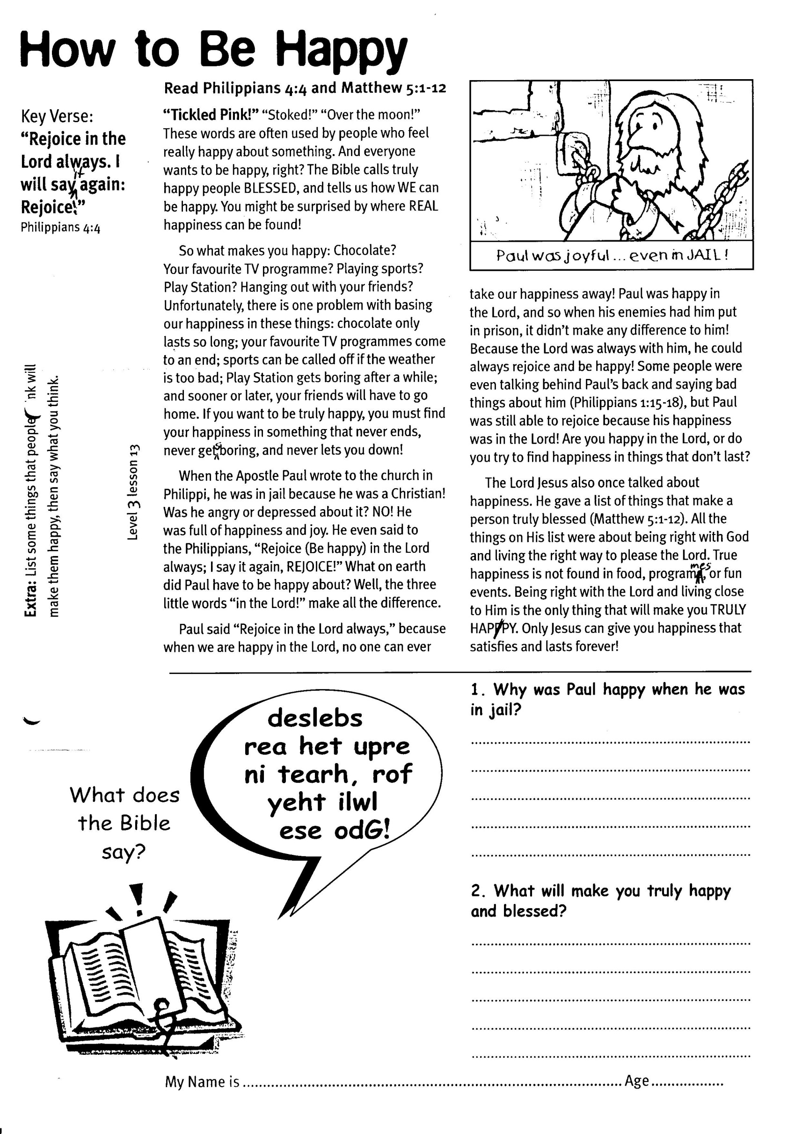

Key Verse:  
**“Rejoice in the Lord always. I will say it again: Rejoice.”**  
Philippians 4:4

**Read Philippians 4:4 and Matthew 5:1-12**

**“Tickled Pink!”** “Stoked!” “Over the moon!” These words are often used by people who feel really happy about something. And everyone wants to be happy, right? The Bible calls truly happy people BLESSED, and tells us how WE can be happy. You might be surprised by where REAL happiness can be found!

So what makes you happy: Chocolate? Your favourite TV programme? Playing sports? Play Station? Hanging out with your friends? Unfortunately, there is one problem with basing our happiness in these things: chocolate only lasts so long; your favourite TV programmes come to an end; sports can be called off if the weather is too bad; Play Station gets boring after a while; and sooner or later, your friends will have to go home. If you want to be truly happy, you must find your happiness in something that never ends, never gets boring, and never lets you down!

When the Apostle Paul wrote to the church in Philippi, he was in jail because he was a Christian! Was he angry or depressed about it? NO! He was full of happiness and joy. He even said to the Philippians, “Rejoice (be happy) in the Lord always; I say it again, REJOICE!” What on earth did Paul have to be happy about? We ll, the three little words “in the Lord!” make all the difference.

**How to be Happy**



Write the answer in this blank speech bubble

deslebs rea het upre ni tearh, rof yeht ilwl ese odG!

1. Why was Paul happy when he was in jail?  
______________________________________  
______________________________________  
______________________________________  
______________________________________  
2. What will make you truly happy and blessed?  
_____________________________________  
_____________________________________  
_____________________________________  
_____________________________________

Paul said “Rejoice in the Lord always,” because when we are happy in the Lord, no one can ever take our happiness away! Paul was happy in the Lord, and so when his enemies had him put in prison, it didn’t make any difference to him! Because the Lord was always with him, he could always rejoice and be happy! Some people were even talking behind Paul’s back and saying bad things about him (Philippians 1:15-18), but Paul was still able to rejoice because his happiness was in the Lord! Are you happy in the Lord, or do you try to find happiness in things that don’t last?

The Lord Jesus also once talked about happiness. He gave a list of things that make a person truly blessed (Matthew 5:1-12). All the things on His list were about being right with God and living the right way to please the Lord. True happiness is not found in food, programmes, or fun events. Being right with the Lord and living close to Him is the only thing that will make you TRULY HAPPY. Only Jesus can give you happiness that satisfies and lasts forever!

**Extra:** List some things that people think will  
make them happy, then say what you think.

**Level 3 lesson 13**

My Name is ……………………………………………………… Age…………………

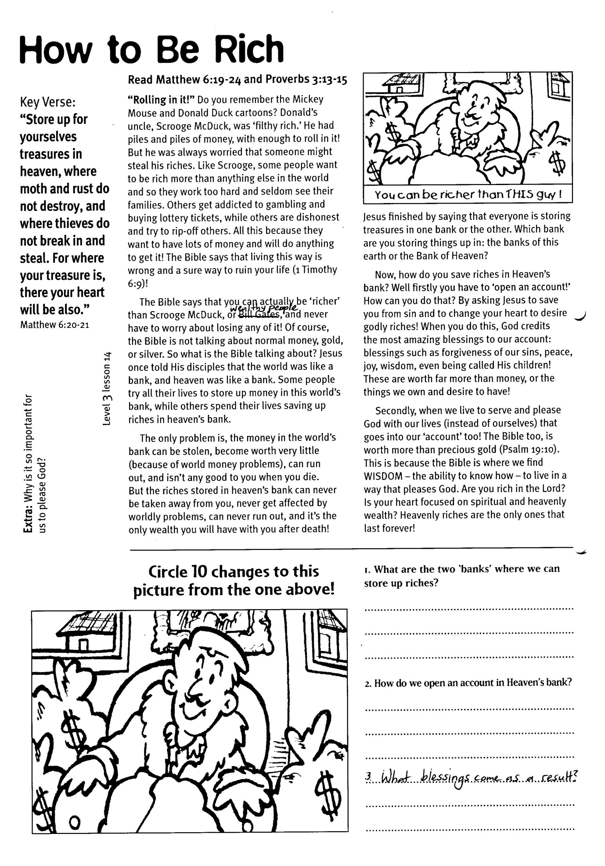

**Read Matthew 6:19-24 and Proverbs 3:13-15**

**“Rolling in it!”** Do you remember the Mickey Mouse and Donald Duck cartoons? Donald’s uncle, Scrooge McDuck, was ‘filthy rich.’ He had piles and piles of money, with enough to roll in it! But he was always worried that someone might steal his riches. Like Scrooge, some people want to be rich more than anything else in the world and so they work too hard and seldom see their families. Others get addicted to gambling and buying lottery tickets, while others are dishonest and try to rip-off others. All this because they want to have lots of money and will do anything to get it! The Bible says that living this way is wrong and a sure way to ruin your life (1 Timothy 6:9)!

The Bible says that you can actually be ‘richer’ than Scrooge McDuck, or wealthy people, and never have to worry about losing any of it! Of course, the Bible is not talking about normal money, gold, or silver. So what is the Bible talking about? Jesus once told His disciples that the world was like a bank, and heaven was like a bank. Some people try all their lives to store up money in this world’s bank, while others spend their lives saving up riches in heaven’s bank.

The only problem is, the money in the world’s bank can be stolen, become worth very little (because of world money problems), can run out, and isn’t any good to you when you die. But the riches stored in heaven’s bank can never be taken away from you, never get affected by

Key Verse:  
**“Store up for yourselves treasures in heaven, where moth and rust do not destroy, and where thieves do not break in and steal. For where your treasure is, there your heart will be also.”**Matthew 6:20,21

**How to Be Rich**



1. What are the two ‘banks’ where we can store up riches?  
__________________________________________  
__________________________________________  
2. How do we open an account in Heaven’s bank? __________________________________________  
__________________________________________  
__________________________________________

3. What blessings come as a result?  
______________________________________  
______________________________________

Spot the Difference! Look at the picture above, then circle 10 changes in this picture!

worldly problems, can never run out, and it’s the only wealth you will have with you after death!

Jesus finished by saying that everyone is storing treasures in one bank or the other. Which bank are you storing things up in: the banks of this earth or the bank of Heaven?

Now, how do you save riches in Heaven’s bank? Well firstly you have to ‘open an account!’ How can you do that? By asking Jesus to save you from sin and to change your heart to desire godly riches! When you do this, God credits the most amazing blessings to our account: blessings such as forgiveness of our sins, peace, joy, wisdom, even being called His children! These are worth far more than money, or the things we own and desire to have!

Secondly, when we live to serve and please God (instead of ourselves) with our lives, that goes into our ‘account’ too! The Bible too, is worth more than precious gold (Psalm 19:10). This is because the Bible is where we find WISDOM – the ability to know how – to live in a way that pleases God. Are you rich in the Lord? Is your heart focused on spiritual and heavenly wealth? Heavenly riches are the only ones that last forever!

**Level 3 lesson 14**

**Extra:** Why is it so important for   
us to please God?

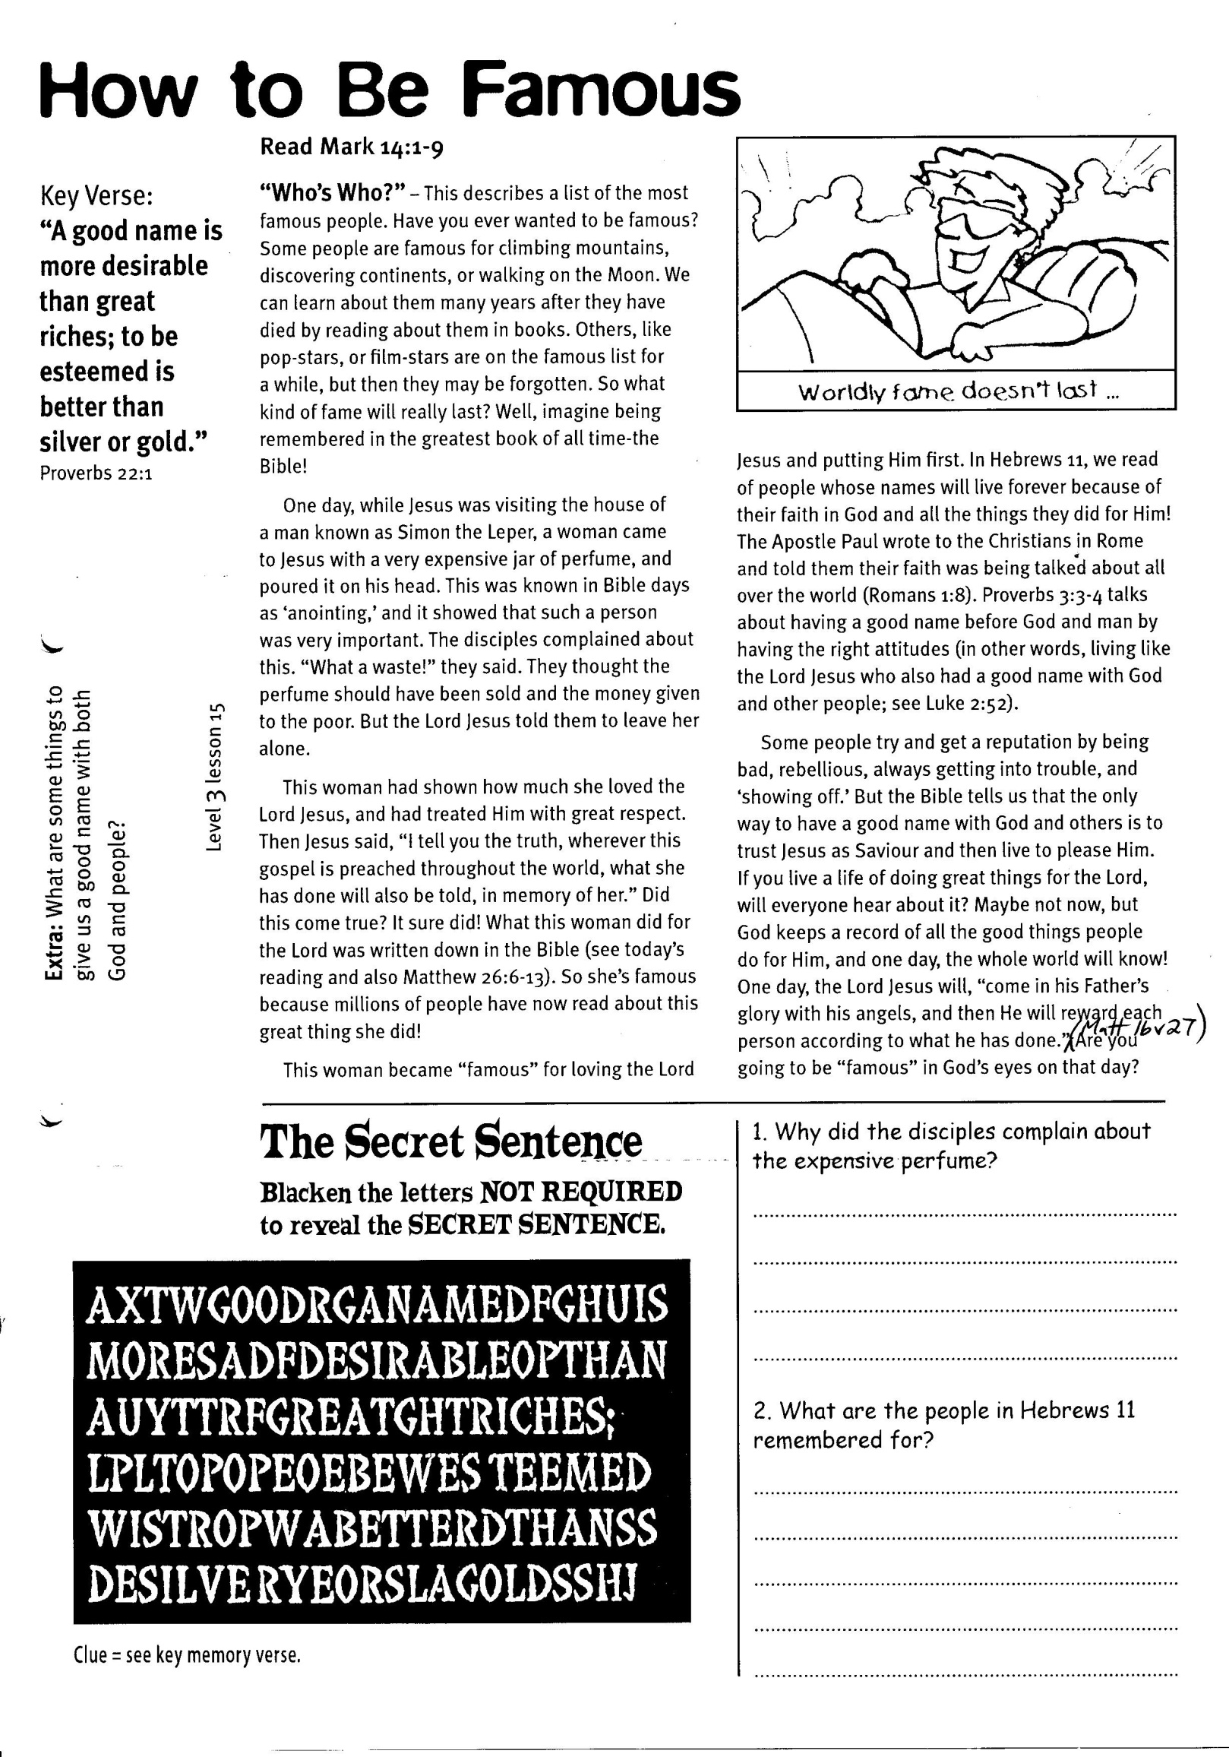

**Read Mark 14:1-9**

**“Who’s Who?”** – This describes a list of the most famous people. Have you ever wanted to be famous? Some people are famous for climbing mountains, discovering continents, or walking on the moon. We can learn about them many years after they have died by reading about them in books. Others, like pop-stars, or film-stars are on the famous list for a while, but then they may be forgotten. So what kind of fame will really last? Well, imagine being remembered in the greatest book of all time ‑ the Bible!

One day, while Jesus was visiting the house of a man known as Simon the Leper, a woman came to Jesus with a very expensive jar of perfume, and poured it on his head. This was known in Bible days as ‘anointing,’ and it showed that such a person was very important. The disciples complained about this. “What a waste!” they said. They thought the perfume should have been sold and the money given to the poor. But the Lord Jesus told them to leave her alone.

This woman had shown how much she loved the Lord Jesus, and had treated Him with great respect. Then Jesus said, “I tell you the truth, wherever this gospel is preached throughout the world, what she has done will also be told, in memory of her.” Did this come true? It sure did! What this woman did for the Lord was written down in the Bible (see today’s reading and also Matthew 26:6-13). So she’s famous because

**How to Be Famous**

Key Verse:  
**“A good name is more desirable than great riches; to be esteemed is better than silver or gold.”**Proverbs 22:1

**FUN**

millions of people have now read about this great thing she did!

This woman became “famous” for loving the Lord Jesus and putting Him first. In Hebrews 11, we read of people whose names will live forever because of their faith in God and all the things they did for Him! The Apostle Paul wrote to the Christians in Rome and told them their faith was being talked about all over the world (Romans 1:8). Proverbs 3:3-4 talks about having a good name before God and man by having the right attitudes (in other words, living like the Lord Jesus who also had a good name with God and other people; see Luke 2:52).

Some people try and get a reputation by being bad, rebellious, always getting into trouble, and ‘showing off.’ But the Bible tells us that the only way to have a good name with God and others is to trust Jesus as Saviour and then live to please Him. If you live a life of doing great things for the Lord, will everyone hear about it? Maybe not now, but God keeps a record of all the good things people do for Him, and one day, the whole world will know! One day, the Lord Jesus will, “come in his Father’s glory with his angels, and then He will reward each person according to what he has done” (Matthew 16:27). Are you going to be “famous” in God’s eyes on that day?

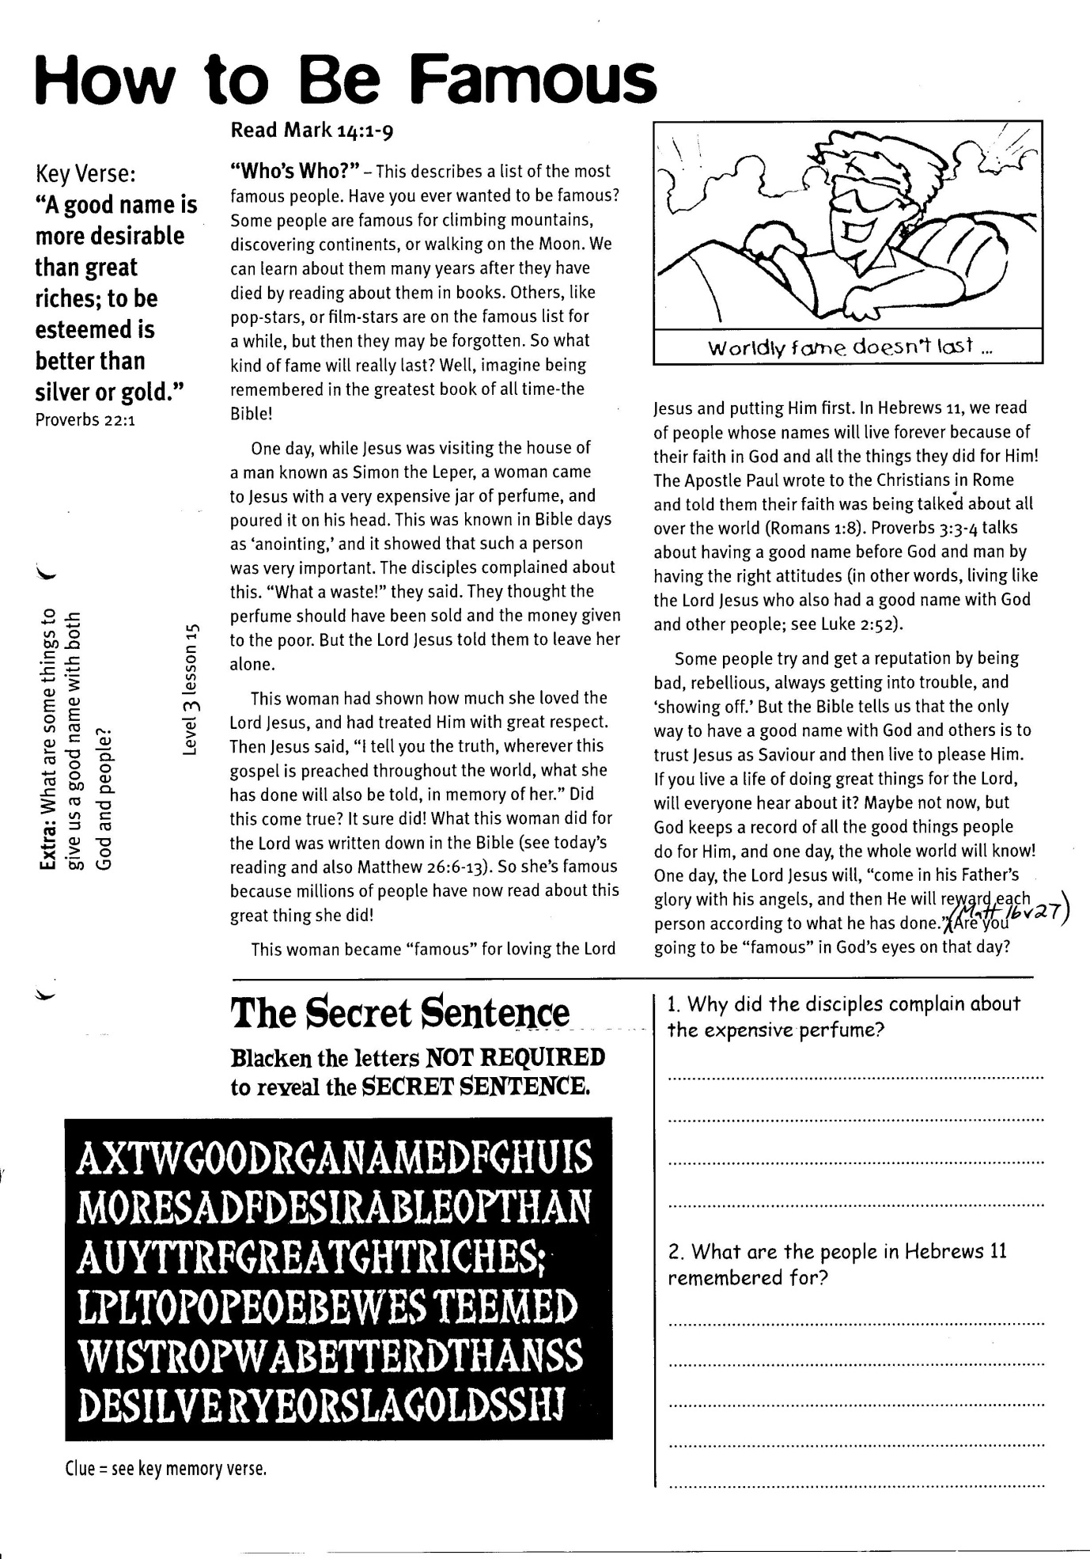

**Extra:** What are some things that give us a good  
name with both God and people?

Clue = see key memory verse.

**The Secret Sentence**Blacken the letters NOT REQUIRED to reveal the SECRET SENTENCE.

1. Why did the disciples complain about the expensive perfume?   
____________________________________  
____________________________________  
____________________________________

2. What are the people in Hebrews 11 remembered for?  
________________________________________________________________________  
____________________________________  
________________________________________________________________________

**Level 3 lesson 15**

|  |  |  |  |  |  |
| --- | --- | --- | --- | --- | --- |
| T | N | O | T | U | P |
| H | E | A | R | M | O |
| O | G | F | O | R | U |
| D | T | O | W | I | N |

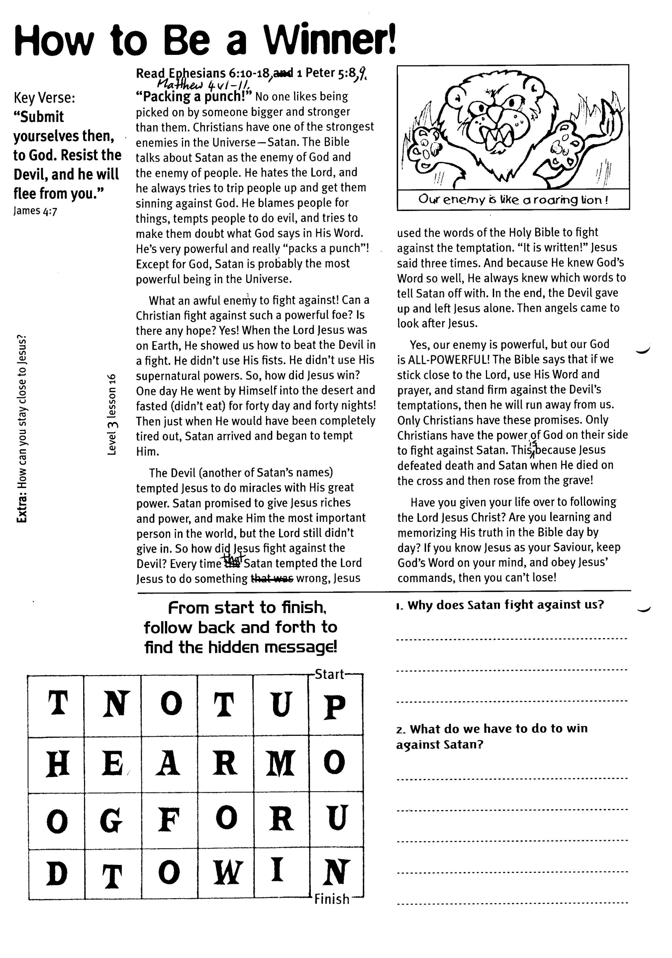

finish

Every time that Satan tempted the Lord Jesus to do something wrong, Jesus used the words of the Holy Bible to fight against the temptation. “It is written!” Jesus said three times. And because He knew God’s Word so well, He always knew which words to tell Satan off with. In the end, the Devil gave up and left Jesus alone. Then angels came to look after Jesus.

Yes, our enemy is powerful, but our God is ALL-POWERFUL! The Bible says that if we stick close to the Lord, use His Word and prayer, and stand firm against the Devil’s temptations, then he will run away from us. Only Christians have these promises. Only Christians have the power of God on their side to fight against Satan. This is because Jesus defeated death and Satan when He died on the cross and then rose from the grave!

Have you given your life over to following the Lord Jesus Christ? Are you learning and memorizing His truth in the Bible day by day? If you know Jesus as your Saviour, keep God’s Word on your mind, and obey Jesus’ commands, then you can’t lose!

**Read Ephesians 6:10-18, 1 Peter 5:8 and Matthew 4:1-11**

**“Packing a punch!”** No one likes being picked on by someone bigger and stronger than them. Christians have one of the strongest enemies in the Universe ­ Satan. The Bible talks about Satan as the enemy of God and the enemy of people. He hates the Lord, and he always tries to trip people up and get them sinning against God. He blames people for things, tempts people to do evil, and tries to make them doubt what God says in His Word. He’s very powerful and really “packs a punch”! Except for God, Satan is probably the most powerful being in the Universe.

What an awful enemy to fight against! Can a Christian fight against such a powerful foe? Is there any hope? YES! When the Lord Jesus was on earth, He showed us how to beat the Devil in a fight. He didn’t use His fists. He didn’t use His supernatural powers. So, how did Jesus win? One day He went by Himself into the desert and fasted (didn’t eat) for forty day and forty nights! Then just when He would have been completely tired out, Satan arrived and began to tempt Him.

The Devil (another of Satan’s names) tempted Jesus to do miracles with His great power. Satan promised to give Jesus riches and power, and make Him the most important person in the world, but the Lord still didn’t give in. So how did Jesus fight against the Devil?

start

From start to finish, follow back and forth to find the hidden message!

**Level 3 lesson 16**

**Extra:** How can you stay close to Jesus?

**How to Be a Winner!**

1. Why does Satan fight against us?  
__________________________________________________

__________________________________________________

__________________________________________________

__________________________________________________  
2. What do we have to do to win against Satan?

__________________________________________________

__________________________________________________

__________________________________________________

Key Verse:  
**“Submit yourselves to God. Resist the Devil, and he will flee from you.”**James 4:7