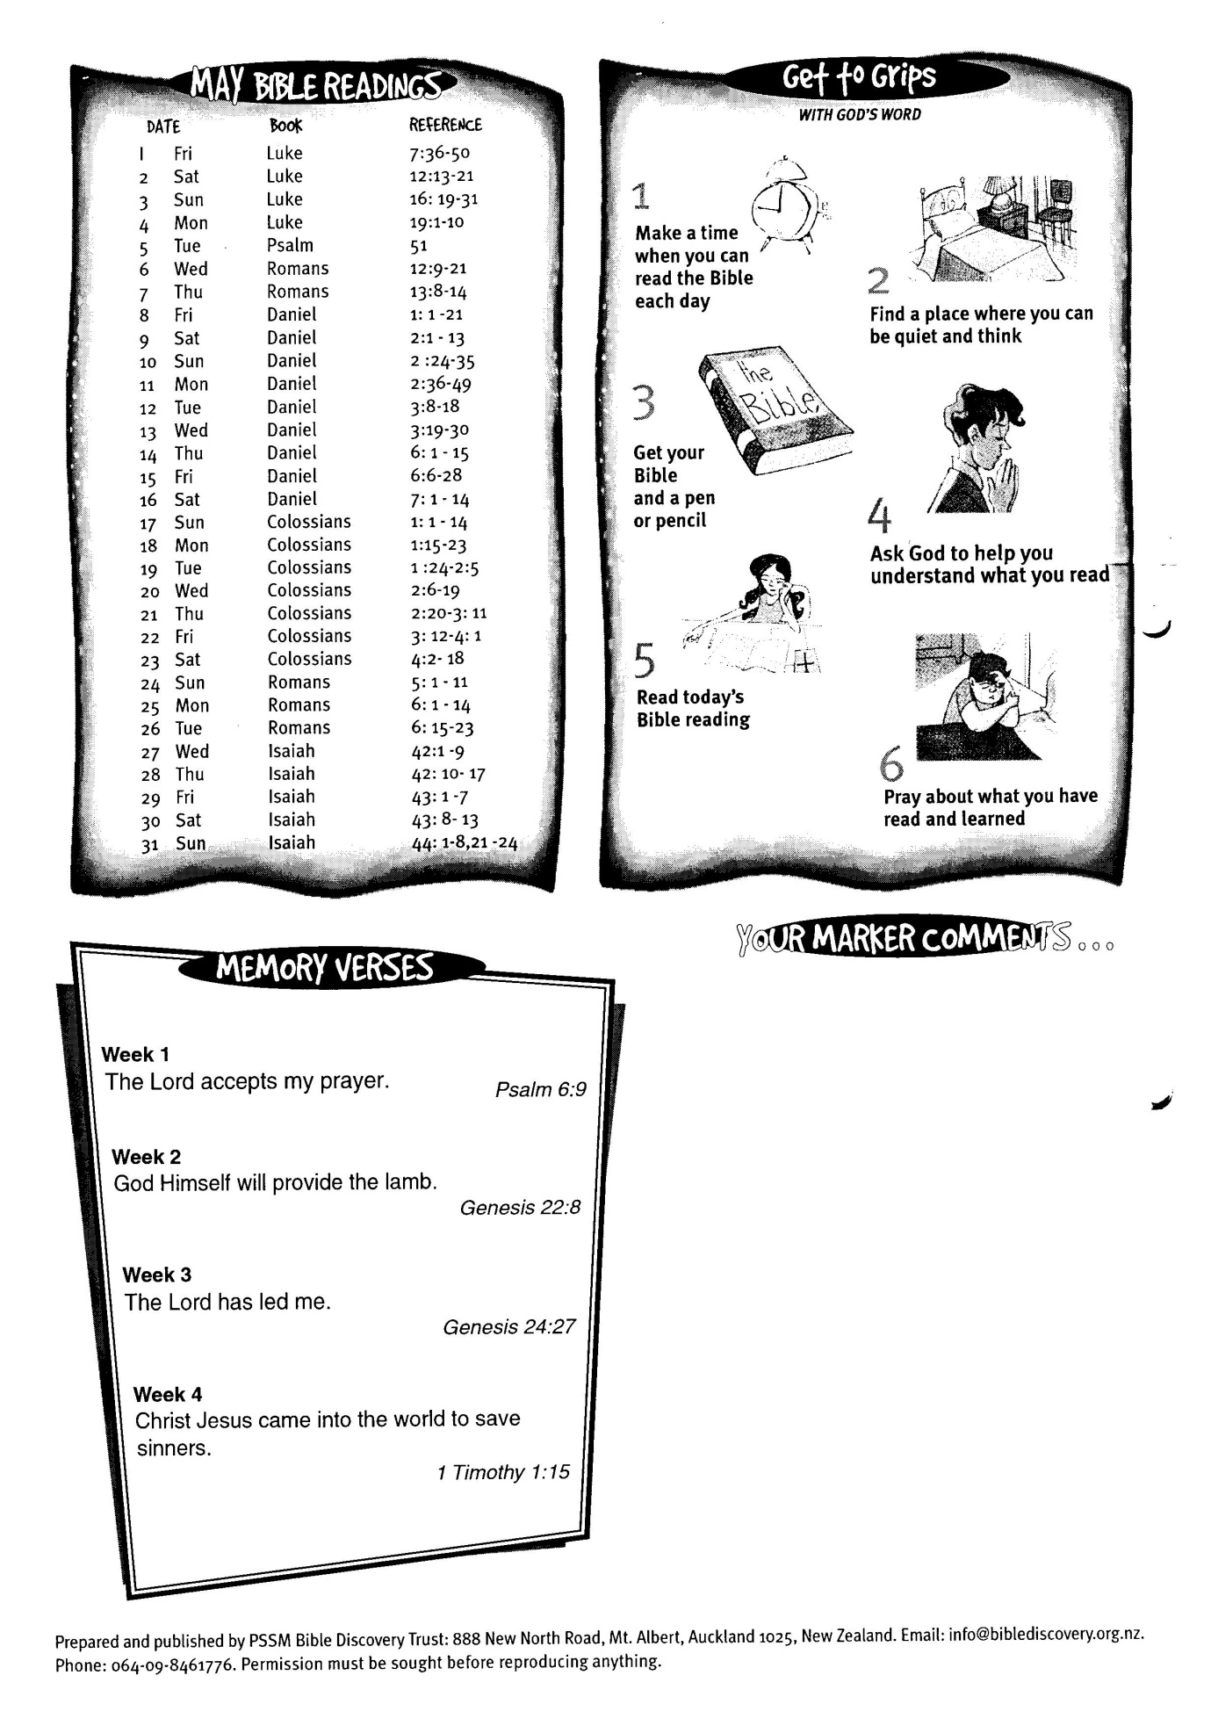

**May Bible Readings**

DATE BOOK REFERENCE

31 Isaiah 44: 1-8; 21-24

6:16 - 28