**June Bible Readings**

DATE BOOK REFERENCE

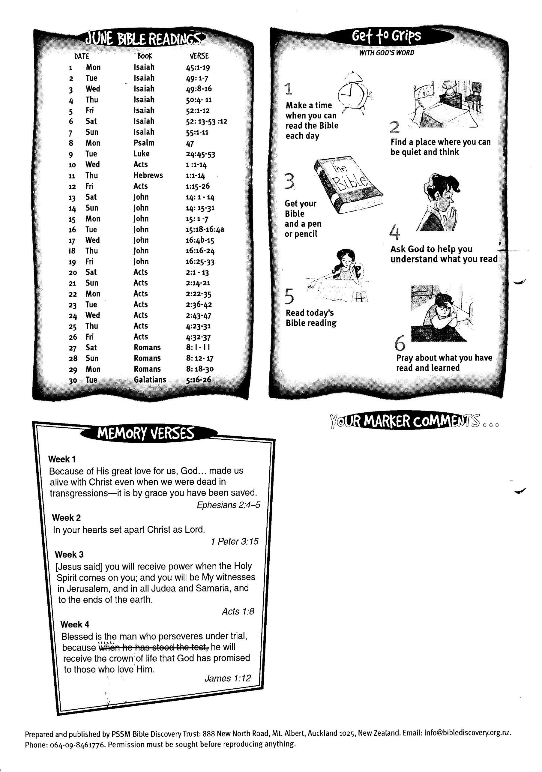

**30 Galatians 5:16-26**

6:16 - 28