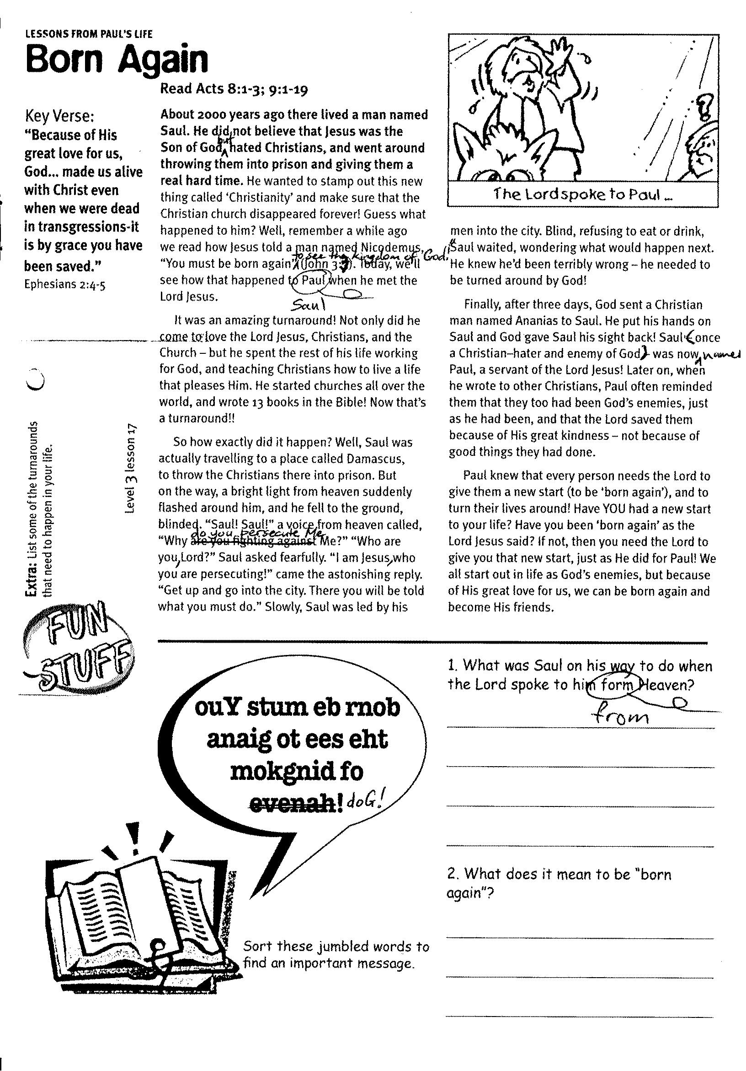

LESSONS FROM PAUL’S LIFE

Key Verse:  
**“Because of His great love for us, God… made us alive with Christ even when we were dead in transgressions - it is by grace you have been saved.”**  
Ephesians 2:4-5

**Read Acts 8:1-3; 9:1-19**

**About 2000 years ago there lived a man named Saul.** He did not believe that Jesus was the Son of God, but hated Christians, and went around throwing them into prison and giving them a really hard time. He wanted to stamp out this new thing called ‘Christianity’ and make sure that the Christian church disappeared forever! Guess what happened to him? Well, remember a while ago we read how Jesus told a man named Nicodemus, “You must be born again to see the kingdom of God!” (John 3:3). Today, we’ll see how that happened to Saul when he met the Lord Jesus.

It was an amazing turnaround! Not only did he come to love the Lord Jesus, Christians, and the Church – but he spent the rest of his life working for God, and teaching Christians how to live a life that pleases Him. He started churches all over the world, and wrote 13 books in the Bible! Now that’s a turnaround!!

So how exactly did it happen? Well, Saul was actually travelling to a place called Damascus, to throw the Christians there into prison. But on the way, a bright light from heaven suddenly flashed around him, and he fell to the ground, blinded. “Saul! Saul!” a voice from heaven called, “Why do you persecute Me?” “Who are you, Lord?” Saul asked fearfully. “I am Jesus, who you are persecuting!” came the astonishing reply. “Get up and go into the city. There you will be told what you must do.”

**Born Again**



My Name is ……………………………………………………………… Age ………………….

Sort these jumbled words. Write   
the answer in this blank speech   
bubble

**ouY stum eb rnob anaig ot ees eht mokgnid fo doG!**

Slowly, Saul was led by his men into the city. Blind, and refusing to eat or drink, Saul waited, wondering what would happen next. He knew he’d been terribly wrong – he needed to be turned around by God!

Finally, after three days, God sent a Christian man named Ananias to Saul. He put his hands on Saul and God gave Saul his sight back! Saul (once a Christian–hater and enemy of God) was now named Paul, a servant of the Lord Jesus! Later on, when he wrote to other Christians, Paul often reminded them that they too had been God’s enemies, just as he had been, and that the Lord saved them because of His great kindness – not because of good things they had done.

Paul knew that every person needs the Lord to give them a new start (to be ‘born again’), and to turn their lives around! Have YOU had a new start to your life? Have you been ‘born again’ as the Lord Jesus said? If not, then you need the Lord to give you that new start, just as He did for Paul! We all start out in life as God’s enemies, but because of His great love for us, we can be born again and become His friends.

**Extra:** List some of the turnarounds  
that need to happen in your life.

**Level 3 lesson 17**

1. What was Saul on his way to do when the Lord spoke to him from Heaven?  
______________________________________  
______________________________________  
______________________________________  
______________________________________  
2. What does it mean to be “born again”?  
_____________________________________  
_____________________________________  
_____________________________________  
_____________________________________

My Name is ……………………………………………………… Age…………………



LESSONS FROM PAUL’S LIFE

**Read Philippians 3:4-14 and Romans 6:1-6**

**When someone becomes a Christian, there are often big changes. A new way of living, new things to aim for, and new things become important. What are the things that are right for a Christian to love and live for?**

What’s your favourite sport? Rugby? Soccer? Netball? We all know that each sport has its own rules. Imagine if someone went to play rugby, but used the rules for soccer! Or what if a soccer player tried to play by the rules for netball? It wouldn’t work, would it? Even if the players were fit and talented and tried to play well – if they played with the wrong rules, their game would be terrible!

It’s like that once someone becomes a Christian, they have a whole new life ahead of them, and that means new goals and a new way of living. Trying to live the same way as before would be like trying to play a sport using the wrong rules!

Before Paul became a Christian, he didn’t think much of the Lord Jesus. He thought that his own life was good enough to please God. He thought too much of himself and even hated the Lord. However, when Paul wrote to the Christians at Philippi, he told them what really mattered to him after he became a Christian: he wanted to know the Lord Jesus more and more.

You see, that’s why Christians read the Bible. It’s not because they ‘have to’ – it’s because they want to hear the words of their Lord.

Key Verse:  
**“In your hearts set apart Christ as Lord.”**1 Peter 3:15

**A New Life**

1. In your own words, what does   
1 Peter 3:15 mean?  
__________________________________________  
__________________________________________  
__________________________________________  
__________________________________________  
2. What are some ways that Paul’s life changed when he became a Christian?  
______________________________________  
______________________________________  
__________________________________________

__________________________________________

Christians can live any way they want ⃝ ⃝

Paul’s name used to be Saul ⃝ ⃝

Paul had always loved the Lord Jesus ⃝ ⃝

Jesus is to be Lord of most of my life ⃝ ⃝

We should read the Bible for the cool stories ⃝ ⃝

These lessons help us to know Jesus better ⃝ ⃝

**T F**

**?**

TRUE OR FALSE

**Level 3 lesson 18**

**Extra:** What are some ways we  
can use our bodies for God?

That’s why Christians love Bible teaching at Church and doing studies like these, too. It’s not because Christians are ‘supposed’ to study things about God; it’s because they are thrilled to be learning about their Lord and Saviour!

That’s why Christians pray, too. It’s not just because ‘that’s what Christians do.’ It’s because they want to talk to the Lord and spend time with Him. Do you find it thrilling to be praying to the Lord, learning about Him, and reading His words in the Bible? If it’s all a big drag for you, maybe you missed the first lesson from Paul’s life and need to be born again!

Paul also wrote to some Christians in Rome and told them that the Christian life is about living a NEW life. When someone isn’t saved, they spend their time and money, and use all their gifts and abilities doing wrong things. Paul said Christians should copy his example, and so give their whole life over to pleasing the Lord. They should use their time and money for the Lord. They should make sure that whatever they do with their bodies – their minds, their tongues, their hands and feet – is only to please God. We pray you will follow Paul’s example and give all you have and are to the Lord, to please HIM and do whatever HE wants.



LESSONS FROM PAUL’S LIFE

**Read Acts 17:16-34 and 2 Timothy 4:1-2**

**“Gospel” means ‘GOOD NEWS.**’ It is the NEWS that we can be saved by the Lord Jesus and it is GOOD! We should tell others the ‘Good News’, too.

In old times, before telephones, faxes and emails, people had to give important news to messengers who would ride or run for miles to pass their message on. Sometimes a king whose men were in battle depended on a messenger to let him know exactly what was happening, so he would be able to know how best to fight the enemy.

Imagine if a messenger decided to stop for a few nights in a nice motel, or to go on a little trip through another country on the way to deliver his message! Or if he got sick of riding or running and just gave up altogether. What a problem that would cause! The whole war might be lost because of the unfaithful messenger.

When Paul became a Christian, he realized that he too had an important message to pass on – everyone needed to hear the same ‘Good News’ that he had! While he was in Athens waiting for some friends to arrive, he noticed that there were so many people that needed to hear the ‘Good News’ about Jesus Christ, and was upset that they were worshipping idols. He didn’t hope that someone else would come and tell these people – he went about ‘witnessing’ himself – telling them about the Lord Jesus.

**Good News to Pass On**

Key Verse:  
**“[Jesus said] you will receive power when the Holy Spirit comes on you; and you will be My witnesses in Jerusalem, and in all Judea and Samaria, and to the ends of the earth.”**Acts 1:8

**FUN**

Some of the people listening to him were saved. If Paul hadn’t bothered passing on the message about Jesus, these people might have never heard about Him. If you read through the book of Acts, you’ll see that Paul kept on telling others about the Lord for the rest of his life.

When he wrote to Timothy (a young man that he loved like a son), he told him to preach the message of Jesus all the time, whether it was popular news or not. That’s what Paul did. Sometimes people listened to his message, other times they hated it – but he was faithful to pass it on anyway!

Just like the poor, sick man that Jesus healed one day and then told to “go home and tell everyone how much the Lord had done for YOU!” Jesus wants us to be His witnesses. If you’re a Christian, you might think you don’t know much, but you can always tell others about how the Lord SAVED YOU! If you have confessed your sin and asked Jesus to be your Saviour, then you can tell others how you did this too – and that’s being a witness! You can help others to see how they need to do the same as you did. Ask God for courage and simply tell your friends and family how God has forgiven your sins and given you new life in Jesus!

|  |  |  |  |  |  |  |
| --- | --- | --- | --- | --- | --- | --- |
| **T** | **T** | **E** | **E** | D | **R** | O |
| G | **O** | **L** | O | **H** | **L** | **S** |

**Extra:** Make a list of friends and family   
you can talk to about the Lord, and tick   
them off the list when you have.

__________ _______________ the ____________ news

Using the jumbled letters below, fill in the gaps in this sentence:

1. Look at the words in Acts 17:16-34 again. What made Paul upset in Athens?  
____________________________________  
____________________________________  
________________________________________________________________________

2. What are some of the things we should tell others about Jesus?  
________________________________________________________________________  
____________________________________  
____________________________________

Hint: Letters that are the same style belong together!

**Level 3 lesson 19**

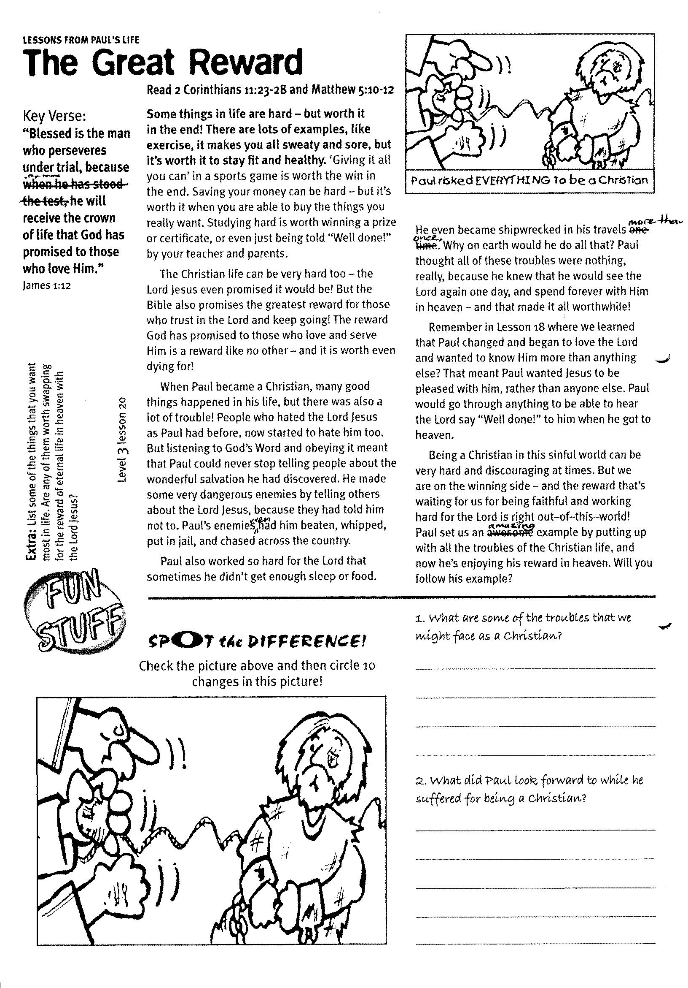

**Read 2 Corinthians 11:23–28 and Matthew 5:10–12**

**Some things in life are hard – but worth it in the end!** There are lots of examples, like exercise, it makes you all sweaty and sore, but it’s worth it to stay fit and healthy. ‘Giving it all you can’ in a sports game is worth the win in the end. Saving your money can be hard – but it’s worth it when you are able to buy the things you really want. Studying hard is worth winning a prize or certificate, or even just being told “Well done!” by your teacher and parents.

The Christian life can be very hard, too – the Lord Jesus even promised it would be! But the Bible also promises the greatest reward for those who trust in the Lord and keep going! The reward God has promised to those who love and serve Him is a reward like no other – and it is worth even dying for!

When Paul became a Christian, many good things happened in his life, but there was also a lot of trouble! People who hated the Lord Jesus as Paul had before, now started to hate him, too. But listening to God’s Word and obeying it meant that Paul could never stop telling people about the wonderful salvation he had discovered. He made some very dangerous enemies by telling others about the Lord Jesus, because they had told him   
not to. Paul’s enemies even had him   
beaten, whipped, put in jail, and chased across the country. Paul also worked so   
hard for the Lord that sometimes he didn’t   
get enough sleep or food.

**Paul also worked so hard for the Lord that sometimes he didn’t get enough sleep or food.**

LESSONS FROM PAUL’S LIFE

**The Great Reward**

**Level 3 lesson 20**

Key Verse:  
**“Blessed is the man who perseveres under trial, because ……. he will receive the crown of life that God has promised to those who love Him.”**James 1:12



Please complete and return by post to   
**PSSM, 888 New North Road, Mt Albert, Auckland 1025**   
or scan & email to **info@biblediscovery.org.nz**

1. What are some of the troubles that we might face as a Christian?  
________________________________________________

________________________________________________

________________________________________________

________________________________________________  
2. What did Paul look forward to while he suffered for being a Christian?

________________________________________________

________________________________________________

________________________________________________

He even became shipwrecked in his travels more than once. Why on earth would he do all that? Paul thought all of these troubles were nothing, really, because he knew that he would see the Lord again one day, and spend forever with Him in heaven – and that made it all worthwhile!

Remember in Lesson 18 where we learned that Paul changed and began to love the Lord and wanted to know Him more than anything else? That meant Paul wanted Jesus to be pleased with him, rather than anyone else. Paul would go through anything to be able to hear the Lord say “Well done!” to him when he got to heaven.

Being a Christian in this sinful world can be very hard and discouraging at times. But we are on the winning side – and the reward that’s waiting for us for being faithful and working hard for the Lord is right out–of–this–world! Paul set us an amazing example by putting up with all the troubles of the Christian life, and now he’s enjoying his reward in heaven. Will YOU follow his example?

**Spot the Difference!**  
Check the picture above and then circle 10 changes in this picture!

**Extra:** List some of the things that you want most in life. Are any of them worth swapping for the reward of eternal life in heaven with the Lord Jesus?

finish