DATE BOOK REFERENCE
July Bible Readings

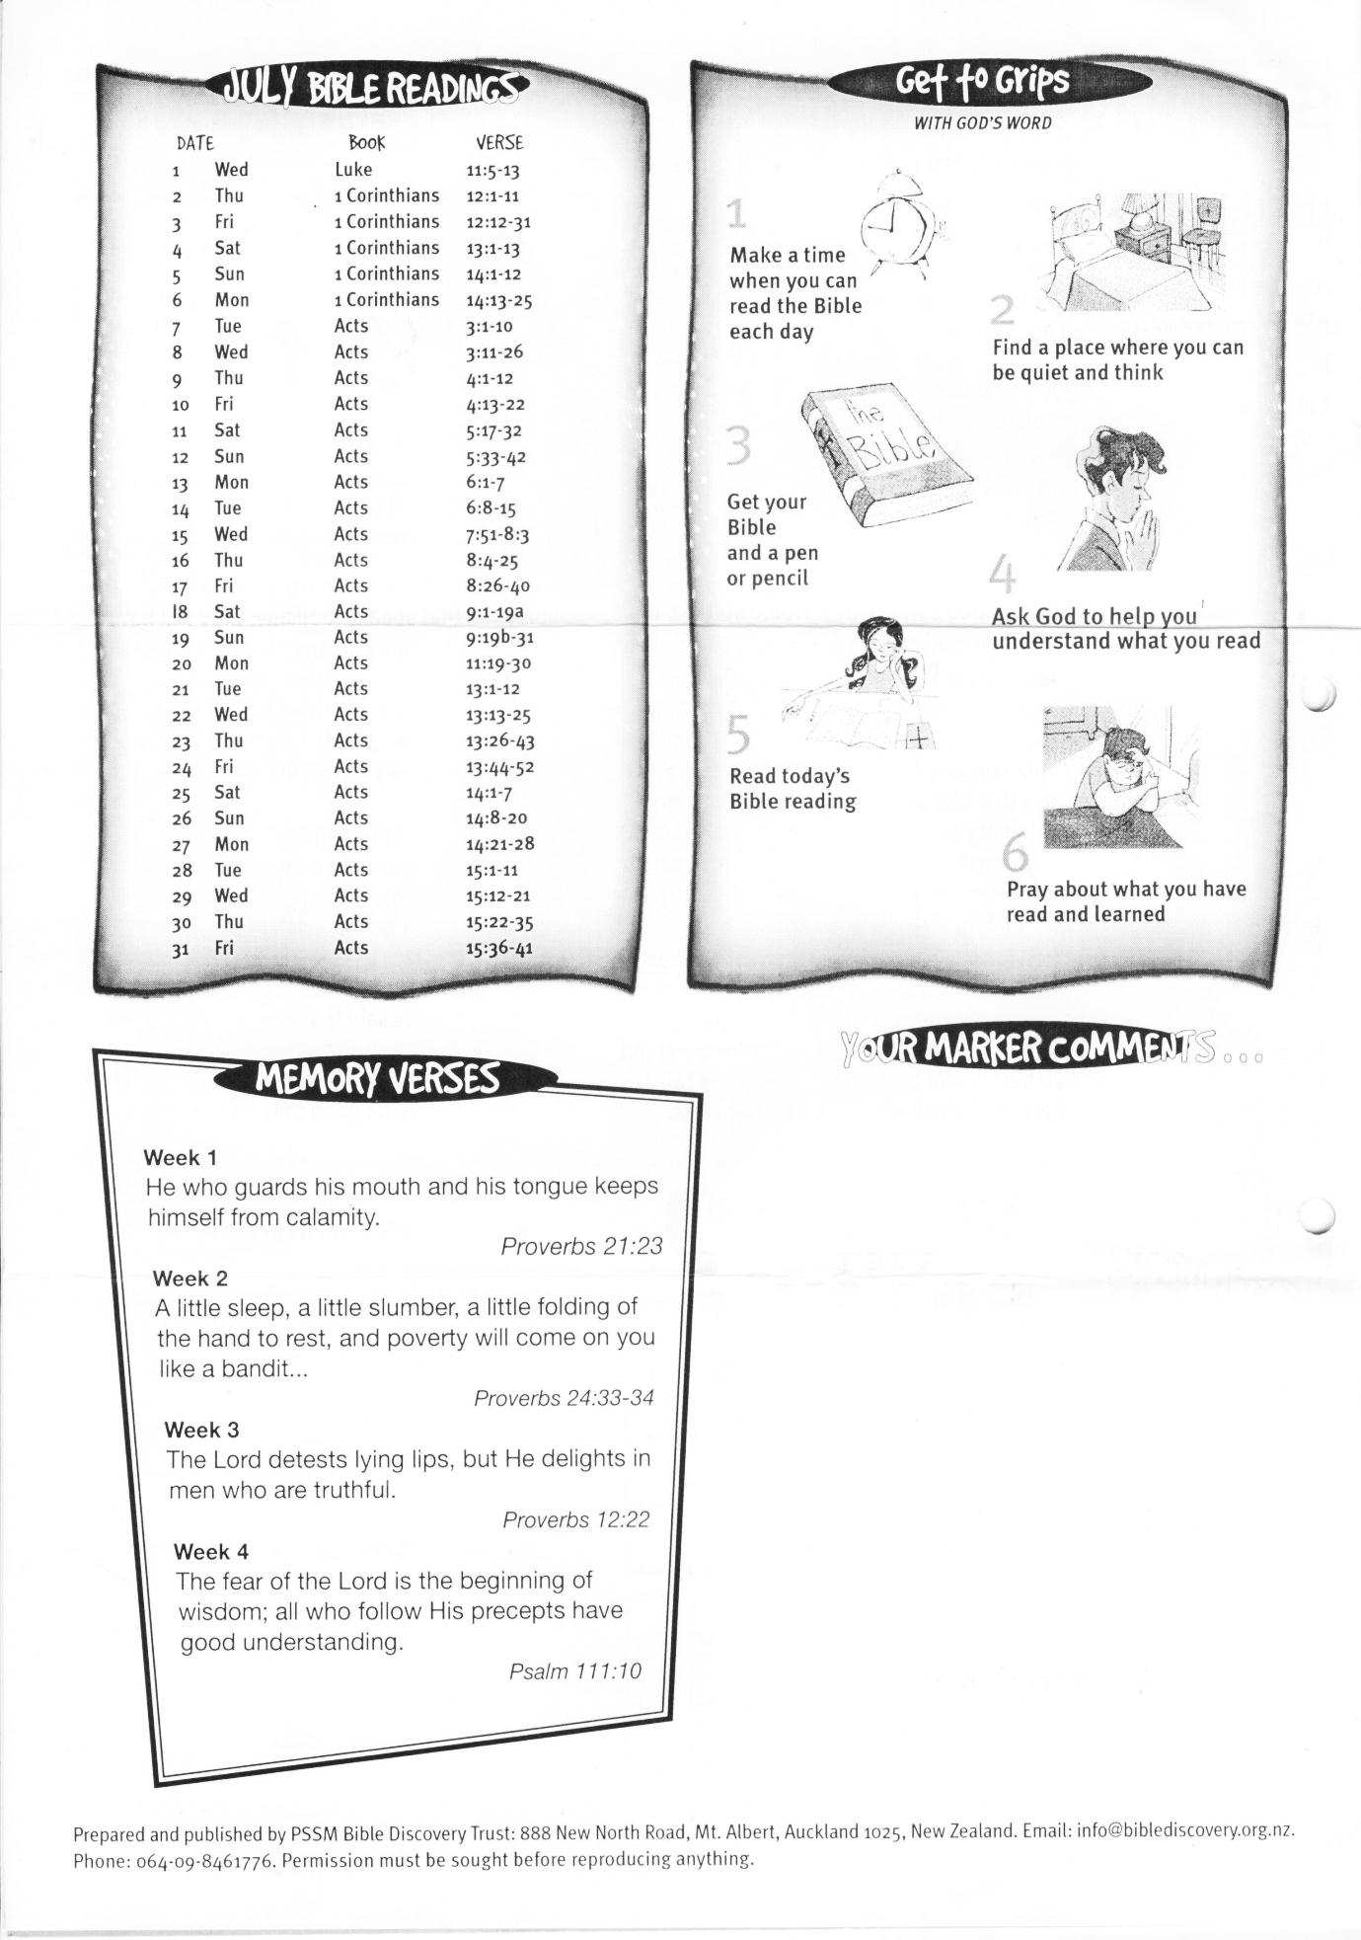

31 Acts 15:36-41

