A Wonderful Dream

Key Verse:
“I am with you and will watch over you wherever you go.”
Genesis 28:15
Read Genesis 28:10-22 and John 14:5-14
Have you ever had a strange or unusual dream? You know, the sort where you wake up and it still seems so real! Sometimes they are interesting and other times they’re frightening, but usually they are all soon forgotten. However, some dreams we never forget. In today’s lesson, we’re going to look at a special dream Jacob had - which he never forgot!
Remember, Jacob had deceived his father Isaac and received the family birthright instead of Esau, his brother. Esau in his anger and disappointment threatened to kill him, so Jacob had to run for his life. That evening as the sun went down, the harsh reality of what he had done began to sink in. He was alone in the desert, without friends or family and only a flat stone for a pillow! Homesick and afraid, he lay down to sleep.
Have you ever gazed up at the stars at night and thought of Heaven, the place where God lives in splendour? Have you perhaps wondered if there was a road or a way there? We don’t know if Jacob had thoughts like these, as he lay out in the open looking up at the stars, but we do know that God was thinking about Jacob! He saw that lonely young man as he lay there. True, God’s Word tells us “the way of wrong- doers is hard,” but God still wanted to show His love and kindness to Jacob. In the dark hours of the night, as Jacob fell asleep, God gave him a vision of a ladder reaching from earth right up to Heaven - with angels passing up and down on it. The ladder started right where Jacob was sleeping!
What did it mean? This was a special message from God: He was near Jacob, and would one day make a way for all people to draw near to
Him. God kept His promise. Many years later, God provided a ‘ladder’ that reached right back to Heaven. Have you guessed it? Yes, Jesus Christ can be likened to a ‘ladder’ and He is now the way to Heaven. When He was here on earth, Jesus said, “I am the way... no-one comes to the Father except through Me” (John 14:6). Therefore, only Jesus can provide access back to God.
Many people try to get to Heaven by their own efforts (or ladders) but they can never meet God’s perfect standard. Prayers, good works, and even going to church will not help if people have not first been saved. Now of course, all these things are right and good. We hope you pray regularly and are always kind, thoughtful and good. We trust that you try to go to church regularly. But these things will not help you get to Heaven!
You see, sin is what stops people entering heaven when they die. Doing good things cannot take away sin. In fact, only Jesus’ blood can wash it away! If you want to be sure of going to Heaven when you leave this world, then confess your sins to God, believe Jesus Christ died on the Cross to pay the penalty for your sin, ask Him to save you, and follow Him as Lord of your life.

1. What did Jacob see in his dream?
2. What did his dream mean?
3. How can Jacob’s dream be likened to the Lord Jesus?
4. Complete John 14 verse 6. Jesus Said “I am the Way, the Truth, and the life…
  ₋
5. How can you be sure of getting to Heaven?
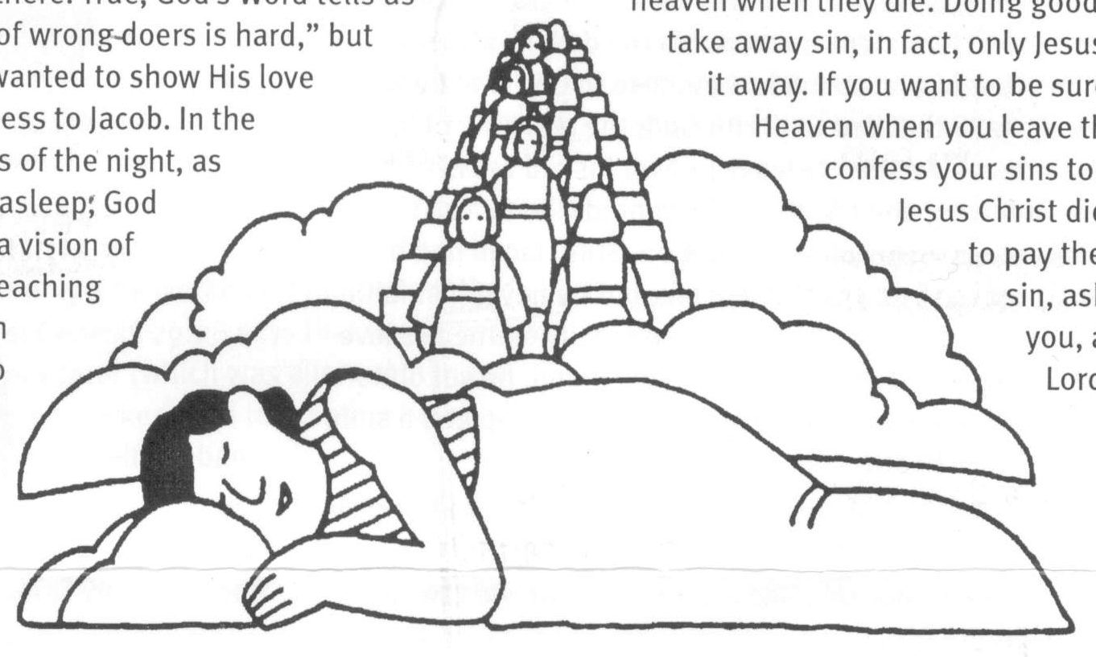
Level 3 lesson 1
Extra: What do you think is meant by
the various ladders mentioned here?
Level 4 lesson 21
QUESTIONS & ANSWERS
The Right Start
Key Verse:
“Jesus said, ‘I tell you the truth, unless a man is born again, he cannot see the kingdom of God.’”
John 3:3
My Name is ……………………………………………………………………… Age ………………….
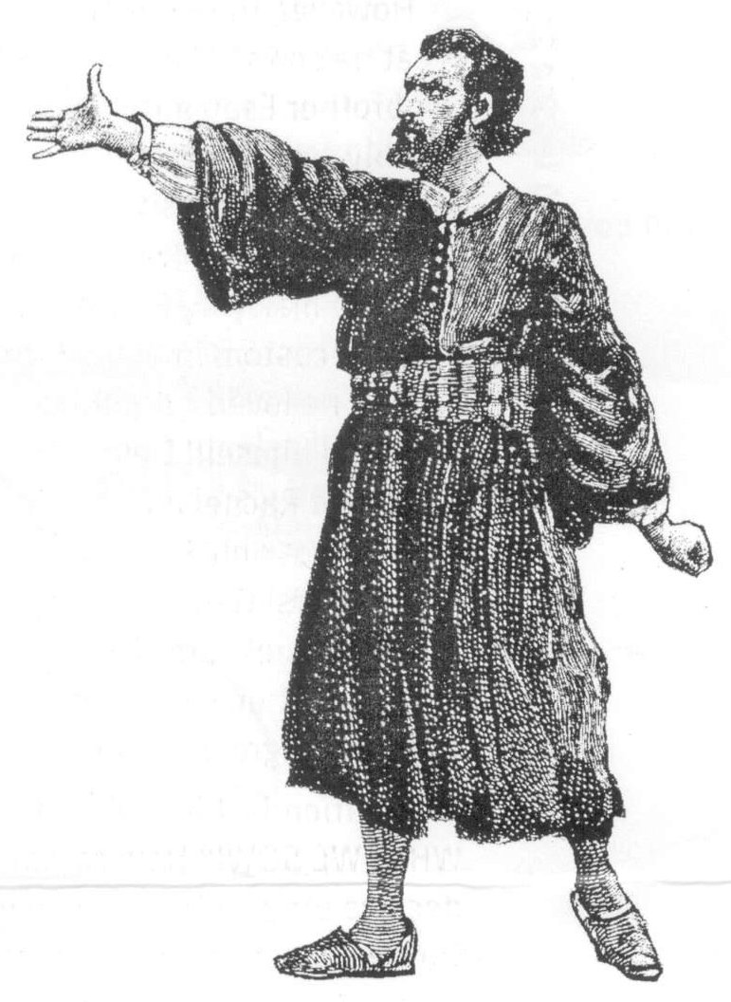
QUESTIONS & ANSWERS
God’s Great Kindness
Key Verse:
“Never will I leave you, never will I forsake you.”
Hebrews 13:5
Read Genesis 28:16-22 and
John 14: 15-31
Startled, Jacob awoke from his dream, half-expecting to see shining angels still going up and down that glittering ladder to Heaven’s glory! Trembling and afraid he said, “How awesome is this place! This is none other than the House of God, this is the gate of Heaven!” Of course, in reality there was nothing special about the place. However, the realisation of God’s holy presence being so near, gave him a really bad conscience about all the sin in his heart and life. He was deeply ashamed of all the wrong things he had done and his deceitful lies to his father.
Jacob was afraid; he knew he was not right with God and should not be in His holy presence. This is what sin does. It makes us afraid of God and to want to run from Him. It gives us wrong ideas about God and all His wonderful love to us. Some think that God only loves ‘good’ people. What a great mistake this is! In fact, the Bible makes it clear that there are NO ‘good’ people (Romans 3:23), but God loves us anyway (Romans 5:10). However, He hates the sinful things people do. That is why in His great love, God sent His only Son Jesus, to die for our sins.
Jacob realised he was no longer alone. God was with him, right there, out in the desert, at Bethel. Humbly, Jacob made a promise to God that he would make the Lord God, HIS God; the real King of his life. Jacob decided to leave forever his old selfish way of lying and cheating. He wanted God to ‘call the shots’ in his life from now on. Sure, Jacob had his ups and downs through life, but he never lost faith in God. There at Bethel, Jacob really learned to love the Lord. Now, with God as his friend, he set off to his uncle Laban’s home, with a light step and a song in his heart!

Even in our world today, God stays close to those who love him! So how does He do that? Does he walk by our side like a normal person we can see? Not quite; it is something more special than that. God lives in the hearts of those He has saved! Before Jesus went back up to heaven He said that He would send the Holy Spirit to come and live in the hearts of all who trust Jesus as Saviour. God the Holy Spirit also brings the Bible to life as we read it and helps us to understand it. He guides and comforts Christians, and is their companion throughout life.
Therefore, God is near in all that we do; in study, in play, and in all that concerns us. He knows every detail about us and is ready to help us whenever we pray to Him. He also gives us strength to resist temptation when we ask. Let us never forget to call on Him whenever we are in need, as well as to thank Him when He has heard and answered our prayers. Accept Jesus Christ as Saviour and friend today and know the presence of God in your life forever! Jacob learnt that in Jesus we have a “friend who sticks closer than a brother.”

1. What does sin do to us (as it did to Jacob)?
2. How has God shown His great love for us all?
3. What promise did Jacob make to God?
4. What great decision did Jacob make at Bethel as a result of his promise?

5. What Did Jesus say the Holy Spirit would do for those who trust Jesus as Saviour?
Extra: What evidence can you find from Jacob’s life that God keeps His promises?
Level 4 lesson 22

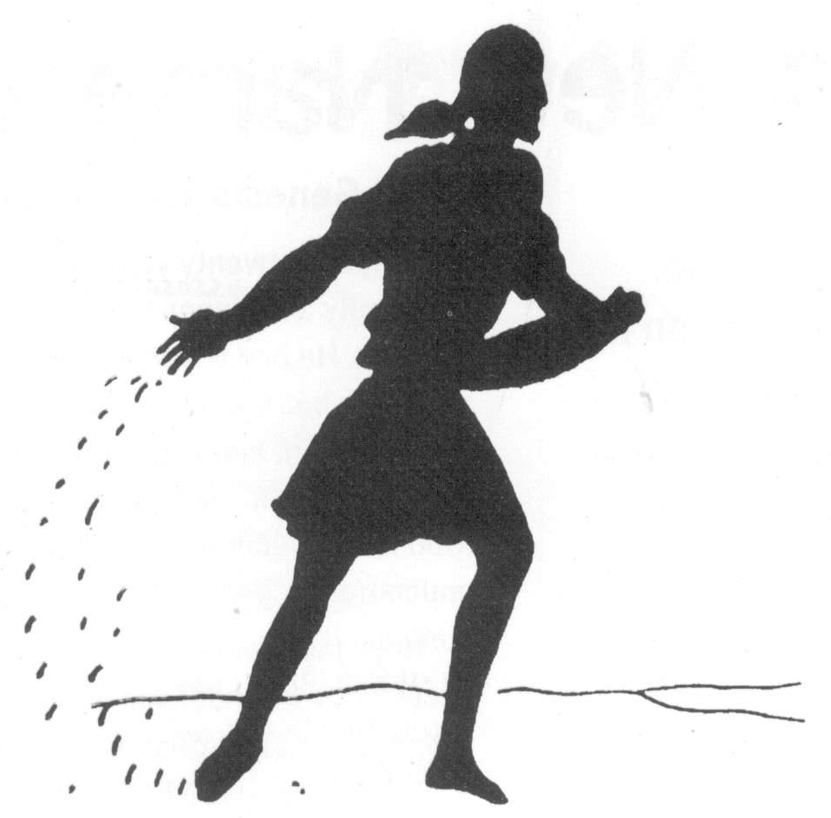
Extra: From this study can you find
one good lesson for everybody?
QUESTIONS & ANSWERS
Harvest Time
Key Verse:
“Do not be deceived; God cannot be mocked. A man reaps what he sows.”
Galatians 6:7
Read Genesis 29:1-30 and 31:1-9, 14-21
One day after a long journey, Jacob reached the place where his Uncle Laban lived, just on sundown. Tired, he sat down and rested by the well where the shepherds drew water for their flocks. Before long, a beautiful girl came to the well. Her name was Rachel. Jacob rolled the heavy stone lid away from the well and helped her give water to her father’s sheep. As soon as she heard who he was, she ran and told her father that her cousin Jacob had arrived.
For Jacob it was ‘love at first sight!’ He wanted to marry Rachel right away and went to ask Laban if she could be his wife. “All right,” said Laban, “but you have nothing you can give as gifts for my daughter. You work for me for seven years - and then you can have her.” Jacob happily agreed and went to work for Laban. Day after day, he toiled under the hot sun, early and late, year after year, until finally the seven years were finished. Now at last he could marry Rachel!
However, the Bible teaches that “a man reaps what he sows” (Galatians 6:7)! Jacob had cheated his brother Esau and deceived his father Isaac terribly, and this had led to broken relationships with them. Now, he was about to learn this bitter lesson. After all of Jacob’s hard work, Laban cheated him into marrying Rachel’s older sister Leah (which was the custom in those days). Instead of getting the girl he loved, Jacob the deceiver had been deceived himself! Despite his disappointment, Jacob still loved Rachel and wanted to marry her. Laban agreed, but only if he worked for him for another seven years! Genesis 29:28 says that Jacob married Rachel a week later (which was allowed in those days) and then worked hard for another seven years as he had agreed with Laban.

Yes friends it is true for us today too, “WE REAP WHAT WE SOW!” How careful we need to be! Do we deceive others? We can expect others to deceive us. Do we say unkind and untrue things about others?
1. Where did Jacob meet a beautiful girl? What was her name?
2. How did Laban cheat Jacob?
3. Can you fill in the missing vowel letters? | D__ N__T B__ D__C__ __ V__D; G__D C__NN__T B__  M__ CK__D. __ M__N R__ __PS WH__T H__ S__WS.
4. What do you think it means that “We reap what we sow?”
5. What can help us avoid a ‘harvest’ of bitter things later in life?
Level 4 lesson 23
Yes friends it is true for us today too, “WE REAP WHAT WE SOW!” How careful we need to be! Do we deceive others? We can expect others to deceive us. Do we say unkind and untrue things about others? Someone will say the same about us. Do we act harshly and unkindly to those who love and care for us? Then someone will spurn and despise our love and act harshly towards us.
When the farmer sows oats, he does not reap turnips, but oats. If you ‘sow’ bad thoughts in your heart and mind, you will not reap good things, but sinful behaviour! This is why it’s so important to ask God to help you ‘sow’ good thoughts and ‘grow’ godly habits in your life. This is especially important while you are young, so keep your thoughts pure and true (see Philippians 4:8) and make it a habit to be gentle and kind. Otherwise, there will be a ‘harvest’ of bitter things later in life!
Over the many years Jacob never forgot his own home. So one day, when Laban was away shearing his sheep, Jacob told his wives, “We are going back to my old home. I am going to take you, the children, and all my sheep, cattle, goats and camels.” Remember, he had come to Laban with almost nothing, but God kept His promise and had blessed Jacob abundantly. Jacob could truly say, as we can today, “God is faithful. There has not failed one word of all his good promise!”
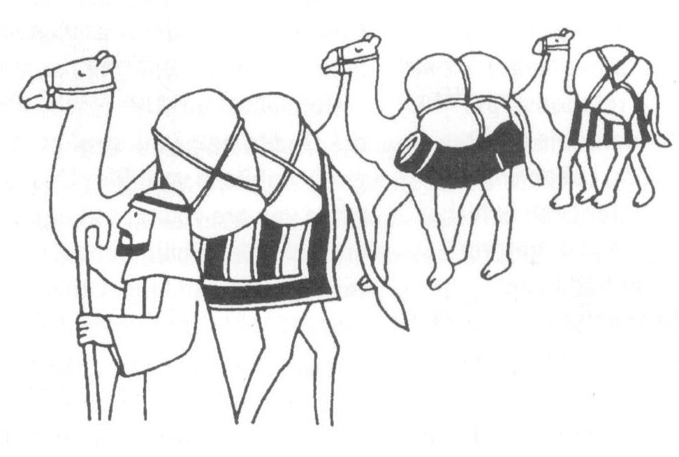
QUESTIONS & ANSWERS
A New Name & Nature
Key Verse:
“Call upon Me in the day of trouble; I will deliver you.”
Psalm 50:15
Read Genesis 32:1-32 and 1 Corinthians 1:26-31
Finally, after twenty years with Laban, Jacob left with his family and possessions to return to his old home in Canaan. He had left there with almost nothing, just his staff; but now he was returning with his wives and children, many servants, huge herds of cattle and sheep, and camels loaded with his possessions. God had been gracious to him and blessed him so much!
Now, Jacob was worried because he had just received word that Esau was on his way to meet him with an army of 400 men! He wondered; would Esau (the brother he had wronged) forgive him, or was he still angry and seeking revenge? He would soon know! So with “great fear and distress,” Jacob divided his large group into two groups. Next, he prayed and asked God to protect him and his family from Esau. Then he selected several gifts of animals (32:13-16) and sent them on ahead in the darkness to pacify Esau.

At this point in the long, slow journey, something happened that was as remarkable as his earlier dream of the Heavenly ladder. That night, Jacob made camp by the Jabbok Stream, which is just on the border of Canaan.
Then strangely, during the night he moved his wives and children over the brook with all their possessions, but stayed alone by himself on the opposite side of the river. Maybe he thought about God’s great goodness to him through all the years, but it seems he was most worried about meeting Esau and preserving his own life!
While he was alone in the darkness, we read that a stranger suddenly appeared and wrestled with him through the remainder of the night. Just before dawn, the Man touched Jacob’s hip area, putting it out of joint. Suddenly, Jacob realised it was the Lord! Helplessly clinging to Him, Jacob said, “I will not let You go until You bless me!” The Lord agreed, and told him that his name was to be changed.
Jacob, you see, means “deceiver (or cheat),” but “Now,” said the Man, “from today, your name will no more be Jacob but Israel.” Israel means “a Prince of (or with) God”. God explained why he was a prince, “because you have struggled with God and men and have overcome.” So Jacob received a new name and a new nature, and what a change! How glad Jacob must have been to leave that old name and nature behind, and to go forward with God - as “a Prince with God!”
There is a great lesson for us in this story. Like Jacob, we have been sinful in our ways, and continually failing too. But the Lord Jesus came into the world to save us from our sin and give us victory over our failures. So let the Lord touch and bless you today, too. Indeed, if you trust Him today, He will blot out all your past sins and give you a new name (“a Christian”), new power to resist the temptations to sin, and a new love for God and others. God’s Word says, “Believe in the Lord Jesus Christ and you shall be saved.” Ask Jesus to save you today and give you a new life “with God!”
Please complete and return by post to
PSSM, 888 New North Road, Mt Albert, Auckland 1025 or scan & email to info@biblediscovery.org.nz

1. How long was Jacob away from his homeland?
2. What bad news reached him on the way home?
3. What new name was given to Jacob and what did it mean?
4. Why did the Lord Jesus come into the world?
5. What will the Lord do for us if we trust Him today?
Extra: What reasons can you give to show we are all a bit like Jacob?
Level 4 lesson 24

