DATE BOOK REFERENCE
August Bible Readings

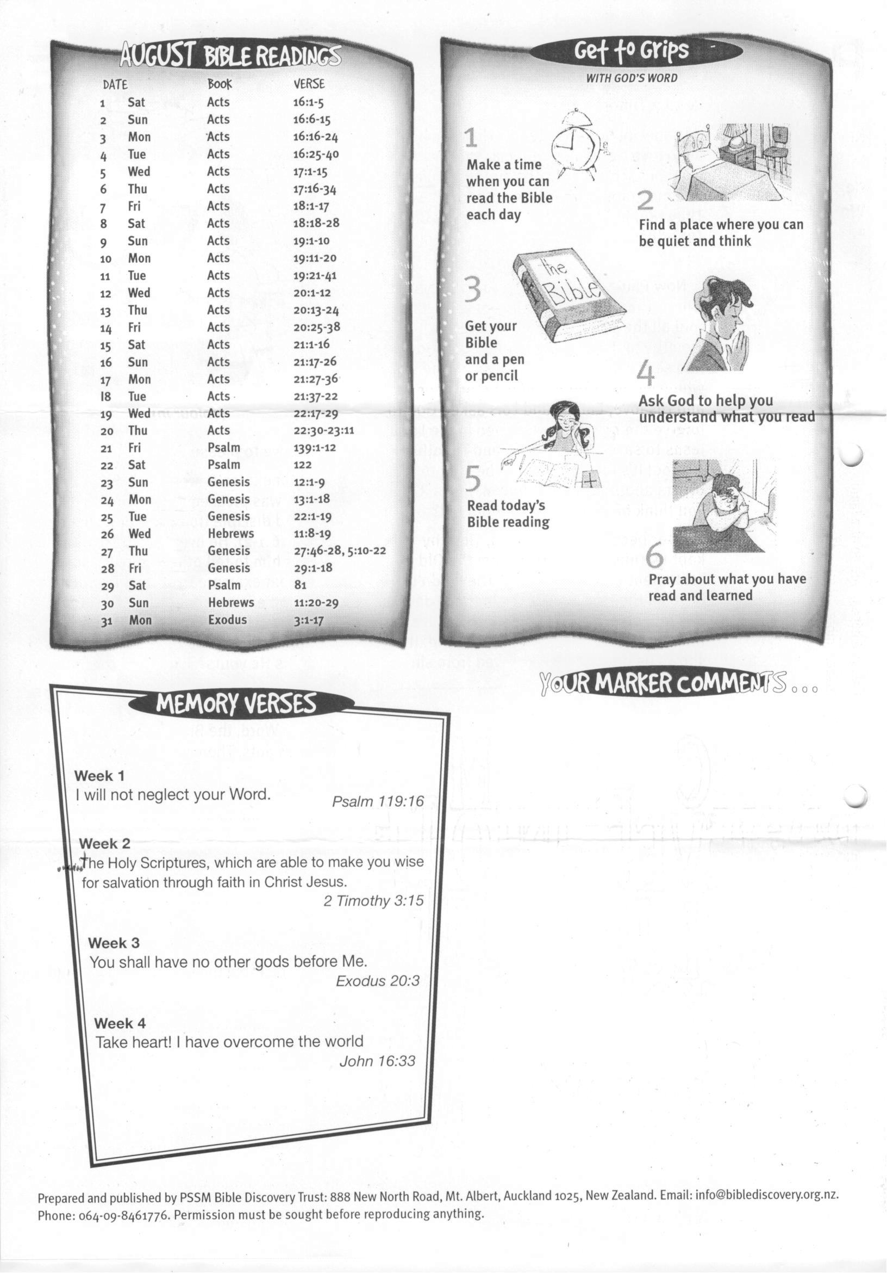

30 Hebrews 11:20-29
31 Exodus 3:1-17

