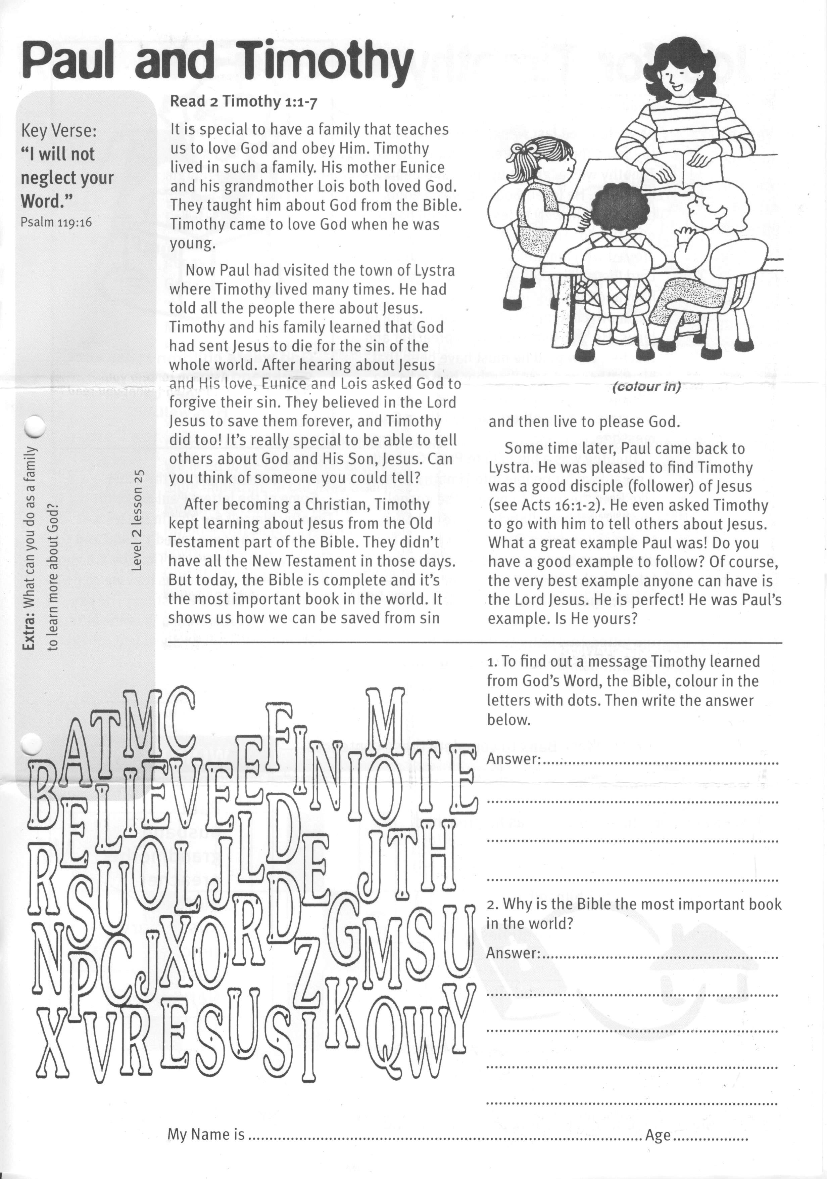

**Paul and Timothy**

Key Verse:  
**“I will not neglect your Word**  
Psalm 119:16

**Extra:** What can you do as a   
family to learn more about God?

**Level 2 lesson 25**

**Read 2 Timothy 1:1-7**

It is special to have a family that teaches us to love God and obey Him. Timothy lived in such a family. His mother Eunice and his grandmother Lois both loved God. They taught him about God from the Bible. Timothy came to love God when he was young.

Now Paul had visited the town of Lystra where Timothy lived many times. He had told all the people there about Jesus. Timothy and his family learned that God had sent Jesus to die for the sin of the whole world. After hearing about Jesus and His love, Eunice and Lois asked God to forgive their sin. They believed in the Lord Jesus to save them forever, and Timothy did too! It’s really special to be able to tell others about God and His Son, Jesus. Can you think of someone you could tell?

After becoming a Christian, Timothy kept learning about Jesus from the Old Testament part of the Bible. They didn’t have all the New Testament in those days.

But today, the Bible is complete and it’s the most important book in the world. It shows us how we can be saved from sin and then live to please God.

Sometime later, Paul came back to Lystra. He was pleased to find Timothy was a good disciple (follower) of Jesus (see Acts 16:1-2). He even asked Timothy to go with him to tell others about Jesus. What a great example Paul was! Do you have a good example to follow? Of course, the very best example anyone can have is the Lord Jesus. He is perfect! He was Paul’s example. Is He yours?



1. To find out a message Timothy learned from God’s Word, the Bible, colour in the letters with dots. Then write the answer below.

Answer:_____________________________

____________________________________

____________________________________

____________________________________

2. Why is the Bible the most important book in the world?

____________________________________

____________________________________

____________________________________

____________________________________

My Name is ……………………………………………………………………… Age……………

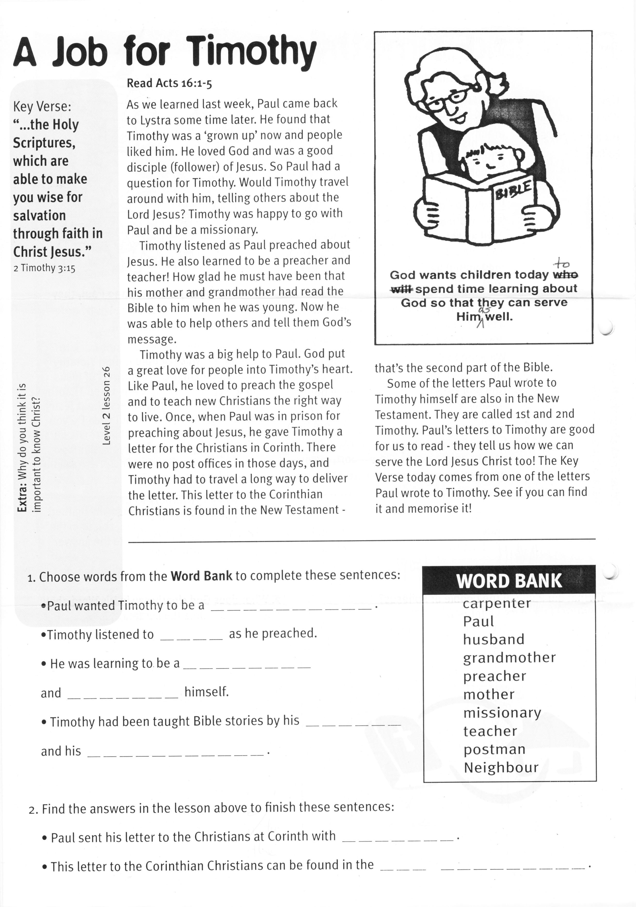

**Read Acts 16:1-5**

As we learned last week, Paul came back to Lystra some time later. He found that Timothy was a ‘grown up’ now and people liked him. He loved God and was a good disciple (follower) of Jesus. So Paul had a question for Timothy. Would Timothy travel around with him, telling others about the Lord Jesus? Timothy was happy to go with Paul and be a missionary.

Timothy listened as Paul preached about Jesus. He also learned to be a preacher and teacher! How glad he must have been that his mother and grandmother had read the Bible to him when he was young. Now he was able to help others and tell them God’s message.

Timothy was a big help to Paul. God put a great love for people into Timothy’s heart. Like Paul, he loved to preach the gospel and to teach new Christians the right way to live. Once, when Paul was in prison for preaching about Jesus, he gave Timothy a letter for the Christians in Corinth.

Key Verse:  
**“…the Holy Scriptures, which are able to make you wise for salvation through faith in Christ Jesus.”**  
2 Timothy 3:15

**A Job for Timothy**

**God wants children today to spend time learning about God so that they can serve Him as well.**

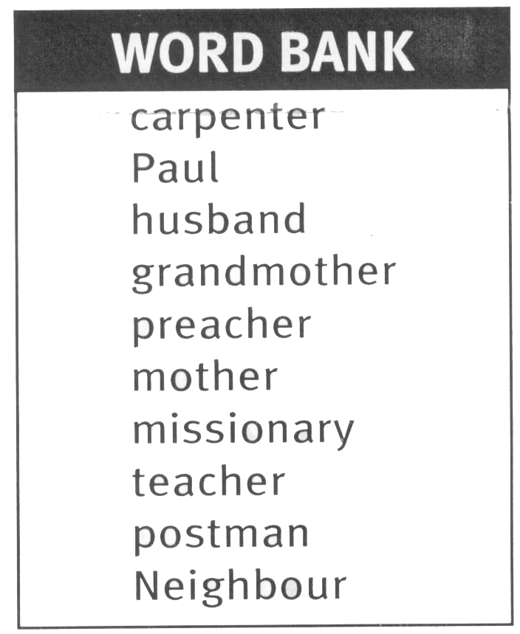

**Level 2 lesson 26**

1. Find the answers in the lesson above to finish these sentences:

• Paul sent his letter to the Christians at Corinth with __ __ __ __ __ __ __ .

• This letter to the Corinthian Christians can be found in the __ __ __

__ __ __ __ __ __ __ __ __ .

2. Choose words from the **Word Bank** to complete these sentences:

* Paul wanted Timothy to be a __ __ __ __ __ __ __ __ __ __ .
* Timothy listened to __ __ __ __ as he preached.
* He was learning to be a __ __ __ __ __ __ __ __ and __ __ __ __ __ __ __ himself.
* Timothy had been taught Bible stories by his __ __ __ __ __ __ and his

__ __ __ __ __ __ __ __ __ __ __.

There were no post offices in those days, and Timothy had to travel a long way to deliver the letter. This letter to the Corinthian Christians is found in the New Testament ­ that’s the second part of the Bible.

Some of the letters Paul wrote to Timothy himself are also in the New Testament. They are called 1st and 2nd Timothy. Paul’s letters to Timothy are good for us to read - they tell us how we can serve the Lord Jesus Christ too! The Key Verse today comes from one of the letters Paul wrote to Timothy. See if you can find it and memorise it!

**Extra:** Why do you think it is   
important to know Christ?.

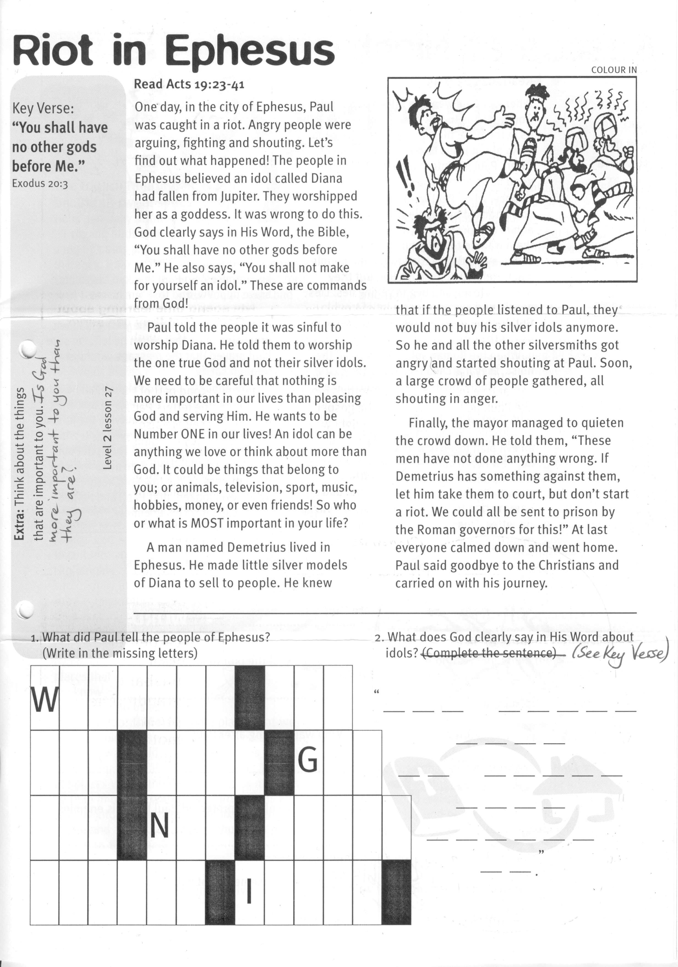

**Read Acts 19:23-41**

One day, in the city of Ephesus, Paul was caught in a riot. Angry people were arguing, fighting and shouting. Let’s find out what happened!

The people in Ephesus believed an idol called Diana had fallen from Jupiter. They worshipped her as a goddess. It was wrong to do this. God clearly says in His Word, the Bible, “You shall have no other gods before Me.” He also says, “You shall not make for yourself an idol.” These are commands from God!

Paul told the people it was sinful to worship Diana. He told them to worship the one true God and not their silver idols. We need to be careful that nothing is more important in our lives than pleasing God and serving Him. He wants to be Number ONE in our lives! An idol can be anything we love or think about more than God. It could be things that belong to you; or animals, television, sport, music, hobbies, money, or even friends! So who or what is MOST important in your life?

**Riot in Ephesus**

Key Verse:  
**“You shall have no other gods before Me.”**  
Exodus 20:3

A man named Demetrius lived in Ephesus. He made little silver models of Diana to sell to people. He knew that if the people listened to Paul, they would not buy his silver idols anymore. So he and all the other silversmiths got angry and started shouting at Paul. Soon, a large crowd of people gathered, all shouting in anger.

Finally, the mayor managed to quieten the crowd down. He told them, “These men have not done anything wrong. If Demetrius has something against them, let him take them to court, but don’t start a riot. We could all be sent to prison by the Roman governors for this!” At last everyone calmed down and went home. Paul said goodbye to the Christians and carried on with his journey.

|  |  |  |  |  |  |  |  |  |  |  |  |  |
| --- | --- | --- | --- | --- | --- | --- | --- | --- | --- | --- | --- | --- |
| W |  |  |  |  |  |  |  |  |  |  |  |  |
|  |  |  |  |  |  |  |  |  | G |  |  |  |
|  |  |  |  | N |  |  |  |  |  |  |  |  |
|  |  |  |  |  |  |  | I |  |  |  |  |  |

**2. What does God clearly say in His Word about idols?** (See Key Verse)

“_ _ _ _ _ _ _ _

_ _ _ _

_ _ _ _ _ _ _

_ _ _ _

_ _ _ _ _ _

_ _ “

**1. What did Paul tell the people of   
Ephesus?** (Write in the missing letters)

**Extra:** Think about the things that are  
important to you. Is God more   
important to you than they are?

**Level 2 lesson 23**

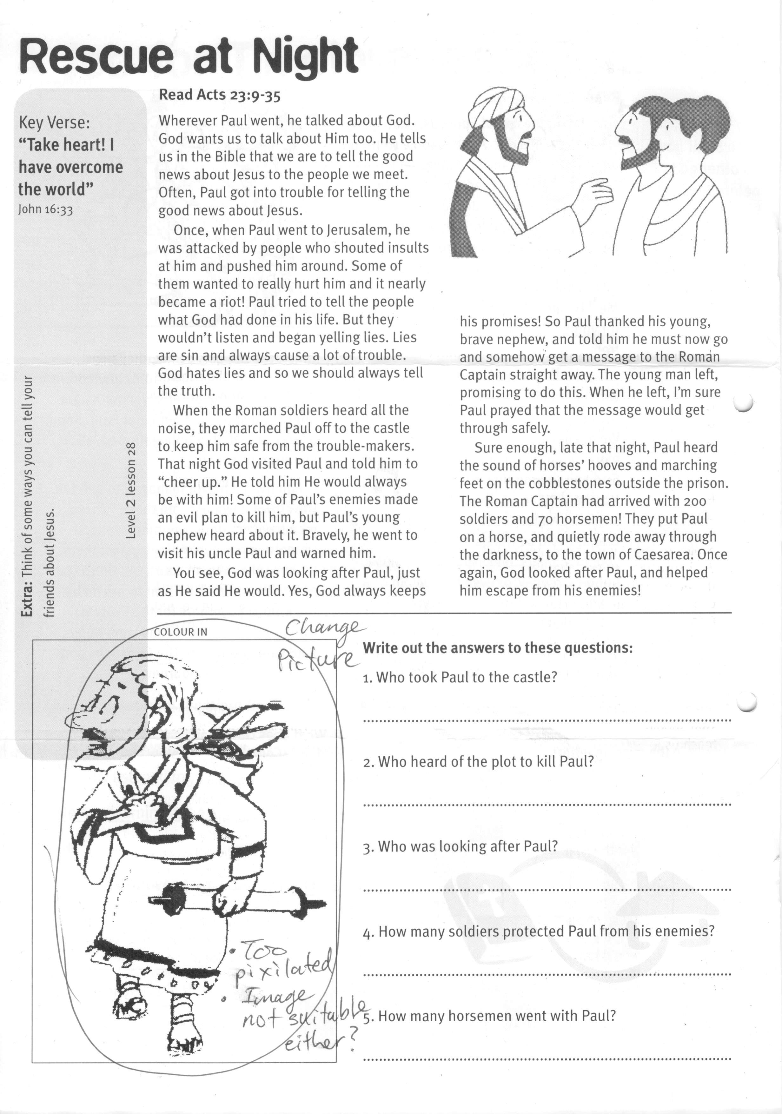

**Read Acts 23:9-35**

Wherever Paul went, he talked about God. God wants us to talk about Him too. He tells us in the Bible that we are to tell the good news about Jesus to the people we meet. Often, Paul got into trouble for telling the good news about Jesus.

Once, when Paul went to Jerusalem, he was attacked by people who shouted insults at him and pushed him around. Some of them wanted to really hurt him and it nearly became a riot! Paul tried to tell the people what God had done in his life. But they wouldn’t listen and began yelling lies. Lies are sin and always cause a lot of trouble. God hates lies and so we should always tell the truth.

When the Roman soldiers heard all the noise, they marched Paul off to the castle to keep him safe from the trouble-makers. That night God visited Paul and told him to “cheer up.” He told him He would always be with him! Some of Paul’s enemies made an evil plan to kill him, but Paul’s young nephew heard about it. Bravely, he went to visit his uncle Paul and warned him.

**Rescue at Night**

Key Verse:  
**“Take heart! I have overcome the world.”**  
John 16:33

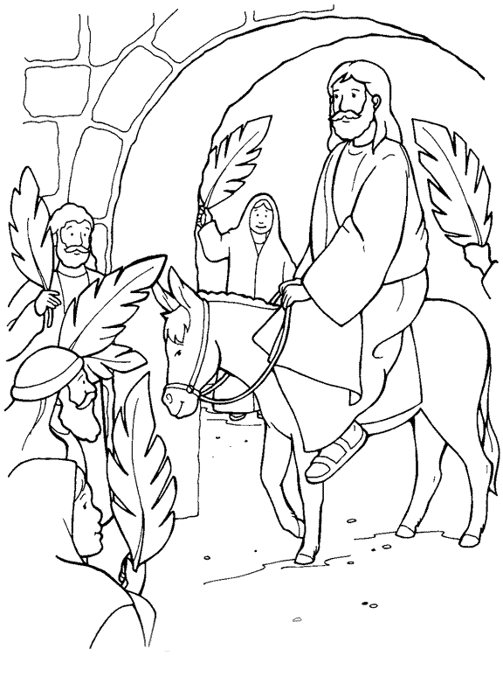1003

Please complete and return by post to   
**PSSM, 888 New North Road, Mt Albert, Auckland 1025**   
or scan & email to **info@biblediscovery.org.nz**

3. Who was looking after Paul?

____________________________________________________

4. How many soldiers protected Paul from his enemies?

____________________________________________________

5. How many horsemen went with Paul?

________________________________________________

Write out the answers to these questions:

1. Who took Paul to the castle?

________________________________

2. Who heard of the plot to kill Paul?

________________________________

You see, God was looking after Paul, just as He said He would. Yes, God always keeps his promises! So Paul thanked his young, brave nephew, and told him he must now go and somehow get a message to the Roman Captain straight away. The young man left, promising to do this. When he left, I’m sure Paul prayed that the message would get through safely.

Sure enough, late that night, Paul heard the sound of horses’ hooves and marching feet on the cobblestones outside the prison. The Roman Captain had arrived with 200 soldiers and 70 horsemen! They put Paul on a horse, and quietly rode away through the darkness, to the town of Caesarea. Once again, God looked after Paul, and helped him escape from his enemies!

**Extra:** Think of some ways you can tell your friends about Jesus.

**Level 2 lesson 28**