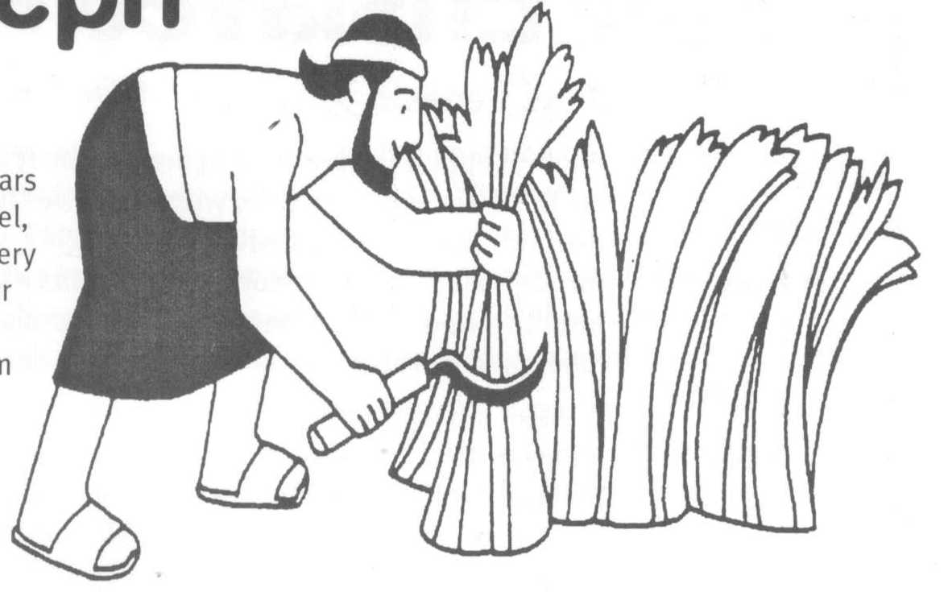
Jacob’s Son, Joseph
Key Verse:
“You are the God who sees me.”
Genesis 16:13
Read Genesis 37 and Psalm 138
Jacob had twelve sons. The eleventh one, Joseph, was born when Jacob was ninety years old! He was also the first child born to Rachel, who Jacob loved dearly. This made Joseph very special to him, but he unwisely made it clear that Joseph was his favourite son. Despite this, God was with Joseph and kept him from becoming spoilt in character. In fact, Joseph always tried to please God!
Jacob saw that Joseph was trustworthy, but that his older brothers were not so genuine or trustworthy in character. Joseph sometimes reported to his father the bad things his older brothers had done. His older brothers were becoming full of envy and hate towards Joseph and these reports made them even angrier. Envy is such a dreadful sin that you need to ask God to take it from your heart, if it’s hiding there. It’s like a snake in the grass, hiding away, but always ready to strike! Remember, “Love does not envy” (1 Corinthians 13:4).
One day, Jacob gave Joseph a special gift – “a coat of many colours.” This made Joseph’s brothers so jealous they couldn’t even speak nicely to him anymore! How sad! Then one day, something happened which made them even madder! Joseph told them about a dream he’d had. In this dream, he was out in the field harvesting wheat with his brothers. His sheaf was standing in the field, he said, when suddenly, all his brother’s sheaves came and bowed down to his sheaf!
Soon after, he had a second dream. In it, he saw the sun, moon and eleven stars bowing before him in his honour. When he told his family these dreams, even his father wondered if he was just ‘showing off.’ Jacob scolded him by questioning the basic meaning of the dream, “Do you mean to say that we will all bow down to you one day?” This incident seemed to turn his brothers’ envy to hatred, but Jacob often wondered about the significance of it.

1. Why was Joseph the favourite son of Jacob?
2. Why did his brothers hate Joseph so much?
3. What did Joseph’s dreams basically mean?
4. What was the terrible decision made by Joseph’s brothers?
5. How did God protect Joseph?
Level 3 lesson 1
Extra: How did the brothers explain
Joseph’s disappearance to Jacob?
Level 4 lesson 25
QUESTIONS & ANSWERS
Key Verse:
“Jesus said, ‘I tell you the truth, unless a man is born again, he cannot see the kingdom of God.’”
John 3:3
My Name is ……………………………………………………………………… Age ………………….
Not long after this, the brothers’ seething resentment and hatred toward Joseph boiled over. One day, while they grazed their flocks far from home, they saw Joseph coming over the hills toward them. Together they made the terrible decision to kill him! Reuben, the eldest one, was not happy with this though. To protect Joseph, he suggested instead that they put him down into a dry well nearby. He planned to free him later.
So upon Joseph’s arrival, they tore his prized coat off him and threw him roughly into the pit. Then these callous brothers sat down to eat the food he had brought them. Poor Joseph! I wonder how he felt, alone in the deep, dark pit? It must have been terrible to be so hated by his own brothers. Yet even there we know God was with him. Joseph probably prayed to God and asked for his life to be protected – and God always answers real prayers!
While the brothers were eating their lunch, a camel train of Ishmaelite traders came along, travelling to distant Egypt. The brothers decided not to kill Joseph, but to sell him to these merchants instead. So the deal was done. Joseph was sold for twenty pieces of silver and sent away with the Ishmaelites.
Reuben, who had left the group for a while, returned to find that his plan to rescue Joseph had been thwarted. Joseph was gone! He was terribly upset at this, but weakly chose to follow along with his brothers’ plan to fool their father into thinking Joseph was dead. Tearing up Joseph’s many-coloured coat, they dipped it in the blood of a goat and took it back with them to show Jacob. When he saw it, Jacob was heartbroken; nothing could comfort him. “A wild animal has torn Joseph to pieces!” he cried, “I will die mourning for my son!”
Joseph Enslaved
Read Genesis 39 and 40
Poor Joseph! It is hard to imagine how he felt as his brothers sent him away with the slave traders. However, we know that whatever thoughts went through his mind, he resolved to trust his life and future to God. His brothers had betrayed him, but his Heavenly Father would never let him down!
After a long journey, Joseph arrived in Egypt and was sold as a slave to Potiphar, one of Pharaoh’s officers. So began a totally new life for Joseph; alone in a new country with different customs and a language he couldn’t understand. But he didn’t despair or give up; he simply tried to learn everything quickly! He was obedient and respectful to his master, working hard and cheerfully at his tasks. He was kind and willing to help others. He never told lies and proved himself totally reliable and trustworthy.
Potiphar soon noticed all this, and put him in charge of his servants. Joseph showed such wisdom, that Potiphar finally put him in charge of everything he owned! God blessed Potiphar with even greater riches, because of Joseph, and for many years they lived in harmony. Then one day, Potiphar’s wife tried to seduce Joseph while her husband was away and no one else was in the house. This was very wicked, but Joseph rejected her sinful advances and fled from the house!
After this, she lied to Potiphar and accused Joseph of trying to rape her! She even used the cloak she had grabbed off Joseph as ‘so-called proof’ he had been there. Potiphar took his wife at her word and became very angry at Joseph! Although Potiphar had been tricked by his wife’s claims, he was possibly both puzzled and hurt. He may have even doubted her story a little bit, because instead of ordering that Joseph be executed (as he could have done), he had Joseph put in prison.

Was Joseph bitter because he’d been wrongfully accused and imprisoned? No! His godly character continued to shine through in all his circumstances. He continued to be trustworthy and honest, and to live for God by doing right. God blessed him, and the prison warden soon made him responsible for the whole prison.
One day, Joseph found two prisoners looking very sad. They had previously been Pharaoh’s butler and baker. “Why are you so sad?” he asked. “We have each had a strange dream,” they said, “and nobody can explain the meaning to us.” But Joseph was so sure that God knew the meanings, he said, “Do not interpretations belong to God? Tell me your dreams.” Joseph had learned to trust God with everything in his life; we too, should do this and ask God’s help and guidance in all things.
The butler spoke first. “I dreamed,” he said, “that I stood by a grape vine with three branches. While I looked, buds grew on the branches; the buds became blossoms and then clusters of ripe grapes. I gathered the grapes, squeezed the juice into Pharaoh’s cup and handed it to him.” “The three branches,” said Joseph, “are three days. In three days Pharaoh will send for you, and take you back into his service.” Joseph added, “When you get back to the palace please remember me. Tell Pharaoh about me, and help me get out of here, for I have done no wrong.”
Then the baker spoke. “In my dream,” he said, “I was carrying three baskets on my head. In the top basket were all sorts of cakes I had baked for Pharaoh, and the birds were eating them.” Joseph replied sadly, “The three baskets are three days. In three days Pharaoh will send for you too, but you will be hung on a tree, where the birds will eat away your flesh.”
In three days’ time, Pharaoh celebrated his birthday, and everything happened as Joseph had said. The poor baker was hanged, and the butler went back to the palace, but he totally forgot about Joseph!

Key Verse:
“But the Lord was with him [Joseph]; He showed him kindness and granted him favour….”
Genesis 39:21
1. What happened to Joseph when he arrived in Egypt?
2. Why did Potiphar make Joseph the manager over everything?
3. What was Joseph’s response to being wrongly accused and imprisoned?
4. Did God notice this? What was His response?

5. After listening to the butler and baker explain their sadness, what was Joseph sure of?
Extra: How would
you describe Joseph?
Level 4 lesson 26
QUESTIONS & ANSWERS

Pharaoh’s Dreams
Key Verse:
“There is a God in Heaven who reveals mysteries.”
Daniel 2:28
Read Genesis 41:1-45 and
Psalm 105:16-22
One morning, two years after Pharaoh’s butler had left the prison, Joseph received a message from Pharaoh. “Pharaoh wants to see you. Come at once!” Excitedly, Joseph hurried to the Palace, where he found Pharaoh the King anxiously waiting for him. What had happened? Pharaoh had woken from sleep filled with fear; “I have dreamed two dreams which trouble me greatly. None of the Wise Men of Egypt can interpret them,” he told Joseph. “But I have heard that you can tell the true meaning of dreams.” We read a lot about dreams in the story of Joseph. In those days God often spoke to people by dreams. Today God the Holy Spirit helps us understand what the Bible teaches us and instructs us to do.
“I can’t do it,” said Joseph humbly, “But” he added confidently, “GOD will give you the answer!” So Pharaoh told Joseph the dreams. (Read them in Genesis 41:17-32). Joseph explained that the two dreams meant there would be seven years of good harvests, and then seven years of famine. “God is warning you,” he told Pharaoh, “so that during the seven good years you can make preparation for the years of famine. You must find a wise, discerning man to be in charge of the Land of Egypt, to oversee the preparations.”
Pharaoh was relieved to finally understand what the dreams meant and to have a plan of action. Gratefully he said, “We will never find a better man than you, Joseph, a man who has God’s Spirit in him!” Then he said to Joseph, “You will be in charge of my palace and all my people. Only I will be greater than you.”
Then Pharaoh gave Joseph some fantastic royal robes, put a gold chain around his neck, took his

signet ring from his own hand, and placed it on Joseph’s finger. He allowed Joseph to ride in the royal chariot, and a guard of honour went ahead of him, crying out “Make way! Make way!” Pharaoh also gave Joseph a lovely wife, Asenath, and he was free to travel anywhere in Egypt. WOW!
We can learn a lot from the story of Joseph so far. Firstly, God is ALWAYS good. Even when it doesn’t seem that way to us! I’m sure Joseph wondered what was happening in his life, as he bounced along on the camel going down to Egypt; or as he stood in the slave market; or when he was unjustly thrown in jail; or forgotten by the cupbearer he’d helped so kindly. He could have become bitter, and thought God was unfair. Instead, he continued to trust in God and live righteously. Finally, he was able to see God’s purposes in it all and praise Him for it.
But remember, God blessed Joseph because he walked by faith, in obedience to God BEFORE he understood the reason why! God never overlooks or forgets us! There is just one thing God chooses not to remember; when a person trusts Christ as Saviour, God says, “Their sins and lawless acts I will remember no more” (Hebrews 10:17). Isn’t that great!
However, while God never forgets us, we often tend to forget God! Ecclesiastes 12:1 tells us, “Remember your Creator in the days of your youth, before the days of trouble come and the years approach when you will say, ‘I find no pleasure in them.” Like Joseph, we need to know and trust God while we are young. Then He can guide us safely through all the ups and downs of life, and we will know that whatever happens, we are safe in HIM!
1. Why did Pharaoh call Joseph from prison? Clue: 1-a, 2=b, 3=c, etc | __ __ __ __ __ __ __ __ __ __ __ __ __ __ __ __ __ __ __ 20 15 9 14 20 5 18 16 18 5 20 8 9 19 4 18 5 1 13
2. What was Joseph confident about?
3. What did Joseph say was the meaning of Pharaoh’s dreams?
4. How did Pharaoh reward Joseph?
5. Name two important things we can learn from this lesson.
Extra: Pharaoh was warned by God. Can you find any other warnings in the Bible?
Level 4 lesson 27
QUESTIONS & ANSWERS
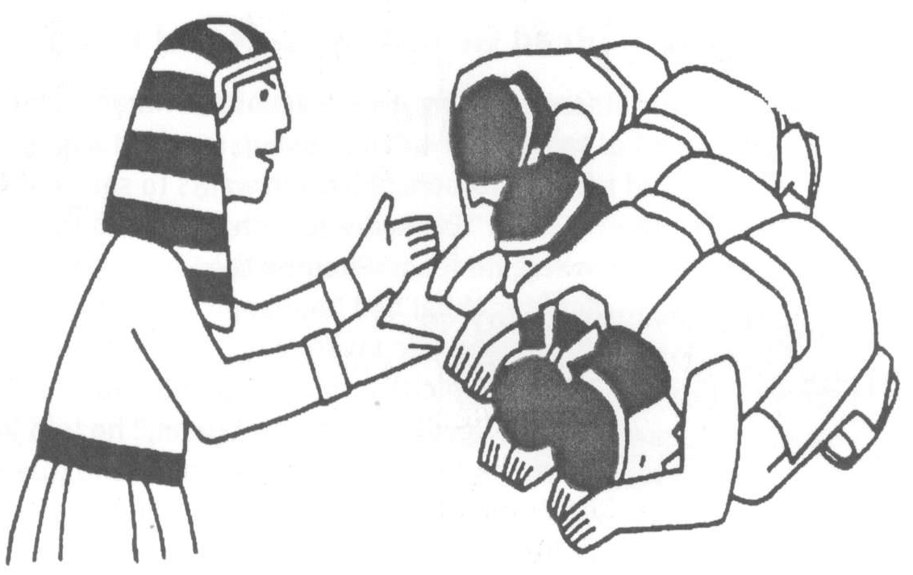
Joseph’s Dreams Come True
Key Verse:
“Do not be overcome by evil, but overcome evil with good.”
Romans 12:21
Read Genesis 42 and 43
Joseph was made Prime Minister of Egypt and, as God had warned, there were seven years of terrific harvests. Joseph was kept busy organising the storage of the huge quantities of grain throughout the land. Genesis 41:49 says, “There was so much he stopped keeping records because it was beyond measure!” However, the famine soon began, and what a famine it was! Not only in Egypt but throughout the known world, people were starving. Slowly, word spread that there was food in Egypt and people came from everywhere to buy it.
One day Joseph sat on his throne, dressed in royal robes and overseeing the selling of grain from the warehouse. Everyone bowed low in front of him before making their purchase. Suddenly Joseph’s heart leaped – there right before him, were his ten brothers! Though he hadn’t seen them for 20 years he recognised them instantly. They didn’t recognise him of course; he was no longer a boy, but an adult, dressed in fine robes and sitting on a throne! They all bowed low before him, just as his dreams had foretold!
Joseph didn’t let on he knew them, although he immediately saw how God had made his dreams come true. Instead, he decided to test his brothers. “Who are you?” he asked sternly, “Why have you come here? You must be spies!” “No, your majesty!” they stammered fearfully. “We are honest men. We’ve simply come to buy food,” they said, “In fact, we’re all brothers, the sons of one man.” “Is your father still alive?” asked Joseph. “And have you another brother?” “What strange questions!” they probably thought. But WE know why he asked them, don’t we?!
Joseph pretended not to believe their story. He said nine of them could return home, but one must stay as a prisoner until the youngest brother was brought before him. Thinking Joseph did not understand their language, they spoke freely amongst themselves in front of him. Joseph heard them say, “All this trouble has come on us because
1. How did Joseph see his dreams come true?
2. How did Joseph test his brothers?
3. What did the brothers confess to each other?
4. What discovery made the brothers puzzled and afraid?
5. Why did Joseph’s brothers come to Egypt the second time, and who did they bring with them? | Unscramble: rof doof dna yeht thguorb nnijbeam
Extra: What do you think about
Joseph’s plan to test his brothers?
Level 4 lesson 28
QUESTIONS & ANSWERS
of what we did to Joseph years ago.” Oh how their guilty secret must have weighed on their hearts all that time. God’s Word is clear, “Be sure that your sin will find you out” (Numbers 32:23)!
Hearing their words, Joseph’s eyes filled with tears and he had to turn away. Privately, he ordered his men to fill up his brother’s sacks with corn, and to put the money each man had paid, back into the top of each sack. The brothers were puzzled and afraid to discover this later. When they got home, they told Jacob all that had happened. He was heart-broken that they had agreed to take Benjamin next time. But, as the famine worsened, they returned to Egypt again, this time with Benjamin.
When Joseph saw him, he ordered a feast be prepared and invited his brothers. When they heard they were to go to the Egyptian ruler’s house, they feared the worst. “It is because of the money that was returned in our sacks,” they said to one another. Before the meal began, the brothers again bowed themselves before Joseph and presented the valuable presents Jacob had sent to him. Turning to his much-loved brother Benjamin, Joseph asked, “Is this the younger brother you spoke about?” Then he added. “God be gracious to you my son!”
Again, Joseph had to leave the room, as tears filled his eyes. Regaining his composure, he returned and seated each man at the table. We can imagine their surprise to find they had been seated in order of their ages, from the eldest to the youngest! Yes, they were amazed, but a greater surprise was still in store!
Please complete and return by post to
PSSM, 888 New North Road, Mt Albert, Auckland 1025 or scan & email to info@biblediscovery.org.nz

