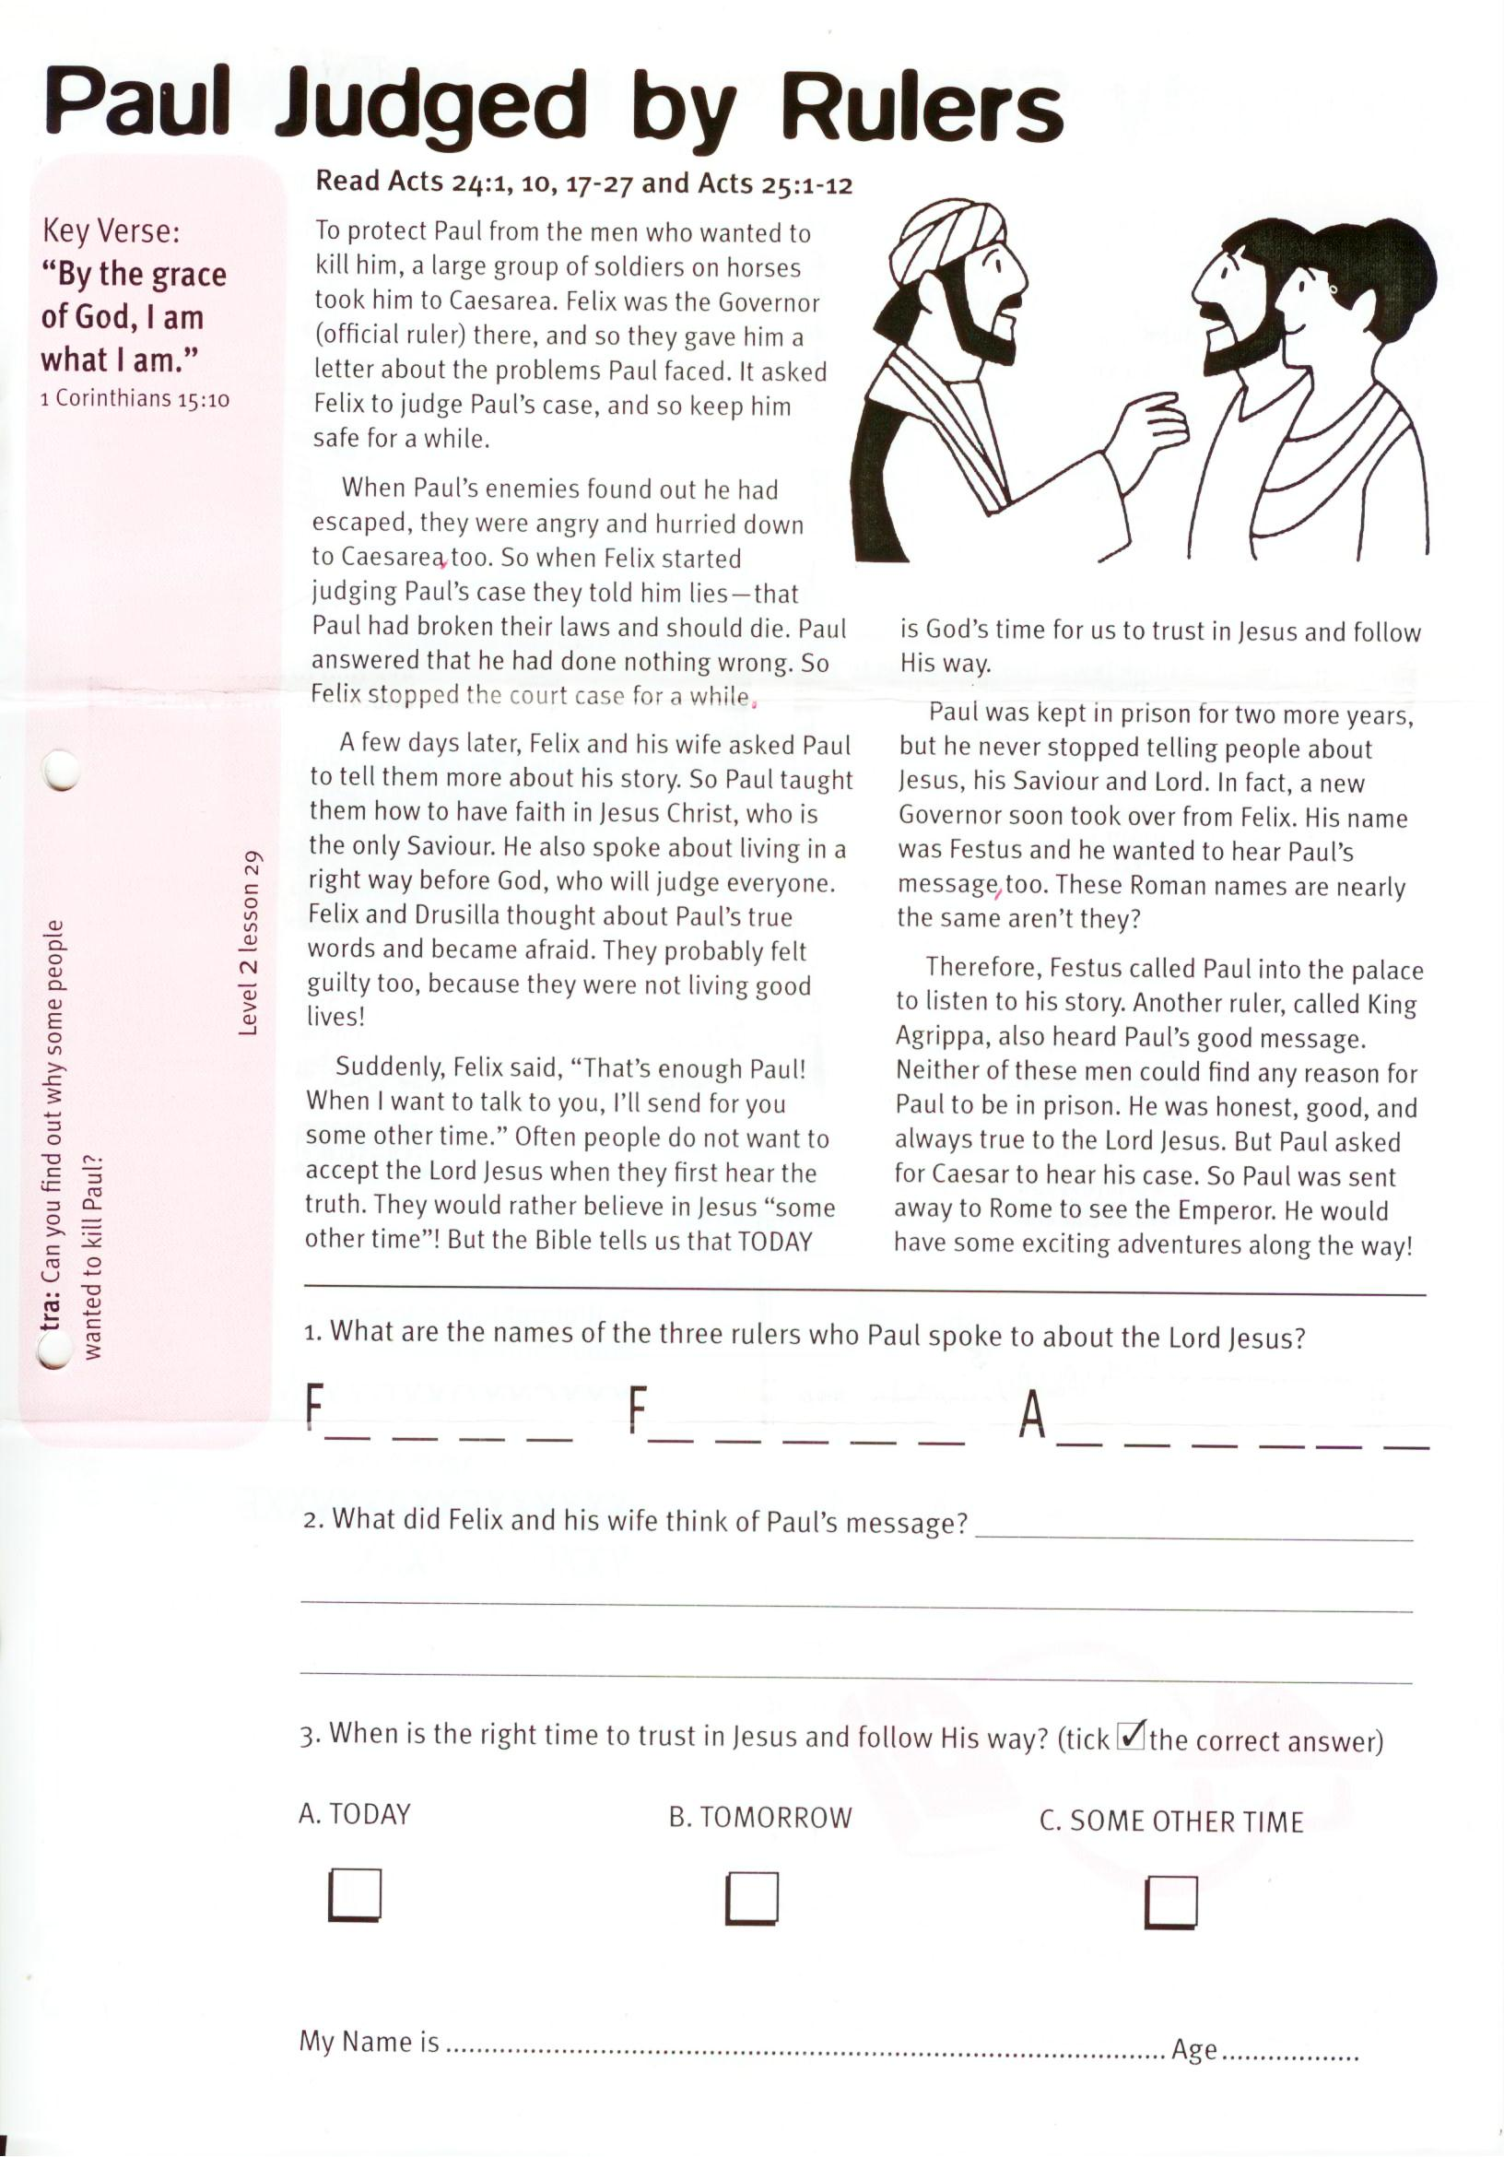

**Paul Judged by Rulers**

Key Verse:  
**“By the grace of God, I am what I am.”**  
1 Corinthians 15:10

**Extra:** Can you find out why some  
people wanted to kill Paul?

**Level 2 lesson 29**

**Read Acts 24:1, 10, 17-27 and Acts 25:1-12**

To protect Paul from the men who wanted to kill him, a large group of soldiers on horses took him to Caesarea. Felix was the Governor (official ruler) there, and so they gave him a letter about the problems Paul faced. It asked Felix to judge Paul’s case, and so keep him safe for a while.

When Paul’s enemies found out he had escaped, they were angry and hurried down to Caesarea, too. So when Felix started judging Paul’s case they told him lies—that Paul had broken their laws and should die. Paul answered that he had done nothing wrong. So Felix stopped the court case for a while.

A few days later, Felix and his wife asked Paul to tell them more about his story. So Paul taught them how to have faith in Jesus Christ, who is the only Saviour. He also spoke about living in a right way before God, who will judge everyone. Felix and Drusilla thought about Paul’s true words and became afraid. They probably felt guilty too, because they were not living good lives!

Suddenly, Felix said, “That’s enough Paul! When I want to talk to you, I’ll send for you some other time.” Often people do not want to accept the Lord Jesus when

they first hear the truth. They would rather believe in Jesus “some other time”! But the Bible tells us that TODAY is God’s time for us to trust in Jesus and follow His way.

Paul was kept in prison for two more years, but he never stopped telling people about Jesus, his Saviour and Lord. In fact, a new Governor soon took over from Felix. His name was Festus and he wanted to hear Paul’s message, too. These Roman names are nearly the same aren’t they?

Therefore, Festus called Paul into the palace to listen to his story. Another ruler, called King Agrippa, also heard Paul’s good message. Neither of these men could find any reason for Paul to be in prison. He was honest, good, and always true to the Lord Jesus. But Paul asked for Caesar to hear his case. So Paul was sent away to Rome to see the Emperor. He would have some exciting adventures along the way!

1. What are the names of the three rulers who Paul   
 spoke to about the Lord Jesus?

F __ __ __ __ F __ __ __ __ __ A __ __ __ __ __ __

2. What did Felix and his wife think of Paul’s message?  
  
_____________________________________________________________________________________

_____________________________________________________________________________________

3. When is the right time to trust in Jesus and follow His way? (tick √ the correct answer)   
 A. TODAY B. TOMORROW C. SOME OTHER TIME

My Name is ……………………………………………………………………… Age……………

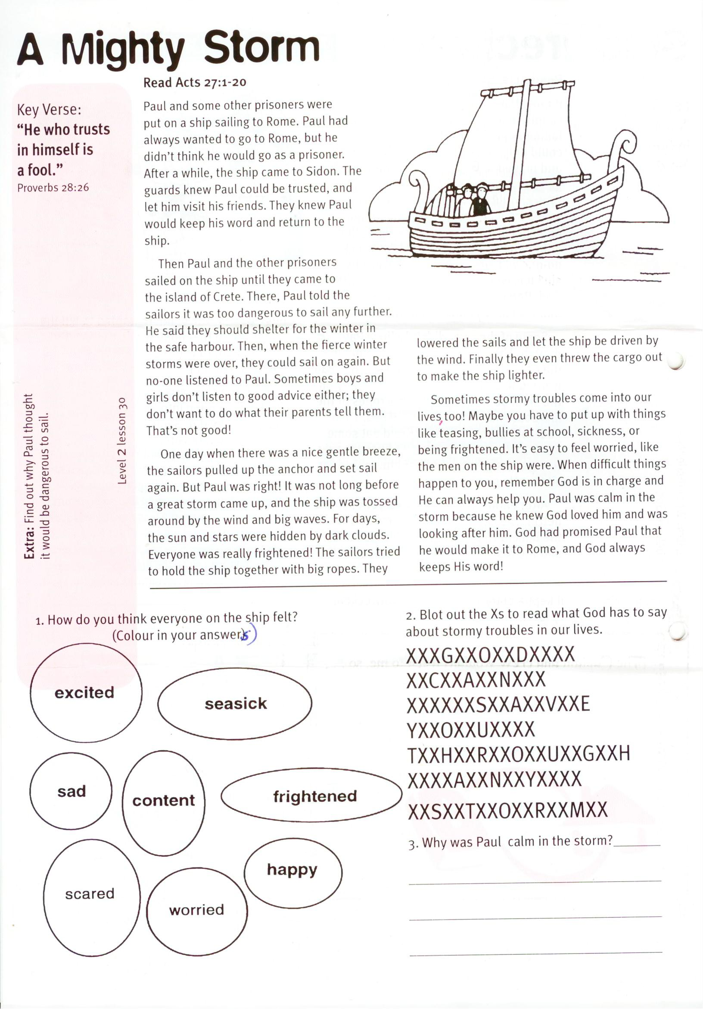

**Read Acts 27:1-20**

Paul and some other prisoners were put on a ship sailing to Rome. Paul had always wanted to go to Rome, but he didn’t think he would go as a prisoner. After a while, the ship came to Sidon. The guards knew Paul could be trusted, and let him visit his friends. They knew Paul would keep his word and return to the ship.

Then Paul and the other prisoners sailed on the ship until they came to the island of Crete. There, Paul told the sailors it was too dangerous to sail any further. He said they should shelter for the winter in the safe harbour. Then, when the fierce winter storms were over, they could sail on again. But no-one listened to Paul. Sometimes boys and girls don’t listen to good advice either; they don’t want to do what their parents tell them. That’s not good!

One day when there was a nice gentle breeze, the sailors pulled up the anchor and set sail again. But Paul was right! It was not long before a great storm came up, and the ship was tossed around by the wind and big waves. For days, the sun and stars were hidden by dark clouds.

Key Verse:  
**“He who trusts in himself is a fool.”**  
Proverbs 28:26

**A Mighty Storm**

gf

happy

seasick

frightened

content

excited

scared

worried

1. How do you think   
everyone on the ship felt?  
 (colour in your answers)

2. Blot out the Xs to read what God has to say about stormy troubles in our lives.

XXXGXXOXXDXXXX  
XXCXXAXXNXXX  
XXXXXXSXXAXXVXXE  
YXXOXXUXXXX  
TXXHXXRXXOXXUXXGXXH  
XXXXAXXNXXYXXXX  
XXSXXTXXOXXRXXMXX

3. Why was Paul calm in the storm?

__________________________________

__________________________________

___________________________________

**Extra:** Find out why Paul thought   
it would be dangerous to sail?

Everyone was really frightened! The sailors tried to hold the ship together with big ropes. They lowered the sails and let the ship be driven by the wind. Finally they even threw the cargo out to make the ship lighter.

Sometimes stormy troubles come into our lives, too! Maybe you have to put up with things like teasing, bullies at school, sickness, or being frightened. It’s easy to feel worried, like the men on the ship were. When difficult things happen to you, remember God is in charge and He can always help you. Paul was calm in the storm because he knew God loved him and was looking after him. God had promised Paul that he would make it to Rome, and God always keeps His word!

**Level 2 lesson 30**

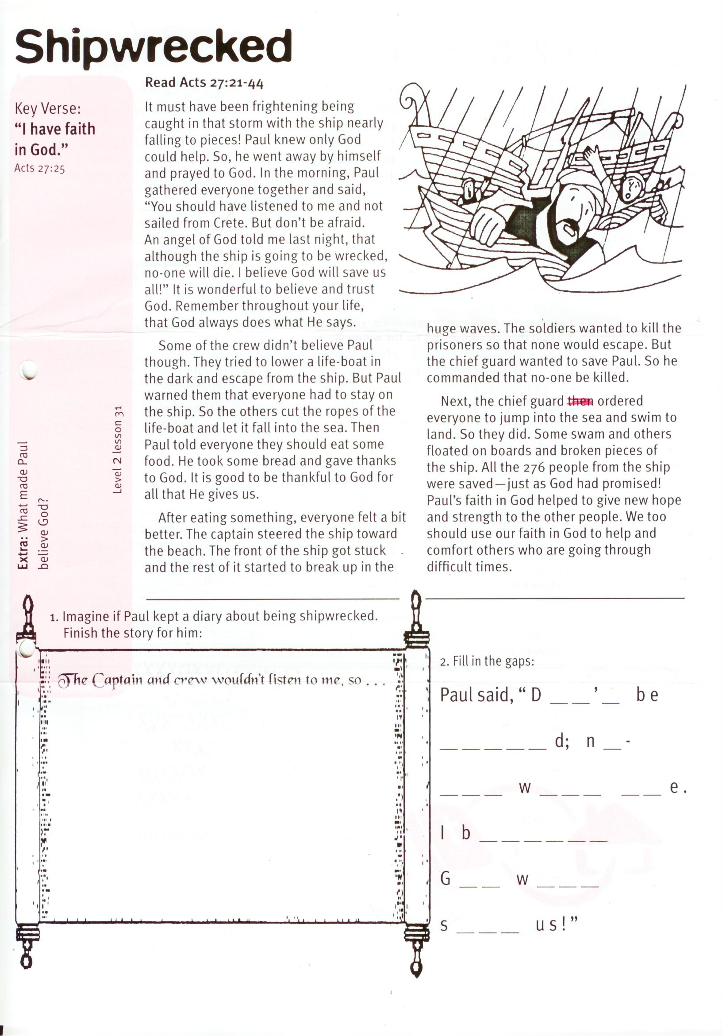

**Read Acts 27:21-44**

It must have been frightening being caught in that storm with the ship nearly falling to pieces! Paul knew only God could help. So, he went away by himself and prayed to God. In the morning, Paul gathered everyone together and said, “You should have listened to me and not sailed from Crete. But don’t be afraid. An angel of God told me last night, that although the ship is going to be wrecked, no-one will die. I believe God will save us all!” It is wonderful to believe and trust God. Remember throughout your life, that God always does what He says.

Some of the crew didn’t believe Paul though. They tried to lower a life-boat in the dark and escape from the ship. But Paul warned them that everyone had to stay on the ship. So the others cut the ropes of the life-boat and let it fall into the sea. Then Paul told everyone they should eat some food. He took some bread and gave thanks to God. It is good to be thankful to God for all that He gives us.

After eating something, everyone felt a bit

**Shipwrecked**

Key Verse:  
**“I have faith in God.”**  
Acts 27:25



The Captain and crew wouldn’t listen to me, so…

1. Imagine if Paul kept a diary about being shipwrecked.  
Finish the story for him:

better. The captain steered the ship toward the beach. The front of the ship got stuck and the rest of it started to break up in the huge waves. The soldiers wanted to kill the prisoners so that none would escape. But the chief guard wanted to save Paul. So he commanded that no-one be killed.

Next, the chief guard ordered everyone to jump into the sea and swim to land. So they did. Some swam and others floated on boards and broken pieces of the ship. All the 276 people from the ship were saved—just as God had promised! Paul’s faith in God helped to give new hope and strength to the other people. We too should use our faith in God to help and comfort others who are going through difficult times.

**Extra:** What made Paul  
believe God?

2. Fill in the gaps:

Paul said, “ D __ __ ’ __   
b e __ __ __ __ __ d;   
n __ – __ __ __ w __ __ __ __ __ e .   
I b __ __ __ __ __ __   
G __ __ w __ __ __   
s __ __ __ u s ! ”

**Level 2 lesson 31**

It was three months before the shipwrecked people could get another boat to take them to Italy. During that time, Paul healed many people on Malta from sickness. Also, he would have told them all about Jesus the Saviour. Some people no doubt believed, but many wouldn’t have. It is always sad when people don’t believe God’s wonderful plan about how we can be saved.

God wants us to also believe and obey the Lord Jesus, and He will forgive our sins, too. He is able to watch over and care for you, and help you to do what is right. God kept His word to Paul and He wants to look after you in the same way. Why don’t you ask God to forgive your sins and for the Lord Jesus to be your Saviour today?

**Read Acts 28:1-10**

When all the people from the wrecked ship arrived on land, they found they were on the island of Malta. See if you can find it on the map below. The local people were very kind to them and soon had a great bonfire blazing on the beach. The survivors were all soaking wet of course, and very cold and tired. They huddled around the fire to get warm.

Paul gladly helped gather firewood, but as he was throwing some wood on the fire, a very poisonous snake came out and bit his hand! All the people thought he would die, but God who had looked after him all the way, was still caring for him. Paul just shook the snake off into the fire and was not hurt. This was a real miracle!

**Paul in Malta**

Key Verse:  
**“I have given you authority to… overcome all the power of the enemy, nothing will harm you.”**  
Luke 10:19

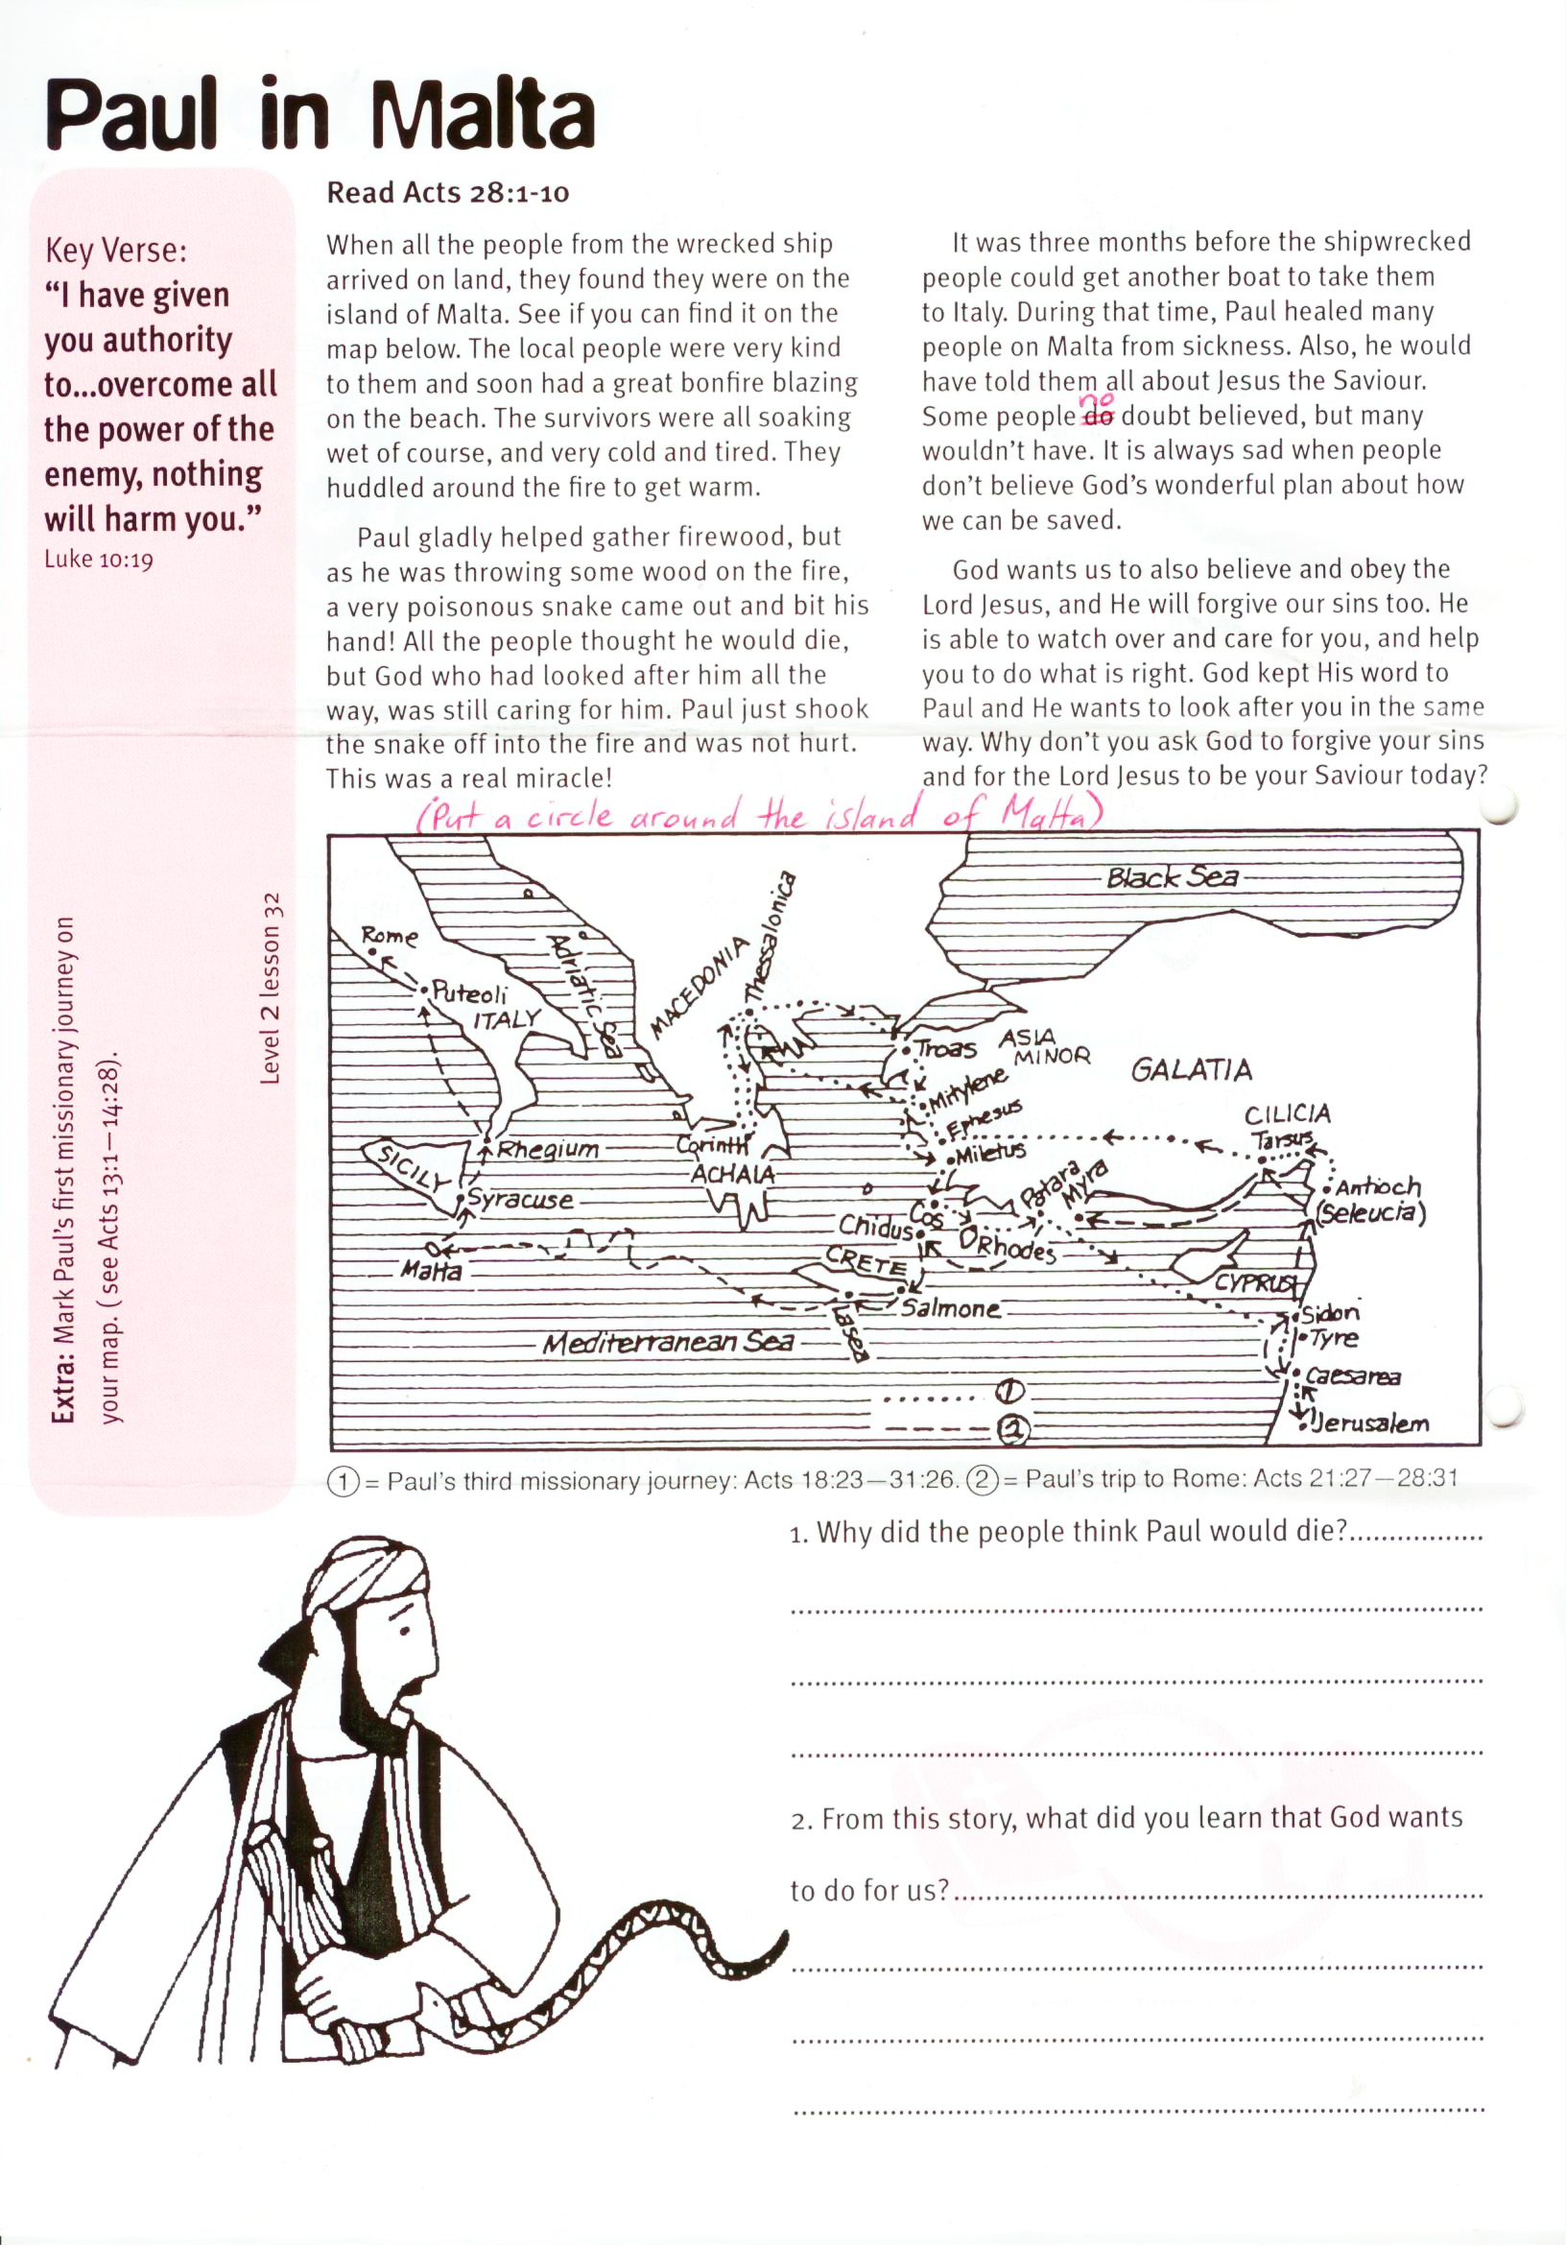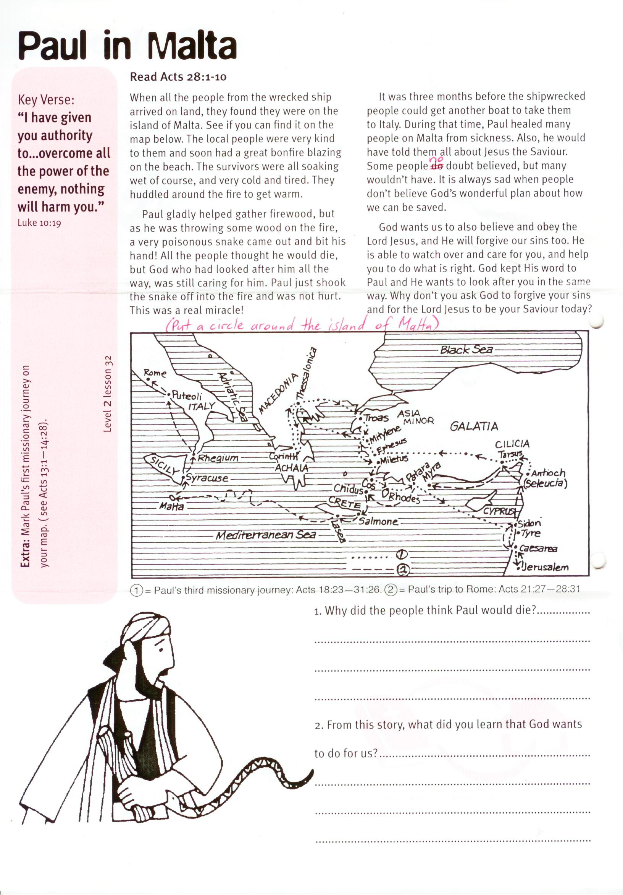1003

**①= Paul’s third missionary journey: Acts 18:23-31:26 ②= Paul’s trip to Rome: Acts 21:27 – 28:31**

1. Put a circle around the island   
of Malta on the map above.

2. Why did the people think Paul would die?

__________________________________________

__________________________________________

3. From this story, what did you learn that God wants to do for us?

__________________________________________

__________________________________________

__________________________________________

Please complete and return by post to   
**PSSM, 1-2a (G2) 93 Dominion Rd, Mt Eden, Auckland 1024**   
or scan & email to **info@biblediscovery.org.nz**

**Extra:** Mark Paul’s first missionary journeys on your map. (see Acts 13:1 – 14:28).

**Level 2 lesson 32**