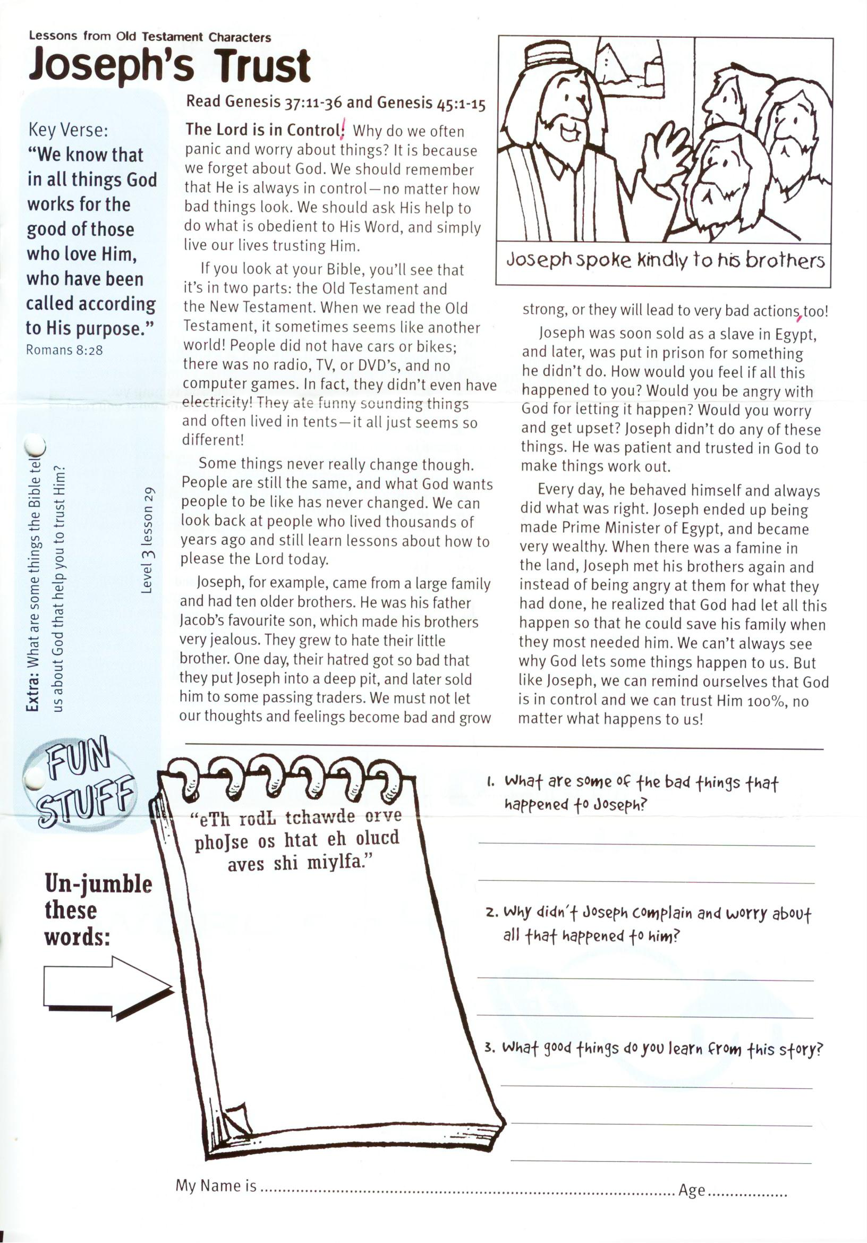

**Read Genesis 37:11-36 and Genesis 45:1-15**

**The Lord is in Control!** Why do we often panic and worry about things? It is because we forget about God. We should remember that He is always in control – no matter how bad things look. We should ask His help to do what is obedient to His Word, and simply live our lives trusting Him.

If you look at your Bible, you’ll see that it’s in two parts: the Old Testament and the New Testament. When we read the Old Testament, it sometimes seems like another world! People did not have cars or bikes; there was no radio, TV, or DVD’s, and no computer games. In fact, they didn’t even have electricity! They ate funny sounding things and often lived in tents – it all just seems so different!

Some things never really change though. People are still the same, and what God wants people to be like has never changed. We can look back at people who lived thousands of years ago and still learn lessons about how to please the Lord today.

Joseph, for example, came from a large family and had ten older brothers. He was his father Jacob’s favourite son, which made his brothers very jealous. They grew to hate their little brother. One day, their hatred got so bad that they put Joseph into a deep pit, and

LIFE LESSONS FROM OLD TESTAMENT CHARACTERS

**Level 3 lesson 29**

Key Verse:  
**“We know that in all things God works for the good of those who love Him, who have been called according to His purpose.”**  
Romans 8:28

**Joseph’s Trust**

later sold him to some passing traders. We must not let our thoughts and feelings become bad and grow strong, or they will lead to very bad actions, too!

Joseph was soon sold as a slave in Egypt, and later, was put in prison for something he didn’t do. How would you feel if all this happened to you? Would you be angry with God for letting it happen? Would you worry and get upset? Joseph didn’t do any of these things. He was patient and trusted in God to make things work out.

Every day, he behaved himself and always did what was right. Joseph ended up being made Prime Minister of Egypt, and became very wealthy. When there was a famine in the land, Joseph met his brothers again and instead of being angry at them for what they had done, he realized that God had let all this happen so that he could save his family when they most needed him. We can’t always see why God lets some things happen to us. But like Joseph, we can remind ourselves that God is in control and we can trust Him 100%, no matter what happens to us!



Un-jumble  
these   
words

1. What are some of the bad things that happened to Joseph?  
________________________________________________  
________________________________________________  
________________________________________________  
2. Why didn’t Joseph complain and worry about all that happened to him?  
________________________________________________  
________________________________________________

3. What good things do you learn from this story?  
_______________________________________________

_______________________________________________

“eTh rodL tchawde orve  
phoJse os htat eh olucd   
aves shi miylfa. “

**Extra:** What are some things the Bible tells us about God that help you to trust Him?

My Name is ……………………………………………………………… Age ………………….

My Name is ……………………………………………………… Age…………………

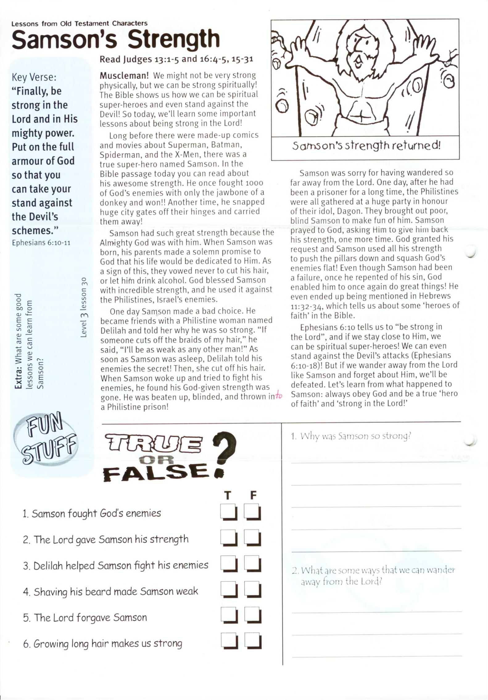

**Read Judges 13:1-5 and 16:4-5,   
15-31**

**Muscleman!** We might not be very strong physically, but we can be strong spiritually! The Bible shows us how we can be spiritual super-heroes and even stand against the Devil! So today, we’ll learn some important lessons about being strong in the Lord!

Long before there were made-up comics and movies about Superman, Batman, Spiderman, and the X-Men, there was a true super-hero named Samson. In the Bible passage today you can read about his awesome strength. He once fought 1000 of God’s enemies with only the jawbone of a donkey and won!! Another time, he snapped huge city gates off their hinges and carried them away!

Samson had such great strength because the Almighty God was with him. When Samson was born, his parents made a solemn promise to God that his life would be dedicated to Him. As a sign of this, they vowed never to cut his hair, or let him drink alcohol. God blessed Samson with incredible strength, and he used it against the Philistines, Israel’s enemies.

One day Samson made a bad choice. He became friends with a Philistine woman named Delilah and told her why he was so strong. “If someone cuts off the braids of my hair,” he said, “I’ll be as weak as any other man!” As soon as Samson was asleep, Delilah told his enemies the secret! Then, she cut off his hair. When Samson woke up and tried to

LIFE LESSONS FROM OLD TESTAMENT CHARACTERS

Key Verse:  
**“Finally, be strong in the Lord and in His mighty power. Put on the full armour of God so that you can take your stand against the Devil’s schemes.”**Ephesians 6:10-11

**Samson’s Strength**

fight his enemies, he found his God-given strength was gone. He was beaten up, blinded, and thrown into a Philistine prison!

Samson was sorry for having wandered so far away from the Lord. One day, after he had been a prisoner for a long time, the Philistines were all gathered at a huge party in honour of their idol, Dagon. They brought out poor, blind Samson to make fun of him. Samson prayed to God, asking Him to give him back his strength, one more time. God granted his request and Samson used all his strength to push the pillars down and squash God’s enemies flat! Even though Samson had been a failure, once he repented of his sin, God enabled him to once again do great things! He even ended up being mentioned in Hebrews 11:32-34, which tells us about some ‘heroes of faith’ in the Bible.

Ephesians 6:10 tells us to “be strong in the Lord”, and if we stay close to Him, we can be spiritual super-heroes! We can even stand against the Devil’s attacks (Ephesians 6:10-18)! But if we wander away from the Lord like Samson and forget about Him, we’ll be defeated. Let’s learn from what happened to Samson: always obey God and be a true ‘hero of faith’ and ‘strong in the Lord!’

Samson fought God’s enemies ⃝ ⃝

The Lord gave Samson his strength ⃝ ⃝

Delilah helped Samson fight his enemies ⃝ ⃝

Shaving his beard made Samson weak ⃝ ⃝

The Lord forgave Samson ⃝ ⃝

Growing long hair makes us strong ⃝ ⃝

These lessons help us to know Jesus better ⃝ ⃝

**T F**

TRUE OR FALSE

**?**

1. Why was Samson so strong?  
__________________________________________________

__________________________________________________

__________________________________________________

__________________________________________________  
2. What are some ways that we can wander away from the Lord?

_____________________________________________

_____________________________________________

_________________________________________________

**Extra:** What are some good lessons   
we can learn from Samson?

**Level 3 lesson 30**

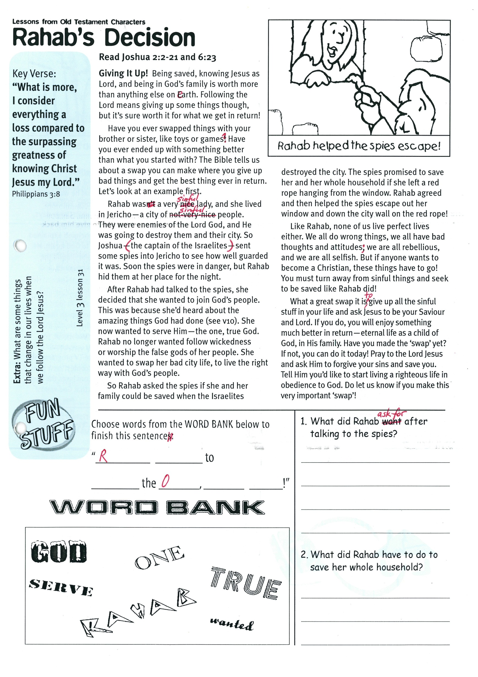

**Read Joshua 2:2-21 and 6:23**

**Giving It Up!** Being saved, knowing Jesus as Lord, and being in God’s family is worth more than anything else on earth. Following the Lord means giving up some things though, but it’s sure worth it for what we get in return!

Have you ever swapped things with your brother or sister, like toys or games? Have you ever ended up with something better than what you started with? The Bible tells us about a swap you can make where you give up bad things and get the best thing ever in return. Let’s look at an example first.

Rahab was a very sinful lady, and she lived in Jericho - a city of sinful people. They were enemies of the Lord God, and He was going to destroy them and their city. So Joshua (the captain of the Israelites) sent some spies into Jericho to see how well guarded it was. Soon the spies were in danger, but Rahab hid them at her place for the night.

After Rahab had talked to the spies, she decided that she wanted to join God’s people. This was because she’d heard about the amazing things God had done (see v10). She now wanted to serve Him - the one, true God! Rahab no longer wanted follow wickedness or worship the false gods of her people. She wanted to swap her bad city life, to live the right way with God’s people.

LIFE LESSONS FROM OLD TESTAMENT CHARACTERS

**Rahab’s Decision**

Key Verse:  
**“What is more, I consider everything a loss compared to the surpassing greatness of knowing Christ Jesus my Lord.”**Philippians 3:8

So Rahab asked the spies if she and her family could be saved when the Israelites destroyed the city. The spies promised to save her and her whole household if she left a red rope hanging from the window. Rahab agreed and then helped the spies escape out her window and down the city wall on the red rope!

Like Rahab, none of us live perfect lives either. We all do wrong things, we all have bad thoughts and attitudes; we are all rebellious, and we are all selfish. But if anyone wants to become a Christian, these things have to go! You must turn away from sinful things and seek to be saved like Rahab did!

What a great swap it is, to give up all the sinful stuff in your life and ask Jesus to be your Saviour and Lord. If you do, you will enjoy something much better in return - eternal life as a child of God, in His family. Have you made the ‘swap’ yet? If not, you can do it today! Pray to the Lord Jesus and ask Him to forgive your sins and save you. Tell Him you’d like to start living a righteous life in obedience to God. Do let us know if you make this very important ‘swap’!

**GOD**  ONE  
 Serve True

RAHAB Wanted

“R________ _________ to ________

the O___, ______ G_____!”

Choose words for the WORD BANK below to finish this sentence:

1. What did Rahab ask for after talking to the spies?  
____________________________________  
____________________________________  
________________________________________________________________________

2. What did Rahab have to do to save her whole household?  
________________________________________________________________________  
____________________________________  
____________________________________

**Extra:** What are some things that change in our lives when we follow the Lord Jesus?

**Level 3 lesson 31**

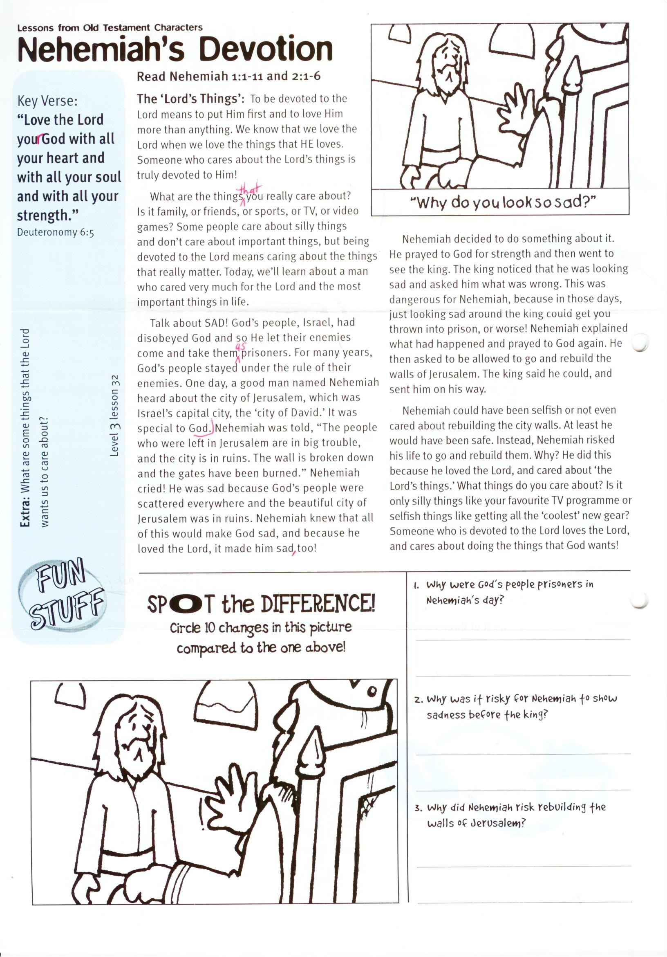

**Read Nehemiah 1:1-11 and 2:1-6**

**The ‘Lord’s Things’:** To be devoted to the Lord means to put Him first and to love Him more than anything. We know that we love the Lord when we love the things that HE loves. Someone who cares about the Lord’s things is truly devoted to Him!

What are the things that you really care about? Is it family, or friends, or sports, or TV, or video games? Some people care about silly things and don’t care about important things, but being devoted to the Lord means caring about the things that really matter. Today, we’ll learn about a man who cared very much for the Lord and the most important things in life.

Talk about SAD! God’s people, Israel, had disobeyed God and so He let their enemies come and take them as prisoners. For many years, God’s people stayed under the rule of their enemies. One day, a good man named Nehemiah heard about the city of Jerusalem, which was Israel’s capital city, the ‘city of David.’ It was special to God.

Nehemiah was told, “The people who were left in Jerusalem are in big trouble, and the city is in ruins. The wall is broken down and the gates have been burned.” Nehemiah cried! He was sad because God’s people   
were scattered everywhere and the   
beautiful city of Jerusalem was in ruins. Nehemiah knew that all of this would   
make God sad, and because he loved   
the Lord, it made him sad, too!

LIFE LESSONS FROM OLD TESTAMENT CHARACTERS

**Nehemiah’s Devotion**

**Level 3 lesson 32**

Key Verse:  
**“Love the Lord your God with all your heart and with all your soul and with all your strength.”**Deuteronomy 6:5



1. Why were God’s people prisoners in Nehemiah’s day?

________________________________________________

________________________________________________  
2. Why was it risky for Nehemiah to show sadness before the king?

________________________________________________

________________________________________________3. Why did Nehemiah risk rebuilding the walls of Jerusalem?

________________________________________________

________________________________________________

Please complete and return by post to   
**1-2A (G2) 93 Dominion Rd, Mt Eden, Auckland 1024**   
or scan & email to **info@biblediscovery.org.nz**

Nehemiah decided to do something about it. He prayed to God for strength and then went to see the king. The king noticed that he was looking sad and asked him what was wrong. This was dangerous for Nehemiah, because in those days, just looking sad around the king could get you thrown into prison, or worse! Nehemiah explained what had happened and prayed to God again. He then asked to be allowed to go and rebuild the walls of Jerusalem. The king said he could, and sent him on his way.

Nehemiah could have been selfish or not even cared about rebuilding the city walls. At least he would have been safe. Instead, Nehemiah risked his life to go and rebuild them. Why? He did this because he loved the Lord, and cared about ‘the Lord’s things.’ What things do you care about? Is it only silly things like your favourite TV programme or selfish things like getting all the ‘coolest’ new gear? Someone who is devoted to the Lord loves the Lord, and cares about doing the things that God wants!

**Extra:** What are some things that the Lord wants us to care about?

**Spot the Difference!**  
Check the picture above and then circle 10 changes in this picture!

finish