I am the Good Shepherd
Key Verse:
“I am the Good Shepherd: the Good Shepherd lays down His life for the sheep.”
John 10:11
Read John 10:11-30 and Isaiah 53
To understand our Key Verse today, we first have to understand who the sheep are that it refers to. The Bible tells us in Isaiah 53:6, “All we like sheep have gone astray; we have turned everyone to his own way.” Hey, that means us! Maybe you have never considered yourself to be like a sheep!
THE SHEPHERD: The Bible tells us in Matthew 9:36 that the Lord Jesus saw the people as “sheep having no Shepherd” and He was “moved with compassion.” Jesus, who is the Good Shepherd, gazed sadly on people who were trying to live without really knowing God. They had ‘missed the point’ of life and were wandering around like lost and scattered sheep, searching for true meaning and purpose in life.
It is an interesting fact, that of all the animals God created, sheep alone are not suited to life without a shepherd. For various reasons, if left totally on their own, they end up in a terrible state. But how they thrive under the care of a good shepherd!
The Bible explains things beautifully in Psalm 23, where David (who was himself a shepherd) wrote, “The Lord is my Shepherd; I shall not want. He makes me lie down in green pastures; He leads me beside quiet waters. He restores my soul: He leads me in paths of righteousness for His name’s sake.”
Perhaps you already know this Psalm? Yet, it is possible to know the Psalm but not The Shepherd Himself! Do you know this One who claimed, “I Am the Good Shepherd” personally?
Let’s look at three things about Jesus:
HIS SYMPATHY: We become His sheep by accepting Him as Saviour. Just as a good
1. Why do you think the Bible compares us with sheep?
2. Give one reason to show that the Shepherd cares for his sheep?
3. How do we become one of the Good Shepherd’s sheep?
  B |  |  | A |  |  |  | P |  |  |  | G |  | H
  A |  |  | S |  |  | I |  |  | R
4. What does this mean: “the Good Shepherd lays down His life for the sheep”?
5. How long will the Good Shepherd keep His sheep safe?
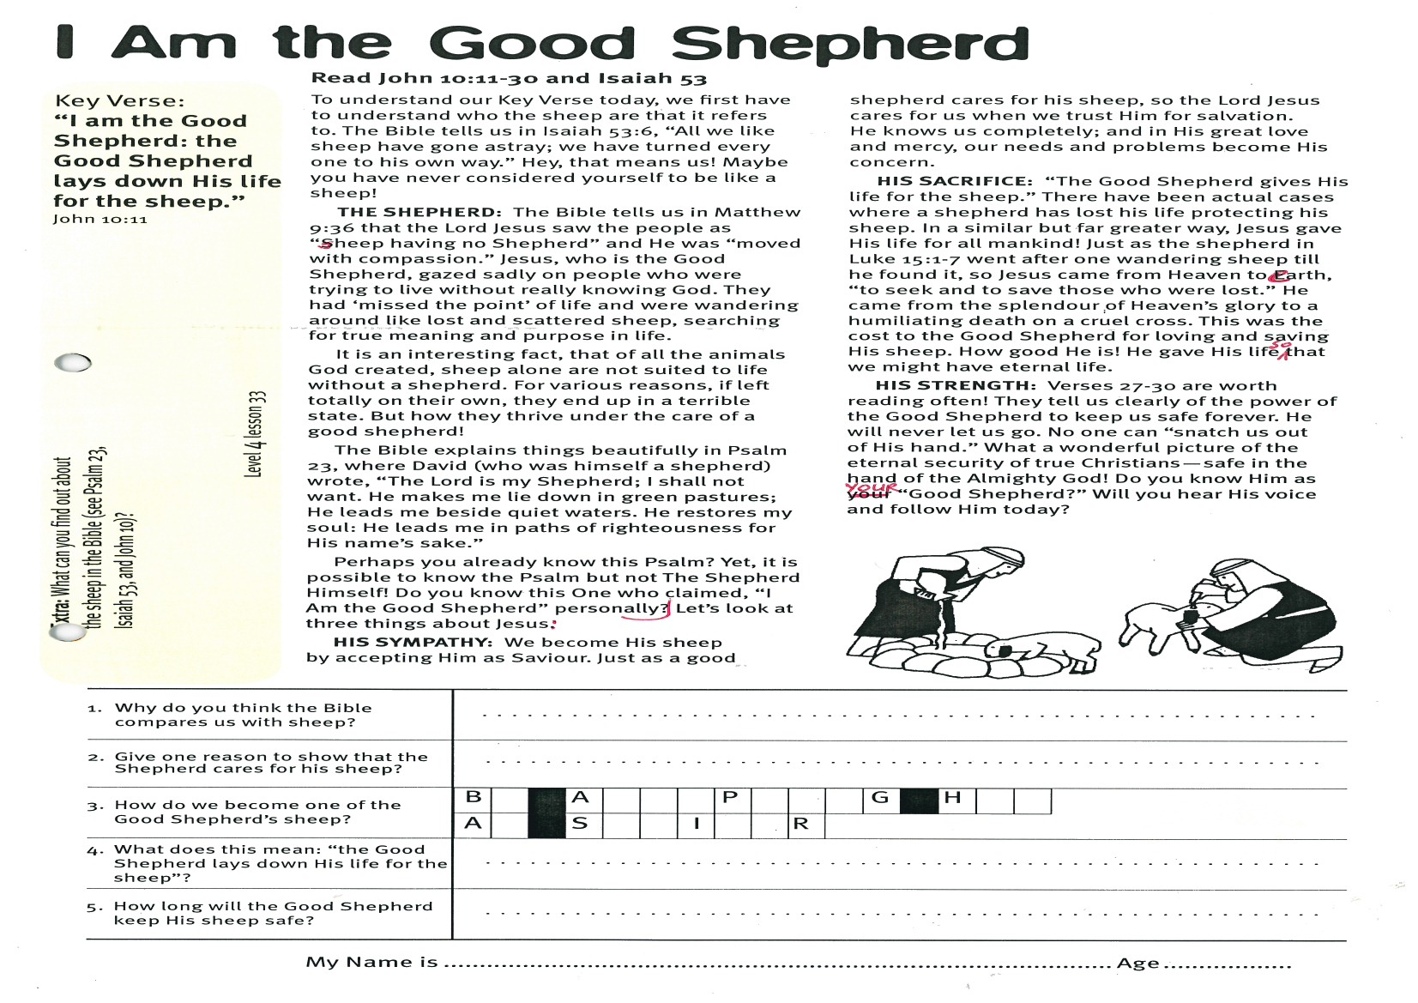
Level 3 lesson 1
Extra: What can you find out about the sheep in the Bible? (See Psalm 23, Isaiah 53, and John 10)
Level 4 lesson 33
QUESTIONS & ANSWERS
Key Verse:
“Jesus said, ‘I tell you the truth, unless a man is born again, he cannot see the kingdom of God.’”
John 3:3
My Name is ……………………………………………………………………… Age ………………….
shepherd cares for his sheep, so the Lord Jesus cares for us when we trust Him for salvation. He knows us completely; and in His great love and mercy, our needs and problems become His concern
HIS SACRIFICE: “The Good Shepherd gives His life for the sheep.” There have been actual cases where a shepherd has lost his life protecting his sheep. In a similar but far greater way, Jesus gave His life for all mankind! Just as the shepherd in Luke 15:1-7 went after one wandering sheep till he found it, so Jesus came from Heaven to earth, “to seek and to save those who were lost.” He came from the splendour of Heaven’s glory to a humiliating death on a cruel cross. This was the cost to the Good Shepherd for loving and saving His sheep. How good He is! He gave His life so that we might have eternal life.
HIS STRENGTH: Verses 27-30 are worth reading often! They tell us clearly of the power of the Good Shepherd to keep us safe forever. He will never let us go. No one can “snatch us out of His hand.” What a wonderful picture of the eternal security of true Christians - safe in the hand of the Almighty God! Do you know Him as YOUR “Good Shepherd?” Will you hear His voice and follow Him today?

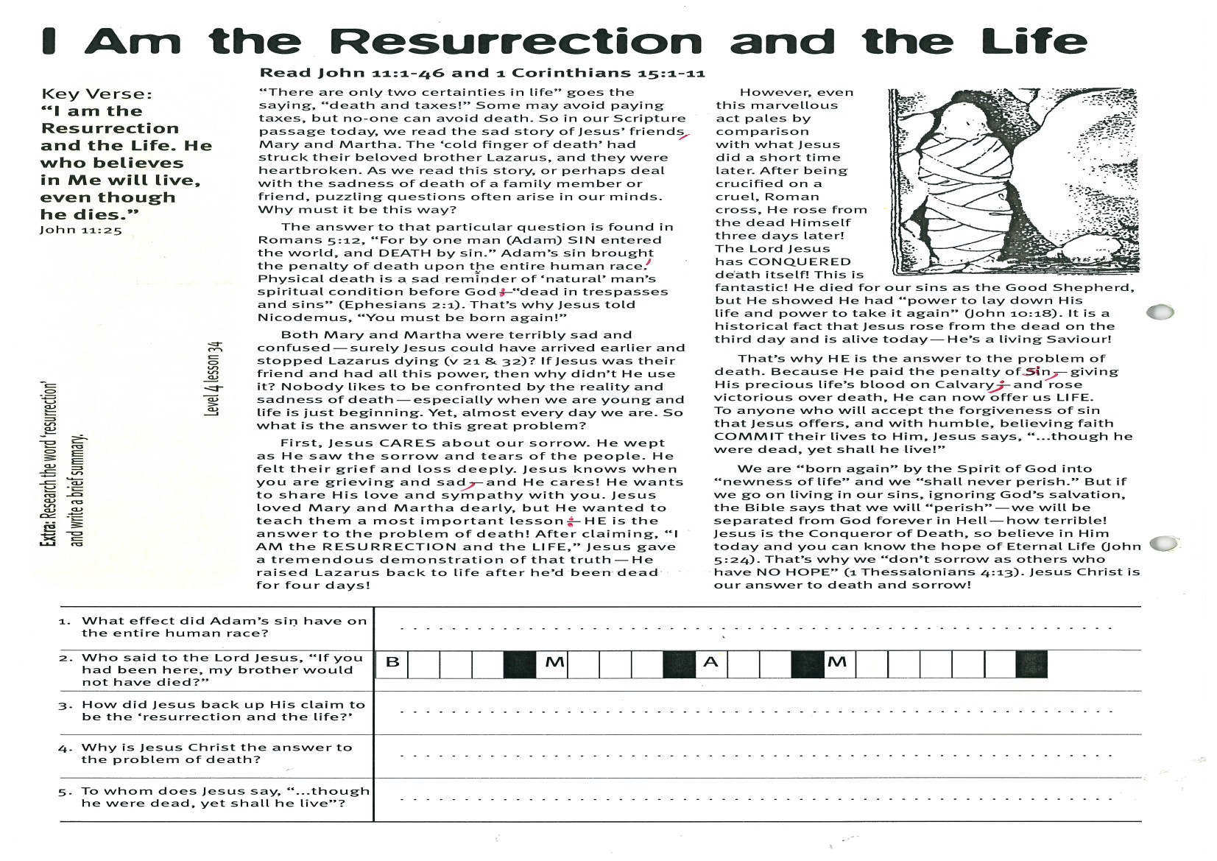
I Am the Resurrection and the Life
Key Verse:
“I am the Resurrection and the Life. He who believes in Me will live, even though he dies.”
John 11:25
Read John 11:1-46 and 1 Corinthians 15:1-11
“There are only two certainties in life” goes the saying, “death and taxes!” Some may avoid paying taxes, but no-one can avoid death. So in our Scripture passage today, we read the sad story of Jesus’ friends, Mary and Martha. The ‘cold finger of death’ had struck their beloved brother Lazarus, and they were heartbroken. As we read this story, or perhaps deal with the sadness of death of a family member or friend, puzzling questions often arise in our minds. Why must it be this way?
The answer to that particular question is found in Romans 5:12, “For by one man (Adam) SIN entered the world, and DEATH by sin.” Adam’s sin brought the penalty of death upon the entire human race! Physical death is a sad reminder of ‘natural’ man’s spiritual condition before God: “dead in trespasses and sins” (Ephesians 2:1). That’s why Jesus told Nicodemus, “You must be born again!”
Both Mary and Martha were terribly sad and confused - surely Jesus could have arrived earlier and stopped Lazarus dying (vs 21 & 32)? If Jesus was their friend and had all this power, then why didn’t He use it? Nobody likes to be confronted by the reality and sadness of death - especially when we are young and life is just beginning. Yet, almost every day we are! So what is the answer to this great problem?
First, Jesus CARES about our sorrow. He wept as He saw the sorrow and tears of the people. He felt their grief and loss deeply. Jesus knows when you are grieving and sad, and He cares! He wants to share His love and sympathy with you. Jesus loved Mary and Martha dearly, but He wanted to teach them a most important lesson: HE is the answer to the problem of death! After
claiming, “I AM the
RESURRECTION and the LIFE,”
Jesus gave a tremendous
demonstration of that truth -
He raised Lazarus back to life
after he’d been dead for four
days!
However, even this marvellous
act pales by comparison with
what Jesus did a short time later. After being crucified on a cruel, Roman cross, He rose from the dead Himself three days later! The Lord Jesus has CONQUERED death itself! This is fantastic! He died for our sins as the Good Shepherd, but He showed He had “power to lay down His life and power to take it again” (John 10:18). It is a historical fact that Jesus rose from the dead on the third day and is still alive today—He’s a living Saviour!
That’s why HE is the answer to the problem of death. Because He paid the penalty of sin, giving His precious life’s blood on Calvary; and rose victorious over death, He can now offer us LIFE. To anyone who will accept the forgiveness of sin that Jesus offers, and with humble, believing faith COMMIT their lives to Him, Jesus says, “…though he were dead, yet shall he live!”
We are “born again” by the Spirit of God into “newness of life” and we “shall never perish.” But if we go on living in our sins, ignoring God’s salvation, the Bible says that we will “perish” - we will be separated from God forever in Hell - how terrible! Jesus is the Conqueror of Death, so believe in Him today and you can know the hope of Eternal Life (John 5:24). That’s why we “don’t sorrow as others who have NO HOPE” (1 Thessalonians 4:13). Jesus Christ is our answer to death and sorrow!
1. What effect did Adam’s sin have on the entire human race?
2. Who said to the Lord Jesus, “If you had been here, my brother would not have died?”
  B |  |  |  |  | M |  |  |  |  | A |  |  |  | M
3. How did Jesus back up His claim to be the ‘Resurrection and the Life?’
4. Why is Jesus Christ the answer to the problem of death?

5. To whom does Jesus say, “…though he were dead, yet shall he live”?
Extra: Research the word ‘resurrection’ and write a brief summary.
Level 4 lesson 34
QUESTIONS & ANSWERS

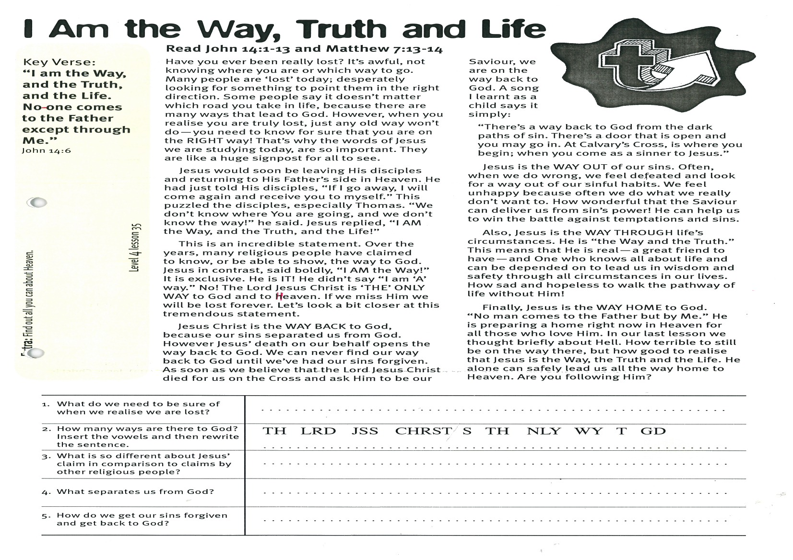
I am the Way, Truth and Life
Key Verse:
“I am the Way, and the Truth, and the Life. No one comes to the Father except through Me.”
John 14:6
Read John 14:1-13 and Matthew 7:13-14
Have you ever been really lost? It’s awful, not knowing where you are or which way to go. Many people are ‘lost’ today; desperately looking for something to point them in the right direction. Some people say it doesn’t matter which road you take in life, because there are many ways that lead to God. However, when you realise you are truly lost, just any old way won’t do - you need to know for sure that you are on the RIGHT way! That’s why the words of Jesus we are studying today, are so important. They are like a huge signpost for all to see.
Jesus would soon be leaving His disciples and returning to His Father’s side in Heaven. He had just told His disciples, “If I go away, I will come again and receive you to myself.” This puzzled the disciples, especially Thomas. “We don’t know where You are going, and we don’t know the way!” he said. Jesus replied, “I AM the Way, and the Truth, and the Life!”
This is an incredible statement. Over the years, many religious people have claimed to know, or be able to show, the way to God. Jesus in contrast, said boldly, “I AM the Way!” It is exclusive. He is IT! He didn’t say “I am ‘A’ way.” No! The Lord Jesus Christ is ‘THE’ ONLY WAY to God and to Heaven. If we miss Him we will be lost forever. Let’s look a bit closer at this tremendous statement.
Jesus Christ is the WAY BACK to God, because our sins separated us from God. However Jesus’ death on our behalf opens the way back to God. We can never find our way back to God until we’ve had our sins forgiven. As soon as we believe that the Lord Jesus Christ died for us on the Cross and ask Him to be our Saviour, we are on the way back to

1. What do we need to be sure of when we realise we are lost?
2. How many ways are there to God? Insert the vowels and then rewrite the sentence. | TH LRD JSS CHRST S TH NLY WY T GD  _________________________________________________
3. What is so different about Jesus’ claim in comparison to claims by other religious people?
4. What separates us from God?
5. How do we get our sins forgiven and get back to God?
Extra: Find out all you can about Heaven.
Level 4 lesson 35
QUESTIONS & ANSWERS
God. A song I learnt as a child says it simply:
“There’s a way back to God from the dark paths of sin. There’s a door that is open and you may go in. At Calvary’s Cross, is where you begin; when you come as a sinner to Jesus.”
Jesus is the WAY OUT of our sins. Often, when we do wrong, we feel defeated and look for a way out of our sinful habits. We feel unhappy because often we do what we really don’t want to. How wonderful that the Saviour can deliver us from sin’s power! He can help us to win the battle against sinful temptations.
Also, Jesus is the WAY THROUGH life’s circumstances. He is “the Way and the Truth.” This means that He is real - a great friend to have, and One who knows all about life - and can be depended on to lead us in wisdom and safety through all circumstances in our lives. How sad and hopeless to walk the pathway of life without Him!
Finally, Jesus is the WAY HOME to God. “No man comes to the Father but by Me.” He is preparing a home right now in Heaven for all those who love Him. In our last lesson we thought briefly about Hell. How terrible to still be on the way there, but how good to realise that Jesus is the Way, the Truth and the Life. He alone can safely lead us all the way home to Heaven. Are you following Him?

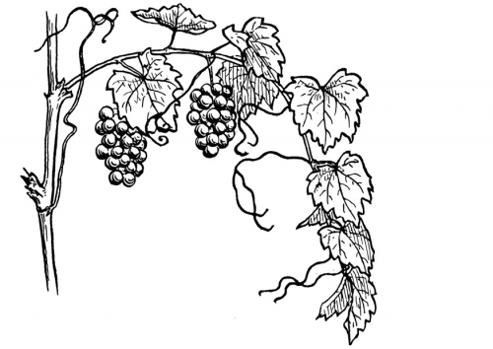
I Am the True Vine
Key Verse:
“I am the Vine, you are the branches… apart from Me you can do nothing.’”
John 15:5
Read John 15:1-16 and Psalm 80:8-19
Here is the seventh and final “I AM” saying by Jesus. However, this one is slightly different from the others. Look back through the other key verses we have had. In each of them, you’ll see that the Lord is referring only to Himself. Now we find a difference. He says, “I AM the Vine, YOU are the branches.” In other words, He is also speaking of Christians - those who have already believed in Him. He is picturing their relationship with Him, and speaks of them as branches growing on a vine.
A vine! What do you think of most, when you think of a vine? Do you think of the beautiful leaves, or the beauty of the wood? No - I think you can answer the question in one word: “fruit!” You see, a pear tree can produce wonderful fruit - ripe, juicy pears. Yet it also produces quite a useful hardwood and pear logs burn with a lovely smell. But a vine is usually only good for one thing - to bear fruit. In Israel where Jesus lived, the vines were mostly grape-vines. Here in New Zealand, in addition to grape-vines, we also have vines which produce world-famous fruit - yes, kiwifruit! However, it too only fulfils one purpose - it produces lovely fruit.
There is a threefold lesson for Christians in this saying of the Lord Jesus:
POSSIBILITY: Only if we are joined to Him is it possible for us to live useful lives for God and produce His ‘fruit’. We cannot produce anything godly and righteous by ourselves (v5). In fact, God’s Word reminds us that even our good deeds “are as filthy rags in God’s sight” (Isaiah 64:6)! However, becoming a Christian changes all that and a wonderful thing happens. When you accept Jesus as Saviour, His life becomes yours! We are “grafted in” to Him, the Vine (Romans 11:17).
1. In the above reading:
(a) Who is the vine?
(b) Who are the branches?
2. What is the main purpose or function of a vine?
3. What is necessary before a person can become fruitful for Jesus? Why?
4. Give two ways in which we can bear fruit in our lives for God.
  C
  a. Fruit of our:
  b. Fruit by:
  W |  |  |  |  |  |  |  | O |  |  |  |  |  |  | F |  |  |  | C
5. What does our scripture passage clearly indicate about God’s plan for Christians?
Extra: Find out all you can about vines and grapes.
Level 4 lesson 36
QUESTIONS & ANSWERS
So, just as the branches of the vine bear fruit because they share the life of the vine, it is now possible for you to be fruitful in your life because you share the life of Christ. Your life has tremendous possibilities for good if you are ‘in Christ.’
PURPOSE: Notice verse 16: How wonderful it is to be chosen by the Saviour to bear ‘fruit’ for Him. But what exactly is this “fruit?’ In Galatians 5:22-23, we read about the “fruit of the Spirit.” These are all ‘fruits’ of our character: wonderful qualities, which are evidence of Jesus living in us, and which influence and encourage others through our teaching and example. We can also produce fruit by winning others for Christ. Once we have and enjoy new life in Christ, we will want to share it with others!
PROCESS: Did you notice the idea of increasing fruit-bearing in this passage? From fruit to more fruit (v2), and then to much fruit (v5), and eventually fruit that lasts (v16). It would be bad, wouldn’t it, if a vine only bore fruit once in three years, or perhaps instead of growing stronger and more productive, it began to fail and wither away? Our passage makes it clear that God’s plan is for Christians to be growing increasingly more ‘fruitful’ for the Lord Jesus Christ.

Please complete and return by post to
PSSM, 1-2A (G2) 93 Dominion Rd, Mt Eden, Auckland 1024 or scan & email to info@biblediscovery.org.nz

