Lazy Bones
Key Verse:
“Laziness brings on deep sleep; and the shiftless (idle) man goes hungry.”
Proverbs 19:15
Read Proverbs 6:6-11; 19:8-15; and Ephesians 5:8-16
Do you enjoy a ‘sleep-in’ sometimes? It’s nice to know that instead of getting up, you can turn over and go back to sleep, isn’t it! There is nothing wrong with that; we all need an extra rest at times. But laziness begins with our attitude. The lazy person expects to do nothing every morning! Then, when they do finally get going, they are just too tired to ‘lift a finger’ to help, to do any work, to ‘get stuck in’ and do things, or study to achieve something. A bumper sticker once read, “I love work; I can watch it all day!” This sums-up the attitude of lazy people: work is for someone else! Our Key Verse today speaks against such behaviour. Such people will be hungry, it says.
Lazy people think that there will always be someone to do things for them and provide for them; maybe their parents, or the Government’s social welfare system. They don’t want to take responsibility for looking after and providing for themselves. They want as much as they can out of life, but without putting much into life. Many aim to be paid highly for doing as little as possible. These people seem to think that life ‘owes’ them a living! They have never learnt there is no such thing as a “free lunch.” Someone has to pay! When we realise this, it helps us to be grateful if we do receive a “free lunch” and a measure of satisfaction if we have earned it.
So why should we work? Well, as with so many principles of Christian doctrine and living, we find their foundation in the Book of Genesis. Look at Genesis 2:15. Even in the perfect, beautiful Garden of Eden, God sent Adam to work!
We were designed by our Creator to work, to find a measure of fulfilment in practical, creative activity. That’s why we hate being bored, and having nothing to do! Although there was plenty of food, it didn’t jump off the trees into Adam’s basket by itself! Proverbs 6:6-11 refers to the little ants who work so hard to gather their food while it is available. God uses them as a rebuke to those who are lazy, and sleep when they should be working. And how often we find that, “Satan finds work for idle hands to do”?
God wants us to be OCCUPIED, doing something constructive with our lives. As a wise man once observed, “The only place where success comes before work is in the dictionary!” We should not expect God to provide our needs if we are simply too lazy to do any work. Even the ants know better than that! The Lord Jesus told the story of a nobleman who went into a far country. Before he left, he gave each of his servants a gold coin. His message to them was “Occupy till I come.” Some servants traded with their coins, and made a profit, but one just buried it and did nothing at all. He was too lazy to be concerned about the value of what he possessed, or what he could do with it. The nobleman was angry when he came back, and took his coin off the lazy, idle man.
As Christians, God has a work for us to do for Him. He does not want us to be lazy or idle. He wants us to use our hands and feet, and our lips and minds in His service. As those who know the Lord Jesus as Saviour, the way we work is an OPPORTUNITY to show our love for God and to serve Him. Colossians 3:23-24 says, “Whatever you do, work at it with all your heart, as working for the Lord, not for men, since you know that you will receive an inheritance from the Lord as a reward.” I do hope that you will determine to live a life that is useful to God and helpful to others.
1. What do we mean by saying that someone is lazy?
2. From this lesson, find the sentence to complete this puzzle: | S |  | T |  | N |  |  |  | N | D |  |  |  | O |  | K
 |  | D |  |  |  | H
3. What did one man do with his gold coin, and why was his master angry?
4 Can you think of ways you can serve God?
5. What have you learnt from this study?
My Name is ……………………………………………………………………… Age ………………….
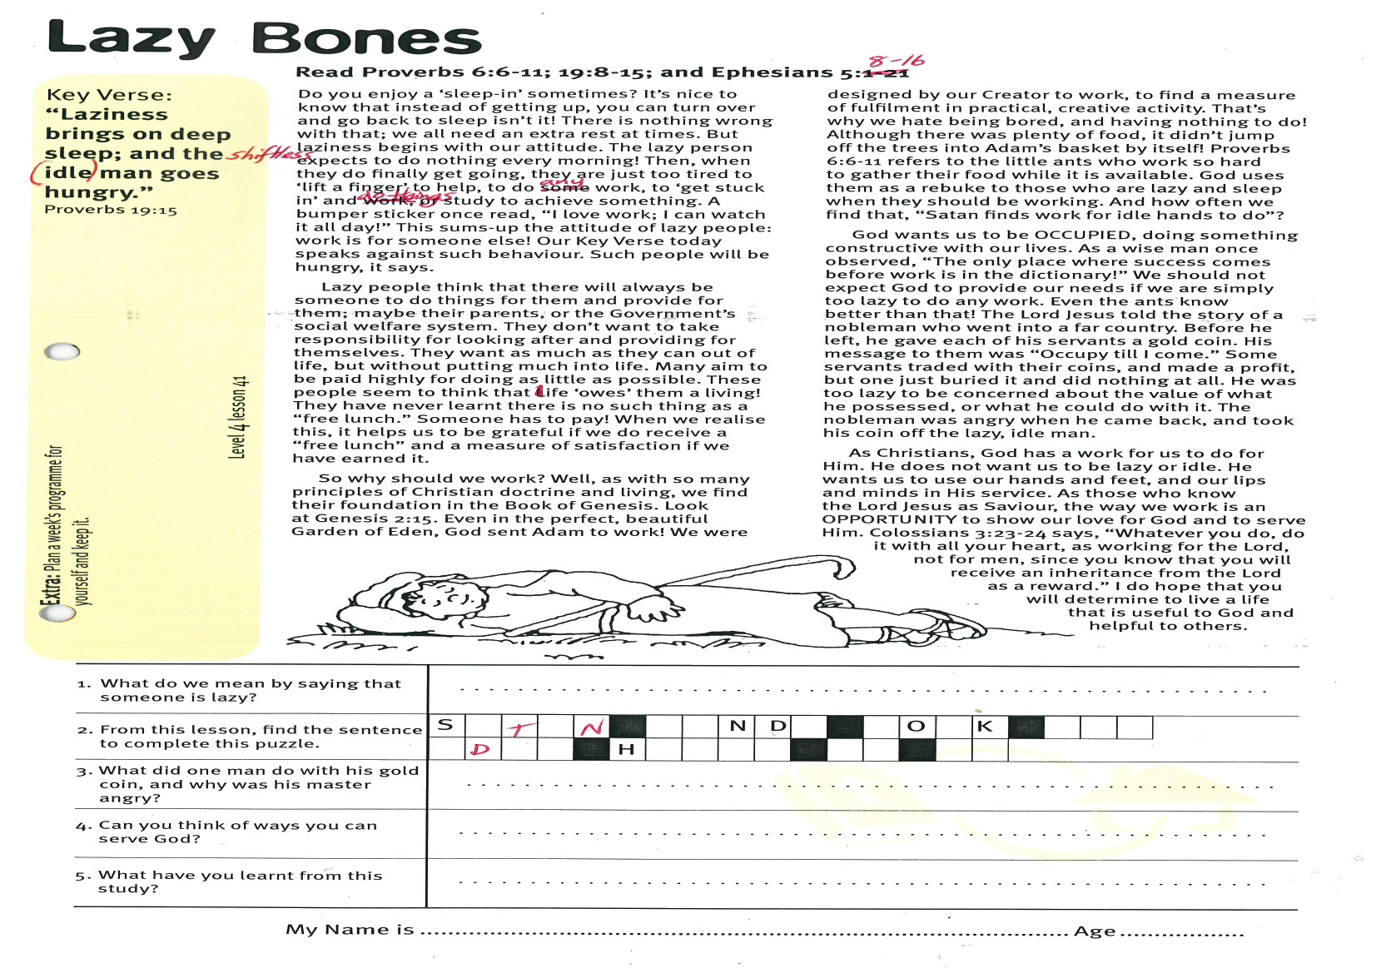
Level 3 lesson 1
Extra: Plan a week’s programme for yourself and keep it.
Level 4 lesson 41
QUESTIONS & ANSWERS
Key Verse:
“Jesus said, ‘I tell you the truth, unless a man is born again, he cannot see the kingdom of God.’”
John 3:3

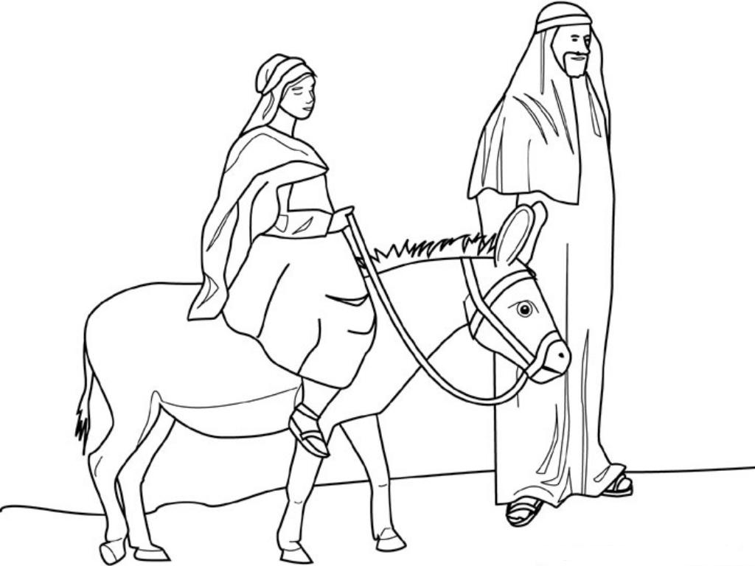
The Promised Saviour
Key Verse:
“And you are to give Him the name Jesus, because He will save His people from their sins.”
Matthew 1:21
Read Luke 1:26-35 and Matthew 1:20-25
Well, it’s nearly Christmas-time again. There will never be a more important thing for us to consider than the “Christmas message” about the birth of Jesus Christ. For centuries, God’s Word had promised that the ‘Messiah’ - God’s Saviour - would come to save His people, and so many people were awaiting Him.
Among the hills of Galilee there lived a young woman named Mary. She was engaged to be married to a carpenter named Joseph, who also lived in the town of Nazareth. One day, God sent an angel to visit Mary at the house where she was living. “The Lord is with you,” he said. Mary was very surprised to see the angel, and a bit frightened, too! But the angel told her not to be scared because He had some happy news for her. Although Mary was a virgin, she would soon have a baby boy! Just as the Old Testament had predicted, He would not be like any other child, before or since: He would be the promised ‘Messiah, the Son of God!’ The angel told Mary that she must name Him Jesus once He was born!
Soon after this, the angel of the Lord also spoke to Joseph in a dream and assured him that Mary was not pregnant by another man, and to take Mary to be his wife for “what is conceived in her is from the Holy Spirit.” This was hugely important, both for Joseph and for us! He told Joseph also to name the child, Jesus, “because He will save His people from their sins.” When Joseph woke up, he immediately obeyed the angel’s instructions and took Mary to be his wife.
Now the Scriptures point out very specifically that Joseph did not have a physical relationship with Mary until this special, holy Child was born (Matthew 1:25). Jesus was a miracle child - He did not have a human father, but was conceived in Mary by the Holy Spirit! This meant that He was both human and sinless! If this were not so, He never could have saved any sinners by His death. He would have been just a normal man, under the condemnation of God’s righteous judgement of death for sin, just like you and I.
1. (a) Who was chosen to be the mother of the Lord Jesus?
(b) Who told her this wonderful news?
2. What was her reaction to the news?
3. How was Jesus different from other children?
4. They were to name the baby Jesus because He ...  __I__ __ __A__ __ __I__ __E__ __L __  __ __O__ __ __E__ __ __I__ __ |  | I |  |  |  |  | A |  |  |  |  | I |  |  |  | E
 |  |  | O |  |  |  |  | E |  |  |  |  | I
5. Why did Joseph and Mary have to go to Bethlehem?
Extra: Comment on: “There will never be a more important thing for us to consider than the Christmas message.”
Level 4 lesson 42
QUESTIONS & ANSWERS
This is very important. Though difficult to understand HOW this happened, we believe God’s Word that it did! Nothing is too hard for God, who created everything from nothing simply by the word of His power!
Now at this time in history, the Romans were ruling over the Jewish people in their great Roman Empire. And so some months after the angel’s visit to Mary, Caesar Augustus the Roman Emperor, sent word to Herod the Governor to take a census of the Jews. A census is when a lot of information is collected about people; like how many people there are, where and when they were born, where they live, and if they are male or female. Caesar Augustus was keen to discover all he could about his Jewish subjects, particularly their numbers, so he would know if they were becoming a military threat. In order to take part in the census, everyone was required to go back to the town of their father’s ancestors and register their names.
Now, both Joseph and Mary were descendants of King David, who was born in Bethlehem. So they prepared for the long journey and then travelled to Bethlehem. You can probably imagine that poor Mary wouldn’t have liked that bumpy trip! She was heavily pregnant by this time, and riding on a donkey is not recommended in this condition! Soon however, the uncomfortable journey was over. Mary was probably looking forward to lying in a comfortable bed and having a well-earned rest. Yet when they arrived, the hotel had no room for them! What were they to do?

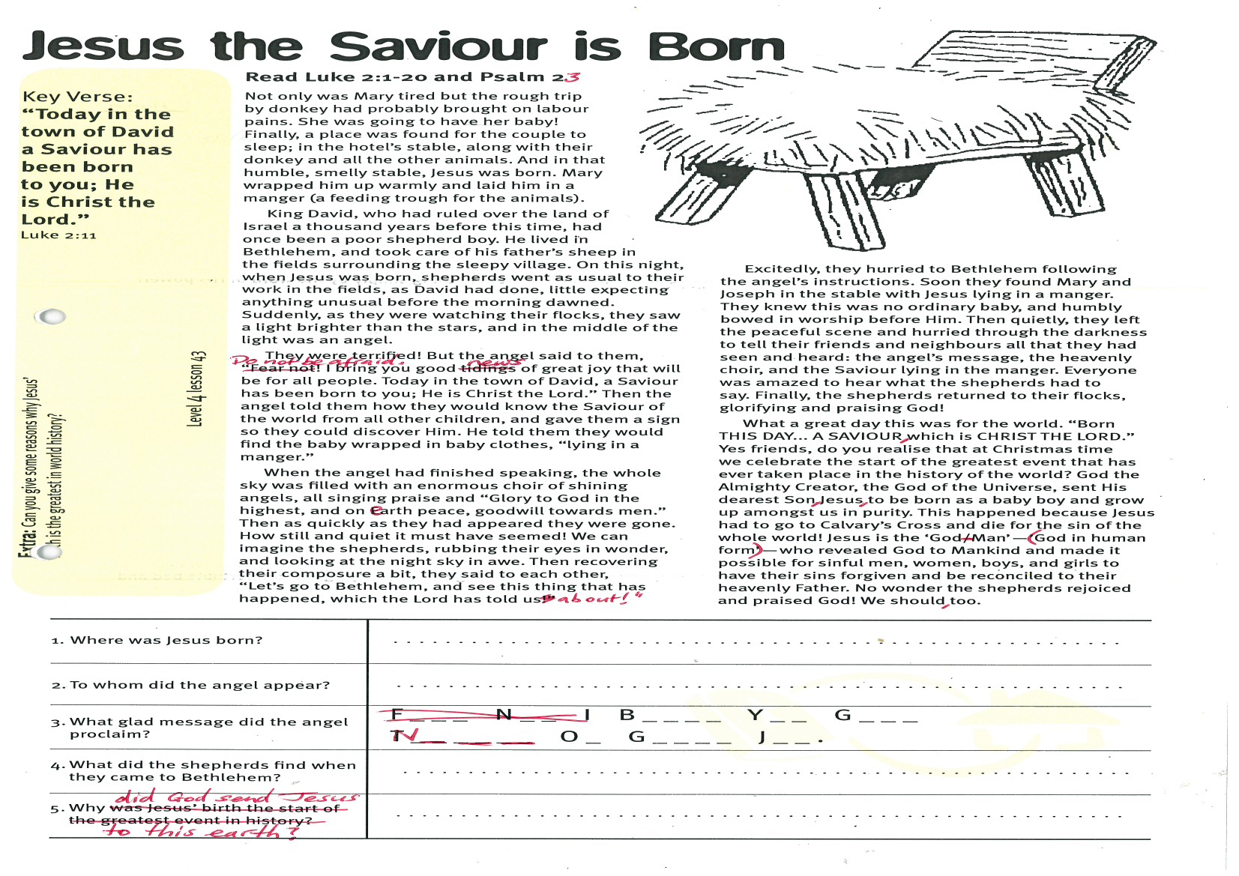
Key Verse:
“Today in the town of David a Saviour has been born to you; He is Christ the Lord.”
Luke 2:11
Read Luke 2:1-20 and Psalm 23
Not only was Mary tired, but the rough trip by donkey had probably brought on labour pains. She was going to have her baby! Finally, a place was found for the couple to sleep; in the hotel’s stable, along with their donkey and all the other animals. And in that humble, smelly stable, Jesus was born. Mary wrapped him up warmly and laid him in a manger (a feeding trough for the animals).
King David, who had ruled over the land of Israel a thousand years before this time, had once been a poor shepherd boy. He lived in Bethlehem, and took care of his father’s sheep in the fields surrounding the sleepy village. On this night, when Jesus was born, shepherds went as usual to their work in the fields (as David had done), little expecting anything unusual before the morning dawned. Suddenly, as they were watching their flocks, they saw a light brighter than the stars, and in the middle of the light was an angel.
They were terrified! But the angel said to them, “Do not be afraid! I bring you good news of great joy that will be for all people. Today in the town of David, a Saviour has been born to you; He is Christ the Lord.” Then the angel told them how they would know the Saviour of the world from all other children, and gave them a sign so they could discover Him. He told them they would find the baby wrapped in baby clothes, “lying in a manger.”
When the angel had finished speaking, the whole sky was filled with an enormous choir of shining angels, all singing praise and “Glory to God in the highest, and on earth peace, goodwill towards men.” Then as quickly as they had appeared they were gone. How still and quiet it must have seemed! We can imagine the shepherds, rubbing their eyes in wonder, and looking at the night sky in awe. Then recovering
their composure a bit, they said to each other, “Let’s go to Bethlehem, and see this thing that has happened, which the Lord has told us about!”
Excitedly, they hurried to Bethlehem following the angel’s instructions. Soon they found Mary and Joseph in the stable with Jesus lying in a manger. They knew this was no ordinary baby, and humbly bowed in worship before Him. Then quietly, they left the peaceful scene and hurried through the darkness to tell their friends and neighbours all that they had seen and heard: the angel’s message, the heavenly choir, and the Saviour lying in the manger. Everyone was amazed to hear what the shepherds had to say. Finally, the shepherds returned to their flocks, glorifying and praising God!
What a great day this was for the world. “Born THIS DAY... A SAVIOUR, which is CHRIST THE LORD.” Yes friends, do you realise that at Christmas time we celebrate the start of the greatest event that has ever taken place in the history of the world? God the Almighty Creator, the God of the Universe, sent His dearest Son, Jesus, to be born as a baby boy and grow up amongst us in purity. This happened because Jesus had to go to Calvary’s Cross and die for the sin of the whole world! Jesus is the ‘God-Man’ (God in human form) who revealed God to mankind and made it possible for sinful men, women, boys, and girls to have their sins forgiven and be reconciled to their heavenly Father. No wonder the shepherds rejoiced and praised God! We should, too.
Jesus the Saviour is Born
1. Where was Jesus born?
2. To whom did the angel appear?
3. What glad message did the angel proclaim | “I B__ __ __ __ Y__ __ G__ __ __ N__ __ __  O__ G__ __ __ __ J__ __”.
4. What did the shepherds find when they came to Bethlehem?
5. Why did God send Jesus to this earth?
Extra: Can you give some reasons why Jesus’ birth is the greatest in world history?
Level 4 lesson 43
QUESTIONS & ANSWERS
The Wise Men Visit Jesus
Key Verse:
“They bowed down and worshipped Him (Jesus). Then they opened their treasures, and presented Him with gifts of gold, frankincense, and myrrh.”
Matthew 2:11
Read Matthew 2:1-18 and Psalm 8
Some wise men lived in a country far to the east of the land of Israel. They were astronomers, who spent time studying the stars in the sky. One night, as they were observing the movements of the stars, these wise men saw a star they had never seen before. It grew brighter and brighter, and soon there could be no doubt that it was in fact, a new star. No doubt, they were amazed to see such a thing and realised that a wonderful event had happened.
Somehow God had allowed for the Magi to see this star rising above Israel, and to learn (maybe in a prophecy) that a king would be born from among the Jews. At this point they must have decided to go to the king, and worship Him, and give Him presents. So the wise men packed their belongings and gifts onto their camels and set off, navigating their way by the stars. Walking toward the star faithfully, mile after mile, they eventually arrived at the court of King Herod in Jerusalem. There they enquired, “Where is the one that is born King of the Jews? We saw His star in the east, and have come to worship Him.”
Now Herod was a wicked king, and upon hearing this he immediately saw a real threat to his own reign. That would not do! Finding out from the wise men how long ago they had first seen the star, he sent for the priests and teachers of the Law in Jerusalem. He found out from them, that the Messiah was to be born in Bethlehem.
Then, feigning interest and concern, he passed this information to the wise men and told them to inform him when they found the new-born king. He claimed that this was so that he could worship Him, also. We will see from his later actions (2:16) what this evil man really had in mind for the Jesus!
So the wise men journeyed toward Bethlehem and followed the moving star, which led them right to the place where Jesus was and stopped there. Going inside the house where Joseph and Mary were now living, they found the young child with Mary, His mother. The Scriptures are plain that they bowed down and worshipped Him. They presented to Him their gifts of gold, frankincense, and myrrh - gifts typically given to kings. What a special moment this must have been for them!
Later that night, God warned the Magi in a dream not to return to Herod, so they travelled home by another route. After they had gone, an Angel of the Lord appeared to Joseph and told him to take Mary and the baby into Egypt, because Herod was planning to kill the new born king. So they left hurriedly, in the middle of the night, and so escaped Herod’s wicked plot. There have always been evil people, bitterly opposed to Jesus Christ and His followers. Remember to pray for those Christians who are persecuted for their faith in Jesus Christ.
We have thought a lot today about the wise men and their loving devotion to the young child, the Lord Jesus Christ. They brought their gifts and set an example, and so for all these years people have been giving gifts, too. This Christmas you may give gifts to family and friends, but what about the Lord Jesus? Have you remembered Him? He is worthy of our hearts, our lives, and our love. Give yourself to Him, trust Him as your Saviour and Lord, and this will be the most wonderful Christmas of your life!

1. Why did the wise men go to Jerusalem and what guided them on their journey?
2. How did the young Child escape Herod’s wicked plot?
3. What did the wise men bring to the Lord Jesus? Clue: Start with “f” and use each 2nd letter. | fgroalndkainndcmeynrsreh
4. What are the gifts we can give the Lord Jesus today?
5. Have you ever asked Jesus to make you clean from sin and help you live for Him? | Yes No Not sure
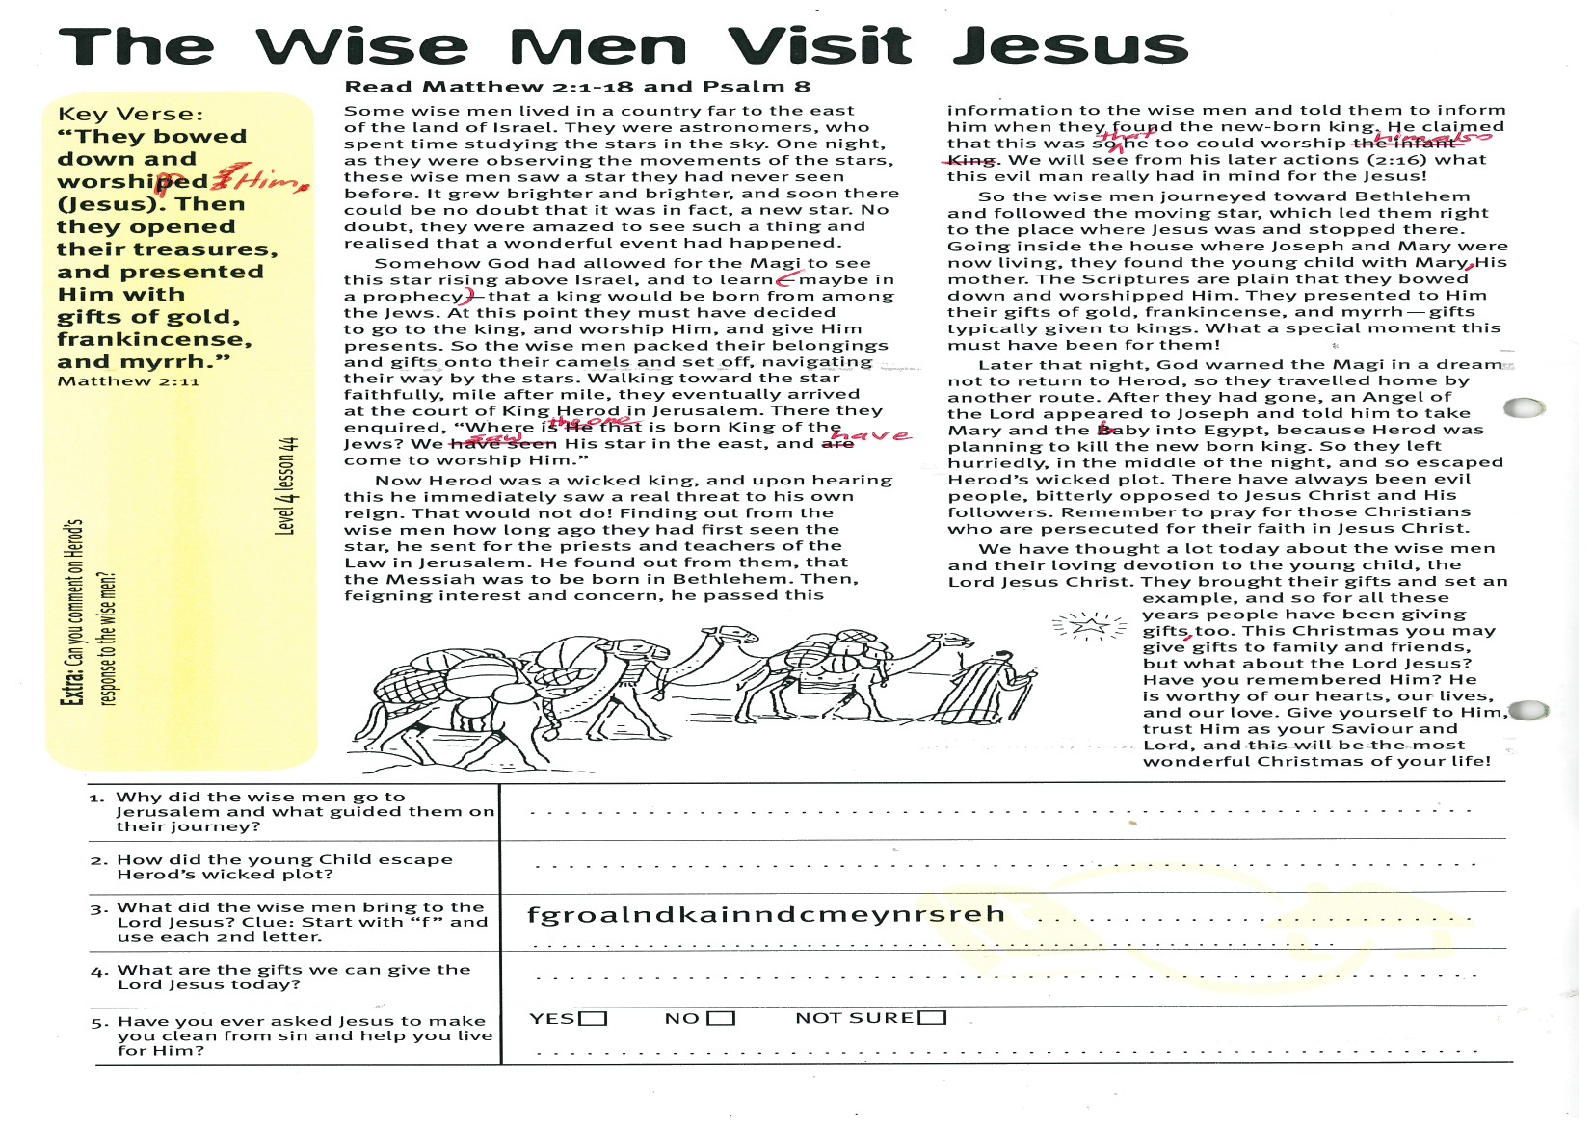
5
Extra: Can you comment on Herod’s response to the wise men?
Level 4 lesson 44
QUESTIONS & ANSWERS
Please complete and return by post to
PSSM, 1-2A (G2) 93 Dominion Rd, Mt Eden, Auckland 1024 or scan & email to info@biblediscovery.org.nz

