

Key Verse:  
**“Let the little children come to Me, and do not hinder them.”**  
Matthew 19:14

**Friends**

**Read 1 Samuel 18:1-5**

David was one of the bravest boys around. Remember last month, we learnt how with God’s help, he fought and killed the enemy giant, Goliath? When King Saul saw how brave David was, he wanted him to be a soldier in his army. He took David to live in his palace. There, David met Jonathan, the King’s son. The two young men became best friends.

We all like to have fun together with friends, don’t we? These two boys did everything together! They went for walks, ate meals and played games together. They shared everything. David was happy to have such a good friend.

Jonathan wanted to show David how much he loved him, so one day he gave him his coat, his sword, his belt and his bow and arrows as a present! How kind! David was poor, and didn’t have anything special to give Jonathan. But he was thankful for the gifts and Jonathan’s promise to always be his best friend.

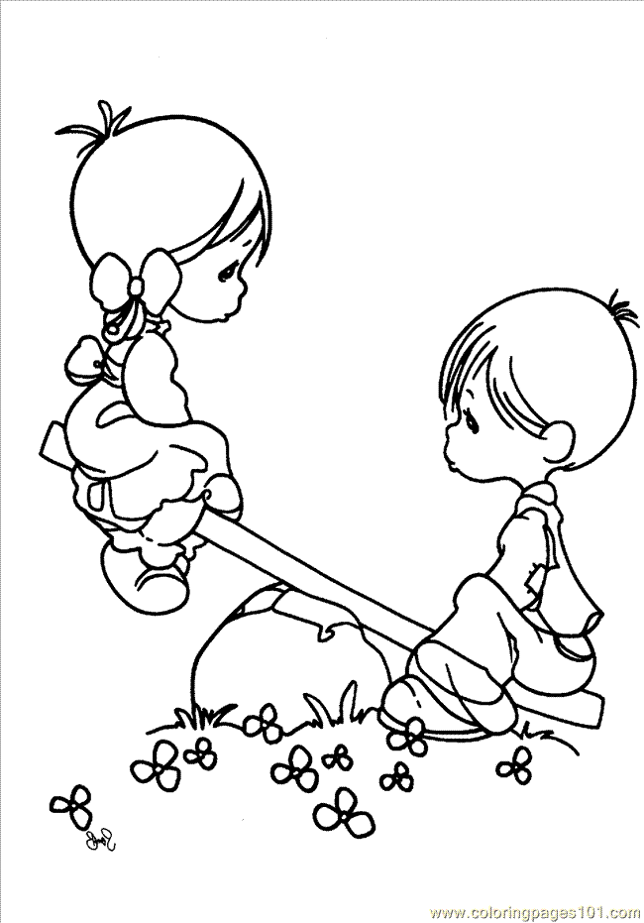

My Name is________________________________________ Age ______________

Colour in this picture

Friends are a gift from God

(write your name)

Who is the very best friend

…………………………………………

can have?

|  |  |  |  |  |
| --- | --- | --- | --- | --- |
| **J** |  |  |  |  |

**PRAYER TIME**

Dear God,   
Thank you for my friend

________________________

Help me to be a good friend at home, at school, and everywhere I go.

Have you got a good friend like this? It’s good to give thanks to God for our friends. They are very special. Did you know that the Lord Jesus is the very best friend we can have? If you love and trust Jesus, He will help you to be a good, kind and generous friend to other people too!

**Level 2 lesson 5**

**Extra:** What are some things I can do for my friends?



Key Verse:  
**“The Lord is my helper; I will not be afraid**  
Hebrews 13:6

**Read 1 Kings 10:1-9**

David became king when Saul died, and when David died, his son Solomon became king. One night God spoke to Solomon in a dream. He asked him what gift he would most like to have. Solomon asked for wisdom to be a good king. God was pleased with his unselfish request. As well as making him very wise, God made Solomon famous and very rich too!

People came from all over the world to see him. The Queen of Sheba did not believe all she heard about Solomon. So she travelled a long way to see for herself. After she met Solomon and talked to him, she said he was twice as great as she had heard!

**Wise Solomon**

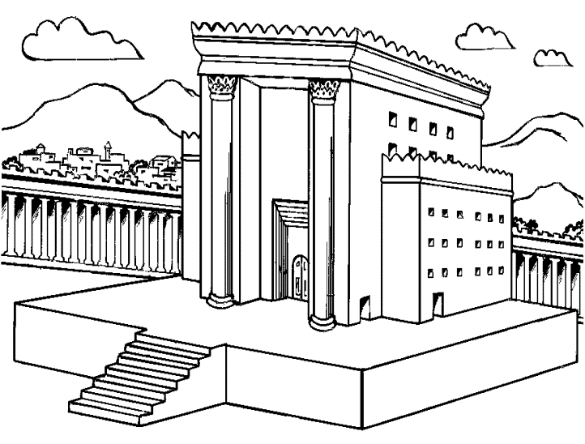

Colour in the picture

1. This wise king was called   
__ __ __ __ __ __ __

2. He was __ __ __ __ __ ‘__ son.

3. People came from all over the   
__ __ __ __ __ to see him.

4. __ __ __ made him famous and rich.

5. Who built the temple for God?

_______________________________________

6. How many years did the temple take to build?   
Circle the correct answer:

1 year 3 years

5 years 7 years

9 years 11 years

Solomon built a beautiful temple for God in Jerusalem. It took seven years to build! Finally, it was finished and King Solomon called all the people together. He thanked God, and prayed that the people would love and serve God all their lives.

Solomon was very wise, but that didn’t mean he couldn’t make mistakes! Although he knew what was right he didn’t always do it. He made some very bad mistakes when he got older. Sometimes we can be like this too. We need to ask God to help us do the right things always.

**Level 2 lesson 6**

**Extra:** Why do you think Solomon built this big temple building?



Key Verse:  
**“The Lord will hear when I call to Him.”**  
Psalm 4:3b

**Read Nehemiah 1:1-6; 2:2-8**

In Bible times the people who lived in different cities were not always friendly to each other. Each city had a high wall around it with big, heavy gates. One day, some enemies attacked Jerusalem. They destroyed the beautiful temple Solomon had built. They also took many people away as prisoners. This happened because after Solomon died many of the Israelites turned away from God. They started worshipping idols instead.

One of the prisoners became a servant in the king’s palace. His name was Nehemiah. He was very sad that the walls of Jerusalem had been broken down. Later, Nehemiah heard that the people left in Jerusalem were being badly treated and the gates of the city had been burnt with fire. All this made Nehemiah very sad.

He wanted to do something to help. He prayed to God about what to say to the

**Nehemiah**

Tick the box with the right answer:

1. Where did Nehemiah live?

In his own home

In the King’s palace

On the farm

2. Who did Nehemiah pray to?

To the King

To a golden image

To God

3. Why did Nehemiah want to go to Jerusalem?

To see his father

To repair the city & the walls

To enjoy travelling

4. Did the King help him?

□ Yes □ No

When can

……………………………………………………….......................  
*(write your name)*  
Pray to God?

Answer: ___________________________________

______________________________

When you are needed to help at home, will you work with

A smile *(put a tick beside one)*

or a frown  
 ?

king. Then he asked the king if he could go home for a while to fix the wall. God answered Nehemiah’s prayer. The king agreed and helped him go.

It took many days for Nehemiah to reach Jerusalem. When he saw the walls all broken down, he knew God wanted him to fix them. He said to the people, “Let’s get the walls fixed up! That will make God happy!” All the people worked hard and they worked well together. God helped them to do their very best. It didn’t take long until the wall was built up again. Nehemiah and his friends were glad to work together. It’s easier to get jobs done when we work well together. You can be a helper too!

**Extra:** Find out why cities used to have walls and gates.

**Level 2 lesson 7**



Please complete and return by post to   
**PSSM, 1-2A (G2) 93 Dominion Rd, Mt Eden, Auckland 1024** or scan & email to **info@biblediscovery.org.nz**

Here’s a song for you to learn about Daniel:   
(sing it to the tune of “Mary had a little lamb”)

Who prayed three times every day?  
Every day?  
Every day?  
Who prayed three times every day?  
Daniel, brave and true.

God wants me to trust Him, too.  
Trust Him, too.  
Trust Him, too.  
God wants me to trust Him, too.  
Like Daniel, brave and true.

1. When should we obey God? (tick one)

a. When everyone else does

b. Always

c. Sometimes

2. Match these sentences (using a ruler and a pen)

The soldiers three friends

Daniel had attacked Jerusalem

Daniel obeyed what God had told his people  
  
The king wanted don’t eat food offered to idols

Daniel remembered some helpers

God said God

So Daniel refused to eat it. He asked the King’s servant to give them water to drink and plain food. Later, the servant could check if this had been better for them. The servant agreed. After some time, he found that Daniel and his friends were fitter than the others who had eaten the king’s food.

They all learned to read and speak the same language as the king and also did very well in their school-work. After three years the king called the men to him and asked them lots of hard questions. Daniel and his friends topped the class! They obeyed God and God helped them. When you obey God and do what God wants you to do, He will help you too!

**Extra:** Tell us something you like about Daniel.

**Level 2 lesson 8**

**Read Daniel 1:3-20**

Six hundred years before Jesus was born, there was a great King named Nebuchadnezzar. That’s an unusual name isn’t it? Nebuchadnezzar was at war with the Jewish people. His soldiers went to Jerusalem and attacked the city. They won the battle and took many prisoners back to their own country.

The soldiers took the prisoners to King Nebuchadnezzar. He said to his servants: “Choose some of the best of the young men and send them to my school. I want them to learn to be my helpers. I will look after them well.”

Daniel was one of the young men chosen. He and his three friends, Shadrach, Meshach and Abednego were taken to live in the king’s palace. They went to the king’s school. He gave them nice clothes and sent them food. But Daniel knew the food and drink had been offered to idols. He remembered that God had told His people not to eat or drink such food.

**Daniel and Friends**

Key Verse:  
**“Those who honour me, I will honour.”**  
1 Samuel 2:30B