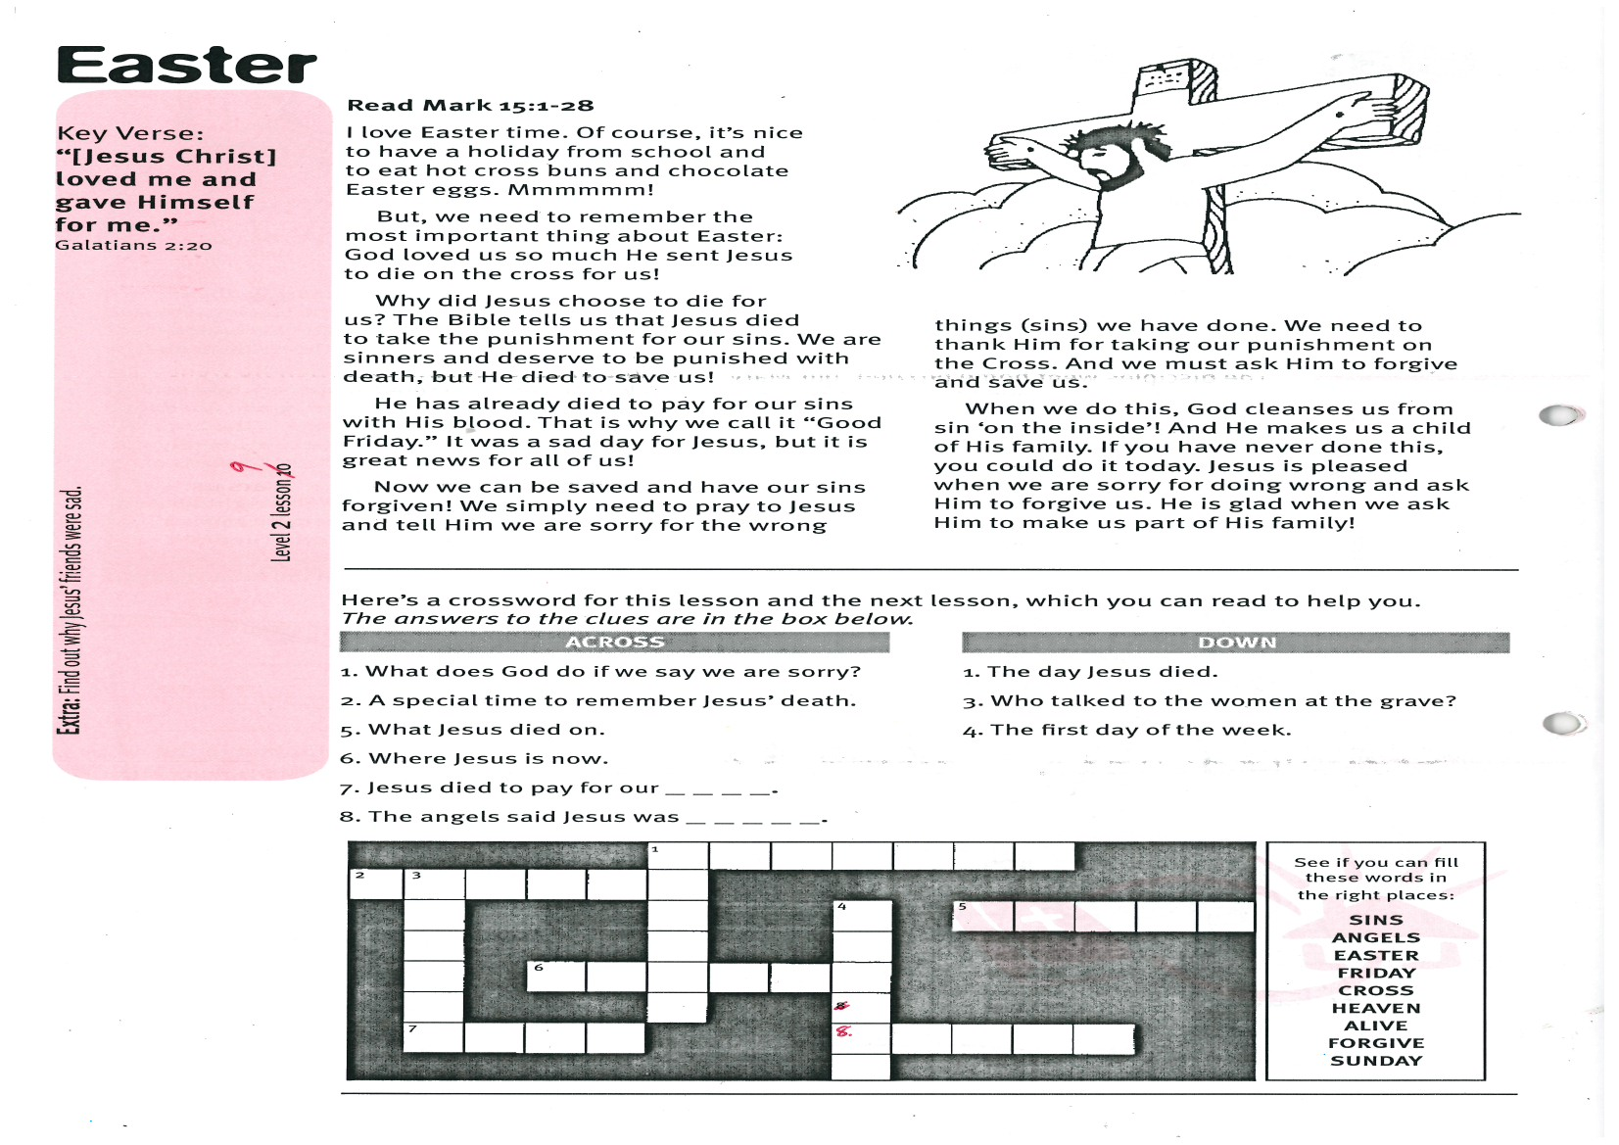

**Read Mark 15:1-28**

I love Easter time. Of course, it’s nice to have a holiday from school and to eat hot cross buns and chocolate Easter eggs. Mmmmmm!

But, we need to remember the most important thing about Easter: God loved us so much He sent Jesus to die on the cross for us!

Why did Jesus choose to die for us? The Bible tells us that Jesus died to take the punishment for our sins. We are sinners and deserve to be punished with death, but He died to save us!

He has already died to pay for our sins with His blood. That is why we call it “Good Friday.” It was a sad day for Jesus, but it is great news for all of us!

Now we can be saved and have our sins forgiven! We simply need to pray to Jesus

Key Verse:  
**“[Jesus Christ] loved me and gave Himself for me.”**  
Galatians 2:20

**Easter**

|  |  |  |  |  |  |  |  |  |  |  |  |  |  |  |
| --- | --- | --- | --- | --- | --- | --- | --- | --- | --- | --- | --- | --- | --- | --- |
|  |  |  |  |  | 1 |  |  |  |  |  |  |  |  |  |
| 2 | 3 |  |  |  |  |  |  |  |  |  |  |  |  |  |
|  |  |  |  |  |  |  |  | 4 |  | 5 |  |  |  |  |
|  |  |  |  |  |  |  |  |  |  |  |  |  |  |  |
|  |  |  | 6 |  |  |  |  |  |  |  |  |  |  |  |
|  |  |  |  |  |  |  |  |  |  |  |  |  |  |  |
|  | 7 |  |  |  |  |  |  | 8 |  |  |  |  |  |  |
|  |  |  |  |  |  |  |  |  |  |  |  |  |  |  |

My Name is________________________________________ Age ______________

**DOWN**

1. The day Jesus died.  
3. Who talked to the women at the grave?  
4. The first day of the week.

Here’s a crossword for this lesson and the next lesson, which you can read to help you. The answers to the clues are in the box below.

**ACROSS**

1. What does God do if we say we are sorry?  
2. A special time to remember Jesus’ death.  
5. What Jesus died on.  
6. Where Jesus is now.  
7. Jesus died to pay for our _ _ _ _.  
8. The angels said Jesus was _ _ _ _ _.

and tell Him we are sorry for the wrong things (sins) we have done. We need to thank Him for taking our punishment on the Cross. And we must ask Him to forgive and save us.  
  
When we do this, God cleanses us from sin ‘on the inside’! And He makes us a child of His family. If you have never done this, you could do it today. Jesus is pleased when we are sorry for doing wrong and ask Him to forgive us. He is glad when we ask Him to make us part of His family!!

**Level 2 lesson 9**

**Extra:** Find out why Jesus’ friends were sad

She thought it was a gardener at first, but then she heard her name called, “Mary!” It was actually Jesus. He really WAS alive! Jesus told her to go and tell the other disciples. Mary was so excited! She ran and told them the news that she had seen Jesus! But the disciples didn’t really believe that Jesus had risen from the dead.  
  
Later that day, most of the disciples were hiding together in a locked room. Suddenly, Jesus Himself appeared right in the room! The disciples were amazed. Jesus showed them the marks where the nails had been in His hands and feet. Yes, it really was Him! Jesus was alive again! Later, Jesus showed Himself to lots of other people too. Then He went back to HEAVEN, where He still is now.

Jesus has promised that He will come back again one day, to take everyone who loves Him back to Heaven with Him. WOW! That will be wonderful! Jesus is alive forever, so we can talk to Him and He always hears us. He also helps us and teaches us the right way through His Word, the Bible. Have you asked Him save you and change your heart?

**Jesus is Alive!**

**Read John 20 and Acts 1:9-11**

Last lesson we saw that Jesus died on the Cross for our sins. We call that day ‘Good Friday.’ Very early the following Sunday morning, Mary Magdalene and a few other women, who loved Jesus, went to his grave.

Right away they knew something had happened. The huge stone that had been placed over the door to Jesus’ tomb had been rolled away! Mary ran to tell the other disciples. Peter and John ran back to the tomb and looked inside. They could see the burial clothes still lying there, but Jesus’ body had gone!

The disciples went home puzzled, but Mary was too upset. She stayed there, just crying. Finally, she looked inside the empty tomb for herself. To her surprise she saw two angels in there. They told her that Jesus was ALIVE again. What great news!

Mary could hardly believe it. As she left the tomb, she saw a man standing nearby.

Key Verse:  
**“Stop doubting and believe’”**  
John 20:27

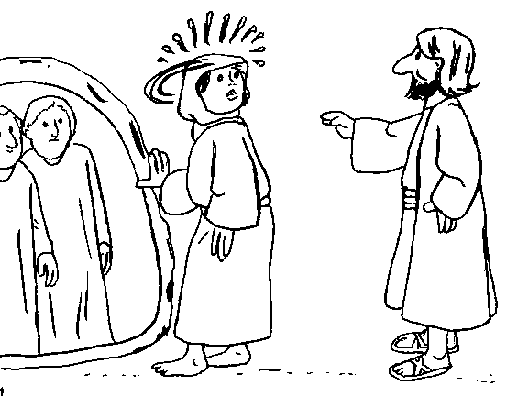

Colour in the picture

**Extra:** What is your favourite part of the Easter Story?

1. What do you think this picture is about?

_______________________________________

_______________________________________

_______________________________________

2. This is written back to front. Please write it out correctly: **evilasisuseJ**

_________________________________

_________________________________

3. Name something wonderful that Jesus can do for us because He is alive.

_______________________________________

_______________________________________

_______________________________________

**Level 2 lesson 10**

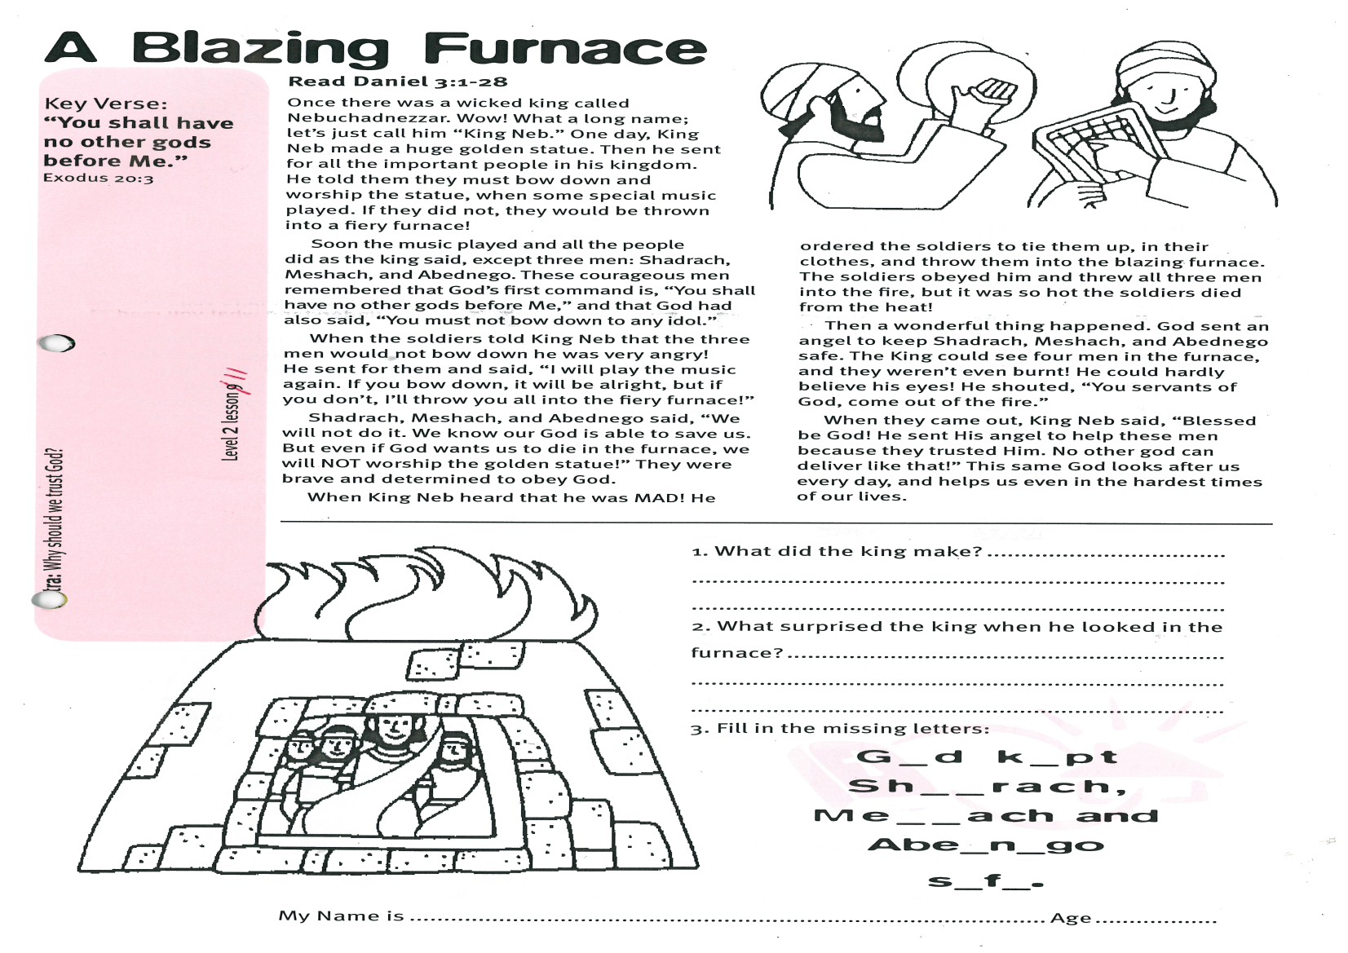

**Read Daniel 3:1-28**

Once there was a wicked king called Nebuchadnezzar. Wow! What a long name; let’s just call him “King Neb.” One day, King Neb made a huge golden statue. Then he sent for all the important people in his kingdom. He told them they must bow down and worship the statue, when some special music played. If they did not, they would be thrown into a fiery furnace!

Soon the music played and all the people did as the king said, except three men: Shadrach, Meshach, and Abednego. These courageous men remembered that God’s first command is, “You shall have no other gods before Me,” and that God had also said, “You must not bow down to any idol.”

When the soldiers told King Neb that the three men would not bow down he was very angry! He sent for them and said, “I will play the music again. If you bow down, it will be alright, but if you don’t, I’ll throw you all into the fiery furnace!”

Shadrach, Meshach, and Abednego said, “We will not do it. We know our God is able to save us. But even if God wants us to die in the furnace, we will NOT worship the golden

Key Verse:  
**“You shall have no other gods before Me.”**  
Exodus 20:3

**A Blazing Furnace**

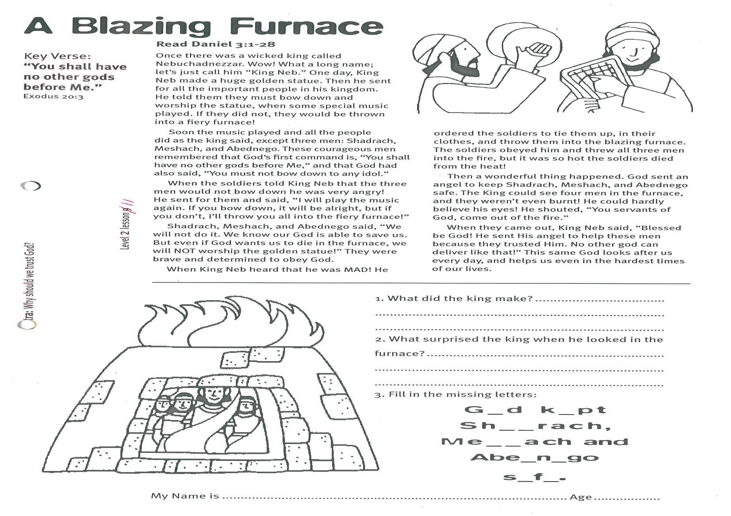

statue!” They were brave and determined to obey God.  
  
When King Neb heard that he was MAD! He ordered the soldiers to tie them up, in their clothes, and throw them into the blazing furnace. The soldiers obeyed him and threw all three men into the fire, but it was so hot the soldiers died from the heat!

Then a wonderful thing happened. God sent an angel to keep Shadrach, Meshach, and Abednego safe. The King could see four men in the furnace, and they weren’t even burnt! He could hardly believe his eyes! He shouted, “You servants of God, come out of the fire.”

When they came out, King Neb said, “Blessed be God! He sent His angel to help these men because they trusted Him. No other god can deliver like that!” This same God looks after us every day, and helps us even in the hardest times of our lives.

1. What did the king make?

___________________________________

___________________________________

2. What surprised the king when he looked in the furnace?

___________________________________

__________________________________

__________________________________

3. Fill in the missing letters:

G_d k_pt Sh__rach,

Me__ach and   
Abe_n_go s_f_.

**Extra:** Why should we trust God?

**Level 2 lesson 11**

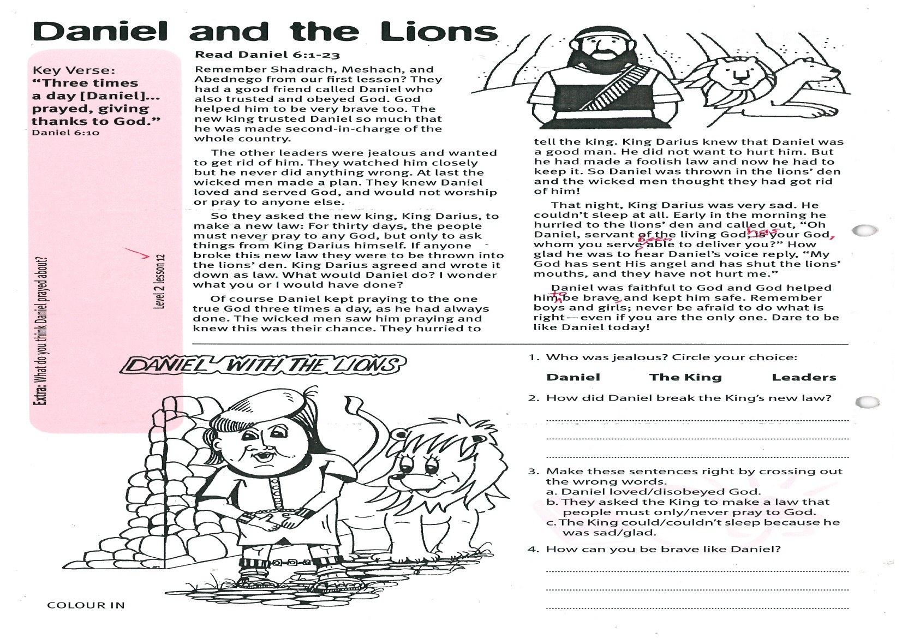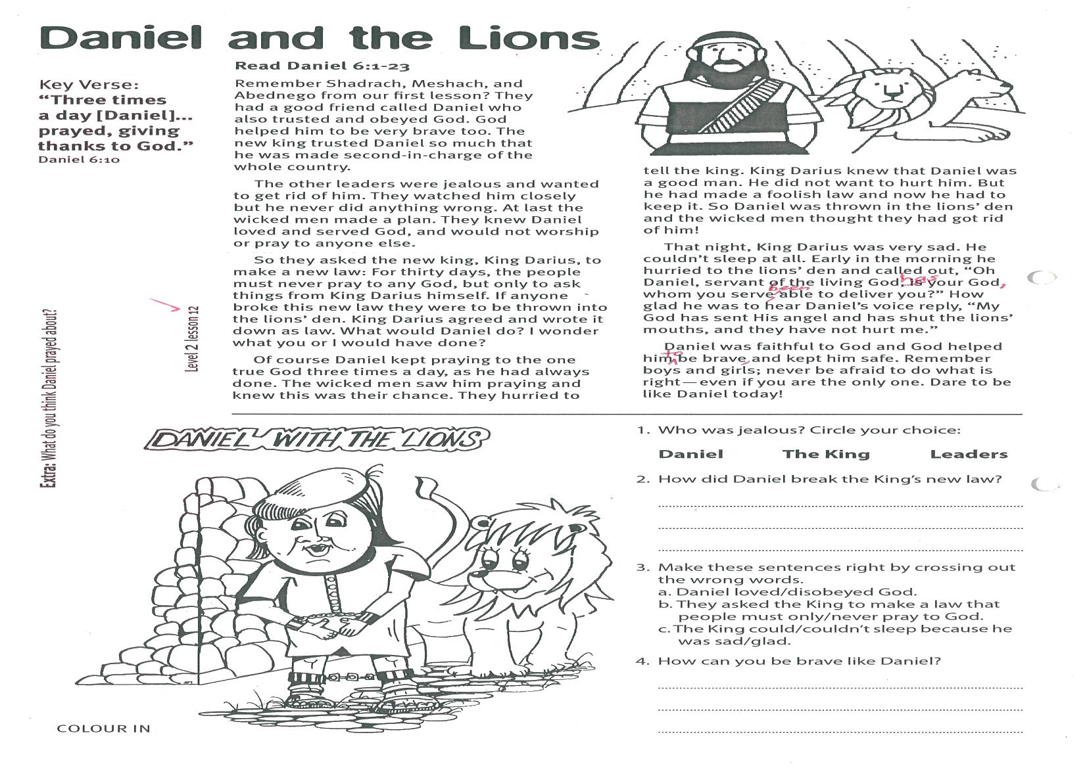

Please complete and return by post to   
**PSSM, 1-2A (G2) 93 Dominion Rd, Mt Eden, Auckland 1024** or scan & email to **info@biblediscovery.org.nz**

Daniel with the Lions  
[colour in]

knew this was their chance. They hurried to tell the king. King Darius knew that Daniel was a good man. He did not want to hurt him. But he had made a foolish law and now he had to keep it. So Daniel was thrown in the lions’ den and the wicked men thought they had got rid of him!

That night, King Darius was very sad. He couldn’t sleep at all. Early in the morning he hurried to the lions’ den and called out, “Oh Daniel, servant of the living God, has your God, whom you serve, been able to deliver you?” How glad he was to hear Daniel’s voice reply, “My God has sent His angel and has shut the lions’ mouths, and they have not hurt me.”

Daniel was faithful to God and God helped him to be brave and kept him safe. Remember boys and girls; never be afraid to do what is right - even if you are the only one. Dare to be like Daniel today!

1. Who was jealous? Circle your choice:

**Daniel The King Leaders**

2. How did Daniel break the King’s new law?

_________________________________________

3. Make these sentences right by crossing out the wrong words.

a. Daniel loved/disobeyed God.

b. They asked the King to make a law that people must only/never pray to God.

c. The King could/couldn’t sleep because he was sad/glad.

4. How can you be brave like Daniel?

________________________________________

________________________________________

**Extra:** What do you think Daniel prayed about?

Key Verse:  
**“Three times a day [Daniel]... prayed, giving thanks to God.”**  
Daniel 6:10

**Level 2 lesson 12**

**Read Daniel 6:1-23**

Remember Shadrach, Meshach, and Abednego from our first lesson? They had a good friend called Daniel who also trusted and obeyed God. God helped him to be very brave too. The new king trusted Daniel so much that he was made second-in-charge of the whole country.

The other leaders were jealous and wanted to get rid of him. They watched him closely but he never did anything wrong. At last the wicked men made a plan. They knew Daniel loved and served God, and would not worship or pray to anyone else.

So they asked the new king, King Darius, to make a new law: For thirty days, the people must never pray to any God, but only to ask things from King Darius himself. If anyone broke this new law they were to be thrown into the lions’ den. King Darius agreed and wrote it down as law. What would Daniel do? I wonder what you or I would have done?

Of course Daniel kept praying to the one true God three times a day, as he had always done. The wicked men saw him praying and

**Daniel and the Lions**