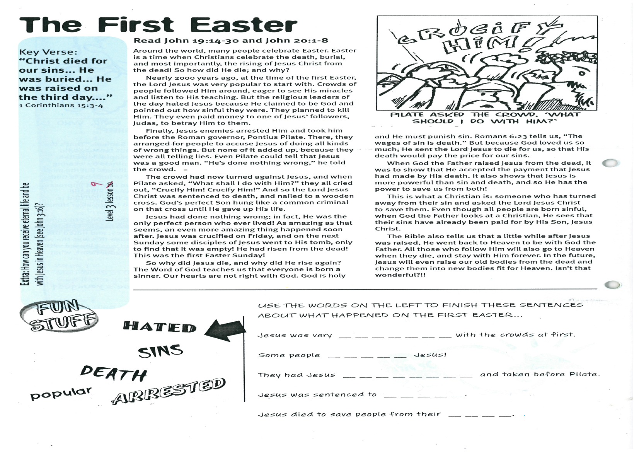

**Read John 19:14-30 and John 20:1-8**

Around the world, many people celebrate Easter. Easter is a time when Christians celebrate the death, burial, and most importantly, the rising of Jesus Christ from the dead! So how did He die; and why?

Nearly 2000 years ago, at the time of the first Easter, the Lord Jesus was very popular to start with. Crowds of people followed Him around, eager to see His miracles and listen to His teaching. But the religious leaders of the day hated Jesus because He claimed to be God and pointed out how sinful they were. They planned to kill Him. They even paid money to one of Jesus’ followers, Judas, to betray Him to them.

Finally, Jesus enemies arrested Him and took him before the Roman governor, Pontius Pilate. There, they arranged for people to accuse Jesus of doing all kinds of wrong things. But none of it added up, because they were all telling lies. Even Pilate could tell that Jesus was a good man. “He’s done nothing wrong,” he told the crowd.

The crowd had now turned against Jesus, and when Pilate asked, “What shall I do with Him?” they all cried out, “Crucify Him! Crucify Him!” And so the Lord Jesus Christ was sentenced to death, and nailed to a wooden cross. God’s perfect Son hung like a common criminal on that cross until He gave up His life.

Jesus had done nothing wrong; in fact, He was the only perfect person who ever lived! As amazing as that seems, an even more amazing thing happened soon after. Jesus was crucified on Friday, and on the next Sunday some disciples of Jesus went to His tomb, only to find that it was empty! He had risen from the dead! This was the first Easter Sunday!

**The First Easter**

Key Verse:  
**“Christ died for our sins... He was buried... He was raised on the third day....”**  
1 Corinthians 15:3-4

So why did Jesus die, and why did He rise again? The Word of God teaches us that everyone is born a sinner. Our hearts are not right with God. God is holy and He must punish sin. Romans 6:23 tells us, “The wages of sin is death.” But because God loved us so much, He sent the Lord Jesus to die for us, so that His death would pay the price for our sins.

When God the Father raised Jesus from the dead, it was to show that He accepted the payment that Jesus had made by His death. It also shows that Jesus is more powerful than sin and death, and so He has the power to save us from both!

This is what a Christian is: someone who has turned away from their sin and asked the Lord Jesus Christ to save them. Even though all people are born sinful, when God the Father looks at a Christian, He sees that their sins have already been paid for by His Son, Jesus Christ.

The Bible also tells us that a little while after Jesus was raised, He went back to Heaven to be with God the Father. All those who follow Him will also go to Heaven when they die, and stay with Him forever. In the future, Jesus will even raise our old bodies from the dead and change them into new bodies fit for Heaven. Isn’t that wonderful?!!

My Name is ……………………………………………………… Age…………………

HATED Sins

**DEATH**

Popular

arrested

USE THE WORDS ON THE LEFT TO FINISH THESE SENTENCES ABOUT WHAT HAPPENED ON THE FIRST EASTER...

Jesus was very __ __ __ __ __ __ __ with the crowds at first.

Some people __ __ __ __ __ Jesus!

They had Jesus __ __ __ __ __ __ __ __ and taken before Pilate.

Jesus was sentenced to __ __ __ __ __.

Jesus died to save people from their __ __ __ __.

**Level 3 lesson 9**

**Extra:** List How can you receive eternal life   
and be with Jesus in Heaven (see John 3:16)?

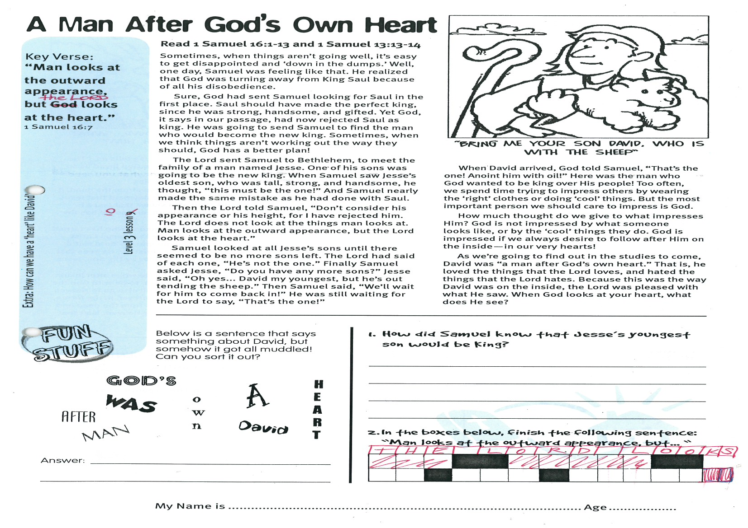

**A Man After God’s Own Heart**

**Read 1 Samuel 16:1-13 and   
1 Samuel 13:13-14**

Sometimes, when things aren’t going well, it’s easy to get disappointed and ‘down in the dumps.’ Well, one day, Samuel was feeling like that. He realized that God was turning away from King Saul because of all his disobedience.

Sure, God had sent Samuel looking for Saul in the first place. Saul should have made the perfect king, since he was strong, handsome, and gifted. Yet God, it says in our passage, had now rejected Saul as King. He was going to send Samuel to find the man who would become the new king. Sometimes, when we think things aren’t working out the way they should, God has a better plan!

The Lord sent Samuel to Bethlehem, to meet the family of a man named Jesse. One of his sons was going to be the new king. When Samuel saw Jesse’s oldest son, who was tall, strong, and handsome, he thought, “This must be the one!” And Samuel nearly made the same mistake as he had done with Saul.

Then the Lord told Samuel, “Don’t consider his appearance or his height, for I have rejected him. The LORD does not look at the things man looks at. Man looks at the outward appearance, but the LORD looks at the heart.”

Samuel looked at all Jesse’s sons until there seemed to be no more sons left. The Lord had said of each one, “He’s not the one.” Finally Samuel asked Jesse, “Do you have any more sons?” Jesse said, “Oh yes… David my youngest,

**Level 3 lesson 10**

Key Verse:  
**“Man looks at the outward appearance, but the Lord looks at the heart.”**1 Samuel 16:7

1. How did Samuel know that Jesse’s youngest son would be King?

_______________________________________

_______________________________________

_______________________________________

2. In the boxes below, finish the following sentence: “Man looks at the outward appearance, but... ”

|  |  |  |  |  |  |  |  |  |  |  |  |  |  |
| --- | --- | --- | --- | --- | --- | --- | --- | --- | --- | --- | --- | --- | --- |
| T | H | E |  | L | O | R | D |  | L | O | O | K | S |
|  |  |  |  |  |  |  |  |  |  |  |  |  |  |

Below is a sentence that says something about David, but somehow it got all muddled! Can you sort it out?

GOD’S AFTER

WAS A DAVID

HEART MAN OWN

Answer:

_______________________________________________

_______________________________________________

but he’s out tending the sheep.” Then Samuel said, “We’ll wait for him to come back in!” He was still waiting for the Lord to say, “That’s the one!”

When David arrived, God told Samuel, “That’s the one! Anoint him with oil!” Here was the man who God wanted to be king over His people! Too often, we spend time trying to impress others by wearing the ‘right’ clothes or doing ‘cool’ things. But the most important person we should care to impress is God.

How much thought do we give to what impresses Him? God is not impressed by what someone looks like, or by the ‘cool’ things they do. God is impressed if we always desire to follow after Him on the inside—in our very hearts!

As we’re going to find out in the studies to come, David was “a man after God’s own heart.” That is, he loved the things that the Lord loves, and hated the things that the Lord hates. Because this was the way David was on the inside, the Lord was pleased with what He saw. When God looks at your heart, what does He see?

**Extra:** How can we have a ‘heart’ like David?

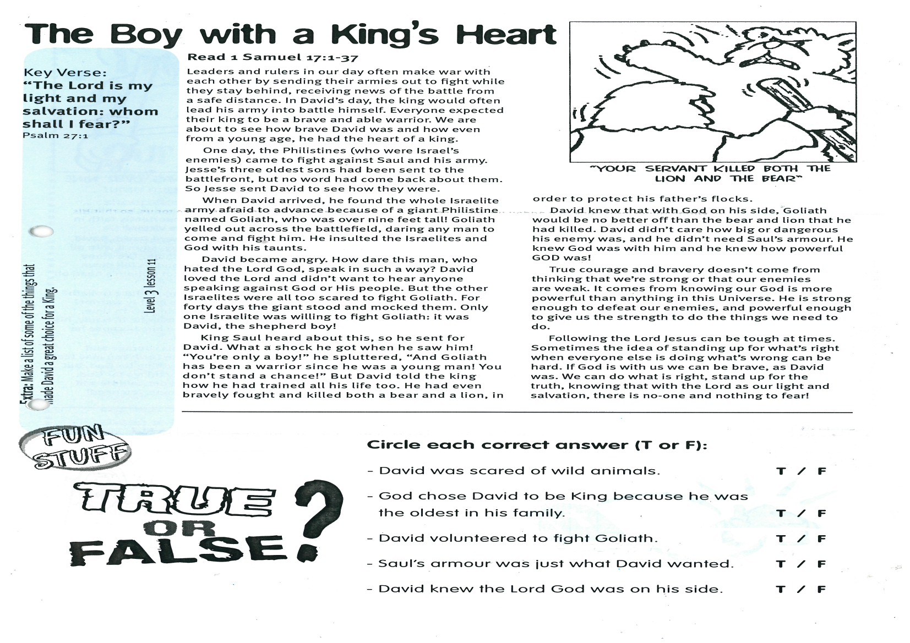

**Read 1 Samuel 17:1-37**

Leaders and rulers in our day often make war with each other by sending their armies out to fight while they stay behind, receiving news of the battle from a safe distance. In David’s day, the king would often lead his army into battle himself. Everyone expected their king to be a brave and able warrior. We are about to see how brave David was and how even from a young age, he had the heart of a king.

One day, the Philistines (who were Israel’s enemies) came to fight against Saul and his army. Jesse’s three oldest sons had been sent to the battlefront, but no word had come back about them. So Jesse sent David to see how they were.

When David arrived, he found the whole Israelite army afraid to advance because of a giant Philistine named Goliath, who was over nine feet tall! Goliath yelled out across the battlefield, daring any man to come and fight him. He insulted the Israelites and God with his taunts.

David became angry. How dare this man, who hated the Lord God, speak in such a way? David loved the Lord and didn’t want to hear anyone speaking against God or His people. But the other Israelites were all too scared to fight Goliath. For forty days the giant stood and mocked them. Only one Israelite was willing to fight Goliath: it was David, the shepherd boy!

King Saul heard about this, so he sent for David. What a shock he got when he saw him! “You’re only a boy!” he spluttered, “And Goliath has been a warrior since he was a young man! You don‘t stand a chance!” But David told the king how he had trained all his life too. He had even bravely fought and killed both a bear and a lion, in order to protect his father’s flocks.

Key Verse:  
**“The Lord is my light and my salvation: whom shall I fear?”**Psalm 27:1

**The Boy with a King’s Heart**

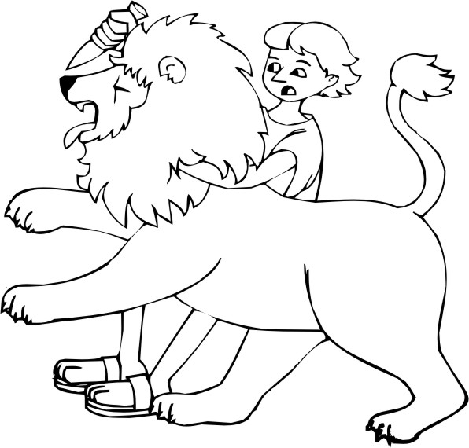

David knew that with God on his side, Goliath would be no better off than the bear and lion that he had killed. David didn’t care how big or dangerous his enemy was, and he didn’t need Saul’s armour. He knew God was with him and he knew how powerful GOD was!

True courage and bravery doesn’t come from thinking that we’re strong or that our enemies are weak. It comes from knowing our God is more powerful than anything in this Universe. He is strong enough to defeat our enemies, and powerful enough to give us the strength to do the things we need to do.

Following the Lord Jesus can be tough at times. Sometimes the idea of standing up for what’s right when everyone else is doing what’s wrong can be hard. If God is with us we can be brave, as David was. We can do what is right, stand up for the truth, knowing that with the Lord as our light and salvation, there is no-one and nothing to fear!

True

or

False?

**Circle each correct answer (T or F)**

- David was scared of wild animals. T/F

- God chose David to be King because   
he was the oldest in his family. T/F

- David volunteered to fight Goliath. T/F

- Saul’s armour was just what David wanted. T/F

- David knew the Lord God was on his side. T/F

**Extra: Make a list of some of the things that made David a great choice for a King.**

**Level 3 lesson 11**

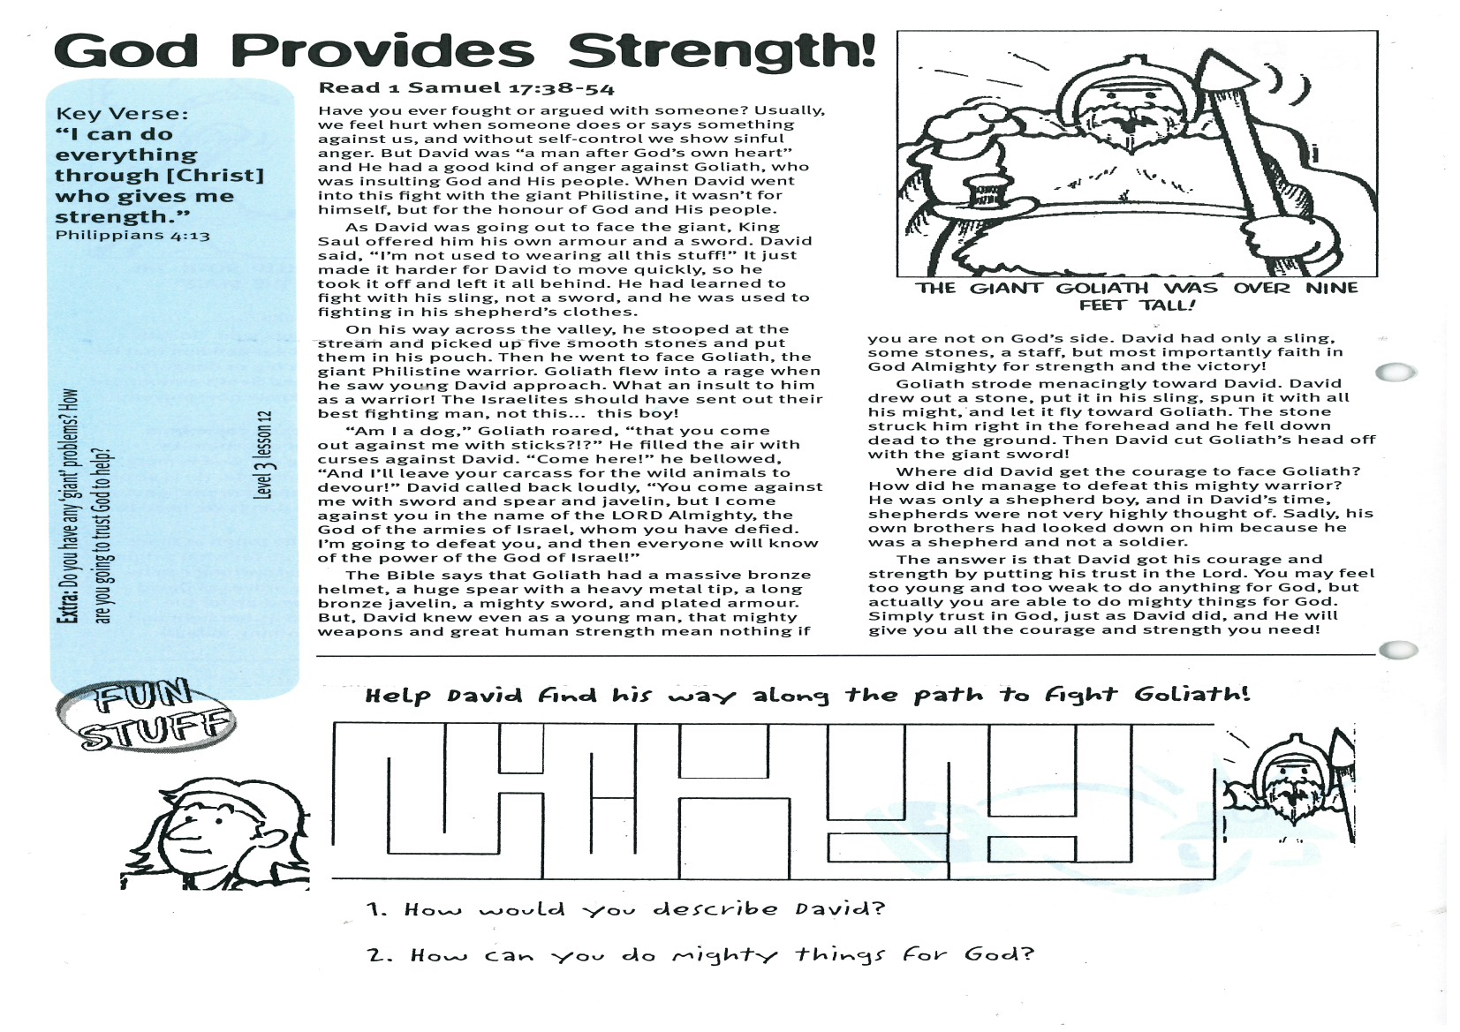

**Read 1 Samuel 17: 38-54**

Have you ever fought or argued with someone? Usually, we feel hurt when someone does or says something against us, and without self-control we show sinful anger. But David was “a man after God’s own heart” and He had a good kind of anger against Goliath, who was insulting God and His people. When David went into this fight with the giant Philistine, it wasn’t for himself, but for the honour of God and His people.

As David was going out to face the giant, King Saul offered him his own armour and a sword. David said, “I’m not used to wearing all this stuff!” It just made it harder for David to move quickly, so he took it off and left it all behind. He had learned to fight with his sling, not a sword, and he was used to fighting in his shepherd’s clothes.

On his way across the valley, he stooped at the stream and picked up five smooth stones and put them in his pouch. Then he went to face Goliath, the giant Philistine warrior. Goliath flew into a rage when he saw young David approach. What an insult to him as a warrior! The Israelites should have sent out their best fighting man, not this… this boy!

“Am I a dog,” Goliath roared, “that you come out against me with sticks?!?” He filled the air with curses against David. “Come here!” he bellowed, “And I’ll leave your carcass for the wild animals to devour!” David called back loudly, “You come against me with sword and spear and javelin, but I come against you in the name of the LORD Almighty, the God of the armies of Israel, whom you have defied. I’m going to defeat you, and then everyone will know of the power of the God of Israel!”

Key Verse:  
**“I can do everything through [Christ] who gives me strength.”**Philippians 4:13

**God Provides Strength!**

**Level 3 lesson 12**

Please complete and return by post to   
**PSSM, 1-2A (G2) 93 Dominion Rd, Mt Eden, Auckland 1024** or scan & email to **info@biblediscovery.org.nz**

**Answer:**

The Bible says that Goliath had a massive bronze helmet, a huge spear with a heavy metal tip, a long bronze javelin, a mighty sword, and plated armour. But, David knew even as a young man, that mighty weapons and great human strength mean nothing if you are not on God’s side. David had only a sling, some stones, a staff, but most importantly faith in God Almighty for strength and the victory!

Goliath strode menacingly toward David. David drew out a stone, put it in his sling, spun it with all his might, and let it fly toward Goliath. The stone struck him right in the forehead and he fell down dead to the ground. Then David cut Goliath’s head off with the giant sword!

Where did David get the courage to face Goliath? How did he manage to defeat this mighty warrior? He was only a shepherd boy, and in David’s time, shepherds were not very highly thought of. Sadly, his own brothers had looked down on him because he was a shepherd and not a soldier.

The answer is that David got his courage and strength by putting his trust in the Lord. You may *feel* too young and too weak to do anything for God, but actually you are able to do mighty things for God. Simply trust in God, just as David did, and He will give you all the courage and strength you need!

**Extra:** Do you have any ‘giant’ problems? How  
are you going to trust God to help?

Help David find his way along the path to fight Goliath!

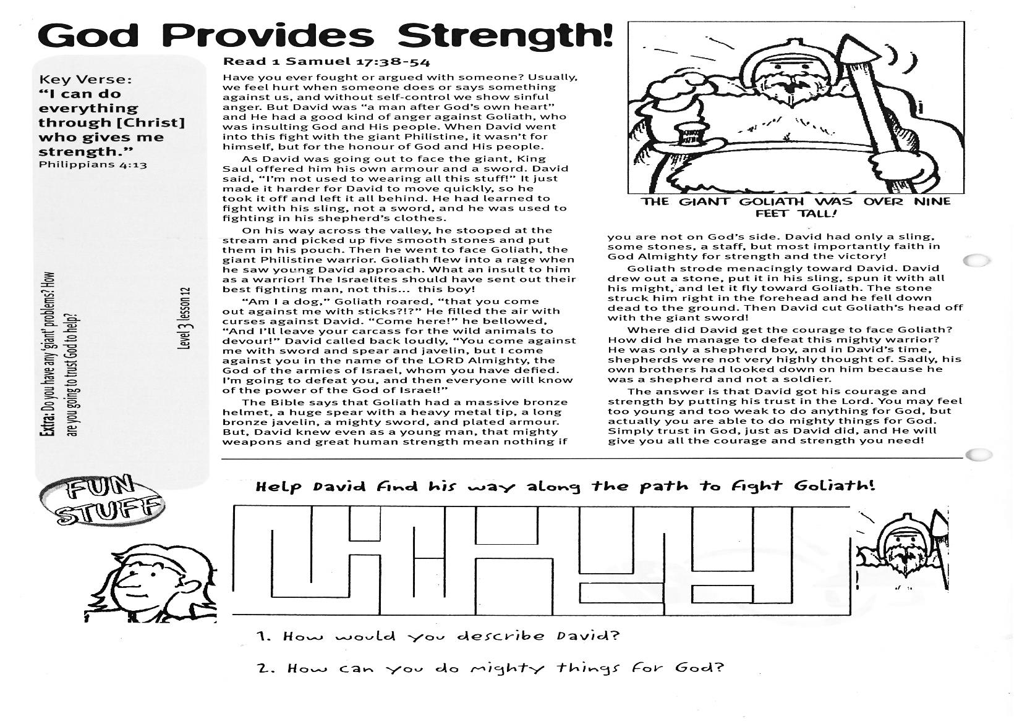

1. How would you describe David? __________________________________________________________________

_________________________________________________________________________________________________

2. How can you do mighty things for God? ___________________________________________________________  
_________________________________________________________________________________________________