Easter
Key Verse:
“He is not here; He has risen, just as He said.”
Matthew 28:6
Read Matthew 28:1-20 and Mark 16:14-18
As we celebrate Easter, let’s take a jump in time to the end of Jesus’ life on earth.
The last couple of days had been the most difficult, dark days in the lives of Jesus’ disciples. They had all thought that Jesus was the Messiah, but now they were simply confused and sad. They had seen Him arrested, falsely accused, beaten, and finally crucified. Now His body lay in a tomb (a cave-like grave), with a big stone rolled in front of the door.
As Sunday dawned, some of the women who had followed Jesus were preparing spices and perfumes to anoint His body as it lay in the tomb. As they walked along in the early dawn they asked each other, “Who will roll away the stone from the tomb?” However, while they were still on the way, God took care of it! He shook the garden with an earthquake and the Angel of the Lord came down and rolled back the stone from the door of the tomb!
The soldiers guarding the tomb were terrified and fainted in fear at such a sight. When the women entered the garden and saw the bright shining angels, they bowed down and trembled with fear too. But one of the angels said, “Don’t be afraid. I know that you came here looking for Jesus who was crucified. But don’t look for the living among the dead. Jesus is not here, He is RISEN! Don’t you remember, when you were still in Galilee, how He told you that sinful men were

going to crucify Him, and that on the third day He would rise again?” Then the ladies remembered the words of Jesus.
“Come and see the place where the Lord lay,” the angel continued, “then go quickly and tell His disciples and Peter that He is risen. Tell them that He will meet them in Galilee.” With their hearts almost bursting with excitement and joy, the ladies hurried to tell the other disciples. While they were still on their way to the city Jesus Himself met them and said, “Peace be with you.” The ladies knelt and worshipped Him. “Don’t be afraid,” said Jesus, “Go tell My disciples that I will see them in Galilee.”
Back at the tomb, the soldiers woke up and realised the tomb was empty! Boy, were they in trouble!! They ran back into the city and told Jesus’ enemies (the chief priests) what had happened. “When the angel rolled back the stone we saw that the tomb was empty,” they gasped. The chief priests thought for a while. Finally, they bribed the soldiers and told them to say that Jesus’ disciples had come and stolen His body.
What a foolish story! Although it defies all logic, there are some people who sadly still believe this today. But it was a real thrill for those who knew the truth, like the ladies and Jesus’ disciples, who discovered that their Lord was truly alive again. That’s why we use the word ‘Easter’ for this time of celebration and remembrance: it means ‘new life’!
By rising from the dead, Jesus showed that He had power over death. He really was “The Life” as He claimed in John 14:6. Now He offers that new life to all who believe in Him and accept Him as Saviour. Will you trust Him as YOUR Saviour? He longs to give you that new life too!


Level 3 lesson 1
Extra: See what you can find out by
reserching the subject of Easter
Level 4 lesson 9
Key Verse:
“Jesus said, ‘I tell you the truth, unless a man is born again, he cannot see the kingdom of God.’”
John 3:3
My Name is _____________________________________________ Age ___________

Sadness to Gladness!
Key Verse:
“[Jesus] asked him, ‘Do you want to get well?’”
John 5:6
Read John 5:1-15 and
Acts 5:12-16
After our joyful celebration of Easter, our studies in the life of Jesus continue with His visit in Jerusalem to the ‘Pool of Bethesda,’ which means “House of Mercy.” The Bible reading today indicates that people living in Jesus’ time believed that when the water in the pool was stirred up, then the first person to enter the pool would be healed. Therefore it was common for a great number of sick and crippled people to be waiting around the pool!
While Jesus was there, He noticed a man who had been a cripple for 38 years. Poor man! Every day, he just lay helplessly beside the pool, no doubt begging for money and food too. He had been paralysed almost all his life and had just about given up hope. This man knew he was helpless to get in the pool first, because he had no friends to carry him. He knew that others were able to move faster and so he would miss out.
Jesus, of course knew all about this poor man’s condition and hopeless situation. He felt so sorry for this lame man and so He approached him and asked, “Do you want to get well?” The crippled man looked up and saw Jesus standing by him. We can imagine that perhaps he wondered if this questioner was a helper or someone mocking him. “Sir, I have no-one to help me into the pool when the water is stirred” he answered, “while I am trying to get in someone else goes down ahead of me.”
Imagine his surprise at Jesus’ next words, “Stand up! Take up your mat and walk!” Imagine how much more shocked he must have been to feel a strange, new strength running through his legs! Obediently and joyfully, he picked up his mat and walked away, no doubt rejoicing with profuse thanks to this kind stranger. However, he soon found himself in unexpected trouble.
1. What did this man know about himself?
2. What did the Lord as the crippled man?
3. What did the Lord say that made the man well again? Fill in the vowels. | ST__ND __P T__K__ __P Y__ __ R M__T __ND W__LK
4. Why were the religious leaders furious?
5. In what ways are we like the crippled man?
Extra: What does this study teach you about Jesus?
Level 4 lesson 10
QUESTIONS & ANSWERS
The Jewish religious leaders saw this man carrying his mat and questioned him about it. They were angry because they had made a rule that people should not carry mats on the Sabbath day. At first, the man could not answer their questions as he didn’t know who had healed him, because after healing him, Jesus had simply disappeared into the crowd. But later, Jesus met him in the Temple and encouraged him. He reminded him that now he had been made well he must stop sinning and live for God!
When the religious leaders questioned him again later on, he told them it was Jesus who had healed him, and they were furious! These men did not really love and obey God from their hearts. They certainly did not believe Jesus’ claim to have come from God and to be equal with Him. But God is able to protect all who trust Him and he gave this man strength to stand up to the pressure from these leaders and to clearly testify the truth of the miracle.
In some ways we are like this crippled man. The Lord Jesus knows all about us too. He knows all our sins and sorrows. There is nothing hidden from His eyes. He knows that we are totally helpless to save ourselves from our sin. Only “He is able to save,” but we must first be willing for Him to save us. Unless we admit our need to be healed from sin, He will do nothing. Have you been saved? If so, you now belong to the Lord Jesus. Live for Him and be a witness to others by stopping your sinful ways and bad habits. Start showing that God is now in control of your life!

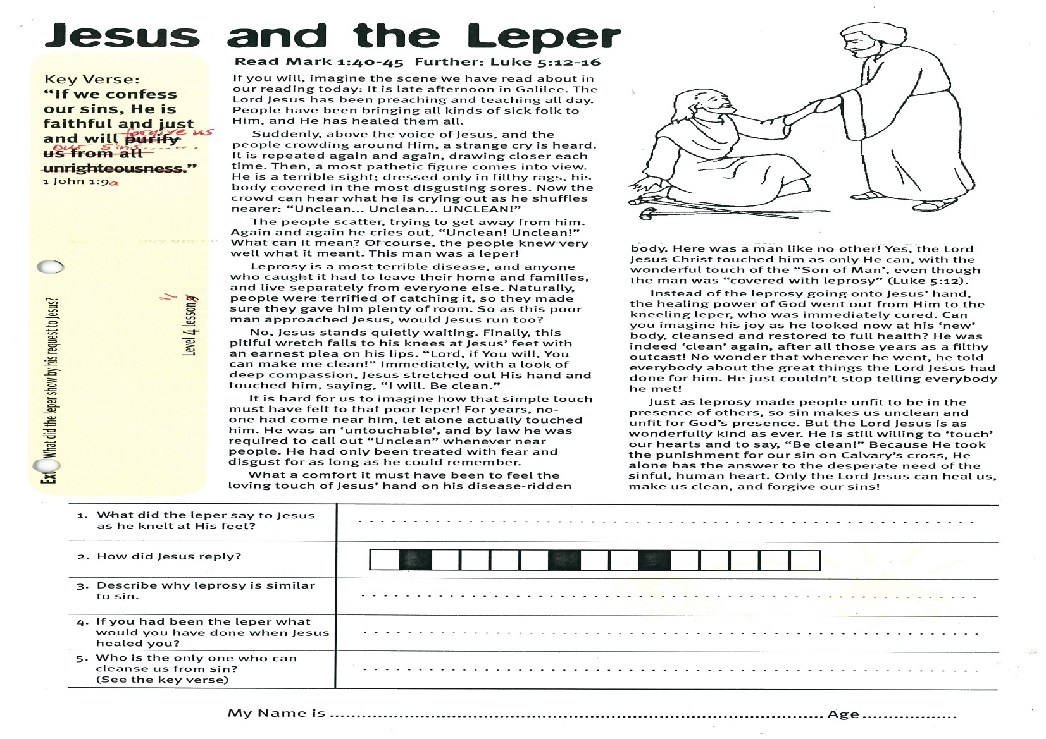
Jesus and the Leper
Key Verse:
“If we confess our sins, He is faithful and just and will forgive us our sins.”
I John 1:9
Read Mark 1:40-45
Further: Luke 5:12-16
If you will, imagine the scene we have read about in our reading today: It is late afternoon in Galilee. The Lord Jesus has been preaching and teaching all day. People have been bringing all kinds of sick folk to Him, and He has healed them all.
Suddenly, above the voice of Jesus, and the people crowding around Him, a strange cry is heard. It is repeated again and again, drawing closer each time. Then, a most pathetic figure comes into view. He is a terrible sight; dressed only in filthy rags, his body covered in the most disgusting sores. Now the crowd can hear what he is crying out as he shuffles nearer: “Unclean... Unclean... UNCLEAN!”
The people scatter, trying to get away from him. Again and again he cries out, “Unclean! Unclean!” What can it mean? Of course, the people knew very well what it meant. This man was a leper!
Leprosy is a most terrible disease, and anyone who caught it had to leave their home and families, and live separately from everyone else. Naturally, people were terrified of catching it, so they made sure they gave him plenty of room. So as this poor man approached Jesus, would Jesus run too?
No, Jesus stands quietly waiting. Finally, this pitiful wretch falls to his knees at Jesus’ feet with an earnest plea on his lips. “Lord, if You will, You can make me clean!” Immediately, with a look of deep compassion, Jesus stretched out His hand and touched him, saying, “I will. Be clean.”
It is hard for us to imagine how that simple touch must have felt to that poor leper! For years, no-one had come near him, let alone actually touched him. He was an ‘untouchable’, and by law he was required to call out “Unclean” whenever near people. He had only been treated with fear and disgust for as long as he could remember.

1. What did the leper say to Jesus as he knelt at His feet?
2. How did Jesus reply?

3. Describe why leprosy is similar to sin?
4. If you had been the leper what would you have done when Jesus healed you?

5. Who is the only one who can cleanse us from sin? (see the key verse)
Extra: What did the leper show by his request to Jesus?
Level 4 lesson 11
QUESTIONS & ANSWERS
What a comfort it must have been to feel the loving touch of Jesus’ hand on his disease-ridden body. Here was a man like no other! Yes, the Lord Jesus Christ touched him as only He can, with the wonderful touch of the “Son of Man’, even though the man was “covered with leprosy” (Luke 5:12).
Instead of the leprosy going onto Jesus’ hand, the healing power of God went out from Him to the kneeling leper, who was immediately cured. Can you imagine his joy as he looked now at his ‘new’ body, cleansed and restored to full health? He was indeed ‘clean’ again, after all those years as a filthy outcast! No wonder that wherever he went, he told everybody about the great things the Lord Jesus had done for him. He just couldn’t stop telling everybody he met!
Just as leprosy made people unfit to be in the presence of others, so sin makes us unclean and unfit for God’s presence. But the Lord Jesus is as wonderfully kind as ever. He is still willing to ‘touch’ our hearts and to say, “Be clean!” Because He took the punishment for our sin on Calvary’s cross, He alone has the answer to the desperate need of the sinful, human heart. Only the Lord Jesus can heal us, make us clean, and forgive our sins!

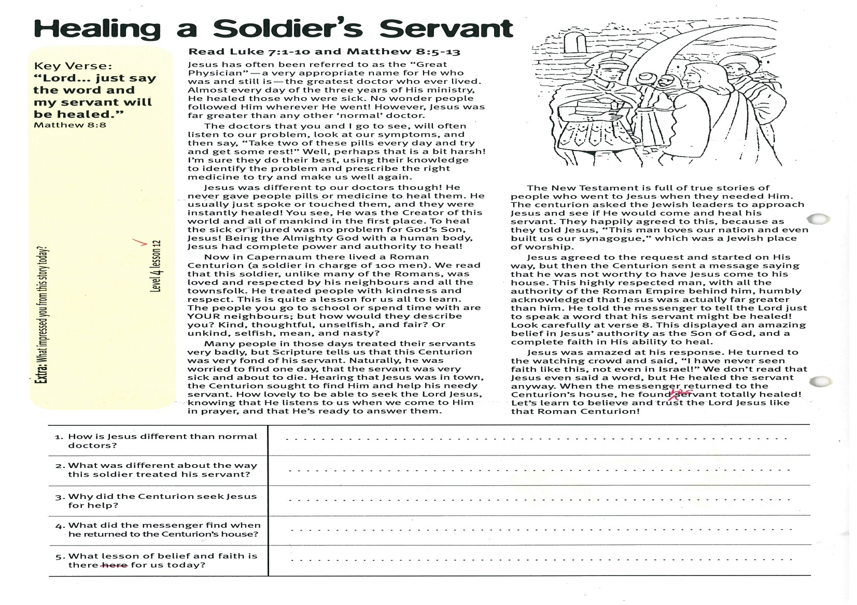
Healing a Soldier’s Servant
Key Verse:
“Lord…. just say the word and my servant will be healed.”
Matthews 8:8
Read Luke 7:1-10 and Matthew 8:5-13
Jesus has often been referred to as the “Great Physician” (a very appropriate name for He who was and still is, the greatest doctor who ever lived). Almost every day of the three years of His ministry, He healed those who were sick. No wonder people followed Him wherever He went! However, Jesus was far greater than any other ‘normal’ doctor.
The doctors that you and I go to see, will often listen to our problem, look at our symptoms, and then say, “Take two of these pills every day and try and get some rest!” Well, perhaps that is a bit harsh! I’m sure they do their best, using their knowledge to identify the problem and prescribe the right medicine to try and make us well again.
Jesus was different to our doctors though! He never gave people pills or medicine to heal them. He usually just spoke or touched them, and they were instant healed! You see, He was the Creator of this world and all of mankind in the first place. To heal the sick or injured was no problem for God’s Son, Jesus! Being the Almighty God with a human body, Jesus had complete power and authority to heal!
Now in Capernaum there lived a Roman Centurion (a soldier in charge of 100 men). We read that this soldier, unlike many of the Romans, was loved and respected by his neighbours and all the townsfolk. He treated people with kindness and respect. This is quite a lesson for us all to learn. The people you go to school or spend time with are YOUR neighbours; but how would they describe you? Kind, thoughtful, unselfish, and fair? Or unkind, selfish, mean, and nasty?
Many people in those days treated their servants very badly, but Scripture tells us that this Centurion was very fond of his servant. Naturally, he was

1. How is Jesus different than normal doctors?
2. What was different about the way the soldier treated his servant?
3. Why did the Centurion seek Jesus for help?

4. What did the messenger find when he returned to the Centurions house?
5. What lesson of belief and faith is there for us today?
Please complete and return by post to
PSSM, 1-2A (G2) 93 Dominion Rd, Mt Eden, Auckland 1024 or scan & email to info@biblediscovery.org.nz

Extra: What impressed you from this story today?
Level 4 lesson 12
QUESTIONS & ANSWERS
worried to find one day, that the servant was very sick and about to die. Hearing that Jesus was in town, the Centurion sought to find Him and help his needy servant. How lovely to be able to seek the Lord Jesus, knowing that He listens to us when we come to Him in prayer, and that He’s ready to answer them.
The New Testament is full of true stories of people who went to Jesus when they needed Him. The centurion asked the Jewish leaders to approach Jesus and see if He would come and heal his servant. They happily agreed to this, because as they told Jesus, “This man loves our nation and even built us our synagogue,” which was a Jewish place of worship.
Jesus agreed to the request and started on His way, but then the Centurion sent a message saying that he was not worthy to have Jesus come to his house. This highly respected man, with all the authority of the Roman Empire behind him, humbly acknowledged that Jesus was actually far greater than him. He told the messenger to tell the Lord just to speak a word that his servant might be healed! Look carefully at verse 8. This displayed an amazing belief in Jesus’ authority as the Son of God, and a complete faith in His ability to heal.
Jesus was amazed at his response. He turned to the watching crowd and said, “I have never seen faith like this, not even in Israel!” We don’t read that Jesus even said a word, but He healed the servant anyway. When the messenger returned to the Centurion’s house, he found his servant totally healed! Let’s learn to believe and trust the Lord Jesus like that Roman Centurion!

