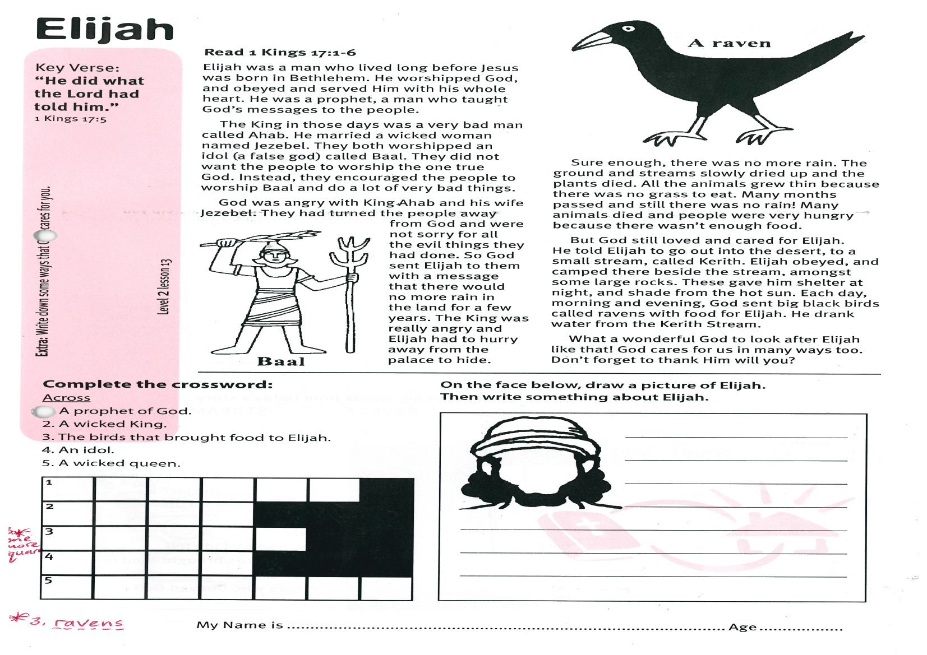

**Read 1 Kings 17:1-6**

Elijah was a man who lived long before Jesus was born in Bethlehem. He worshipped God, and obeyed and served Him with his whole heart. He was a prophet, a man who taught God’s messages to the people.

The King in those days was a very bad man called Ahab. He married a wicked woman named Jezebel. They both worshipped an idol (a false god) called Baal. They did not want the people to worship the one true God. Instead, they encouraged the people to worship Baal and do a lot of very bad things.

God was angry with King Ahab and his wife Jezebel. They had turned the people away from God and were not sorry for all the evil things they had done. So God sent Elijah to them with a message  
 that there would no   
more rain in the land   
for a few years. The   
King was really angry   
and Elijah had to hurry   
away from the palace   
to hide.

Key Verse:  
**“He did what the Lord had told him.”**  
1 Kings 17:5

**Elijah**

|  |  |  |  |  |  |  |
| --- | --- | --- | --- | --- | --- | --- |
| 1 |  |  |  |  |  |  |
| 2 |  |  |  |  |  |  |
| 3 |  |  |  |  |  |  |
| 4 |  |  |  |  |  |  |
| 5 |  |  |  |  |  |  |



**Complete the crossword:**

Across  
1. A prophet of God.  
2. A wicked King.  
3. The birds that brought food to Elijah.  
4. An idol.  
5. A wicked queen

**On the face below, draw a picture of Elijah.**  
**Then write something about Elijah.**

_______________________

_______________________

_______________________

_______________________

___________________________________________

___________________________________________

___________________________________________

Sure enough, there was no more rain. The ground and streams slowly dried up and the plants died. All the animals grew thin because there was no grass to eat. Many months passed and still there was no rain! Many animals died and people were very hungry because there wasn’t enough food.

But God still loved and cared for Elijah. He told Elijah to go out into the desert, to a small stream, called Kerith. Elijah obeyed, and camped there beside the stream, amongst some large rocks. These gave him shelter at night, and shade from the hot sun. Each day, morning and evening, God sent big black birds called ravens with food for Elijah. He drank water from the Kerith Stream.

What a wonderful God to look after Elijah like that! God cares for us in many ways too. Don’t forget to thank Him will you?

**Level 2 lesson 13**

**Extra:** Write down some ways that God cares for you.

My Name is________________________________________ Age ______________

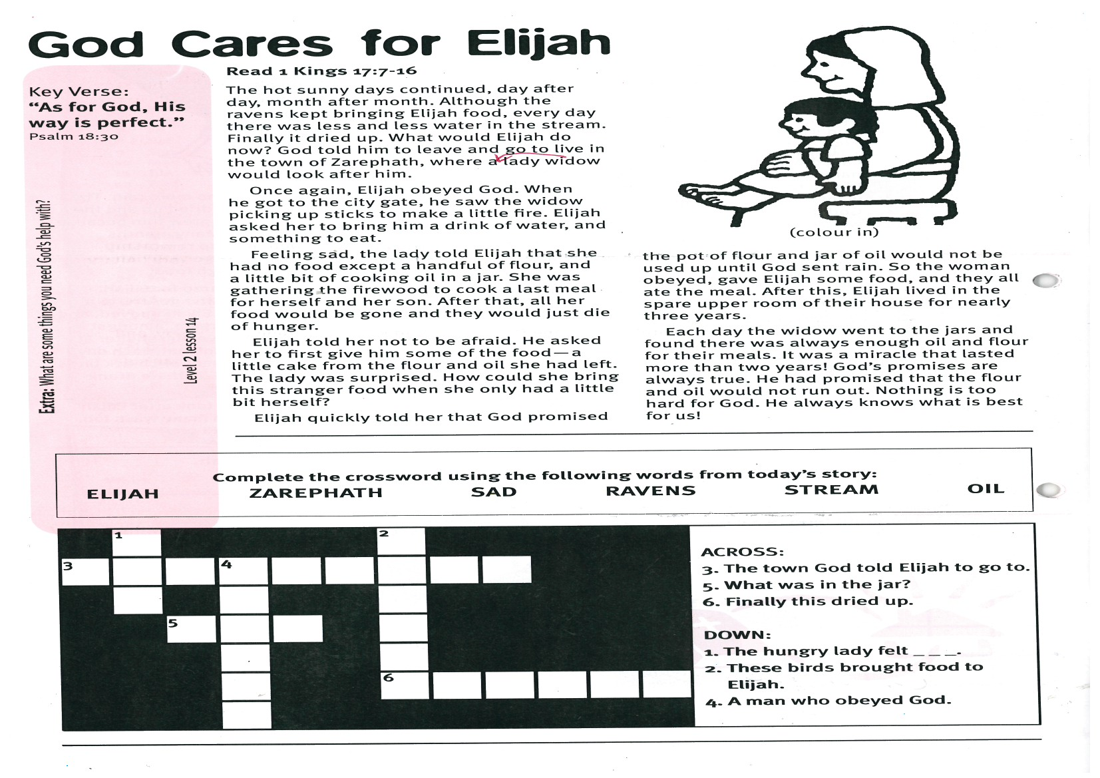

**God Cares for Elijah**

**Read 1 Kings 17:7-16**

The hot sunny days continued, day after day, month after month. Although the ravens kept bringing Elijah food, every day there was less and less water in the stream. Finally it dried up. What would Elijah do now? God told him to leave and go to live in the town of Zarephath, where a widow lady would look after him.

Once again, Elijah obeyed God. When he got to the city gate, he saw the widow picking up sticks to make a little fire. Elijah asked her to bring him a drink of water, and something to eat.

Feeling sad, the lady told Elijah that she had no food except a handful of flour, and a little bit of cooking oil in a jar. She was gathering the firewood to cook a last meal for herself and her son. After that, all her food would be gone and they would just die of hunger.

Elijah told her not to be afraid. He asked her to first give him some of the food - a little cake from the flour and oil she had

Key Verse:  
**“As for God, His way is perfect”**  
Psalm 18:30

|  |  |  |  |  |  |  |  |  |  |  |  |
| --- | --- | --- | --- | --- | --- | --- | --- | --- | --- | --- | --- |
|  | 1 |  |  |  |  | 2 |  |  |  |  |  |
| 3 |  |  | 4 |  |  |  |  |  |  |  |  |
|  |  |  |  |  |  |  |  |  |  |  |  |
|  |  | 5 |  |  |  |  |  |  |  |  |  |
|  |  |  |  |  |  |  |  |  |  |  |  |
|  |  |  |  |  |  | 6 |  |  |  |  |  |
|  |  |  |  |  |  |  |  |  |  |  |  |

left. The lady was surprised. How could she bring this stranger food when she only had a little bit herself?

Elijah quickly told her that God promised the pot of flour and jar of oil would not be used up until God sent rain. So the woman obeyed, gave Elijah some food, and they all ate the meal. After this, Elijah lived in the spare upper room of their house for nearly three years.

Each day the widow went to the jars and found there was always enough oil and flour for their meals. It was a miracle that lasted more than two years! God’s promises are always true. He had promised that the flour and oil would not run out. Nothing is too hard for God. He always knows what is best for us!

Complete the crossword using the following words from today’s story:

ELIJAH ZAREPHATH SAD RAVENS STREAM OIL

ACROSS:

3. The town God told Elijah to go to.

5. What was in the jar?

6. Finally this dried up.

DOWN:

1. The hungry lady felt _ _ _.

2. These birds brought food to Elijah.

4. A man who obeyed God.

**Level 2 lesson 14**

**Extra:** What are some things you need God’s help with?

**The Great Contest**

So Elijah built an altar with 12 big stones and made his sacrifice ready on it. To prove it wasn’t a trick, he dug a trench around the altar and poured water over and around the altar. He did this until the trench was full and everything was soaking wet.

Then Elijah prayed, asking God to prove that He really was God. Straight away God sent down powerful fire and it burned up the sacrifice, the stone altar, and even the soil and water in the trench!

The people bowed down and worshipped God, saying, “The Lord, He is God!” All the wicked men of Baal were then punished with death. Then Elijah told King Ahab to hurry home for heavy rain was coming. After all those years of no rain, the rain really came!

God kept His promises that day, and He still keeps His promises today. God is as powerful today as He was in Elijah’s day. Isn’t that great!

**Read 1 Kings 18:17-46**

The terrible drought continued throughout the land, but still King Ahab would not repent or worship God. He and Jezebel continued to worship Baal and encouraged many of the Israelites to do the same. Finally, God told Elijah to challenge King Ahab to a contest on the top of Mt. Carmel.

The priests of Baal would make an altar and prepare an offering ready for sacrifice. Elijah would do the same. “Then let us each call on the name of our God,” said Elijah, “We will prove who is God by the one that sends down fire.” King Ahab and all the people agreed.

So, the followers of Baal prepared the sacrifice on their altar. Then they prayed and cried out to Baal to send fire down from heaven to burn it up. Nothing happened! For hours they pleaded with Baal to do something. But nothing happened because Baal was just a man-made idol.

Key Verse:  
**“The Lord, He is God.”**  
1 Kings 18:39

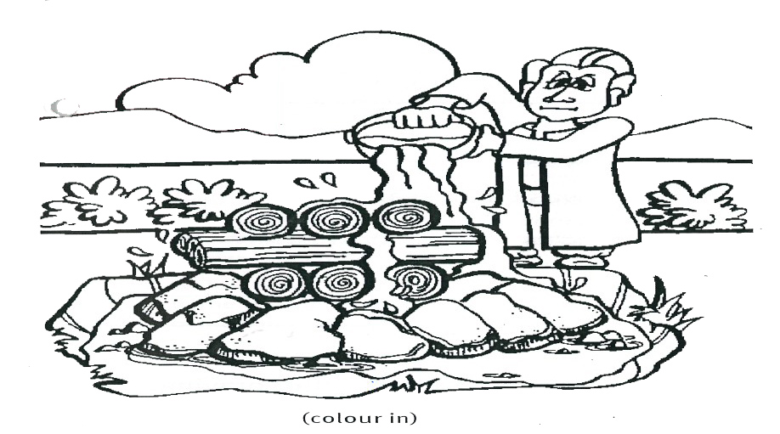

1. Why did nothing happen to Ahab’s altar?

___________________________________

___________________________________

2. Why did Elijah pour water on his altar?

___________________________________

__________________________________

__________________________________

3. What does this story show?

___________________________________

__________________________________

__________________________________

**Extra:** What does today’s Key Verse mean?

**Level 2 lesson 15**

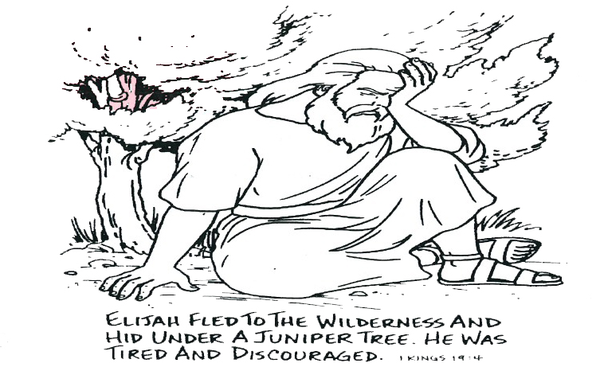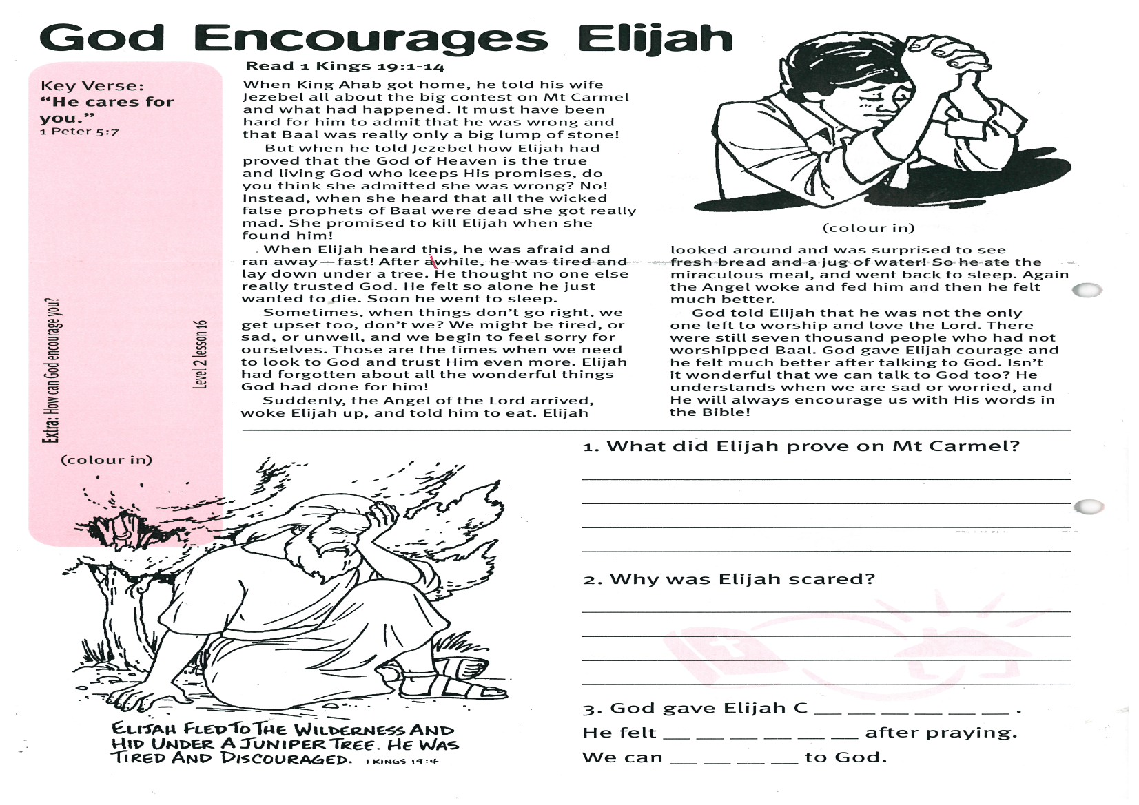

(colour in)

1. What did Elijah prove on Mt Carmel?

___________________________________

___________________________________

2. Why was Elijah scared?

___________________________________

__________________________________

__________________________________

3. God gave Elijah C __ __ __ __ __ __ .

He felt __ __ __ __ __ __ after praying.

We can __ __ __ __ to God.

**Read 1 Kings 19:1-14**

When King Ahab got home, he told his wife Jezebel all about the big contest on Mt Carmel and what had happened. It must have been hard for him to admit that he was wrong and that Baal was really only a big lump of stone!

But when he told Jezebel how Elijah had proved that the God of Heaven is the true and living God who keeps His promises, do you think she admitted she was wrong? No! Instead, when she heard that all the wicked false prophets of Baal were dead she got really mad. She promised to kill Elijah when she found him!

When Elijah heard this, he was afraid and ran away - fast! After a while, he was tired and lay down under a tree. He thought no one else really trusted God. He felt so alone he just wanted to die. Soon he went to sleep.

Sometimes, when things don’t go right, we get upset too, don’t we? We might be tired, or sad, or unwell, and we begin to feel sorry for ourselves. Those are the times when we need to look to God and trust Him even

more. Elijah had forgotten about all the wonderful things God had done for him!

Suddenly, the Angel of the Lord arrived, woke Elijah up, and told him to eat. Elijah looked around and was surprised to see fresh bread and a jug of water! So he ate the miraculous meal, and went back to sleep. Again the Angel woke and fed him and then he felt much better.

God told Elijah that he was not the only one left to worship and love the Lord. There were still seven thousand people who had not worshipped Baal. God gave Elijah courage and he felt much better after talking to God. Isn’t it wonderful that we can talk to God too? He understands when we are sad or worried, and He will always encourage us with His words in the Bible!

**Extra:** How can God encourage you?

**Level 2 lesson 16**

Key Verse:  
**“He cares for you.”**  
1 Peter 5:7

Please complete and return by post to   
**PSSM, 1-2A (G2) 93 Dominion Rd, Mt Eden, Auckland 1024** or scan & email to **info@biblediscovery.org.nz**

**God Encourages Elijah**