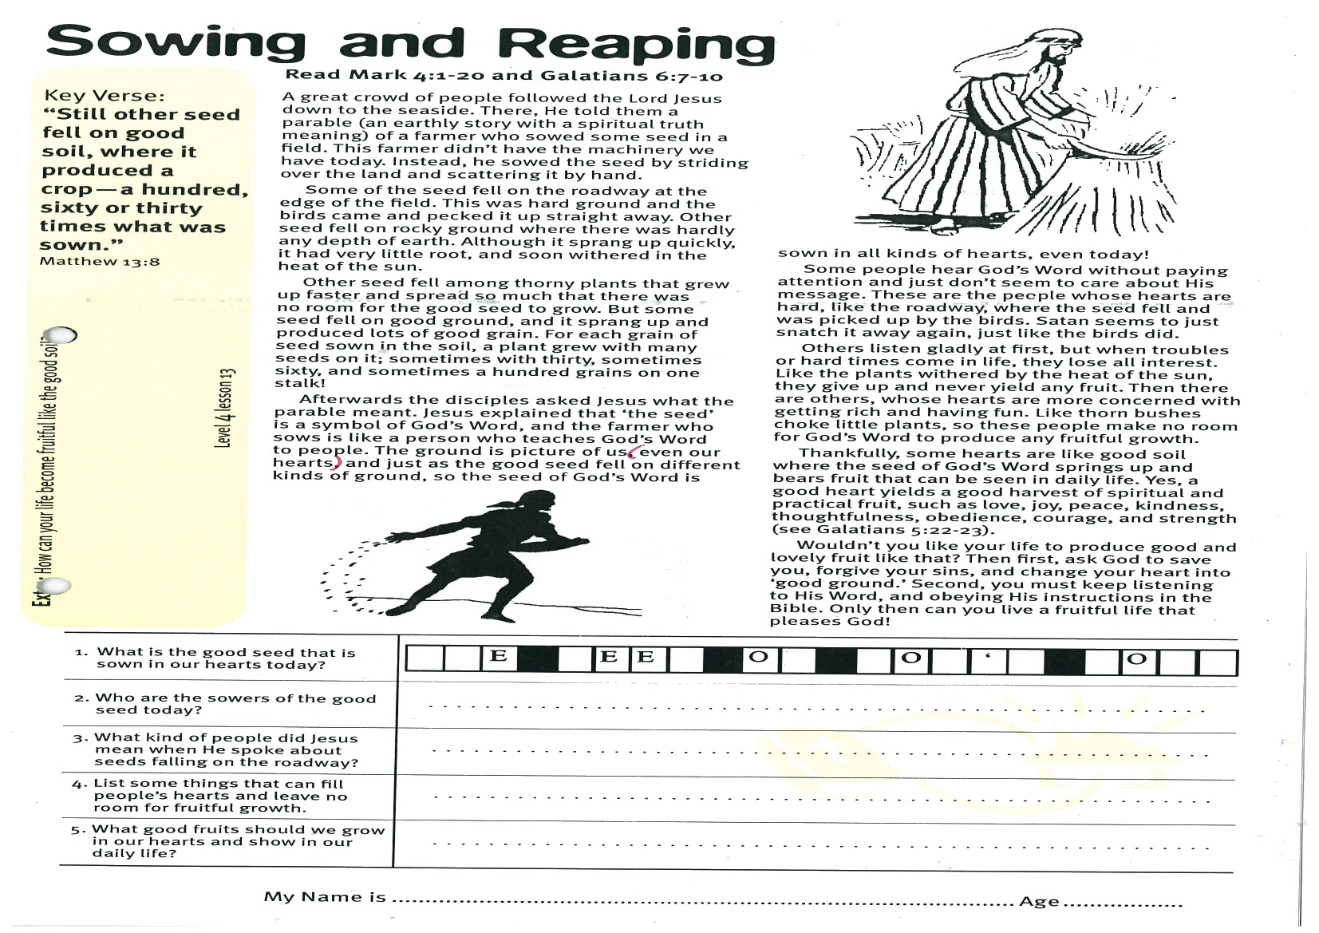
Sowing and Reaping
Key Verse:
“Still other seed fell on good soil, where it produced a crop - a hundred, sixty or thirty times what was sown.”
Matthew 13:8
Read Mark 4:1-20 and
Galatians 6:7-10
A great crowd of people followed the Lord Jesus down to the seaside. There, He told them a parable (an earthly story with a spiritual truth meaning) of a farmer who sowed some seed in a field. This farmer didn’t have the machinery we have today. Instead, he sowed the seed by striding over the land and scattering it by hand.
Some of the seed fell on the roadway at the edge of the field. This was hard ground and the birds came and pecked it up straight away. Other seed fell on rocky ground where there was hardly any depth of earth. Although it sprang up quickly, it had very little root, and soon withered in the heat of the sun.
Other seed fell among thorny plants that grew up faster and spread so much that there was no room for the good seed to grow. But some seed fell on good ground, and it sprang up and produced lots of good grain. For each grain of seed sown in the soil, a plant grew with many seeds on it; sometimes with thirty, sometimes sixty, and sometimes a hundred grains on one stalk!
Afterwards the disciples asked Jesus what the parable meant. Jesus explained that ‘the seed’ is a symbol of
God’s Word,
and the farmer
who sows is
like a person
who teaches
God’s Word to
people. The
ground is
picture of us
(even our hearts)
1. What is the good seed that is sown in our hearts today? | __ __ E __ E E __ O__ __ O __ ‘ __ __ O __ __
2. Who are the sowers of the good seed today?
3. What kind of people did Jesus mean when He spoke about seeds falling on the roadway?
4. List some things that can fill people’s hearts and leave no room for fruitful growth.
5. What good fruits should we grow in our hearts and show in our daily life?
Level 3 lesson 1
Extra: How can your life become fruitful
like the good soil?
Level 4 lesson 13
QUESTIONS & ANSWERS
Key Verse:
“Jesus said, ‘I tell you the truth, unless a man is born again, he cannot see the kingdom of God.’”
John 3:3
and just as the good seed fell on different kinds of ground, so the seed of God’s Word is sown in all kinds of hearts, even today!
Some people hear God’s Word without paying attention and just don’t seem to care about His message. These are the people whose hearts are hard, like the roadway, where the seed fell and was picked up by the birds. Satan seems to just snatch it away again, just like the birds did.
Others listen gladly at first, but when troubles or hard times come in life, they lose all interest. Like the plants withered by the heat of the sun, they give up and never yield any fruit. Then there are others, whose hearts are more concerned with getting rich and having fun. Like thorn bushes choke little plants, so these people make no room for God’s Word to produce any fruitful growth.
Thankfully, some hearts are like good soil where the seed of God’s Word springs up and bears fruit that can be seen in daily life. Yes, a good heart yields a good harvest of spiritual and practical fruit, such as love, joy, peace, kindness, thoughtfulness, obedience, courage, and strength (see Galatians 5:22-23).
Wouldn’t you like your life to produce good and lovely fruit like that? Then first, ask God to save you, forgive your sins, and change your heart into ‘good ground.’ Second, you must keep listening to His Word, and obeying His instructions in the Bible. Only then can you live a fruitful life that pleases God!

My Name is _____________________________________________ Age ___________
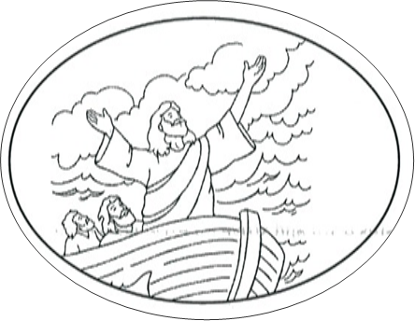
Jesus Calms the Storm
Key Verse:
“You will keep in perfect peace him whose mind is steadfast, because he trusts in You’”
Isaiah 26:3
1. What happened when Jesus and his disciples were crossing the lake?
2. What did the disciples say to Jesus when they awakened Him?
3. What did Jesus say to the sea? Unscramble: | P B S E E T A I C L E L
4. If you had been there when Jesus spoke to the wind and sea, what would you have thought?
5. What are some of the storms we meet in life?
Extra: Make a list for yourself of some things you need Jesus’ help with. Talk to Him about them.
Level 4 lesson 14
QUESTIONS & ANSWERS
Read Mark 4:35-41 and Matthew 8:23-27
Whenever Jesus preached, people listened because they were eager to hear what He taught. Of course, many who needed to be healed of some problem or sickness also flocked around Him wherever He preached. One day, the Lord Jesus had been speaking to a huge crowd on the shores of Lake Galilee. The crowd was so big that He stood in a little fishing boat belonging to one of His disciples, and taught the people from there.
How wonderful it would be to have been there, listening to Jesus teach God’s truth! Thankfully, lots of the things Jesus said and did have been recorded for us in the first four books of the New Testament. These are the Gospels of Matthew, Mark, Luke, and John, and we can learn much as we study them together.
When evening came, Jesus asked His disciples to row Him across to the other side of the lake. So they sent the crowd of people back to their homes and set off. However, after the disciples had been rowing for a while, a very strong wind sprang up. Before long a terrific storm was raging! The waves were enormous, breaking right over the boat at times and threatening to swamp it. Even the disciples who had been in lots of storms, thought they were about to sink!
Frantically, they tried to continue rowing and baling out the water, but it was useless. The water was coming in faster than they could cope with. Terrified, the disciples suddenly remembered Jesus. Looking around, they saw Him in the back of the boat - sound asleep! Of course, He’d had a very tiring day preaching to the great crowd of people, and He was exhausted. But how could Jesus be asleep at a time like this, they wondered?!! Didn’t He realise the danger they were all in?

Waking Jesus up, they yelled loudly, “Master, don’t You care that we are nearly drowning?” Jesus stood up and rebuked the wind and sea in a loud voice, “Peace, be still!” What a change! One minute it was blowing a terrific gale, tossing the little boat around on the raging sea, and then next, there was a great calm! Jesus stopped the wind, and the sea became smooth and flat. The disciples were amazed! Looking at one another they said, “What kind of man is this? Even the wind and the waves obey Him!”
Remember that nothing is too hard for the Lord Jesus. Nothing is too small or too big. He is Lord over all! Jesus said to His disciples, “Why were you so afraid? How is it that you have no faith?” Sometimes we think that the disciples were very slow to understand how safe they always were when Jesus was with them. Yet, there are boys and girls who are afraid of storms, wind, lightning, and very often of the dark.
Then there are stormy times in life too. We often face the stormy trials of temptation, sadness, and disappointment. Or even times of turmoil with poor health, disasters, war, or the death of loved ones. Remember, Jesus is the One who can calm all storms, or help us get through them. We must TRUST THAT JESUS IS ALL POWERFUL and will do what is best for us - even if that means He allows us to endure some storms in life (see Romans 8:18, 28, & 38-39)! Only He can take away all our fear, if we will first trust in Him and pray for help and strength.

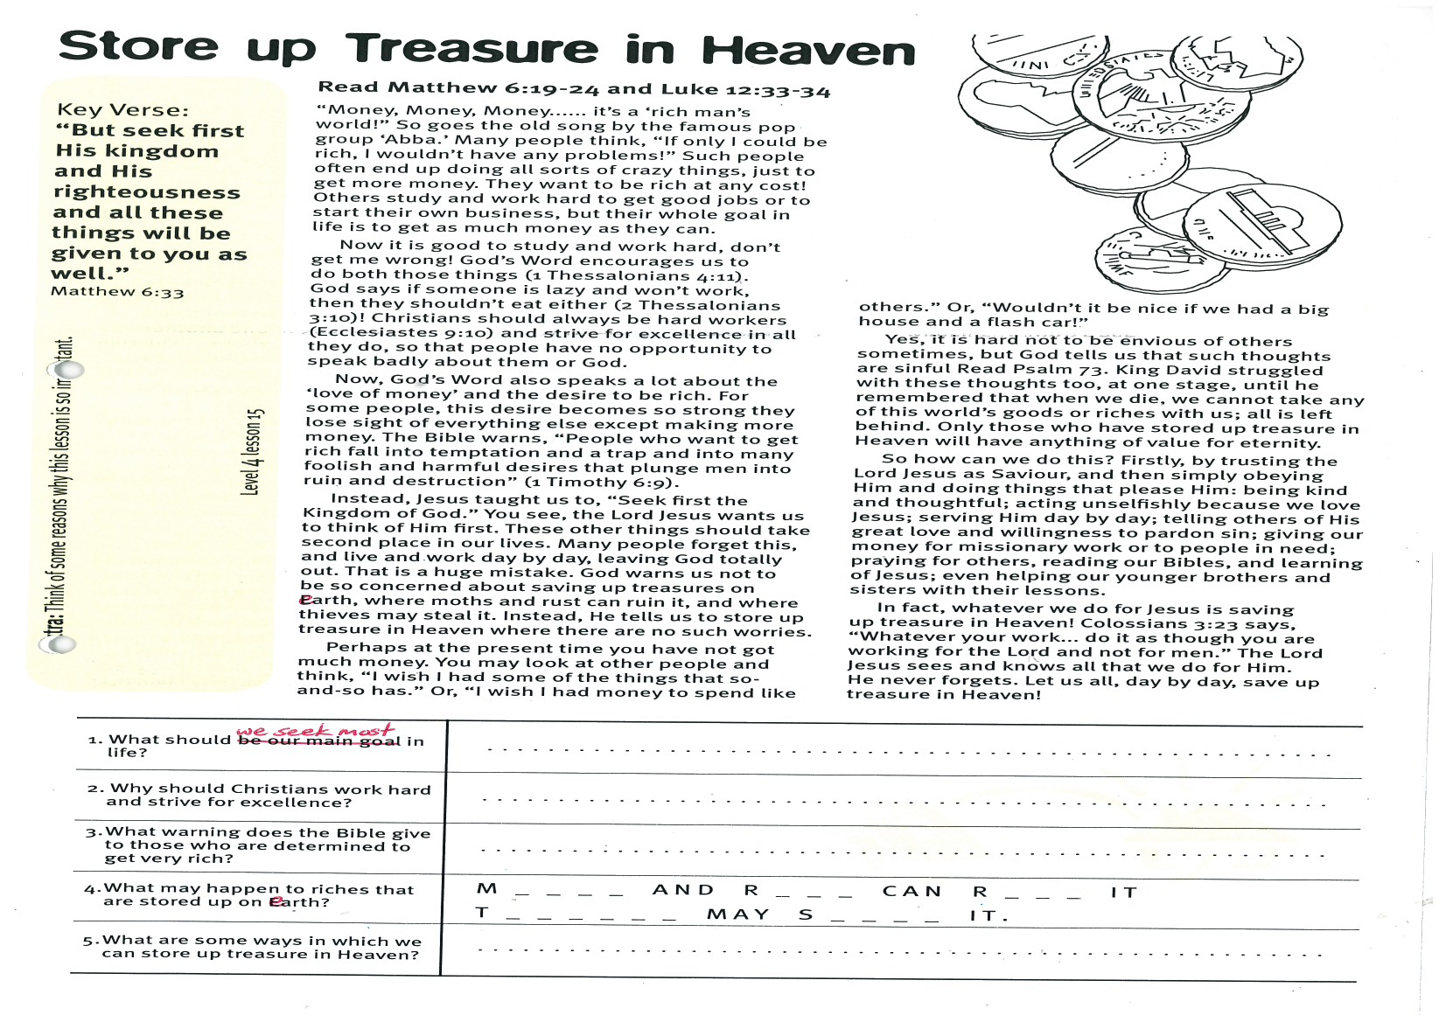
Key Verse:
“But seek first His kingdom and His righteousness and all these things will be given to you as well.”
Matthew 6:33
Read Matthew 6:19-24 and Luke 12:33-34
“Money, Money, Money...... it’s a ‘rich man’s world!” So goes the old song by the famous pop group ‘Abba.’ Many people think, “If only I could be rich, I wouldn’t have any problems!” Such people often end up doing all sorts of crazy things, just to get more money. They want to be rich at any cost! Others study and work hard to get good jobs or to start their own business, but their whole goal in life is to get as much money as they can.
Now it is good to study and work hard, don’t get me wrong! God’s Word encourages us to do both those things (1 Thessalonians 4:11). God says if someone is lazy and won’t work, then they shouldn’t eat either (2 Thessalonians 3:10)! Christians should always be hard workers (Ecclesiastes 9:10) and strive for excellence in all they do, so that people have no opportunity to speak badly about them or God.
Now, God’s Word also speaks a lot about the ‘love of money’ and the desire to be rich. For some people, this desire becomes so strong they lose sight of everything else except making more money. The Bible warns, “People who want to get rich fall into temptation and a trap and into many foolish and harmful desires that plunge men into ruin and destruction” (1 Timothy 6:9).
Instead, Jesus taught us to “Seek first the Kingdom of God.” You see, the Lord Jesus wants us to think of Him first. These other things should take second place in our lives. Many people forget this, and live and work day by day, leaving God totally out. That is a huge mistake. God warns us not to be so concerned about saving up treasures on earth, where moths and rust can ruin it, and where thieves may steal it. Instead, He tells us to store up treasure in Heaven where there are no such worries.
Perhaps at the present time you have not got much money. You may look at other people and think, “I
Store up Treasure in Heaven
1. What should we seek most in life?
2. Why should Christians work hard and strive for excellence?

3. What warning does the Bible give to those who are determined to get very rich?
4. What may happen to riches that are stored up on earth? | M __ __ __ __ AND R __ __ __ CAN R __ __ __ IT,  T __ __ __ __ __ __ MAY S __ __ __ __ IT.
5. What are some ways in which we can store up treasure in Heaven?
Extra: Think of some reasons why this lesson is so important.
Level 4 lesson 15
QUESTIONS & ANSWERS
wish I had some of the things that so-and-so has.” Or, “I wish I had money to spend like others.” Or, “Wouldn’t it be nice if we had a big house and a flash car!”
Yes, it is hard not to be envious of others sometimes, but God tells us that such thoughts are sinful. Read Psalm 73. King David struggled with these thoughts too, at one stage, until he remembered that when we die, we cannot take any of this world’s goods or riches with us; all is left behind. Only those who have stored up treasure in Heaven will have anything of value for eternity.
So how can we do this? Firstly, by trusting the Lord Jesus as Saviour, and then simply obeying Him and doing things that please Him: being kind and thoughtful; acting unselfishly because we love Jesus; serving Him day by day; telling others of His great love and willingness to pardon sin; giving our money for missionary work or to people in need; praying for others, reading our Bibles, and learning of Jesus; even helping our younger brothers and sisters with their lessons.
In fact, whatever we do for Jesus is saving up treasure in Heaven! Colossians 3:23 says, “Whatever your work… do it as though you are working for the Lord and not for men.” The Lord Jesus sees and knows all that we do for Him. He never forgets. Let us all, day by day, save up treasure in Heaven!

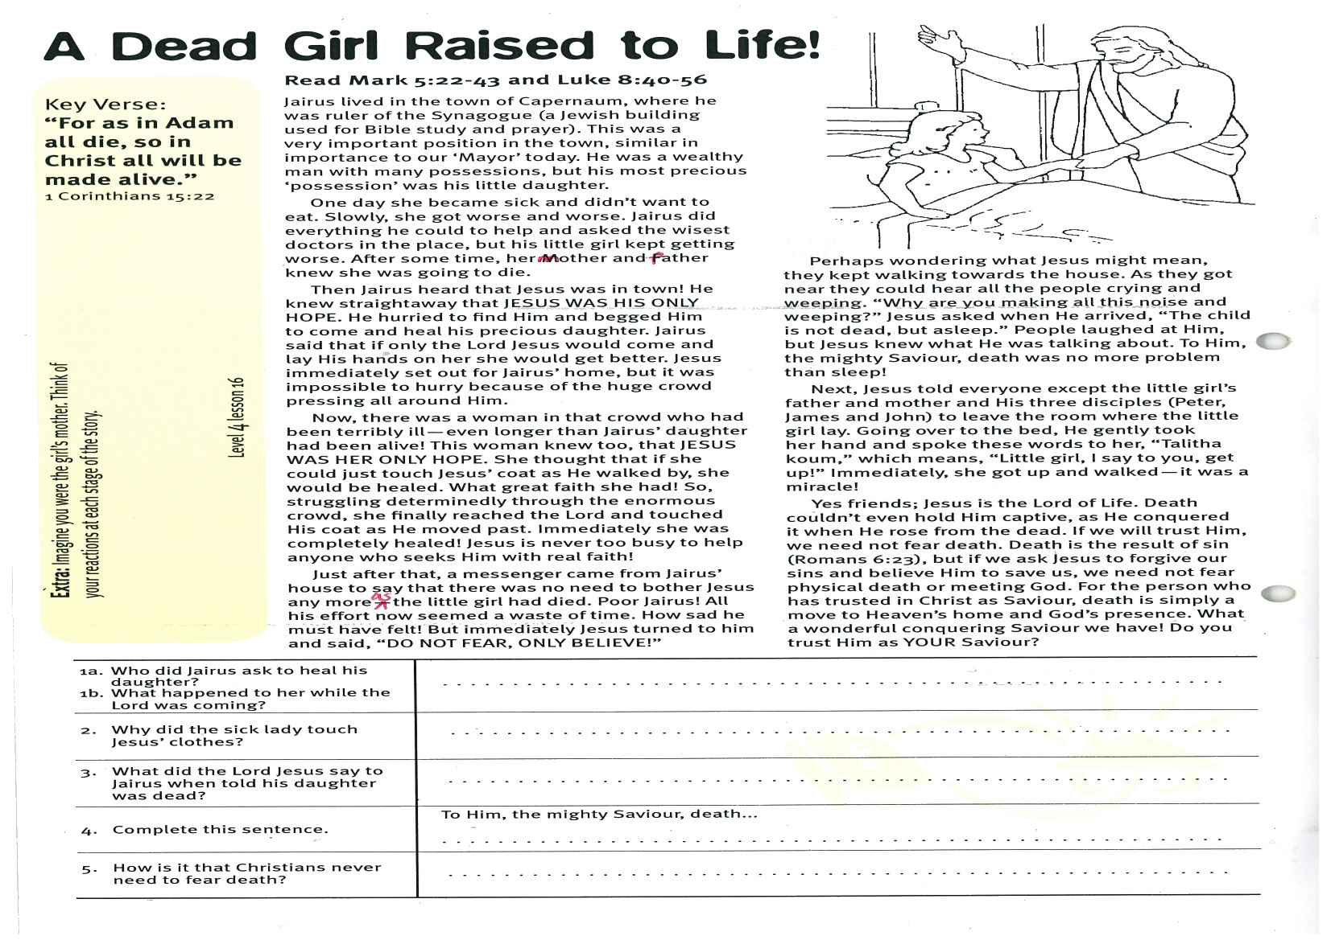
A Dead Girl Raised to Life
Key Verse:
“For as in Adam all die, so in Christ all will be made alive.”
1 Corinthians 15:22
Read Mark 5:22-43 and
Luke 8:40-56
Jairus lived in the town of Capernaum, where he was ruler of the Synagogue (a Jewish building used for Bible study and prayer). This was a very important position in the town, similar in importance to our ‘Mayor’ today. He was a wealthy man with many possessions, but his most precious ‘possession’ was his little daughter.
One day she became sick and didn’t want to eat. Slowly, she got worse and worse. Jairus did everything he could to help and asked the wisest doctors in the place, but his little girl kept getting worse. After some time, her mother and father knew she was going to die.
Then Jairus heard that Jesus was in town! He knew straightaway that JESUS WAS HIS ONLY HOPE. He hurried to find Him and begged Him to come and heal his precious daughter. Jairus said that if only the Lord Jesus would come and lay His hands on her she would get better. Jesus immediately set out for Jairus’ home, but it was impossible to hurry because of the huge crowd pressing all around Him.
Now, there was a woman in that crowd who had been terribly ill - even longer than Jairus’ daughter had been alive! This woman knew too, that JESUS WAS HER ONLY HOPE. She thought that if she could just touch Jesus’ coat as He walked by, she would be healed. What great faith she had! So, struggling determinedly through the enormous crowd, she finally reached the Lord and touched His coat as He moved past. Immediately she was completely healed! Jesus is never too busy to help anyone who seeks Him with real faith!
Just after that, a messenger came from Jairus’ house to say that there was no need to bother
1a. Who did Jairus ask to heal his daughter?
1b. What happened to her while the Lord was coming?
2. Why did the sick lady touch Jesus’ clothes?
3. What did the Lord Jesus say to Jairus when told his daughter was dead?

4. Complete this sentence: | To Him, the mighty Saviour, death…
5. How is it that Christians never need to fear death?
Please complete and return by post to
PSSM, 1-2A (G2) 93 Dominion Rd, Mt Eden, Auckland 1024 or scan & email to info@biblediscovery.org.nz

Extra: Imagine you were the girl’s mother. Think of your reactions at each stage of the story.
Level 4 lesson 16
QUESTIONS & ANSWERS
Jesus any more as the little girl had died. Poor Jairus! All his effort now seemed a waste of time. How sad he must have felt! But immediately Jesus turned to him and said, “DO NOT FEAR, ONLY BELIEVE!”
Perhaps wondering what Jesus might mean, they kept walking towards the house. As they got near they could hear all the people crying and weeping. “Why are you making all this noise and weeping?” Jesus asked when He arrived, “The child is not dead, but asleep.” People laughed at Him, but Jesus knew what He was talking about. To Him, the mighty Saviour, death was no more problem than sleep!
Next, Jesus told everyone except the little girl’s father and mother and His three disciples (Peter, James and John) to leave the room where the little girl lay. Going over to the bed, He gently took her hand and spoke these words to her, “Talitha koum,” which means, “Little girl, I say to you, get up!” Immediately, she got up and walked - it was a miracle!
Yes friends; Jesus is the Lord of Life. Death couldn’t even hold Him captive, as He conquered it when He rose from the dead. If we will trust Him, we need not fear death. Death is the result of sin (Romans 6:23), but if we ask Jesus to forgive our sins and believe Him to save us, we need not fear physical death or meeting God. For the person who has trusted in Christ as Saviour, death is simply a move to Heaven’s home and God’s presence. What a wonderful conquering Saviour we have! Do you trust Him as YOUR Saviour?

