Elisha told her to go to her friends and borrow as many empty jars, pots and bottles as she could. She was to take them inside her house, with her sons, and close the door. Then she was to take her little pot of oil and begin to fill all the empty jars, pots, and bottles she had borrowed.

That must have seemed a bit strange to the widow, don’t you think? But the lady did what Elisha told her and began pouring the oil into the first jar. When it was full, she filled the next one, then another, and then another! On and on she went, until all the jars were full! Then the oil stopped flowing. What a wonderful miracle God had done!

Elisha told her to sell the oil, and pay back all the money she owed. So she did and there was still enough money for her and her sons to use for a long time. Now imagine if the widow had not believed Elisha and not obeyed what he told her? She would have totally missed out on God’s provision for her. We know that God’s way is always best. So like that widow, we should always trust Him and obey Him.

**Read 2 Kings 4:1-7**

Elijah was one of God’s special messengers called a prophet. God gave him special messages to tell to the people. God even gave him special power to do miracles sometimes. When Elijah grew older, God sent a young man named Elisha to help him. It is always good when those who are older can teach the younger ones about God. Elisha learned a lot from Elijah. He learned to trust and obey God and God was pleased with him.

One day, an amazing thing happened. As Elijah and Elisha were walking together, God sent a flaming chariot and took Elijah up to heaven in it with a whirlwind! After that, God honoured Elisha and he became God’s prophet, just as Elijah had been.

One day a widow lady came to Elisha. “Please help me!” she begged. “My husband has died and I have no money to pay back what we borrowed. Now the man we borrowed from wants to take my two sons as slaves.” Elisha asked her what she had in the house. “Only a pot of oil,” she replied sadly.

Key Verse:  
**“Do whatever Jesus tells you.”**  
John 2:5

**Elisha the Prophet**

|  |  |  |  |  |  |  |  |  |
| --- | --- | --- | --- | --- | --- | --- | --- | --- |
| 1  **h** |  |  | 2 **o** |  |  | 3 **e** |  |  |
|  |  |  |  |  |  |  |  |  |
|  |  |  |  |  |  |  |  |  |
|  |  |  |  |  |  |  |  |  |
| 4 |  |  |  |  |  |  |  |  |
|  |  |  |  |  | 5 |  |  |  |

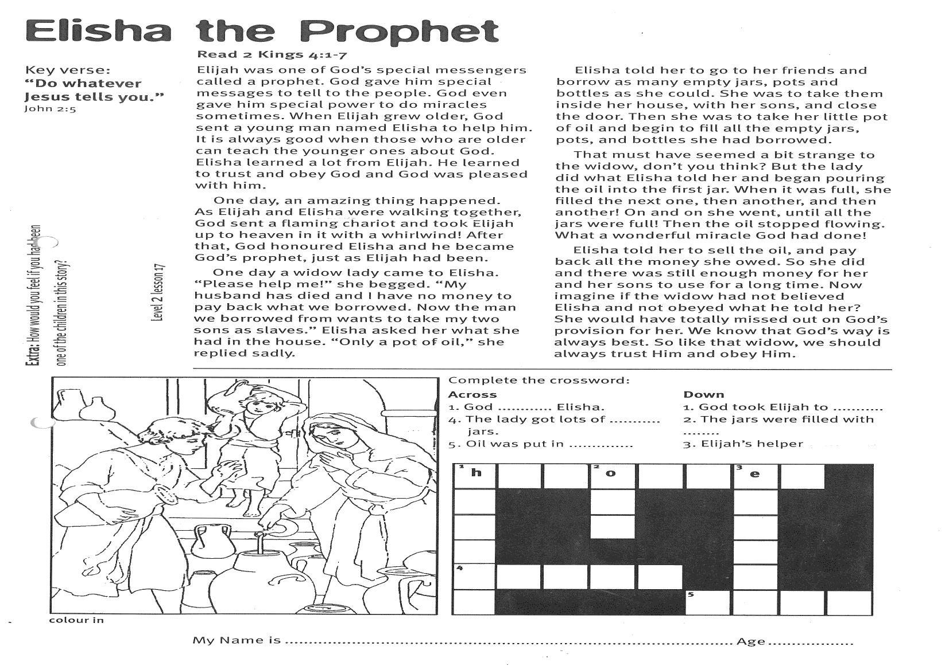

**Extra:** How would you feel if you had been   
one of the children in this story?

Down  
1. God took Elijah to ...........  
2. The jars were filled with ........  
3. Elijah’s helper

My Name is___________________________________________________ Age ______________

**Level 2 lesson 17**

Complete the crossword:

Across  
1. God ............ Elisha.  
4. The lady got lots of ........... jars.  
5. Oil was put in ..............

Down

1. God took Elijah to ...........

2. The jars were filled with ........

3. Elijah’s helper

**Prayer Time**

“Thank you Lord for people who visit our house. Please help me to make them feel really welcome.”  
Amen.

Key Verse:  
**“Be kind and compassionate to one another.**

Ephesians 4:32

**Showing Kindness**

**Read 2 Kings 4:8-11**

Elisha was a busy man. He worked very hard for God by teaching and helping the people. He travelled around the country on foot, and often passed through the town of Shunem. There, he always passed the beautiful home of a rich woman and her husband. They were called Shunammites. Can you say it? Shoo-nam-mites!

One day, the Shunammite woman invited Elisha to have a meal with her and her husband. The three of them talked together, and soon became good friends. The Shunammite woman decided to make a little room for Elisha in her big house. Then he would have a place to stay and rest as he travelled around. Wasn’t that kind of her?

So they built a nice room on the roof for Elisha. It had a bed, a table and chair, and a candle for light. There was no electric

|  |  |  |  |  |  |  |  |  |  |  |  |  |
| --- | --- | --- | --- | --- | --- | --- | --- | --- | --- | --- | --- | --- |
| **b** | **a** | **c** | **a** | **n** | **d** | **l** | **e** | **s** | **t** | **i** | **c** | **k** |
| **a** | **t** | **h** | **a** | **n** | **k** | **f** | **u** | **l** | **l** | **y** | **p** | **m** |
| **e** | **n** | **s** | **w** | **o** | **v** | **e** | **r** | **n** | **i** | **g** | **h** | **t** |
| **s** | **h** | **u** | **n** | **a** | **m** | **m** | **i** | **t** | **e** | **s** | **o** | **p** |
| **c** | **r** | **o** | **o** | **m** | **z** | **l** | **q** | **u** | **i** | **t** | **h** | **r** |
| **b** | **o** | **l** | **e** | **c** | **t** | **g** | **o** | **d** | **k** | **l** | **e** | **a** |

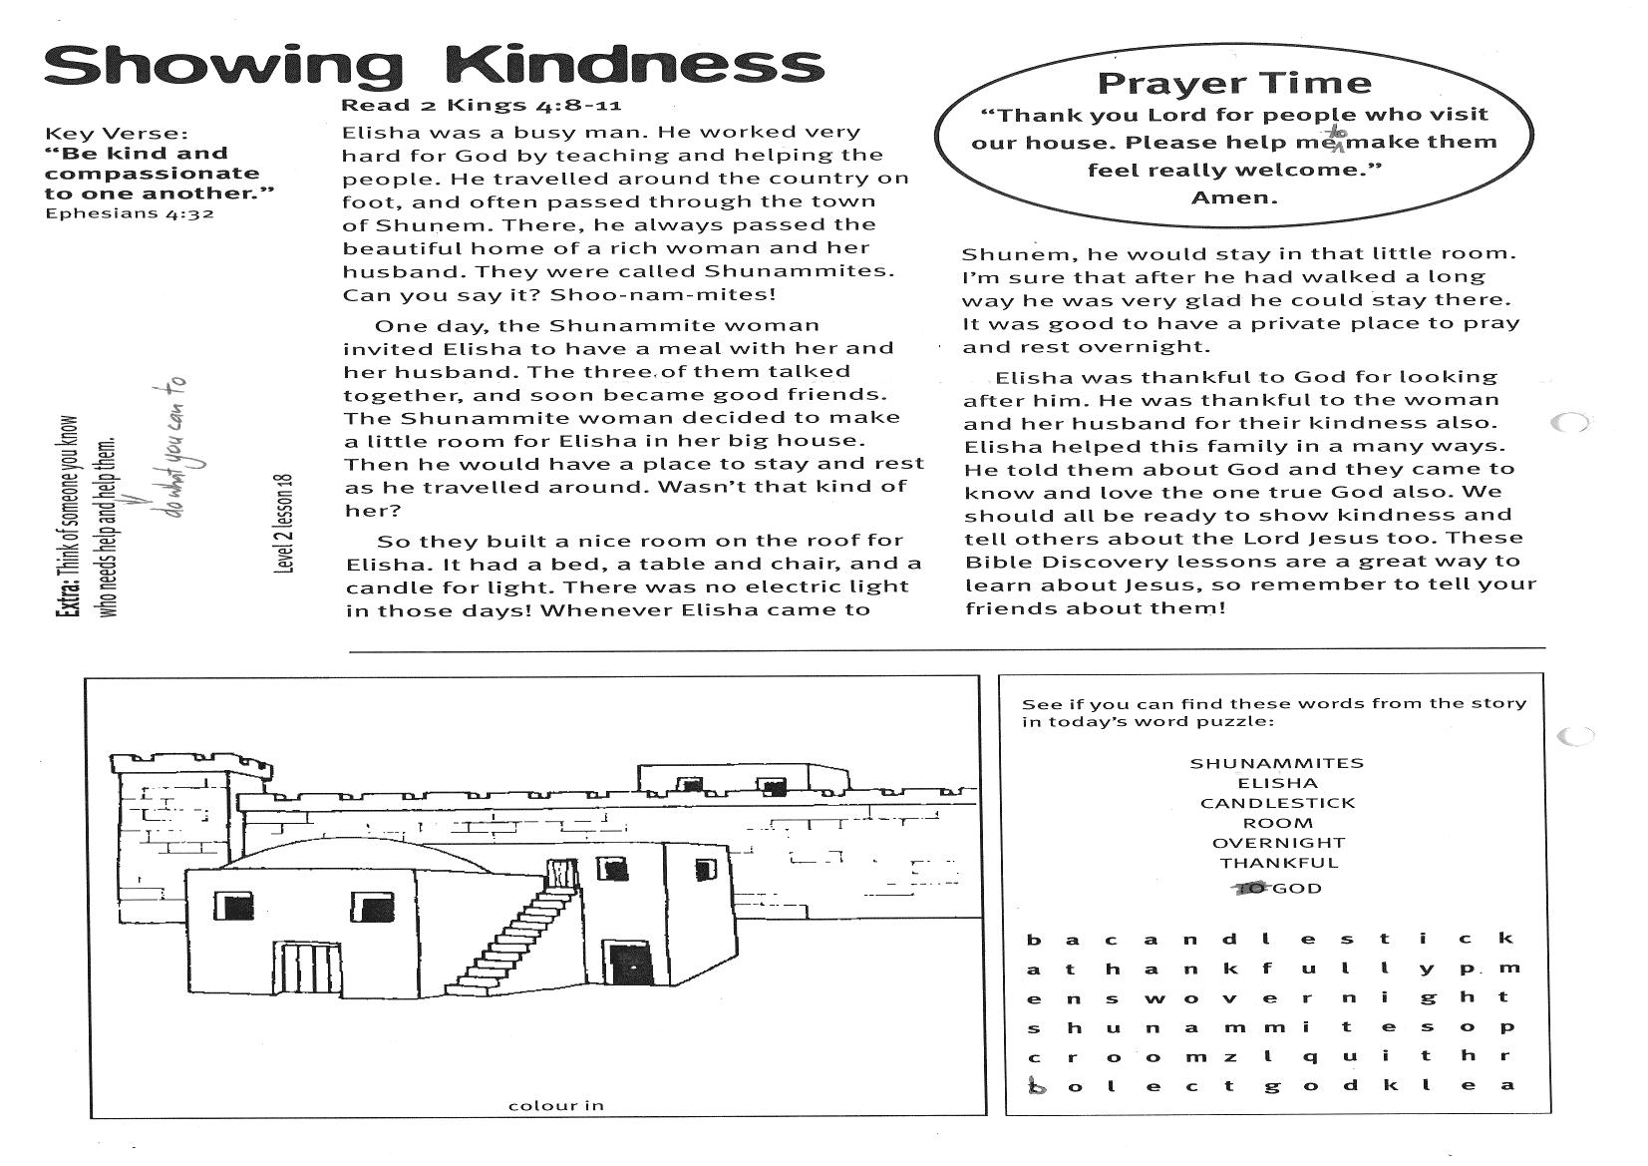

**Extra:** Think of someone you know who   
needs help and do what you can to help them.

See if you can find these words from the story in today’s word puzzle:

SHUNAMMITES  
ELISHA  
CANDLESTICK  
ROOM  
OVERNIGHT  
THANKFUL  
GOD

light in those days! Whenever Elisha came to Shunem, he would stay in that little room.

I’m sure that after he had walked a long way he was very glad he could stay there. It was good to have a private place to pray and rest overnight.

Elisha was thankful to God for looking after him. He was thankful to the woman and her husband for their kindness also. Elisha helped this family in a many ways. He told them about God and they came to know and love the one true God also.

We should all be ready to show kindness and tell others about the Lord Jesus too. These Bible Discovery lessons are a great way to learn about Jesus, so remember to tell your friends about them!

**Level 2 lesson 18**



**Naaman: A Man in Need**

Key Verse:  
**“Surely God is my help.”**Psalm 54:4

**Read 2 Kings 5:1-12**

Once, when Israel was at war, a little girl was captured. She was taken back to Syria, a long way from her home and parents. There she was made a slave, and had to care for the wife of Naaman, a captain in the Syrian army. Naaman was a brave soldier and a very important man. But one day he found that he had caught leprosy!

Leprosy was a terrible skin disease which could not be cured. Lepers had to leave their families and live alone, separated from people. This was so that no one else would catch the disease. Naaman and his wife were very sad.

Soon the little slave-girl from Israel heard that her master had caught leprosy. She was very kind and wanted to help him. She could have said, “Ha Ha! Serve him right! I don’t care. He took me away from my family.” But she didn’t! She loved and served God and she knew that God loved Naaman too.

So she hurried to tell Naaman’s wife about Elisha, the prophet of the Living God. She said she was sure he could cure Naaman of leprosy. So Naaman went with his horses and chariot to Elisha’s house. When he arrived, he thought Elisha would come out and make a big fuss of him. He was proud and thought he was very important

**Level 2 lesson 19**

So she hurried to tell Naaman’s wife about Elisha, the prophet of the Living God. She said she was sure he could cure Naaman of leprosy. So Naaman went with his horses and chariot to Elisha’s house. When he arrived, he thought Elisha would come out and make a big fuss of him. He was proud and thought he was very important.

Instead of coming out to welcome him, Elisha simply sent his servant with a message for Naaman. “Go and dip in the River Jordan seven times,” he told him, “and you will be healed.” Naaman was angry! He wasn’t going to do that! It was quite a simple thing he was asked to do, but he didn’t want to dip in that dirty river seven times. So he turned his chariot around and headed away! What do you think will happen next?

**Extra:** Imagine you were the slave girl.   
Would you have told your master about God?

2. If you had been the slave girl, what would you have done when you found out your boss had leprosy?

_________________________________________

_________________________________________

_________________________________________

_________________________________________

3. Why do you think Naaman got angry?

_________________________________________

_________________________________________

_________________________________________

_________________________________________

1. Tick the box with the right answer:

Naaman was a □ bad man  
 □ leper  
 □ prophet

The little girl was □ frightened  
 □ angry  
 □ kind

Elisha told Naaman □ to dip in the river 7 times  
 □ to pay him lots of money  
 □ to go to the doctor

Naaman □ laughed  
 □ cried   
 □ got angry

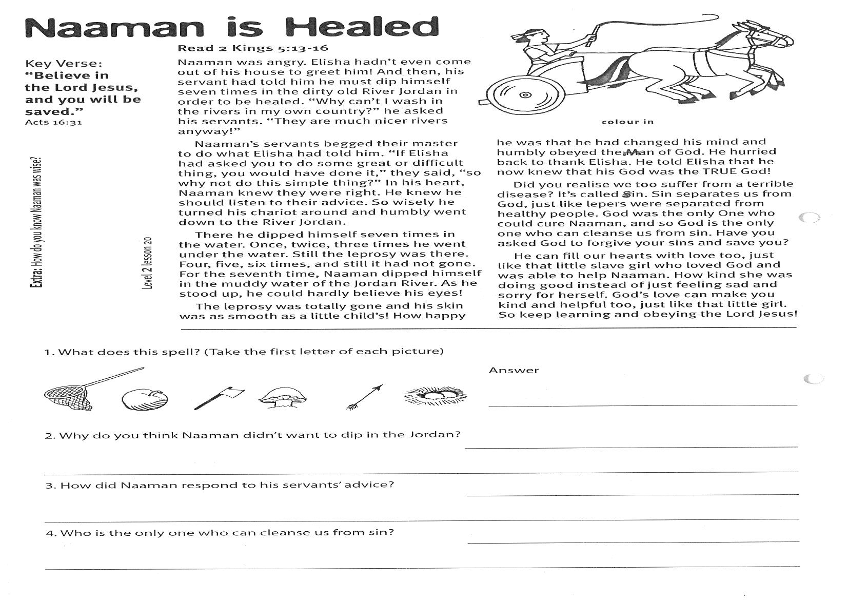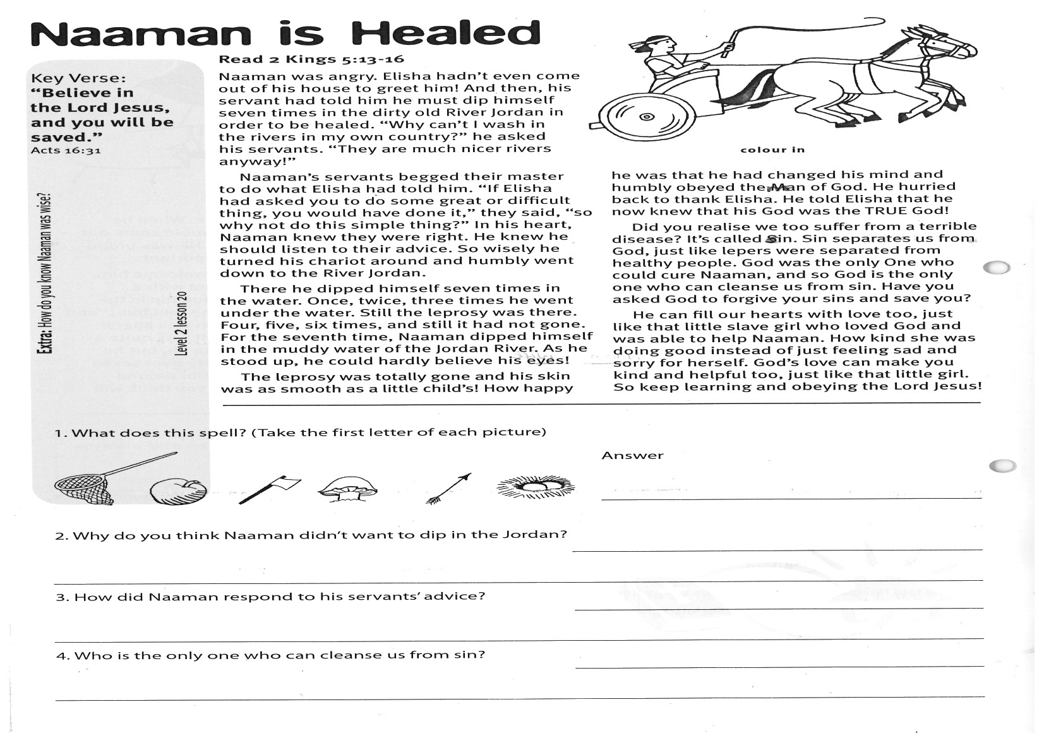

1. What does this spell? (Take the first letter of each picture)

Answer __________________________________

2. Why do you think Naaman didn’t want to dip in the Jordan? __________________________________

_____________________________________________________________________________________

3. How did Naaman respond to his servants’ advice? __________________________________________

_____________________________________________________________________________________

4. Who is the only one who can cleanse us from sin? __________________________________________

_____________________________________________________________________________________

The leprosy was totally gone and his skin was as smooth as a little child’s! How happy he was that he had changed his mind and humbly obeyed the man of God. He hurried back to thank Elisha. He told Elisha that he now knew that his God was the TRUE God!

Did you realise we too suffer from a terrible disease? It’s called sin. Sin separates us from God, just like lepers were separated from healthy people. God was the only One who could cure Naaman, and so God is the only one who can cleanse us from sin. Have you asked God to forgive your sins and save you?

He can fill our hearts with love too, just like that little slave girl who loved God and was able to help Naaman. How kind she was doing good instead of just feeling sad and sorry for herself. God’s love can make you kind and helpful too, just like that little girl. So keep learning and obeying the Lord Jesus!

Key Verse:  
**“Believe in the Lord Jesus, and you will be saved.”**Acts 16:31

Acts 16:31

**Level 2 lesson 20**

**Read 2 Kings 5:13-16**

Naaman was angry. Elisha hadn’t even come out of his house to greet him! And then, his servant had told him he must dip himself seven times in the dirty old River Jordan in order to be healed. “Why can’t I wash in the rivers in my own country?” he asked his servants. “They are much nicer rivers anyway!”

Naaman’s servants begged their master to do what Elisha had told him. “If Elisha had asked you to do some great or difficult thing, you would have done it,” they said, “so why not do this simple thing?” In his heart, Naaman knew they were right. He knew he should listen to their advice. So wisely he turned his chariot around and humbly went down to the River Jordan.

There he dipped himself seven times in the water. Once, twice, three times he went under the water. Still the leprosy was there. Four, five, six times, and still it had not gone. For the seventh time, Naaman dipped himself in the muddy water of the Jordan River. As he stood up, he could hardly believe his eyes!

**Extra:** How do you know Naaman was wise?

Please complete and return by post to   
**PSSM, 1-2A (G2) 93 Dominion Rd, Mt Eden, Auckland 1024** or scan & email to **info@biblediscovery.org.nz**

**Naaman is Healed**