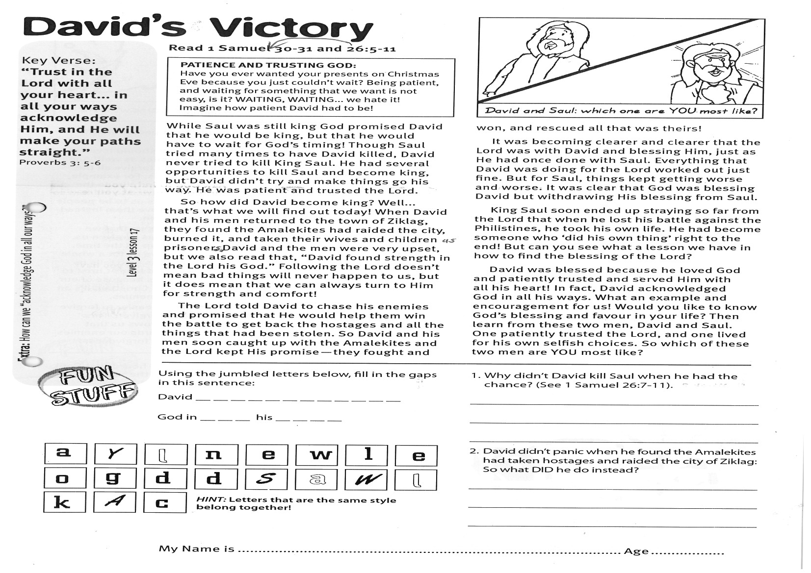

**Read 1 Samuel 26:5-11 and**

**1 Samuel 30-31**

**PATIENCE AND TRUSTING GOD:**

Have you ever wanted your presents on Christmas Eve because you just couldn’t wait? Being patient, and waiting for something that we want is not easy, is it? WAITING, WAITING... we hate it! Imagine how patient David had to be!

While Saul was still king God promised David that he would be king, but that he would have to wait for God’s timing! Though Saul tried many times to have David killed, David never tried to kill King Saul. He had several opportunities to kill Saul and become king, but David didn’t try and make things go his way. He was patient and trusted the Lord.

So how did David become king? Well... that’s what we will find out today! When David and his men returned to the town of Ziklag, they found the Amalekites had raided the city, burned it, and taken their wives and children as prisoners. David and the men were very upset, but we also read that, “David found strength in the Lord his God.” Following the Lord doesn’t mean bad things will never happen to us, but it does mean that we can always turn to Him for strength and comfort!

The Lord told David to chase his enemies and promised that He would help them win the battle to get back the hostages and all the things that had been stolen.

**David’s Victory**

Key Verse:  
**“Trust in the Lord with all your heart... in all your ways acknowledge Him, and He will make your paths straight.”**Proverbs 3:5-6



1. Why didn’t David kill Saul when he  
had the chance? (See 1 Samuel 26:7-11)

___________________________________

___________________________________

___________________________________  
2. David didn’t panic when he found the Amalekites had taken hostages and raided the city of Ziklag. So what DID he do instead?

___________________________________

___________________________________

___________________________________

___________________________________

_________________________________

_________________________________(

**Level 3 lesson 17**

**Extra:** How can we “acknowledge   
God in all our ways” too?

My Name is ……………………………………………………… Age…………………

Using the jumbled letters below,   
 fill in the gaps in this sentence:

David __ __ __ __ __ __ __ __ __ __ __ __

God in __ __ __ his __ __ __ __

So David and his men soon caught up with the Amalekites and the Lord kept His promise - they fought and won, and rescued all that was theirs!

It was becoming clearer and clearer that the Lord was with David and blessing Him, just as He had once done with Saul. Everything that David was doing for the Lord worked out just fine. But for Saul, things kept getting worse and worse. It was clear that God was blessing David but withdrawing His blessing from Saul.

King Saul soon ended up straying so far from the Lord that when he lost his battle against the Philistines, he took his own life. He had become someone who ‘did his own thing’ right to the end! But can you see what a lesson we have in how to find the blessing of the Lord?

David was blessed because he loved God and patiently trusted and served Him with all his heart! In fact, David acknowledged God in all his ways. What an example and encouragement for us! Would you like to know God’s blessing and favour in your life? Then learn from these two men, David and Saul. One patiently trusted the Lord, and one lived for his own selfish choices. So which of these two men are YOU most like?

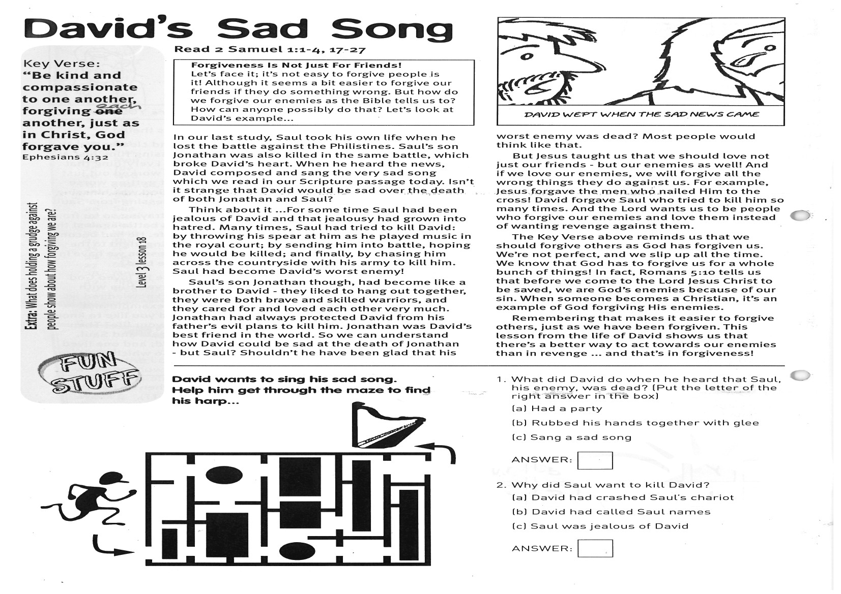

**David’s Sad Song**

**Read 2 Samuel 1:1-4, 17-27**

**FORGIVENESS IS NOT JUST FOR FRIENDS!**Let’s face it; it’s not easy to forgive people is it! Although it seems a bit easier to forgive our friends if they do something wrong. But how do we forgive our enemies as the Bible tells us to? How can anyone possibly do that? Let’s look at David’s example...

In our last study, Saul took his own life when he lost the battle against the Philistines. Saul’s son Jonathan was also killed in the same battle, which broke David’s heart. When he heard the news, David composed and sang the very sad song which we read in our Scripture passage today. Isn’t it strange that David would be sad over the death of both Jonathan and Saul?

Think about it ...For some time Saul had been jealous of David and that jealousy had grown into hatred. Many times, Saul had tried to kill David: by throwing his spear at him as he played music in the royal court; by sending him into battle, hoping he would be killed; and finally, by chasing him across the countryside with his army to kill him. Saul had become David’s worst enemy!

Saul’s son Jonathan though, had become like a brother to David - they liked to hang out together, they were both brave and skilled warriors, and they cared for and loved each other very much. Jonathan had always protected David from his father’s evil plans to kill him. Jonathan was David’s best friend in the world. So we can understand how David could be sad at the death of Jonathan – but Saul?

Key Verse:  
**“Be kind and compassionate to one another, forgiving each other, just as in Christ, God forgave you.”** Ephesians 4:32

Shouldn’t he have been glad that his worst enemy was dead? Most people would think like that!

But Jesus taught us that we should love not just our friends - but our enemies as well! And if we love our enemies, we will forgive all the wrong things they do against us. For example, Jesus forgave the men who nailed Him to the cross! David forgave Saul who tried to kill him so many times. And the Lord wants us to be people who forgive our enemies and love them instead of wanting revenge against them.

The Key Verse above reminds us that we should forgive others as God has forgiven us. We’re not perfect, and we slip up all the time. We know that God has to forgive us for a whole bunch of things! In fact, Romans 5:10 tells us that before we come to the Lord Jesus Christ to be saved, we are God’s enemies because of our sin. When someone becomes a Christian, it’s an example of God forgiving His enemies.

Remembering that makes it easier to forgive others, just as we have been forgiven. This lesson from the life of David shows us that there’s a better way to act towards our enemies than in revenge ... and that’s in forgiveness!



**Extra:** What does holding a grudge against   
people show about how forgiving we are?

**David wants to sing his sad song. Help him get through the maze to find his harp.**

1. What did David do when he heard that Saul, his enemy was dead? (Put the letter of the right answer in the box)

[a] Had a party

[b] Rubbed his hands together with glee

[c] Sang a sad song

ANSWER:

2. Why did Saul want to kill David?

[a] David had crashed Saul’s chariot

[b] David had called Saul names

[c] Saul was jealous of David

ANSWER:

**Level 3 lesson 18**

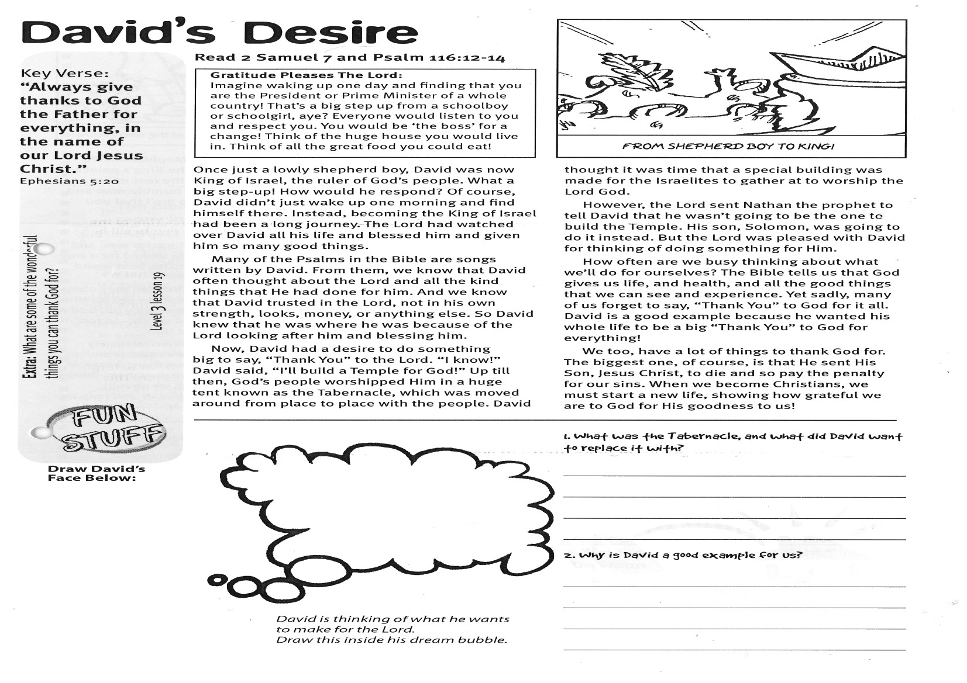

Key Verse:  
**“Always give thanks to God the Father for everything, in the name of our Lord Jesus Christ.”**Ephesians 5:20

**David’s Desire**

**Read 2 Samuel 7 and**

**Psalm 116:12-14**

**GRATITUDE PLEASES THE LORD!**

Imagine waking up one day and finding that you are the President or Prime Minister of a whole country! That’s a big step up from a schoolboy or schoolgirl, aye? Everyone would listen to you and respect you. You would be ‘the boss’ for a change! Think of the huge house you would live in. Think of all the great food you could eat!

Once just a lowly shepherd boy, David was now King of Israel, the ruler of God’s people. What a big step-up! How would he respond? Of course, David didn’t just wake up one morning and find himself there. Instead, becoming the King of Israel had been a long journey. The Lord had watched over David all his life and blessed him and given him so many good things.

Many of the Psalms in the Bible are songs written by David. From them, we know that David often thought about the Lord and all the kind things that He had done for him. And we know that David trusted in the Lord, not in his own strength, looks, money, or anything else. So David knew that he was where he was because of the Lord looking after him and blessing him.

Now, David had a desire to do something big to say, “Thank You” to the Lord. “I know!” David said, “I’ll build a Temple for God.”

Up till then, God’s people worshipped Him in a huge tent known as the Tabernacle, which was moved around from place to place with the people. David thought it was time that a special building was made for the Israelites to gather at to worship the Lord God.

However, the Lord sent Nathan the prophet to tell David that he wasn’t going to be the one to build the Temple. His son, Solomon, was going to do it instead. But the Lord was pleased with David for thinking of doing something for Him.

How often are we busy thinking about what we’ll do for ourselves? The Bible tells us that God gives us life, and health, and all the good things that we can see and experience. Yet sadly, many of us forget to say, “Thank You” to God for it all. David is a good example because he wanted his whole life to be a big “Thank You” to God for everything!

We too, have a lot of things to thank God for. The biggest one, of course, is that He sent His Son, Jesus Christ, to die and so pay the penalty for our sins. When we become Christians, we must start a new life, showing how grateful we are to God for His goodness to us!

*David is thinking of what he wants to make for the Lord.  
Draw this inside his dream bubble.*

Why is David a good example for us?

______________________________________

______________________________________

___________________________________________________

1. What was the Tabernacle, and what did David want to replace it with?

______________________________________

______________________________________

______________________________________

**Draw David’s face below:**

**Extra*:*** What are some of the wonderful   
things you can thank God for?

**Level 3 lesson 19**

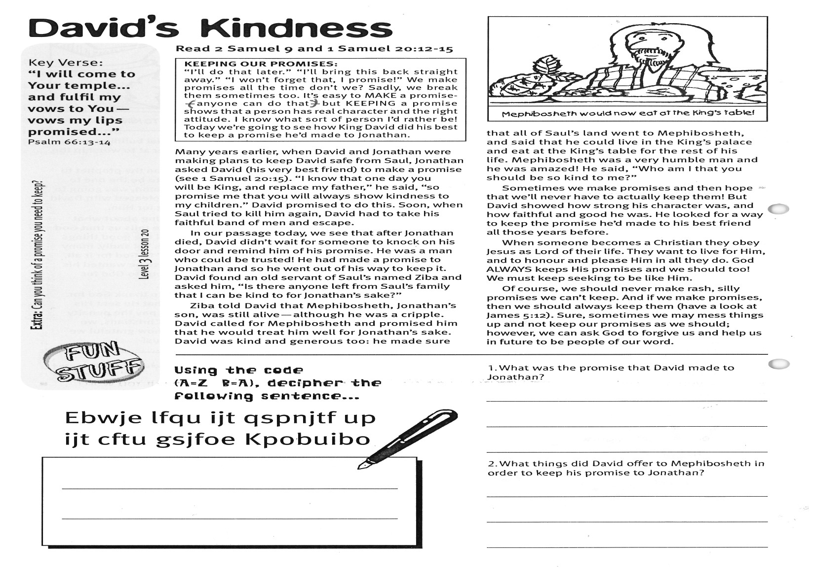

**Read 2 Samuel 9 and  
1 Samuel 20:12-15**

**KEEPING OUR PROMISES!**“I’ll do that later.” “I’ll bring this back straight away.” “I won’t forget that, I promise!” We make promises all the time don’t we? Sadly, we break them sometimes too. It’s easy to MAKE a promise (anyone can do that) but KEEPING a promise shows that a person has real character and the right attitude. I know what sort of person I’d rather be! Today we’re going to see how King David did his best to keep a promise he’d made to Jonathan.

Many years earlier, when David and Jonathan were making plans to keep David safe from Saul, Jonathan asked David (his very best friend) to make a promise (see 1 Samuel 20:15). “I know that one day you will be King, and replace my father,” he said, “so promise me that you will always show kindness to my children.” David promised to do this. Soon, when Saul tried to kill him again, David had to take his faithful band of men and escape.

In our passage today, we see that after Jonathan died, David didn’t wait for someone to knock on his door and remind him of his promise. He was a man who could be trusted! He had made a promise to Jonathan and so he went out of his way to keep it. David found an old servant of Saul’s named Ziba and asked him, “Is there anyone left from Saul’s family that I can be kind to for Jonathan’s sake?”

Ziba told David that Mephibosheth, Jonathan’s son, was still alive - although he was a cripple. David called for Mephibosheth and promised him that he would treat him well for Jonathan’s sake.

**David’s Kindness**

Key Verse:  
**“I will come to Your temple... and fulfil my vows to You - vows my lips promised...”**Psalm 66:13-14

David was kind and generous too: he made sure that all of Saul’s land went to Mephibosheth, and said that he could live in the King’s palace and eat at the King’s table for the rest of his life. Mephibosheth was a very humble man and he was amazed! He said, “Who am I that you should be so kind to me?”

Sometimes we make promises and then hope that we’ll never have to actually keep them! But David showed how strong his character was, and how faithful and good he was. He looked for a way to keep the promise he’d made to his best friend all those years before.

When someone becomes a Christian they obey Jesus as Lord of their life. They want to live for Him, and to honour and please Him in all they do. God ALWAYS keeps His promises and we should too! We must keep seeking to be like Him.

Of course, we should never make rash, silly promises we can’t keep. And if we make promises, then we should always keep them (have a look at James 5:12). Sure, sometimes we may mess things up and not keep our promises as we should; however, we can ask God to forgive us and help us in future to be people of our word.

Please complete and return by post to   
**PSSM, 1-2A (G2) 93 Dominion Rd, Mt Eden, Auckland 1024** or scan & email to **info@biblediscovery.org.nz**

**Answer:**

**Level 3 lesson 20**

**Extra:** Can you think of a promise you need to keep?

Using The code A = Z B = A, decipher the following sentence:

1. What was the promise that David made to Jonathan?

_____________________________________

_____________________________________

_____________________________________

2. What things did David offer to Mephibosheth in order to keep his promise to Jonathan?

_____________________________________ _____________________________________

_____________________________________

**Ebwje lfqu ijt qspnjtf up  
Ijt cftu gsjfoe Kpobuibo**

_________________________________________

_________________________________________

Please complete and return by post to   
**PSSM, 1-2A (G2) 93 Dominion Rd, Mt Eden, Auckland 1024** or scan & email to **info@biblediscovery.org.nz**