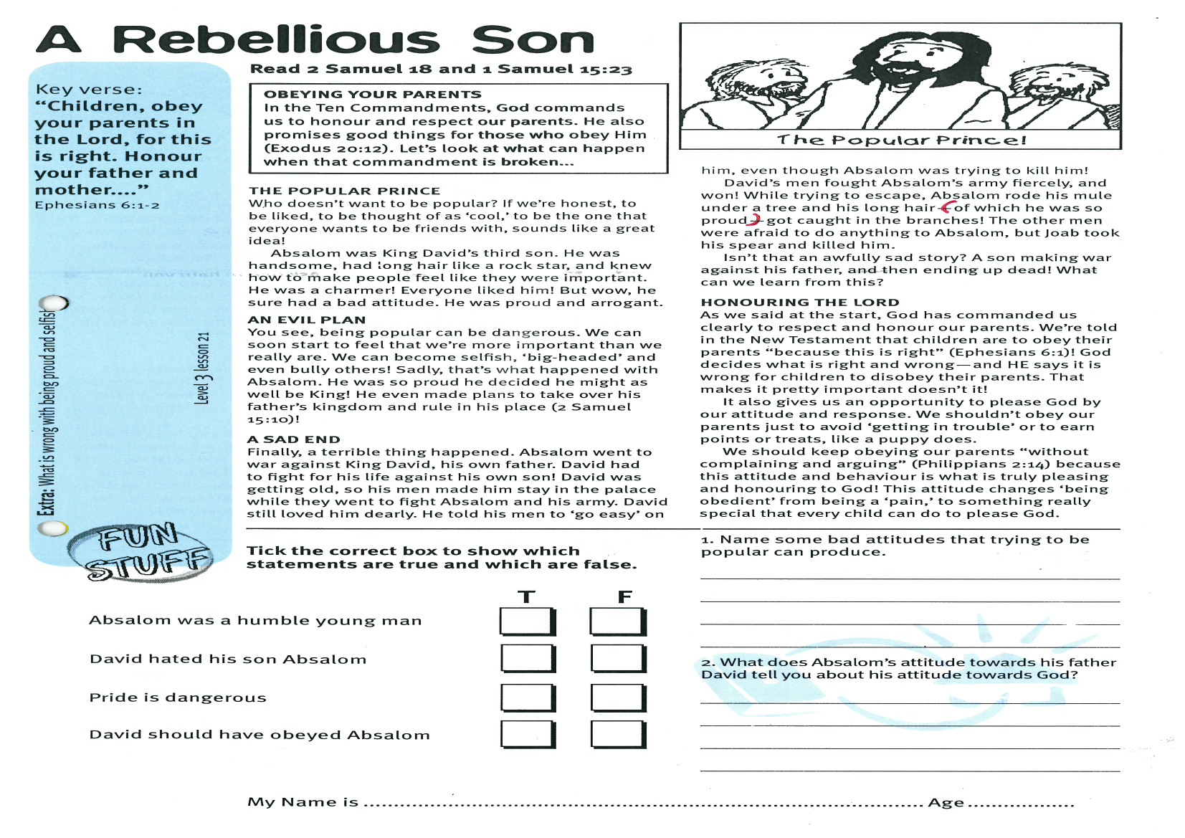

**Read 2 Samuel 18 and**

**1 Samuel 15:23**

**OBEYING YOUR PARENTS**In the Ten Commandments, God commands us to honour and respect our parents. He also promises good things for those who obey Him (Exodus 20:12). Let’s look at what can happen when that commandment is broken...  
 **THE POPULAR PRINCE**Who doesn’t want to be popular? If we’re honest, to be liked, to be thought of as ‘cool,’ to be the one that everyone wants to be friends with; sounds like a great idea!Absalom was King David’s third son. He was handsome, had long hair like a rock star, and knew how to make people feel like they were important. He was a charmer! Everyone liked him! But wow, he sure had a bad attitude. He was proud and arrogant**.  
  
AN EVIL PLAN**You see, being popular can be dangerous. We can soon start to feel that we’re more important than we really are. We can become selfish, ‘big-headed’ and even bully others! Sadly, that’s what happened with Absalom. He was so proud he decided he might as well be King! He even made plans to take over his father’s kingdom and rule in his place (2 Samuel 15:10)! **A SAD END**Finally, a terrible thing happened. Absalom went to war against King David, his own father. David had to fight for his life against his own son! David was getting old, so his men made him stay in the palace while they went to fight Absalom and his army. David still loved him dearly. He told his men to ‘go

**A Rebellious Son**

Key Verse:  
**“Children, obey your parents in the Lord, for this is right. Honour your father and mother….”**

Ephesians 6:1-2

Tick the correct box to show which statements are true and which are false:

1. Name some bad attitudes that trying to be popular can produce.  
___________________________________

___________________________________

___________________________________

___________________________________

2. What does Absalom’s attitude towards his father David tell you about his attitude towards God?

___________________________________

___________________________________

___________________________________

easy’ on him, even though Absalom was trying to kill him!  
David’s men fought Absalom’s army fiercely, and won! While trying to escape, Absalom rode his mule under a tree and his long hair (of which he was so proud) got caught in the branches! The other men were afraid to do anything to Absalom, but Joab took his spear and killed him.  
Isn’t that an awfully sad story? A son making war against his father, and then ending up dead! What can we learn from this?  
 **HONOURING THE LORD**As we said at the start, God has commanded us clearly to respect and honour our parents. We’re told in the New Testament that children are to obey their parents “because this is right” (Ephesians 6:1)! God decides what is right and wrong - and HE says it is wrong for children to disobey their parents. That makes it pretty important doesn’t it!It also gives us an opportunity to please God by our attitude and response. We shouldn’t obey our parents just to avoid ‘getting in trouble’ or to earn points or treats, like a puppy does.  
We should keep obeying our parents “without complaining and arguing” (Philippians 2:14) because this attitude and behaviour is what is truly pleasing and honouring to God! This attitude changes ‘being obedient’ from being a ‘pain,’ to something really special that every child can do to please God.

My Name is ……………………………………………………… Age…………………

True False

Absalom was a humble young man

David hated his son Absalom

Pride is dangerous

David should have obeyed Absalom

**Extra:** What is wrong with being proud and selfish?

**Level 3 lesson 21**

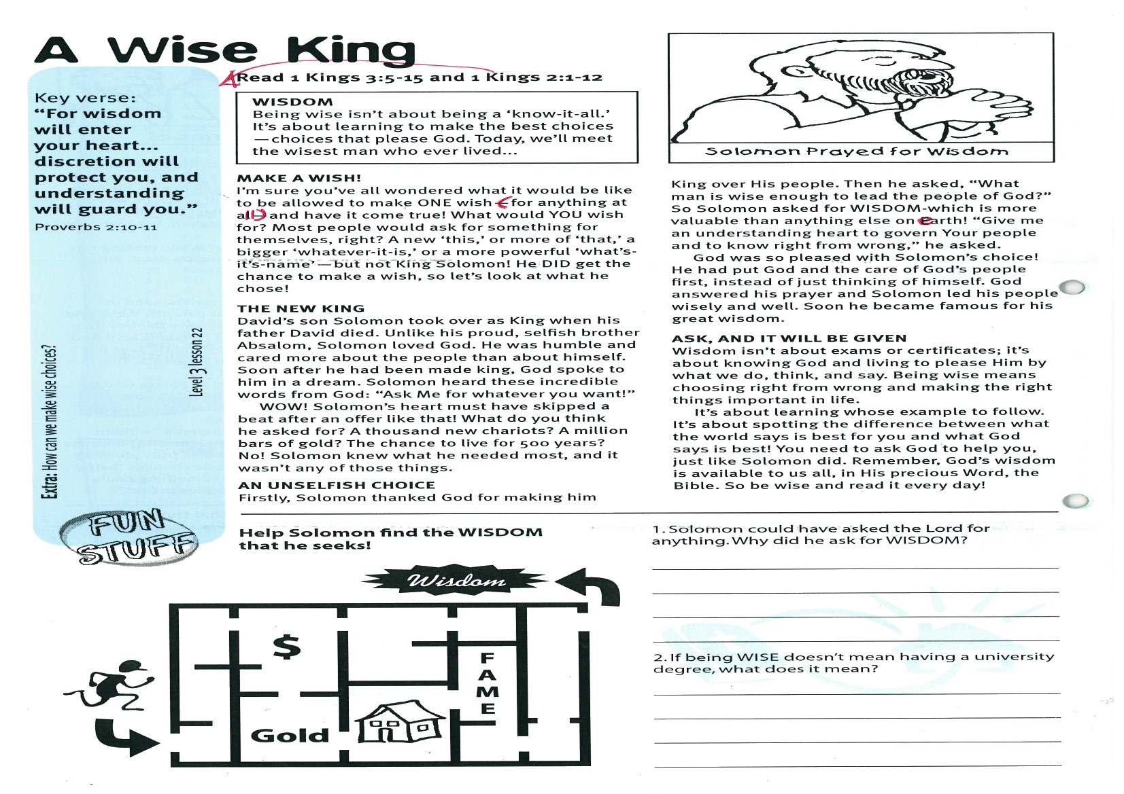

**Read 1 Kings 2:1-12 and   
1 Kings 3:5-15**

**WISDOM**Being wise isn’t about being a ‘know-it-all.’ It’s about learning to make the best choices - choices that please God. Today, we’ll meet the wisest man who ever lived...

**MAKE A WISH!**I’m sure you’ve all wondered what it would be like to be allowed to make ONE wish (for anything at all) and have it come true! What would YOU wish for? Most people would ask for something for themselves, right? A new ‘this,’ or more of ‘that,’ a bigger ‘whatever-it-is,’ or a more powerful ‘what’s-it’s-name’ - but not King Solomon! He DID get the chance to make a wish, so let’s look at what he chose!

**THE NEW KING**David’s son Solomon took over as King when his father David died. Unlike his proud, selfish brother Absalom, Solomon loved God. He was humble and cared more about the people than about himself. Soon after he had been made king, God spoke to him in a dream. Solomon heard these incredible words from God: “Ask Me for whatever you want!”   
WOW! Solomon’s heart must have skipped a beat after an offer like that! What do you think he asked for? A thousand new chariots? A million bars of gold? The chance to live for 500 years? No! Solomon knew what he needed most, and it wasn’t any of those things.

**Level 3 lesson 22**

**Extra:** How can we make wise choices?

Key Verse:  
**“For wisdom will enter your heart... discretion will protect you, and understanding will guard you.”**

Proverbs 2:10-11

**A Wise King**

**AN UNSELFISH CHOICE**Firstly, Solomon thanked God for making him King over His people. Then he asked, “What man is wise enough to lead the people of God?” So Solomon asked for WISDOM - which is more valuable than anything else on earth! “Give me an understanding heart to govern Your people and to know right from wrong,” he asked. God was so pleased with Solomon’s choice! He had put God and the care of God’s people first, instead of just thinking of himself. God answered his prayer and Solomon led his people wisely and well. Soon he became famous for his great wisdom.

**ASK, AND IT WILL BE GIVEN**Wisdom isn’t about exams or certificates; it’s about knowing God and living to please Him by what we do, think, and say. Being wise means choosing right from wrong and making the right things important in life.  
It’s about learning whose example to follow. It’s about spotting the difference between what the world says is best for you and what God says is best! You need to ask God to help you, just like Solomon did. Remember, God’s wisdom is available to us all, in His precious Word, the Bible. So be wise and read it every day!



**Help Solomon find the WISDOM that he seeks!**

1. Solomon could have asked the Lord for anything. Why did he ask for WISDOM?

__________________________________

__________________________________

__________________________________

2. If being WISE doesn’t mean having a university degree, what does it mean?

__________________________________

__________________________________

__________________________________

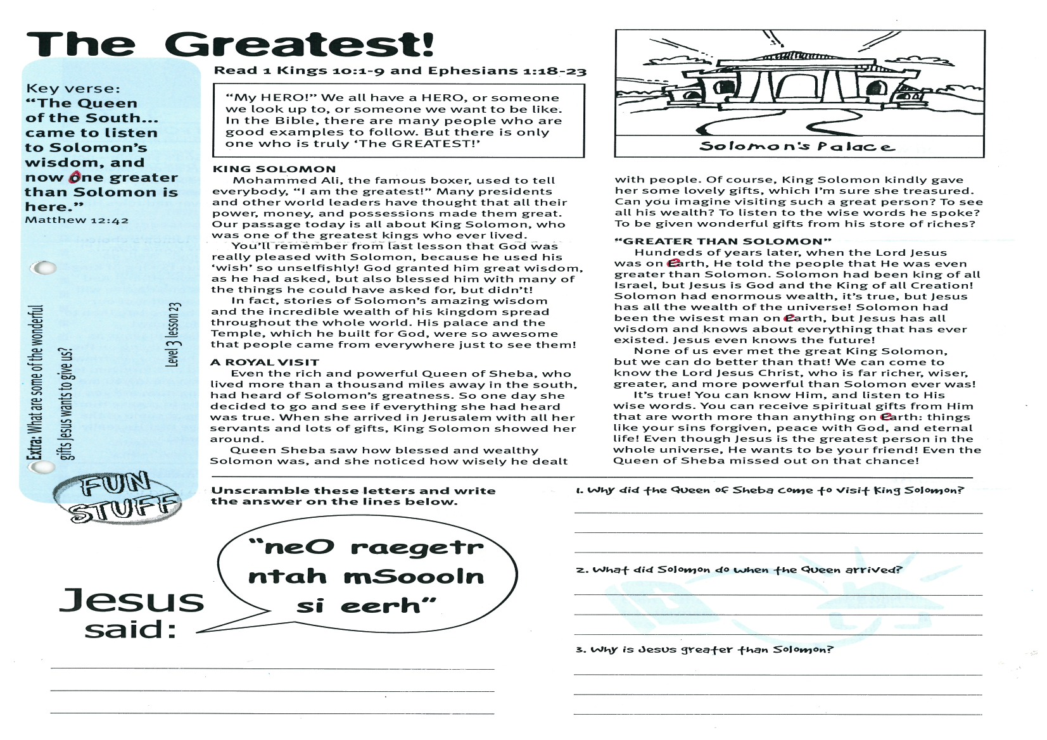

**Read 1 Kings 10:1-9 and  
Ephesians 1:18-23**

**“MY HERO!”** We all have a HERO, or someone we look up to, or someone we want to be like. In the Bible, there are many people who are good examples to follow. But there is only one who is truly ‘The GREATEST!’

**KING SOLOMON**

Mohammed Ali, the famous boxer, used to tell everybody, “I am the greatest!” Many presidents and other world leaders have thought that all their power, money, and possessions made them great. Our passage today is all about King Solomon, who was one of the greatest kings who ever lived.

You’ll remember from last lesson that God was really pleased with Solomon, because he used his ‘wish’ so unselfishly! God granted him great wisdom, as he had asked, but also blessed him with many of the things he could have asked for, but didn’t!

In fact, stories of Solomon’s amazing wisdom and the incredible wealth of his kingdom spread throughout the whole world. His palace and the Temple, which he built for God, were so awesome that people came from everywhere just to see them!

**A ROYAL VISIT**

Even the rich and powerful Queen of Sheba, who lived more than a thousand miles away in the south, had heard of Solomon’s greatness. So one day she decided to go and see if everything she had heard was true. When she arrived in Jerusalem with all her servants and lots of gifts, King Solomon showed her around.

Queen Sheba saw how blessed and wealthy

**The Greatest!**

**Level 3 lesson 23**

Key Verse:  
**“The Queen of the South... came to listen to Solomon’s wisdom, and now One greater than Solomon is here.”**

Matthew 12:42

1. Why did the Queen of Sheba come to visit King Solomon?

___________________________________

___________________________________

2. What did Solomon do when the Queen arrived?

___________________________________

3. Why is Jesus greater than Solomon?

___________________________________

___________________________________

_______________________________________

_______________________________________

“neO raegetr  
ntah mSoooln  
si eerh”

Unscramble these letters and write the answer on the lines below:

Jesus

said:

Solomon was, and she noticed how wisely he dealt with people. Of course, King Solomon kindly gave her some lovely gifts, which I’m sure she treasured. Can you imagine visiting such a great person? To see all his wealth? To listen to the wise words he spoke? To be given wonderful gifts from his store of riches?

**“GREATER THAN SOLOMON”**

Hundreds of years later, when the Lord Jesus was on earth, He told the people that He was even greater than Solomon. Solomon had been King of all Israel, but Jesus is God and the King of all Creation! Solomon had enormous wealth, it’s true, but Jesus has all the wealth of the universe! Solomon had been the wisest man on earth, but Jesus has all wisdom and knows about everything that has ever existed. Jesus even knows the future!

None of us ever met the great King Solomon, but we can do better than that! We can come to know the Lord Jesus Christ, who is far richer, wiser, greater, and more powerful than Solomon ever was!

It’s true! You can know Him, and listen to His wise words. You can receive spiritual gifts from Him that are worth more than anything on earth: things like having your sins forgiven, peace with God, and eternal life! Even though Jesus is the greatest person in the whole universe, He wants to be your friend! Even the Queen of Sheba missed out on that chance!

**Extra:** What are some of the wonderful gifts Jesus wants to give us?

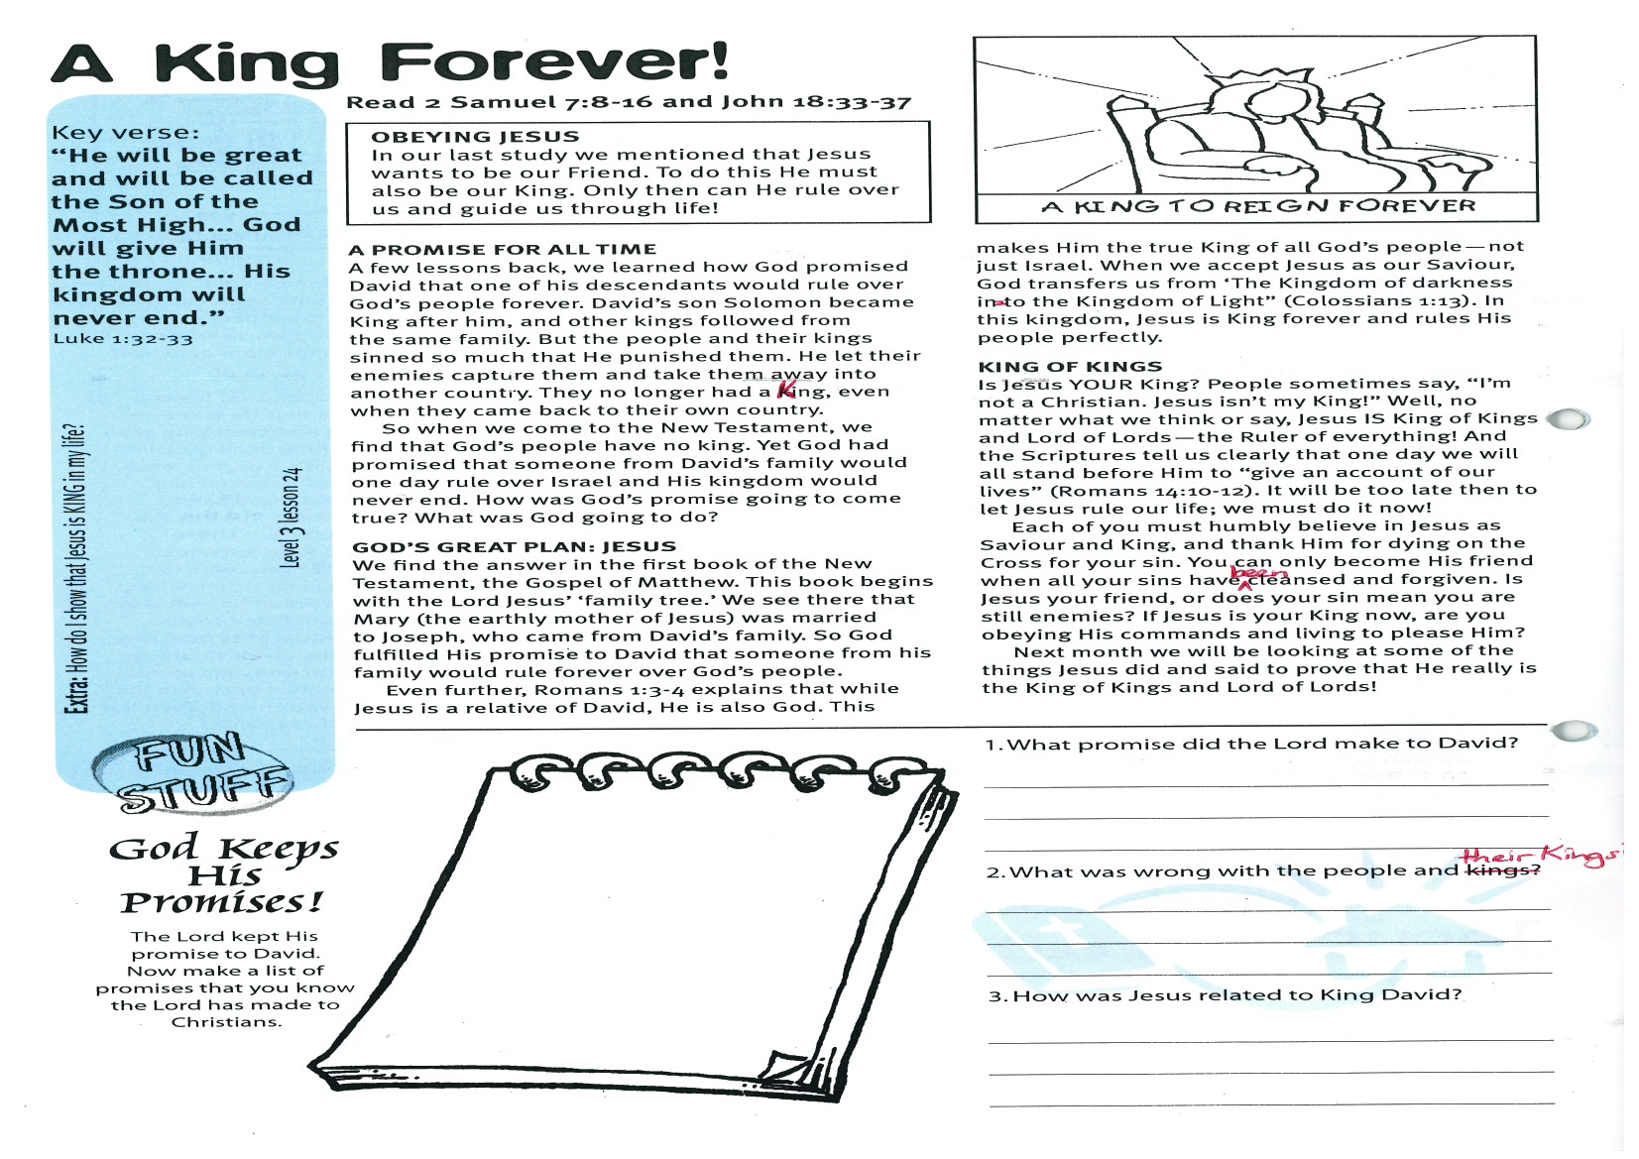

**Read 2 Samuel 7: 8-16 and  
John 18:33-37**

**OBEYING JESUS**

In our last study we mentioned that Jesus wants to be our Friend. To do this He must also be our King. Only then can He rule over us and guide us through life!

**A PROMISE FOR ALL TIME**

A few lessons back, we learned how God promised David that one of his descendants would rule over God’s people forever. David’s son Solomon became King after him, and other kings followed from the same family. But the people and their kings sinned so much that He punished them. He let their enemies capture them and take them away into another country. They no longer had a King, even when they came back to their own country.

So when we come to the New Testament, we find that God’s people have no King. Yet God had promised that someone from David’s family would one day rule over Israel and His kingdom would never end. How was God’s promise going to come true? What was God going to do?

**GOD’S GREAT PLAN: JESUS**

We find the answer in the first book of the New Testament, the Gospel of Matthew. This book begins with the Lord Jesus’ ‘family tree.’ We see there that Mary (the earthly mother of Jesus) was married to Joseph, who came from David’s family. So God fulfilled His promise to David that someone from his family would rule forever over God’s people.

**A King Forever!**

Key Verse:  
**“He will be great and will be called the Son of the Most High... God will give Him the throne... His kingdom will never end.”**

Luke 1:32-33

Please complete and return by post to   
**PSSM, 1-2A (G2) 93 Dominion Rd, Mt Eden, Auckland 1024** or scan & email to **info@biblediscovery.org.nz**

**Answer:**

Even further, Romans 1:3-4 explains that while Jesus is a relative of David, He is also God. This makes Him the true King of all God’s people - not just Israel.

When we accept Jesus as our Saviour, God transfers us from ‘The Kingdom of darkness into the Kingdom of Light” (Colossians 1:13). In this kingdom, Jesus is King forever and rules His people perfectly.

**KING OF KINGS**Is Jesus YOUR King? People sometimes say, “I’m not a Christian. Jesus isn’t my King!” Well, no matter what we think or say, Jesus IS King of Kings and Lord of Lords - the Ruler of everything! And the Scriptures tell us clearly that one day we will all stand before Him to “give an account of our lives” (Romans 14:10-12). It will be too late then to let Jesus rule our life; we must do it **now**!  
Each of you must humbly believe in Jesus as Saviour and King, and thank Him for dying on the Cross for your sin. You can only become His friend when all your sins have been cleansed and forgiven. Is Jesus your friend, or does your sin mean you are still enemies? If Jesus is your King now, are you obeying His commands and living to please Him?  
Next month we will be looking at some of the things Jesus did and said to prove that He really isthe King of Kings and Lord of Lords!

**Level 3 lesson 24**

**Extra:** How do I show that Jesus is KING in my life?



1. What promise did the Lord make to David?

_____________________________

_____________________________

2. What was wrong with the people and their Kings?

_____________________________

_____________________________

3. How was Jesus related to King David?

_____________________________

_____________________________

**God Keeps His   
Promises!**

The Lord kept His promise to David. Now make a list of promises that you know the Lord has made to Christians.