Jesus Provides Freedom!
Key Verse:
“I do believe, help me overcome my unbelief.”
Mark 9:24
Read Mark 9:14-29 and
Luke 9:37-43
As we begin our study today, try to imagine the scene: some of Jesus’ disciples were faced with a young man who was controlled by an evil spirit. His father confronted the disciples, begging them, “Can’t you save him or heal him?” A large crowd of people gathered quickly, watching curiously. Some were asking questions and criticising while others were mocking and shouting excitedly. In the centre of it all stood the disciples; apparently, unable to help the man.
While all this was taking place, the Lord Jesus approached the scene. Remember the Lord Jesus is ALWAYS near whenever there is distress, trouble, or need. We only need to turn to Him and trust Him for help and blessing. When Jesus asked what was the matter, the father of this poor boy said, “Master, I brought my son to Your disciples to be cured, and they could not do anything for him!”
Calmly Jesus responded, “Bring him to Me.” When Jesus asked how long his boy had been like this, the father said, “Ever since he was a child. Many times this evil spirit has mastered him. Please have compassion on us and help us!” Jesus said, “If you can BELIEVE, all things are possible to him that believes.” Immediately the father announced, “Lord, I DO believe! Strengthen my weak faith.”
At this, Jesus rebuked the evil spirit and ordered it to come out of the boy. At once, the evil spirit left the boy and he was healed! Jesus had performed another of His mighty miracles! Although the Bible doesn’t say, we can imagine how happy the father and son must have been!
1. What did Jesus say to the father who wanted His help?
2. Why couldn’t the disciples heal this young man?
3. What are some of the sins that can overcome and enslave us?
4. How can you overcome wrong things in your life?
5. What special lesson did you learn from this study?
Level 3 lesson 1
Extra: Make a list of the sins you often commit, and for each one, write down what the Bible says to do instead.
Level 4 lesson 21
QUESTIONS & ANSWERS
Key Verse:
“Jesus said, ‘I tell you the truth, unless a man is born again, he cannot see the kingdom of God.’”
John 3:3
Maybe they rejoiced and praised the Lord together. What do you think? I’m pretty sure they would have followed Jesus and done those things which pleased Him, too.
Later, the disciples gathered with Jesus in a house and asked Him, “Why couldn’t we do what You did to that young man?” Jesus answered, “Because you can’t do such things without much prayer.” This young man was ruled over by a power that was stronger than him and he needed Jesus to free him!
The Bible says that we can become enslaved to sins, too. Sinful habits show up in all sorts of ways. Perhaps you are often ANGRY or SELFISH. Perhaps you decide to tell LIES or STEAL things day after day. You may CHEAT, be PROUD, or be JEALOUS. You may often be DISOBEDIENT to your parents or teachers. Yet, whatever the sins are, you can become free of them!
How does the Bible say we can overcome sins and be free? Remember, Jesus told the boy’s father, “If you can believe” - that’s FAITH. He also said, “Bring him to Me,” and the father did - that’s OBEDIENCE. To the disciples He said, “PRAY.” There we have it: faithful, prayerful, obedience to the Word of God! That’s the way to overcome the wrong things in your life which seem too strong.
Why not confess your sins to the Lord Jesus in prayer today? Go on, trust in the Mighty Christ for daily strength and form a habit of faithful obedience day by day! Jesus can truly free you!
My Name is _____________________________________________ Age ___________
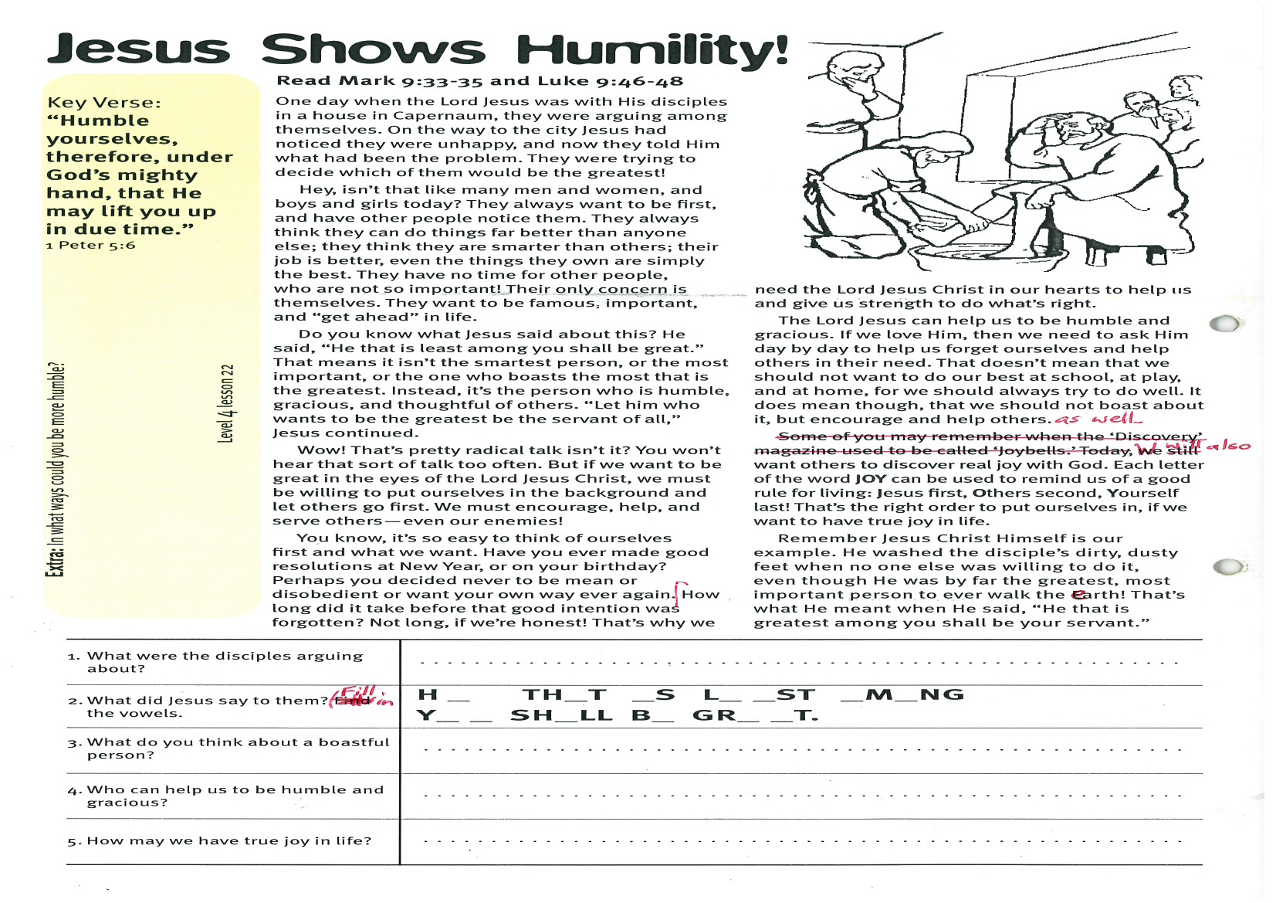
Jesus Shows Humility!
Key Verse:
“Humble yourselves, therefore, under God’s mighty hand, that He may lift you up in due time.”
1 Peter 5:6
1. What were the disciples arguing about?
2. What did Jesus say to them? (Fill in the vowels) | H __ T H __ T __ S L __ __ S T __ M __ N G  Y __ __ S H __ L L B __ G R __ __ T
3. What do you think about a boastful person?
4. Who can help us to be humble and gracious?
5. How may we have true joy in life?
Extra: In what ways could you be more humble?
Level 4 lesson 22
QUESTIONS & ANSWERS
Read Mark 9:33-35 and
Luke 9:46-48
One day when the Lord Jesus was with His disciples in a house in Capernaum, they were arguing among themselves. On the way to the city Jesus had noticed they were unhappy, and now they told Him what had been the problem. They were trying to decide which of them would be the greatest!
Hey, isn’t that like many men and women, and boys and girls today? They always want to be first, and have other people notice them. They always think they can do things far better than anyone else; they think they are smarter than others; their job is better, even the things they own are simply the best. They have no time for other people, who are not so important! Their only concern is themselves. They want to be famous, important, and “get ahead” in life.
Do you know what Jesus said about this? He said, “He that is least among you shall be great.” That means it isn’t the smartest person, or the most important, or the one who boasts the most that is the greatest. Instead, it’s the person who is humble, gracious, and thoughtful of others. “Let him who wants to be the greatest be the servant of all,” Jesus continued.
Wow! That’s pretty radical talk isn’t it? You won’t hear that sort of talk too often. But if we want to be great in the eyes of the Lord Jesus Christ, we must be willing to put ourselves in the background and let others go first. We must encourage, help, and serve others - even our enemies!
You know, it’s so easy to think of ourselves first and what we want. Have you ever made good resolutions at New Year, or on your birthday? Perhaps you decided never to be mean or disobedient or want your own way ever again.
How long did it take before that good intention was forgotten? Not long, if we’re honest! That’s why we need the Lord Jesus Christ in our hearts to help us and give us strength to do what’s right.
The Lord Jesus can help us to be humble and gracious. If we love Him, then we need to ask Him day by day to help us forget ourselves and help others in their need. That doesn’t mean that we should not want to do our best at school, at play, and at home, for we should always try to do well. It does mean though, that we should not boast about it, but encourage and help others as well.
We will also want others to discover real joy with God. Each letter of the word JOY can be used to remind us of a good rule for living: Jesus first, Others second, Yourself last! That’s the right order to put ourselves in, if we want to have true joy in life.
Remember Jesus Christ Himself is our example. He washed the disciple’s dirty, dusty feet when no one else was willing to do it, even though He was by far the greatest, most important person to ever walk the earth! That’s what He meant when He said, “He that is greatest among you shall be your servant.”

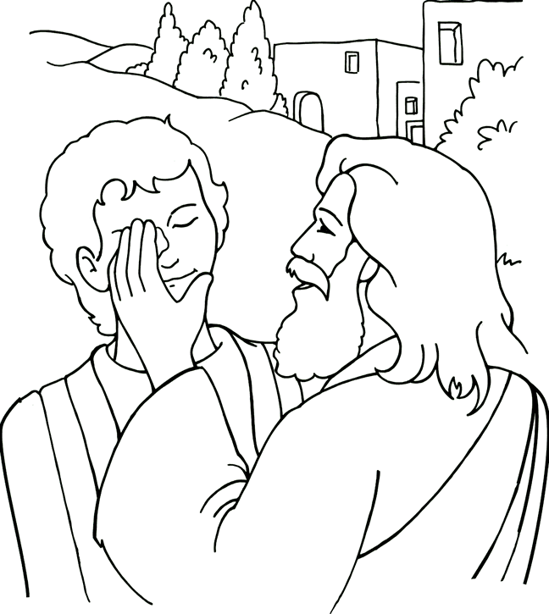
Key Verse:
“The Lord is near to all who call on Him in truth.”
Psalm 145:18
Read Mark 10:46-52 and
Luke 18:35-43
Blind people are often very clever in the way they get around and do so many things. Of course, there are times when they are glad of some help too! Whenever you see a blind person, always be ready to help them in whatever way you can. The Lord Jesus always helped and often HEALED the blind people He met. In Bible days, blind people were not well cared for. Many of them were regarded as outcasts; they were neglected and forced to sit by the roadside and beg.
Our reading today, concerns a poor blind man named Bartimaeus, which simply means “Son of Timaeus.” He lived in Jericho and grew up without any education, and was unable to work because of his blindness. Every day, he would sit by the roadside and beg for a living. His favourite spot was near the gate of the city, where there were always people coming and going.
One day as he sat begging, he heard the sound of a big crowd of people coming along the road. He asked what was going on and found out that Jesus was coming! Excitedly, he thought to himself, “Jesus, the great Healer is coming this way. This is my chance to get my sight!” As the crowd came nearer, he called out loudly, “Jesus, Son of David, have mercy on me!”
Some people standing close by said, “Keep quiet! Stop yelling! This is the great Teacher and you are just a blind beggar. He won’t have time for you!” But Bartimaeus ignored them and called out again even louder! Suddenly, everything went quiet. The crowd had stopped. Someone touched Bartimaeus and said, “Jesus heard you calling. Come on, He’s calling for you!” His heart pounding, Bartimaeus sprang up, threw off his dirty coat, and guided by one of the people, he hurried to Jesus.

Jesus Heals Blindness!
1. When Bartimaeus cried out, how was the crowd’s reaction different to Jesus’ reaction?
2. What did he say when Jesus asked what he wanted?

3. What did he do after Jesus healed him? Code: 1=Z, 2=Y, 3=Z, etc. | __ __ __ __ __ __ __ __ __ __ __ __ __ __ __  19 22 21 12 15 15 12 4 22 23 17 22 8 6 8
4. How is sin like blindness?

5. What must you do so that Jesus can make your life pure?
Extra: Comment on those who witnessed this miracle but still did not believe Jesus.
Level 4 lesson 23
QUESTIONS & ANSWERS
Then he heard Jesus’ kind voice ask, “What do you want Me to do for you?” “Oh Master,” Bartimaeus replied, “that I might receive my sight!”Knowing his faith, Jesus replied, “Go, your faith has healed you.” Immediately Bartimaeus could see! How amazing! He was so happy his heart was nearly bursting! What a change this would mean for him. He would not be a beggar any more. He was so grateful to Jesus.
Now, what was Bartimaeus to do? Go home and forget all about Jesus? Go away and selfishly enjoy the blessing he had received? No! He FOLLOWED JESUS. He wanted to serve Jesus, the one who had given him his sight. How gracious the Lord Jesus is! Always ready to help and listening for the faintest call. He’s never too tired or busy to help and bless whenever He finds a heart to trust Him.
Now, we know that this man was blind physically, but there is a ‘blindness’ which we can have in our hearts and minds which is far worse! Yes friends, it is possible to see with our eyes, and yet be blind in our hearts because of our selfishness and sin. Many in the crowd that day who saw Bartimaeus receive his sight, still did not believe in Jesus!
Sin ‘blinds’ us so that we cannot ‘see’ God, and we refuse His love and willingness to forgive sin. The Bible says the ‘pure in heart shall see God,’ and only the Lord Jesus can make our lives pure. Ask Him to open your spiritual eyes today, so that you might know His love and grace, and realise that He alone can take away your selfishness and sin!

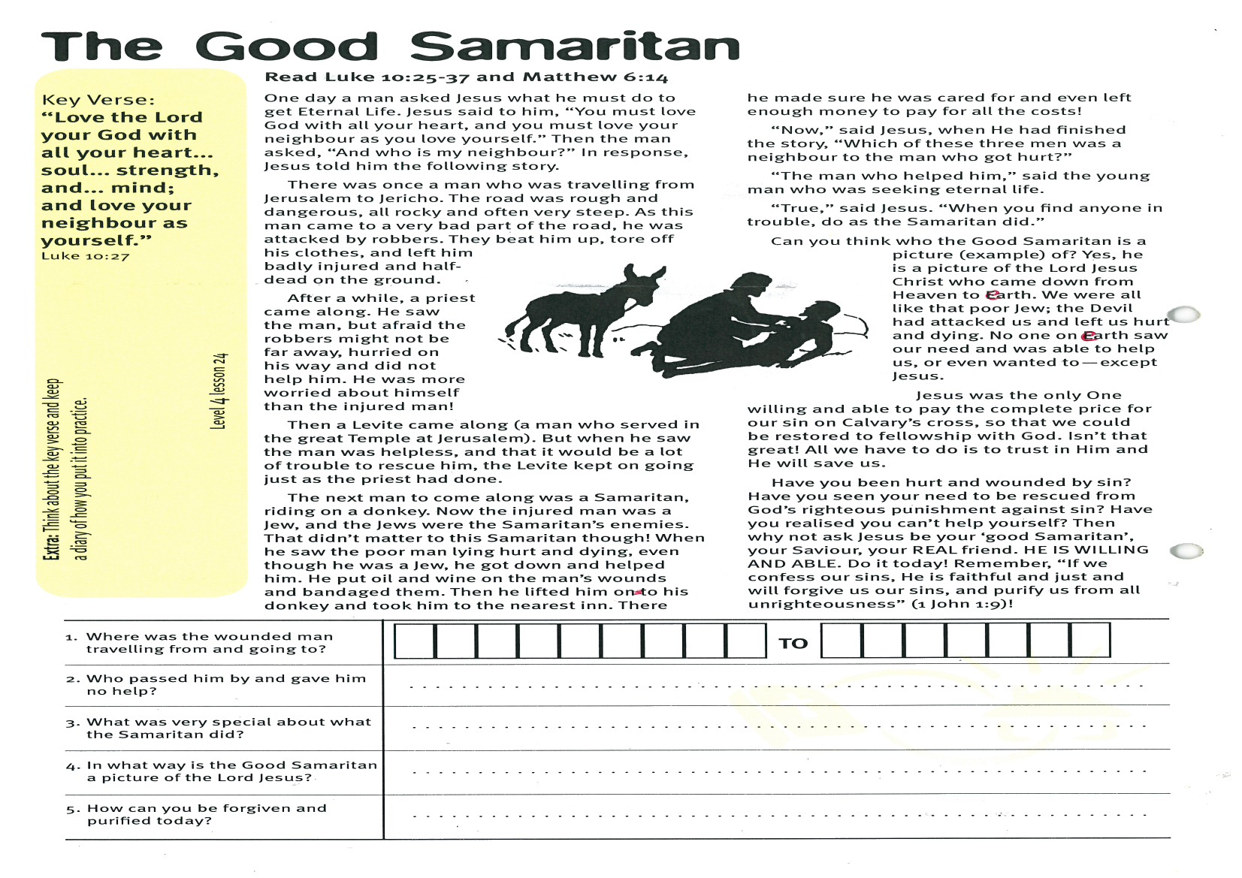
The Good Samaritan
Key Verse:
“Love the Lord your God with all your heart... soul... strength, and... mind; and love your neighbour as yourself.”
Luke 10:27
Read Luke 10:25-37 and
Matthew 6:14
One day a man asked Jesus what he must do to get Eternal Life. Jesus said to him, “You must love God with all your heart, and you must love your neighbour as you love yourself.” Then the man asked, “And who is my neighbour?” In response, Jesus told him the following story.
There was once a man who was travelling from Jerusalem to Jericho. The road was rough and dangerous, all rocky and often very steep. As this man came to a very bad part of the road, he was attacked by robbers. They beat him up, tore off his clothes, and left him badly injured and half-dead on the ground.
After a while, a priest came along. He saw the man, but afraid the robbers might not be far away, hurried on his way and did not help him. He was more worried about himself than the injured man!
Then a Levite came along (a man who served in the great Temple at Jerusalem). But when he saw the man was helpless, and that it would be a lot of trouble to rescue him, the Levite kept on going just as the priest had done.
The next man to come along was a Samaritan, riding on a donkey. Now the injured man was a Jew, and the Jews were the Samaritan’s enemies. That didn’t matter to this Samaritan though! When he saw the poor man lying hurt and dying, even though he was a Jew, he got down and helped him. He put oil and wine on the man’s wounds and bandaged them. Then he lifted him onto his donkey and took him to the nearest inn. There he
1. Where was the wounded man travelling from and going to?
  TO
2. Who passed him by and gave him no help?
3. What was very special about what the Samaritan did?

4. In what way is the Good Samaritan a picture of the Lord Jesus?
5. How can you be forgiven and purified today?
Please complete and return by post to
PSSM, 1-2A (G2) 93 Dominion Rd, Mt Eden, Auckland 1024 or scan & email to info@biblediscovery.org.nz

Extra: Think about the key verse and keep a diary of how you put it into practice.
Level 4 lesson 24
QUESTIONS & ANSWERS
made sure he was cared for and even left enough money to pay for all the costs!
“Now,” said Jesus, when He had finished the story, “Which of these three men was a neighbour to the man who got hurt?” “The man who helped him,” said the young man who was seeking eternal life. “True,” said Jesus. “When you find anyone in trouble, do as the Samaritan did.”
Can you think who the Good Samaritan is a picture (example) of? Yes, he is a picture of the Lord Jesus Christ who came down from Heaven to earth. We were all like that poor Jew; the Devil had attacked us and left us hurt and dying. No one on earth saw our need and was able to help us, or even wanted to - except Jesus.
Jesus was the only One willing and able to pay the complete price for our sin on Calvary’s cross, so that we could be restored to fellowship with God. Isn’t that great! All we have to do is to trust in Him and He will save us.
Have you been hurt and wounded by sin? Have you seen your need to be rescued from God’s righteous punishment against sin? Have you realised you can’t help yourself? Then why not ask Jesus be your ‘good Samaritan’, your Saviour, your REAL friend. HE IS WILLING AND ABLE. Do it today! Remember, “If we confess our sins, He is faithful and just and will forgive us our sins, and purify us from all unrighteousness” (1 John 1:9)!

