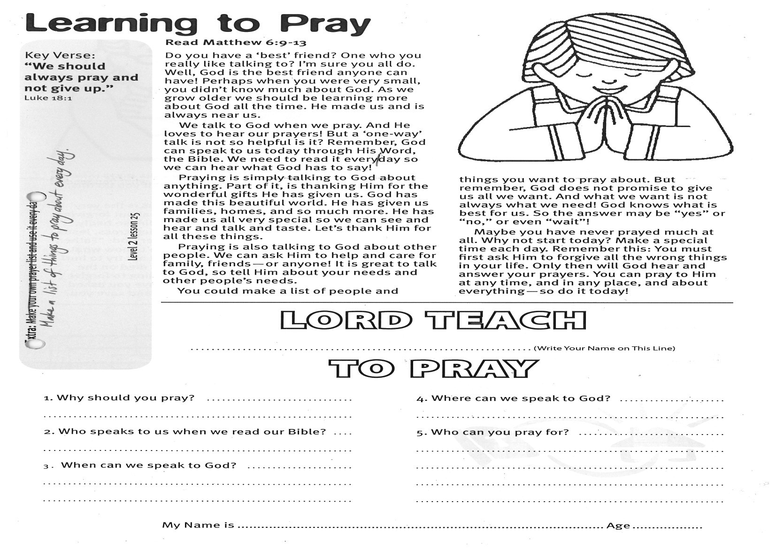

**Read Matthew 6:9-13**

Do you have a ‘best’ friend? One who you really like talking to? I’m sure you all do. Well, God is the best friend anyone can have! Perhaps when you were very small, you didn’t know much about God. As we grow older we should be learning more about God all the time. He made us and is always near us.

We talk to God when we pray. And He loves to hear our prayers! But a ‘one-way’ talk is not so helpful is it? Remember, God can speak to us today through His Word, the Bible. We need to read it every day so we can hear what God has to say!  
  
Praying is simply talking to God about anything. Part of it, is thanking Him for the wonderful gifts He has given us. God has made this beautiful world. He has given us families, homes, and so much more. He has made us all very special so we can see and hear and talk and taste. Let’s thank Him for all these things.

Key Verse:  
**“We should always pray and not give up.”**Luke 18:1

**Learning to Pray**

**LORD TEACH   
  
_________________________ ___** (write your name on this line)  
TO PRAY

4. Where can we pray to God?

________________________________________

________________________________________

5. Who can you pray for?

________________________________________

________________________________________

________________________________________

________________________________________

1. Why should you pray?

_________________________________________

_________________________________________

2. Who speaks to us when we read our Bible?

_________________________________________

3. When can we speak to God?

_________________________________________

_________________________________________

My Name is________________________________________ Age ______________

Praying is also talking to God about other people. We can ask Him to help and care for family, friends, - or anyone! It is great to talk to God, so tell Him about your needs and other people’s needs.  
You could make a list of people and things you want to pray about. But remember, God does not promise to give us all we want. And what we want is not always what we need! God knows what is best for us. So the answer may be “yes” or “no,” or even “wait”!

Maybe you have never prayed much at all. Why not start today? Make a special time each day. Remember this: You must first ask Him to forgive all the wrong things in your life. Only then will God hear and answer your prayers. You can pray to Him at any time, and in any place, and about everything - so do it today!

**Extra:** Make a list of things to pray about every day.

**Level 2 lesson 25**

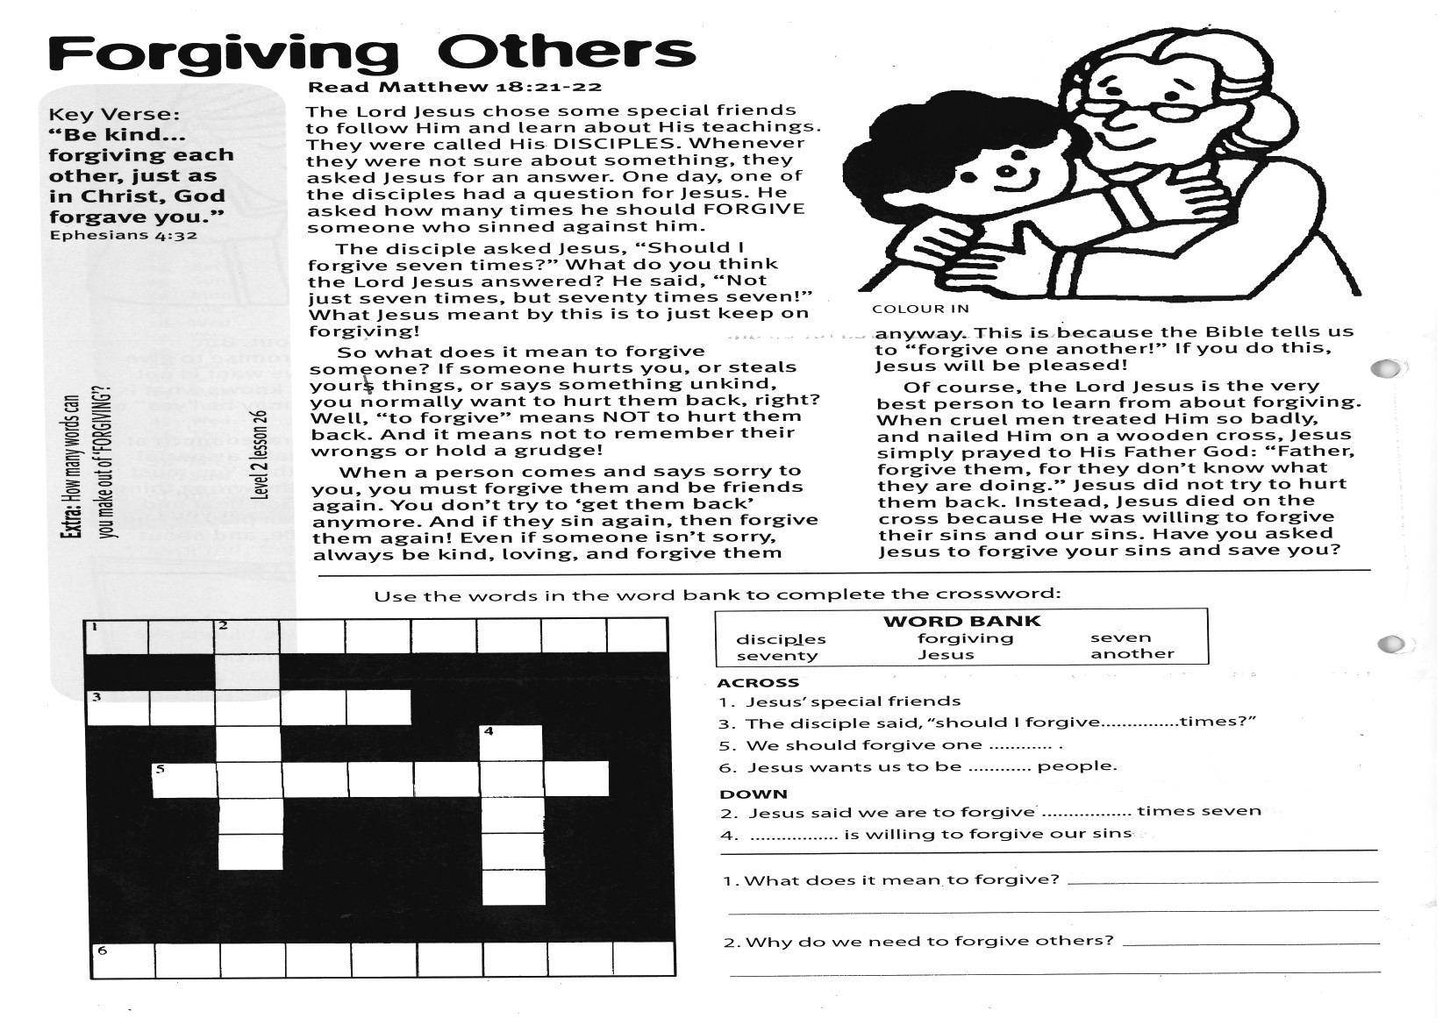

**Read Matthew 18:21-22**

The Lord Jesus chose some special friends to follow Him and learn about His teachings. They were called His DISCIPLES. Whenever they were not sure about something, they asked Jesus for an answer. One day, one of the disciples had a question for Jesus. He asked how many times he should FORGIVE someone who sinned against him.

The disciple asked Jesus, “Should I forgive seven times?” What do you think the Lord Jesus answered? He said, “Not just seven times, but seventy times seven!” What Jesus meant by this is to just keep on forgiving!

So what does it mean to forgive someone? If someone hurts you, or steals yours things, or says something unkind, you normally want to hurt them back, right? Well, “to forgive” means NOT to hurt them back. And it means not to remember their wrongs or hold a grudge!

When a person comes and says sorry to you, you must forgive them and be

Key Verse:  
**“Be kind... forgiving each other, just as in Christ, God forgave you.”** Ephesians 4:32

**Forgiving Others**

|  |  |  |  |  |  |  |  |  |
| --- | --- | --- | --- | --- | --- | --- | --- | --- |
| 1. |  | 2. |  |  |  |  |  |  |
|  |  |  |  |  |  |  |  |  |
| 3. |  |  |  |  |  |  |  |  |
|  |  |  |  |  |  | 4. |  |  |
|  | 5. |  |  |  |  |  |  |  |
|  |  |  |  |  |  |  |  |  |
|  |  |  |  |  |  |  |  |  |
|  |  |  |  |  |  |  |  |  |
|  |  |  |  |  |  |  |  |  |
| 6. |  |  |  |  |  |  |  |  |

**ACROSS**1. Jesus’ special friends  
3. The disciple said, “should I forgive……………times?”  
5. We should forgive one …………   
6. Jesus wants us to be ………… people.

**DOWN**2. Jesus said we are to forgive ………..…… times seven  
4. …………….. is willing to forgive our sins.

**QUESTIONS:** 1. What does it mean to forgive?

______________________________________________

______________________________________________

2. Why do we need to forgive others?

______________________________________________

______________________________________________

friends again. You don’t try to ‘get them back’ anymore. And if they sin again, then forgive them again! Even if someone isn’t sorry, always be kind, loving, and forgive them anyway. This is because the Bible tells us to “forgive one another!” If you do this, Jesus will be pleased!

Of course, the Lord Jesus is the very best person to learn from about forgiving. When cruel men treated Him so badly, and nailed Him on a wooden cross, Jesus simply prayed to His Father God: “Father, forgive them, for they don’t know what they are doing.” Jesus did not try to hurt them back. Instead, Jesus died on the cross because He was willing to forgive their sins and our sins. Have you asked Jesus to forgive your sins and save you?

**Level 2 lesson 26**

**Extra:** How many words can you make out of ‘FORGIVING’?

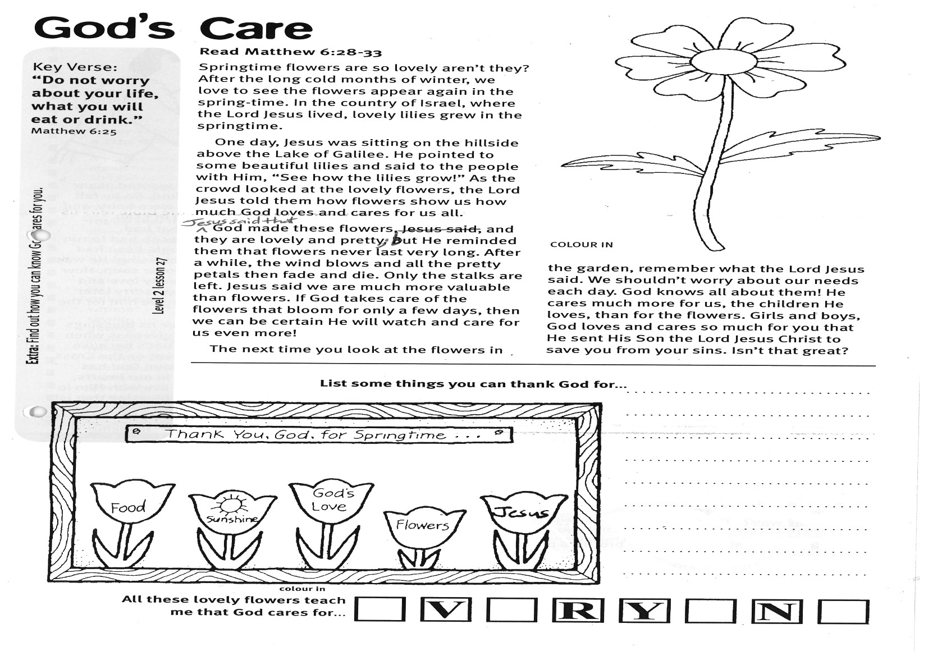

**Read Matthew 6:28-33**

Springtime flowers are so lovely, aren’t they? After the long cold months of winter, we love to see the flowers appear again in the spring-time. In the country of Israel, where the Lord Jesus lived, lovely lilies grew in the springtime.

One day, Jesus was sitting on the hillside above the Lake of Galilee. He pointed to some beautiful lilies and said to the people with Him, “See how the lilies grow!” As the crowd looked at the lovely flowers, the Lord Jesus told them how flowers show us how much God loves and cares for us all.

Jesus said that God made these flowers, and they are lovely and pretty; but He reminded them that flowers never last very long. After a while, the wind blows and all the pretty petals then fade and die. Only the stalks are left. Jesus said we are much more valuable than flowers. If God takes care of the flowers that bloom for only a few days, then we can be certain He will watch and care for us even more!

Key Verse:  
**“Do not worry about your life, what you will eat or drink.”**Matthew 6:25

**Extra:** Find out how you can know God cares for you.

**God’s Care**

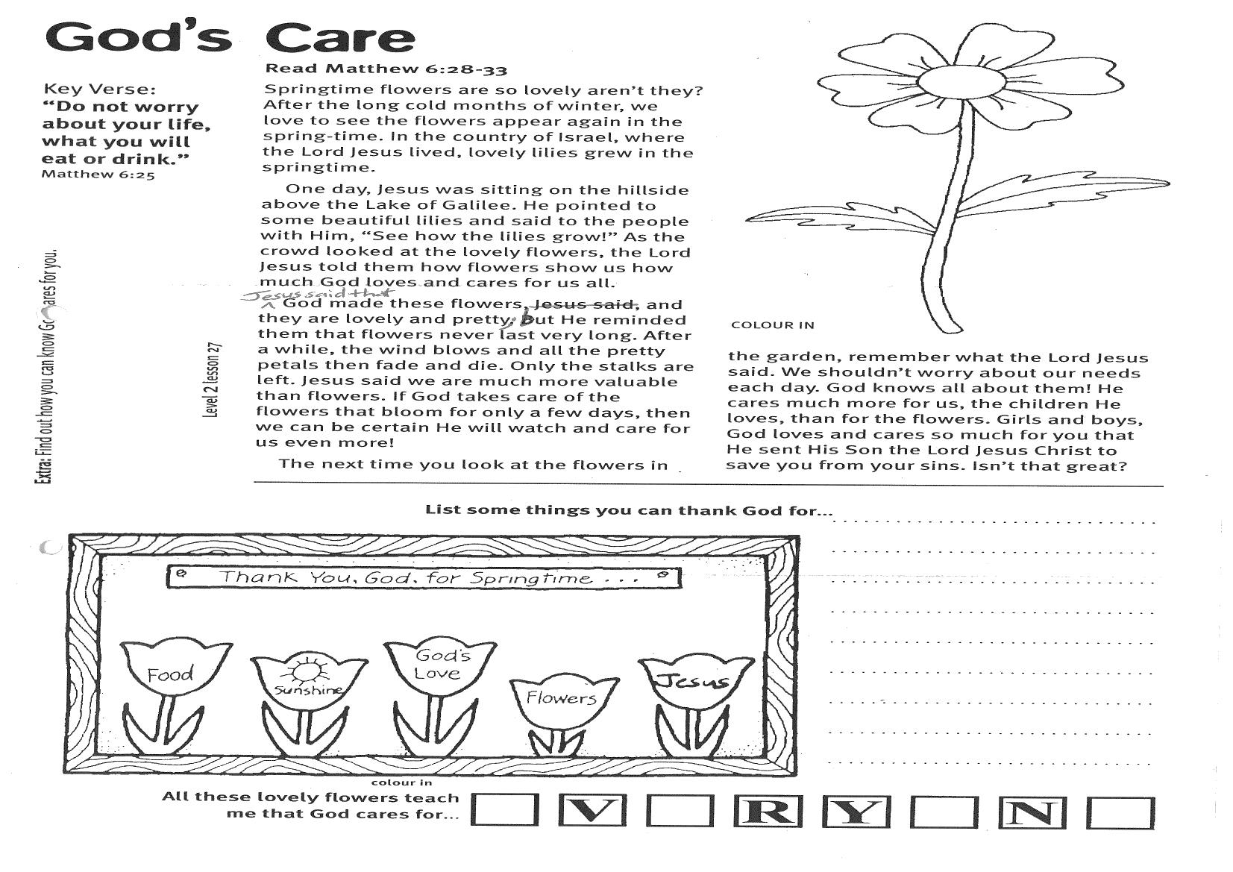

List some things you can thank God for…

___________________________

___________________________

___________________________

___________________________

___________________________

___________________________

___________________________

All these lovely flowers teach me that God cares for **__ V __ R Y __ N __**

The next time you look at the flowers in the garden, remember what the Lord Jesus said. We shouldn’t worry about our needs each day. God knows all about them! He cares much more for us, the children He loves, than for the flowers. Girls and boys, God loves and cares so much for you that He sent His Son the Lord Jesus Christ to save you from your sins. Isn’t that great?

**Level 2 lesson 27**

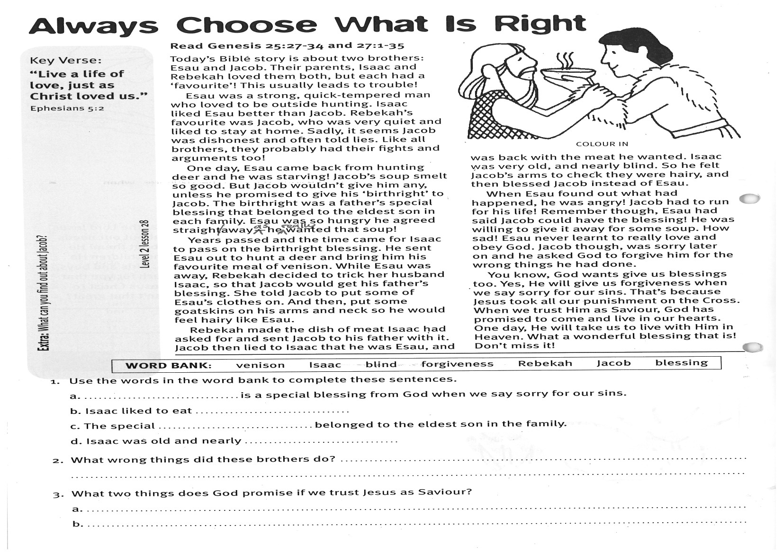

1. Use the words in the Word Bank to complete these sentences:

a. ……………………………………is a special blessing from God when we say sorry for our sins.

b. Isaac liked to eat………………………………………. .

c. The special………………………………………belonged to the eldest son in the family.

d. Isaac was old and nearly…………………………. .

2. What wrong things did these brothers do?   
  
_________________________________________________________________________________________

3. What two things does God promise if we trust Jesus as Saviour?

a. _____________________________________________________________________________________

b. ____________________________________________________________

**WORD BANK:** venison Isaac blind forgiveness Rebekah Jacob blessing

Please complete and return by post to   
**PSSM, 1-2A (G2) 93 Dominion Rd, Mt Eden, Auckland 1024** or scan & email to **info@biblediscovery.org.nz**

Rebekah made the dish of meat Isaac had asked for and sent Jacob to his father with it. Jacob then lied to Isaac that he was Esau, and was back with the meat he wanted. Isaac was very old, and nearly blind. So he felt Jacob’s arms to check they were hairy, and then blessed Jacob instead of Esau.   
  
When Esau found out what had happened, he was angry! Jacob had to run for his life! Remember though, Esau had said Jacob could have the blessing! He was willing to give it away for some soup. How sad! Esau never learnt to really love and obey God. Jacob though, was sorry later on and he asked God to forgive him for the wrong things he had done.  
  
You know, God wants give us blessings, too. Yes, He will give us forgiveness when we say sorry for our sins. That’s because Jesus took all our punishment on the Cross. When we trust Him as Saviour, God has promised to come and live in our hearts. One day, He will take us to live with Him in Heaven. What a wonderful blessing that is! Don’t miss it!

**Read Genesis 25:27-34   
and 27:1-35**

Today’s Bible story is about two brothers: Esau and Jacob. Their parents, Isaac and Rebekah loved them both, but each had a ‘favourite’! This usually leads to trouble!  
Esau was a strong, quick-tempered man who loved to be outside hunting. Isaac liked Esau better than Jacob. Rebekah’s favourite was Jacob, who was very quiet and liked to stay at home. Sadly, it seems Jacob was dishonest and often told lies. Like all brothers, they probably had their fights and arguments too!  
  
One day, Esau came back from hunting deer and he was starving! Jacob’s soup smelt so good. But Jacob wouldn’t give him any, unless he promised to give his ‘birthright’ to Jacob. The birthright was a father’s special blessing that belonged to the eldest son in each family. Esau was so hungry he agreed straight away, as he really wanted that soup!   
  
Years passed and the time came for Isaac to pass on the birthright blessing. He sent Esau out to hunt a deer and bring him his favourite meal of venison. While Esau was away, Rebekah decided to trick her husband Isaac, so that Jacob would get his father’s blessing. She told Jacob to put some of Esau’s clothes on. And then, put some goatskins on his arms and neck so he would feel hairy like Esau.

**Level 2 lesson 28**

**Extra:** What can you find out about Jacob?

**Always Choose What Is Right**

**“Live a life of love, just as Christ loved us.”**Ephesians 5:2