**September 2013  
Bible Readings**

DATE BOOK REFERENCE

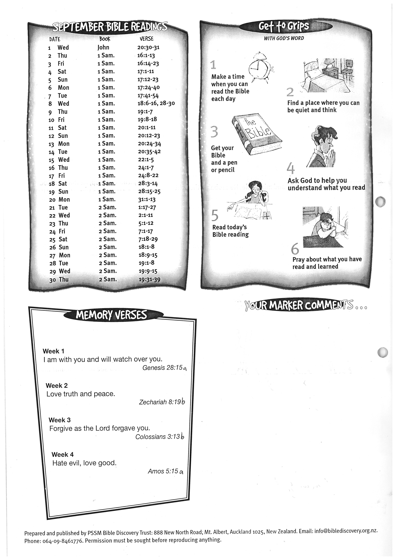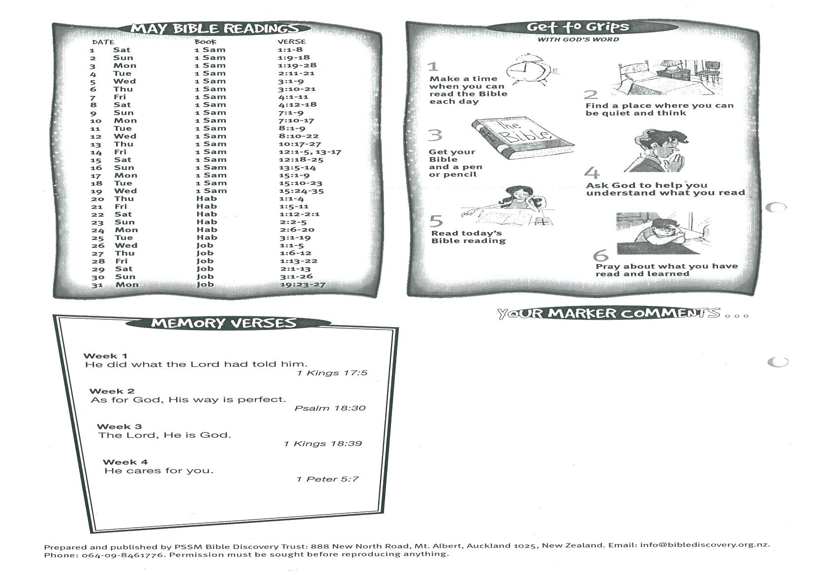



**2 Sam 19:31-39**

**29  
30 Luke 10:38-42  
31 Luke 7:18-23**